**Liferay**

The advantage of Liferay Portal is its easy scalability, the ability to work in a cluster, and cloud deployment.

Clustering is an advanced process used in Liferay DXP to connect two different nodes in a way that they behave like a single application. Clustering promotes parallel processing, load balancing, and fault tolerance, ensuring availability, scalability, and load balancing of different web apps.

Clustering in Liferay DXP fits for high-traffic websites. Clustering eliminates the possibility of server overloading and unresponsiveness and makes an app, platform or website resistant to failures and unavailability.

**Roles & Permissions (Role Based Content Delivery)**

Roles allow the portal administration to define a variety of permissions in any combination they desire, which gives great flexibility.

**Integration Capabilities:**

Liferay is known for its strong integration capabilities. It provides out-of-the-box integrations with various systems and technologies, including CRM systems, enterprise resource planning (ERP) systems, single sign-on (SSO), and more. Liferay's integration framework allows organizations to connect and leverage their existing systems, providing a unified and seamless user experience.

Try it risk-free.

Compatibility with all major operating systems, application servers, and databases means that you can download, install and try Liferay Portal in your existing IT environment, with your existing IT staff.

While other portals make you pay for additional features, Liferay Portal comes with over 60 tools, over 20 themes, and a number of developer tools.

Liferay Portal uses industry standard, government-grade encryption technologies, so you can always be confident in the security of your data. Log in once to access all your files. Varying layers of security with customized access to sensitive information also lets you control who sees what.

From investment banks to the Department of Defense and other government agencies, Liferay Portal is a trusted solution that keeps confidential information safe.

Liferay Portal's open, flexible SOA architecture allows different applications in various languages to work together easily. Liferay's ServiceBuilder automatically generates supporting classes for SOAP-based web services and JSON for Javascript-based access.

**Run your other applications in Liferay too.**

Tools written in other popular programming languages (PHP, Ruby, Python) can run in Liferay, right alongside Liferay's own applications.

Liferay targets the enterprise market and is designed for larger organizations with complex content management and collaboration requirements. It provides a more extensive set of features and capabilities to support enterprise-level digital experiences, intranets, and customer portals.

Liferay is built to handle large-scale deployments and complex enterprise requirements. It offers robust scalability and can support high-traffic websites, multi-site architectures, and complex content structures. Liferay's flexibility allows for extensive customization and integration with existing systems, making it suitable for organizations with unique needs.

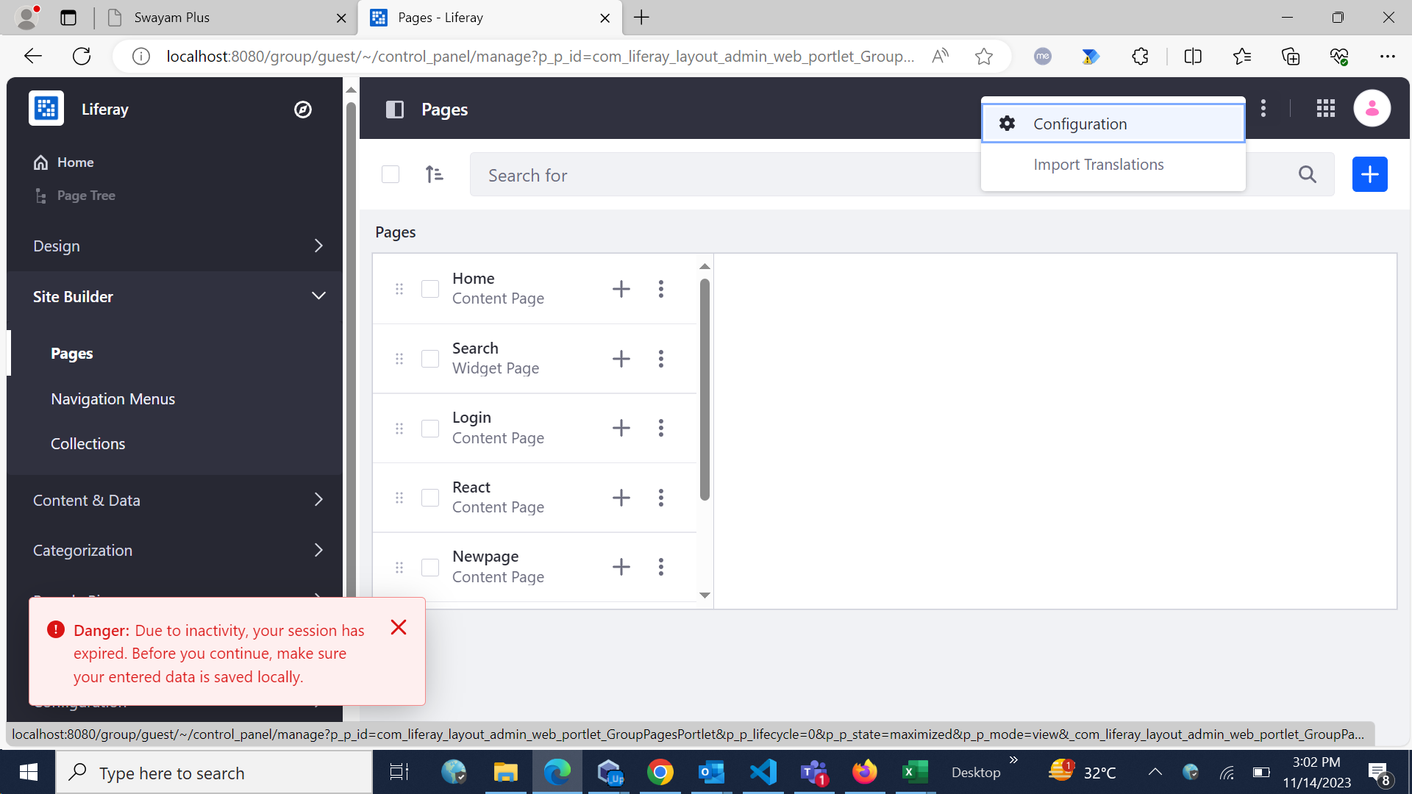

Change favicon