**BANK LOAN ANALYSIS:**

**VALIDATION FOR DASHBOARD:**

**KPI’s:**

1. Total Loan Applications

SELECT COUNT(id) as Total_Loan_Applications FROM bankloan_data;

2.MTD Total Loan Applications

SELECT COUNT(id) as MTD_Total_Loan_Applications FROM bankloan_data

WHERE MONTH(issue_date)=12;

3.PMTD Total Loan Applications

SELECT COUNT(id) as PMTD_Total_Loan_Applications FROM bankloan_data

WHERE MONTH(issue_date)=11;

4.Total Funded Amount

SELECT SUM(loan_amount) AS Total_Funded_Amount FROM bankloan_data;

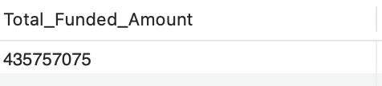

5.MTD Total Funded Amount

SELECT SUM(loan_amount) AS MTD_Total_Funded_Amount FROM bankloan_data

WHERE MONTH(issue_date) = 12 AND YEAR(issue_date)= 2021;

6. PMTD Total Funded Amount

SELECT SUM(loan_amount) AS PMTD_Total_Funded_Amount FROM bankloan_data

WHERE MONTH(issue_date) = 11 AND YEAR(issue_date)= 2021;

7.Total Amount Collected

SELECT SUM(total_payment) AS Total_Amount_Collected FROM bankloan_data;

8.MTD Total Amount Collected

SELECT SUM(total_payment) AS MTD_Total_Amount_Collected FROM bankloan_data

WHERE MONTH(issue_date) = 12 AND YEAR(issue_date)= 2021;

9.PMTD Total Amount Collected

SELECT SUM(total_payment) AS PMTD_Total_Amount_Collected FROM bankloan_data

WHERE MONTH(issue_date) = 12 AND YEAR(issue_date)= 2021;

10.Average Interest Rate

SELECT ROUND(AVG(int_rate)*100,2) AS Avg_Intrest_Rate FROM bankloan_data;

11.MTD Average Interest Rate

SELECT ROUND(AVG(int_rate)*100,2) AS MTD_Avg_Intrest_Rate FROM bankloan_data

WHERE MONTH(issue_date) = 12 AND YEAR(issue_date)= 2021;

12.PMTD Average Interest Rate

SELECT ROUND(AVG(int_rate)*100,2) AS PMTD_Avg_Intrest_Rate FROM bankloan_data

WHERE MONTH(issue_date) = 11 AND YEAR(issue_date)= 2021;

13.Average DTI

SELECT ROUND(AVG(dti)*100,2) AS Avg_DTI FROM bankloan_data;

14.MTD Average DTI

SELECT ROUND(AVG(dti)*100,2) AS MTD_Avg_DTI FROM bankloan_data

WHERE MONTH(issue_date) = 12 AND YEAR(issue_date)= 2021;

15.PMTD Average DTI

SELECT ROUND(AVG(dti)*100,2) AS PMTD_Avg_DTI FROM bankloan_data

WHERE MONTH(issue_date) = 11 AND YEAR(issue_date)= 2021;

---GOOD LOAN VS BAD LOAN

16.Good loan Percentage

SELECT

(COUNT(CASE WHEN loan_status = 'Fully Paid' OR loan_status = 'Current' THEN id END) * 100.0) /

COUNT(id) AS Good_Loan_Percentage

FROM bankloan_data;

17. Good Loan Applications

SELECT COUNT(id) AS Good_Loan_Applications FROM bankloan_data

WHERE loan_status = 'Fully Paid' OR loan_status = 'Current';

18.Good Loan Funded Amount

SELECT SUM(loan_amount) AS Good_Loan_Funded_amount FROM bankloan_data

WHERE loan_status = 'Fully Paid' OR loan_status = 'Current';

19.Good Loan Received Amount

SELECT SUM(total_payment) AS Good_Loan_amount_received_amount FROM bankloan_data

WHERE loan_status = 'Fully Paid' OR loan_status = 'Current';

20.Bad Loan Percentage

SELECT

(COUNT(CASE WHEN loan_status = 'Charged Off' THEN id END) * 100.0) /

COUNT(id) AS Bad_Loan_Percentage

FROM bankloan_data;

21.Bad Loan Applications

SELECT COUNT(id) AS Bad_Loan_Applications FROM bankloan_data

WHERE loan_status = 'Charged Off';

22.Bad Loan Funded Amount

SELECT SUM(loan_amount) AS Bad_Loan_Funded_amount FROM bankloan_data

WHERE loan_status = 'Charged Off';

23.Bad Loan Received Amount

SELECT SUM(total_payment) AS Bad_Loan_amount_received FROM bankloan_data

WHERE loan_status = 'Charged Off';

--LOAN STATUS

24.

SELECT

loan_status,

COUNT(id) AS LoanCount,

SUM(total_payment) AS Total_Amount_Received,

SUM(loan_amount) AS Total_Funded_Amount,

AVG(int_rate * 100) AS Interest_Rate,

AVG(dti * 100) AS DTI

FROM

bankloan_data

GROUP BY

loan_status;



25. SELECT

loan_status,

SUM(total_payment) AS MTD_Total_Amount_Received,

SUM(loan_amount) AS MTD_Total_Funded_Amount

FROM bankloan_data

WHERE MONTH(issue_date) = 12

GROUP BY loan_status;

--OVERVIEW

26.

SELECT

MONTH(issue_date) AS Month_number,

MONTHNAME(issue_date) AS Month_name,

COUNT(id) AS Total_Loan_Applications,

SUM(loan_amount) AS Total_Funded_Amount,

SUM(total_payment) AS Total_Amount_Received

FROM bankloan_data

GROUP BY MONTH(issue_date), MONTHNAME(issue_date)

ORDER BY MONTH(issue_date);

27.

SELECT

address_state AS State,

COUNT(id) AS Total_Loan_Applications,

SUM(loan_amount) AS Total_Funded_Amount,

SUM(total_payment) AS Total_Amount_Received

FROM bankloan_data

GROUP BY address_state

ORDER BY Total_Funded_Amount DESC;

28.

SELECT

term AS Term,

COUNT(id) AS Total_Loan_Applications,

SUM(loan_amount) AS Total_Funded_Amount,

SUM(total_payment) AS Total_Amount_Received

FROM bankloan_data

GROUP BY term

ORDER BY term;

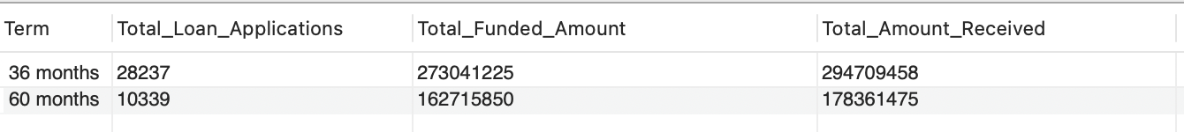

29.

SELECT

emp_length AS Employee_Length,

COUNT(id) AS Total_Loan_Applications,

SUM(loan_amount) AS Total_Funded_Amount,

SUM(total_payment) AS Total_Amount_Received

FROM bankloan_data

GROUP BY emp_length

ORDER BY Total_Loan_Applications DESC;

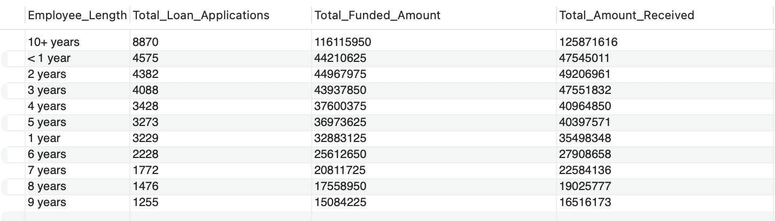

30.

SELECT

purpose AS PURPOSE,

COUNT(id) AS Total_Loan_Applications,

SUM(loan_amount) AS Total_Funded_Amount,

SUM(total_payment) AS Total_Amount_Received

FROM bankloan_data

GROUP BY purpose

ORDER BY Total_Loan_Applications DESC;

31.

SELECT

home_ownership AS Home_Ownership,

COUNT(id) AS Total_Loan_Applications,

SUM(loan_amount) AS Total_Funded_Amount,

SUM(total_payment) AS Total_Amount_Received

FROM bankloan_data

GROUP BY home_ownership

ORDER BY Total_Loan_Applications DESC;

--DETAILS

32. SELECT

purpose AS PURPOSE,

COUNT(id) AS Total_Loan_Applications,

SUM(loan_amount) AS Total_Funded_Amount,

SUM(total_payment) AS Total_Amount_Received

FROM bankloan_data

WHERE grade = 'A'

GROUP BY purpose

ORDER BY purpose;

