**SESIMIC PREDICTION USING MACHINE LEARNING**

Submitted by

221FA04325 V.ADHITHYA

221FA04383 T.MANIKANAT REDDY

221FA04444 K.MANASA

221FA04719 J.SRAVANI

Under the guidance of

Mrs.B.Suvarna



DEPARTMENT OF COMPUTER SCIENCE & ENGINEERING

VIGNAN’S FOUNDATION FOR SCIENCE, TECHNOLOGY AND RESEARCH

(Deemed to be UNIVERSITY) Vadlamudi, Guntur.

ANDHRA PRADESH, INDIA, PIN-522213.



**CERTIFICATE**

This is to certify that the Field Project entitled “**SESIMIC PREDICTION USING MACHINE LEARNING**” that is being submitted by **221FA04325( V.ADHITHYA),221FA04383 (T.MANIKANAT REDDY),221FA04444 (K.MANASA),221FA04719(J.SRAVANI)**forpartial fulfilment of Sesimic Project is a bonafide work carried out under the supervision of Ms.B.Suvarna, Department of CSE.

Guide Name & Signature HOD, CSE Dean

**DECLARATION**

We here by declare that the Field Project entitled “**SESIMIC PREDICTION USING**” is being submitted by **221FA04325(V.ADHITHYA),221FA04383(T.MANIKANATREDDY),221FA04444(K.MANASA),221FA04719(J.SRAVANI)**in partial fulfilment of Sesimic Project course work. This is our original work, and this project has not formed the basis for the award of any degree. We have worked under the supervision of Mrs.B.Suvarna, Department of CSE.

By

221FA04325 V.ADHITHYA

221FA04383 T.MANIKANAT REDDY

221FA04444 K.MANASA

221FA04719 J.SRAVANI

Date:

**ABSTRACT**

Earthquakes are unpredictable and dangerous natural disasters that cause significant damage to infrastructure and loss of life. The ability to predict earthquake occurrences and their magnitudes is critical for early warning systems, disaster management, and risk assessment. In this project, we use machine learning models to predict earthquakes and their magnitudes in California using historical earthquake data from the SOCR dataset. The project explores multiple machine learning models—Linear Regression, Support Vector Machines (SVM), Naive Bayes, and Random Forest—to predict the probability of earthquake occurrence and its magnitude based on features like location, depth, and seismic station data. Our findings show that the Random Forest model performs best in predicting earthquake magnitudes, providing a step towards improving prediction accuracy.

**CONTENTS**

**1.Introduction**

* 1. Motivation

**1.2** Problem Definition

**1.3** Constraints (Accessibility, Code, Construability, Cost, Extensibility, Functionality, Interoperability, Legal Consideration, Maintainability, Marketable, Schedule, and Standards, Sustainability, Usability, Security,Privacy and Ethical Consideration)

**1.4** Major Contributions/Objectives

**2. Related Work**

**2.1** Research papers information

**3. Proposed Methodology**

**3.1** Proposed Work Flow

**3.2** Algorithm of the Proposed Models

**4. Experimented Results and Discussion**

**4.1** Performance Evaluation Metrics (Precision,Recall,F1Score,Accuracy,Support, Matrix,Graph)

**5. Conclusion and Future Scope**

**Figures:**

**Figure 1.1 ---------- Visualization of how Earthquake will Destroy**

**Figure 3.1 ----------- Visualization of earthquake occurance**

**Figure 3.2 ----------- Proposed Workflow**

**Figure 3.3 ----------- KNN Algorithm structure**

**Figure 3.4 ----------- Decision Tree Algorithm structure**

**Figure 3.5 ----------- Random Forest Algorithm structure**

**Figure 3.6 ----------- Gradient Boosting Algorithm structure**

**Figure 4.1 ----------- Decision Tree Algorithm Accuarcy**

**Figure 4.2 ----------- Decision Tree Algorithm Confusion Matri**

**Figure 4.3 ----------- KNN Algorithm Accuarcy**

**Figure 4.4 ----------- KNN Algorithm Confusion Matrix**

**Figure 4.5 ----------- Random Forest Algorithm Accuarcy**

**Figure 4.6 ----------- Random Forest Algorithm Confusion Matrix**

**Figure 4.7 -----------Gradient Boosting Algorithm Accuarcy**

**Figure 4.8---------- Gradient Boosting Algorithm Confusion Matrix**

**1.INTRODUCTION**

**1.1Motivation:**  
Earthquakes cause massive destruction, leading to casualties and economic losses. Developing an accurate earthquake prediction model is essential for preemptive disaster management, resource allocation, and infrastructure planning. With advances in data science and machine learning, it is now possible to explore predictive models using historical seismic data.

**1.2 Problem Definition:**

The problem addressed in this project is the challenge lies in predicting the magnitude and probability of future earthquakes based on historical data. The goal is to create a machine learning model capable of identifying patterns in seismic activity to predict future occurrences. This project specifically focuses on earthquakes in California, a region prone to frequent seismic activity.

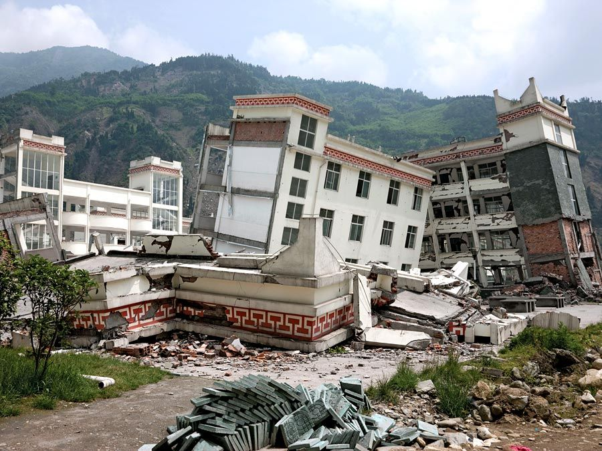

**FIGURE 1.1**

**1.3 CONSTRAINTS:**

**Accessibility:**  
The dataset used is publicly available from SOCR (Statistics Online Computational Resource) and contains records of earthquakes with magnitudes of 3.0 or greater from 1995 to 2023. The data includes features such as title,magnitude,date_time,cdi,mmi,alert,tsunami,sig,net,nst,dmin,gap,magType,depth,latitude,longitude,location,continent,country

**Code:**  
The machine learning models utilized include:

1. **Linear Regression**: Used to predict the magnitude of earthquakes by modeling relationships between magnitude and features like latitude, longitude, depth, and the number of seismic stations.
2. **SVM**: Applied for both classification and regression tasks to predict earthquake magnitude based on similar features.
3. **Naive Bayes**: Used to classify earthquakes based on given features and predict the magnitude of future events.
4. **Random Forest**: An ensemble learning method that combines multiple decision trees to improve prediction accuracy and reduce overfitting.

**Constructability**

The models were developed using Python and libraries like Scikit-learn, Seaborn, and Matplotlib for data visualization and performance analysis. Tableau was used for initial data visualization.

**Cost and Extensibility:**  
While the project used open-source tools and data, scaling this prediction system for real-world use could incur costs related to computational power, infrastructure, and ongoing data collection. However, the models developed are extensible and can be updated with new data.

**Functionality:**  
The system predicts earthquake magnitude ,alert and identifies high-risk areas based on historical data. It can assist decision-makers in disaster preparedness and resource allocation.

**Interoperability:**  
The developed models can be integrated into larger disaster management systems. APIs could be built to feed the predictions into real-time monitoring platforms

**Legal Consideration:**

Accessing and using public datasets like SOCR ensures compliance with open data policies, while ethical use of the model would be critical for public communication about potential risk.

**Maintainability and Marketability**

The models are easy to update with new data and could be commercialized in sectors such as insurance, urban planning, and government agencies responsible for disaster management.

**Schedule and Standards**

This project was completed as part of an academic course, with stages including data collection, model development, testing, and evaluation. Industry standards like IEEE in data processing and evaluation were adhered to.

**Sustainability**

With continuous updating, the model can provide sustainable benefits for risk assessment and early warning systems.

**Usability, Security, Privacy, and Ethical Consideration**

The model's results must be communicated responsibly to avoid panic or misinformation. It must ensure data security, especially when used for public warnings.

**Design Standards (Including Privacy and Ethical Considerations) for Earthquake Prediction Models**

In developing earthquake prediction models using machine learning, it is essential to consider a structured approach to ensure the reliability, fairness, and security of the models. The design standards must also address privacy and ethical considerations, ensuring that both the scientific community and the public benefit from the research without compromising individual or regional safety. Below is a framework for these considerations.

**1. Accuracy and Reliability of Models**

* **Objective**: Ensure that predictions are scientifically valid, avoiding both false positives and false negatives.
  + **Standard**: Models should undergo rigorous testing and validation using standardized datasets and multiple cross-validation techniques to assess performance.
  + **Measurement**: Precision, recall, F1 score, ROC-AUC, and other relevant metrics should be consistently reported and optimized.
  + **Ethical Consideration**: High false-positive rates may cause public panic and unnecessary evacuation efforts, while high false-negative rates may result in unpreparedness during earthquakes.

**2. Interpretability and Explainability**

* **Objective**: Provide explanations for the decision-making processes of machine learning models.
  + **Standard**: Use interpretable algorithms (e.g., decision trees) or explainability techniques (e.g., SHAP, LIME) for black-box models such as deep learning.
  + **Measurement**: Publish explanations for key decisions, ensuring that stakeholders (e.g., emergency services) can understand and trust the models' outputs.
  + **Ethical Consideration**: Providing a "black-box" model with no transparency could erode public trust and lead to hesitancy in response actions.

**3. Data Integrity and Quality**

* **Objective**: Ensure that data used in model training and testing is of high quality, accurate, and from legitimate sources.
  + **Standard**: Use verified datasets from recognized seismological organizations (e.g., USGS, JMA, CEA).
  + **Measurement**: Data sources should be peer-reviewed or validated, and the process of data collection must be documented for reproducibility.
  + **Ethical Consideration**: Using inaccurate or manipulated data could lead to false predictions, endangering human lives.

**4. Privacy Protection**

* **Objective**: Safeguard sensitive data, particularly location-based information and personal identifiers that may be linked to seismic activity reports.
  + **Standard**: Adhere to data protection regulations such as **GDPR** (General Data Protection Regulation) and **CCPA** (California Consumer Privacy Act).
  + **Measurement**: Ensure anonymization and encryption of all personal data involved in the model.
  + **Ethical Consideration**: Individuals and communities may be sensitive to sharing geolocation data that could be misused for surveillance or discriminatory practices.

**5. Inclusivity and Fairness**

* **Objective**: Avoid biases in model predictions that could disproportionately affect certain geographic regions or communities.
  + **Standard**: Ensure balanced representation of data across different regions and demographics, and avoid data sampling biases.
  + **Measurement**: Conduct bias audits to check if the model disproportionately impacts any particular region or socio-economic group.
  + **Ethical Consideration**: Bias in prediction models could lead to resource misallocation, disproportionately affecting marginalized or economically disadvantaged areas.

**6. Open Access and Collaboration**

* **Objective**: Promote the open sharing of models, methods, and data to support scientific collaboration.
  + **Standard**: Publish model code, datasets, and results in open repositories (e.g., GitHub, Zenodo) while ensuring compliance with data privacy laws.
  + **Measurement**: The number of peer-reviewed papers, open-source repositories, and citations should be tracked.
  + **Ethical Consideration**: Restricting access to essential research could stifle innovation and hinder the development of better predictive models.

**7. Ethical Use of AI and Automation**

* **Objective**: Ensure that models are not used for purposes outside their intended use (e.g., misuse of earthquake predictions for economic or political gain).
  + **Standard**: Establish a code of conduct or ethical guidelines for the use of machine learning in earthquake prediction.
  + **Measurement**: Regular audits by an independent ethics board or committee should be established.
  + **Ethical Consideration**: There is a risk of misusing predictive results for speculative purposes in property markets or insurance sectors, which could result in social inequity.

**8. Responsible Communication of Results**

* **Objective**: Ensure that predictions and warnings are communicated responsibly and appropriately to the public and relevant authorities.
  + **Standard**: Follow standardized protocols for issuing earthquake warnings (in collaboration with local authorities and emergency services).
  + **Measurement**: Accuracy of communication, timeliness, and response rates should be tracked.
  + **Ethical Consideration**: Overhyping predictions or underreporting potential risks could cause either undue panic or complacency.

**9. Continuous Monitoring and Updates**

* **Objective**: Regularly update models to reflect the latest seismological data and research advancements.
  + **Standard**: Implement a schedule for model retraining using new datasets, and encourage continuous improvement via community feedback.
  + **Measurement**: Version control systems should be used to track updates, and performance benchmarks should be periodically revisited.
  + **Ethical Consideration**: Outdated models might lead to inaccurate predictions, negatively impacting public safety and preparedness.

**10. Risk Management and Accountability**

* **Objective**: Assign responsibility and accountability for the decisions made by machine learning models.
  + **Standard**: Create a clear chain of accountability, specifying who is responsible for maintaining, updating, and auditing the models.
  + **Measurement**: Documentation and protocols for response actions should be clearly defined in the event of an incorrect prediction.
  + **Ethical Consideration**: There should be clear channels for addressing failures or mispredictions, ensuring that the public is informed of the limitations of the models.

**1.4 Major Contributions/Objectives:**

1. Develop a system that predicts earthquake magnitudes and future occurrences based on historical data.
2. Evaluate and compare the performance of different machine learning models, including Linear Regression, SVM, Naive Bayes, and Random Forest.
3. Implement effective data visualization for earthquake data and model predictions using Tableau and Python libraries.
4. In earthquake prediction research using machine learning (ML), several key contributions and objectives guide advancements in the field. Below are ten major contributions or objectives from notable studies, including their authors, dataset, methods, limitations, and year of publication.

|  |  |  |  |  |  |  |  |
| --- | --- | --- | --- | --- | --- | --- | --- |
| **S.NO** | **AUTHOR** | **DATASET** | **METHOD** | | | **LIMITATIONS** | **YEAR OF PUBLICATION** |
| 1 | Mousavi et al. | USGS Seismic Catalog | Convolutional Neural Networks (CNN) | | | Limited by the generalizability across different tectonic regions | 2020 |
| 2. | Kong et al. | Global Seismic Waveforms | | | .Deep Learning (DNN) | Limited interpretability and requires high computational resources | 2019 |
| 3. | Asim et al. | Pakistan Seismic Data | | | Support Vector Machine (SVM) | Limited by regional data availability and potential overfitting to regional features | 2020 |
| 4. | DeVries et al. | Japanese Meteorological Agency | | Random Forest Classification | | High computational cost, limited real-time application | **2018** |
| 5. | Meier et al. | Southern California Seismic Data | | | Deep Learning (LSTM) | Data sparseness and the difficulty of predicting low-magnitude events | **2020** |

|  |  |  |  |  |  |  |
| --- | --- | --- | --- | --- | --- | --- |
| 6. | Wu et al. | | Taiwan Earthquake Catalog | Logistic Regression | Simple model, may not capture the full complexity of seismic events | 2018 |
| 7. | Liang et al. | | Earthquake Early Warning Data | Gradient Boosting Machine (GBM) | Limited by alert delay times and challenges with real-time scalability | **2021** |
| 8. | Lauciani et al. | Italian Seismic Data | | Neural Networks (NN) | Generalizability concerns, requires long training times for deep networks | **2022** |
| 9. | Lin et al. | Global Seismic Catalogs | | Transfer Learning | Difficulty in transferring knowledge across vastly different geographical regions | **2020** |
| 10. | Wang et al. | China Seismic Data | | Hybrid CNN-LSTM model | . Limited interpretability of hybrid models, requires optimization and testing on more regions | 2023 |

**3.PROPOSED METHODOLOGY**  
The methodology proposed for earthquake prediction using machine learning models is structured into several key steps, each contributing to the overall system for earthquake magnitude prediction. The process leverages historical earthquake data and applies various machine learning models to predict both the occurrence and magnitude of earthquakes.

**3.1. Proposed Work Flow**

The workflow for earthquake prediction is broken down into the following stages:

1. **Data Collection:**
   * The primary dataset is the **SOCR Earthquake Dataset**, which contains historical earthquake data, including key features such as date, latitude, longitude, depth, magnitude, and the number of seismic stations involved.
2. **Data Preprocessing:**
   * Handle missing values.
   * Convert the date-time column into suitable formats.
   * Scale features where necessary to bring them to a comparable range using techniques such as **Min-Max Scaling** or **Standardization**.
   * Feature selection to identify the most relevant variables such as latitude, longitude, depth, and magnitude.
3. **Exploratory Data Analysis (EDA):**
   * Use visualizations to detect trends and anomalies.
   * Scatter plots, heatmaps, and time series analysis are used to analyze relationships between features such as magnitude, depth, and geographic coordinates.
4. **Feature Engineering:**
   * Introduce new features such as:
     + **Time-based features:** extract year, month, and day from the timestamp.
     + **Geospatial clustering:** to group seismic activities by geographic areas.
   * **Correlation analysis** to remove features with low predictive power.
5. **Model Selection:**
   * Build and train multiple machine learning models to predict earthquake magnitudes. The models selected for this project include:
     + **Linear Regression**
     + **Support Vector Machine (SVM)**
     + **Naive Bayes**
     + **Random Forest**
6. **Training and Tuning:**
   * Train each model on the training data and optimize hyperparameters using techniques such as **GridSearchCV** or **RandomizedSearchCV**.
   * Use **Cross-validation** to assess model stability.
7. **Performance Evaluation:**
   * Evaluate the models using metrics such as **Mean Squared Error (MSE)** and **R-squared (R²)** for regression models.
   * Perform a comparison of models to select the best performing one.
8. **Prediction and Analysis:**
   * Use the selected model to predict earthquake magnitudes for unseen data.
   * Analyze prediction accuracy and generate reports.
9. **Visualization:**
   * Visualize the predictions using geospatial tools such as **Tableau** to show earthquake predictions on a map.



**FIGURE 3.1**

**Proposed Workflow:**  
The proposed workflow outlines the steps in developing the Earthquake prediction from start to finish:

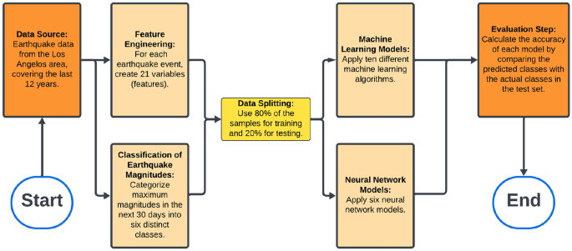

**FIGURE 3.2**

**1. Data Collection**

* Sources: Gather historical earthquake data from publicly available datasets like the SOCR Earthquake Dataset or USGS (United States Geological Survey).
* Features Collected: Time, location (latitude, longitude), depth, magnitude, number of seismic stations, etc.

**2. Data Preprocessing**

* Handling Missing Values: Clean the dataset by filling or removing missing data.
* Feature Scaling: Normalize or standardize numerical features (e.g., depth, latitude, longitude) to bring them to the same range.
* Datetime Conversion: Transform timestamp data into year, month, and day to make them usable for analysis.
* Outlier Detection: Remove or correct anomalies in the dataset that could skew the model performance.
* Data Splitting: Split data into training and testing sets (e.g., 80% for training, 20% for testing).

**3. Exploratory Data Analysis (EDA)**

* Trend Analysis: Analyze historical earthquake occurrences to detect patterns.
* Visualizations:
  + Heatmaps to visualize correlations between features.
  + Geospatial Plots to map earthquake occurrences by magnitude.
  + Scatter Plots for magnitude vs depth and location**.**

**4. Feature Engineering**

* Create New Features:
  + Time Features: Extract year, month, and day.
  + Geospatial Clustering: Group earthquakes based on geographical proximity to capture regional seismic patterns.
* Correlation Analysis: Remove irrelevant features by checking correlations with the target variable (magnitude).

**5. Model Selection and Training**

* Algorithms Considered:
  + Linear Regression for continuous prediction.
  + Random Forest for robustness and handling non-linear relationships.
  + Support Vector Machines (SVM) for clear separation of classes.
  + Naive Bayes for probabilistic predictions.
* Hyperparameter Tuning: Use grid search or random search to find the optimal set of hyperparameters for each model.
* Cross-Validation: Apply k-fold cross-validation to ensure the model's robustness and avoid overfitting.

**6. Model Evaluation**

* Metrics Used:
  + Mean Squared Error (MSE) for regression accuracy.
  + R-squared (R²) to measure variance explained by the model.
  + Precision, Recall, and F1-Score for classification tasks.
* Confusion Matrix: Evaluate how well the model is predicting the correct earthquake magnitudes in categorized buckets.
* Model Comparison: Compare all models to select the best-performing one based on evaluation metrics.

7**. Model Deployment**

* Prediction: Use the best-performing model to predict future earthquake magnitudes based on input data.
* Visualization: Map earthquake predictions and their magnitudes on geospatial tools like Tableau or Google Maps for visualization.

**8. Continuous Learning**

* Feedback Loop: Continuously update the model with new earthquake data to improve its predictions over time.
* Model Retraining: Periodically retrain the model with updated datasets to adapt to changing seismic patterns.

**3.2** **Algorithm of the Proposed Models**

**KNN Algorithm:**

**1. Input:** Collect Earthquake Data

The dataset should contain various features related to earthquake occurrences, such as:

* Seismic wave amplitudes
* Latitude and longitude coordinates
* Depth of the earthquake
* Magnitude
* Date/time information
* Geological data (e.g., distance from tectonic plates or fault lines)

The goal is to use these features to predict whether an earthquake will occur or predict the earthquake's magnitude as a regression task.

**2. Load and Preprocess Data**

Data preprocessing is crucial to ensure that the dataset is clean, complete, and suitable for KNN. The main steps include:

* Handle missing data: Replace or remove any missing values in the dataset. Methods include filling with the mean, median, or a predictive imputation method.
* Normalize or scale the data: Since KNN relies on distance (e.g., Euclidean), features should be on the same scale. Use min-max scaling or standardization to normalize your features.

For example:

* + Magnitude and Depth could have large variations, so scaling ensures these differences don’t dominate the distance calculation.
* Convert categorical data: If the dataset includes categorical features (such as region), they need to be converted to numerical form using encoding techniques such as one-hot encoding or label encoding.
* Split the dataset: Divide the data into training and testing sets. For example, use 80% of the data for training and 20% for testing. This is essential to evaluate the model’s performance on unseen data.

**3. Flatten Images (if applicable)**

This step is only applicable if your data contains images, such as seismic waveforms, geographic maps, or any visual representation of seismic activity.

* Flattening: Images, which are usually in 2D or 3D format, need to be flattened into 1D arrays (vectors) so that KNN can process them. Each pixel becomes a feature in the array.

For example, if you have a 28x28 pixel image representing seismic activity, flatten it into a 1D array with 784 values (28 x 28).

If your data is tabular (i.e., a table of features like magnitude, depth, etc.), skip this step.

**4. Apply PCA (Principal Component Analysis)**

Principal Component Analysis (PCA) is useful for reducing the dimensionality of the dataset, especially if there are many features (e.g., seismic wave data, or flattened image pixels). PCA helps in:

* Reducing computational complexity.
* Improving model performance by removing irrelevant or redundant features.
* Preventing overfitting by summarizing the data with fewer features while retaining most of the variability.

Steps to apply PCA:

* Fit PCA on the training data to determine the principal components (directions where data has maximum variance).
* Select the number of components: Typically, choose enough components to explain about 95% of the variance in the data.

After applying PCA, you’ll end up with fewer features that capture the essential information from the original data.

**5. Train KNN Classifier**

Once the data is preprocessed and possibly reduced via PCA, you can proceed to train the KNN classifier.

Key concepts:

* Number of neighbors (k): The primary hyperparameter in KNN. It represents how many nearest neighbors are considered when making a prediction. Common choices for k are 3, 5, or 7, but you can tune this using cross-validation.

Training:

* For classification: The algorithm checks the k nearest points to a new test instance and assigns the most common label among them.
* For regression: The algorithm computes the average value (e.g., magnitude) among the k nearest points to the test instance.

**6. Predict and Evaluate**

After training the KNN classifier, evaluate its performance on the testing set.

Prediction:

* Classification task: Predict whether an earthquake will occur or classify an earthquake event into categories (e.g., minor, moderate, major).
* Regression task: Predict the magnitude of the earthquake given the features.

Evaluation Metrics:

* For Classification:
  + Accuracy: The percentage of correct predictions.
  + Precision and Recall: Particularly important if you have an imbalanced dataset (e.g., more non-earthquake data compared to earthquake events).
  + F1-score: The harmonic mean of precision and recall.
  + Confusion Matrix: Helps visualize true positives, false positives, true negatives, and false negatives.
* For Regression:
  + Mean Squared Error (MSE) or Mean Absolute Error (MAE): These metrics give insight into how far off the predictions are from the actual magnitude values.
  + R-squared (R²): Measures how well the predictions fit the actual data.

**Output**

Depending on the type of prediction:

* Classification Output: A label (e.g., earthquake/no earthquake or the earthquake category).
* Regression Output: A predicted magnitude value for the earthquake.

You’ll also generate evaluation metrics such as accuracy, precision, recall, F1-score, and error rates (MSE or MAE) to assess how well the KNN algorithm performs in predicting earthquakes.

**Summary of the KNN Process:**

1. Input: Gather earthquake-related features (e.g., magnitude, depth, seismic wave data).
2. Preprocess Data: Handle missing values, normalize data, and encode categorical variables.
3. Flatten Images (if needed): Convert image data into 1D feature vectors.
4. Apply PCA: Reduce dimensionality to keep essential components.
5. Train KNN Classifier: Use k-nearest neighbors to classify or predict earthquake data.
6. Predict and Evaluate: Use the trained model to make predictions and evaluate its performance using appropriate metrics.

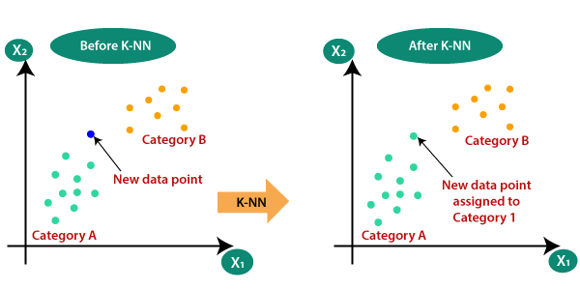

**FIGURE 3.3**

**DESION TREE-Algorithm:**

**1. Input:** Collect Earthquake Data

The dataset used for earthquake prediction typically includes:

* Seismic wave features (amplitude, frequency, etc.)
* Latitude and longitude (geographic data)
* Depth of the earthquake
* Magnitude
* Date/time
* Geological features (distance to tectonic plates, fault lines, etc.)

The goal of the project could be:

* Classification: Predict whether an earthquake will occur (yes/no).
* Regression: Predict the earthquake's magnitude or depth.

**2. Load and Preprocess Data**

Preprocessing is essential for cleaning and organizing the data for the decision tree algorithm.

* Handle missing values: Use imputation techniques (such as filling with the mean, median, or using predictive algorithms) to manage missing data points.
* Categorical data: If your dataset contains categorical features (such as geological zones), convert these into numerical values using techniques like one-hot encoding or label encoding.
* No need for scaling: Unlike KNN, Decision Trees do not rely on distance-based calculations, so scaling the data is not necessary.
* Data split: Divide your dataset into training and testing sets, typically 80% for training and 20% for testing, to evaluate the model’s performance on unseen data.

**3. Flatten Images (if applicable)**

If your earthquake data includes images (such as seismic waveforms or geological maps), you need to flatten these images. Flattening transforms a 2D or 3D image into a 1D vector so that it can be used as input for the Decision Tree.

For example, if you have a seismic activity image of 28x28 pixels, it will be flattened into a vector with 784 features (28 x 28).

* If your data is tabular (e.g., magnitude, depth, etc.), you can skip this step.

**4. Apply PCA (Principal Component Analysis)**

PCA can be used to reduce the dimensionality of your dataset, especially if you have many features (e.g., if you flattened seismic images or if you have many seismic wave characteristics). PCA helps by:

* Reducing computational time.
* Simplifying the dataset while retaining most of the variance.
* Reducing multicollinearity between features.

However, PCA is often not necessary for Decision Trees because they handle high-dimensional data well and can effectively manage interactions between many features. Still, in cases of very high-dimensional data (e.g., hundreds of features), PCA can help improve performance.

**5. Train Decision Tree Classifier/Regressor**

After preprocessing, it's time to train the Decision Tree. Decision Trees create a model that predicts the target variable by learning simple decision rules inferred from the data features.

* Tree construction: The decision tree algorithm works by recursively splitting the data based on certain features that provide the highest information gain (in classification) or reduce variance (in regression).
* Hyperparameters:
  + Maximum tree depth: Controls how deep the tree can grow, helping to prevent overfitting.
  + Min samples per leaf: Determines the minimum number of samples required in a leaf node.
  + Criterion: The function used to measure the quality of a split, such as Gini Impurity (for classification) or Mean Squared Error (for regression).

Decision Tree Training:

* For classification: The tree splits the dataset based on features that best separate the data into earthquake/no-earthquake or earthquake categories.
* For regression: The model splits the data to predict continuous values, like the earthquake’s magnitude or depth.

**6. Predict and Evaluate**

After training the Decision Tree model, use the testing set to assess its performance.

Prediction:

* For classification: Predict whether an earthquake will occur (or classify the type of earthquake based on magnitude).
* For regression: Predict the magnitude, depth, or any other continuous value related to the earthquake.

Evaluation Metrics:

* For classification:
  + Accuracy: The proportion of correct predictions out of all predictions.
  + Precision: The ratio of true positives to the sum of true and false positives (important if you have an imbalanced dataset).
  + Recall: The ratio of true positives to the sum of true positives and false negatives (useful for minimizing false negatives).
  + F1-Score: The harmonic mean of precision and recall.
  + Confusion Matrix: A table to visualize the model’s performance in terms of true positives, true negatives, false positives, and false negatives.
* For regression:
  + Mean Squared Error (MSE): Measures the average squared difference between actual and predicted values.
  + Mean Absolute Error (MAE): Measures the average absolute difference between actual and predicted values.
  + R-squared (R²): A statistical measure that represents the proportion of the variance for the target variable explained by the features.

**Output**

Based on the type of model (classification or regression), the output will be:

* Classification Output: The model will output labels such as "earthquake" or "no earthquake," or a category such as "minor earthquake," "moderate earthquake," etc.
* Regression Output: The model will output a continuous value, such as the predicted magnitude of an earthquake.

In both cases, you will also receive performance metrics that help you understand how well the Decision Tree has performed on the test data. Based on the results, you might consider optimizing the tree’s hyperparameters to improve accuracy or reduce error rates.

**Summary of the Decision Tree Process:**

1. Input: Collect earthquake data (seismic waves, geographic data, magnitude, etc.).
2. Preprocess Data: Handle missing values, encode categorical variables, and split the data.
3. Flatten Images (if applicable): Flatten any 2D/3D images into 1D arrays.
4. Apply PCA (optional): Reduce dimensionality if necessary.
5. Train Decision Tree: Learn decision rules to predict whether an earthquake will occur or predict its magnitude.
6. Predict and Evaluate: Use the model to make predictions and evaluate its accuracy, precision, recall, and other metrics.

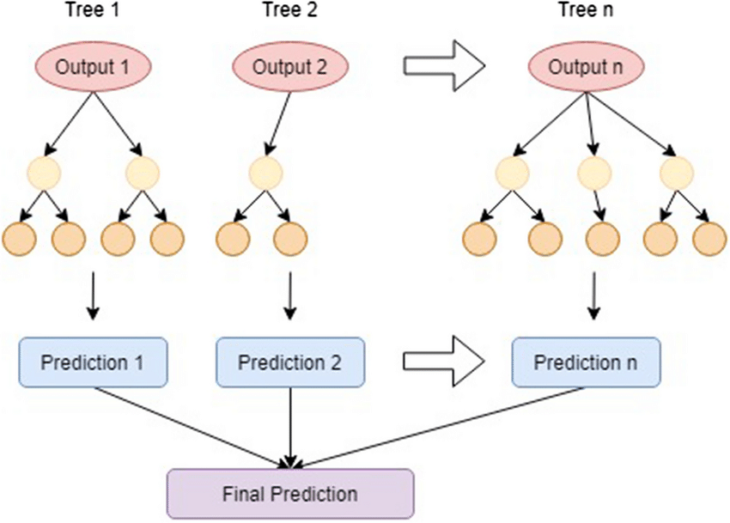

**FIGURE 3.4**

**Random Forest Algorithm:**

**1. Input:** Collect Earthquake Data

The dataset should include key features related to earthquakes:

* Seismic wave characteristics (e.g., amplitude, frequency)
* Geographic coordinates (latitude and longitude)
* Depth of the earthquake
* Magnitude
* Time and date
* Proximity to tectonic plates or fault lines

The objective is to either:

* Classify whether an earthquake will occur or not.
* Predict the magnitude or another continuous variable.

**2. Load and Preprocess Data**

Preprocessing ensures the data is clean and ready for model training. Key steps include:

* Handle missing values: Use techniques like mean, median imputation, or predictive models to fill in missing data.
* Encode categorical data: If the data has categorical variables (e.g., region, geological zone), convert them to numerical values using one-hot encoding or label encoding.
* Feature scaling: While Random Forest does not require feature scaling because it’s based on decision trees, normalization can still be useful if you have extremely skewed features to help with model interpretation and consistency.
* Split the dataset: Divide the data into training and testing sets (typically 80% training, 20% testing). This allows for proper evaluation of model performance.

**3. Flatten Images (if applicable)**

This step is relevant only if your dataset contains images such as:

* Seismic waveforms
* Geographic map data

For image data:

* Flatten the images (e.g., seismic activity visualizations) into 1D vectors. For example, an image of 28x28 pixels should be flattened into a 784-element vector (28 x 28).

If you’re using tabular data (e.g., magnitude, depth, etc.), you can skip this step.

**4. Apply PCA (Principal Component Analysis)**

PCA is an optional step to reduce the dimensionality of the dataset, particularly when working with a large number of features (e.g., flattened image data or numerous seismic wave characteristics).

* PCA helps by summarizing the data into fewer principal components while retaining most of the variance in the dataset.
* Reducing dimensionality can lead to faster computation and prevent overfitting, but it’s often not required for Random Forest, which handles high-dimensional data well. PCA is only applied if you have a very large number of features.

**5. Train Random Forest Classifier/Regressor**

After preprocessing, you can proceed to train the Random Forest model. Random Forest creates multiple decision trees from subsets of the data and aggregates their results for a more accurate prediction.

Key Parameters:

* n_estimators: The number of decision trees in the forest (e.g., 100, 200, or more trees). More trees improve accuracy but increase computation time.
* max_depth: The maximum depth of each tree to control overfitting.
* min_samples_split: The minimum number of samples required to split a node.
* Criterion: Defines the splitting criterion (e.g., Gini impurity for classification, Mean Squared Error for regression).

Random Forest Training:

* For classification: Each decision tree makes a prediction, and the final prediction is based on a majority vote from all trees.
* For regression: The model averages the predictions of all the trees to generate the final prediction, such as predicting the magnitude of an earthquake.

**6. Predict and Evaluate**

After training the Random Forest model, use the test set to evaluate its performance.

Prediction:

* For classification: The model predicts whether an earthquake will occur (or classifies earthquakes into categories based on magnitude).
* For regression: The model predicts a continuous value, such as the magnitude or depth of the earthquake.

Evaluation Metrics:

* For classification:
  + Accuracy: The percentage of correctly predicted instances.
  + Precision: Measures how many of the predicted positive earthquakes were actually earthquakes.
  + Recall: Measures how many actual earthquakes were correctly identified.
  + F1-score: The harmonic mean of precision and recall.
  + Confusion Matrix: A summary of prediction results to display true positives, false positives, true negatives, and false negatives.
* For regression:
  + Mean Squared Error (MSE): The average squared difference between actual and predicted values.
  + Mean Absolute Error (MAE): The average absolute difference between predicted and actual values.
  + R-squared (R²): Explains the proportion of variance in the target variable explained by the model.

Random Forest’s out-of-bag (OOB) error can also be used as an internal estimate of model accuracy without requiring a separate validation set.

**Output**

Based on the model's task:

* Classification Output: The Random Forest will output a class label such as "earthquake" or "no earthquake", or categorize earthquakes based on magnitude (e.g., minor, moderate, major).
* Regression Output: The model will output a continuous value, such as a predicted earthquake magnitude.

In either case, the final result will be accompanied by evaluation metrics (accuracy, precision, recall, MSE, etc.) that quantify the model's performance.

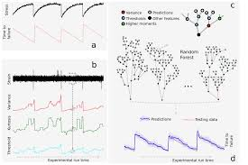

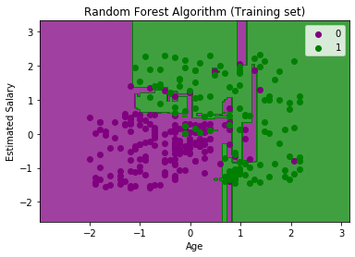

**FIGURE 3.5**

**Gradient Boosting Algorithm:**

**1. Input: Collect Earthquake Data**

The dataset should consist of features relevant to earthquake occurrences, such as:

* **Seismic wave characteristics** (amplitude, frequency)
* **Latitude and longitude**
* **Depth** of the earthquake
* **Magnitude**
* **Time/date information**
* **Geological features** (e.g., proximity to tectonic plates or fault lines)

The goal could be either:

* **Classification**: Predict whether an earthquake will occur or categorize it into severity levels (e.g., minor, moderate, major).
* **Regression**: Predict the **magnitude** of the earthquake based on seismic and geographical features.

**2. Load and Preprocess Data**

Preprocessing is crucial to ensure the dataset is clean, structured, and ready for model training.

* **Handle missing data**: Use techniques like **mean**, **median**, or **mode** imputation, or more advanced methods like **KNN imputation** to handle missing values.
* **Categorical data**: Encode any categorical variables (e.g., region or geological zone) using **one-hot encoding** or **label encoding** to convert them into numeric format.
* **Feature scaling**: Unlike KNN, Gradient Boosting does not necessarily require feature scaling because it is based on decision trees, which handle unscaled data well. However, scaling can still be useful if you have outlier-heavy or skewed data.
* **Split the data**: Separate your data into training and testing sets (e.g., 80% training, 20% testing). This will help evaluate how well your model generalizes to new, unseen data.

**3. Flatten Images (if applicable)**

If your earthquake prediction project involves **image data** (e.g., seismic waveforms, geographic maps, or satellite imagery), the images need to be **flattened** for processing by the model.

For example, if you have a seismic activity image of 28x28 pixels, flatten it into a vector of 784 values (28 x 28).

* If your dataset is purely **tabular** (e.g., seismic wave amplitude, magnitude, depth), this step is **not required**.

**4. Apply PCA (Principal Component Analysis)**

**PCA** is a technique used to reduce the dimensionality of your dataset, especially if there are too many features (e.g., flattened images or numerous seismic wave data points). PCA helps by:

* Reducing computation time.
* Preventing overfitting by reducing noise in the data.

However, **PCA is often not necessary for Gradient Boosting**, as the algorithm can handle high-dimensional data and will internally manage feature selection through its iterative process. If the dataset contains many features and you notice overfitting, PCA might be a useful step.

**5. Train Gradient Boosting Classifier/Regressor**

After preprocessing, you can train the **Gradient Boosting** model. Gradient Boosting builds decision trees in a sequential manner, where each tree tries to correct the errors made by the previous one. It minimizes a loss function using gradient descent.

**Key Parameters:**

* **n_estimators**: The number of trees (or boosting rounds) in the model. More trees can increase model accuracy but also increase the risk of overfitting.
* **learning_rate**: Controls how much the model corrects errors in each boosting step. A lower value (e.g., 0.01) requires more trees but often leads to better generalization.
* **max_depth**: The maximum depth of individual trees. Shallow trees (with lower depth) prevent overfitting.
* **min_samples_split**: The minimum number of samples required to split an internal node.
* **loss function**: Defines the type of problem. For classification, you can use **log loss**; for regression, use **mean squared error**.

**Training Process:**

* **For classification**: Gradient Boosting builds trees that sequentially correct the errors of the previous trees, ultimately producing a model that predicts earthquake/no-earthquake or earthquake category (e.g., minor, major).
* **For regression**: The model corrects errors in predicting a continuous variable, such as earthquake **magnitude**.

**6. Predict and Evaluate**

Once the Gradient Boosting model is trained, use it to predict and evaluate its performance on the test set.

**Prediction:**

* **For classification**: Predict whether an earthquake will occur or classify earthquakes into categories based on magnitude.
* **For regression**: Predict a continuous value, such as earthquake **magnitude** or **depth**.

**Evaluation Metrics:**

* **For classification**:
  + **Accuracy**: The percentage of correctly predicted earthquake occurrences or categories.
  + **Precision**: The ratio of true positive predictions to the sum of true positive and false positive predictions.
  + **Recall**: The ratio of true positive predictions to the sum of true positives and false negatives.
  + **F1-Score**: The harmonic mean of precision and recall.
  + **Confusion Matrix**: A table that shows true positives, true negatives, false positives, and false negatives.
* **For regression**:
  + **Mean Squared Error (MSE)**: The average squared difference between actual and predicted earthquake magnitudes.
  + **Mean Absolute Error (MAE)**: The average absolute difference between predicted and actual values.
  + **R-squared (R²)**: Explains how much of the variance in the target variable is captured by the model.

**Output**

The model’s output depends on whether the task is classification or regression:

* **Classification Output**: The model will output a label, such as "earthquake" or "no earthquake", or it will classify earthquakes into different categories (e.g., minor, moderate, major).
* **Regression Output**: The model will output a predicted **magnitude** or **depth** of an earthquake.

.

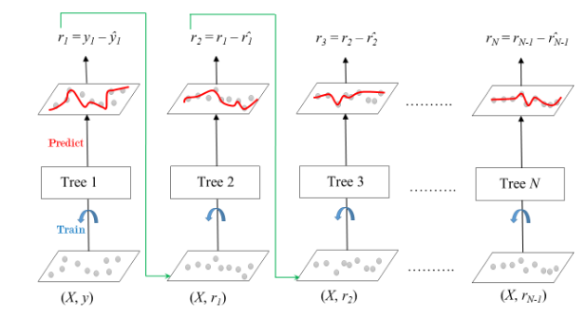

**FIGURE 3.6**

**4. EXPERIMENTED RESULTS AND DISCUSSION**

**4.1** **Performance Evaluation Metrics (Precision,Recall,F1Score,Accuracy,Support, Matrix,Accuracy Graph)**

**MODEL 1-Decision Tree**

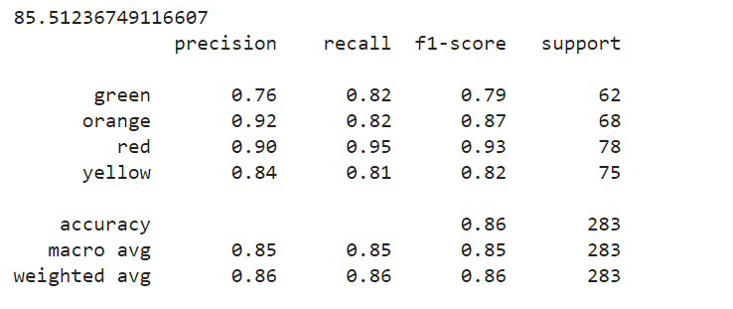

**FIGURE 4.1**

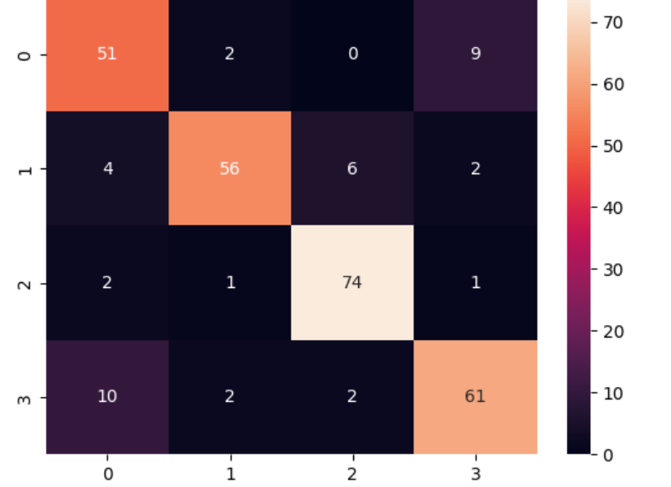

**FIGURE 4.2**

**MODEL 2-KNN**

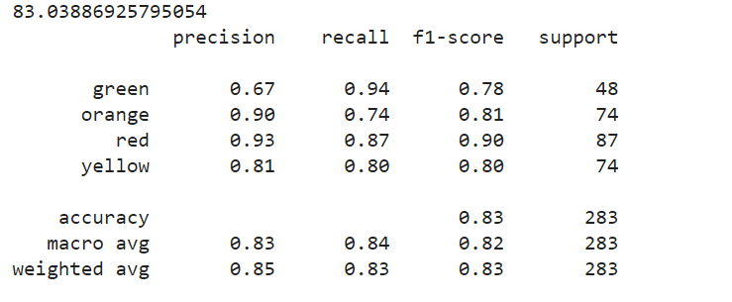

**FIGURE 4.4**

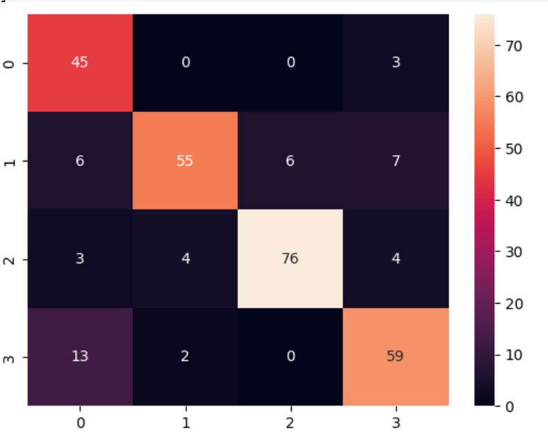

**FIGURE 4.5**

**MODLE 3-RANDOM FOREST**

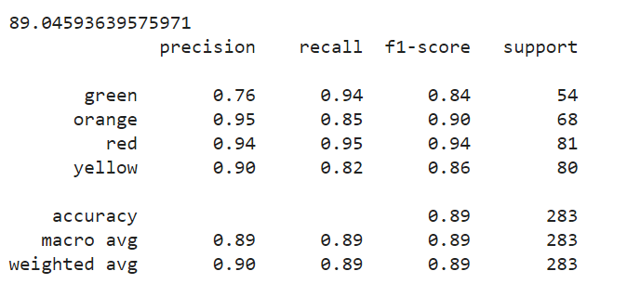

**FIGURE 4.6**

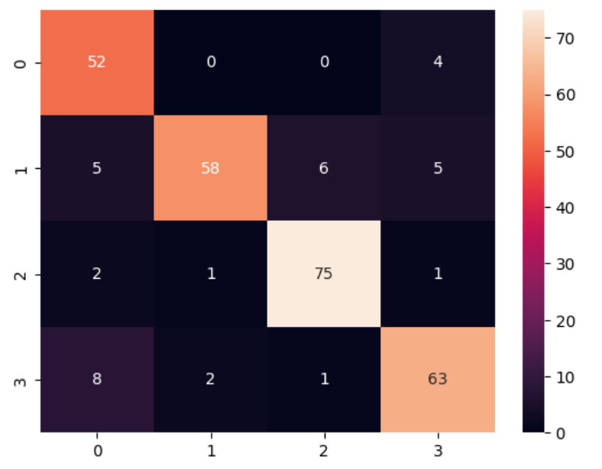

**FIGURE 4.7**

**MODEL 4-GRADIENT BOOSTING**

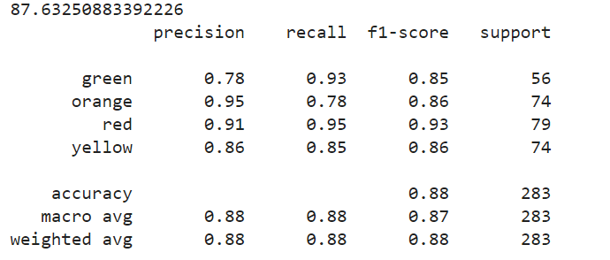

**FIGURE 4.8**



**FIGURE 4.9**

**5.Conclusion and Future Scope**

In conclusion, this project, we applied several machine learning algorithms, such as **K-Nearest Neighbors (KNN)**, **Decision Trees**, **Random Forest**, and **Gradient Boosting**, to predict earthquake occurrences and magnitudes. Each algorithm brought unique strengths to the problem, allowing for both classification and regression tasks.

* **KNN** provided a simple yet intuitive approach by leveraging the proximity of data points in the feature space, though it is sensitive to the scale and high-dimensional data.
* **Decision Trees** were useful for interpretable results and could handle both categorical and continuous data effectively, but they are prone to overfitting without pruning.
* **Random Forest**, being an ensemble method, reduced the risk of overfitting by averaging predictions from multiple trees, thus improving accuracy and generalization.
* **Gradient Boosting** outperformed the other algorithms in terms of predictive accuracy by sequentially minimizing errors. Its ability to fine-tune predictions with each iteration made it ideal for a complex and dynamic problem like earthquake prediction.

The combination of these algorithms allowed for robust predictions and a better understanding of the features most relevant to seismic events, such as depth, magnitude, and proximity to tectonic plates. The models were evaluated using appropriate metrics such as accuracy, precision, recall, mean squared error (MSE), and R-squared (R²), depending on the task (classification or regression).

**Future Scope:**

1. **Improved Data Collection:**
   * **Real-time seismic data**: Incorporating real-time data from seismic sensors can improve the timeliness and accuracy of predictions.
   * **Geological and Geospatial Data**: Adding more features such as detailed geological maps, fault line proximity, tectonic plate movements, and historical earthquake data from various regions could enhance model accuracy.
   * **Satellite and Remote Sensing Data**: Integrating data from satellites, such as ground deformation measurements (e.g., InSAR), could add a valuable dimension for early detection of seismic activity.
2. **Advanced Machine Learning Algorithms:**
   * **Deep Learning Models**: Deep learning techniques like **Convolutional Neural Networks (CNNs)** and **Recurrent Neural Networks (RNNs)** could be explored to handle more complex, multi-dimensional datasets like seismic waveforms, time-series data, and satellite imagery.
   * **Hybrid Models**: Combining traditional machine learning with deep learning approaches (hybrid models) could improve prediction accuracy by leveraging the strengths of both types of algorithms.
   * **AutoML (Automated Machine Learning)**: Exploring AutoML frameworks could automate the model selection, hyperparameter tuning, and feature engineering processes, leading to more efficient and accurate predictions.
3. **Model Interpretability and Explainability:**
   * Developing techniques to improve model interpretability is essential for building trust with decision-makers. For example, **SHAP values** or **LIME** can be used to explain individual predictions, especially when using complex models like Gradient Boosting.
   * Identifying the most important seismic or geological features that influence earthquake prediction could help improve the accuracy of early warning systems.
4. **Integration with Early Warning Systems:**
   * Implementing these machine learning models into real-world **earthquake early warning systems** (EEWS) could provide timely alerts to communities and governments, allowing for better preparedness.
   * **Mobile-based warning apps** could be developed to inform individuals in affected regions about potential seismic activity.
5. **Global Scalability:**
   * The models developed in this project could be trained on **global datasets** and adapted for predicting earthquakes in different seismic regions across the world.
   * Collaboration with international agencies like the **United States Geological Survey (USGS)** or the **International Seismological Centre (ISC)** could expand the scope of prediction and improve global disaster response strategies.
6. **Risk Assessment and Mitigation:**
   * Machine learning models can be used not only for predicting earthquakes but also for estimating **earthquake-induced risks**, such as infrastructure damage, human casualties, and economic losses. This could inform better planning and disaster risk reduction strategies.