**Industrial Internship Report on**

**CROP AND WEED DETECTION**

**Prepared by**

**Sravani Chanda**

|  |
| --- |
| *Executive Summary* |
| This report provides details of the Industrial Internship provided by upskill Campus and The IoT Academy in collaboration with Industrial Partner UniConverge Technologies Pvt Ltd (UCT).  This internship was focused on a project/problem statement provided by UCT. We had to finish the project including the report in 6 weeks’ time.  My project was (Tell about ur Project)  This internship gave me a very good opportunity to get exposure to Industrial problems and design/implement solution for that. It was an overall great experience to have this internship. |

**TABLE OF CONTENTS**

1 Preface 3

2 Introduction 4

2.1 About UniConverge Technologies Pvt Ltd 4

2.2 About upskill Campus 8

2.3 Objective 9

2.4 Reference 9

2.5 Glossary 10

3 Problem Statement 11

4 Existing and Proposed solution 12

5 Proposed Design/ Model 13

5.1 High Level Diagram (if applicable) 13

5.2 Low Level Diagram (if applicable) 13

5.3 Interfaces (if applicable) 13

6 Performance Test 14

6.1 Test Plan/ Test Cases 14

6.2 Test Procedure 14

6.3 Performance Outcome 14

7 My learnings 15

8 Future work scope 16

# Preface

Summary of the whole 6 weeks’ work.

About need of relevant Internship in career development.

Brief about Your project/problem statement.

Opportunity given by USC/UCT.

How Program was planned

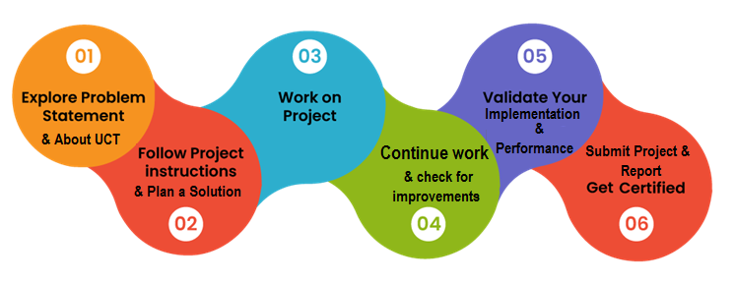

Your Learnings and overall experience.

Thank to all (with names), who have helped you directly or indirectly.

Your message to your juniors and peers.

# Introduction

## About UniConverge Technologies Pvt Ltd

A company established in 2013 and working in Digital Transformation domain and providing Industrial solutions with prime focus on sustainability and RoI.

For developing its products and solutions it is leveraging various**Cutting Edge Technologies e.g. Internet of Things (IoT), Cyber Security, Cloud computing (AWS, Azure), Machine Learning, Communication Technologies (4G/5G/LoRaWAN), Java Full Stack, Python, Front end**etc.



1. UCT IoT Platform **(****)**

**UCT Insight** is an IOT platform designed for quick deployment of IOT applications on the same time providing valuable “insight” for your process/business. It has been built in Java for backend and ReactJS for Front end. It has support for MySQL and various NoSql Databases.

* It enables device connectivity via industry standard IoT protocols - MQTT, CoAP, HTTP, Modbus TCP, OPC UA
* It supports both cloud and on-premises deployments.

It has features to  
• Build Your own dashboard  
• Analytics and Reporting  
• Alert and Notification  
• Integration with third party application(Power BI, SAP, ERP)  
• Rule Engine

 

1. **Smart Factory Platform (****)**

Factory watch is a platform for smart factory needs.

It provides Users/ Factory

* with a scalable solution for their Production and asset monitoring
* OEE and predictive maintenance solution scaling up to digital twin for your assets.
* to unleased the true potential of the data that their machines are generating and helps to identify the KPIs and also improve them.
* A modular architecture that allows users to choose the service that they what to start and then can scale to more complex solutions as per their demands.

Its unique SaaS model helps users to save time, cost and money.

 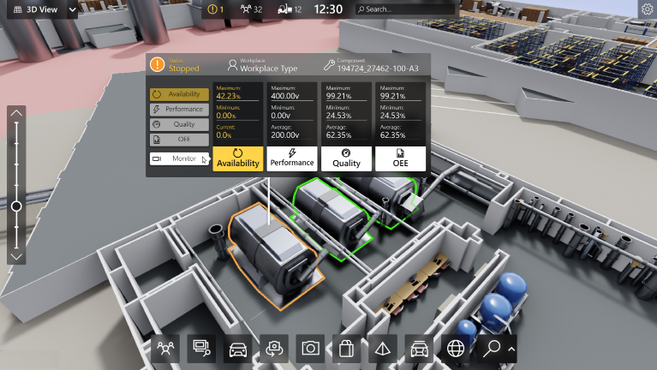

1.  based Solution

UCT is one of the early adopters of LoRAWAN teschnology and providing solution in Agritech, Smart cities, Industrial Monitoring, Smart Street Light, Smart Water/ Gas/ Electricity metering solutions etc.

1. Predictive Maintenance

UCT is providing Industrial Machine health monitoring and Predictive maintenance solution leveraging Embedded system, Industrial IoT and Machine Learning Technologies by finding Remaining useful life time of various Machines used in production process.



## About upskill Campus (USC)

upskill Campus along with The IoT Academy and in association with Uniconverge technologies has facilitated the smooth execution of the complete internship process.

USC is a career development platform that delivers **personalized executive coaching** in a more affordable, scalable and measurable way.



Seeing need of upskilling in self paced manner along-with additional support services e.g. Internship, projects, interaction with Industry experts, Career growth Services

<https://www.upskillcampus.com/>

upSkill Campus aiming to upskill 1 million learners in next 5 year

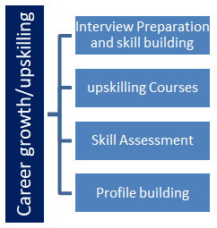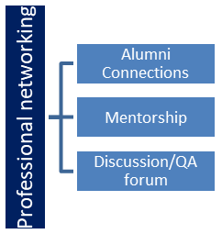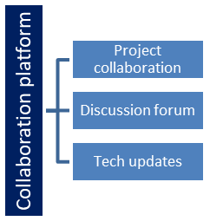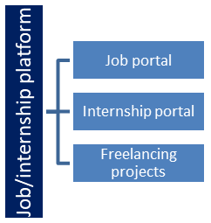

## The IoT Academy

The IoT academy is EdTech Division of UCT that is running long executive certification programs in collaboration with EICT Academy, IITK, IITR and IITG in multiple domains.

## Objectives of this Internship program

The objective for this internship program was to

 ☛ get practical experience of working in the industry.

 ☛ to solve real world problems.

 ☛ to have improved job prospects.

 ☛ to have Improved understanding of our field and its applications.

 ☛ to have Personal growth like better communication and problem solving.

## Reference

[1] Machine learning previous projects

## Glossary

|  |  |
| --- | --- |
| Terms | Acronym |
| cv2 | Python API for OpenC |
| np | numpy |
| pd | pandas |
|  |  |
|  |  |

# Problem Statement

Weed is an unwanted thing in agriculture. Weed use the nutrients, water, land and many more things that might have gone to crops. Which results in less production of the required crop. The farmer often uses pesticides to remove weed which is also effective but some pesticides may stick with crop and may causes problems for humans.

Weeds compete with crops for vital resources like nutrients, water, and sunlight, which can reduce the yield and quality of cultivated crops. To manage weeds, farmers commonly use herbicides, a type of pesticide designed to kill or inhibit unwanted plants. While effective, some herbicide residues can remain on crops and enter the food chain, potentially posing health risks to humans. These residues may lead to health issues when ingested, as certain chemicals in herbicides can be toxic if consumed in large amounts or over long periods. Additionally, excessive pesticide use can harm soil health and biodiversity, leading to long-term environmental damage.

# Existing and Proposed solution

Existing Solution:

The current approach to managing weeds in agriculture often involves chemical herbicides. These herbicides effectively control weed growth, but they pose risks to human health and the environment. Some herbicides may leave harmful residues on crops, which can enter the food chain. Additionally, prolonged use of chemical herbicides can lead to soil degradation, reduced biodiversity, and the development of herbicide-resistant weed species, making them less effective over time.

Proposed Solution:

To address these challenges, alternative and integrated weed management solutions are proposed.

1. Biological Control: Introducing natural weed predators, such as insects or microorganisms, that can reduce weed growth without harming crops or the environment.

2. Organic Herbicides: Developing plant-based or natural herbicides that are less toxic to humans and degrade more quickly in the environment.

3. Crop Rotation and Cover Cropping: Implementing diverse planting strategies to suppress weed growth naturally, as some crop rotations can prevent weed dominance.

4. Precision Agriculture: Using advanced technology, such as drones or sensors, to precisely apply minimal amounts of herbicides only where needed, reducing overall chemical use.

5. Mechanical Weeding: Utilizing machines or manual labor to remove weeds, especially in organic farming where chemical use is restricted.

By combining these approaches in an Integrated Weed Management (IWM) system, the goal is to reduce reliance on chemical herbicides, promoting sustainable and healthier agricultural practices.

## Code submission (Github link)

https://github.com/SravaniChanda/CropAndWeedDetection.git

## Report submission (Github link) :

https://github.com/SravaniChanda/CropAndWeedReport.git

# Proposed Design/ Model

1. Machine Learning and Machine Vision-based Weed Control:

* Design: This approach involves using cameras and sensors to capture images of the field. Machine learning algorithms are then trained to differentiate between crops and weeds. Once identified, the system can trigger targeted spraying of herbicides or other control measures.

* Model: Convolutional Neural Networks (CNNs) are commonly used for image classification and object detection tasks in weed control. These models can accurately identify weeds even in challenging conditions like varying lighting and soil types.

2. Robotics-based Weed Control:

* Design: Robotic systems equipped with cameras and sensors can navigate fields autonomously and identify weeds. They can then use mechanical tools like weeding arms or targeted herbicide sprayers to remove or control weeds.

* Model: These systems often rely on a combination of computer vision algorithms and control systems to navigate the field, identify weeds, and execute precise control actions.

3. Biological Control:

* Design: This approach involves introducing natural enemies like insects or fungi that prey on specific weed species.

* Model: Researchers study the ecology of weeds and their natural enemies to identify suitable biological control agents. They then release these agents into the field to control weed populations.

4. Integrated Weed Management (IWM):

* Design: IWM combines multiple control methods, including cultural practices, mechanical control, biological control, and chemical control, to achieve sustainable weed management.

* Model: This approach involves a holistic understanding of the weed ecology and the crop system. It requires careful planning and implementation of various control measures to minimize the impact on the environment and human health.

Choosing the Right Design and Model:

The most suitable design and model for a weed control project will depend on various factors, including:

* Weed species: The type of weed and its growth habits will influence the choice of control methods.

* Crop type: The specific crop being grown will determine the compatibility with different control methods.

* Field size and topography: The size and layout of the field will impact the feasibility of using robotic or manual control methods.

* Environmental regulations: Local regulations may restrict the use of certain chemicals or control methods.

* Economic considerations: The cost of implementing different control methods will need to be considered.

# Performance Test

* Weed Detection Accuracy:

* Precision: The ability to correctly identify weeds among crops.

* Recall: The ability to identify all weed instances in an image.

* F1-Score: A balanced metric combining precision and recall.

* Intersection over Union (IoU): Measures the overlap between predicted and ground truth bounding boxes.

* Weed Control Efficacy:

* Weed Reduction Rate: Percentage reduction in weed biomass or density.

* Crop Damage: Minimal or no damage to the crop plants.

* Herbicide Usage Efficiency: Minimizing herbicide usage while maximizing weed control.

* System Throughput:

* Area Coverage Rate: The amount of area covered per unit of time.

* Operational Efficiency: Time taken for tasks like field navigation, weed detection, and spraying.

* System Reliability:

* Mean Time Between Failures (MTBF): Average time between system failures.

* Mean Time To Repair (MTTR): Average time to repair a system failure.

Testing Methodology:

* Field Trials:

* Conduct experiments in real-world field conditions to assess performance under various environmental factors (e.g., varying light conditions, soil types, weed densities).

* Compare the performance of the system with traditional methods (e.g., manual weeding, broadcast spraying).

* Monitor crop yield, quality, and overall economic impact.

* Laboratory Simulations:

* Create controlled environments to test the system's performance under specific conditions.

* Use simulated images or real-world images to assess the accuracy of weed detection algorithms.

* Evaluate the precision and efficiency of herbicide application mechanisms.

* Hardware and Software Testing:

* Test the reliability and durability of hardware components (e.g., sensors, actuators, power systems).

* Assess the computational efficiency and accuracy of software algorithms.

* Monitor system responsiveness and latency.

Performance Evaluation Tools:

* Image Processing Software: MATLAB, OpenCV, Python libraries (e.g., TensorFlow, PyTorch)

* Data Analysis Tools: Statistical software (e.g., R, SPSS), data visualization tools (e.g., Matplotlib, Plotly)

* Field Data Collection Tools: GPS devices, data loggers, mobile applications

# My learnings

I learned many things from this project those are:

Technical Skills:

* Image Processing and Computer Vision:

* Understanding image acquisition techniques

* Image preprocessing and feature extraction

* Object detection and segmentation algorithms

* Deep learning techniques (e.g., CNNs) for image analysis

* Machine Learning and AI:

* Model training and validation

* Hyperparameter tuning

* Model deployment and optimization

* Evaluating model performance

* Robotics and Automation:

* Robot kinematics and dynamics

* Motion planning and control

* Sensor integration and calibration

* Real-time system design

Problem-Solving and Critical Thinking:

* Identifying Challenges: Recognizing the specific challenges posed by different weed species and field conditions.

* Developing Solutions: Designing innovative solutions that combine technology and agriculture practices.

* Iterative Design: Continuously refining and improving the system based on feedback and performance evaluation.

Domain Knowledge:

* Agricultural Practices: Understanding crop growth cycles, soil types, and climate conditions.

* Weed Biology and Ecology: Learning about weed life cycles, dispersal mechanisms, and resistance to control measures.

* Herbicide Application Techniques: Gaining knowledge about different herbicide formulations, application rates, and environmental impact.

Interdisciplinary Collaboration:

* Working with Experts: Collaborating with agricultural scientists, engineers, and computer scientists.

* Effective Communication: Clearly articulating technical concepts to diverse audiences.

Ethical Considerations:

* Environmental Impact: Minimizing the use of harmful chemicals and promoting sustainable practices.

* Social and Economic Impact: Considering the impact of the technology on farmers and communities.

# Future work scope

1. Advanced AI and Machine Learning:

* Real-time, High-Precision Weed Detection: Improve the accuracy of weed detection algorithms to minimize false positives and negatives.

* Adaptive Learning: Develop systems that can learn and adapt to changing field conditions and weed species.

* Predictive Weed Modeling: Use AI to predict weed emergence and growth patterns, allowing for proactive control measures.

2. Robotic Systems:

* Autonomous Field Operations: Enhance the autonomy of robotic systems for tasks like navigation, weed detection, and precise herbicide application.

* Multi-Modal Sensing: Combine various sensors (e.g., vision, LiDAR, thermal) for more robust weed detection in challenging conditions.

* Collaborative Robotics: Develop cooperative robotic systems for efficient and scalable weed control.

3. Biological Control:

* Novel Biological Agents: Discover and develop new biological control agents (e.g., insects, fungi) to target specific weed species.

* Augmented Biological Control: Combine biological control with other methods (e.g., herbicides, cultural practices) for synergistic effects.

4. Sustainable Herbicide Use:

* Precision Herbicide Application: Develop technologies for targeted herbicide application to minimize environmental impact.

* Herbicide-Resistant Crop Development: Engineer crops with enhanced herbicide tolerance to reduce reliance on chemical control.

5. Integration with Precision Agriculture:

* Data-Driven Decision Making: Utilize data from sensors and drones to optimize weed control strategies.

* Variable-Rate Technology: Implement variable-rate herbicide application based on site-specific weed pressure.

6. Environmental and Economic Considerations:

* Eco-Friendly Herbicides: Develop and promote environmentally friendly herbicides with minimal off-target effects.

* Economic Analysis: Conduct economic assessments to evaluate the cost-effectiveness of different weed control strategies.