**Industrial Internship Report on**

**”QUIZ GAME”**

**Prepared by**

**Sravani Chanda**

|  |
| --- |
| *Executive Summary* |
| This report provides details of the Industrial Internship provided by upskill Campus and The IoT Academy in collaboration with Industrial Partner UniConverge Technologies Pvt Ltd (UCT).  This internship was focused on a project/problem statement provided by UCT. We had to finish the project including the report in 6 weeks’ time.  My project was Quiz Game and it can improve the knowledge in their respective domains.  This internship gave me a very good opportunity to get exposure to Industrial problems and design/implement solution for that. It was an overall great experience to have this internship. |

**TABLE OF CONTENTS**

1 Preface 3

2 Introduction 4

2.1 About UniConverge Technologies Pvt Ltd 4

2.2 About upskill Campus 8

2.3 Objective 9

2.4 Reference 9

2.5 Glossary 10

3 Problem Statement 11

4 Existing and Proposed solution 12

5 Proposed Design/ Model 13

5.1 High Level Diagram (if applicable) 13

5.2 Low Level Diagram (if applicable) 13

5.3 Interfaces (if applicable) 13

6 Performance Test 14

6.1 Test Plan/ Test Cases 14

6.2 Test Procedure 14

6.3 Performance Outcome 14

7 My learnings 15

8 Future work scope 16

# Preface

During these 6 weeks, I learned so much by learning and practicing week by week as steps. We started from basics in first week and learned so many advanced topics like numpy and pandas.

As this is a python project it has been a good opportunity to explore my knowledge by doing projects like this.

This project majorly focused on building a Quiz game and give score according to the number of correct answers.

I am thankful to the USC/UCT for giving me such a good opportunity to improve my knowledge.

This program is planned like the below:

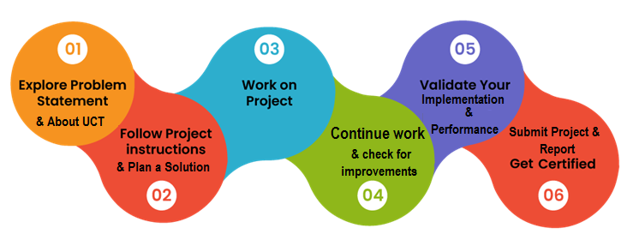

It has been a good experience for me through this learning by building this project using python.

The opportunities like this are very helpful for one who wants to improve and explore their knowledge.

# Introduction

## About UniConverge Technologies Pvt Ltd

A company established in 2013 and working in Digital Transformation domain and providing Industrial solutions with prime focus on sustainability and RoIes.

For developing its products and solutions it is leveraging various**Cutting Edge Technologies e.g. Internet of Things (IoT), Cyber Security, Cloud computing (AWS, Azure), Machine Learning, Communication Technologies (4G/5G/LoRaWAN), Java Full Stack, Python, Front end**etc.

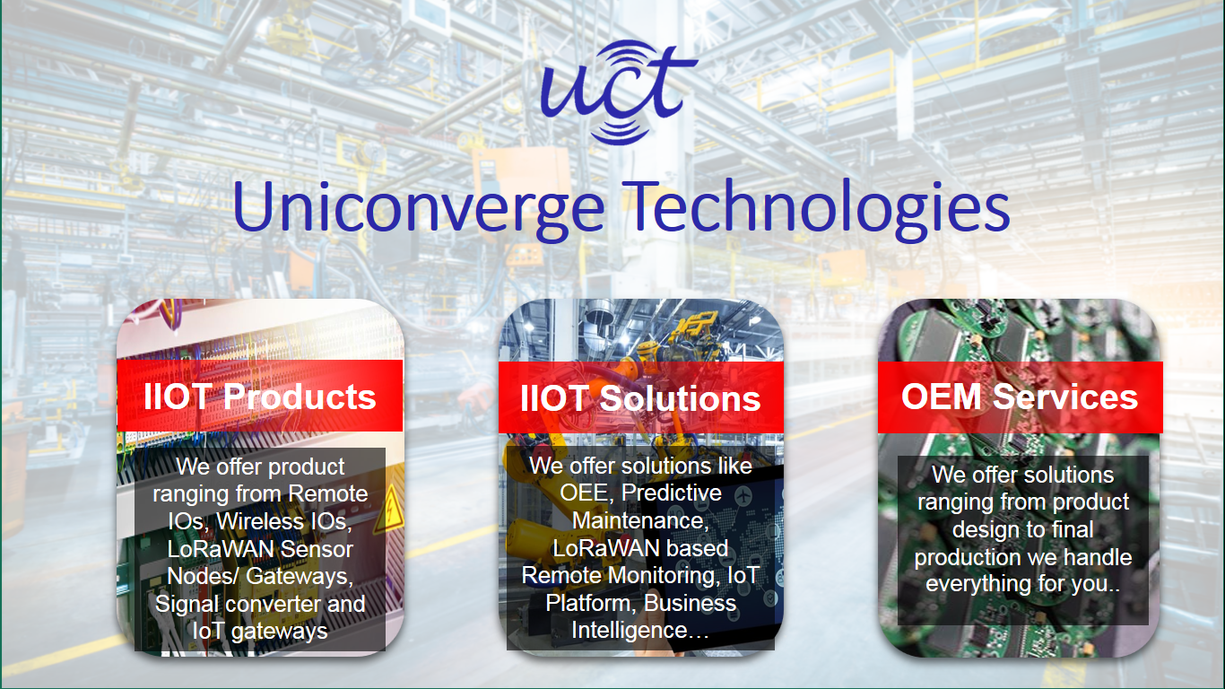

1. UCT IoT Platform **(****)**

**UCT Insight** is an IOT platform designed for quick deployment of IOT applications on the same time providing valuable “insight” for your process/business. It has been built in Java for backend and ReactJS for Front end. It has support for MySQL and various NoSql Databases.

* It enables device connectivity via industry standard IoT protocols - MQTT, CoAP, HTTP, Modbus TCP, OPC UA
* It supports both cloud and on-premises deployments.

It has features to  
• Build Your own dashboard  
• Analytics and Reporting  
• Alert and Notification  
• Integration with third party application(Power BI, SAP, ERP)  
• Rule Engine

 

1. **Smart Factory Platform (****)**

Factory watch is a platform for smart factory needs.

It provides Users/ Factory

* with a scalable solution for their Production and asset monitoring
* OEE and predictive maintenance solution scaling up to digital twin for your assets.
* to unleased the true potential of the data that their machines are generating and helps to identify the KPIs and also improve them.
* A modular architecture that allows users to choose the service that they what to start and then can scale to more complex solutions as per their demands.

Its unique SaaS model helps users to save time, cost and money.

 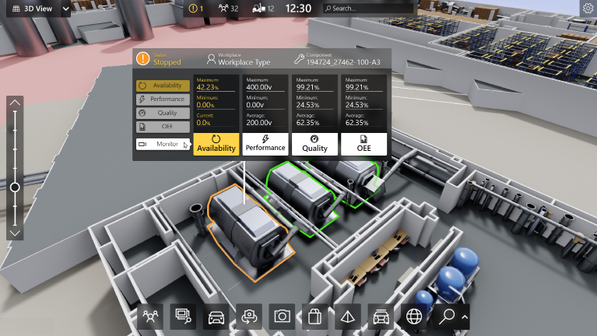

1. 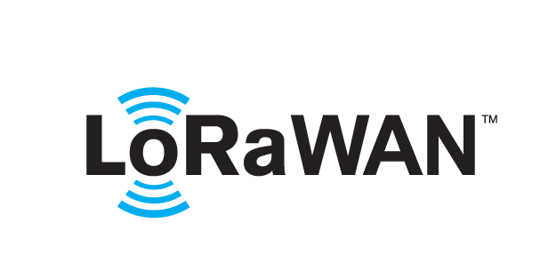 based Solution

UCT is one of the early adopters of LoRAWAN teschnology and providing solution in Agritech, Smart cities, Industrial Monitoring, Smart Street Light, Smart Water/ Gas/ Electricity metering solutions etc.

1. Predictive Maintenance

UCT is providing Industrial Machine health monitoring and Predictive maintenance solution leveraging Embedded system, Industrial IoT and Machine Learning Technologies by finding Remaining useful life time of various Machines used in production process.



## About upskill Campus (USC)

upskill Campus along with The IoT Academy and in association with Uniconverge technologies has facilitated the smooth execution of the complete internship process.

USC is a career development platform that delivers **personalized executive coaching** in a more affordable, scalable and measurable way.



Seeing need of upskilling in self paced manner along-with additional support services e.g. Internship, projects, interaction with Industry experts, Career growth Services

<https://www.upskillcampus.com/>

upSkill Campus aiming to upskill 1 million learners in next 5 year

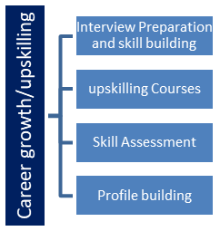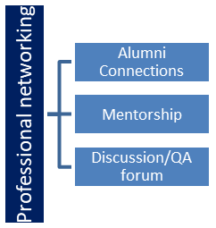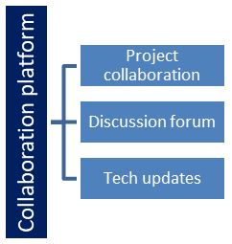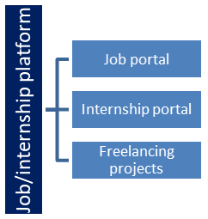

## The IoT Academy

The IoT academy is EdTech Division of UCT that is running long executive certification programs in collaboration with EICT Academy, IITK, IITR and IITG in multiple domains.

## Objectives of this Internship program

The objective for this internship program was to

 ☛ get practical experience of working in the industry.

 ☛ to solve real world problems.

 ☛ to have improved job prospects.

 ☛ to have Improved understanding of our field and its applications.

 ☛ to have Personal growth like better communication and problem solving.

## Reference

[1] We know this from Edunet Foundation.

# Problem Statement

Description: The quiz game is a Python project that quizzes users on various topics. It read questions and answers from a file or database, presents them to the user, and keeps track of their score.

In this project we have to develop a quiz game by using python and keep tracking of score, got by the players.

# Existing and Proposed solution

1. Database Setup:

- Set up an SQLite database to store user scores.

- Create a table named `'scores'` with columns for `id` (primary key), `username`, and `score`.

2. Question Handling:

- Define questions as a list of dictionaries, where each dictionary represents a question.

- Each question dictionary contains keys for `'question'`, `'options'`, and `'answer'`.

- `'options'` should be a list of possible choices for the question.

- `'answer'` should be the correct answer to the question.

3. Asking Questions:

- Implement a function to present a question to the user and collect their answer.

- Display the question and its options to the user.

- Prompt the user to enter their answer (either as text or by selecting an option number).

- Validate the user's input to determine if it matches the correct answer.

4. Scoring:

- Keep track of the user's score as they progress through the quiz.

- Increment the score for each correct answer.

5. Saving Scores:

- After the quiz ends, prompt the user to enter their username.

- Insert the username and score into the `'scores'` table in the database.

6.Finalization:

- Display the user's final score at the end of the quiz.

- Provide feedback on each question (e.g., "Correct!" or "Wrong!").

- Close the database connection after saving the score.

7. Optional Enhancements:

- Allow users to choose the number of questions or the difficulty level.

- Implement a timer to limit the time for answering each question.

- Add support for multiple-choice questions with more than one correct answer.

- Customize the user interface with colors, formatting, or graphics.

## Code submission (Github link):

https://github.com/SravaniChanda/upskillcampus/blob/main/quiz_game.py

## Report submission (Github link) :

# Proposed Design/ Model

[Start]

|

V

[Initialize Database Connection] --> [Create 'scores' Table if Not Exist] --> [Define Questions] --> [User Enters Username]

|

V

[Start Asking Questions Loop]

|

V

[For Each Question]

|

V

[Present Question and Options]

|

V

[Collect User's Answer]

|

V

[Validate Answer]

|

V

[Provide Feedback ("Correct!" or "Wrong!")]

|

V

[End Asking Questions Loop]

|

V

[Calculate and Display Final Score]

|

V

[Insert Username and Score into 'scores' Table]

|

V

[Commit Changes to Database]

|

V

[Close Database Connection]

|

V

[End]

# Performance Test

This is very important part and defines why this work is meant of Real industries, instead of being just academic project.

Performance test is done by running it with multiple times using different features.

## 6.1 Performance Outcome

It gives good results.

**7.My learnings**

It has been a good learning and it will helpful for my future .It helps me to enhance my knowledge in python.

**8. Future Scope**

Scope: The scope of this project involves designing a user interface to display questions and collect user answers, implementing a database or file system to store quiz data, and developing a scoring algorithm to track the user's progress and calculate their final score