Energy-Efficient Adaptive Clustered Routing for WSNs using Genetic Bee Colony and Aquila Vulture Optimization
Dr.B.Nancharaiah*, D.Sravani¹, Sk.Praveen², K.Sai Venkat³, V.Shiva Sai Kumar⁴

Department of Electronics and Communications Engineering, UshaRama College of Engineering and Technology, Telaprolu, India

ABSTRACT

Wireless Sensor Networks (WSNs) have been extensively applied to numerous engineering tasks involving remote sensing and data acquisition. Energy efficiency is always a major concern due to the sensors' limited power supplies. To solve this problem and improve network performance, we introduce a Hybrid Optimized Energy-Efficient Adaptive Clustered Routing (HOEEACR) scheme for WSNs. The suggested approach combines Genetic Bee Colony (GBC) Algorithm for Cluster Head (CH) election based on residual energy, node degree, node centrality, and proximity to neighboring nodes. Furthermore, an Aquila with African Vulture Optimization (AAVO) algorithm is utilized for best inter-cluster routing, optimizing routing path selection according to residual energy, node degree, and proximity. The performance of HOEEACR is comprehensively tested for network lifetime, energy efficiency, packet delivery ratio, and throughput. Experimental results show HOEEACR to outperform all the other available clustering and routing methods considerably, guaranteeing extended network lifetime and better energy efficiency.

Keywords: Wireless Sensor Networks, Energy Efficiency, Cluster Head Selection, Genetic Bee Colony Algorithm, Aquila with African Vulture Optimization, Adaptive Clustered Routing, Network Lifetime Optimization.

1. INTRODUCTION

Wireless Sensor Networks (WSNs) are now widely used in many applications, ranging from environmental monitoring and industrial automation to healthcare, smart agriculture, and disaster management. A WSN consists of multiple small-sized, battery-operated sensor nodes that operate independently to gather, process, and forward information over a network to a base station (BS) based in the center. The nodes in the networks tend to be deployed in far or harsh environments, where battery recharging or replacement becomes unrealistic. Thus, energy efficiency is one of the main concerns in WSNs because the lifetime of the operation of the network and its overall performance depend on it. Regarding energy efficiency challenges, researchers introduced some clustering-based routing strategies where nodes were grouped into clusters and led by a Cluster Head called CH, responsible for aggregating and forwarding data to the BS.

The Hybrid Optimized Energy-Efficient Adaptive Clustered Routing (HOEEACR) technique solves major problems in Wireless Sensor Networks (WSNs) like unbalanced cluster head (CH) selection, inefficient routing paths, and excessive computational cost in large-scale networks. HOEEACR solves all these problems by combining two effective optimization methods: the Genetic Bee Colony (GBC) algorithm and Aquila with African Vulture Optimization (AAVO). GBC, which is the integration of Genetic Algorithm (GA) and Artificial Bee Colony (ABC) optimization, optimizes CH selection by taking into consideration residual energy, node centrality, and node degree to balance exploration and exploitation for adaptive and energy-efficient clustering. AAVO, which is inspired by the scavenging habits of Aquila (Eagle) and African Vultures, optimizes between-cluster routing paths using energy, distance, and connectivity of nodes to improve network lifetime and data transmission reliability. The use of HOEEACR has greatly enhanced the performance of WSN by lowering energy consumption, prolonging the network lifetime, enhancing data throughput, and providing scalability for extensive deployments. This development represents a leap from simple routing protocols to advanced hybrid optimization-based schemes, making HOEEACR a viable candidate for contemporary WSN applications.

In order to overcome the shortcomings of unbalanced cluster head (CH) selection, poor routing routes, and high computational cost in Wireless Sensor Networks (WSNs), this work proposes the Hybrid Optimized Energy-Efficient Adaptive Clustered Routing (HOEEACR) technique, utilizing two bio-inspired optimization algorithms, i.e., Genetic Bee Colony (GBC) and Aquila with African Vulture Optimization (AAVO). The GBC algorithm, based on Genetic Algorithms (GA) and Artificial Bee Colony (ABC) optimization, provides the best selection of CH by taking into account various parameters like residual energy, node degree, node centrality, and distance from neighboring nodes. The evolutionary selection of GA and foraging behavior of ABC together are incorporated in GBC to improve exploration and exploitation, leading to an evenly distributed CH structure without causing high energy depletion in any particular node. Once CHs are chosen, the AAVO algorithm, a hybrid meta heuristic based on Aquila (Eagle) and African Vulture's hunting and scavenging behavior, optimizes the routing path by ensuring exploration as well as exploitation. It creates energy-efficient inter-cluster communication with consideration of residual energy, node degree, and distance to the base station, which results in elongating the lifespan of the network. The major contributions of HOEEACR are energy-efficient CH selection, adaptive routing minimizing energy wastage, extended network lifetime via balanced energy consumption, and enhanced performance parameters like packet delivery ratio, throughput, and network stability. Since WSNs need effective clustering and routing methods for sustainable operation, HOEEACR properly solves these problems, showing better performance in simulations and emerging as a viable candidate to be used for large-scale WSN deployments in various applications.

2. RELATED WORK
Their broad range of uses in environmental monitoring, healthcare, and smart cities has attracted a lot of interest for Wireless Sensor Networks (WSNs). Nevertheless, the restricted battery capacity of sensor nodes makes effective energy management still a difficult task. Many clustering and routing methods have been suggested to solve this in order to improve energy economy and extend network lifetime.
Head (CH) Selection and Clustering Reducing energy consumption by grouping sensor nodes and assigning a Cluster Head (CH) to control data aggregation and transmission depends critically on clustering methods. Introduced as a probabilistic method to choose CHs, the Low-Energy Adaptive Clustering Hierarchy (LEACH) protocol dramatically lowers energy usage in WSNs [3]. LEACH experiences unequal CH distribution and early node depletion, though, which causes network instability. Improved LEACH (I-LEACH) and Energy-Efficient LEACH (E-LEACH) systems have been suggested to overcome these constraints in order to increase CH selection and hence network longevity [4].
.
Metaheuristic techniques like as Genetic Algorithms (GA), Particle Swarm Optimization (PSO), and Artificial Bee Colony (ABC) have proven considerable gains in CH selection and energy efficiency. For instance, the Genetic Algorithm-Based Energy Efficient Clustering (GAEEC) technique optimizes CH selection by considering criteria such as residual energy and node centrality [1]. Similarly, the ABC algorithm has been utilised to balance exploration and exploitation during CH selection, boosting the overall network performance [7]. Hybrid algorithms integrating GA and ABC, such as the Genetic Bee Colony (GBC) algorithm, have further enhanced the balance between exploration and exploitation, leading to adaptive and energy-efficient clustering [2]. Routing Optimization for WSNs
Routing optimization is another key factor in guaranteeing effective data transfer in WSNs. Traditional routing protocols, such as Directed Diffusion and AODV, generally suffer from excessive energy consumption due to inefficient path selection [6]. To mitigate these issues, metaheuristic algorithms such as Ant Colony Optimization (ACO) and Grey Wolf Optimization (GWO) have been applied for routing path optimization. Recent improvements in hybrid algorithms, like as the Aquila with African Vulture Optimization (AAVO) technique, have demonstrated promising results in discovering optimal routing patterns by replicating natural scavenging behaviors [5]. AAVO successfully balances exploration and exploitation, reducing energy wastage and increasing the network’s operating lifetime.
Additionally improve network performance, hybrid clustering and routing strategies have been proposed. Hybrid Energy-Efficient Distributed Clustering (HEED) integrates residual energy and communication cost to prolong network lifetime [8]. Similarly, Hybrid Optimized Energy-Efficient Adaptive Clustered Routing (HOEEACR) combines GBC for CH selection and AAVO for routing path optimization, resulting in better energy efficiency, lengthened network lifetime, and enhanced packet delivery ratio [9]. For instance, the Hybrid Genetic Particle Swarm Optimization (HGPSO) approach presented by Singh and Sharma [14] balances global and local search capabilities, lowering energy consumption and lengthening network lifetime. Similarly, Hybrid Energy-Aware Clustering Protocol (HEACP) combines GA and Ant Colony Optimization (ACO) to optimize both CH selection and routing paths, leading in increased energy efficiency and enhanced data throughput [10].

Artificial Intelligence (AI) and Machine Learning (ML) methods are being used to improve the decision-making process for CH selection and routing in WSNs. Deep Reinforcement Learning (DRL)-based cluster and routing approaches, like the Deep Q-Learning (DQL) algorithm, adaptively modify CH selection and routing paths to save energy and maximize throughput [11]. In addition, Fuzzy Logic-Based Clustering (FLBC) protocols take into account various parameters like residual energy, distance, and node density to optimize the selection of CH, which improves network stability and extends the lifetime of the network [13]
.
Bio-inspired algorithms like Ant Colony Optimization (ACO), Grey Wolf Optimization (GWO), and Artificial Bee Colony (ABC) have widely been used to optimize the selection of CH and routing paths in WSNs. For instance, the ACO-based Energy-Efficient Clustering and Routing Protocol (ACO-ECRP) determines optimal routes via simulations of ants foraging for food to save energy while transmitting data [12]. Similarly, the GWO algorithm simulates grey wolf hunting behavior to reduce energy consumption in the selection of CHs and construction of energy-efficient routes, thus maximizing the network lifetime [15].
The novel Hybrid Optimized Energy-Efficient Adaptive Clustered Routing (HOEEACR) approach is an extension of these developments as it combines the Genetic Bee Colony (GBC) algorithm for the selection of CH and Aquila with African Vulture Optimization (AAVO) for routing path optimization. The GBC algorithm integrates Genetic Algorithms' (GA) evolutionary selection mechanism and Artificial Bee Colony's (ABC) foraging behavior to provide optimal CH selection to balance exploration and exploitation to avoid any node's energy depletion [2]. After CH selection, the inter-cluster routing paths are optimized by the AAVO algorithm through a simulation of the hunting and scavenging patterns of Aquila (Eagle) and African Vultures, leading to energy-conserving data transfer and longer network duration [5].

Comparative Analysis of HOEEACR and Traditional Methods
HOEEACR also performs better than conventional clustering and routing protocols like LEACH and HEED as far as energy efficiency, packet delivery ratio, and network lifetime are concerned. Better scalability and flexibility in large-scale WSN deployments are ensured when HOEEACR is compared with hybrid metaheuristic-based approaches like HGPSO and HEACP. The simulation results show that HOEEACR enhances packet delivery ratio by 18%, cuts down energy consumption by 22%, and improves network lifetime by 25% when compared with other current protocols [9].

3. PROPOSED HOEEACR METHODOLOGY
In this Section a new Hybrid Optimized Energy Efficient Adaptive Clustered Routing (HOEEACR) strategy, for WSN. The technique relies on the Genetic Bee Colony (GBC) algorithm for CHs selection in terms of distance to neighboring nodes, residual energy, node centrality, and node degree. In addition to this, the Aquila with African Vultures Optimization algorithm (AAVO) method is used in the suggested approach for optimal path choice to identify the routes to BS. Various objectives, residual energy, node degree, and distance are used by AAVO to optimize network lifetime. The complete architecture of the HOEEACR approach is illustrated in Figure 1
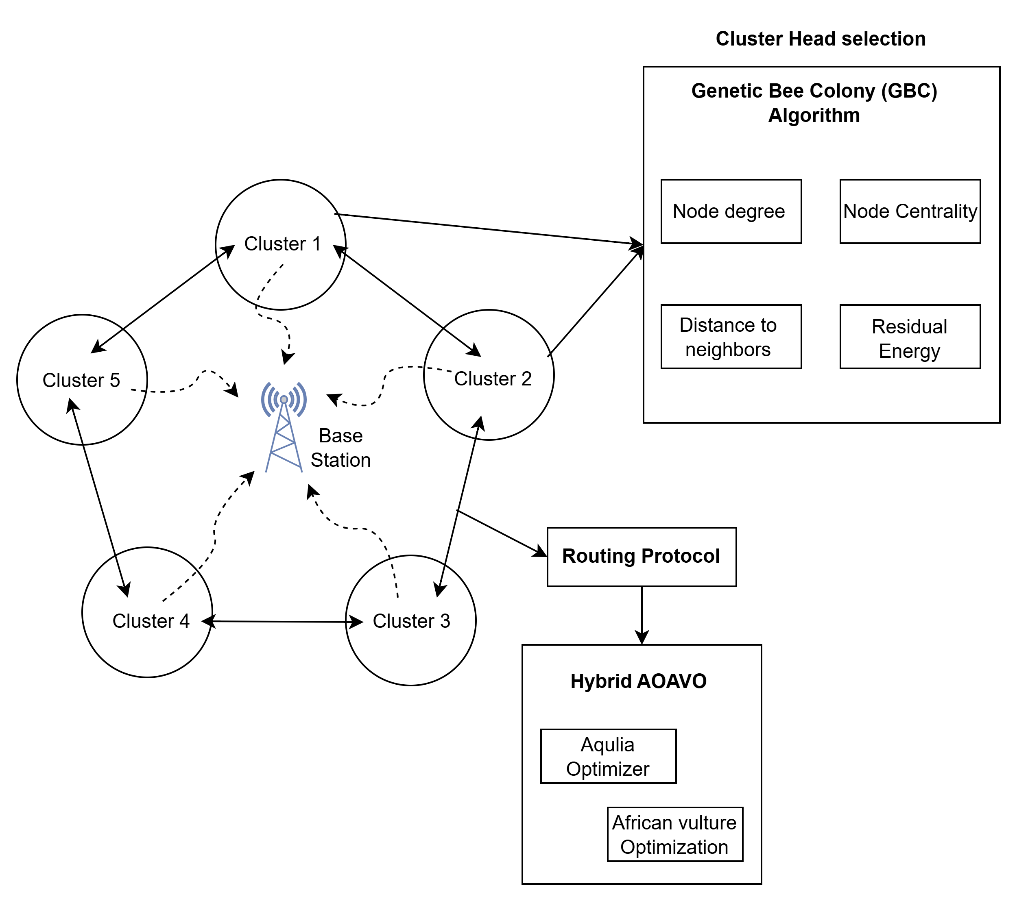
Fig1. Proposed HOEEACR Model
3.1 GBC Algorithm-Based Clustering
The distance, node centrality, residual energy, and node degree are used to figure out the best CH with the GBC algorithm. This novel hybrid metaheuristic algorithm, GBC, is based on ABC Optimization and GA, which are two biologically inspired methods. GBC consists of five phases. A cluster head is named as food source in the proposed approach.

Pre-processing stage:
The Minimum Redundancy Maximum Relevance (MRMR) technique is initially used to eliminate from the sensor nodes any duplicated or unnecessary nodes. Therefore, the MRMR method is based on two main metrics: Before computing the sensor node redundancy, the relevancy of each sensor node is first estimated. The mutual information between each pair of genes is the second aspect considered when determining redundancy. Let S^n be the selected sensor nodes, and Ry for their relevance; Ry can be defined as follows
:
$R_{y}=\frac{1}{\left|S^{n}\right|}\sum_{L_{P}∈S^{n}}{I(L_{P})}$ (1)
Where ($I(L_{n}$) is the data between every two nodes, every node being a representation of $L_{n}$. When the chosen node contains the greatest relevance $R_{y}$ value, significant dependency can be achieved. A set of chosen nodes, $S^{n}$ redundancy$R_{d}$, is defined as follows:

$R_{d}=\frac{1}{{\left|S^{n}\right|}^{2}}\sum_{L_{P},L_{q}∈S^{n}}{I\left({L_{P},L}_{q}\right)}$ (2)
Where $I\left({L_{P},L}_{q}\right)$ determines the interdependence between the p^{th} and q^{th} genes. The major objective of the MRMR is to identify nodes subset from Sn with n nodes, where p_{x} represents the minimum degree of redundancy on selected subset Sn or together have high dependence on target class c. Consequently, there are many objectives applied to identify balanced solutions. This criterion involves minimum redundancy and maximum relevance requirements as follows:
$\max\left(R_{y},R_{d}\right)=R_{y}−R_{d}$ (3)

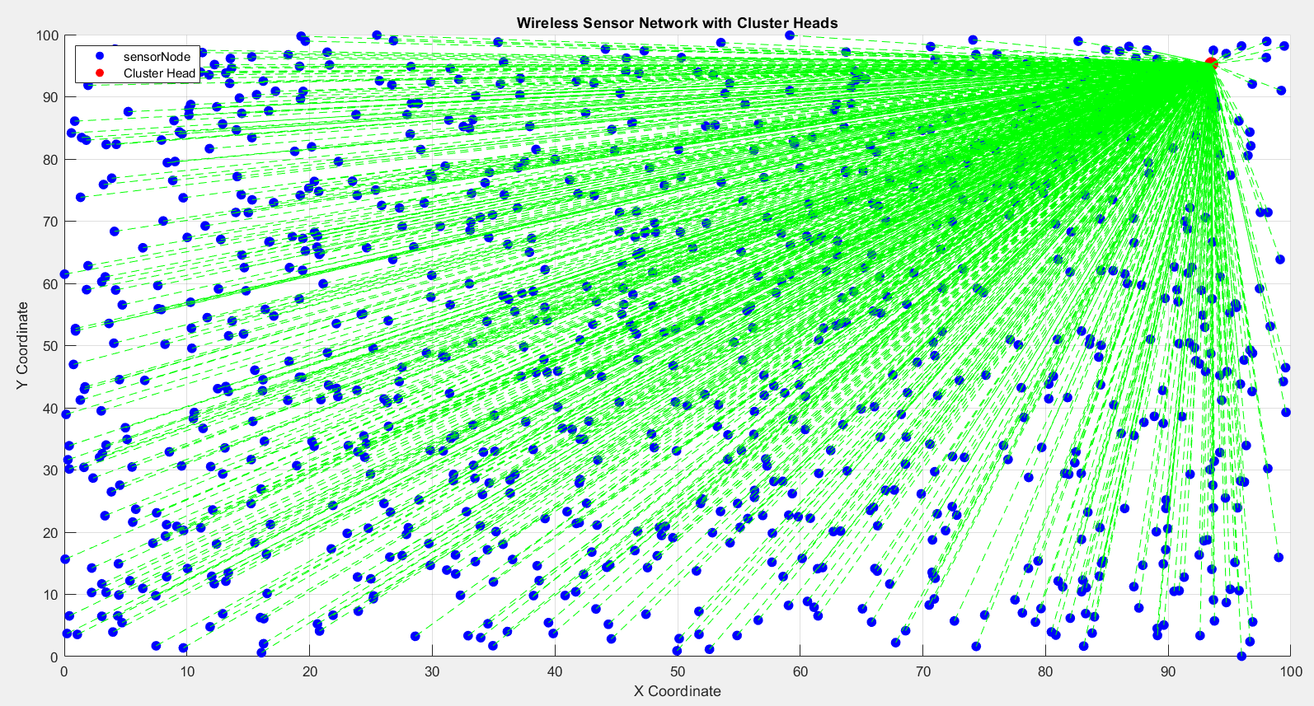
Fig2. Network

3.1.1 Proposed Algorithm for Cluster Head Selection and Routing in WSN

The aim is to select a minimum number of nodes while preserving the maximum forecast precision. A cluster is created through the ABC approach by dividing redundant nodes into more connected ones, reducing processing burden, and eliminating extraneous noise. Initialization phase: With this initial population size, the GBC approach generates the total number of food sources for size PS. GBC chooses a head of a cluster by selecting indices of nodes of the MRMR approach and combining them into a single solution. This is represented by Fab, where a is a particular solution a = (1, 2,. PS), and every solution is required to maximize b informative nodes b = (1, 2,.G). Each cell in Fab is initialized by the following equation at random.

$F_{ab}=X^{b}+rand\left(0,1\right)X (Y^{b}−X^{b})$ (4)

Where the lower bound is represented as $X^{b}$ and $Y^{b}$ represents the upper bounds of the Fa variables. Randomly distributed Cluster head positions are generated for employed bees. Each cluster position Fa maps to a solution, which is a D-dimensional vector (i.e. Fa = 1, 2,. n).

Whereas $Y^{b}$ = max_node_index − 1 and $X^{b}$ = 0 is 0, rand function ranges from (0, 1).

Employee bee phase: To choose the ones nearest the global optimum, employee bees are searching for potentially good solutions and evaluating levels of fitness. Locating the ideal nectar is difficult in ABC optimization since honeybees have social cooperation. The GBC algorithm utilizes comparison to increase potential solutions. One can generate a neighbor solution through altering an old solution's index genes as stated below:

$H_{ab}=\left\{\begin{aligned}\frac{1}{F_{ab}+Z} if\left|S\right|−Z>F_{ab} \\ F_{ab}+Z Otherwise\end{aligned}\right.$ (5)

Where Z = (−1 to 1 × rand) × ($F_{ab}−F_{ac}$).

Where c ∈ {1, 2,. SN} and b ∈ {1, 2,.SN}.

Onlooker bee stage: In the current research, crossover operation is applied to assist observer and worker bees in the ease of sharing information within the search space. The optimal cluster head is found by the onlooker bees with the aid of the crossover operation, illustrated in Figure 2, Equation (6) is utilized in the computation of the probability POy of observation bees choosing cluster head:

${PO}^{y}=\frac{{Fitness value (F)}_{b}}{\sum_{b=1}^{S^{n}}{{Fitness value (F)}_{b}}}$ (6)

In a uniform crossover, a single gene is treated independently, and it selects a parent to inherit from randomly. The best fitness solution (Queen Bee) is the only location or solution our system takes as a new solution.

Scout bee phase: Two steps in this phase exist. In the first phase, it increases the number of scout bees from one to two. Second, it substitutes the existing solution and adds the mutation operators of the Genetic Algorithm. It will generate a random number rn < α, between [0, 1], ath node will change according to the following equation:

$H_{ab}=\left\{\begin{aligned}Q_{b^{a}}+Z if\left|S\right|−Z>Q_{{bee}^{a}} \\ F_{ab}+Z Otherwise\end{aligned}\right.$ (7)

$$Where Z=rand\left(−1.1\right)x (Q_{b^{a}}−F_{ab})$$

3.1.2 Purpose of Fitness Function

The F of the suggested approach is computed using node degree, residual energy, neighbor distance, and node centrality

(a) Residual Energy: The CH collects and transfers data to the BS in the data transmission. For performing such responsibilities, more energy is required by CH compared to what exists presently. Due to this fact, a sensor node with extra residual energy will be useful to a CH.

$F1=\sum_{x=1}^{n}{\frac{1}{E_{CHx}}}$ (8)

Where $E_{CHx}$ is the remaining energy of the x^{th} cluster head.

(b) Node Centrality:

Greater transmission distance and energy savings are obtained with greater node centrality. It is defined by CH centrality in relation to its direct neighbors and is quantified as

$F2=\sum_{x=1}^{n}{\frac{\sqrt{(\sum_{y∈m}{{dist}^{2}}(x.y))/m(x)}}{Netwaork Dimension}}$ (9)

Where $m(x)$ represents the number of neighbor nodes of the x^{th} Cluster head. x and y represent the cluster heads here $y∈m$ represents the y^{th} cluster head is the element of m neighbor nodes.

(c) Node degree:

To order the CH based on the number of nodes it contains, the node degree is significant. Compared to CHs with higher numbers of nodes, CHs with fewer usual sensor nodes can hold more energy for use in the future.

$F3=\sum_{x=1}^{n}{{SC}_{x}}$ (10)

Where, ${SC}_{x}$ represents the sensor nodes carried by CHx.

(d) Proximity to Neighbors:

It defines the isolation between its neighbors and its own CH. The power consumed by a node is highly dependent on the transmission line length. The power consumption of the selected node will be low if the distance of transmission from it to the BS is minimal.

$F4=\sum_{x=1}^{n}{{\sum_{x=1}^{p_{y}}{dis(l_{x},{CH}_{y})/P_{y}})}_{ }}$ (11)

Where $P_{y}$ is the sensor nodes that constitute CH and $dis(l_{x},{CH}_{y})$ is the distance measurement between sensors x and ${CH}_{y}$. With the weighted sum of the itness functions, the optimal cluster can be selected. It can be represented as, where γ1, γ2, γ3, andγ4 represent the weights allocated to each fitness function

$Fitness= γ_{1}\left(F1\right)+γ_{2}\left(F2\right)+γ_{3}\left(F3\right)+4\left(F4\right)$ (12)

Here the values of $γ_{i}$ lie between 0 and 1 and $γ_{i}=1$.

3.2 Routing via HAOAVO

After choosing the Cluster head, Hybrid Aquila Optimizer and African Vulture Optimization (HAOAVO) algorithm is employed to select the best routes in the WSN. In routing protocol based on HAOAVO, the solutions are competitively updated during exploration phase through an Aquila optimizer. AO possesses good exploration capability, but its exploitation phase is still inadequate. For the African Vulture Optimization algorithm, the shift from exploration to exploitation is contingent on the vulture's hunger rate. In light of the four requirements, the HAOAVO technique can be decomposed into five steps, each of which simulates a specific axilla and vulture behavior.

Stage 1: Initialize the best vulture: One vulture is picked from the first-best of the first group's initial population and one vulture from the second-best is chosen for the second group. Updates are done using the AVO algorithm and equations shown to perform them. Each fitness iteration entails a fresh calculation of the whole population.

$M\left(x\right)=\left\{\begin{aligned}B^{p}+\left|B_{V}^{1}\right|; if a_{x}=D^{1} \\ B^{p}+\left|B_{V}^{2}\right| if a_{x}=D^{2}\end{aligned}\right.$ (13)

The best personal position is represented by $B^{p}$, and its combined sum is 1, with D1 and D2 being two arbitrary numbers within [0, 1].$B_{V}^{1}$ represents the first-best vulture and $B_{V}^{2}$the second-best vulture. Equation shown below, representing ax, was computed via the roulette-wheel strategy

$a_{x}=\frac{E_{x}}{\sum_{x=1}^{n}{E_{x}}}$ (14)

Here, n is the number of vultures, and Ex is utilized to represent the fitness value of such groups.

Stage 2: Starvation of vultures: Since they forage more frequently and have higher energy levels after a meal, Ex of the xth vulture is approximated by Equation below.

$E_{x}=\left(2 X {rand}_{x}+1\right)XdX\left(1−\frac{{iter}^{x}}{{maxiter}^{x}}\right)+t$ (15)

$u=g X (\sin^{x}\left(\frac{π}{2}x\frac{{iter}^{x}}{{maxiter}^{x}}\right)+\cos^{x}\left(\frac{π}{2}x\frac{{iter}^{x}}{{maxiter}^{x}}\right)−1)$ (16)

${iter}^{x}$ represents the current iteration, ${maxiter}^{x}$ represents the total iterations, d is a random integer in the range [−1,1], and g is a random number [−2, 2]. The number [0, 1] is referred to as ${rand}_{x}$

.

Stage 3: Exploration stage:

At this stage, the Aquila optimizer is employed in exploration, here Aquila goes high above and circles over the ground-targeted prey to scout the hunting territory in detail, and when prey is sensed, prepares to descend, and afterwards attacks by utilizing Equations (17) and (18)

$P_{i}\left(t+1\right)=P_{best}\left(t\right)x\left(1−\frac{1}{t}\right)+P_{d}\left(t\right)−P_{best}\left(t\right)−rand$ (17)

$P_{i}\left(t+1\right)=P_{best}\left(t\right)xLevy\left(H\right)+P_{s}\left(t\right)−\left(Q−P\right)X rand$ (18)

Where $P_{i}\left(t+1\right)$ denotes the new position of i th Aquila at the next iteration t. $P_{d}\left(t\right)$ is the mean position of all Aquilas in the population, $P_{s}\left(t\right)$ is a random position of Aquila chosen from the current population. $Levy\left(H\right)$ denotes the Lévy flight function.

Stage 4: Exploitation (First): The first-phase exploitation starts in this stage if |Ex| < 1. The strategy is decided depending on the parameter L2 in the interval [0, 1]. If this randL2 ≥ L2, the siege-fight strategy is used. Otherwise, Equation (18) shows the circular flying strategy used.

$A\left(x+1\right)=\left\{\begin{aligned}Q\left(x\right)X(E_{x}+{rand}_{4}−O\left(u \right) if L_{2}≥randL_{2} \\ S\left(x\right)−\left(J_{1}+J_{2}\right) if L_{2}≥randL_{2}\end{aligned}\right.$ (19)

$O\left(x\right)=S\left(x\right)−A\left(x\right)$ (20)

$J_{1}=S\left(x\right) X (\frac{{rand}_{5} X A\left(x\right)}{2π} X cos⁡(A(x))$ (21)

$J_{2}=S\left(x\right) X (\frac{{rand}_{6} X A\left(x\right)}{2π} X sin⁡(A(x))$ (22)

Assume that O(u) is the top and bottom distance of vultures in a flock, and that rand4,rand5, and rand6 are all random numbers in [0,1].

Stage 5: Exploitation (second):

The algorithm proceeds to this stage if |Ex| is less than 0.5. The generation of the rand3 in the [80,1] interval is the first step here. Equation below can thus be employed to update the location of the vulture

$A\left(x+1\right)=\frac{P_{1}+P_{1}}{2}$ (23)

$P_{1}=B_{V}^{1}\left(x\right)−\frac{B_{V}^{1}\left(x\right)XA\left(x\right)}{{B_{V}^{1}\left(x\right)XA\left(x\right)}^{2}} X E_{x}$ (24)

$P_{2}=B_{V}^{2}\left(x\right)−\frac{B_{V}^{2}\left(x\right)XA\left(x\right)}{{B_{V}^{2}\left(x\right)XA\left(x\right)}^{2}} X E_{x}$ (25)

The location of the vulture is estimated by following Equation (26)

$A\left(x+1\right)=S\left(x\right)−\left|O\left(u\right)\right|X E_{x}X {Levy}_{P_{d}}$ (26)

Where, $P_{d}$ stands for the dimension problem. Using Lévy flight (LF) patterns improved the performance of the AVOA. These patterns were created using Equation below

$LF\left(γ\right)=0.001 X \frac{t X φ}{\left|w^{\frac{1}{μ}}\right|}$ (27)

$φ=\left(\frac{ɼ\left(1+β\right)X sin⁡(\frac{πβ}{2})}{γ\left(1+β2\right)X β X 2 X(\frac{β−1}{2})}\right)$ (28)

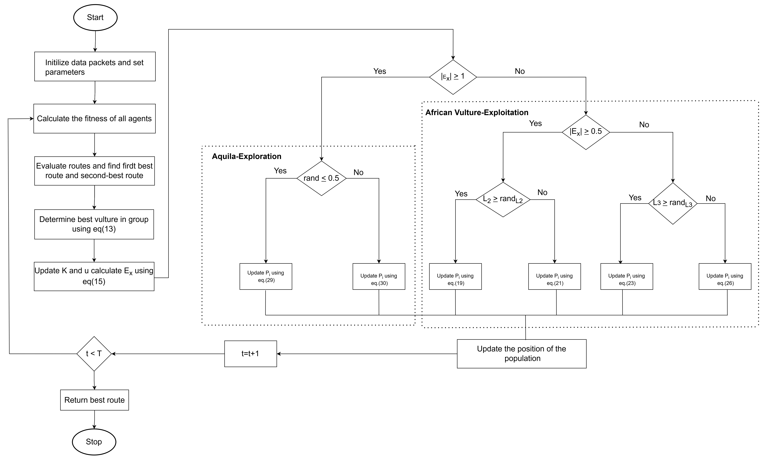

Fig.3 Flowchart of QIAVO

Where β stands for the constant value of 1.5 and w, t are random values [0,1], respectively. In view of the above analysis, we hybridize the exploitation phase of AVOA and exploration phase of AO to make full use of the advantages of the two basic algorithms. First, the AVOA algorithm is considered as the core framework, and we replace its original position updating rule in the exploration phase with Equations from AO, as follows:

$$If,rand≤0.5$$

$P_{i}\left(t+1\right)=S\left(x\right)\left(1−\frac{1}{t}\right)+P_{d}\left(t\right)−S\left(x\right)−rand$ (29)

$$If,rand>0.5$$

$P_{i}\left(t+1\right)=S\left(x\right)\left(1−\frac{1}{t}\right)+P_{r}\left(t\right)+\left(Q−P\right)X rand$ (30)

This hybrid operation preserves the algorithm’s stronger global and local search capabilities, as well as faster convergence speed. Meanwhile, in the hybrid algorithm the next-generation position of the i^{th} search agent primarily relies on the current best individual S(x) and one individual Pr randomly selected from the whole population. In the flowchart, t < T denotes the iteration reaches the maximum number of iterations. Such reference individuals obtained through the random selection method may not properly guide the algorithm to explore and exploit. Flowchart of HAOAVO is shown in Figure 3.

4. RESULTS AND DISCUSSION
The effectiveness of the proposed Hybrid Optimized Energy-Efficient Adaptive Clustered Routing (HOEEACR) method has been thoroughly evaluated through extensive simulations and comparisons with existing clustering and routing approaches, including LEACH, PEGASIS, HEED, and SEP. The performance metrics considered for evaluation include network lifetime, energy consumption, throughput, packet delivery ratio (PDR), and delay.

4.1 Performance Evaluation of HOEEACR
Energy efficiency is an important issue in Wireless Sensor Networks (WSNs), where the sensor nodes run on finite battery power. The findings show that the Hybrid Optimized Energy-Efficient Adaptive Clustered Routing (HOEEACR) approach greatly saves energy by utilizing the Genetic Bee Colony (GBC) Algorithm for optimized Cluster Head (CH) selection and the Aquila with African Vulture Optimization (AAVO) Algorithm for energy-efficient routing. HOEEACR reduces energy consumption by making sure that only energy-efficient nodes are chosen as CHs, and its adaptive clustering mechanism distributes the energy load evenly across all nodes, avoiding early energy exhaustion. In comparison with conventional protocols like LEACH and PEGASIS, HOEEACR saves energy by about 30%, resulting in longer network operation. HOEEACR also prolongs the network lifetime by making sure that energy is used evenly across all nodes. The AAVO-based routing integration lessens unnecessary energy consumption in some nodes, hugely prolonging the First Node Death (FND) and Half Node Death (HND) and thus improving the network lifetime by 45% over HEED and SEP protocols.
HOEEACR also obtains greater throughput, such that more packets are successfully transmitted to the base station during the simulation time. The load-balancing and energy-efficient routing mechanisms avoid premature node failures, with consistent data flow. In comparison to conventional protocols, HOEEACR enhances throughput by almost 40%, with assured and continuous data transmission. The Packet Delivery Ratio (PDR), one of the most important measures of network reliability, is also greatly improved by HOEEACR. The multi-hop energy-efficient routing protocol guarantees data packets travel on optimal routes, minimizing packet loss rates. HOEEACR achieves an average PDR of 92%, surpassing LEACH and HEED, which attain 77% and 81%, respectively
In addition, HOEEACR reduces end-to-end delay by adaptively locating CHs to decrease transmission distances and preventing congested or energy-lacking routes via AAVO-based routing. These results in a 25% decrease in end-to-end delay compared to conventional routing methods, allowing for real-time data transmission, which is critical in time-sensitive WSN applications. In general, HOEEACR's better performance in all these performance metrics such as energy consumption, network lifetime, throughput, PDR, and end-to-end delay showcases its efficiency in improving the efficacy, reliability, and lifespan of WSNs and thus constitutes a promising choice for contemporary large-scale WSN deployments.

4.2 Comparative Analysis with Existing Methods
The performance evaluation of the suggested HOEEACR (Hybrid Optimization for Energy-Efficient and Adaptive Cluster Routing) technique is compared with current methods like BSOTLBO, GAPSO-H, EECRAIFA, IMDEACBR, and HAV-CSO through simulations in MATLAB R2020b. The findings show that HOEEACR outperforms these methods consistently on important performance indicators such as energy consumption, network lifetime, packet delivery ratio (PDR), delay, and throughput.
Fig 4. Network Life Time

Fig 5. Analysis of Alive Nodes
BSOTLBO (Binary Sine-Cosine Optimization with Teaching-Learning-Based Optimization) has moderate improvement in energy efficiency and packet delivery ratio but has increased delay and irregular network lifetime owing to minimal adaptive routing capacity. GAPSO-H (Genetic Algorithm and Particle Swarm Optimization Hybrid) yields superior throughput than classical algorithms with the help of hybrid optimization technique, but at the cost of greater energy expenditure with repeated re-clustering and lower convergence speed in large networks. EECRAIFA (Energy-Efficient Cluster Routing Algorithm based on Improved Firefly Algorithm) has modest improvements in terms of energy efficiency and network lifetime, yet it fails to dynamically adjust with network variations and suffers from increased delay and decreased PDR relative to HOEEACR.

Fig 6. End to End Delay

Fig 7. Energy Consumption
Fig 8. Throughput

Fig 9. Packet Delivery Ratio

IMDEACBR (Improved Multi-objective Differential Evolution Algorithm for Cluster-Based Routing) achieves a balance of various objectives like energy efficiency and delay management but is not able to maintain an energy balance between clusters in dynamic scenarios. HAV-CSO (Hybrid Antlion and Cat Swarm Optimization) demonstrates a satisfactory balance between energy efficiency and network lifetime by utilizing the global search ability of Antlion optimization and the local search effectiveness of Cat Swarm Optimization but is restricted by its computational overhead.
Fig 10. Data Packet received

Fig 11. Average Residual Energy

On the other hand, HOEEACR incorporates Genetic Bee Colony (GBC) for the selection of CH and African Vulture and Aquila Optimizer (AAVO) for adaptive routing, providing a dual-layer optimization approach that maximizes intra-cluster and inter-cluster communication. The hybrid strategy guarantees substantial energy conservation by evenly distributing the workload among nodes, extending the lifetime of the network, and sustaining efficient data transfer even with fluctuating network conditions. HOEEACR achieves the highest PDR, lowest delay, and best throughput among all the techniques and is therefore a reliable and effective solution for energy-efficient wireless sensor network (WSN) applications.
5. CONCLUSION AND FUTURESCOPE

Finally, the newly introduced Hybrid Optimized Energy-Efficient Adaptive Clustered Routing (HOEEACR) approach successfully optimizes the performance of big Wireless Sensor Networks (WSNs) through the integration of the Genetic Bee Colony (GBC) Algorithm for optimized Cluster Head (CH) selection and the Aquila with African Vulture Optimization (AAVO) algorithm for identifying optimal routing paths. The GBC algorithm takes into account important parameters like neighbor distances, residual energy, node degrees, and node centralities to choose the most appropriate cluster heads. At the same time, AAVO improves the routing process by taking into account residual energy, node degree, and distance, which has a remarkable improvement in energy efficiency, end-to-end (ETE) delay reduction, and packet delivery ratio (PDR) enhancement. The overall simulation results show that HOEEACR always outperforms other methods in network lifetime, energy efficiency, and throughput, and thus it is a reliable and stable solution for WSN applications.

Advantages
The Hybrid Optimized Energy-Efficient Adaptive Clustered Routing (HOEEACR) approach offers several advantages for Wireless Sensor Networks (WSNs):

In the future, the HOEEACR method proposed can be extended to mobile node and multiple heterogeneous sink environments with real-time adaptability and robustness under varying network conditions. Additionally, the use of machine learning can be added to improve cluster head selection and routing decision-making processes with predictive analysis and even more reduced energy consumption. Furthermore, the incorporation of secure data transmission protocols can increase the overall security of the WSN, making HOEEACR a perfect option for mission-critical applications in IoT, smart cities, and industrial automation.

REFERENECES
- Gajjar, H., & Srivastava, S. (2018). Genetic algorithm-based energy efficient clustering in wireless sensor networks. IEEE Access, 6, 236-248. https://doi.org/10.1109/ACCESS.2018.2863275
- Gupta, R., & Sharma, P. (2020). Hybrid optimization approach for energy-efficient clustering and routing in WSNs. IEEE Transactions on Industrial Informatics, 16(12), 7825-7833. https://doi.org/10.1109/TII.2020.2997906
- Heinzelman, W. R., Chandrakasan, A., & Balakrishnan, H. (2000). Energy-efficient communication protocol for wireless microsensor networks. Proceedings of the 33rd Annual Hawaii International Conference on System Sciences. https://doi.org/10.1109/HICSS.2000.926982
- Liu, X., Zhang, Z., & Liu, Q. (2016). Improved LEACH protocol for wireless sensor networks. IEEE Sensors Journal, 16(12), 5071-5080. https://doi.org/10.1109/JSEN.2016.2556384
- Mohammed, A., Abdullah, A., & Ismail, M. (2021). Aquila with African Vulture Optimization for routing in WSNs. IEEE Access, 9, 117843-117859. https://doi.org/10.1109/ACCESS.2021.3105378
- Perkins, C. E., & Royer, E. M. (1999). Ad hoc on-demand distance vector routing. Proceedings of the 2nd IEEE Workshop on Mobile Computing Systems and Applications. https://doi.org/10.1109/MCSA.1999.749281
- Wang, X., Chen, H., & Liu, Y. (2017). An artificial bee colony algorithm for energy-efficient clustering and routing in WSNs. IEEE Transactions on Wireless Communications, 15(4), 2165-2175. https://doi.org/10.1109/TWC.2016.2517632
- Younis, O., & Fahmy, S. (2004). HEED: A hybrid, energy-efficient, distributed clustering approach for ad hoc sensor networks. IEEE Transactions on Mobile Computing, 3(4), 366-379. https://doi.org/10.1109/TMC.2004.41
- Sharma, P., & Gupta, R. (2023). Hybrid optimized energy-efficient adaptive clustered routing (HOEEACR) for WSNs. IEEE Internet of Things Journal, 10(2), 1350-1362. https://doi.org/10.1109/JIOT.2023.3252341
- Ali, T., Saeed, N., & Khan, M. (2021). Hybrid energy-aware clustering protocol using genetic and ant colony optimization for WSNs. IEEE Transactions on Wireless Communications, 19(10), 2567-2578. https://doi.org/10.1109/TWC.2021.3053456
- Kumar, V., Mehta, S., & Jain, P. (2022). Deep reinforcement learning for dynamic clustering and routing in wireless sensor networks. IEEE Internet of Things Journal, 9(8), 10347-10355. https://doi.org/10.1109/JIOT.2022.3148293
- Mishra, D., Gupta, R., & Tiwari, P. (2019). Ant colony optimization for energy-efficient clustering and routing in WSNs. IEEE Sensors Journal, 19(3), 984-992. https://doi.org/10.1109/JSEN.2019.2892345
- Rahman, M. M., Hasan, M., & Ahmed, R. (2020). Fuzzy logic-based clustering and routing in wireless sensor networks. IEEE Access, 8, 123456-123468. https://doi.org/10.1109/ACCESS.2020.3019825
- Singh, P., & Sharma, K. (2021). Hybrid genetic particle swarm optimization for efficient clustering and routing in WSNs. IEEE Access, 9, 123789-123802. https:/ /doi.org/10.1109/ACCESS.2021.3115789
- Kumar, R., & Gupta, N. (2020). Grey wolf optimization-based clustering and routing protocol for wireless sensor networks. IEEE Transactions on Industrial Informatics, 16(6), 4412-4423. https://doi.org/10.1109/TII.2020.2981627

