Technologies

Spring Boot, Jpa, H2

Store longest palindrom value [http://localhost:8080/insertLongestPalindrom](http://localhost:8080/storeLongestPalindromValue)

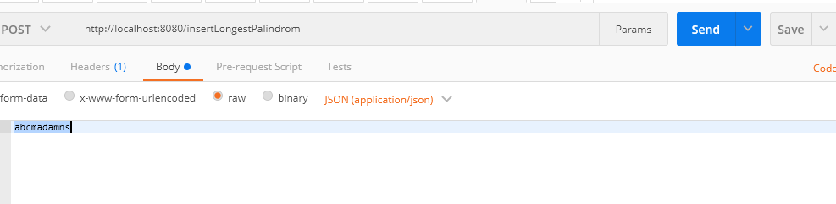

Check the values in h2 db

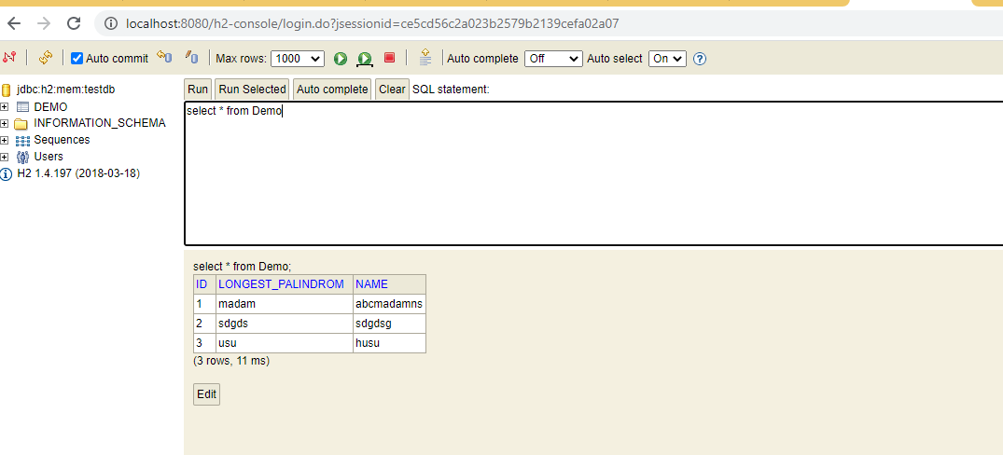

Retreive the longest palindrom value

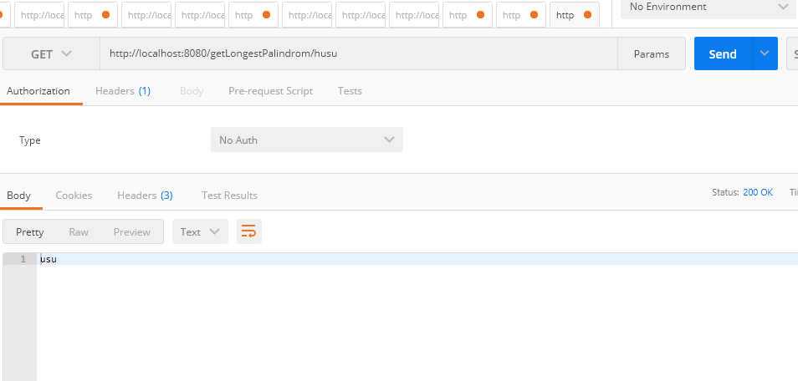

Incase of value is not available in DB

