Kubernetes:
Monolith application: one single big application
Microservice application: single big application divided into multiple small applications
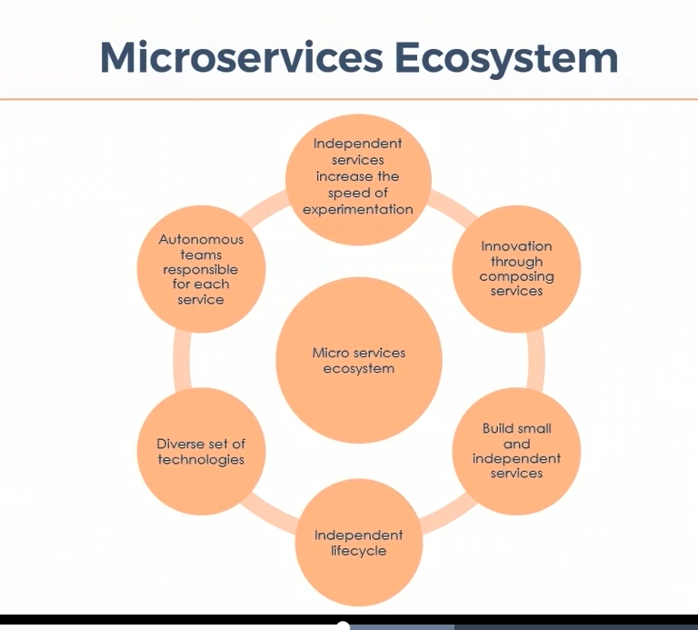
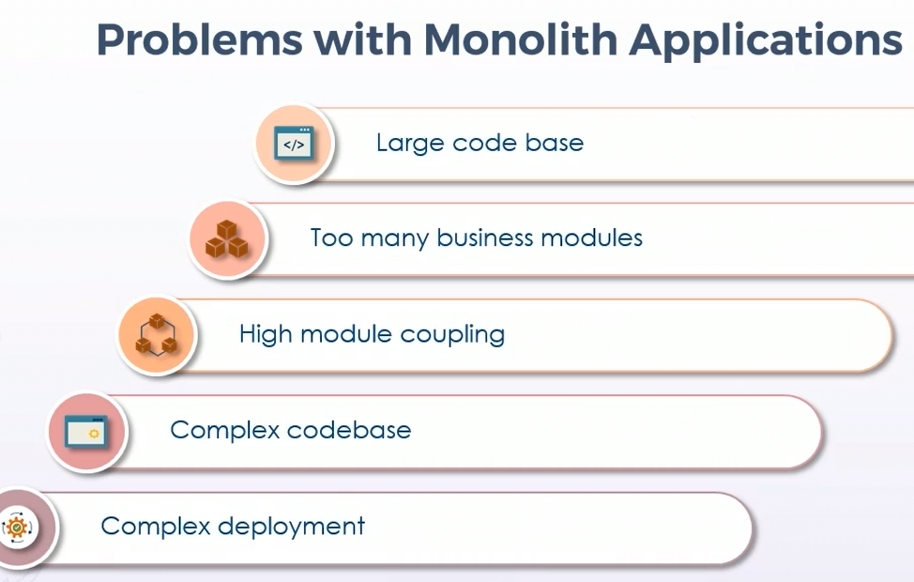
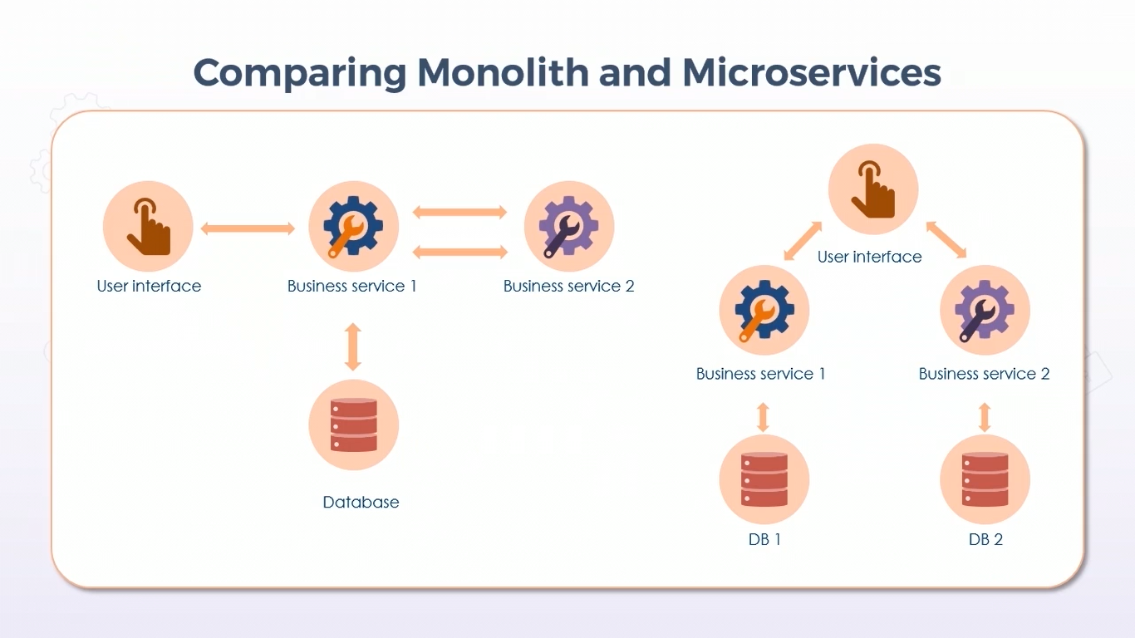
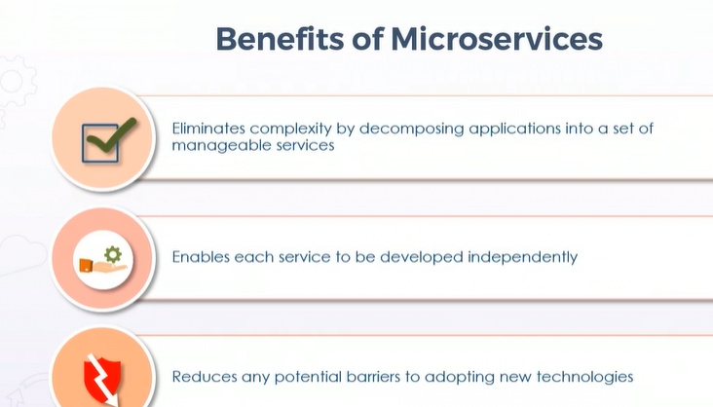
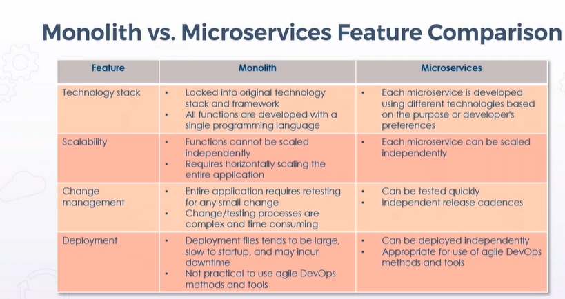
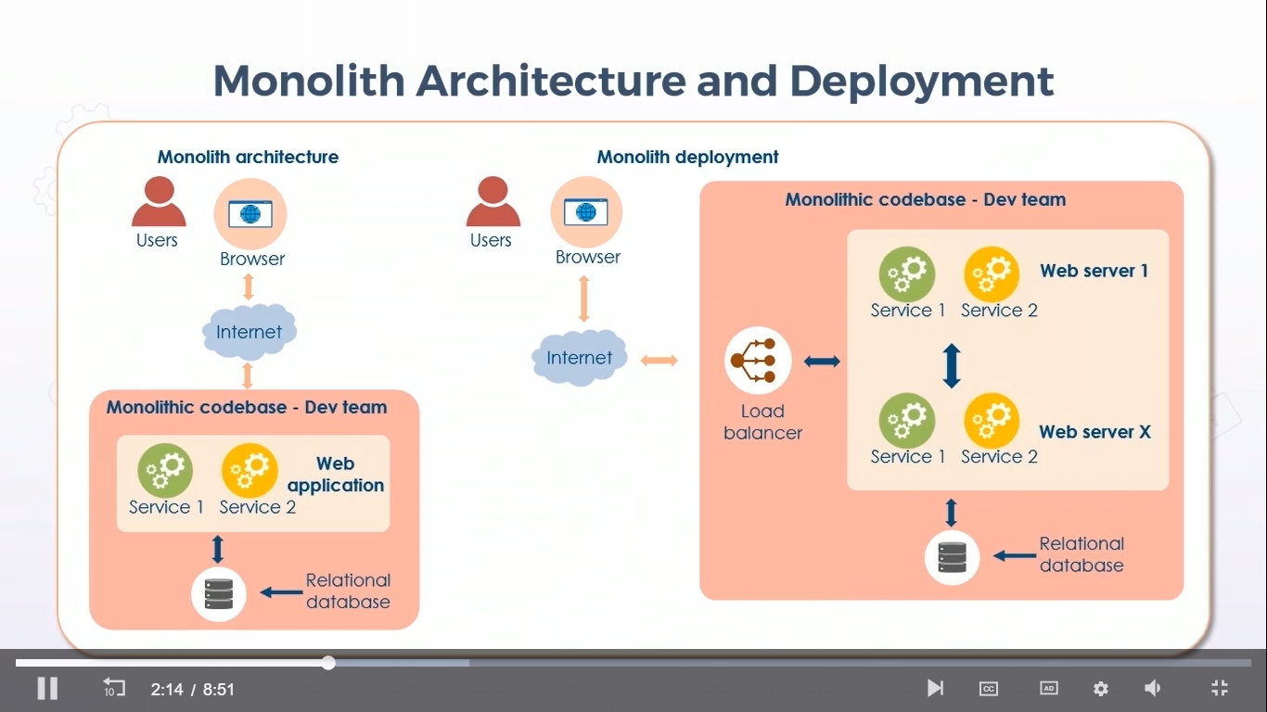
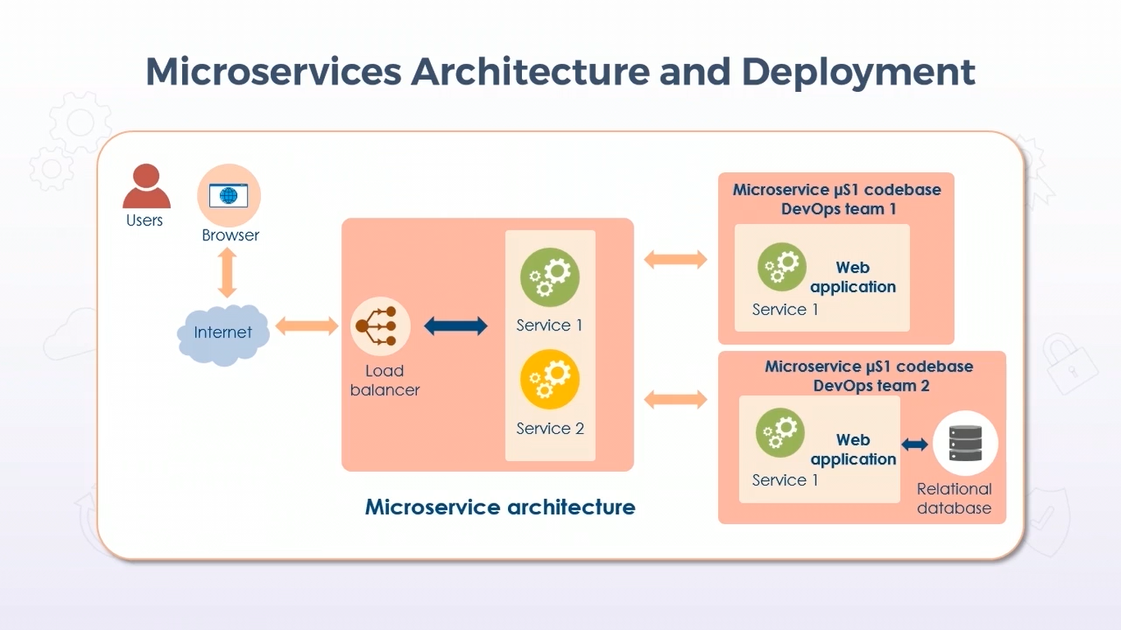
Each service has its own deployment
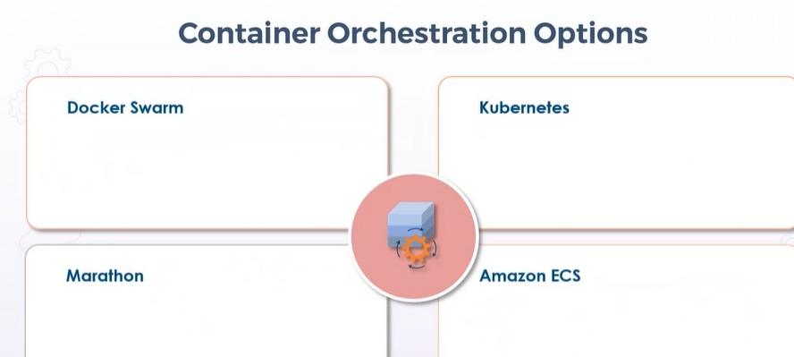
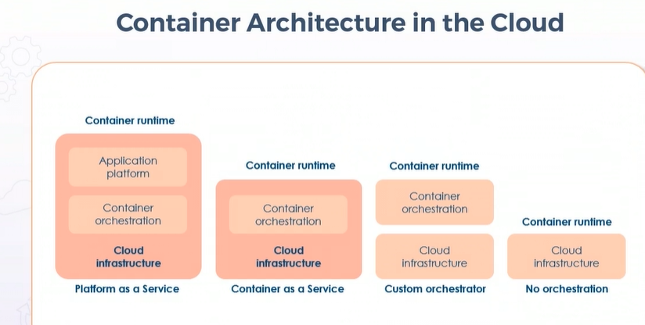
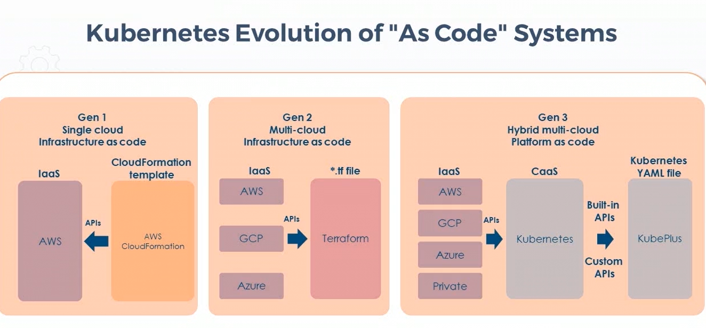
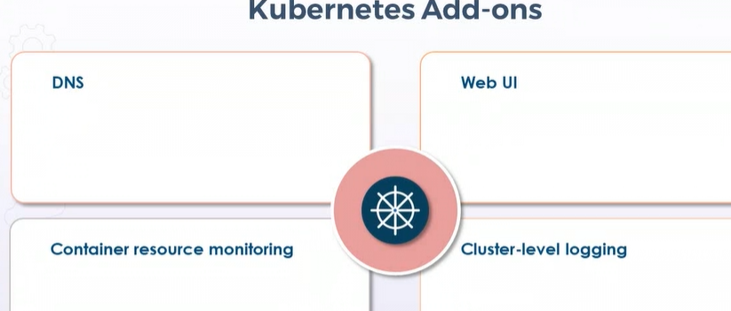
Cluster-level-logging -> saves the container logs to central log storage
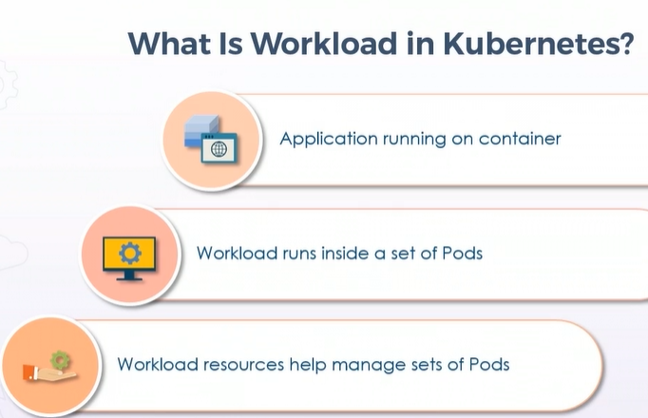
Workload: application running on container is considered as workload
Statefulset: stores the state information and other information of a stateful pod.
Daemonset: makes sure pod is running in all nodes or not, useful for collecting logs.
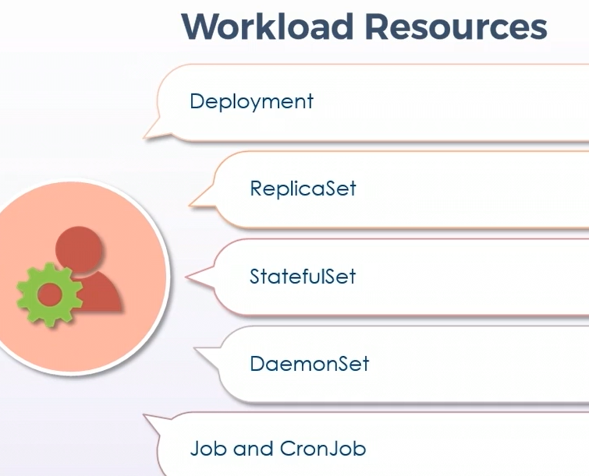
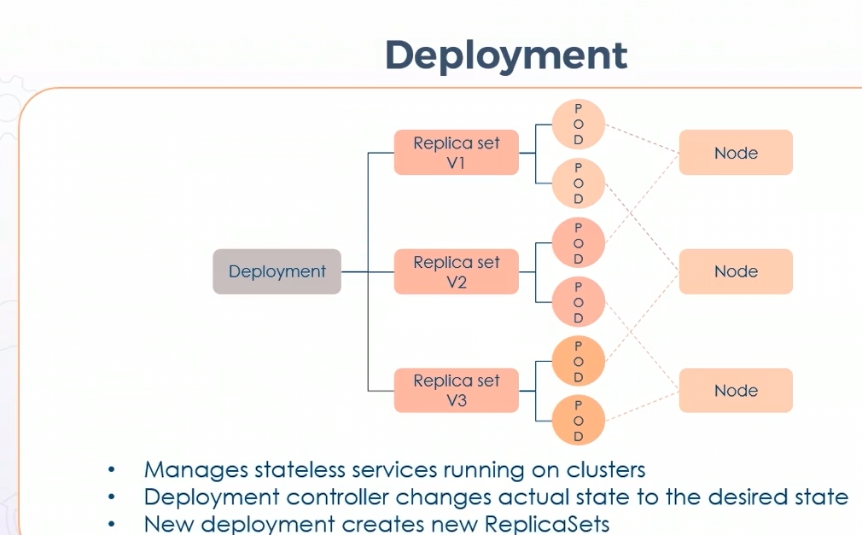
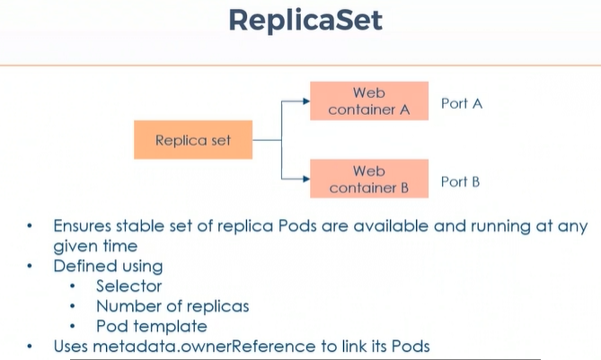
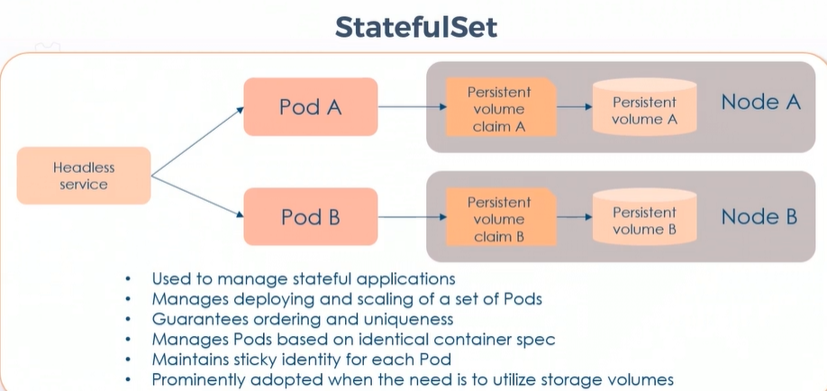
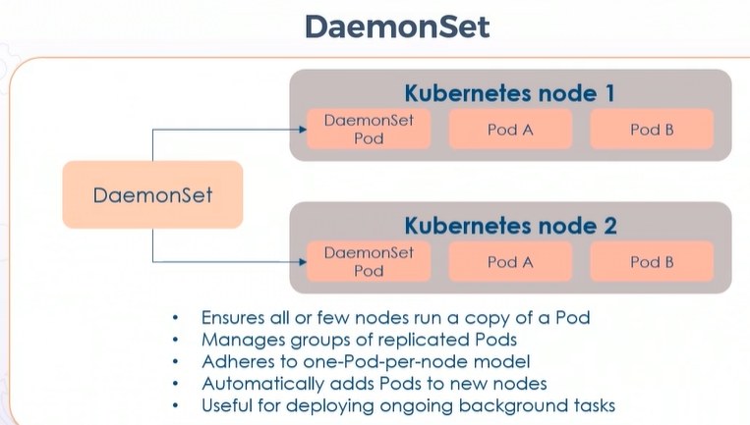
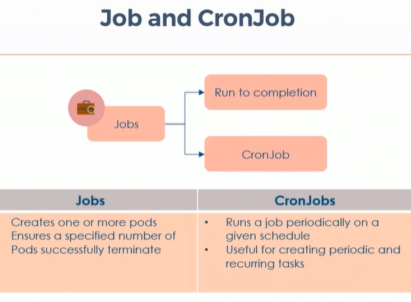
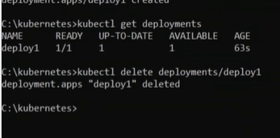
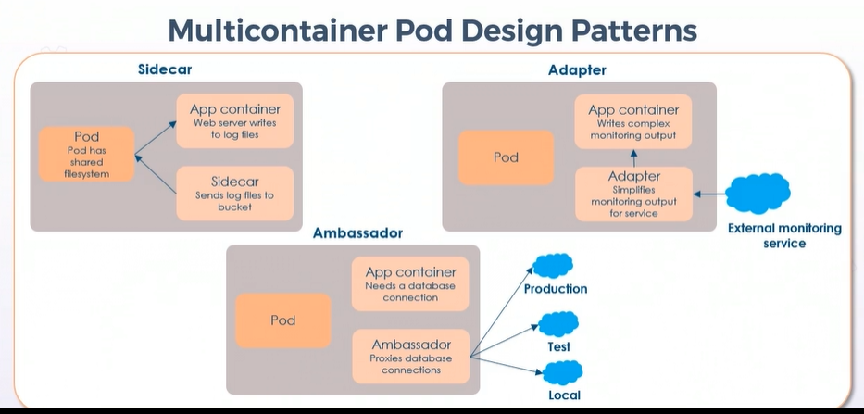
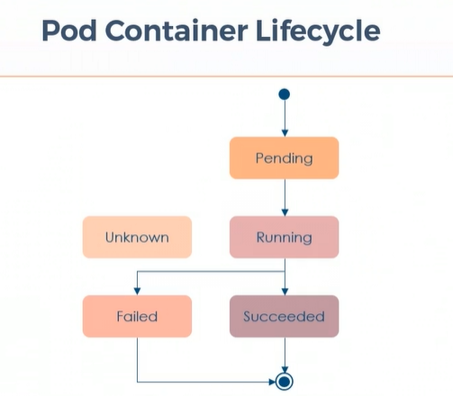
Kubelet stopped communicating with api server then pod state will be unknown
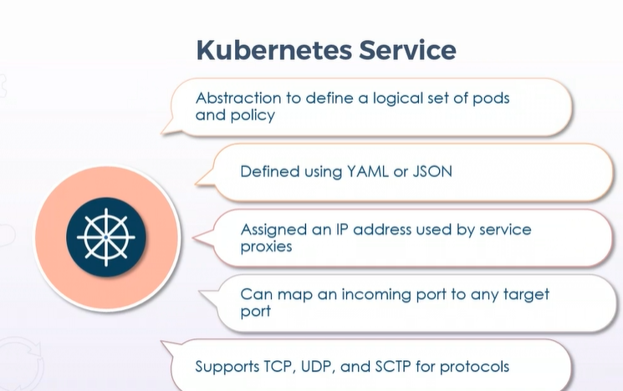
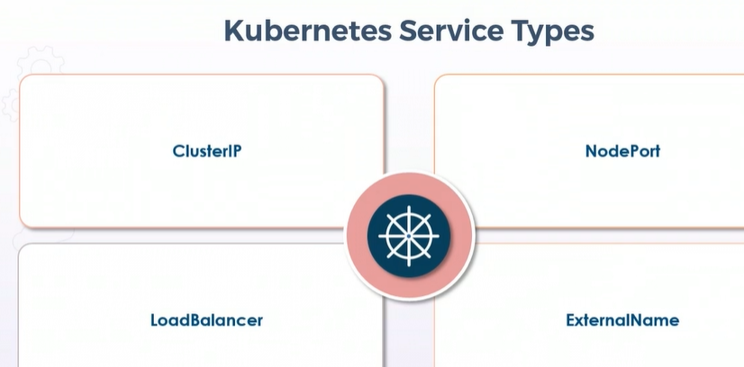
ExternalName can be used to map a cname for a resource
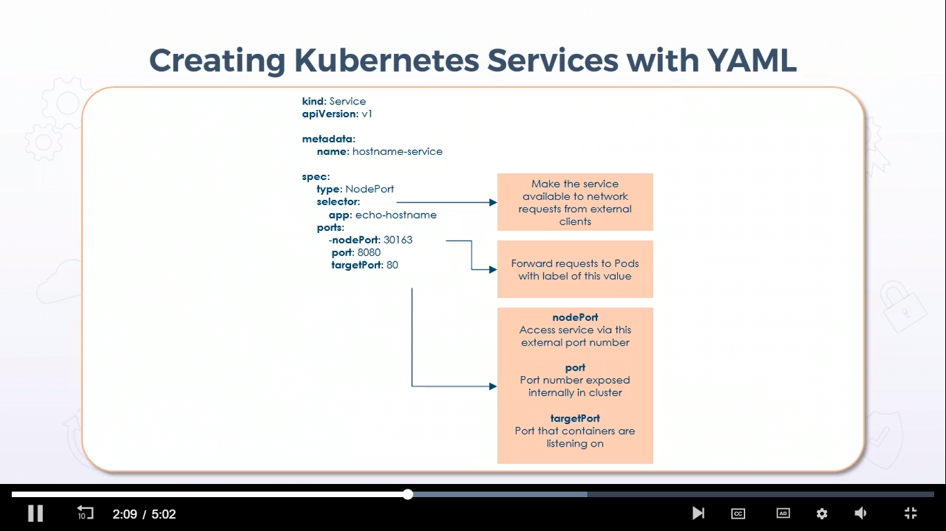
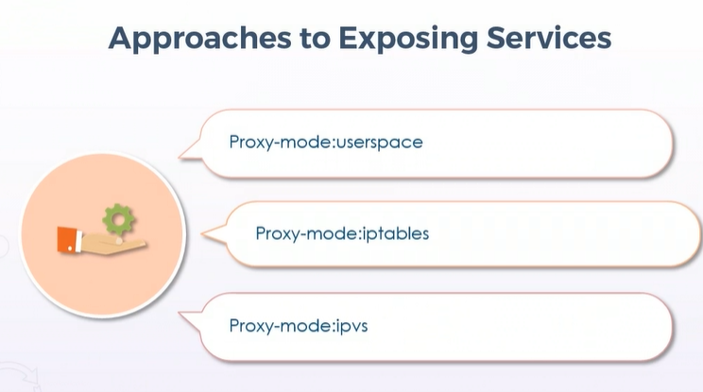
Proxy-mode:userspace: kube proxy continuously watches the master and endpoints which are added in the userspace
Proxy-mode:iptables: : kube proxy continuously watches the master and endpoints with the help of iptables

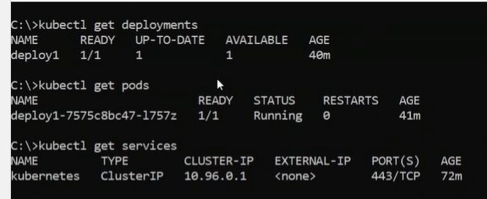
Commands to create a service and expose it:
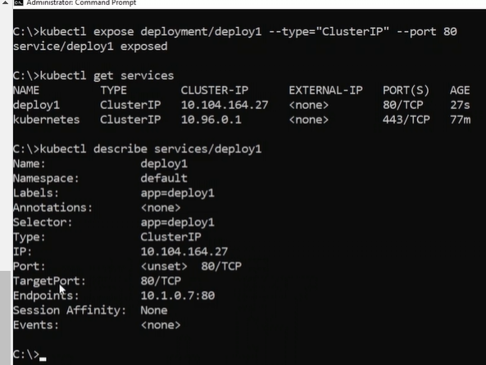
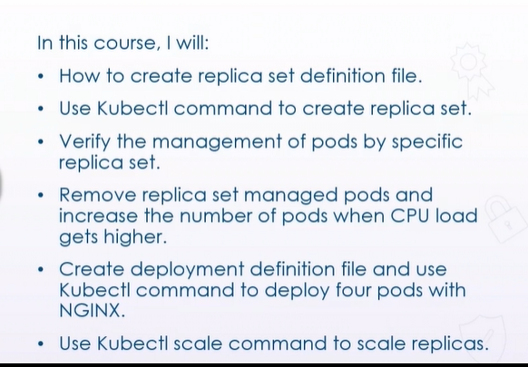
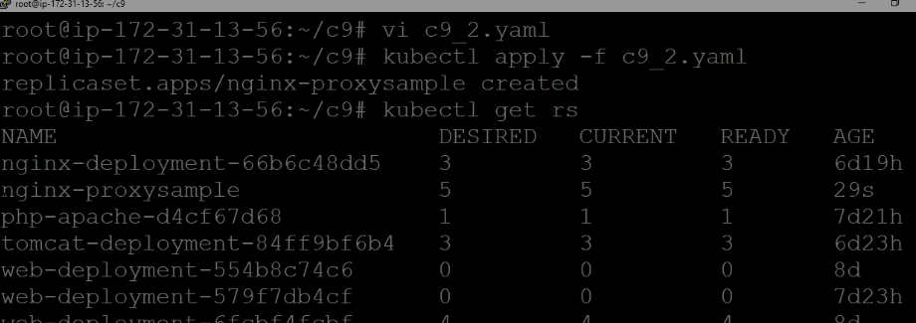
Nginx-proxysample is ours: as we have given 5 replicas so it creates 5 pods, to check those pods we can enter command like kubectl get pods
To edit a pod: kubectl edit pods podname

BLOG NOTES:
6 subnets: 2 public[load balancer to forward requests to 2 availability zones] 4 private[ 2 ec2 instances to run that application and 2 rds instances to store the creds and all]
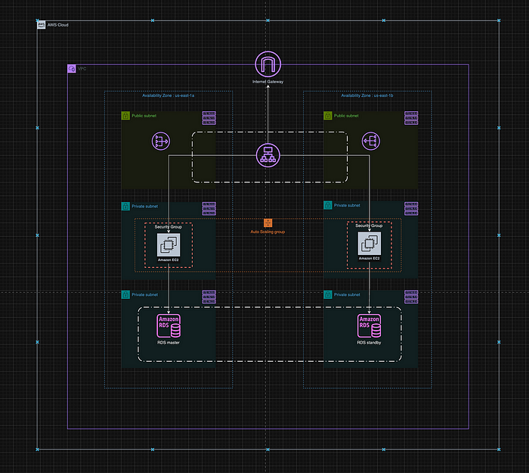
Rds needs creds so that creds will be kept on aws secret manager, with the help of userdata we can retrieve those secret values
How wordpress uses rds as database? – wordpress has a config file and we need to fill rds details inside there.
Certifications: explained abt monolith vs microservices architecture, how the deployment goes , difficulty level of testing
Pods and deployments – basic commands along with handson [docker desktop - run minikube img and minikube start]
Kts:
Project: eks cluster using terraform and ec2 jenkins
Just created a vpc and inside that created a eks cluster
Created an ec2 instance and installed jenkins, git, terraform, kubectl using userdata.sh
After adding eks cluster code I just used jenkins pipeline to get the code from git and done terraform init, plan, apply
Then I have deployed an nginx application using kubectl apply -f deployment.yaml'
'kubectl apply -f service.yaml'
To create a replicaset:
Go to that replicaset loc and kubectl apply -f replicaset.yml
Then to view the replicaset: kubectl get rs
Take one specific pod name from replicaset and check whether this pod is controlled by our replicaset or not: kubectl get pods podname -o yaml
Now replicaset has 5pods to remove 1pod from that specific replicaset cmd: kubectl edit pods podname
And at the time of editing just change the label name and do get pods.
For horizontal scaling: kubectl autoscale deployment deploymentname --cpu-percent=60 –-min=3 --max=5
To check the status of current autoscaler: kubectl get hpa
To scale a deployment: kubectl scale deployment.v1.apps/deploymentname –replicas=6

Service account: just a bridge between aws and k8s world.
Ex: if pod wanna read objects in s3 bucket then we need to add service account b/w them. Permissions like read/write on s3 bucket that we need to define in iam role and attach that iam role to service account.

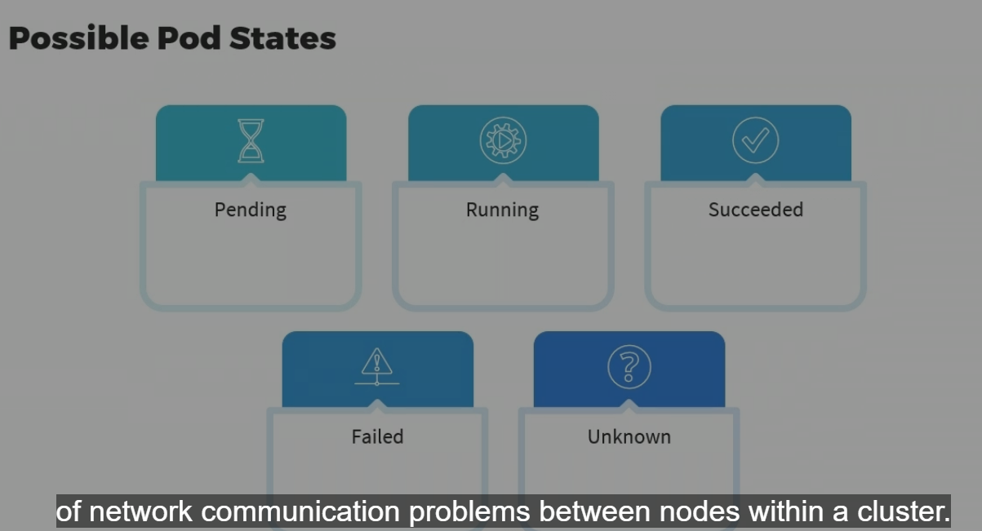
Diff pod status: unknown means there might be n/w problems b/w nodes inside cluster.
Container probes:
1)startup probe: make sure that containers within a pod are initialized and ready for work
2)readiness probe: when containers within a pod are ready to accept traffic over the n/w
3)liveness probe: containers inside the pod are healthy by periodically probing them.
