Helm: code with nana
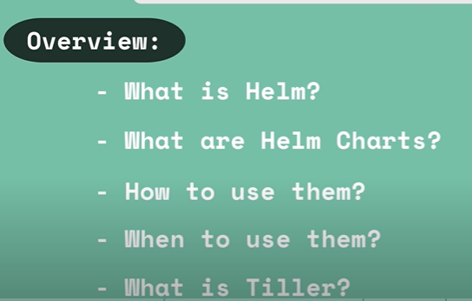
Package manager for Kubernetes
Ex: to deploy elastic stack logging in eks cluster u need a stateful set(like db) and secrets store cheyadaniki something, configmap, k8s user with permissions. So ivanni yaml files manam malli raaskoni work avuthundha ledha ani test cheskodam ante helm will provide all those things.
Ex: for suppose to deploy a application we need deployment.yaml, ingress.yaml and service account(k8 world) so if u have 20 application then u need to create the same file 20 times which is not good. To avoid that issue we do have HELM which helps in redundancy we can create 1 template for deployment.yaml likewise for other files. Everytime u deploy a new application just change the values using values.yaml in that template.
Template -> aka Helm chart
Ex: 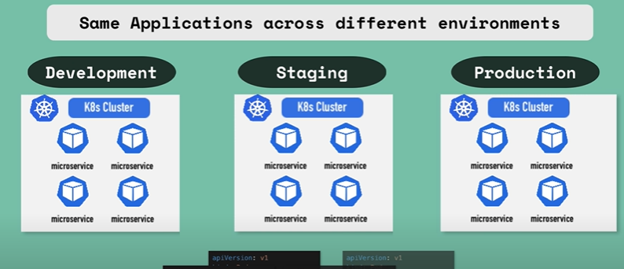
Same set of files will be placed in diff diff environments. Instead of that just create a template for similar kind of files and just replace values using values.yml.
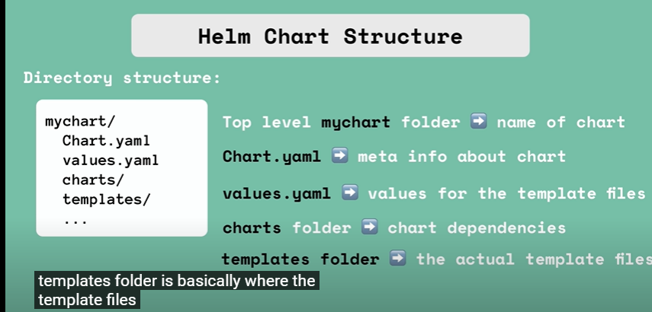
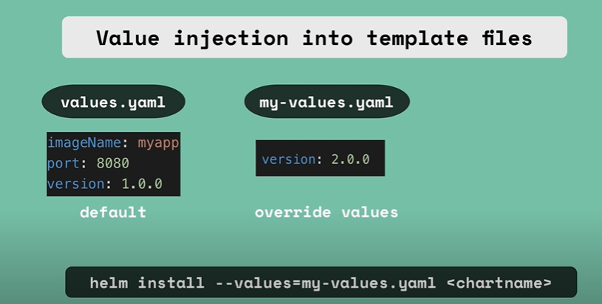
Now the version would be overridden from 1.0.0 to 2.0.0
Release management feature in helm charts:
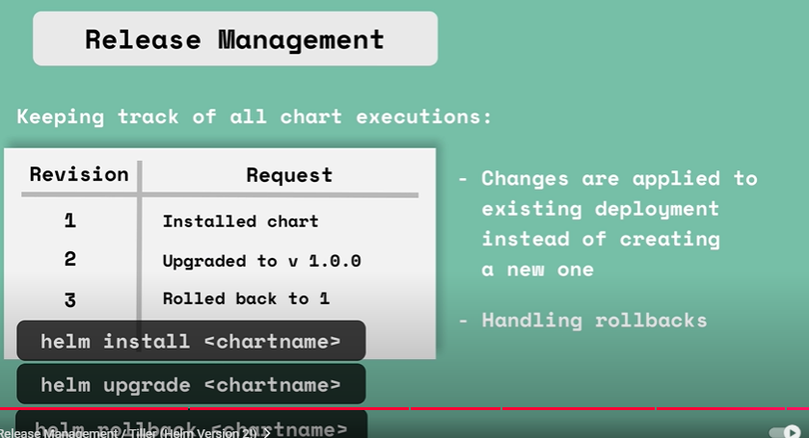
*)server(tiller) stores all the modifications, if we wanna upgrade(helm uprade chartname) then instead of creating a new deployment it actually modifies the existing deployment with new values.
As it saves all the info it can easily upgrade or rollback
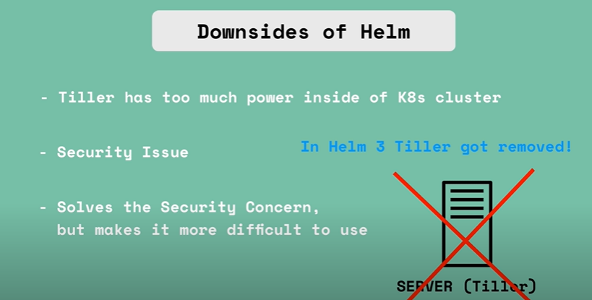
Tiller has too much power like create upgrade rollback delete in k8s cluster which means a big security issue might cause with this in the future. So they have removed this tiller which means loses the release management.
RBAC Authorization and Authentication:
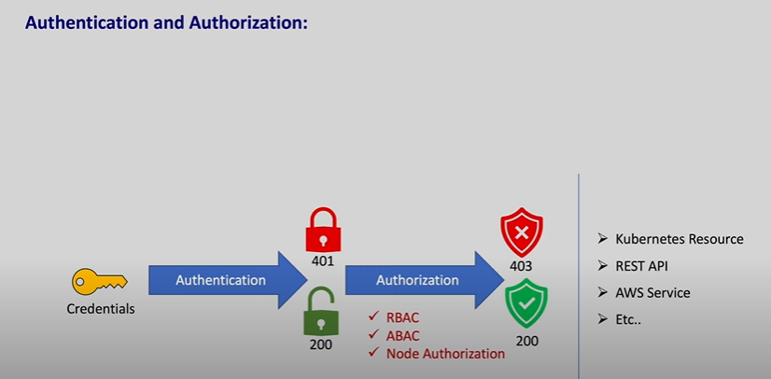
Creds required for authentication and after authentication if u r not authorized to perform an action then it’ll throw 403
**)RBAC by johny: whatever functionality iam does in AWS samething will be done by rbac in k8s. Bridge: service account. Ippudu pod related emaina actions cheyyali ante u need to have some permissions. Ahh permissions anni k8s lo Role ki ichi ahh role ni service account ki add cheyyali how? Using role binding ( indhulo rendu untayi subject reference and role ref => role ref emo role subj ref emo service account/user/user groups) . So ila e mem actions perform cheyyali ane dhaaniki role dhwara permission ivvochu
Cluster role: will be attached to all the namespaces inside the cluster using cluster role binding
During the authentication if u provide proper certificate then u’ll be allowed access into the cluster.
Cluster role applies to all the namespaces. To bind this cluster role we need cluster rolebinding
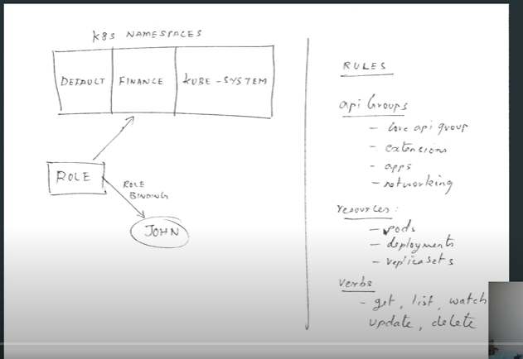
Aws lo iam role permissions ki access ela isthamo same k8s rbac ki verbs ala
To view the server address: kubectl config view
Cluster>>namespace>>deployment>>replicaset>>pods
Actually a role gives access to particular namespace. (this role which we r creating lists all the pods inside the finance namespace)
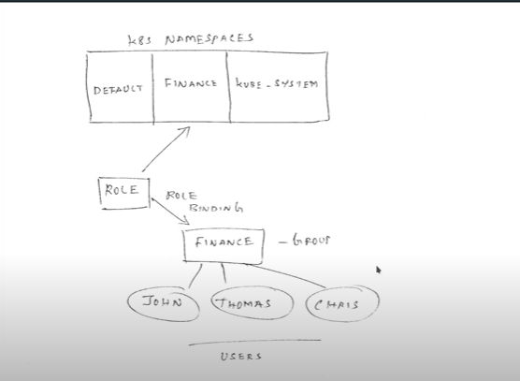
With the help of role binding we can attach the role to a finance namespace. Users connected to that namespace were also given same permissions inside that role. Coz users are connected to namespace and we attach that role to namespace.
kubectl create ns finance – (Created)
generated a rsa private key using 2048 bits
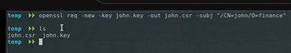
The above ss makes him to add in the group inside namespace
Created a new cluster. Created creds for john and then attached that role to john so that he can access finance namespace inside that k8s cluster
John: set cluster, set creds, set context if he set all those then he can directly have kube-config file in his local. OR we can set cluster, set creds, set context and just send kube-config file to him so that he can access.
With the help of kube-config file john can able to access the k8s cluster. He will place that kube-config file in his local kube directory.Post that u can start running kubectl commands
Create a role
And attach that role to finance ns using rolebinding
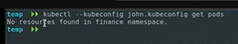
Also add finance ns in kube-config file otherwise it might pull pods from default ns
Attach that user-john to user group so that in future ppl added to that grp will inherit the role
Coredns: whenever a pod or service(like loadbalancer forwards the req to available pods) is created then this coredns will map ip to that pod/service name.(but this coredns is only inside k8s)

