Assignment-1

**Insert Documents:**

**Query Documents:**

**Update Documents:**

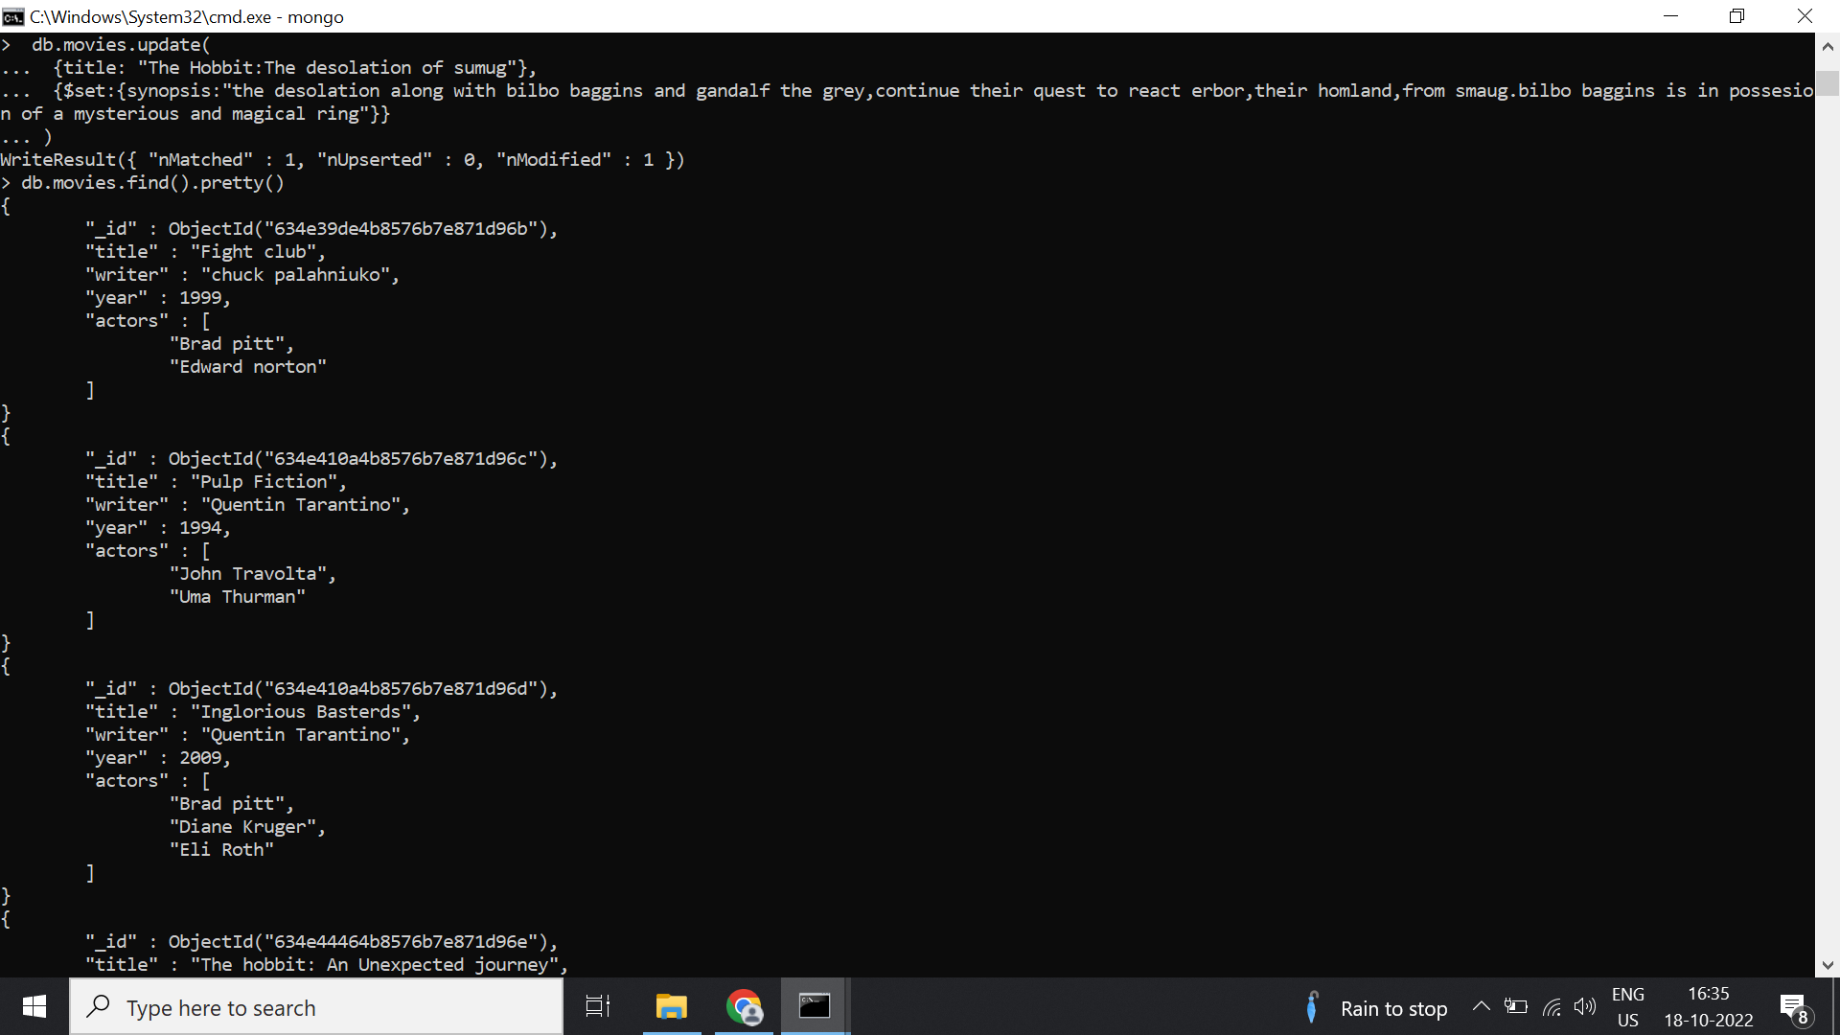

**Text Search: & Delete Documents:**

**Relationships:**

