

AWS Three tier architecture

PROJECT

COURSE : AWS DEVOPS

Trainer : Mr . MADHUKAR REDDY

NAME: B.Sravani

Mail-id:sravanireddybhavanam1@gmail.com

* Create VPC with CIDR Range 10.0.0.0/16

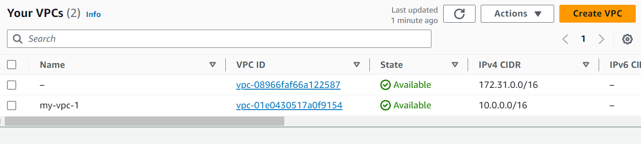

* Create 2 Public Subnets and 4 Private Subnets in 2 Availability Zones

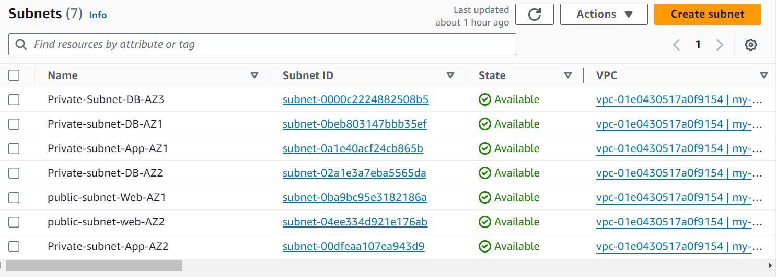

* Create Internet Gateway and 2 NAT Gateways

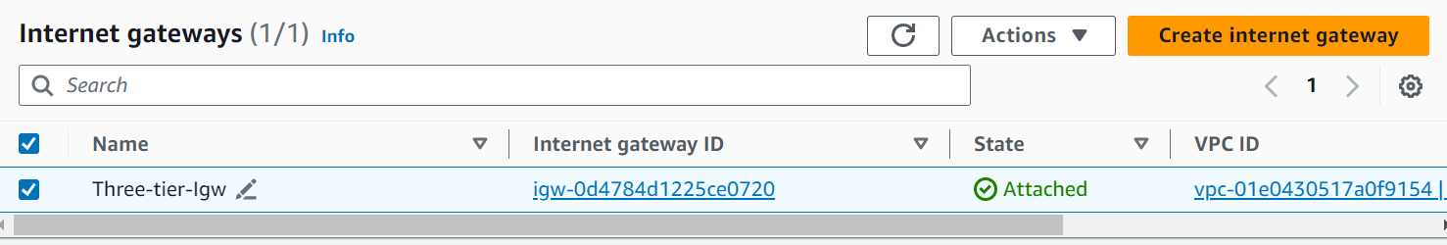

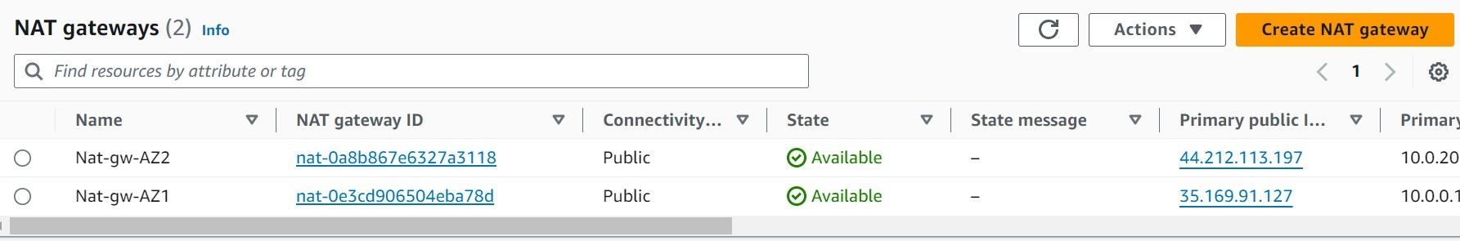

* Create 3 Route tables and attach IGW to public routes, add NAT GW to Private routes.

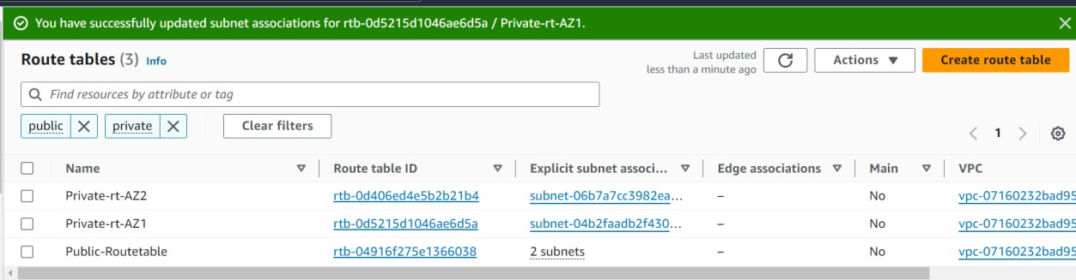

* Create Security Group and Configure.



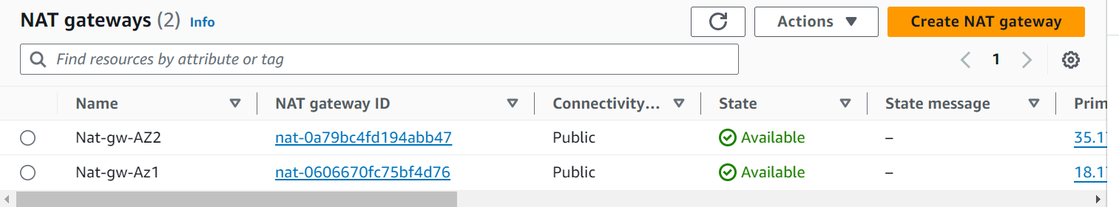

* Creating 2 web servers and 2 private servers.

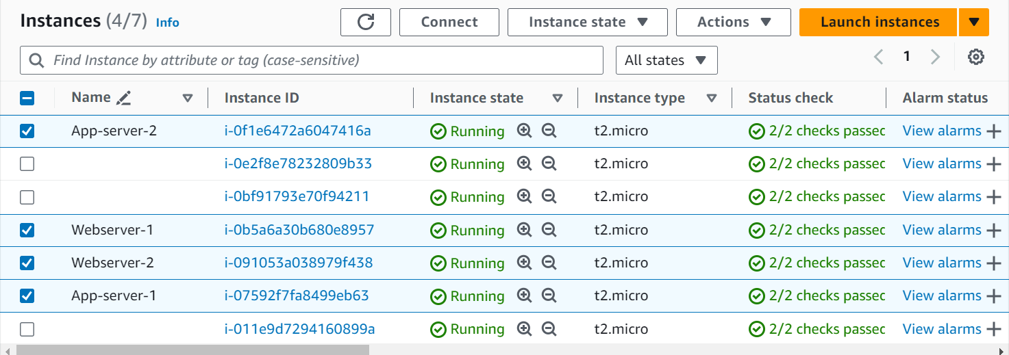

* Create Web tier(2 Public Web servers), App tier(2 Private servers)



* Create RDS and attach Private EC2 to RDS Database.

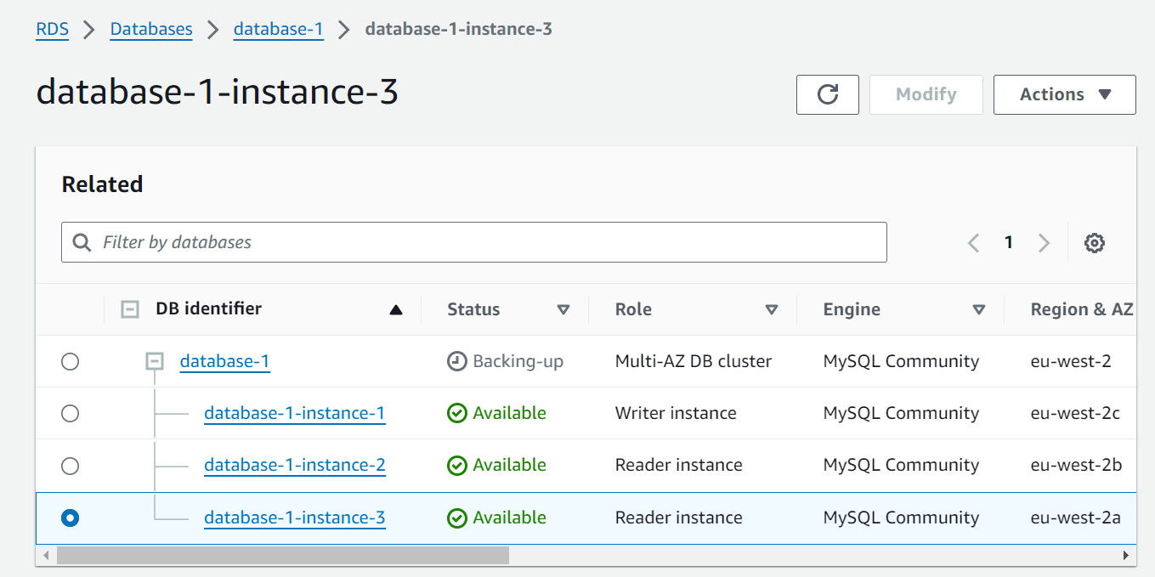

* Login to Public EC2 server connect from Public server to private server And install My sql in private server.
* Copy endpoint url and login into database in private server.

.

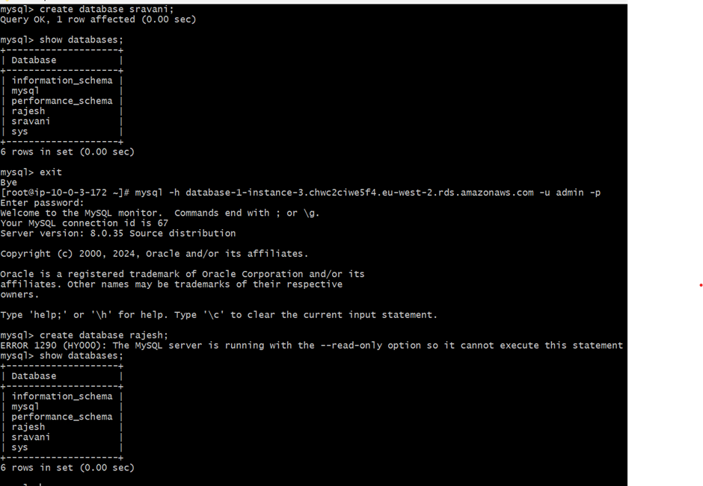

* Create AMI and Launch Template for Public and Private servers

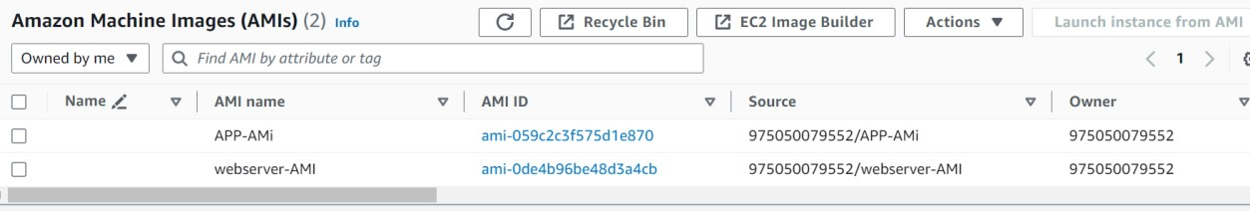

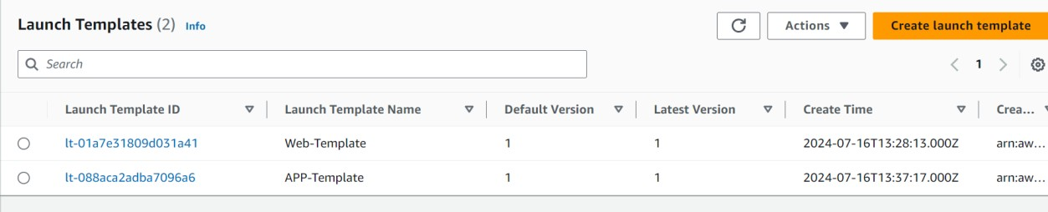

* Create 2 target Groups and Create 2 Application Load balancer for External and internal Layer, attach 2 Public Ec2 server mention pending as below.

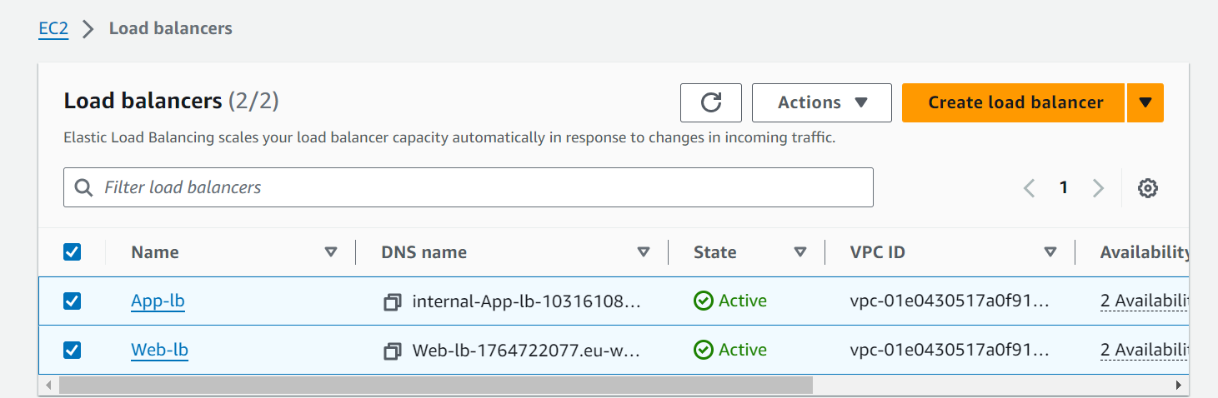

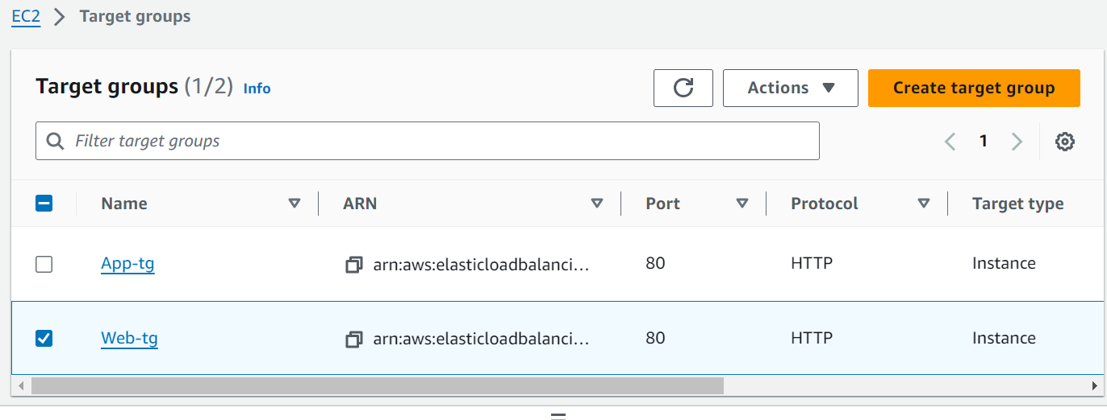

* Create Web Autoscaling group and App Autoscaling group and test the result. New EC2 instances are creating as per below image.

