SIMATS ENGINEERING (SAVEETHA SCHOOL OF ENGINEERING)
Department of Artificial Intelligence and Data Science
ASSESSMENT TOOL 2 – Technical Presentation

Course Code: | DSA03 | Course Title: | Natural Language Processing
CO Assessed: | CO1 – Imitation (L1) | Assessment: | Assessment Tool 2 – Technical Presentation
Weightage: | 30% of CIA
CO1 Statement: | Analyse NLP models, regular expression patterns, finite state automata, morphological processing techniques and to interpret language processing. (BL-3)
Student Name: | I. Leela Sravan Kumar | Reg. No.: | 192425272
Section / Batch: | AIML | Date: | 16-07-2026

Code of Conduct
I I. Leela Sravan Kumar (192425272) (Name / Reg No) certify that this submission is my original work and that I have adhered to the guidelines specified for this assessment. I understand that any violation of academic integrity rules will result in disciplinary action.
Signature of the Student: _________________________

Instructions
- Suggested Team Member Roles (3 Members)
- Member 1: Theory, Concepts, and Literature Review
- Member 2: Algorithm Design, Models, and Technical Analysis
- Member 3: Demonstration, Case Study, Applications, and Conclusion
- GPS photo must submit.
- Duration: 30 minutes.

Section / Topic | Focus | Q Nos
Evolution of Natural Language Processing: From Rule-Based Systems to Modern NLP | NLP Models, Language Processing Evolution | TP-01
Comparative Study of NLP Models and Algorithms | Model Analysis, Algorithm Comparison | TP-02
Regular Expressions for Real-World Text Processing | Pattern Matching, Information Extraction | TP-03
Designing Efficient Regular Expression Patterns for Information Extraction | Text Mining, Data Extraction Techniques | TP-04
Finite State Automata in Natural Language Processing | State Transitions, Language Recognition | TP-05
Building a Finite State Automaton for Token Recognition | Lexical Analysis, Token Validation | TP-06
Morphology and Word Formation in Natural Languages | Morpheme Analysis, Word Structure Processing | TP-07
Inflectional Morphology: Understanding Grammatical Variations | Grammatical Analysis, Word Normalization | TP-08
Derivational Morphology and Vocabulary Expansion | Word Generation, Semantic Transformation | TP-09
Comparative Analysis of Inflectional and Derivational Morphology | Morphological Classification, Language Analysis | TP-10
Finite-State Morphological Parsing Techniques | Morphological Parsing, Finite-State Processing | TP-11
Morphological Analysis for Indian Languages | Language-Specific Morphology, NLP Challenges | TP-12
Porter Stemmer: Design, Working Mechanism, and Applications | Stemming Algorithms, Text Preprocessing | TP-13
Stemming vs Morphological Parsing: A Comparative Study | Word Reduction, Morphological Processing | TP-14
Integrated NLP Pipeline: From Regular Expressions to Morphological Processing | End-to-End Language Processing Pipeline | TP-15

Annexure A – Technical Presentation
Team No. | Technical Presentation Title | Description
1 | Evolution of Natural Language Processing: From Rule-Based Systems to Modern NLP | Analyze the historical development of NLP models, key milestones, and how language processing has evolved from handcrafted rules to intelligent systems.
2 | Comparative Study of NLP Models and Algorithms | Explore different NLP models and algorithms used for language processing, comparing their working principles, strengths, and limitations.
3 | Regular Expressions for Real-World Text Processing | Demonstrate how regular expressions are used for data validation, text extraction, log analysis, and information retrieval in practical applications.
4 | Designing Efficient Regular Expression Patterns for Information Extraction | Analyze complex regular expression patterns used to extract emails, phone numbers, URLs, dates, and structured information from unstructured text.
5 | Finite State Automata in Natural Language Processing | Explain the concepts of deterministic and non-deterministic finite automata and their role in lexical analysis and language recognition.
6 | Building a Finite State Automaton for Token Recognition | Design and demonstrate a finite state automaton that recognizes tokens such as identifiers, keywords, and numbers in textual data.
7 | Morphology and Word Formation in Natural Languages | Investigate how words are structured and formed using morphemes, and analyze the importance of morphology in NLP systems.
8 | Inflectional Morphology: Understanding Grammatical Variations | Examine how inflectional changes affect word forms based on tense, number, gender, and case across different languages.
9 | Derivational Morphology and Vocabulary Expansion | Analyze derivational processes that create new words and study their impact on semantic interpretation and language understanding.
10 | Comparative Analysis of Inflectional and Derivational Morphology | Compare the characteristics, applications, and challenges of inflectional and derivational morphology in NLP tasks.
11 | Finite-State Morphological Parsing Techniques | Explore finite-state transducers and parsing techniques used to analyze and generate morphological structures in natural languages.
12 | Morphological Analysis for Indian Languages | Study the challenges and solutions involved in performing morphological processing for morphologically rich Indian languages such as Tamil, Hindi, and Telugu.
13 | Porter Stemmer: Design, Working Mechanism, and Applications | Analyze the Porter Stemming algorithm, its rule-based approach, implementation steps, and role in information retrieval systems.
14 | Stemming vs Morphological Parsing: A Comparative Study | Compare stemming and morphological parsing techniques based on accuracy, computational complexity, and application scenarios.
15 | Integrated NLP Pipeline: From Regular Expressions to Morphological Processing | Demonstrate a complete NLP preprocessing pipeline incorporating regular expressions, finite state automata, stemming, and morphological analysis for text processing.

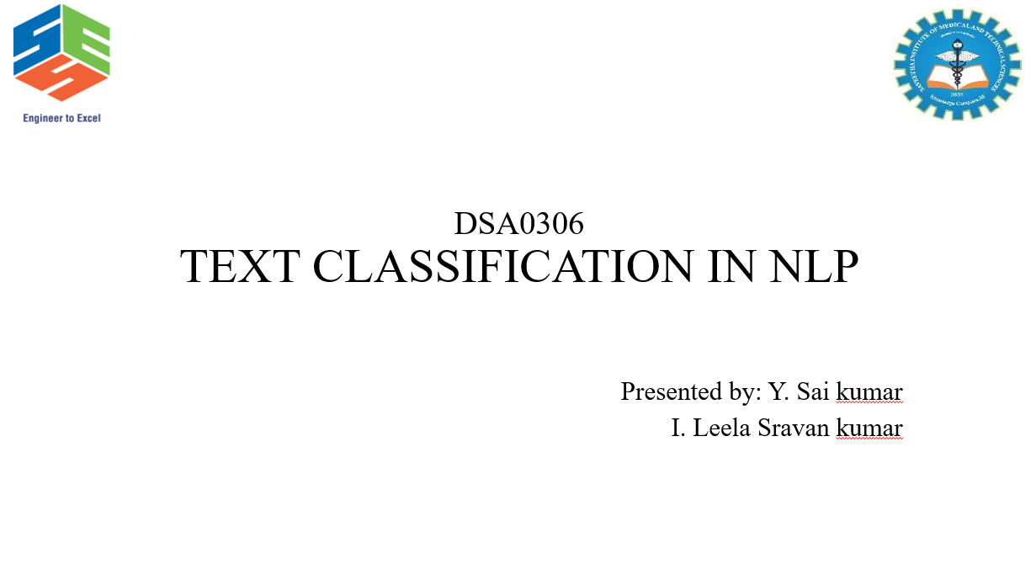
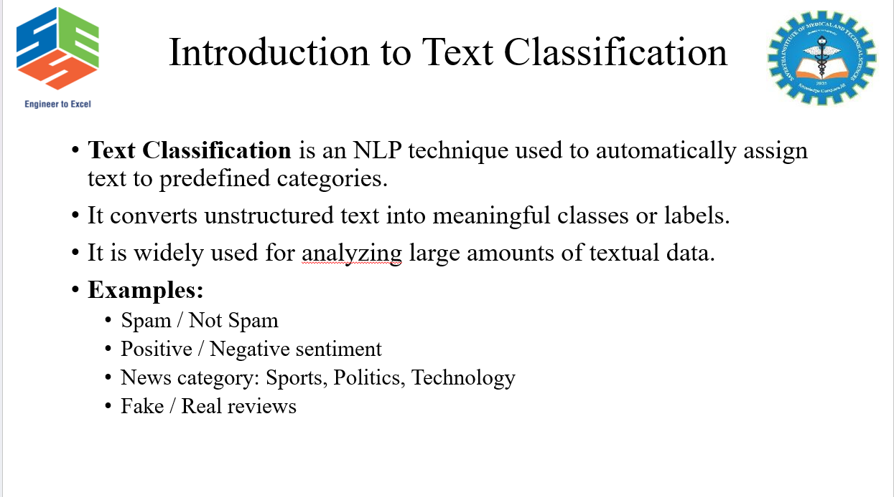
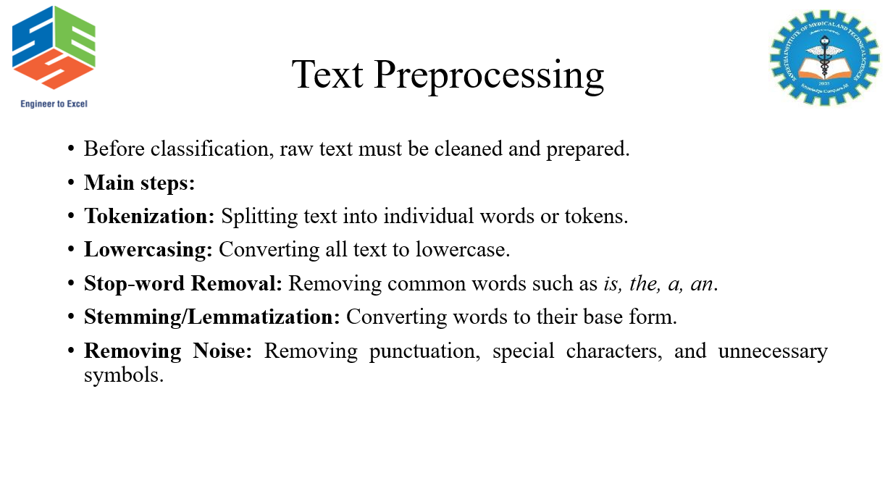
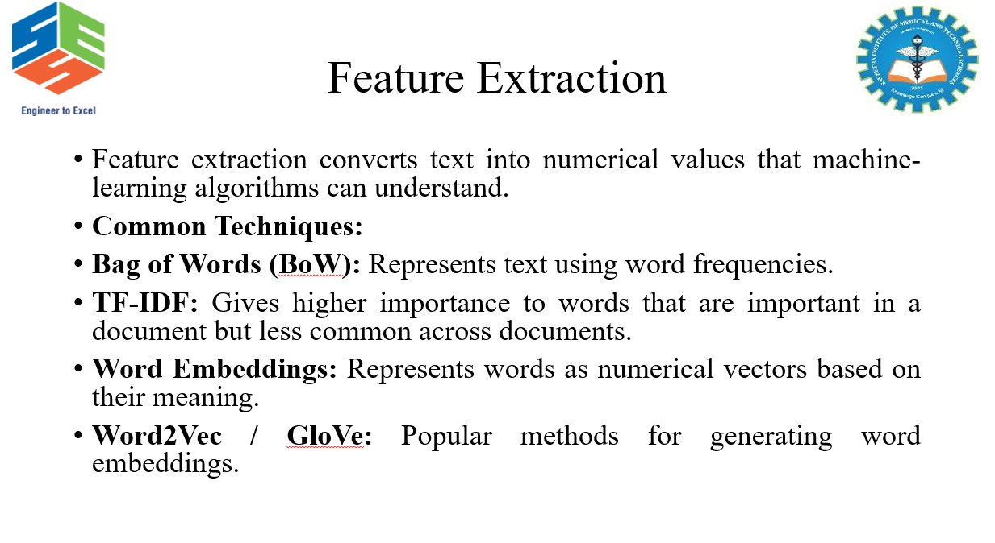
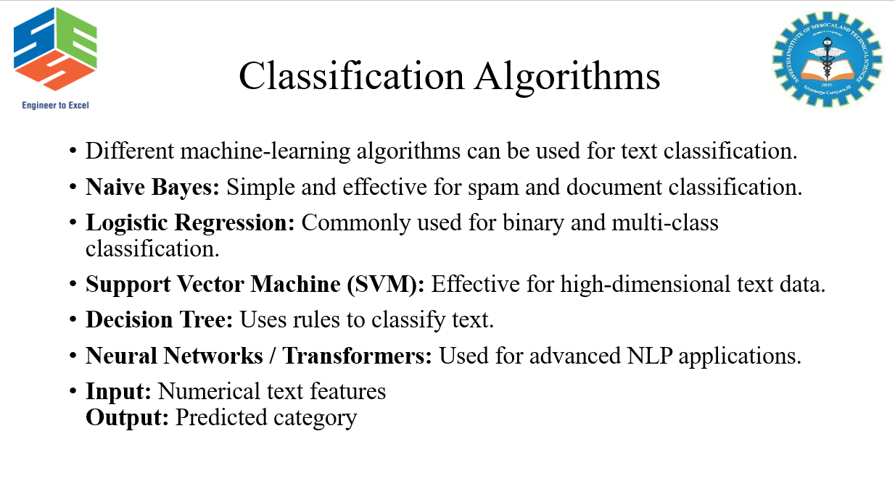
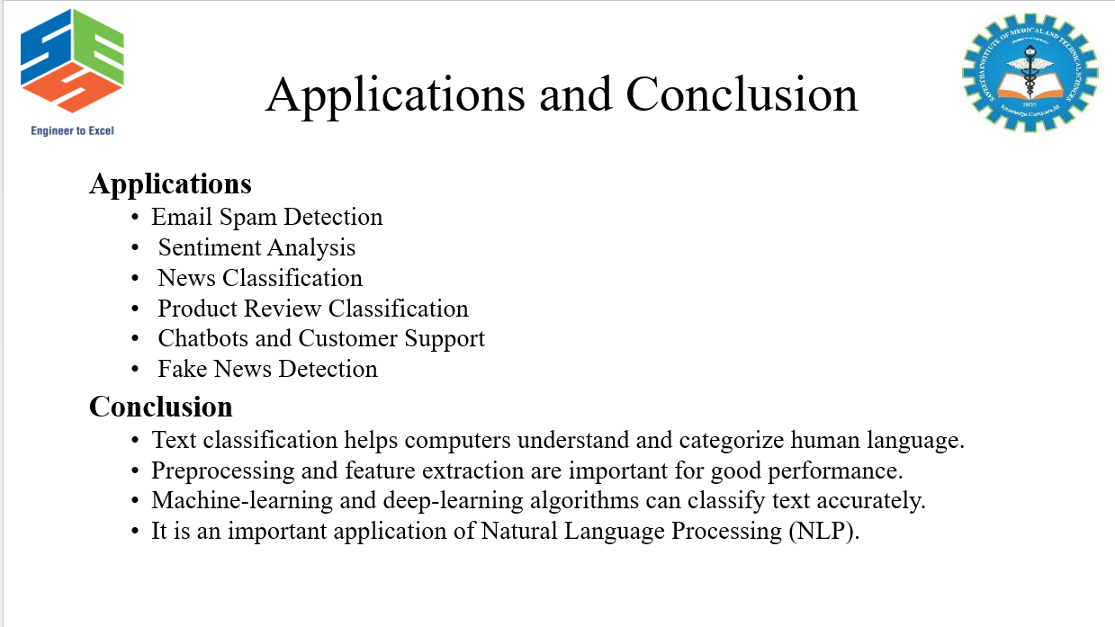

Geotag Photo:
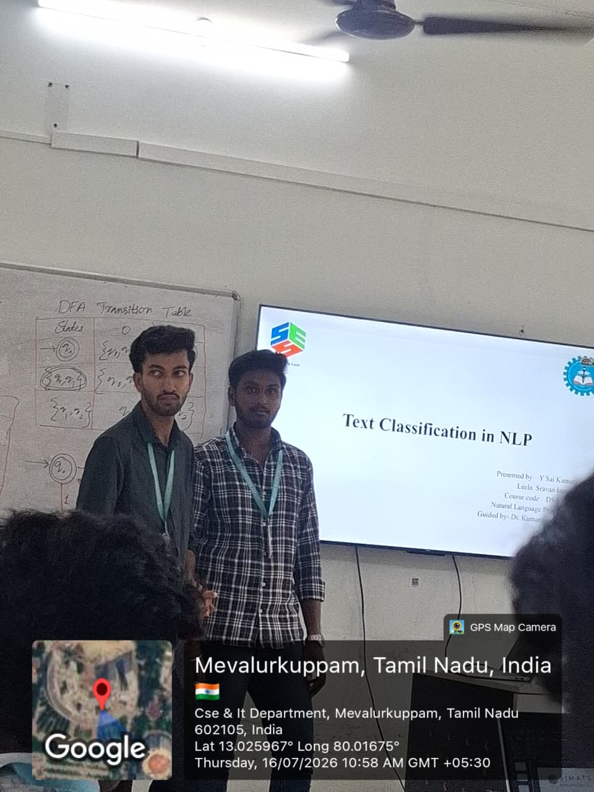

Rubrics for Calculation

Technical Presentation
Criteria | Weightage | Level 4 – Exemplary | Level 3 – Proficient | Level 2 – Developing | Level 1 – Beginning
Technical Content Accuracy | 30 | Highly accurate, in-depth, and insightful technical explanation | Technically correct content with adequate depth and clarity | Basic concepts presented with limited accuracy and depth | Content contains major technical errors; concepts poorly understood
Problem Identification | 25 | Problem rigorously analyzed using appropriate and advanced methods | Problem clearly defined with a logical engineering approach | Problem identified but analysis or methodology is weak | Problem statement unclear or incorrect; no logical approach
Use of Tools | 20 | Advanced tools, well-analyzed data, and highly effective visuals | Appropriate tools and data used effectively with clear visuals | Limited use of tools and basic data interpretation | Minimal or incorrect use of tools and data; poor visuals
Communication | 15 | Highly engaging, confident, and audience-focused delivery | Clear, organized, and professional communication | Understandable but lacks clarity, structure, or confidence | Poor organization, unclear speech, ineffective slides
Professionalism | 10 | Exemplary professionalism, leadership, and ethical awareness | Professional conduct with effective team collaboration | Basic professionalism; uneven team participation | Lacks professionalism; minimal contribution or ethical awareness

Team No. / Criteria Level | Technical Content Accuracy | Problem Identification | Use of Tools | Communication | Professionalism | Total %
17 | 22 | 19 | 20 | 12 | 10 | 83

Faculty In-charge | Course Coordinator | Program Director
Dr. Kumaragurubaran T
Signature: _______________ | Signature: _______________ | Signature: _______________
Date: ___________________ | Date: ___________________ | Date: ___________________

