SIMATS ENGINEERING (SAVEETHA SCHOOL OF ENGINEERING)
Department of Artificial Intelligence and Machine Learning

ASSESSMENT 2: GAME-BASED LEARNING (5 QUESTIONS)

Course Code: | MLA0407 | Course Title: | Deep Learning  Assessment 2: Game-Based Learning  (5 Questions × 10 Marks)
CO Assessed: | CO3 | Assessment:
Weightage: | 35% of CIA | Total Marks:
CO1 Statement: | Apply the fundamental concepts of machine learning and neural networks to design and analyze learning algorithms using perceptrons, multilayer perceptrons, forward propagation, backpropagation, gradient descent optimization techniques, and Maximum Likelihood Estimation for solving real-world problems.
Student Name: | I. Leela Sravan Kumar | Reg. No.: | 192425272  20.08.2026
Section / Batch: | AIML -2024 | Date:

Code of Conduct
I I. Leela Sravan Kumar (192425272) (NAME/ REG NO) certify that this submission is my original work and
that I have adhered to the guidelines specified for this assessment. I understand that any violation of academic integrity rules will result in disciplinary action. Signature of the Student: I. Leela Sravan Kumar

QUESTIONS: 5 Total Marks: 50

Annexure A

Game-Based Learning

Game Title: CNN Quest – The Image Intelligence Challenge Game Scenario:
Students act as AI Engineers responsible for building a CNN-based image classification system. They must complete different levels by correctly applying CNN concepts. Each level tests a different part of the CO3 syllabus.
Level 1 – CNN Fundamentals
- What is the primary purpose of a CNN in image processing, and how is it different from a traditional Artificial Neural Network (ANN)?
- Arrange the following CNN components in the correct order:
Convolution Layer → Pooling Layer → Fully Connected Layer → Input Image → Output/Classification.
- Identify the CNN component:
“I scan across an image and detect patterns such as edges and textures. I use the same set of weights at different locations.” Who am I?

Level 2 – Convolution & Filters
- A 5 × 5 image is processed using a 3 × 3 kernel with a stride of 1 and no padding.
What will be the size of the resulting feature map? Explain how you obtained the answer.
- A CNN uses different kernels to detect edges, curves, textures, and other patterns.
Explain why a CNN requires multiple filters instead of using only one filter throughout the network.
- Match the following:
Component | Function
Kernel | ?
Feature Map | ?
Stride | ?
Padding | ?
- Students must correctly match each component with its function.

Level 3 – Feature Map & Pooling Challenge
- A CNN produces a feature map containing strong activation values around the edges of an object.
What does this feature map tell us about the image, and why are feature maps important in CNNs?
- A 4 × 4 feature map is given below:
- 1 3 2 4 10. 5 6 1 2
- 7 2 8 3
4 5 6 9
Apply 2 × 2 Max Pooling with a stride of 2 and calculate the resulting feature map.
- Max Pooling vs Average Pooling:
Students are given different scenarios and must choose which pooling method would be more appropriate and justify their choice.
Level 4 – CNN Architecture Challenge
10. A CNN model performs extremely well on training images but gives poor results on new images.
Identify the problem and select the most appropriate solution from the following:
- Increase overfitting
- Remove all training data
- Use regularization/data augmentation
- Increase the image noise Explain your choice.
- Parameter Sharing Puzzle:
A convolution filter contains 9 weights and is applied across different regions of an image. Explain how the same 9 weights can be reused at different locations and why this significantly reduces the number of parameters in a CNN.

Level 5 – Architecture Battle: AlexNet vs ResNet
- Students are shown two simplified CNN architectures and must identify which represents AlexNet and which represents ResNet.
- AlexNet vs ResNet Challenge:
Match the characteristics with the correct architecture:
- Introduced residual/skip connections
- Famous for ImageNet performance
- Helps solve vanishing-gradient problems in deep networks • Uses a relatively deep CNN architecture for its time 14. Scenario Challenge:
You are given a complex image-classification problem requiring a very deep CNN.
Would you choose AlexNet or ResNet? Why?
Students must provide a justification based on architecture and training considerations.

Level 6 – CNN Real-World Mission
15. Students are given different applications:
- Face Recognition
- Self-Driving Cars
- Medical Image Diagnosis
- Handwritten Digit Recognition
- Object Detection
- Agricultural Disease Detection
Match each application with the image-processing task performed by CNNs.
16. Final Boss Challenge :
Design a basic CNN architecture for a cat-vs-dog image classification system. Students must specify:
- Input image
- Number/type of convolution layers
- Filters
- Pooling layers
- Fully connected layer
- Output layer
- Classification result

COMPLEX QUESTION 1 – FULLY CONNECTED LAYER Problem

A fully connected neural network receives an input vector of 120 features and passes it through three dense layers:
- FC1: 120 → 80 neurons
- FC2: 80 → 40 neurons
- FC3: 40 → 10 neurons Each neuron has one bias.

1. Calculate the Total Number of Trainable Parameters A fully connected layer connects every neuron in one layer to every neuron in the next layer. Network Structure

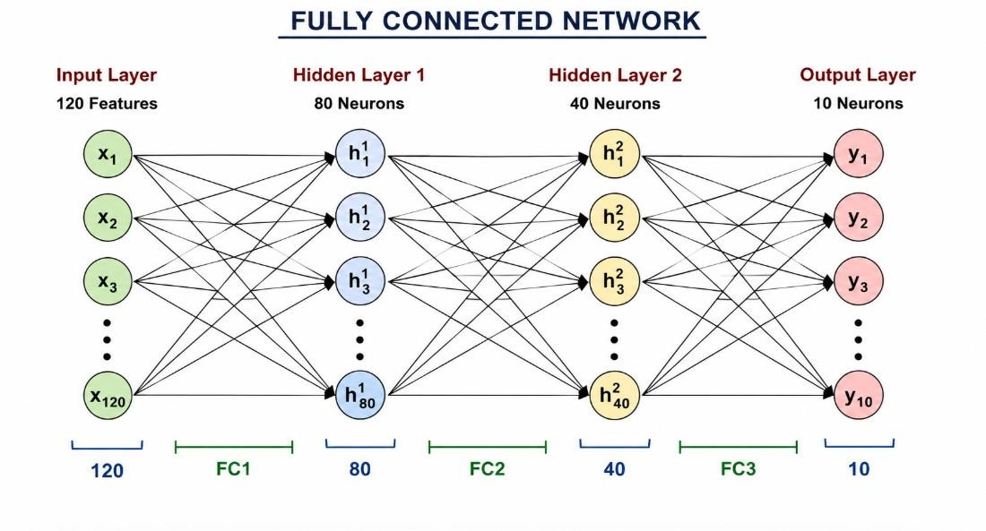

Every input is connected to every neuron

Formula
Number of parameters:
Parameters = Weights + Biases Weights:
Weights = Number of inputs × Number of neurons Biases:
Biases = Number of neurons

FC1: 120 → 80 Weights: 120 × 80 = 9,600 Biases:
80
Therefore:
FC1 Parameters = 9,600 + 80 = 9,680

FC2: 80 → 40 Weights: 80 × 40 = 3,200 Biases:
40
Therefore:
FC2 Parameters = 3,200 + 40 = 3,240

FC3: 40 → 10 Weights: 40 × 10 = 400 Biases:
10
Therefore:
FC3 Parameters = 400 + 10 = 410

Total Parameters
Total = 9,680 + 3,240 + 410 = 13,330
Therefore:

TOTAL TRAINABLE PARAMETERS = 13,330

2. Number of Multiplications and Additions
During a forward pass, each connection performs a multiplication.
FC1
120 × 80 = 9,600 multiplications
FC2
80 × 40 = 3,200 multiplications

FC3
40 × 10 = 400 multiplications Therefore:
Total multiplications:
9,600 + 3,200 + 400

= 13,200 multiplications

Additions
The weighted inputs must be added together.
Ignoring bias:
- FC1 = 9,600 additions
- FC2 = 3,200 additions
- FC3 = 400 additions
Total = 13,200 additions
There are also 130 bias additions: 80 + 40 + 10 = 130 Therefore:
Total additions including bias:
13,200 + 130

= 13,330 additions Summary Layer Multiplications Additions
FC1 9,600 | 9,680
FC2 3,200 | 3,240
FC3 400 | 410
TOTAL 13,200 | 13,330

3. FC2 Changed from 40 to 60 Neurons The new architecture becomes: 120 Inputs
│
▼
80 Neurons
│
▼
60 Neurons
│
▼
10 Neurons
Changing FC2 affects both FC2 and FC3, because FC3 now receives 60 inputs instead of 40.

FC1: 120 → 80 Parameters:
(120 × 80) + 80 = 9,680

FC2: 80 → 60 Parameters:
(80 × 60) + 60
= 4,800 + 60 = 4,860

FC3: 60 → 10 Parameters:
(60 × 10) + 10
= 600 + 10 = 610

New Total
9,680 + 4,860 + 610 = 15,150 Therefore:

NEW TOTAL TRAINABLE PARAMETERS = 15,150
Increase: 15,150 − 13,330

= 1,820 additional parameters

4. Effect of Increasing FC2 Neurons
Increasing the neurons from 40 to 60 increases the capacity of the neural network. FC2: 40 Neurons
↓
Smaller Model
↓
Less computation
↓
Lower memory usage

FC2: 60 Neurons
↓
Larger Model
↓
More parameters
↓
More computation
↓
Higher memory usage
↓
Can learn more complex patterns
↓
Higher risk of overfitting

Advantages
- Can learn more complex relationships.
- Provides greater model capacity.
- May improve accuracy if the original network was underfitting.

Disadvantages
- More parameters.
- More computation.
- More memory required.
- Training can take longer.
- Increased risk of overfitting.

Conclusion
Changing FC2 from 40 to 60 neurons increases the parameters from 13,330 to 15,150. The larger network can learn more complex patterns, but regularization techniques such as Dropout and L2 regularization may be required to control overfitting.

COMPLEX QUESTION 2 – PARAMETER SHARING Problem

A CNN processes an RGB image of size:
64 × 64 × 3 It uses:
- Number of filters = 32
- Filter size = 5 × 5
- Stride = 1
- Padding = 0

1. Calculate Trainable Parameters Using Parameter Sharing Because the input is an RGB image, it has 3 channels.
Therefore, each filter must have depth 3.

One Filter
RGB Image
┌─────────────┐
│ R G B │
│ │
│ 5 × 5 │
│ Filter │
│ │
└─────────────┘

Filter Size = 5 × 5 × 3 Number of weights:
5 × 5 × 3 = 75
Each filter also has one bias.
Therefore:
- + 1 = 76 parameters per filter For 32 filters:
- × 32
= 2,432 Therefore:

TOTAL TRAINABLE PARAMETERS = 2,432

2. Calculate Output Feature Map Dimensions Formula:
Output Size = ((Input Size − Filter Size) / Stride) + 1 Substitute the values:
Output Size = ((64 − 5) / 1) + 1
= 59 + 1
= 60
So each filter produces a:

60 × 60 feature map
Since there are 32 filters: Output = 60 × 60 × 32

Visual Explanation
Input Image
64 × 64 × 3
│
│ 5 × 5 Filter ▼
┌─────────────────┐
│ │
│ Feature Map │
│ 60 × 60 │
│ │
└─────────────────┘
│
│
32 Filters
│
▼
60 × 60 × 32
Output

3. Total Number of Neuron Activations Output dimensions: 60 × 60 × 32 Therefore:
60 × 60 = 3,600
3,600 × 32 = 115,200
Therefore:

TOTAL NEURON ACTIVATIONS = 115,200

4. Parameters Without Parameter Sharing
In a CNN, the same filter is normally reused at different spatial locations.
This is called parameter sharing.
Without parameter sharing, every spatial location would have its own separate set of weights.

Number of Spatial Locations
60 × 60
= 3,600 locations
Each location requires: 5 × 5 × 3 = 75 weights Plus 1 bias:
75 + 1 = 76 parameters Therefore:
3,600 × 76

= 273,600 parameters

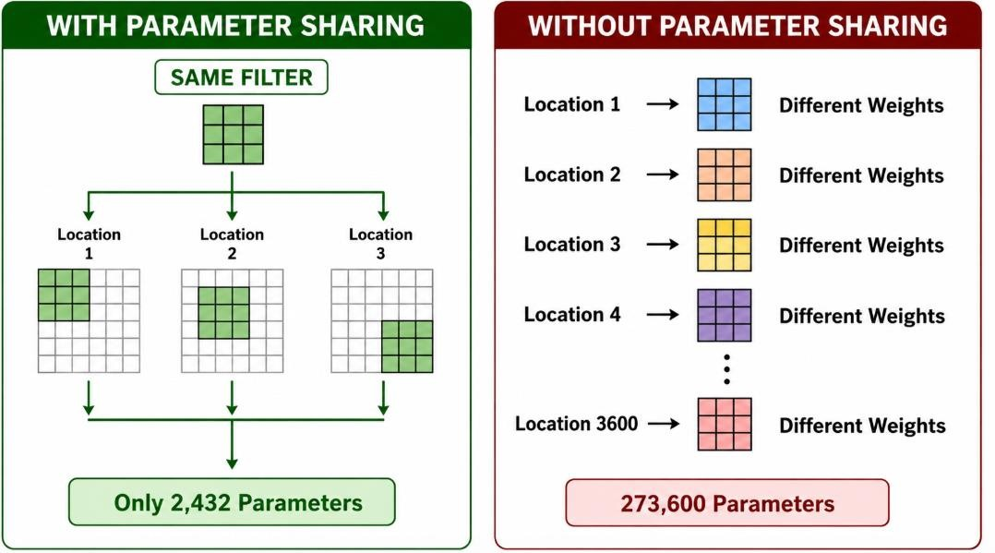

Comparison Diagram

5. Comparison of Both Approaches
Feature | With Parameter Sharing | Without Parameter Sharing
Parameters | 2,432 | 273,600
Memory | Low | Very High
Computation | Efficient | More Expensive
Training | Faster | Slower
Overfitting | Lower | Higher
Generalization | Better | Lower
Feature Detection | Same feature anywhere | Location-specific

Memory Usage
Parameter sharing requires only 2,432 trainable parameters, while no parameter sharing requires 273,600 parameters.
Therefore, parameter sharing greatly reduces memory requirements.

Computational Efficiency
With parameter sharing, the same filter is reused throughout the image. One Filter
↓
Location 1
Location 2
Location 3
Location 4
...
Location 3600
This makes CNNs much more efficient than assigning separate parameters to every location.

Generalization
Parameter sharing allows the network to recognize the same feature regardless of where it appears in the image. For example:
Edge on left side → Detected
Edge in center → Detected Edge on right side → Detected
The same filter can detect the edge in all these locations.
This improves generalization and reduces the risk of overfitting.

FINAL CONCLUSION

Fully Connected Network
The original network contains:
13,330 trainable parameters
After changing FC2 from 40 to 60 neurons:

15,150 trainable parameters
The increase improves model capacity but also increases computation and overfitting risk.
CNN Parameter Sharing With parameter sharing:
2,432 parameters
Without parameter sharing:

273,600 parameters
Thus, parameter sharing is one of the major reasons CNNs are efficient. It significantly reduces the number of parameters, memory usage, and overfitting while allowing the same feature detector to work across different locations of an image.

Rubrics for Calculation

Criteria | Weightage | Level 4 (Exemplary) | Level 3 (Proficient) | Level 2 (Developing) | Level 1 (Beginning)
Technical Content  Accuracy | 30 | Highly accurate, indepth, and  insightful technical explanation | Technically correct content  with adequate depth and clarity | Basic concepts presented with  limited accuracy and depth | Content contains major technical  errors; concepts poorly understood
Problem  Identification | 25 | Problem rigorously analyzed using  appropriate and advanced methods | Problem clearly defined with a logical  engineering approach | Problem  identified but analysis or  methodology is weak | Problem statement unclear or incorrect; no logical approach
Use of Tools | 20 | Advanced tools, wellanalyzed data, and highly effective visuals | Appropriate tools and data  used effectively with clear visuals | Limited use of tools and basic data  interpretation | Minimal or incorrect use of tools and data; poor visuals
Communication | 15 | Highly engaging, confident, and  audience-focused delivery | Clear, organized, and professional communication | Understandable but lacks clarity, structure, or confidence | Poor organization,  unclear speech, ineffective slides
Professionalism | 10 | Exemplary professionalism, leadership, and ethical awareness | Professional conduct with  effective team collaboration | Basic professionalism;  uneven team participation | Lacks professionalism; minimal  contribution or ethical  awareness

Faculty In-charge | Course Coordinator | Program Director
Signature: | Signature: | Signature:
Date: | Date: | Date:

