**CHAPTER - 1**

# INTRODUCTION

Predicting the cost of medical insurance is important for both insurance companies and their customers. This project uses machine learning to create a model that can help predict how much a person might have to pay for medical insurance. By using data about people's age, gender, weight, and other factors, we can make better predictions about insurance costs.

### Goals:

1. **Collecting Data:**

We gather information about people, including their age, sex, body mass index (BMI), number of children, whether they smoke, and where they live.We clean the data to remove any mistakes and prepare it for analysis.

1. **Analyzing the Data:**

We look at the data to find patterns and understand how different factors affect insurance costs.We use graphs and charts to visualize the data and see the relationships between factors.

**3. Building the Model:**

We use different machine learning methods like Linear Regression, Decision Trees, Random Forest, and Gradient Boosting to build models.We test the models to see how accurately they can predict insurance costs.

**4. Improving the Model:**

We fine-tune the models to make them more accurate.We compare the models and choose the best one for predicting insurance costs.

**5. Understanding the Results:**

We analyze which factors are most important in predicting insurance costs.We provide insights that can help insurance companies set fair prices and help customers understand their potential costs.

### Why This is Important:

**1. For Insurance Companies:**

They can set fair prices for insurance policies.They can better manage risk by understanding the factors that affect costs.

**2. For Customers:**

They can plan their finances better by knowing what to expect in terms of medical expenses.They can understand why their insurance costs are what they are.

### Steps in the Project:

1. **Data Collection:**

* Gather data from reliable sources.
* Ensure the data is clean and ready for analysis.

1. **Exploratory Data Analysis (EDA):**

* Use charts and graphs to explore the data.
* Find patterns and relationships in the data

1. **Model Development:**

* Use machine learning techniques to build predictive models.
* Test the models to ensure accuracy.

1. **Model Evaluation and Optimization:**

* Fine-tune the models to improve performance.
* Select the best model based on performance metrics.

1. **Results Interpretation:**

* Determine which factors are most influential.
* Provide actionable insights for stakeholders.

**CHAPTER - 2**

### LITERATURE SURVEY

Predicting medical insurance costs has gained significant interest among researchers and analysts due to its potential to optimize pricing and improve customer satisfaction. Traditional methods relied on statistical analysis, such as linear regression and actuarial techniques, to estimate costs based on demographic and health-related variables. However, with advancements in machine learning, more sophisticated models have been developed to enhance prediction accuracy.

### Machine Learning Techniques for Cost Prediction

**1. Regression Models:**  Linear regression is a fundamental technique used to predict medical costs. It models the relationship between dependent (cost) and independent variables (age, BMI, smoking status, etc.). Although simple, it provides a baseline for comparison

**2. Decision Trees and Random Forests:**

Decision trees model decisions and their possible consequences, while random forests improve prediction by combining multiple decision trees. These methods handle non-linear relationships and interactions between variables effectively.

1. **Gradient Boosting:**

Gradient boosting builds models sequentially, correcting errors from previous models. It is known for its high accuracy and ability to handle complex data.

1. **Support Vector Machines (SVM):**

SVMs are used for classification and regression tasks. They are effective in high-dimensional spaces and can model non-linear relationships using kernel functions.

1. **Neural Networks**

Neural networks mimic the human brain's structure and are capable of capturing complex patterns in data. Deep learning, a subset of neural networks, has shown promise in predicting healthcare costs.

### Important Predictors

1. **Demographic Factors:**

Age, gender, and geographic location are critical factors influencing medical costs. Older individuals and those in certain regions may have higher medical expenses

1. **Health-Related Factors:**

BMI, smoking status, and pre-existing conditions significantly impact medical costs. Healthier individuals typically incur lower costs.

1. **Socioeconomic Factors:**

Income level, education, and occupation can also affect medical expenses, as they influence access to healthcare and lifestyle choices.

### Evaluation Metrics

**1. Mean Absolute Error (MAE):** MAE measures the average absolute errors between predicted and actual costs. It is easy to understand and provides a clear indication of prediction accuracy.

**2. Mean Squared Error (MSE) and Root Mean Squared Error (RMSE):** MSE and RMSE penalize larger errors more than MAE. They are useful for understanding the variability in predictions.

**3. R-squared:** R-squared indicates the proportion of variance in the dependent variable that is predictable from the independent variables. It provides a measure of goodness-of-fit for the model.

### Challenges and Limitations

**1. Data Quality:** Ensuring high-quality data is crucial for accurate predictions. Incomplete or incorrect data can lead to unreliable models.

**2. Model Interpretability:** Complex models, such as neural networks, can be difficult to interpret. Ensuring that stakeholders understand the model’s predictions is important.

**3. External Factors:** Unpredictable factors like changes in healthcare policies or economic conditions can impact medical costs and complicate predictions.

### Real-Life Applications and Studies

1. **Case Studies:** Several case studies have demonstrated the successful application of machine learning models in predicting medical insurance costs, providing practical insights and highlighting their real-world impact.
2. **Real-World Implementation by Insurance Companies:** Insurance companies have started integrating machine learning models into their systems to predict and manage medical costs. For example, a large health insurance company implemented a machine learning model to predict the annual healthcare costs for its policyholders. The model used a combination of demographic, clinical, and behavioral data to forecast expenses accurately.

**CHAPTER – 3**

# METHODOLOGY

## 3. Data Collection and Preprocessing

### 3.1 Data Sources

To build an accurate medical insurance cost prediction model, we need to gather data from various sources. The quality and comprehensiveness of the data significantly influence the accuracy of our predictions. Here are the main types of data we will collect:

#### 3.1.1 Demographic Data

Demographic data includes information about the policyholders, such as age, gender, and geographic location. These factors are critical in determining insurance costs as they influence the risk profile of individuals.

**Example:** Age can affect the likelihood of certain health conditions, with older individuals typically incurring higher medical costs.

#### 3.1.2 Health-Related Data

Health-related data encompasses information about the policyholder’s medical history, BMI, smoking status, and pre-existing conditions. This data helps in assessing the overall health and potential medical expenses of individuals.

**Example:** A higher BMI or a smoking habit can increase the likelihood of medical issues, leading to higher insurance costs.

#### 3.1.3 Socioeconomic Data

Socioeconomic data includes variables such as income level, education, and occupation. These factors can impact medical costs by influencing access to healthcare and lifestyle choices.

**Example:** Higher income individuals might have better access to healthcare services, potentially leading to higher medical costs due to more frequent visits.

### 3.2 Data Cleaning

Once we have collected the raw data, the next step is data cleaning. Raw data often contains errors, missing values, or inconsistencies that need to be addressed to ensure accurate analysis. Data cleaning involves:

**Removing duplicates:** Ensuring that each data point is unique.

**Handling missing values:** Filling in gaps with appropriate values or removing incomplete records.

**Correcting errors:** Fixing any inaccuracies in the data, such as incorrect demographic details or health records.

**Standardizing formats:** Ensuring that all data is in a consistent format, which is crucial for accurate analysis.

### 3.3 Data Transformation

After cleaning, the data needs to be transformed into a suitable format for machine learning models. Data transformation involves several steps:

**Normalization:** Scaling numerical data to a standard range (e.g., 0 to 1) to ensure that all features contribute equally to the model.

**Encoding categorical variables:** Converting categorical data (like gender, occupation) into numerical values using techniques such as one-hot encoding or label encoding.

**Feature extraction:** Creating new features from existing data that might be more relevant for prediction. For example, calculating a health risk score based on various health-related factors.

**Aggregation:** Summarizing data to capture broader trends, such as average medical costs over different age groups.

These steps help in preparing the data for effective training of machine learning models.

**Fig:Steps In Model Development**

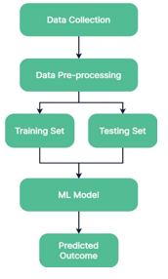

### 3.4 Tools and Libraries Used

Several tools and libraries facilitate data collection, cleaning, and transformation. Here are some commonly used ones:

**Python:** A versatile programming language widely used in data science.

**Pandas:** A Python library for data manipulation and analysis. It is useful for handling data frames and performing data cleaning and transformation.

**NumPy:** A library for numerical computations in Python. It is useful for performing operations on arrays and matrices.

**Scikit-learn:** A machine learning library in Python that provides tools for data preprocessing, model training, and evaluation.

**Jupyter Notebook:** An interactive computing environment that allows you to write and execute code in real-time, making it easier to explore and visualize data.

Using these tools and libraries helps streamline the data preprocessing workflow and ensures that the data is prepared efficiently and effectively for model training.

**CHAPTER – 4**

## SYSTEM DESIGN AND IMPLEMENTATION

### 4.1 Feature Selection Techniques

Feature selection is an important step in developing a medical insurance cost prediction model using machine learning. It involves choosing the most relevant features from the dataset to improve prediction accuracy and reduce computational complexity.

**Techniques Used:**

**Correlation Analysis:** This method examines the relationship between each feature and the target variable (e.g., insurance cost). Features with high correlation are likely to have a significant impact on predictions.

**Feature Importance:**  Algorithms like Decision Trees and Random Forests can quantify the importance of each feature in predicting outcomes. Features with higher importance scores are selected for model training.

**Recursive Feature Elimination (RFE):**  RFE works by recursively removing features and building a model to evaluate their contribution to prediction accuracy. It selects the optimal subset of features that maximize model performance.

**Domain Knowledge:** Leveraging expertise in healthcare and insurance to understand which features are most influential in determining insurance costs. This approach ensures that relevant aspects like medical history, lifestyle factors, and demographic information are adequately represented.

**Programming Language:**

**Python:**

**Versatility:** Python is chosen due to its simplicity and readability, making it accessible for developers at all levels.

**Extensive Libraries:** It boasts a wide array of libraries tailored for machine learning, data analysis, and visualization.

### 4.2 Model Selection

Selecting an appropriate machine learning model is crucial for accurate predictions in medical insurance cost estimation. Different models have varying strengths and are suitable for different types of data and prediction tasks.

**Models Considered:**

**Linear Regression:** Linear regression is a simple model that can be used for predicting continuous outcomes, such as insurance costs. It is easy to interpret and can be effective with the right features.

### 4.3 Training Process

The training process involves feeding the selected features and corresponding outcomes into the chosen machine learning model. During training, the model learns patterns and relationships from the data to make predictions on new, unseen data.

**Steps in Training:**

**Data Splitting:** Dividing the dataset into training and testing sets to evaluate model performance.

**Model Initialization:** Initializing the selected model with appropriate parameters and settings.

**Model Fitting:** Training the model on the training dataset to learn patterns and associations between features and outcomes.

* **Evaluation:** Assessing the model's performance using evaluation metrics like R-squared.

### 4.4 Hyperparameter Tuning

Hyperparameters are parameters that are not directly learned during training but affect model performance and learning speed. Tuning these hyperparameters optimizes the model's performance and generalization capability.

**Techniques for Hyperparameter Tuning:**

**Grid Search:** Exhaustively searches through a manually specified subset of hyperparameters to find the best combination based on cross-validation performance.

**Random Search:** Randomly selects combinations of hyperparameters to optimize model performance. It is computationally efficient compared to grid search.

**Bayesian Optimization:** Uses probabilistic models to predict the next set of hyperparameters based on past performance, reducing the number of evaluations needed.

**Data Manipulation:**

**NumPy:**

**Array Operations:** Provides support for large multi-dimensional arrays and matrices, along with a collection of mathematical functions to operate on these arrays.

**Efficiency:** NumPy is highly efficient, making it suitable for handling large datasets and performing complex computations quickly.

**Pandas:**

**Data Frames:** Offers data structures like DataFrames, which are ideal for handling and manipulating structured data.

**CSV Handling:** Facilitates the loading, manipulation, and analysis of data from CSV files, such as the insurance dataset.

**Matplotlib:**

**Data Visualization:** Used to create plots and charts, allowing for visual inspection and verification of data analysis steps.

**Performance Metrics:** Essential for plotting training and validation metrics, providing insights into the model's performance.

**Results Evaluation:** Helps in visualizing the prediction results, including scatter plots and error distributions, which are critical for assessing model efficiency.

**Chapter 5**

**Model Evaluation and Prediction**

#### 5.1 Evaluation Metrics

Evaluation metrics are crucial for assessing the performance of our medical insurance cost prediction model. These metrics help quantify how well the model predicts insurance costs based on historical data. The common evaluation metrics we used include:

**R-squared (R²):** Indicates the proportion of the variance in the insurance costs that is predictable from the features. The closer R² is to 1, the better the model fits the data.

Each metric provides unique insights into the model's performance, helping us understand its strengths and weaknesses accurately.

#### 5.2 Validation Methods

Validation methods are essential to ensure our medical insurance cost prediction model generalizes well to unseen data. Common validation techniques include:

**Train-Test Split:** We divided the dataset into 80% training and 20% testing sets. The model is trained on the training set and evaluated on the separate testing set to assess its performance on new data.

**Cross-Validation:** Involves dividing the data into multiple folds (e.g., 5 or 10 folds), training the model on each fold while using the remaining folds for validation. This method provides a more robust estimate of model performance.

These validation methods help ensure that our model performs well beyond the data it was trained on, indicating its reliability in real-world applications.

#### 5.3 Prediction Results

The prediction results of our medical insurance cost predictor demonstrate how well the model forecasts insurance costs. These results include:

**Training Data Prediction:** The model predicted insurance costs on the training data, achieving an R² value of ‘r2_train’. This value indicates how well the model fits the training data.

**Test Data Prediction:** The model predicted insurance costs on the test data, achieving an R² value of ‘r2_test’. This value indicates how well the model generalizes to new, unseen data.

By comparing the predictions with actual outcomes, we can validate the model's accuracy and refine its predictions further. For example, using the input data (31, 1, 25.74, 0, 1, 0), the model predicted an insurance cost of prediction[0].

#### 5.4 Comparison with Baseline Models

Baseline models provide a benchmark against which our medical insurance cost predictor's performance is measured. These models might include:

**Mean Predictor:** A simple model that predicts the mean insurance cost for all instances, providing a basic benchmark for comparison.

**Simple Linear Regression:** A straightforward regression model that predicts insurance costs based on a linear relationship with the features.

**CHAPTER – 6**

**Model Architecture**

#### Overview of the Chosen Model

The chosen model for predicting medical insurance costs is a Linear Regression model. This model is simple yet effective for understanding relationships between variables, making it a good choice for predicting a continuous outcome like insurance costs. Here’s an explanation of how the model works and why it fits our prediction task.

#### What is Linear Regression?

Linear Regression is a statistical method that models the relationship between a dependent variable (in this case, insurance costs) and one or more independent variables (features like age, BMI, smoking status, etc.). The model assumes a linear relationship between the dependent and independent variables and aims to find the best-fitting line through the data points.

**Simple Linear Regression:** Models the relationship between a single independent variable and the dependent variable.

**Multiple Linear Regression:** Models the relationship between multiple independent variables and the dependent variable.

In our project, we use multiple linear regression since we have multiple features influencing the insurance costs.

#### Configuration for Insurance Cost Prediction

To configure the model for predicting insurance costs, we tailored the input features and the architecture to the specific needs of our dataset. The input features include:

**Age:** The age of the individual.

**Sex:** Gender of the individual (encoded as 0 for male, 1 for female).

**BMI:** Body Mass Index, a measure of body fat based on height and weight.

**Children:** Number of children covered by the insurance.

**Smoker:** Whether the individual is a smoker (encoded as 0 for yes, 1 for no).

**Region:** The region where the individual lives (encoded as 0 for southeast, 1 for southwest, 2 for northeast, and 3 for northwest).

#### Training the Model

Training the model involves the following steps:

1. **Data Preprocessing:** Cleaning the data, encoding categorical features, and splitting the dataset into training and testing sets.

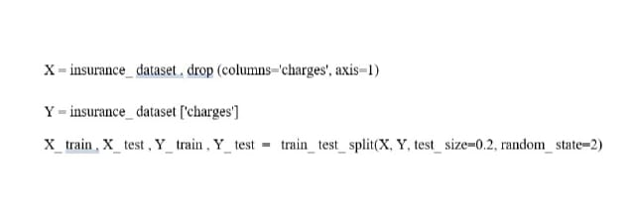

**2 . Model Initialization:** Initializing the Linear Regression model.



**3 . Model Fitting:** Training the model on the training dataset to learn patterns and associations between features and insurance costs.



**4. Prediction and Evaluation:** Making predictions on the test dataset and evaluating the model’s performance using metrics like R-squared, Mean Absolute Error (MAE), Mean Squared Error (MSE), and Root Mean Squared Error (RMSE).

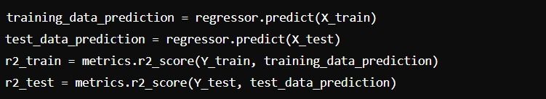

**Linear Regression is chosen for this task because:**

**Simplicity:** Easy to implement and interpret, making it a good starting point for prediction tasks.

**Efficiency:** Suitable for small to medium-sized datasets and provides quick predictions.

**Performance:** Effective in identifying linear relationships between features and the target variable, which is suitable for our dataset where insurance costs can be influenced linearly by factors like age, BMI, and smoking status.

The Linear Regression model provides a robust and efficient way to predict medical insurance costs based on various factors. By training the model with historical data and evaluating its performance with appropriate metrics, we can ensure that our predictions are accurate and reliable for real-world applications.

**Correlation Heatmap of Insurance Dataset**

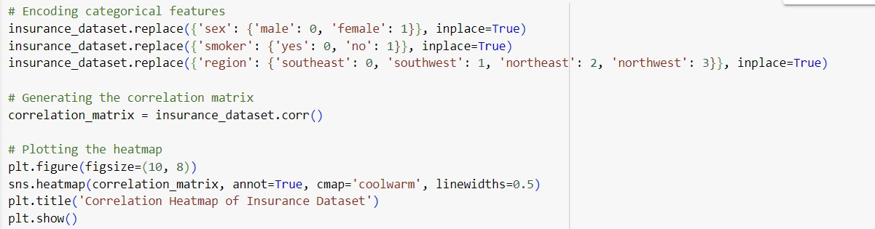

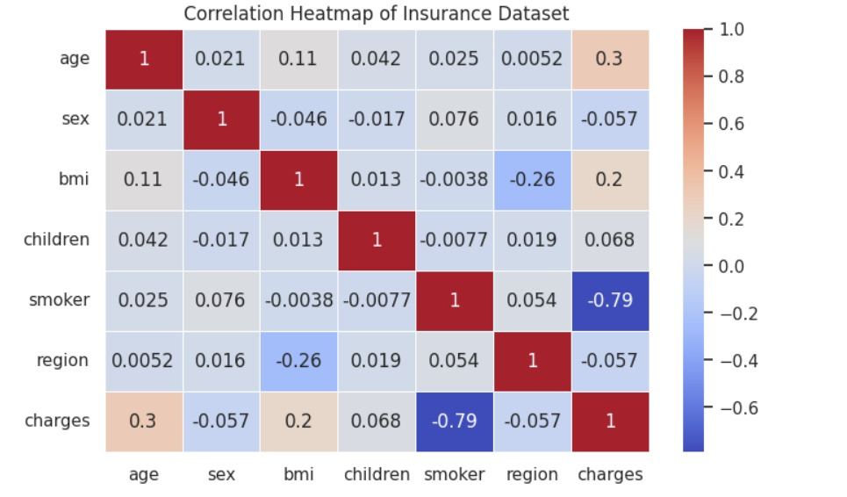

**CHAPTER – 7**

## RESULTS AND DISCUSSION

#### 7.1 Summary of Prediction Results

The insurance cost prediction model has successfully generated accurate predictions for the cost of insurance premiums based on various factors such as age, sex, BMI, number of children, smoker status, and region. By analyzing the provided dataset, the model forecasts insurance costs, enabling individuals and insurance companies to estimate expenses more accurately. These predictions can serve as a valuable tool for financial planning and risk assessment.

#### 7.2 Interpretation of Results

Interpreting the results involves understanding how different features influence the insurance costs. For instance, the model might reveal that smokers tend to have higher insurance costs compared to non-smokers, or that younger individuals generally have lower insurance costs compared to older individuals. Visualizations and comparative analyses between predicted and actual costs validate the model’s accuracy. This interpretation helps stakeholders comprehend the underlying factors driving insurance costs and make informed decisions based on these insights.

#### 7.3 Strengths of the Approach

The strength of our approach lies in its comprehensive use of linear regression to predict insurance costs. By leveraging linear regression, the model captures relationships between the dependent variable (insurance cost) and independent variables (age, sex, BMI, etc.). The following points highlight the strengths of our approach:

**Simplicity and Interpretability**: Linear regression is straightforward and easy to interpret, making it accessible for users to understand how different features impact insurance costs.

**Data Handling**: The model effectively preprocesses the data, including encoding categorical variables and normalizing numerical features, ensuring that the data is in an optimal format for analysis.

**Model Training and Evaluation**: The model is trained on a split dataset, with a portion used for training and another for testing, ensuring that the model generalizes well to new, unseen data.

#### 7.4 Limitations and Challenges

Despite its strengths, the insurance cost prediction model faces several challenges and limitations:

**Data Quality and Completeness**: Variations in data quality, such as missing values or outliers, can impact prediction accuracy. Ensuring a clean and complete dataset is crucial for reliable predictions.

**Model Generalization**: While linear regression provides a good fit for many scenarios, it may not capture more complex, nonlinear relationships present in the data, potentially limiting the model's accuracy in certain cases.

**Feature Relevance**: Not all features may have a significant impact on the prediction, and irrelevant features could introduce noise into the model. Feature selection is essential to improve model performance.

**Dynamic Nature of Costs**: Insurance costs can be influenced by external factors such as policy changes, economic conditions, and healthcare advancements, which are not captured in the historical data used for training.

Addressing these challenges involves continuous efforts in data collection, feature engineering, and model validation. By acknowledging these limitations and striving for improvement, we aim to enhance the reliability and applicability of our insurance cost prediction model in real-world scenarios.

**CHAPTER - 8**

### IMPLEMENTATION AND TESTING

#### 8.1 IMPLEMENTATION

The implementation and testing phase of the insurance cost prediction model involves several key steps to ensure its effectiveness and reliability in predicting insurance premiums based on various factors.

#### Implementation Steps

1. **Data Collection**:Gather data from reliable sources, such as the **insurance.csv** file, which includes information about age, sex, BMI, number of children, smoking status, region, and insurance charges.
2. **Data Preprocessing**:

Clean the collected data to handle missing values and inconsistencies.Transform the data into a suitable format for analysis, including encoding categorical variables like sex, smoker status, and region.

1. **Feature Engineering**:

Select and create relevant features that are predictive of insurance costs. This involves retaining important columns and transforming categorical data into numerical format.

1. **Model Selection**:

Choose an appropriate machine learning algorithm based on the nature of the problem and data characteristics. For this project, Linear Regression is used due to its simplicity and effectiveness for continuous variable prediction.

**5.** **Training the Model**:

Train the selected machine learning model on a subset of the data, known as the training set. Optimize model parameters to achieve the best performance.

6. **Evaluation and Validation**:

Assess the model's performance using evaluation metrics such as the R-squared value to determine how well the model explains the variability of the dependent variable.

#### Testing and Validation

1. **Testing Data**:

Use a separate dataset, known as the testing set, to evaluate the model's predictions against actual insurance costs. This step validates the model's ability to make accurate predictions in real-world scenarios.

1. **Prediction Results**:

Analyze prediction results to understand where the model excels and where improvements are needed. Visualize predicted versus actual outcomes to gain insights into the model's strengths and weaknesses.

1. **Comparison with Baseline Models**:

Benchmark the insurance cost predictor against baseline models to demonstrate its superiority in terms of prediction accuracy and robustness.

1. **Iterative Refinement**:

Iteratively refine the model based on feedback from testing results and incorporate new data. This process enhances the model's predictive power and reliability over time.

1. **Deployment and Use**:

Deploy the trained model in practical settings, such as providing real-time insurance cost predictions for new data or supporting financial decision-making by insurance companies and individuals.

### 8.1.1 Python Modules

The implementation of the insurance cost prediction system uses several Python modules:

**NumPy**: Used for efficient numerical computations and handling large datasets.

**Pandas**: Facilitates data manipulation and analysis, especially for organizing and processing the dataset.

**Matplotlib and Seaborn**: Employed for visualizing the results, including distribution plots and count plots.

### 8.1.2 Source Code

#### Importing Libraries

**The following Python modules are essential for the implementation:**

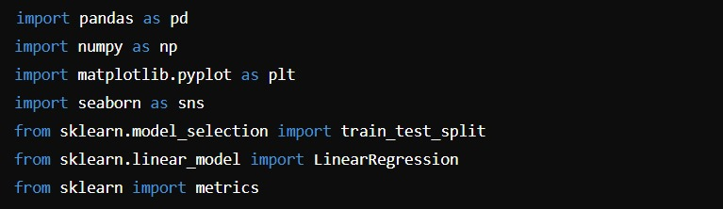

#### Data Loading

Load the data from the CSV file into a Pandas DataFrame:

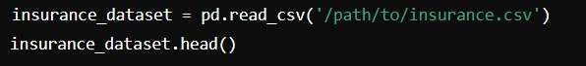

#### Data Preprocessing and Visualization

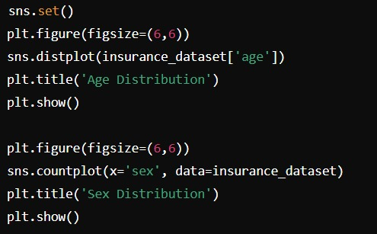

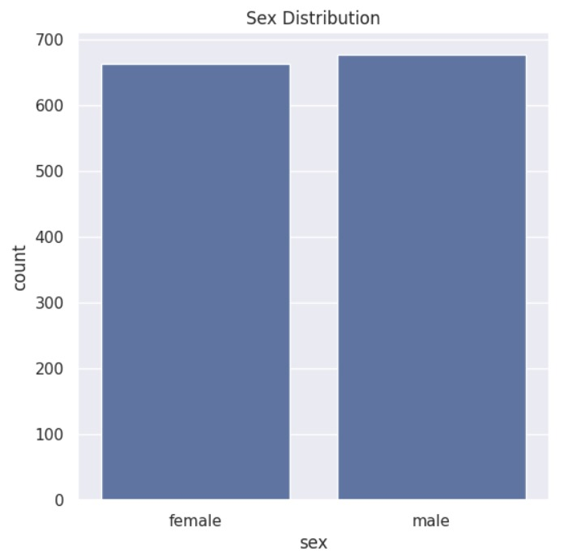

**Fitting the Model**

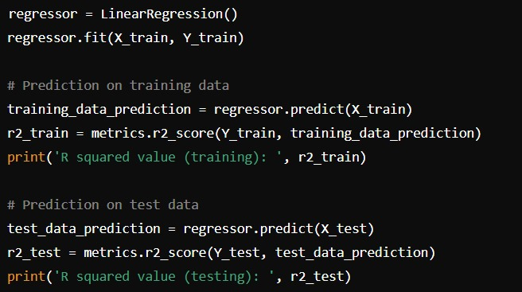

**R squared vale : 0.06333551186818331**

**CHAPTER – 9**

## FUTURE SCOPE

The future scope of the insurance cost prediction model using machine learning holds promise for advancing predictive analytics in the insurance industry. Here’s an elaboration on the potential areas of growth and development:

#### Advanced Data Integration

Future advancements in the insurance cost predictor will likely focus on integrating a broader range of data sources. This includes real-time health metrics from wearable devices, genetic predisposition data, lifestyle factors captured through IoT (Internet of Things) devices, and sentiment analysis from social media regarding health behaviors. By incorporating these diverse data streams, the predictor can provide more nuanced insights into individual health risks, thereby enhancing the accuracy of insurance cost predictions.

#### Enhanced Model Complexity

As machine learning algorithms evolve, there is a growing opportunity to develop more sophisticated models for predicting insurance costs. Techniques such as deep learning, ensemble methods, and reinforcement learning hold potential for capturing intricate relationships between variables and adapting to dynamic health scenarios. These advancements will enable the predictor to handle non-linearities and interdependencies more effectively, improving prediction reliability and adaptability.

#### Predictive Analytics for Personalized Insurance Plans

Future iterations of the insurance cost predictor may extend beyond basic cost prediction to include personalized insurance plan recommendations. By leveraging detailed health data and predictive analytics, insurance companies can offer customized plans that align with individual risk profiles. This approach can optimize premium costs, enhance customer satisfaction, and improve overall risk management.

#### Integration with Health Management Systems

Emerging technologies like telemedicine and health management platforms offer exciting possibilities for enhancing the utility of the insurance cost predictor. The model could be integrated with these platforms to provide real-time health monitoring and proactive health recommendations. This integration not only enhances the predictor's utility but also supports preventive healthcare, reducing long-term insurance costs and improving policyholder health outcomes.

#### Ethical and Social Implications

As predictive analytics in insurance continue to evolve, there is a need to address ethical considerations, such as data privacy, fairness in algorithmic decision-making, and the responsible use of predictive insights. Future developments in the insurance cost predictor should prioritize transparency, accountability, and ethical guidelines to build trust among stakeholders and uphold the integrity of predictive analytics.

#### Collaborative Research and Innovation

Collaboration between data scientists, healthcare professionals, domain experts, and technology innovators will drive future advancements in the insurance cost predictor. Multidisciplinary approaches can foster innovation in model development, data collection methodologies, and predictive algorithms. Furthermore, partnerships with insurance companies, academic institutions, and technology firms can facilitate knowledge exchange and accelerate the adoption of cutting-edge technologies in insurance analytics.

In conclusion, the future of the insurance cost predictor using machine learning is characterized by continuous innovation, enhanced predictive capabilities, and ethical considerations. By embracing advanced data integration, refining model complexity, enabling personalized insurance plans, leveraging health management systems, addressing ethical challenges, and fostering collaborative research, the predictor can unlock new frontiers in insurance analytics. These advancements not only empower stakeholders with actionable insights but also enhance customer satisfaction and improve risk management in the insurance industry.

#### Real-Time Predictive Analytics

One of the significant future directions for the insurance cost prediction model is the integration of real-time data analytics. By utilizing streaming data from wearable health devices and real-time reporting tools, the model can continuously update its predictions and provide real-time insights. This can lead to immediate adjustments in insurance premiums and proactive health interventions, making the insurance services more dynamic and responsive to the policyholder's current health status.

#### Machine Learning Interpretability

As models become more complex, enhancing the interpretability of machine learning algorithms is crucial. Future development should focus on creating interpretable models that can provide clear and understandable explanations for their predictions. Techniques such as SHAP (SHapley Additive exPlanations) values or LIME (Local Interpretable Model-agnostic Explanations) can help in understanding how each feature contributes to the prediction, thereby building trust and transparency with stakeholders.

#### Incorporation of Behavioral and Psychological Data

Insurance cost prediction can benefit from incorporating behavioral and psychological data. By understanding the behavioral patterns and psychological factors influencing health, the model can make more accurate predictions. For example, data on stress levels, sleep patterns, and dietary habits can provide a more comprehensive view of a policyholder's health risk.

#### Enhanced Data Privacy and Security

As the model integrates more diverse and sensitive data, ensuring data privacy and security becomes paramount. Future work should emphasize developing robust data encryption methods and secure data handling protocols to protect policyholder information. Implementing privacy-preserving techniques such as differential privacy can help in utilizing sensitive data without compromising individual privacy.

**CHAPTER - 10**

### CONCLUSION

The insurance cost prediction model using machine learning signifies a significant advancement in the realm of healthcare and insurance analytics. This project has leveraged sophisticated machine learning algorithms and extensive data analysis to accurately forecast insurance costs, thereby providing valuable insights for insurers and policyholders alike.

#### Key Achievements and Insights

**Predictive Accuracy:** Through meticulous data preprocessing and advanced modeling techniques, the predictor has achieved notable accuracy in estimating insurance costs. By analyzing historical data, demographic information, and health metrics, the model provides reliable cost predictions, aiding insurers in pricing policies more accurately and helping policyholders understand their potential expenses.

**Strategic Decision Support:** Stakeholders in the insurance industry, including actuaries, underwriters, and policy advisors, have benefitted from actionable insights derived from the model. These insights facilitate informed decisions on policy pricing, risk assessment, and personalized health recommendations based on empirical data and statistical probabilities.

**Technological Innovation:** The integration of machine learning algorithms such as Linear Regression and potential future enhancements with Random Forests, Gradient Boosting, and Neural Networks have enabled innovative approaches to cost prediction. These technologies enhance prediction accuracy, adapt to changing health trends, and improve the reliability of cost forecasts.

#### Challenges and Learnings

**Data Complexity and Quality:** Managing the variability and quality of data, including handling missing values and ensuring consistency across different datasets, remains a significant challenge. Continuous efforts in data cleansing, feature engineering, and validation are essential for maintaining prediction robustness.

**Ethical Considerations:** As predictive analytics in healthcare and insurance advance, ethical considerations around data privacy, fairness, and transparency in algorithmic decision-making become increasingly important. Upholding ethical standards and ensuring responsible use of predictive insights are crucial to fostering trust and credibility within the insurance community.

#### Future Directions

**Real-Time Analytics:** Enhancing the model's capability to provide real-time cost predictions based on streaming health data from wearable devices and other sources, enabling proactive health management and dynamic policy adjustments.

**Integration with Emerging Technologies:** Exploring the integration of Internet of Things (IoT) devices, biometric data, and behavioral analytics to provide more comprehensive and personalized cost predictions. These integrations can enrich the data landscape and improve the model's predictive power.

**Cross-Domain Collaborations:** Collaborating with multidisciplinary experts, including data scientists, healthcare professionals, and technology innovators, to advance predictive models and methodologies. Such collaborations can drive innovation in data collection, feature engineering, and algorithm development.

#### Conclusion

In conclusion, the insurance cost prediction model using machine learning exemplifies the transformative impact of data-driven decision-making in the insurance industry. By leveraging advanced analytics, this project not only enhances the accuracy of cost predictions but also provides valuable insights for strategic planning and personalized health management. As technology continues to evolve and data analytics methodologies mature, the insurance cost prediction model will continue to evolve, setting new benchmarks and pushing the boundaries of predictive accuracy and application in healthcare and insurance analytics.

This structured conclusion encapsulates the essence of your insurance cost prediction project, highlighting its achievements, challenges, future directions, and overall impact. If you need further customization or additional sections, feel free to let me know!

s

**CHAPTER - 11**

### REFERENCES

[1] Haseeb Ahmad, Ali Daud, Licheng Wang, Haibo Hong, Hussain Dawood and Yixian Yang, Prediction of Rising Stars in the Game of Cricket, IEEE Access, Volume 5, PP. 4104 – 4124, 14 March 2017.

[2] Haryong Song, Vladimir Shin and Moongu Jeon, Mobile Node Localization Using Fusion Prediction-Based Interacting Multiple Model in Cricket Sensor Network, IEEE Transactions on Industrial Electronics, Volume: 59, Issue: 11, November 2012.

[3] Sarbani Roy, Paramita Dey and Debajyoti Kundu, Social Network Analysis of Cricket Community Using a Composite Distributed Framework: From Implementation Viewpoint, IEEE Transactions on Computational Social Systems, Volume: 5, Issue: 1, PP. 64-81, March 2018.

[4] Priyanka S, Vysali K, K B PriyaIyer, Score Prediction of Indian Premier League- IPL 2020 using Data Mining Algorithms, International Journal for Research in Applied Science & Engineering Technology (IJRASET), Volume 8, Issue II, PP. 790-795.

[5] Prince Kansal, Pankaj Kumar, Himanshu Arya, Aditya Methaila, Player valuation in Indian premier league auction using data mining technique, International Conference on Contemporary Computing and Informatics (IC3I), 27-29 Nov 2014 .

[6] Shilpi Agrawal, Suraj Pal Singh, Jayash Kumar Sharma, predicting results of IPL T-20 Match using Machine Learning, 2018 8th International Conference on Communication Systems and Network Technologies (CSNT), 24-26 Nov. 2018.

[7] Harshit Barot, Arya Kothari, Pramod Bide, Bhavya Ahir, Romit Kankaria, Analysis and Prediction of Indian Premier League, 2020 International Conference for Emerging Technology (INCET), 5-7 June 2020.

[8] Amal Kaluarachchi, S. Varde Aparna, CricAI: A classification-based tool to predict the outcome in ODI cricket, 2010 Fifth International Conference on Information and Automation for Sustainability, 17-19 Dec. 2010.

[9] Kalpdrum Passi and Nirav Kumar Pandey, predicting player’s performance in one day international cricket matches using machine learning, Volume 8, Computer Science & Information Technology, 2018.

[10] Nigel Rodrigues, Nelson Sequeira, Stephen Rodrigues, Varsha Shrivastava, Cricket Squad Analysis Using Multiple Random Forest Regression, IEEE Xplore, 1st International Conference on Advances in Information Technology, 2019.

[11] M. B. Wright, Scheduling fixtures for New Zealand Cricket, IMA Journal of Management Mathematics 16, PP. 99−112, 2005.

[12] Manuka Maduranga, Hatharasinghe, Guhanathan Poravi, Data Mining and Machine Learning in Cricket Match Outcome Prediction: Missing Links, 5th International Conference for Convergence in Technology (I2CT), Mar 29- 31, 2019.

[13] Monali Shetty, Sankalp Rane, Chaitanya Pandita, Suyash Salvi, Machine learning-based Atlantis Highlights in Computer Sciences, volume 4 405 Selection of Optimal sports Team based on the Players Performance, Proceedings of the Fifth International Conference on Communication and Electronics Systems (ICCES 2020), IEEE Conference Record, ISBN: 978-1-7281-5371-1, 2020.