**Ansible Playbook for provisioning a new EC2 instance in AWS | Create new EC2 instance in AWS cloud using Ansible Playbook**

We will learn how to create Ansible Playbook for provisioning a new EC2 instance in AWS cloud. Please follow the below steps in the machine where you have installed Ansible.

[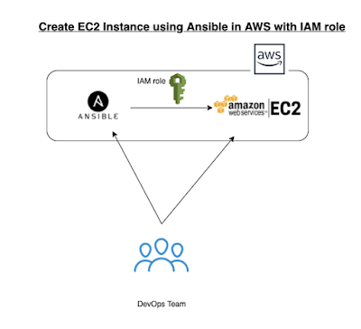](https://1.bp.blogspot.com/-g20rwtkBLDQ/YPB5vPk2pCI/AAAAAAAADmM/StR8itQoL_U4gmfl8sJdTKi_vOLitJTgwCLcBGAsYHQ/s566/Screen%2BShot%2B2021-07-15%2Bat%2B1.08.37%2BPM.png)  
**Watch here for YouTube Video:**

**Pre-requistes:**

[Ansible is installed and Boto is also installed](https://www.coachdevops.com/2020/04/install-ansible-on-ubuntu-how-to-setup.html) on Ubuntu EC2 instance

Make sure you create an IAM role with AmazonEC2FullAccess policy and attach the role to EC2 instance.

[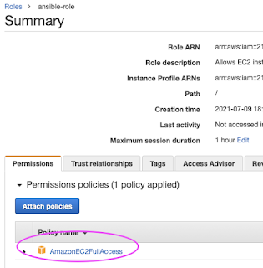](https://1.bp.blogspot.com/-cZ9tPnVMqGU/YPB4PGWzWDI/AAAAAAAADmE/r2ERljoyAyY6PjBI7T486tD4lRDhboNcACLcBGAsYHQ/s534/Screen%2BShot%2B2021-07-15%2Bat%2B1.01.54%2BPM.png)

**Steps to create EC2 instance using Ansible:**

Login to EC2 instance using Git bash or ITerm/putty where you installed Ansible. Execute the below command:

Edit Ansible hosts or inventory file

sudo vi /etc/ansible/hosts   
Add the below two lines in the end of the file:  
[localhost]  
local

[](https://4.bp.blogspot.com/-_vWRo1PX0Dg/XCRRzKpNn2I/AAAAAAAAAnU/WrhhnT_-vB4M5XLVAwzIez6b9a-bTl_OACLcBGAs/s1600/Screen%2BShot%2B2018-12-26%2Bat%2B10.14.48%2BPM.png)  
cd ~  
mkdir playbooks

cd playbooks

**Create Ansible playbook**

**sudo vi create_ec2.yml**(copy the below content in green color)

edit the create_jenkins_ec2.yml to make sure you update the key which is red marked below:

---

 - name:  provisioning EC2 instances using Ansible

   hosts: localhost

   connection: local

   gather_facts: False

   tags: provisioning

   vars:

     keypair: MyEC2Key

     instance_type: t2.small

     image: ami-020db2c14939a8efb

     wait: yes

     group: webserver

     count: 1

     region: us-east-2

     security_group: my-jenkins-security-grp

   tasks:

     - name: **Task # 1**- Create my security group

       local_action:

         module: ec2_group

         name: "{{ security_group }}"

         description: Security Group for webserver Servers

         region: "{{ region }}"

         rules:

            - proto: tcp

              from_port: 22

              to_port: 22

              cidr_ip: [0.0.0.0/0](http://0.0.0.0/0)

            - proto: tcp

              from_port: 8080

              to_port: 8080

              cidr_ip: [0.0.0.0/0](http://0.0.0.0/0)

            - proto: tcp

              from_port: 80

              to_port: 80

              cidr_ip: [0.0.0.0/0](http://0.0.0.0/0)

         rules_egress:

            - proto: all

              cidr_ip: [0.0.0.0/0](http://0.0.0.0/0)

       register: basic_firewall

     - name: **Task # 2** Launch the new EC2 Instance

       local_action:  ec2

                      group={{ security_group }}

                      instance_type={{ instance_type}}

                      image={{ image }}

                      wait=true

                      region={{ region }}

                      keypair={{ keypair }}

                      count={{count}}

       register: ec2

     - name: **Task # 3**Add Tagging to EC2 instance

       local_action: ec2_tag resource={{ item.id }} region={{ region }} state=present

       with_items: "{{ ec2.instances }}"

       args:

         tags:

           Name: MyTargetEc2Instance

[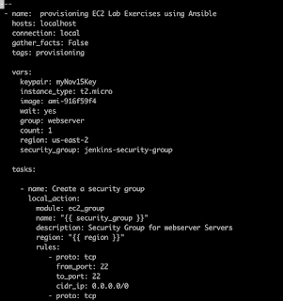](https://2.bp.blogspot.com/-fopvg-RVjzQ/XCRS3f17B3I/AAAAAAAAAno/DzEcS8u8CgARiDh4-TwMtXycW-KLwPBaACLcBGAs/s1600/Screen%2BShot%2B2018-12-26%2Bat%2B10.19.06%2BPM.png)

now execute the ansible playbook by  
**sudo ansible-playbook create_ec2.yml**

[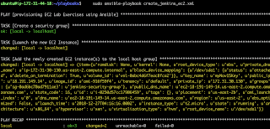](https://1.bp.blogspot.com/-N3ugduvLL7c/XCRSgzV8z-I/AAAAAAAAAnc/J8u_-qACSlQtJe4vLT0DeZwt5_wtQ741QCLcBGAs/s1600/Screen%2BShot%2B2018-12-26%2Bat%2B10.17.17%2BPM.png)

***Fix the warnings by executing below command***

**pip install --upgrade requests==2.20.1**

[](https://1.bp.blogspot.com/-u7VW6U6-gV0/XqYYhKqhPMI/AAAAAAAACAg/G2vYLQJlxxAZ9RlpZBgabjq_BX4sN1pCwCLcBGAsYHQ/s1600/url%2Blib.png)

If everything is good, you should see the new instance created on AWS console. make sure you are able to connect to that instance.

That's it!! That is how you create a new EC2 instance using Ansible.