**Hosting a ESPOCRM Application on Google Cloud Platform**

**Creating a Compute Engine Instance**

We can create a instance using cloud Console or Cloud SDK, or using Cloud Shell.

* Using Cloud Console:

Ensure that We have a project.

In Cloud Console =>Navigate to Compute Engine Service => Create Instance => ‘instance Name’ (we can specify our required reguirements like region, zone, machine type,etc)

* Using Cloud Shell :

gcloud compute instances create <instance name>

gcloud compute instances create instance-1 –machine-type=n1-standard-1

--zone=us-central1-b

After instance Creation, click on SSH to install required reguirements and dependencies to host the application

**Requirements:**

Php 7.4 and later

mysql (5.7 &above) or mariadb(10.1 &above)

Nginx

* **To install mysql run below commands :**

sudo apt-get update

sudo apt-get install mysql-server

sudo mysql_secure_installation

You will get a prompt to answer the following questions:

* Enter the current password for root (Press Enter for none): Then, just press the Enter key
* Set the root password? [Y/n]: Y
* New-password: Enter the password
* Next, re-enter the new password: Repeat your password
* Remove any anonymous users? [Y/n]: Y
* Disallow the root-login remotely? [Y/n]: Y
* Remove the test database and access to it? [Y/n]: Y
* Reload the privilege tables now? [Y/n]: Y

You will need to restart the MariaDB server using the following command:

sudo systemctl restart mysql.service

* **To install php & nginx run below commands :**

sudo apt-get install php7.4

sudo apt-get install nginx

**Dependencies:**

1. To Install required php libraries run the following command

sudo apt-get update

sudo apt-get install php-mysql php-json php-gd php-zip php-imap php-mbstring

sudo apt-get install php-curl php-exif php-ldap

sudo phpenmod imap mbstring

sudo apt-get install php7.4-fpm

sudo service nginx restart

By default fpm is listening to socket. We need to change it to the port .

vim /etc/php/7.4/fpm/pool.d/www.conf

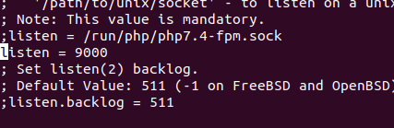

Comment(#) the line which is listening to socket(php7.4-fpm.sock)

and add the line

listen = 9000

we made fpm to listen on 9000 port , then restart the fpm service

service php7.4-fpm restart

* Edit the php.ini file add change follwing changes:

max_execution_time = 180

max_input_time = 180

memory_limit = 256M

post_max_size = 50M

upload_max_filesize = 50M

* **To Download the ESPOCRM installation package :**

1. To get the latest version of espoCRM follow the below given link

https://www.espocrm.com/download/

* Then, unzip the downloaded zip file using unzip command:

unzip <file name>

* Then move the file to *var*/www/html location:

mv espocrm *var*/www/html

* To edit the nginx configuration :

cd etc/nginx/sites-availble

sudo cp /etc/nginx/sites-available/default /etc/nginx/sites-available/espocrm.conf

* To edit espocrm.conf file use vim espocrm.conf

remove the entire configuration and copy and paste below provided configuration :

https://docs.espocrm.com/administration/nginx-server-configuration/

In espocrm.conf file change the *path-to-espo the absolute path of your espocrm path*

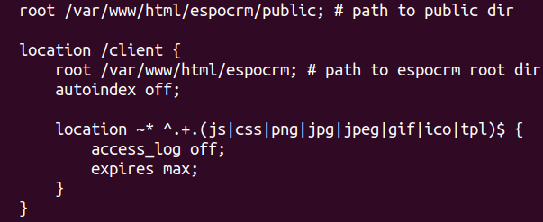 *( var/www/html/espocrm/public)*

And add the port number where the fpm is running .

location ~ \.php$ {

fastcgi_pass espocrm-php:9000;

include fastcgi_params;

fastcgi_index index.php;

fastcgi_param SCRIPT_FILENAME $document_root$fastcgi_script_name;

fastcgi_param QUERY_STRING $query_string;

}



Change the espocrm-php:9000 to localhost:9000;

* Link the espocrm.conf file to */et*c/nginx/sites-enabled/ location

sudo ln -s /etc/nginx/sites-available/espocrm.conf /etc/nginx/sites-enabled/espocrm.conf

* To check the nginx configuration file syntax run command

nginx-t

sudo service nginx restart

**Creating EspoCRM Database :**



After, installing all the packages, now we need to create databaseNow, run the command to create the EspoCRM database.

Run the below command to logon to the database server. You will get a prompt for a password. So, type the root password you created above:

sudo mysql -u root -p

1. To create Database :

CREATE DATABASE espocrm;

1. Then create a database user as vegayser, with new password.

CREATE USER 'espo-user'@'localhost' IDENTIFIED BY 'password';

1. Grant the user Privileges:

GRANT ALL ON espocrm.* TO 'espo-user'@'localhost' IDENTIFIED BY 'password';

1. Save the changes and exit

FLUSH PRIVILEGES;

exit ;

Then move to Espocrm directory location : /*var*/www/html/espocrm

* To set the permisions , execute below commands in the terminal :

sudo chown -R www-data:www-data /var/www/espocrm

* Change access permissions for the directory.

sudo chmod -R 755 /var/www/espocrm

If you see the following screen the installation was successful

* Then open the browser and enter the domain name / localhost:9000 to view the Espocrm application

If you see the following screen the installation was successful

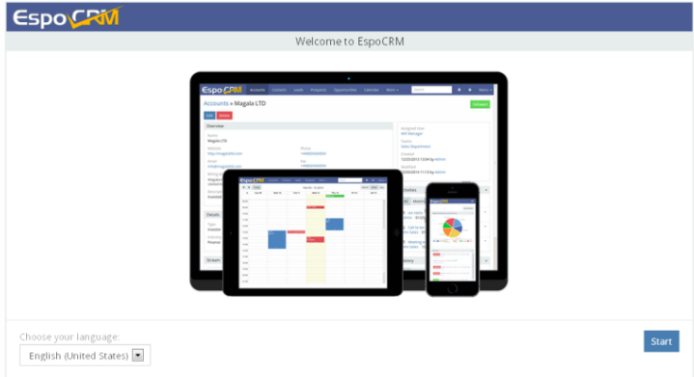

* Enter the details for your newly created MySQL database.
* 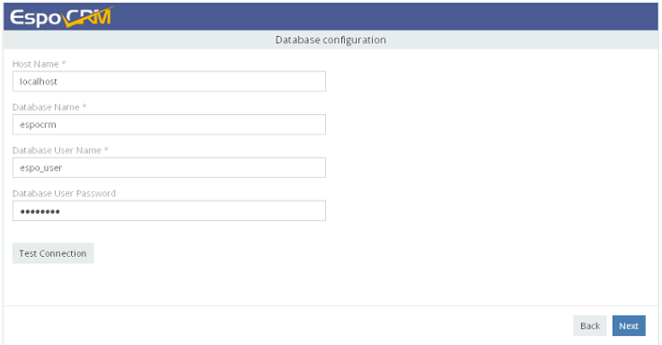After entering everything correctly. Then, you will have EspoCRM installed and ready to use.

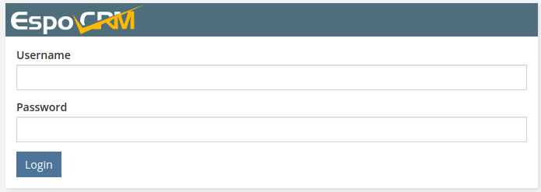Enter user name and password to login,

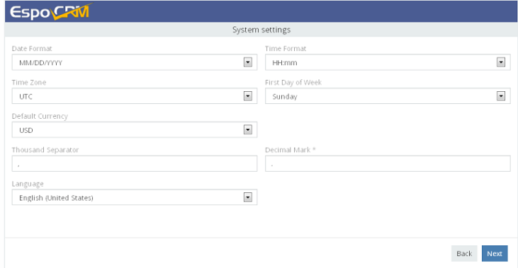

* 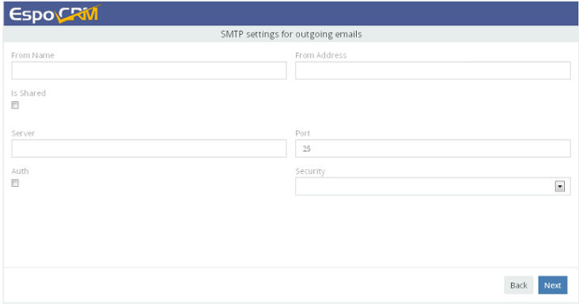Enter SMTP settings for outgoing emails. This step can be skipped by clicking the Next button.

The installation was done , now we need to set up a corn

**Set up the crontab expression**

* Edit crontab to enable automation of EspoCRM tasks using Crontab.

Open a terminal and run this command:

crontab -e -u WEBSERVER_USER

* * * * * /usr/bin/php -f /var/www/html/espocrm/cron.php > /dev/null 2>&1

* Copy the below expression and Add the following expression at the bottom of the file. Save and close the file.

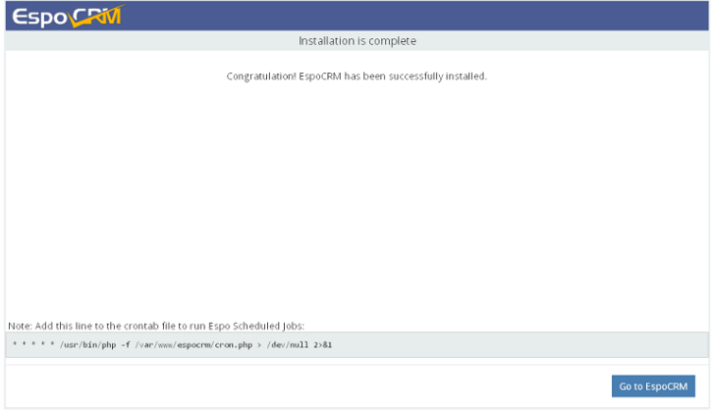

Installing Prometheus for Monitoriing

* Requirements:

prometheus

grafana

node exporter

Prometheus is a open-source monitoring system that collects metrics from our services and stores them in a time-series database and has a good alerting mechanism.

* *create a user for prometheus :*

sudo useradd --no-create-home --shell /bin/false prometheus

* *create folders for prometheus in /etc directory & /var/lib :*

sudo mkdir /etc/prometheus

sudo mkdir /var/lib/prometheus

* set the user and group ownership on the new directories to the prometheus user:

sudo chown prometheus:prometheus /etc/prometheus

sudo chown prometheus:prometheus /var/lib/prometheus

* To install prometheus follow below steps :

wget https://github.com/prometheus/prometheus/releases/download/v2.38.0/prometheus-2.38.0.linux-amd64.tar.gz

* to unzip the tar file, run below command:

tar -xvzf prometheus-2.38.0.linux-amd64.tar.gz

Then copy the binary files (prometheus & promtool) to /usr/local/bin and configuration directories and files to (console_libraries, consoles & prometheus.yml) to /etc/prometheus.

sudo cp prometheus-2.0.0.linux-amd64/prometheus /usr/local/bin/

sudo cp prometheus-2.0.0.linux-amd64/promtool /usr/local/bin/

* set the user and group ownership on the binaries to the prometheus user :

sudo chown prometheus:prometheus /usr/local/bin/prometheus

sudo chown prometheus:prometheus /usr/local/bin/promtool

* copy the consoles, console_libraries,prometheus.yml files to /*etc*/prometheus location:

sudo cp -r prometheus-2.0.0.linux-amd64/consoles /etc/prometheus

sudo cp -r prometheus-2.0.0.linux-amd64/console_libraries /etc/prometheus

sudo cp prometheus-2.0.0.linux-amd64/prometheus.yml /*etc*/prometheus

* set the user and group ownership on the directories to the prometheus user:

sudo chown -R prometheus:prometheus /etc/prometheus/

* create the prometheus service file :

sudo vim /etc/systemd/system/prometheus.service

* Add the following code to prometheus.service file

[Unit]

Description=Prometheus

Wants=network-online.target

After=network-online.target

[Service]

User=prometheus

Group=prometheus

Type=simple

ExecStart=/usr/local/bin/prometheus \

--config.file /etc/prometheus/prometheus.yml \

--storage.tsdb.path /var/lib/prometheus/ \

--web.console.templates=/etc/prometheus/consoles \

--web.console.libraries=/etc/prometheus/console_libraries

[Install]

WantedBy=multi-user.target

* then reload the systemd

sudo systemctl daemon-reload

* then start the prometheus service using following command :

sudo systemctl start prometheus

* to check the service is started or not run the below command :

sudo systemctl status prometheus

* Install the node exporter:

node exporter exposes a wide variety of hardware and kernal related metrics.

* Create a user to node exporter:

sudo useradd --no-create-home --shell /bin/false node_exporter

To download node exporter run the below command on terminal:

using wget

https://github.com/prometheus/node_exporter/releases/download/v1.4.0-rc.0/node_exporter-1.4.0-rc.0.linux-amd64.tar.gz

* to unzip the tar file run below command:

tar xvzf node_exporter-1.4.0-rc.0.linux-amd64.tar.gz

* copy the binary to the /*usr*/local/bin directory and set the user and group ownership to the node_exporter :

sudo cp node_exporter-1.4.0-rc.0.linux-amd64/node_exporter /usr/local/bin

sudo chown node_exporter:node_exporter /usr/local/bin/node_exporter

* create a node_exporter service file :

sudo vim /etc/systemd/system/node_exporter.service

* Add the following code to node_exporter.service file

[Unit]

Description=Node Exporter

Wants=network-online.target

After=network-online.target

[Service]

User=node_exporter

Group=node_exporter

Type=simple

ExecStart=/usr/local/bin/node_exporter

[Install]

WantedBy=multi-user.target

* then reload the systemd

sudo systemctl daemon-reload

* to start the node_exporter service using following command :

sudo systemctl start node_exporter

* to check the service is started or not run the below command :

sudo systemctl status node_exporter

* Configure prometheus.yml :

the configuration file looks like this

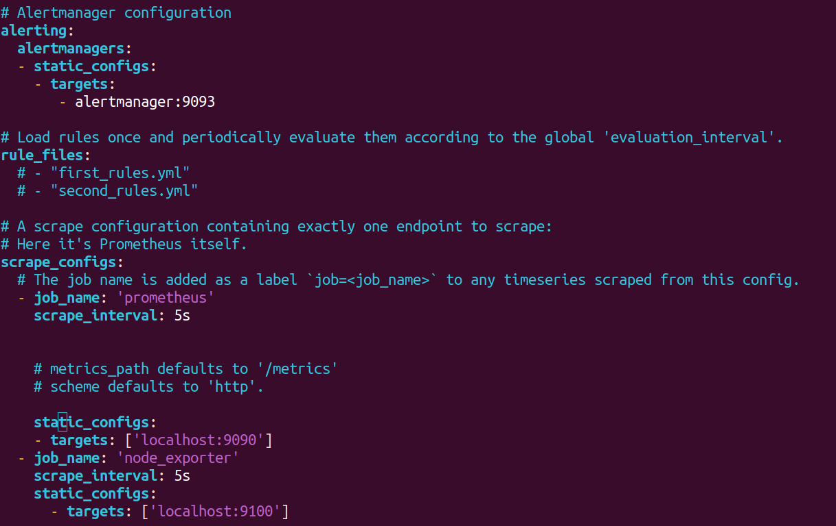save the file and exit

* Finally Restart the prometheus service:

sudo systemctl restart prometheus

* to check the service is started or not run the below command :

sudo systemctl status prometheus

* Installing Grafana:

Grafana is a multi platform open source analytics and interactive visualization web application. It provides charts, graphs, and alerts for the web when connected to supported data sources.

To install grafana run below command in terminal:

sudo apt-get install grafana

To start the grafana service run below command:

sudo systemctl start grafana-server

* to check the service is started or not run the below command :

sudo systemctl status grafana-server

* Create grafana.conf in /*etc*/nginx/sites-available location :

sudo vim /etc/nginx/sites-available/grafana.conf

* Add the following code in grafana.conf file.

server {

server_name _;

listen 90 ;

access_log /var/log/nginx/grafana.log;

location / {

proxy_pass http://localhost:3000;

proxy_set_header Host $http_host;

proxy_set_header X-Forwarded-Host $host:$server_port;

proxy_set_header X-Forwarded-Server $host;

proxy_set_header X-Forwarded-For $proxy_add_x_forwarded_for;

}

}

* Link and activate the configuration file

sudo ln -s /etc/nginx/sites-available/grafana.conf /etc/nginx/sites-enabled/grafana.conf

* to check the syntax

nginx -t

* Then restart the nginx service:

sudo systemctl restart nginx

* Then open the browser and type localhost:3000 to access the grafana.

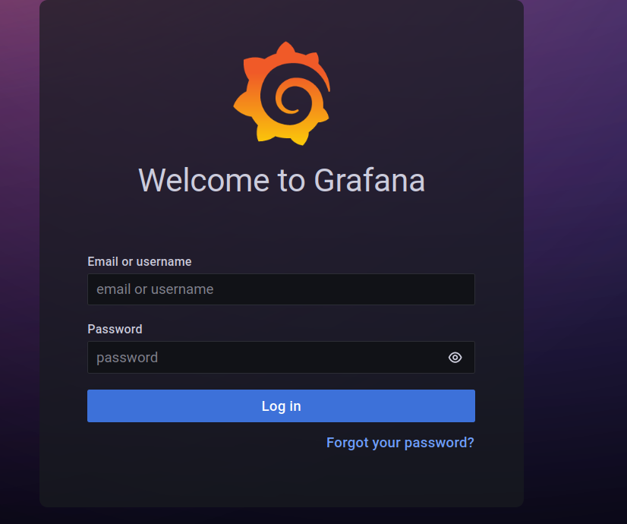

Then create logins and login to the grafana dashboard.

* Then Navigate to dashboard-->datasource-->add datasource--> prometheus

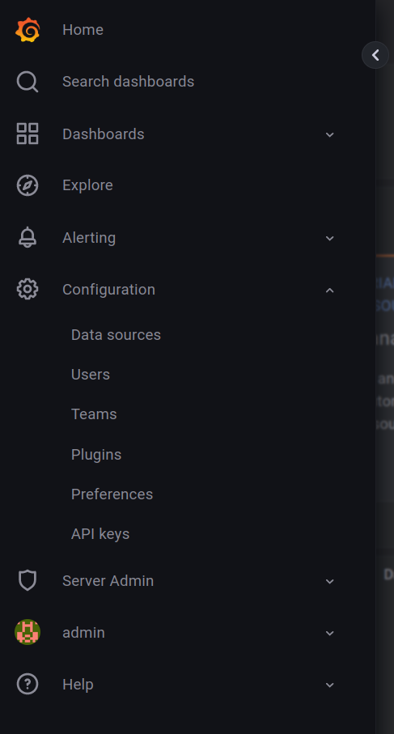

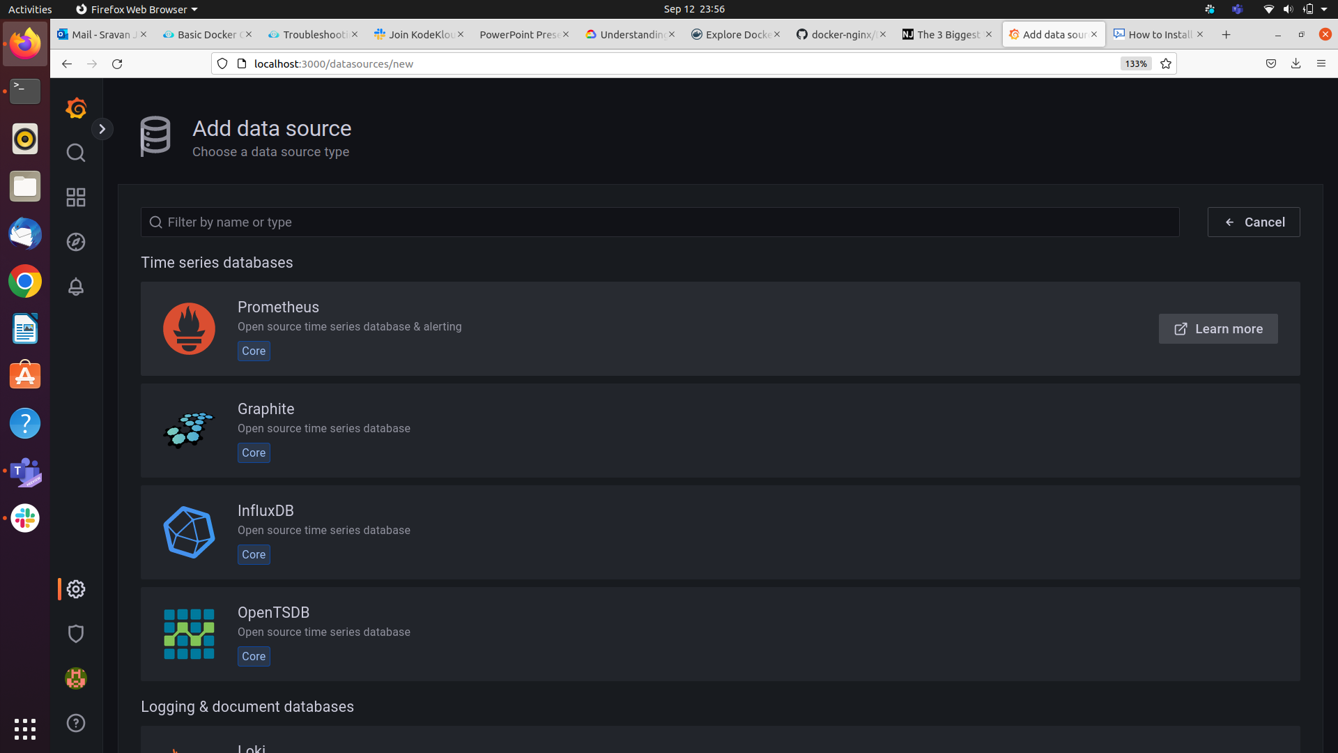

* Click on prometheus and then add the promethues url path to it([http://localhost:9000](http://localhost:9000/)).

Thn navigate to dashboard-->import

* then add the node exporter full id in the and load it.(1860)

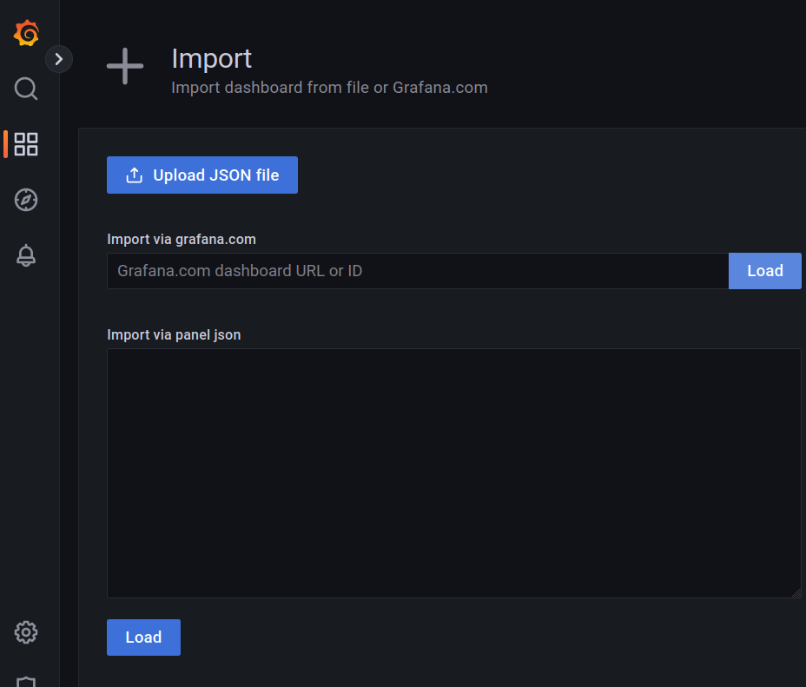

Then goto dashboards-->browse--->node_exporter full and view the metrics..

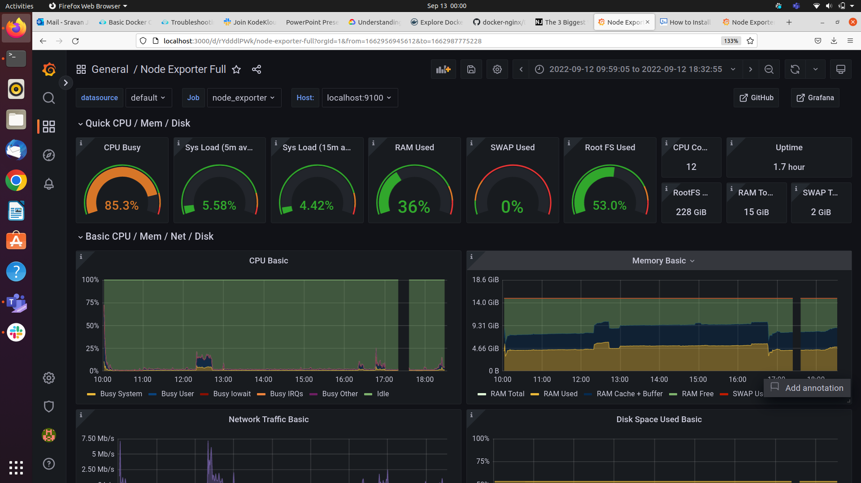

------Thank you -------