VitaNexus RX Detailed Theory Architecture and Execution Report
  - Medication safety analysis, FAERS serious outcome classification and alternative drug ranking

Major Project Technical Documentation
System status reviewed on 14 September 2026

Problem definition, existing and proposed systems, architecture, datasets, clinical workflow, machine learning, recommendation logic, technologies, evaluation, limitations and future work

Abstract
VitaNexus-RX is a research-oriented clinical decision-support system that assists clinicians in reviewing a proposed medicine in the context of a patient's active medications and recorded conditions. Medication safety evidence is distributed across terminology datasets, interaction databases, disease relationships and postmarketing reports. The system brings these sources into one consultation workflow while preserving their different meanings.
Indian brand names are normalized to generic active ingredients. DDInter 2.0 supplies documented drug-drug interaction classifications. DrugCentral supplies drug-disease relationships and medicines associated with the same indication. A LightGBM classifier trained on historical FDA Adverse Event Reporting System reports estimates whether a matching report belongs to the documented serious-outcome class. Serious outcomes include death, life-threatening events, hospitalization, disability, congenital anomalies, required intervention and other recorded serious outcomes.
The FAERS estimate is conditional on an adverse-event report already existing. It is not the probability that a particular patient will experience a side effect or require hospitalization. The system uses isotonic calibration, twenty case-level bootstrap models and split-conformal classification to communicate model behavior and uncertainty. A separate protected baseline HGNN ranks specific event-label associations as audit-pending supplementary evidence; its scores are not patient-incidence probabilities and never affect recommendations. Alternative medicines pass deterministic safety gates before eligible candidates are ranked using a transparent research-configured formula. PostgreSQL stores patients, consultations, analyses, model outputs, recommendations, notes, follow-ups and audit events. VitaNexus-RX is a major-project research prototype, not an autonomous prescriber or validated medical device.

Contents
Sections 1 to 9 | Sections 10 to 18 | Sections 19 to 27
1 Project Definition and Scope | 10 Clinical Safety Analysis | 19 Technologies Used
2 Introduction | 11 Risk Classifications | 20 Security Reliability and Failure Handling
3 Problem Statement | 12 FAERS Data Pipeline | 21 Model Evaluation
4 Objectives | 13 Machine Learning Pipeline | 22 Advantages
5 Existing System | 14 Understanding Model Outputs | 23 Limitations
6 Proposed System | 15 Recommendation Engine | 24 Future Development
7 System Architecture | 16 Application Modules | 25 Baseline HGNN Specific Event Profile
8 Inputs and Outputs | 17 Database Design | 26 Conclusion
9 End to End Execution | 18 API Design
 |  | 27 Appendices

1 Project Definition and Scope
A scientifically accurate project title is VitaNexus-RX An Evidence-Aware Medication Safety Assessment and Alternative-Drug Ranking System. The application integrates clinical knowledge retrieval, FAERS report classification, transparent ranking and longitudinal consultation management.
The implemented system solves three related but distinct tasks.
1. Retrieve known drug-drug and drug-disease safety evidence for a proposed medicine.
2. Classify whether a matching FAERS adverse-event report resembles the serious-outcome or no-documented-serious-outcome class.
3. Generate DrugCentral same-indication alternatives, apply safety gates and rank only candidates with complete usable evidence.
The system does not calculate the probability that a particular patient will experience a side effect after taking the proposed medicine. Hospitalization is not predicted separately. It is one outcome within the combined FAERS serious-outcome label.

2 Introduction
Medication selection becomes more difficult when a patient uses several medicines or has multiple medical conditions. A newly proposed drug may interact with an active medicine, conflict with an existing disease or have a history of serious outcomes in postmarketing reports. Clinicians may need to search different resources, reconcile brand and generic names, interpret incomplete records and document why one option was chosen over another.
VitaNexus-RX organizes this work into one consultation workflow. The application records the patient's context, resolves medicine names, retrieves known relationships, obtains an uncertainty-aware FAERS report classification and evaluates same-indication alternatives. Each analytical branch keeps its original meaning. DDInter and DrugCentral provide database relationships. LightGBM provides a learned report-classification estimate. Neither type of evidence independently proves that a medicine caused an event or that the medicine is safe for a particular patient.

2.1 Clinical Terminology
Term | Meaning
Adverse event | Any unfavorable medical occurrence after medicine use, whether or not the medicine caused it.
Adverse drug reaction | A harmful and unintended response for which the medicine is reasonably suspected to be the cause.
Side effect | Common language for a secondary effect of a medicine; it usually suggests some relationship to the medicine.
Serious outcome | A reported consequence such as death, hospitalization, disability or another medically serious result.

3 Problem Statement
The project addresses the following problem. How can heterogeneous medication-safety evidence be integrated into one clinician workflow that checks a proposed medicine against the patient's active medicines and conditions, represents missing evidence honestly, presents uncertainty-aware FAERS report classification and ranks same-indication alternatives transparently?

3.1 Specific Problems
- Safety information is distributed across independent sources.
- Indian brand names may not match generic names used by international datasets.
- Every active medicine must be checked during polypharmacy review.
- A medicine may be unsuitable because of a disease even when no drug-drug interaction is present.
- Missing terminology can be mistaken for low risk if the system does not separate unknown evidence from negative evidence.
- FAERS percentages can be misinterpreted as patient incidence even though the database contains reports without a complete exposure denominator.
- A single model percentage can hide instability and incomplete input coverage.
- Alternative ranking can become unsafe when a numerical model is allowed to override documented contraindications.
- Clinical decisions require persistence, provenance and an audit trail.

3.2 Formal Analytical Tasks
Let d represent the proposed drug, M the patient's active medicines, C the recorded conditions, i the selected indication and X the LightGBM feature vector. The known-evidence branch evaluates every pair d with each medicine in M and every pair d with each resolvable condition in C. The learned-evidence branch estimates the serious-outcome class among FAERS reports. The ranking branch orders eligible DrugCentral alternatives after hard safety gates.

4 Objectives
- Normalize entered medicine names to reusable generic identities.
- Retrieve DDInter relationships for every proposed-drug and active-medication pair.
- Resolve patient conditions and retrieve DrugCentral relationships.
- Classify FAERS report seriousness using a calibrated LightGBM model.
- Display bootstrap variability, conformal classification and feature coverage.
- Generate evidence-backed same-indication alternatives.
- Apply deterministic safety gates before numerical ranking.
- Preserve analyses, model versions, input hashes, notes and follow-ups.
- Fail safely when a dataset, term or model artifact is unavailable.

5 Existing System

5.1 Conventional Workflow
In a conventional workflow, a clinician may review the patient record, identify generic ingredients, search a drug-interaction reference, search disease restrictions separately, consult postmarketing information and manually compare alternatives. The evidence may then be recorded in a different system.
This fragmented workflow increases repeated searching and makes terminology mismatches more likely. Different tools may use different names, scales and definitions. Missing evidence may not be clearly separated from a negative result, and the reasoning behind an alternative selection may not be reproducible later.

5.2 Limitations of the Conventional Workflow
- Drug-drug and drug-disease evidence may be checked in separate tools.
- Brand names may hide the active ingredient needed for matching.
- Manual checking becomes difficult when several medicines are active.
- Search tools may return no match without explaining whether the lookup was complete.
- Postmarketing report counts may be interpreted as actual incidence.
- The final medicine choice may lack a reproducible ranking explanation.
- Patient history, evidence and follow-up may remain disconnected.

5.3 Earlier Project Prototype
The earlier VitaNexus-RX prototype used demonstration services and browser-oriented state. The current implementation replaces demonstration values with imported clinical knowledge, PostgreSQL persistence, a trained LightGBM subsystem, a FastAPI inference service, model-version tracking, input hashing and explicit failure semantics.

6 Proposed System
The proposed system provides an authenticated clinical workspace. A clinician creates or selects a patient, records clinical context, selects a normalized medicine and verified indication, runs clinical safety analysis, reviews the FAERS serious-outcome assessment, generates alternatives, records notes and submits follow-up information.
The core safety rule is that missing or unresolved evidence cannot be converted into zero or low risk. A major DDInter relationship or high DrugCentral restriction blocks normal ranking. Incomplete evidence produces a clinical-review state. Only candidates with complete known evidence and a usable full-mode ML result receive a ranking score.

6.1 Main Capabilities
- Secure clinician registration and login
- Doctor contact profile management
- Patient and medication-history management
- Brand-to-generic medicine normalization
- Verified indication selection with source provenance
- Drug-drug interaction analysis
- Drug-disease interaction analysis
- FAERS serious-outcome report classification
- Bootstrap model-variability reporting
- Split-conformal classification sets
- Dataset-backed alternative generation
- Hard safety gates and deterministic ranking
- Consultation notes, follow-up and audit records

6.2 Safety Principle
The absence of usable evidence must trigger clinical review rather than an assumption of safety. This principle applies to unresolved medicines, ambiguous conditions, missing ML artifacts and incomplete model vocabulary coverage.

7 System Architecture
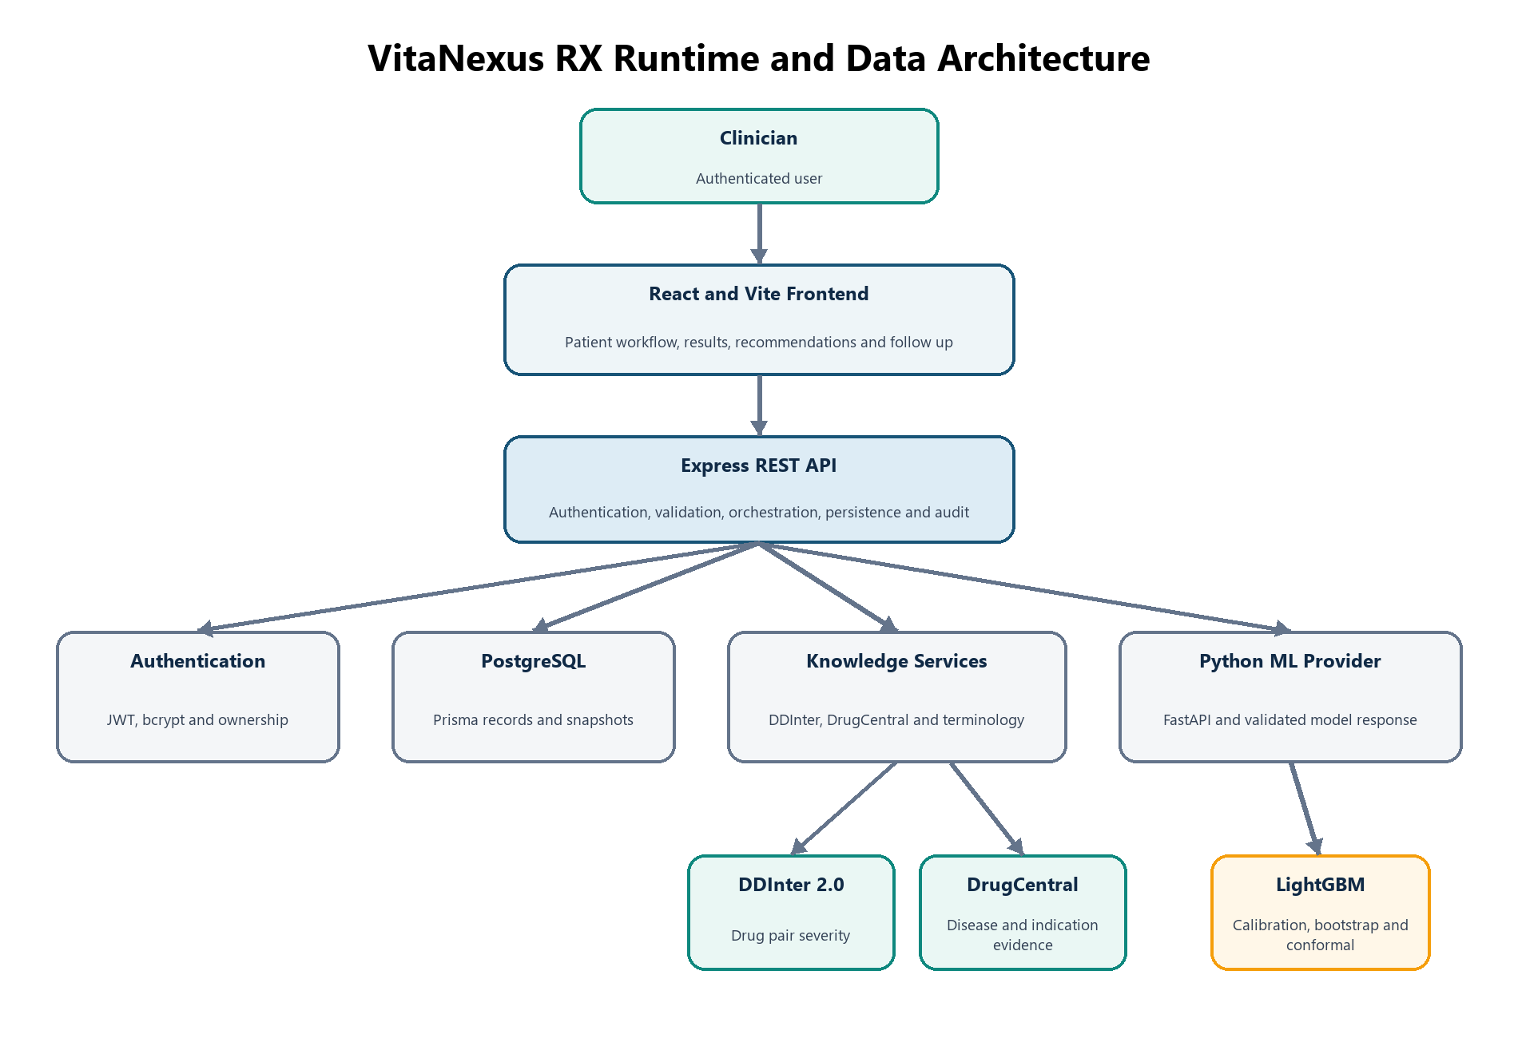
Figure 1 VitaNexus RX runtime and data architecture

7.1 Architectural Style
VitaNexus-RX uses a layered web architecture with a separate internal machine-learning service. The presentation layer runs in the browser. Express manages authentication, validation, clinical workflow orchestration and persistence. Prisma provides typed access to PostgreSQL. Clinical repositories query imported DDInter and DrugCentral tables. The Python service loads approved model artifacts once at startup and exposes prediction endpoints to Express.
Offline processing remains separate from runtime patient data. Dataset processors create normalized clinical-knowledge files and the FAERS Parquet cohort. Training creates versioned artifacts. The browser never loads raw datasets or model files directly.

7.2 Presentation Layer
The React single-page application displays public pages, authenticated dashboards, patient intake, patient records, clinical safety, adverse-risk assessment, recommendations, follow-up and the doctor profile. React Router controls protected routes and direct links. Context providers restore authentication, patient collections and theme state.

7.3 Application Service Layer
Express exposes the versioned REST API. It validates writes through Zod, verifies clinician ownership, normalizes request and response envelopes, calculates deterministic input hashes, invokes clinical services and persists generated results.

7.4 Knowledge Layer
The clinical knowledge repository isolates dataset queries from request orchestration. It performs DDInter pair searches, DrugCentral condition resolution, drug-disease lookup and same-indication candidate retrieval. Each returned relationship retains its source and dataset version.

7.5 Machine Learning Layer
The Python FastAPI service loads LightGBM and the protected baseline HGNN independently. LightGBM uses the persisted feature builder, calibrated selected model, twenty bootstrap models and conformal metadata. HGNN uses the hash-verified epoch 20 selection checkpoint, ordered 100-event vocabulary and saved development associations. Express communicates with both model paths over an internal HTTP boundary and accepts a response only when it satisfies the corresponding versioned schema.

7.6 Persistence Layer
PostgreSQL stores application data, imported clinical knowledge and versioned analytical snapshots. Prisma provides the schema, relations, migrations and typed database access.

8 Inputs and Outputs

8.1 Patient Inputs
- Name, age and gender
- Active and historical conditions
- Recorded allergies
- Current and previous medicines
- Dosage, frequency, route and medication status

8.2 Consultation Inputs
- Proposed medicine
- Canonical generic ingredient
- DrugCentral-backed indication and provenance
- Dosage and frequency
- Optional route
- Clinician notes

8.3 LightGBM Runtime Inputs
The active LightGBM model uses age, age-missing status, sex, candidate drug, selected indication, candidate-indication combination, current medicines, medicine count, a polypharmacy indicator and an unknown-medicine count. Dosage, frequency, route, diseases and allergies are stored by the application but are not active LightGBM features.

8.4 System Outputs
- Drug-drug interaction severity and source evidence
- Drug-disease assessment and condition-resolution status
- Overall ordinal clinical assessment
- Calibrated FAERS serious-outcome class probability
- Bootstrap model-variability range and conservative upper value
- Split-conformal prediction set
- Ranked baseline HGNN event-label model scores with coverage and provenance
- Evidence-completeness and failure status
- Safety-gated and deterministically ranked alternatives
- Persisted notes, follow-ups, provenance and audit events

9 End to End Execution
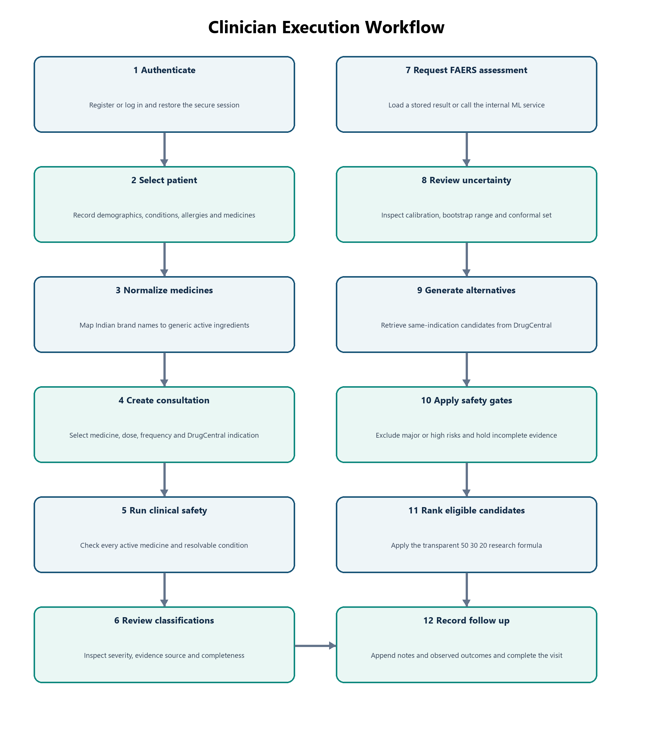
Figure 2 End to end clinician execution workflow

9.1 Authentication and Session Restoration
The clinician registers or logs in. Passwords are hashed with bcrypt, and protected requests use a signed JWT access token. Protected frontend routes wait for session restoration before deciding whether to redirect. This prevents a refreshed authenticated URL from being incorrectly sent to the login page.

9.2 Doctor Profile
The doctor name in the top bar opens the doctor profile. Email and phone number are editable. Name, gender, specialty and practice setting remain read-only. Both the frontend and a strict backend schema reject unsupported profile changes.

9.3 Patient Creation
The clinician records the patient's identity, age, gender, active conditions, allergies and current medicines. The backend stores the patient and associated collections in PostgreSQL. A public patient identifier is used in the interface in addition to the internal UUID.

9.4 Medicine Normalization
The clinician searches by brand or generic name. A selected result carries the entered name, normalized name, brand, generic ingredient, mapping source and mapping version. This step improves matching across Indian medicine terminology, DDInter, DrugCentral and the FAERS vocabulary.

9.5 Consultation Creation
The clinician selects the proposed medicine, dosage, frequency and a verified DrugCentral indication. The API validates the indication identifier, display text, source and dataset version. Arbitrary typed indication text cannot be submitted as a verified selection.

9.6 Clinical Safety Analysis
The system checks the proposed drug against all active medicines and all resolvable conditions. It returns the worst documented interaction, the source evidence, condition-resolution details and an overall ordinal assessment.

9.7 FAERS Serious Outcome Assessment
The frontend first attempts to load a persisted prediction. If none exists, Express builds the model input and calls the internal FastAPI service. The result includes the calibrated estimate, bootstrap range, conservative upper bound, conformal set, input coverage, data window and artifact versions.

9.8 Specific Event Profile
The frontend loads a matching persisted HGNN profile or requests the protected baseline model through Express and FastAPI. The result contains ordered event-label model scores, coverage, versions and audit state. It remains supplementary and never enters the recommendation path.

9.9 Alternative Generation and Ranking
DrugCentral supplies medicines associated with the selected indication. The current proposed drug is removed. Each alternative passes known-evidence safety gates. Eligible candidates receive batch LightGBM inference and the configured ranking score.

9.10 Notes and Follow Up
The clinician can append notes to the consultation. Follow-up records an observed adverse event, severity, duration and optional notes. Submitting follow-up marks the consultation as completed. Follow-up data is persisted for longitudinal review and does not automatically retrain the model.

10 Clinical Safety Analysis

10.1 Medicine Normalization
Dataset terms are converted to lowercase normalized alphanumeric forms. Combination products are split into ingredients for DDInter checking. Known cross-dataset synonyms are applied where necessary. A typical mapping is Crocin to paracetamol and then to the DDInter term acetaminophen.

10.2 Drug Drug Interaction Analysis
The proposed medicine is checked against every active medication. DDInter pairs are stored in canonical order, so the query does not depend on which medicine appears first. If several ingredient-level pairs match, the highest severity is retained.
The system distinguishes three cases. A matching DDInter row provides documented severity. A complete lookup with no pair provides a no-interaction-detected result. An unrecognized drug leaves the evidence unresolved and requires review.

10.3 Drug Disease Interaction Analysis
Each condition is resolved to a DrugCentral identity using the canonical disease term, concept name, SNOMED alias, UMLS identifier or DrugCentral identifier. A unique identity can then be checked against the proposed medicine. An ambiguous or unresolved condition produces incomplete evidence; the system does not fabricate a relationship.
DrugCentral relationship text is mapped to project assessment levels. Contraindication or avoidance language maps to high. Warning, caution or not-recommended language maps to moderate. Precaution or monitoring language maps to low. This mapping is transparent but requires clinical validation.

10.4 Overall Clinical Assessment
The overall result is an ordinal synthesis of the highest DDInter severity and highest DrugCentral assessment. A major DDI or high disease restriction produces high. Moderate evidence produces moderate. Minor DDI or low disease evidence produces low. Unresolved essential evidence requires clinical review. This result is not a probability.

11 Risk Classifications
Drug Drug Classification | Meaning
MAJOR | Documented interaction with potentially serious clinical importance.
MODERATE | Documented interaction that may require caution, adjustment or monitoring.
MINOR | Documented interaction considered less clinically significant.
NO INTERACTION DETECTED | The dataset check completed and no pair relationship was found.
REQUIRES CLINICAL REVIEW | One or more essential terms could not be evaluated reliably.

Drug Disease Classification | Source relationship and meaning
HIGH | DrugCentral relationship text indicates contraindication or avoidance.
MODERATE | Relationship text indicates warning, caution or not recommended.
LOW | Relationship text indicates precaution or monitoring.
NO DOCUMENTED RELATIONSHIP | The condition and medicine were evaluated but no relationship was found.
REQUIRES CLINICAL REVIEW | The condition was unresolved, ambiguous or otherwise not fully evaluable.

11.1 Meaning of Requires Clinical Review
Requires Clinical Review is a missing-evidence state. It is not another name for moderate risk. For example, if the proposed medicine is recognized but an active medicine is outside DDInter evidence coverage, the system cannot determine whether the pair is safe or dangerous. It therefore withholds a normal classification and asks the clinician to review the case using another trusted source.
No interaction detected also has a limited meaning. It states that the imported dataset did not return a documented relationship for the evaluated terms. It is not proof of absolute safety.

12 FAERS Data Pipeline
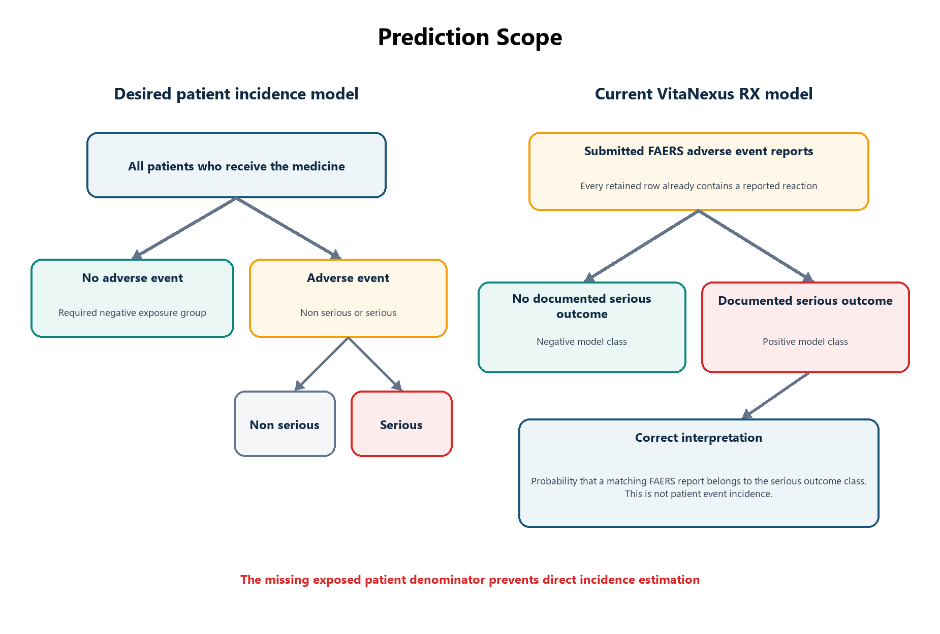
Figure 3 Difference between patient incidence prediction and the current FAERS report classification

12.1 Dataset Source
The model uses FDA FAERS ASCII quarterly files from 2022Q1 through 2025Q4 for development, tuning, calibration and threshold work. Reports from 2026Q1 and 2026Q2 form the untouched temporal holdout.

12.2 Source Tables
FAERS Table | Role
DEMO | Report identity, dates, age and sex
DRUG | Medicines, active ingredients and reported drug roles
REAC | Reported reaction terms
INDI | Indications linked to drug sequence identifiers
OUTC | Documented serious outcome codes
THER | Therapy information
RPSR | Report source information

12.3 Discovery Audit and Deduplication
The preprocessing pipeline discovers ZIP archives or extracted ASCII files, ignores incomplete browser downloads, audits expected tables and headers and records malformed rows. Every ZIP is fingerprinted with SHA-256. Case history is built globally before temporal assignment. For each CASEID, the highest CASEVERSION is retained, with date and PRIMARYID used for deterministic tie-breaking.

12.4 Cohort Construction Rules
- A usable CASEID and PRIMARYID must exist.
- At least one REAC term must exist.
- Exactly one drug must have ROLE_COD equal to PS, meaning primary suspect.
- The active ingredient is preferred over the reported drug name.
- ROLE_COD equal to C supplies concomitant medicines.
- Indications are linked by INDI_DRUG_SEQ and DRUG_SEQ.

12.5 Serious Outcome Target
Code | Meaning
DE | Death
LT | Life-threatening outcome
HO | Hospitalization or prolonged hospitalization
DS | Disability
CA | Congenital anomaly
RI | Required intervention
OT | Other serious outcome

The binary label has_serious_outcome equals one when at least one mapped OUTC code is present. It equals zero when no serious outcome code is documented. The negative class does not represent a person who took the medicine without an adverse event because every retained cohort row already contains a reaction report.

12.6 Cohort Size
Class | Reports
Documented serious outcome | 3,498,823
No documented serious outcome | 2,810,941
Total | 6,309,764

13 Machine Learning Pipeline
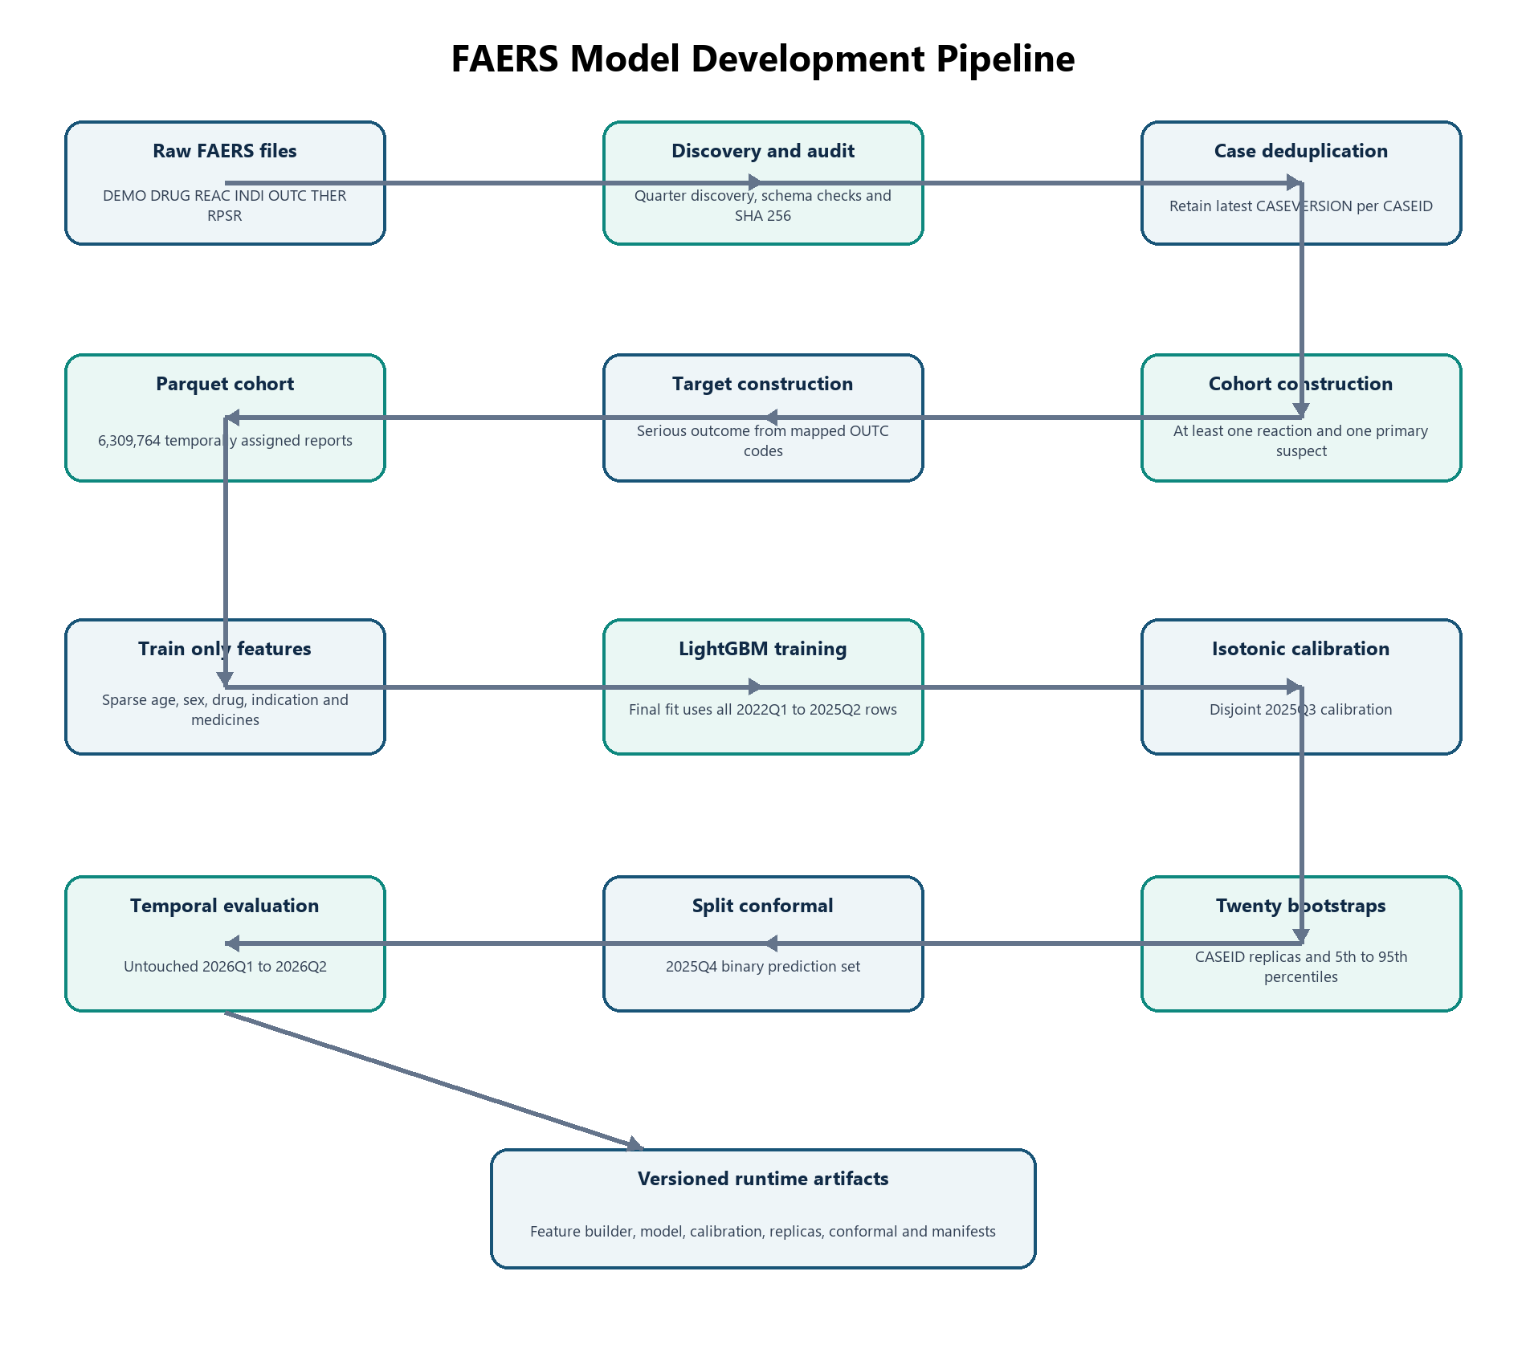
Figure 4 FAERS LightGBM model development pipeline

13.1 Feature Engineering
A deterministic feature builder is fitted only on development rows. It creates separate vocabularies for candidate medicines, indications, candidate-indication combinations and concomitant medicines. Numeric features include scaled age, age-missing status, medicine count, polypharmacy and unknown-medicine count. Categorical values are represented in a sparse compressed-row matrix. Explicit unknown categories preserve a stable feature schema during serving.

13.2 Temporal Design
Purpose | Period
Initial development | 2022Q1 to 2024Q4
Tuning validation | 2025Q1 to 2025Q2
Final selected model fit | 2022Q1 to 2025Q2
Isotonic calibration | 2025Q3
Conformal calibration | Deterministic half of 2025Q4
Operating threshold selection | Other deterministic half of 2025Q4
Untouched temporal evaluation | 2026Q1 to 2026Q2

No CASEID crosses partitions. The later holdout measures temporal generalization more realistically than a random split, although it does not replace external or prospective clinical validation.

13.3 LightGBM Training
LightGBM trains a sequence of gradient-boosted decision trees. Each tree reduces errors from the existing ensemble. The algorithm handles nonlinear relationships, sparse structured inputs and millions of observations efficiently. Hyperparameter tuning uses a deterministic quarter-and-class representative subset. The selected model is fitted on every final-fit row from 2022Q1 through 2025Q2.

13.4 Baseline Models
The laptop-safe training workflow compares the selected LightGBM configuration with scalable baseline families, including a prior dummy, SGD logistic classification and Complement Naive Bayes. Baselines use the same development-only representation and temporal validation period so the comparison remains meaningful.

13.5 Probability Calibration
Raw classification probabilities are mapped through isotonic regression fitted on 2025Q3. Calibration improves agreement between predicted probabilities and observed serious-class frequencies in the calibration setting. It does not turn FAERS output into exposed-population incidence.

13.6 Bootstrap Model Variability
Twenty LightGBM replicas use deterministic CASEID-level bootstrap multiplicities. Runtime inference obtains twenty calibrated probabilities. The 5th and 95th percentiles form the displayed 90 percent model-variability range. The upper percentile is the conservative adjusted value used by the recommendation formula. The range measures variation across retrained models; it is not a patient confidence interval.

13.7 Split Conformal Classification
Split-conformal classification uses a disjoint 2025Q4 subset to produce a set of plausible classes. A singleton set focused on SERIOUS_OUTCOME or NO_DOCUMENTED_SERIOUS_OUTCOME expresses a narrower classification. A two-class set means both classes remain plausible. The nominal target coverage is 90 percent. The untouched 2026 holdout achieved approximately 87.39 percent empirical coverage, so the result must not be presented as a guaranteed 90 percent confidence statement.

13.8 Operating Threshold
A threshold of 0.389 was selected on the separate operating-point half of 2025Q4 by maximizing specificity while maintaining sensitivity of at least 90 percent. This threshold is preserved for offline evaluation. It is not consumed by the live probability display, recommendation ranking, clinical safety tiers or conformal output.

13.9 Reproducibility and Checkpointing
The training pipeline fingerprints cohort.parquet, dataset_manifest.json, data_quality.json, pipeline version and configuration. Mismatched identities stop execution instead of reusing stale checkpoints. The sparse feature cache, tuning models, baselines, final model, calibrator and each bootstrap replica are checkpointed. Partial full artifacts remain isolated until every required stage completes.

14 Understanding Model Outputs

Figure 5 Correct mathematical interpretation of the FAERS classifier

14.1 Correct Probability Meaning
Let R equal one when a FAERS adverse-event report exists. Let Y equal one when that report contains at least one documented serious-outcome code. Let X contain the runtime patient-drug context. The model estimates the probability that Y equals one given X within the selected reporting population where R already equals one.
It does not estimate the probability that an adverse event occurs among all patients exposed to the medicine. FAERS does not contain the complete number of exposed people who experienced no event, so the denominator required for incidence estimation is unavailable.

14.2 Meaning of an 89 Percent Result
An 89 percent result means that the calibrated model assigns 0.89 probability to the documented serious-outcome class for a FAERS report with a similar encoded context. It does not mean that the patient has an 89 percent probability of developing a side effect. It also does not mean that the patient has an 89 percent probability of hospitalization because hospitalization is combined with six other serious-outcome categories.
The training cohort contains reports submitted after an adverse event occurred. Runtime use applies the model to a proposed medicine before prescribing. This training-to-use difference is a major scientific limitation and must be stated in project presentations.

14.3 Point Estimate
The point estimate is the isotonic-calibrated output of the primary LightGBM model. The current frontend describes it as a FAERS report-level estimate. A more accurate page title is FAERS Serious Outcome Assessment rather than Overall Adverse Risk.

14.4 Bootstrap Range
A display such as 88 to 91 percent means that twenty case-bootstrap model replicas produced values whose 5th and 95th percentiles were 0.88 and 0.91. It describes model variability under the bootstrap procedure. It is not a statement that the patient's true medical risk lies in that interval.

14.5 Uncertainty Adjusted Value
The uncertainty-adjusted value is the upper bootstrap percentile. The recommendation engine uses this value conservatively so the primary model's lower point estimate does not dominate ranking when bootstrap replicas produce higher values.

14.6 Conformal Prediction Set
Prediction Set | Interpretation
SERIOUS OUTCOME only | The conformal output is focused on the serious-outcome class.
NO DOCUMENTED SERIOUS OUTCOME only | The output is focused on the no-documented-serious-outcome class.
Both classes | The result is ambiguous at the configured conformal threshold.
Empty set | The result is invalid or unavailable and requires review.

Conformal prediction produces a set of labels, not a probability confidence interval. It does not receive an independent weight in recommendation ranking.

14.7 Degraded Coverage
Degraded coverage means that the candidate drug, indication or one or more current medicines were not fully represented by the trained vocabularies. A numerical output may still exist, but the system does not present it as complete evidence. Degraded is an input-coverage status, not a medical severity category.

14.8 Unavailable Assessment
When the Python service cannot be reached, the request times out, full model artifacts are missing or response validation fails, the page shows an unavailable or failed state. It explicitly states that no low or zero risk was inferred. Retrying repeats the assessment request; it does not reuse a fabricated fallback value.

15 Recommendation Engine
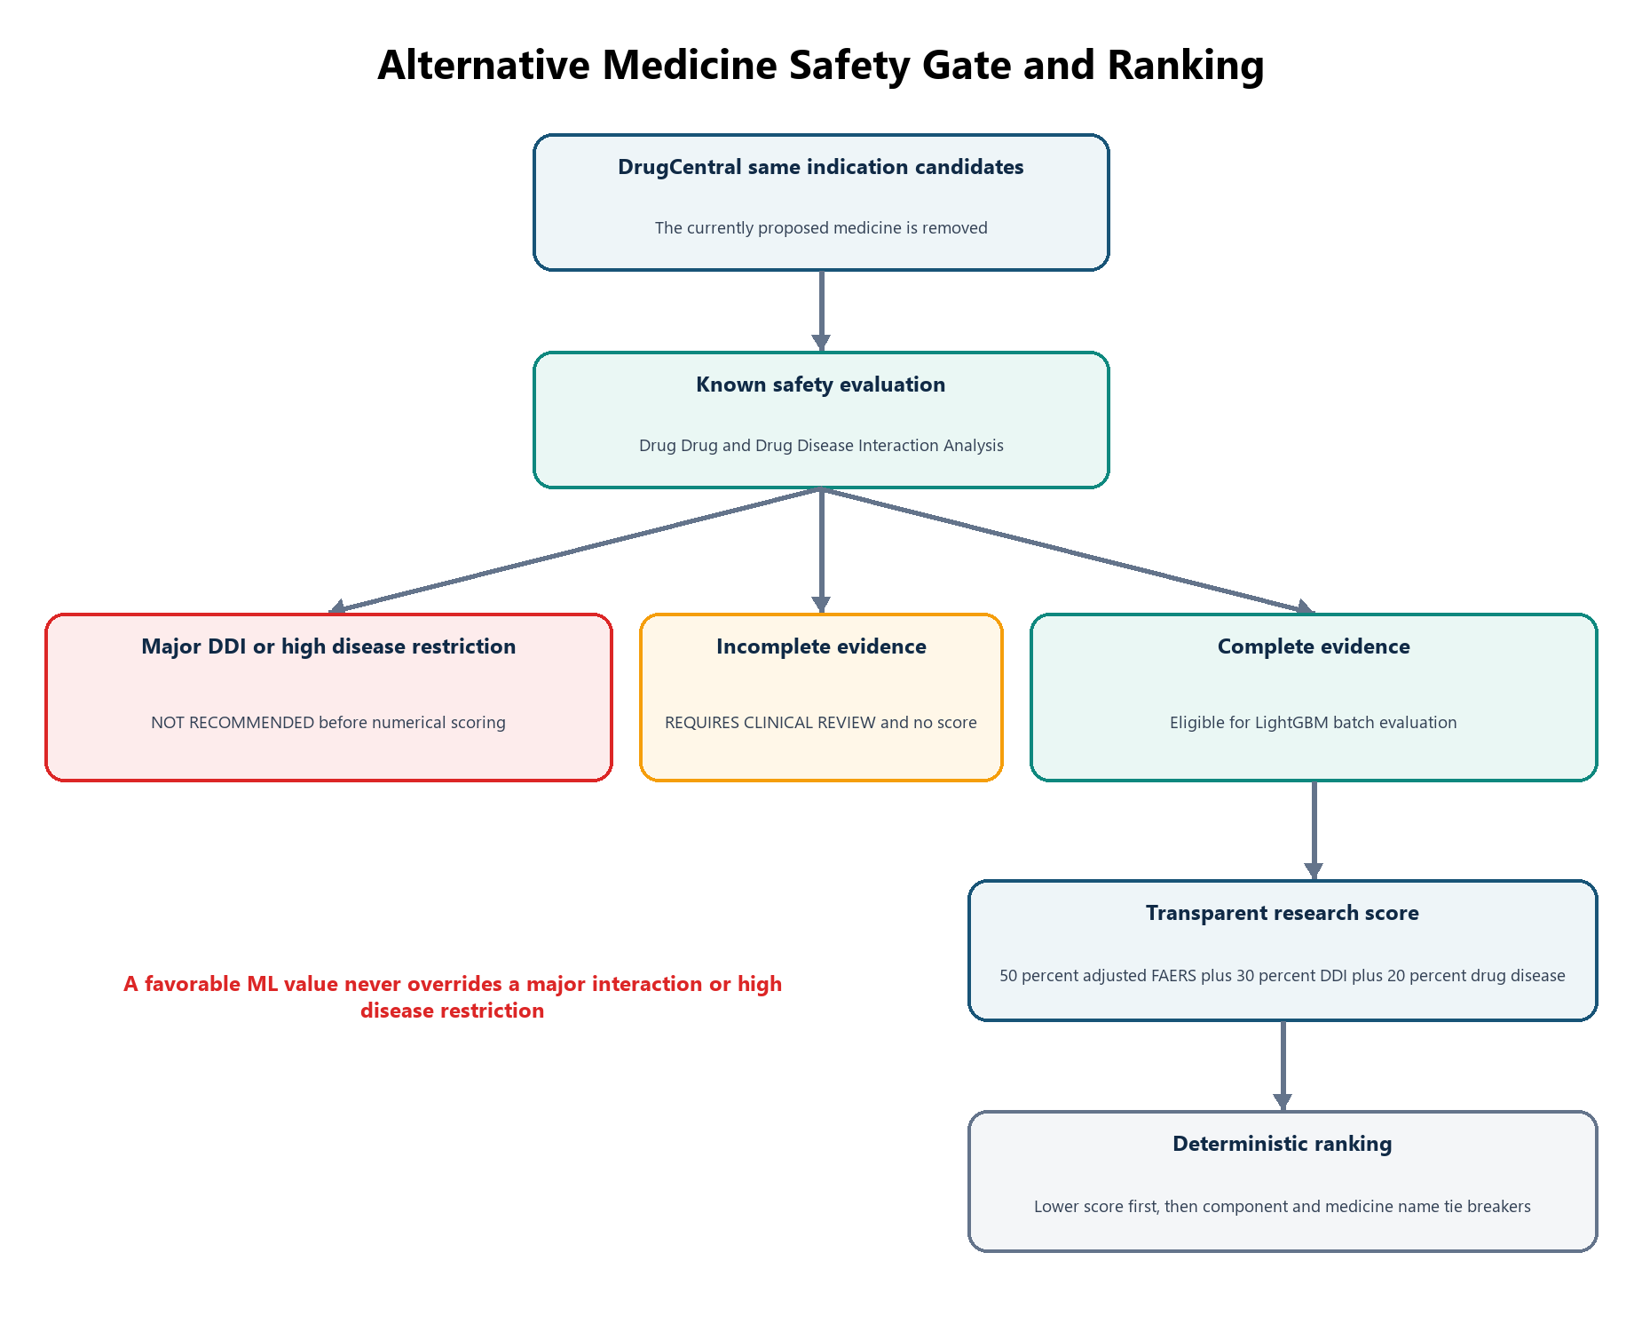
Figure 6 Alternative medicine safety gate and ranking pipeline

15.1 Candidate Generation
DrugCentral supplies up to twenty-five generic medicines linked to the selected indication. The currently proposed medicine is removed from the alternative list. Each remaining candidate is evaluated independently against the patient's active medicines and conditions.

15.2 Known Evidence Evaluation
For each alternative, the system determines whether the candidate and every active medicine have sufficient DDInter coverage. It evaluates every candidate-current medicine pair, retains the worst documented severity and records unresolved terms. Conditions are resolved to DrugCentral disease identities and checked against the candidate. Evidence is complete only when essential drug and condition terms can be evaluated.

15.3 Safety Gates
A candidate with a major DDI or high drug-disease restriction is marked NOT RECOMMENDED before scoring. A candidate with incomplete known evidence is marked REQUIRES CLINICAL REVIEW. LightGBM runs only for candidates that pass the known-evidence gate. A missing or degraded ML result also causes review rather than a substituted zero.

15.4 Numeric Mappings
Evidence | Normalized Input
Complete check with no documented relationship | 0.00
Minor DDI or low disease assessment | 0.10
Moderate DDI or moderate disease assessment | 0.50
Major DDI or high disease assessment | Excluded before scoring
Incomplete evidence | No score inferred

15.5 Ranking Formula

Figure 7 Research configured recommendation formula

Figure 8 Displayed safety aware score
The weights indicate relative influence inside the project ranking algorithm. Fifty percent comes from the upper LightGBM bootstrap value, thirty percent from normalized DDInter evidence and twenty percent from normalized drug-disease evidence. These are configured research hyperparameters. They have not been established as universal clinical weights.
A higher displayed safety-aware score means better placement under the configured formula. It is not a clinically validated percentage of safety and should not be interpreted as the chance that the patient will remain free from side effects.

15.6 Ranking Order and Tie Breaking
1. Lower final risk score
2. Lower adjusted FAERS value
3. Lower DDI value
4. Lower drug-disease value
5. Alphabetical generic medicine name
This ordering makes results reproducible. No language model or random-number generator participates in the ranking.

15.7 Recommendation Page Parameters
Parameter | Meaning
Assessment | Final workflow state such as recommended, not recommended or requires clinical review
Source | Dataset that supplied the same-indication candidate
Indication relationship | DrugCentral evidence connecting the candidate with the selected indication
Drug Drug Interaction Analysis | Worst DDInter classification against active medicines
Drug Disease Interaction Analysis | Worst DrugCentral assessment against recorded conditions
Safety gate | Whether the candidate may proceed to numerical ranking
Evidence completeness | Whether every essential known-evidence input was resolved
Final risk score | Weighted project-ranking result
Final safety aware score | One minus the final risk score, displayed on a 0 to 100 scale
Adjusted FAERS value | Upper bootstrap value used as the LightGBM component
Bootstrap range | Variability across twenty model replicas
Conformal reliability | Focused or ambiguous classification-set information

16 Application Modules
Module | Responsibility
Authentication | Registration, login, logout, session restoration and clinician identity
Doctor Profile | Contact updates with protected professional details
Patient Management | Demographics, conditions, allergies, medicines and timeline
Consultation | Candidate medicine, verified indication, dosage, frequency and status
Clinical Safety | DDInter and DrugCentral analyses with explanations
FAERS Assessment | Calibrated LightGBM output, bootstrap range, conformal set and coverage
Recommendations | Candidate retrieval, safety gates, ranking and reason text
Doctor Notes | Consultation-linked clinical notes
Follow Up | Observed event, severity, duration, notes and completion
Audit | Actor, action, entity, request identifier, time and metadata
Specific Event Profile | Protected baseline HGNN event-label scores, coverage, provenance and explicit failure states

16.1 Frontend Page Structure
Public pages contain the landing, registration and login experiences. Protected pages contain the dashboard, doctor profile, new-patient workflow, patient record, FAERS assessment and event-risk status page. A shared application layout provides the product header, doctor controls, theme control, patient identity strip and visit timeline.

16.2 Wizard Navigation
Clinical Safety, Adverse Risk Assessment, Event Profile and Recommendations operate as one visit workflow. The headings provide direct navigation to available stages. Follow-up remains locked until the required earlier stage is complete. The current stage is visually distinct and cannot trigger redundant navigation.

16.3 Event Level Model Status
The Specific Event Profile loads the protected epoch 20 baseline HGNN through the internal model service. It displays ordered event-label model scores as supplementary evidence and labels the output Baseline and Audit Pending. These scores are not patient-incidence probabilities. The module never influences LightGBM, clinical safety gates, candidate generation, recommendation scoring or tie-breaking.

17 Database Design
Entity | Purpose
Clinician | Account and professional profile
Patient | Patient identity, demographics and version
PatientCondition | Recorded diseases and terminology identifiers
PatientAllergy | Recorded allergy information
PatientMedication | Medication history and normalization provenance
Consultation | Proposed treatment encounter
ClinicalAnalysis | Persisted DDInter and DrugCentral result
AdrPrediction | Persisted FAERS model result
RecommendationSet | Versioned alternative snapshot
DoctorNote | Consultation notes
FollowUp | Observed post-consultation event
IntakeDraft | Incomplete form state
MedicationTerminology | Brand-to-generic knowledge
DrugInteractionKnowledge | DDInter pair relationships
DrugDiseaseKnowledge | DrugCentral disease relationships
DrugIndicationKnowledge | DrugCentral indication relationships
AuditEvent | Traceability record
HgnnEventPrediction | Versioned baseline HGNN event profile

17.1 Clinical Relationships
A clinician owns patients and consultations. A patient owns conditions, allergies, medications and consultations. Each consultation can have analyses, ADR predictions, versioned HGNN event profiles, recommendation sets, notes and follow-ups. Cascade deletion applies to child analytical records, while patient deletion through the API is implemented as a soft archive.

17.2 Persistence and Version Invalidation
An ADR prediction stores its result JSON, model version, input hash and generation time. An HGNN event profile stores result JSON, model and checkpoint versions, model stage, audit state, input hash, coverage state and generation time. A recommendation set stores candidate snapshots, the composite engine version and an input hash that includes indication provenance, medicines, conditions, safety evidence, model coverage and model versions. Changed inputs or artifacts therefore produce a distinct reproducible snapshot instead of silently changing an older result.

17.3 Audit Events
Audit records contain the actor, action, entity type, entity identifier, request identifier, timestamp and non-sensitive metadata. Examples include patient creation, consultation creation, safety assessment generation, ADR prediction generation, recommendation generation, note append and follow-up append.

18 API Design
Area | Principal Endpoints
Health | GET /api/v1/health and GET /api/v1/ready
Authentication | POST register, login and logout; GET current clinician
Patients | GET and POST patients; GET, PATCH and DELETE patient
Profile Collections | PUT conditions, allergies and medicines
Consultations | POST patient consultation and GET consultation
Clinical Safety | POST and GET clinical-safety-assessment
FAERS Assessment | POST and GET adr-predictions
Specific Event Profile | GET and POST adverse-event-risks
Recommendations | POST and GET recommendations
Follow Up | POST and GET follow-ups
Terminology | Medication, indication, condition and adverse-event lookups
Python Service | GET health and HGNN status; POST LightGBM predict, batch predict and HGNN predict events

Successful Express responses contain data and a request identifier. Errors contain a structured code, message, optional details and the same request identifier. Express propagates request identifiers to the Python service, uses a bounded timeout and validates successful ML responses before persistence.

19 Technologies Used

19.1 Frontend
Technology | Purpose
React 19 | Component-based clinician interface
React Router | Protected routes and wizard navigation
Vite | Development server and production build
Tailwind CSS | Responsive design and application color system
Framer Motion | Controlled interface transitions
Lucide React | Interface icons
Context API | Authentication, theme and patient state

19.2 Backend
Technology | Purpose
Node.js | JavaScript server runtime
Express 5 | Versioned REST API
PostgreSQL | Relational persistence
Prisma | Schema, migrations and database access
Zod | Request and ML-response validation
bcrypt | Password hashing
JSON Web Tokens | Access authentication
Helmet | HTTP security headers
CORS | Allowed-origin control
Express Rate Limit | Authentication abuse protection
Morgan | Request logging

19.3 Machine Learning
Technology | Purpose
Python 3.12 | ML runtime
Pandas and NumPy | Tabular and numerical processing
PyArrow and Parquet | Efficient large-cohort storage
SciPy sparse matrices | Memory-efficient feature representation
scikit-learn | Calibration, baselines and metrics
LightGBM | Active serious-outcome classifier
Joblib | Model-artifact persistence
FastAPI and Uvicorn | Internal inference service
PyTorch and PyTorch Geometric | Protected baseline HGNN graph construction and inference
XGBoost | Research comparison dependency
pytest | ML verification

19.4 Testing and Development
Vitest and Supertest validate JavaScript services and API behavior. pytest covers preprocessing, deduplication, normalization, feature parity, unknown categories, bootstrap quantiles, conformal construction, HGNN leakage safeguards and API validation. ESLint checks JavaScript quality. Prisma validates the data model. Vite produces the frontend bundle.

20 Security Reliability and Failure Handling

20.1 Security Controls
- bcrypt password hashing
- JWT validation
- Clinician ownership filtering
- Zod validation at write boundaries
- Request body limits
- CORS allow list
- Helmet security headers
- Authentication rate limiting
- Sanitized error responses
- Request correlation identifiers
- Audit logging
- Soft patient deletion
- Optimistic version checking

20.2 Model Service Reliability
The Python service loads only approved full-mode artifacts. Runtime validation requires a manifest that declares full final data, fastMode false and exactly twenty contiguous bootstrap replicas. Express applies a timeout, validates the returned schema and persists the model version. Smoke or partial artifacts cannot be presented as final evidence.

20.3 Failure States
Status | Meaning
SUCCESS | Full usable model output was produced.
DEGRADED COVERAGE | A result exists, but some inputs were outside the trained vocabulary.
ML UNAVAILABLE | The internal service or required full artifacts are unavailable.
INFERENCE FAILED | The prediction process did not complete.
OUT OF VOCABULARY | An essential term cannot be represented reliably.
REQUIRES REVIEW | Essential known or learned evidence is incomplete.
NOT RECOMMENDED | A major DDI or high disease restriction blocked ranking.
RECOMMENDED | The candidate passed gates and received a score.

The system never replaces an unavailable result with zero risk. This behavior prevents a technical failure from appearing as clinical reassurance.

21 Model Evaluation
The untouched 2026Q1 to 2026Q2 holdout contains 696,604 FAERS reports. It includes 370,840 serious-outcome labels and 325,764 no-documented-serious-outcome labels. The holdout was not used to select the operating threshold.
Metric | Holdout Result | Interpretation
AUROC | 0.8177 | Discrimination across classification thresholds
AUPRC | 0.8212 | Precision-recall performance for the serious class
Brier score | 0.1743 | Mean squared probability error; lower is better
Expected calibration error | 0.0358 | Average probability calibration gap
Sensitivity at 0.389 | 0.9018 | Serious reports correctly identified
Specificity at 0.389 | 0.5404 | Non-serious reports correctly identified
Precision | 0.6907 | Predicted-serious reports that were labelled serious
F1 score | 0.7823 | Balance between precision and sensitivity
Balanced accuracy | 0.7211 | Average of sensitivity and specificity

21.1 Conformal Evaluation
Measure | 2026 Holdout
Nominal target coverage | 0.9000
Empirical coverage | 0.8739
Average prediction-set size | 1.3183
Singleton rate | 0.6817
Ambiguous two-class rate | 0.3183
Empty-set rate | 0.0000

These results demonstrate useful FAERS report-level discrimination with meaningful temporal degradation and imperfect conformal coverage. They do not establish clinical utility, causality or individual event incidence.

21.2 Metric Interpretation
AUROC measures whether serious reports tend to receive higher scores than non-serious reports. AUPRC focuses on precision and recall for the serious class. Sensitivity measures how many serious reports are detected at the chosen threshold. Specificity measures how many no-documented-serious reports are correctly rejected. Brier score evaluates squared probability error. Expected calibration error evaluates the difference between predicted probabilities and observed class frequencies.

22 Advantages
- One workflow integrates terminology, DDI, drug-disease and FAERS evidence.
- Indian brand names retain their mapping source and generic identity.
- Every active medicine is included in pairwise interaction review.
- Missing evidence remains distinct from a completed negative lookup.
- Hard safety gates precede numerical ranking.
- Bootstrap and conformal results make model limitations visible.
- Temporal evaluation reduces optimistic random-split reporting.
- Results retain model versions, dataset provenance and input hashes.
- Clinician ownership and audit records support traceability.
- Deterministic tie-breaking makes repeated rankings reproducible.

23 Limitations

23.1 Scientific Limitations
- FAERS is a spontaneous-reporting system with reporting, selection and notoriety bias.
- FAERS lacks the complete number of exposed patients, so incidence cannot be calculated.
- A submitted report does not prove that the medicine caused the event.
- The model is trained on reports created after an event but is applied to a proposed medicine before prescribing.
- The positive label combines hospitalization, death, disability and other serious outcomes.
- Temporal holdout evaluation is not prospective or external clinical validation.

23.2 Input Limitations
The active model does not use dosage, frequency, route, laboratory measurements, kidney function, liver function, pregnancy, genetics, previous reactions, treatment duration or detailed longitudinal history. Conditions are evaluated through DrugCentral rather than included in the LightGBM vector. Allergies remain manual clinician-reference information.

23.3 Knowledge Limitations
No documented database relationship does not prove safety. DrugCentral relationship severity is derived through transparent keyword rules that require further clinical review. Unrecognized terminology can reduce coverage. Allergy automation is not active.

23.4 Recommendation Limitations
The 50 30 20 weights are research choices. The resulting score is not a validated medical safety scale. Alternative candidates depend on DrugCentral indication coverage. Efficacy, dose suitability and individual treatment benefit are not comprehensively modeled.

23.5 Deployment Limitations
The project has not completed prospective validation, regulatory review, formal fairness assessment, production privacy review or clinical governance approval. Production deployment would also require managed identity, refresh-token rotation, TLS, secret management, backups, monitoring and approved data-retention procedures.

24 Future Development

24.1 Patient Level Adverse Event Prediction
A patient-level occurrence model requires a different cohort containing every exposed patient, including patients with no event during a defined follow-up period. A suitable target could be a clinically documented adverse drug reaction within thirty days after treatment initiation. Hospitalization should be a separate endpoint rather than combined automatically with every adverse event.
Required data would include prescription dates, dosage, route, exposure duration, diagnoses, laboratory values, renal and liver function, previous admissions, concurrent medicines, confirmed outcomes and complete follow-up time. Candidate methods include calibrated LightGBM, survival analysis, longitudinal neural networks and pretrained EHR encoders fine-tuned on a precisely defined endpoint.

24.2 Event Level Prediction
The protected baseline HGNN is now available through a separate supplementary runtime path. Its event-label outputs remain model scores rather than calibrated probabilities, and the interface identifies its audit as pending. Future work must complete temporal and external evaluation, calibration, subgroup analysis, leakage review and clinical interpretation before any claim of individual event probability or any proposal to change ranking.

24.3 Additional Work
- Develop separate models for specific adverse reactions and hospitalization.
- Add clinically governed allergy and dose checking.
- Validate terminology mapping across institutions and languages.
- Calibrate and externally validate the ranking formula and weights.
- Evaluate fairness across demographic and clinical subgroups.
- Add prospective silent-mode testing before clinical use.
- Introduce model monitoring, drift detection and formal change control.
- Use a managed production identity provider and secure deployment infrastructure.

25 Baseline HGNN Specific Event Profile

25.1 Purpose and Correct Interpretation
The Specific Event Profile answers a narrow supplementary question: which saved event labels receive the strongest association scores from the existing heterogeneous graph model for the encoded medicine and consultation context? A higher score means the baseline graph model learned a stronger event-label association. It does not mean that the patient has that percentage chance of developing the event. The output is not a diagnosis, incidence estimate or prescribing decision.

25.2 Protected Model Selection
Runtime uses the hash-verified hgnn_selection_best.pt checkpoint for faers-specific-adr-hgnn-1.0.0. The post-training manifest records selection at training epoch 20, while the checkpoint stores zero-based epoch 19. Its SHA-256 is 7ca91da8449c87e65c08550083eab12cf3e267faa9e44284c496853de7fa5420. The incomplete five-epoch final-refit checkpoint remains experimental and is not served. Integration did not retrain the model, change its layers, calibrate its outputs or optimize thresholds.

25.3 Graph Architecture
The model preserves four node types: report, drug, indication and ADR. Four lazy linear projections map their original features to 96 hidden channels. Two heterogeneous convolution layers use GraphSAGE operations, sum aggregation, residual addition and ReLU. A linear layer emits 100 logits in the exact order of the saved event vocabulary.
Component | Preserved implementation
Nodes | Report, drug, indication and ADR
Primary context edges | Report to primary-suspect drug, concomitant drugs and indication, with reverse relations
Historical edges | Drug to ADR and indication to ADR associations, with reverse relations
Encoder | Two HeteroConv layers with SAGEConv, sum aggregation, residual connections and ReLU
Output | Linear layer with 100 logits followed by one sigmoid operation at inference

25.4 Runtime Inputs and Graph Construction
Only age, normalized sex, candidate medicine, indication and active current medicines are accepted. Runtime reuses the training graph builder, including age scaling and missingness, sex indicators, medicine-count scaling, deterministic hashed entity features and saved development associations. Dose, route, laboratory results, allergies, genetics, renal or liver measurements and free-form notes are not invented as HGNN features.

25.5 End to End Pipeline
React Specific Event Profile
-> authenticated Express consultation route
-> ownership check and exact feature mapping
-> FastAPI HGNN status and prediction endpoints
-> protected checkpoint vocabulary and development associations
-> validated top K event-label scores
-> versioned PostgreSQL persistence
-> display only with ranking influence set to none
FastAPI validates the protected artifact bundle at startup and loads the HGNN once. It uses CUDA when available or CPU otherwise, sets evaluation mode and disables gradient recording. The endpoint applies sigmoid exactly once, rejects non-finite values, sorts by descending score with the event name as a deterministic tie-breaker and returns the configured top K labels.

25.6 API Persistence and Failure Behavior
Interface | Responsibility
GET v1 hgnn status | Reports readiness, versions, checkpoint hash, vocabulary, graph schema, device and audit state
POST v1 hgnn predict events | Validates supported inputs and returns actual ordered baseline event scores
GET application adverse event risks | Reuses a matching persisted event profile or generates one
POST application adverse event risks | Retries or regenerates the profile for the exact current input
HgnnEventPrediction | Stores versions, stable input hash, result, coverage, status and generation time
Unknown medicines or indications are identified and produce limited coverage. Missing files, hash or vocabulary mismatch, incompatible architecture, timeout, unreachable service, malformed response or inference failure produce an explicit unavailable state with an empty event list. The system never changes missing evidence into zero risk.

25.7 Interface Design
The responsive page follows the existing navy, clinical blue and teal design system and supports dark mode. It presents consultation context, wizard navigation, Baseline HGNN and Audit Pending badges, graph-coverage status, an ordered event list, numeric model-score text, accessible progress indicators, a short interpretation guide and expandable provenance. The bars use neutral blue and teal rather than clinical severity colors because the outputs are not validated low, moderate or high risk categories. Loading, empty, limited-coverage and unavailable states remain visually distinct. Navigation to Clinical Safety, Adverse Risk Assessment and Recommendations remains available even when HGNN inference fails.

25.8 Isolation and Remaining Audit
The event profile is display-only. Its result is not supplied to LightGBM, bootstrap or conformal calculations, DDInter analysis, DrugCentral analysis, safety gates, candidate generation, recommendation weights, sorting or tie-breaking. Before any future patient-probability claim, the project still requires calibration, temporal and external validation, label-quality review, subgroup and fairness analysis, clinical usability testing, monitoring and formal governance approval.

26 Conclusion
VitaNexus-RX integrates medication terminology, known interaction evidence, FAERS report classification, a supplementary event-label profile, uncertainty information, alternative ranking and consultation persistence. DDInter identifies documented drug-drug relationships. DrugCentral supports disease checks and same-indication candidate retrieval. LightGBM classifies serious outcomes within the selected FAERS reporting context. The protected baseline HGNN ranks event-label associations without changing any clinical safety or recommendation decision. Deterministic safety gates prevent major known risks from being overridden by either model.
The system's principal contribution is an evidence-aware workflow rather than an individual side-effect probability. Its safest behavior is the explicit separation of negative evidence, missing evidence and technical failure. Unknown evidence requires clinical review instead of being treated as low or zero risk.

Appendix A Correct Viva Description
VitaNexus-RX is an evidence-aware medication safety decision-support prototype. It normalizes Indian medicine brands to generic ingredients, checks a proposed medicine against active medicines using DDInter, checks it against patient conditions using DrugCentral and classifies whether a matching historical FAERS adverse-event report resembles the serious-outcome class using calibrated LightGBM. Twenty bootstrap replicas express model variability, and split-conformal prediction supplies a classification set. DrugCentral provides same-indication alternatives, which pass hard safety gates before eligible candidates receive a transparent research-configured ranking score. The system preserves patients, consultations, analyses, notes, recommendations, follow-ups, provenance and audit records. It does not predict the patient's actual probability of experiencing a side effect and is not an autonomous prescribing system.

Appendix B Technical Execution Commands
The following sequence describes the standard local development setup. Full FAERS preprocessing should not be repeated when the immutable cohort already exists.
npm install
npx prisma migrate deploy
npm run data:process
npm run data:import
py -3.12 -m venv ml\.venv
ml\.venv\Scripts\python.exe -m pip install -r ml\requirements.txt
npm run ml:benchmark
npm run ml:train:lightgbm
npm run ml:status
npm run ml:serve
npm run dev
Verification commands include npm run ml:test, npm run api:test, npm run lint, npm run build and npx prisma validate.

Appendix B.1 Runtime Service Order
The FastAPI model service should run through npm run ml:serve. Express and Vite should then run through npm run dev. The browser uses the Vite origin, Vite proxies API requests to Express and Express calls the internal Python service at the configured ADR_ML_BASE_URL.

Appendix C Implementation References
- Project README.md
- docs/CURRENT_SYSTEM_ARCHITECTURE.md
- docs/DATASET_INTEGRATION.md
- docs/LIGHTGBM_EVALUATION_SUMMARY.md
- ml/reports/FINAL_ML_IMPLEMENTATION_REPORT.md
- ml/src/vitanexus_ml/data/faers.py
- ml/src/vitanexus_ml/features/builder.py
- ml/src/vitanexus_ml/inference/predictor.py
- server/services/clinicalDemo.js
- server/services/recommendationRankingService.js
- server/services/rankingConfig.js
- docs/HGNN_EVENT_PROFILE.md
- docs/HGNN_IMPLEMENTATION_REPORT.md
- ml/src/vitanexus_ml/inference/hgnn_predictor.py
- server/services/hgnnEventProvider.js
- src/pages/AdverseEventRisks.jsx
- prisma/schema.prisma
- FDA Understanding CDER Postmarket Safety Surveillance Programs and Public Data
- ICH E2A Clinical Safety Data Management Definitions and Standards for Expedited Reporting
FDA reference URL https://www.fda.gov/drugs/cder-conversations/understanding-cders-postmarket-safety-surveillance-programs-and-public-data
ICH reference URL https://database.ich.org/sites/default/files/E2A_Guideline.pdf

