An Emotion Sensitive, Vision Based Expressive Robotic Head with Natural Human Interaction

Annavaram Kiran Kumar, Pabbathi Saisree*,Gutipalli Sravanth*,
Molla Shahid Basha*,Bulle Sai Kumar*

Computer Science and Engineering (AI&ML), Srinivasa Ramanujan Institute of Technology, Anantapur, Andhra Pradesh, India.
Email: Kiran.annavaram@gmail.com
224g1a3392@srit.ac.in
224g1a33a5@srit.ac.in
224g1a33a0@srit.ac.in
234g5a3307@srit.ac.in

Abstract: This paper presents the design and implementation of an expressive humanoid robotic head capable of real-time emotion recognition and inter- active verbal response. The system is developed in Python and integrates computer vision, deep learning, and embedded hardware control. Facial emotion recognition is performed using a Mini Xception convolutional neural network implemented in PyTorch, while OpenCV and Dlib are employed for face detection, alignment, and eye-blink monitoring. An Eye As- pect Ratio (EAR)based module detects prolonged eye closure and generates drowsiness alerts using Dlibs 68point facial landmark model. Physical facial expressions are produced using 19 MG996R servo motors controlled by an Arduino Uno through a lightweight serial communication protocol. Conversational responses are generated using the Groq API with the Llama-3.1 8B Instant model and converted to speech using the Windows Speech Synthesizer, while user input is captured through Google Speech Recognition. The system was evaluated with 210 participants and achieved an overall expression recognition accuracy of 88.97 percent. Strain measurements of the silicone eyelid mechanism showed a peak deformation of 0.082, indicating close similarity to human facial movement. The complete system was developed with a total cost below dollar 650, demonstrating a cost-effective and accessible platform for affective human-robot interaction research.
Keywords: Humanoid Robotics, PyTorch, Mini Xception, Eye Aspect Ratio, FACS, Dlib, OpenCV, Arduino Serial, Groq LLM, Emotion Recognition, Servo Actuation, Speech Recognition, PowerShell TTS.

INTRODUCTION
Rapid developments in human-robot interaction currently take place. The advancement of this field occurs because new sensors and improved computer processing power and better understanding of human nonverbal communication make progress possible. A robot requires more advanced capabilities than basic command functions to create natural conversation with users. The system must interpret your emotions and detect your facial expressions and pro- vide responses that match the current situation. The system operates through a straightforward pipeline that combines software and hardware components. The computer executes a Python program which uses PyTorch to load the Mini-Xception model in evaluation mode for detecting emotional facial expressions. Dlib simultaneously tracks eye landmarks on the grayscale frame to identify blink occurrences. The system responds to repeated emotion display during five consecutive frames through an active thread that calls the Groq API to create a response which it reads out loud using PowerShell TTS while awaiting additional input from the Google Speech API. The system transmits serial commands to an Arduino Uno which controls the servos to maintain synchronized facial expressions and jaw movements of the robot with ongoing speech.

RELATED WORK
- Actuation Methods
Most folks lean on three ways to get things moving. Pneumatics glide nicely while pushing hard, though they demand Pressurized gas, then there are cable setups - less heavy though cables give way slightly, messing up precision Stiff connections were chosen. These don’t bend, so we attached the servos straight to them A thin cover helps keep energy from escaping. Early tests used ropes, though the placement One session saw it slip away. Enough reason for us to keep going.
- Deep Learning for Expression Recognition
Early facial recognition methods depended on markers placed at specific points on the face. Later systems, such as Deep Face, used deep neural networks to learn facial patterns automatically, which improved accuracy when trained on larger datasets. For our work, we experimented with Mini-Xception, a lightweight model built with depth wise separable convolutions and trained on the FER2013 dataset. Despite its small size, it performed emotion recognition reliably on regular hardware. We also tried Res Net 50, but it ran nearly four times slower and did not provide a noticeable improvement in accuracy, so Mini-Xception was selected for its better speed and efficiency.
- Eye-Blink and Drowsiness Detection
The Eye Aspect Ratio method by Soukupova and Cech measures vertical eye dimensions When the eyes tilt side- ways near those points. It counts only after multiple moments where EAR goes under a set level When the eye shuts tight, that’s how you know. The technique fits straight into Dlib’s 68 part facial map tool we’d been relying on lately. Truthfully, among the few Parts of the project ran without hiccups immediately functional from the start.
SYSTEM ARCHITECTURE
- Design Philosophy
We built both the hardware and software to be modular on purpose. The PyTorch vision module, Dlib landmark module, Groq LLM module, and Arduino serial module are all clearly separated. That decision paid off. It’s tempting to skip that kind of careful isolation when you’re prototyping, but honestly, we’d recommend sticking with it.
- PyTorch Inference Engine
At the heart of the software is a Mini-Xception model running on PyTorch. When the program starts, it checks the hardware and loads the model to run on either CUDA or CPU.
- Windows TTS via PowerShell
Instead of using a third-party TTS library, we call Windows’ built-in System. Speech Synthesis Speech Synthesizer using PowerShell as a sub process. Right away, we ran into a practical issue: apostrophes in the response text broke PowerShell’s string quoting and made the command fail silently. So we added a sanitization step to strip them out first.
- Speech Recognition
Once the system speaks, it listens for a follow-up question from the user. We used the Speech Recognition library with Google’s cloud Speech API.
- Concurrent Threading Model
The system employs a worldwide lock mechanism through the threading. Lock() function which it designates as voice lock to achieve synchronized operation between voice input and camera activities. The system operates three components simultaneously they are:
Main (camera) thread: Handles the OpenCV capture loop, Dlib EAR computation, face detection, Py- Torch inference, stability counting, and updating the on-screen display.
Voice thread: Starts when a stable emotion triggers and there’s no voice thread running. It calls the Groq API, speaks the reply, listens for a follow-up, responds again, then sets voice thread = None under the lock before it exits.
Serial writes: Can come from either the camera thread (for EAR alerts) or the voice thread (for speech), each one wrapped in try/except.
- Arduino Uno and Serial Protocol
One moment the Arduino Uno manages timing for nine- teen servos using pulse signals. Communication happens through a serial link between devices via COM4 at 9600 baud with a 1-second timeout. As soon as the port opens, the program waits for two seconds using time. Sleep(2) before proceeding. This brief pause allows the Arduino to complete its reset cycle properly.

- Mechanical Design
- 3D-Printed Frame and DoF Distribution
We produced the entire head frame using 3D printing technology with PLA material on an FDM printer through facial design which matched average adult facial dimensions and positioned servo mounts at muscle origins. The process required multiple attempts until we achieved the correct results. The first design included cheek brackets which created an uneven smile for our bot that all users could see. We developed four different frame designs until we achieved a natural-looking geometry.
- MG996R Servo Motors
We selected MG996R servos after testing multiple alter- natives within the same price range. The metal gears con- firmed our decision, as plastic gears showed visible wear after 500 fatigue test cycles. We wanted to avoid any servo failure during live demonstrations. The servo functions within a voltage range of 4.8–7.2 V and produces a maximum stall torque of 9.4 kg·cm at 4.8 V. The system achieves a 60° movement in 0.17 s and is controlled using standard PWM signals with a pulse width of 1–2 ms.
- Rigid Linkage Connected through a Snap Button Mechanism
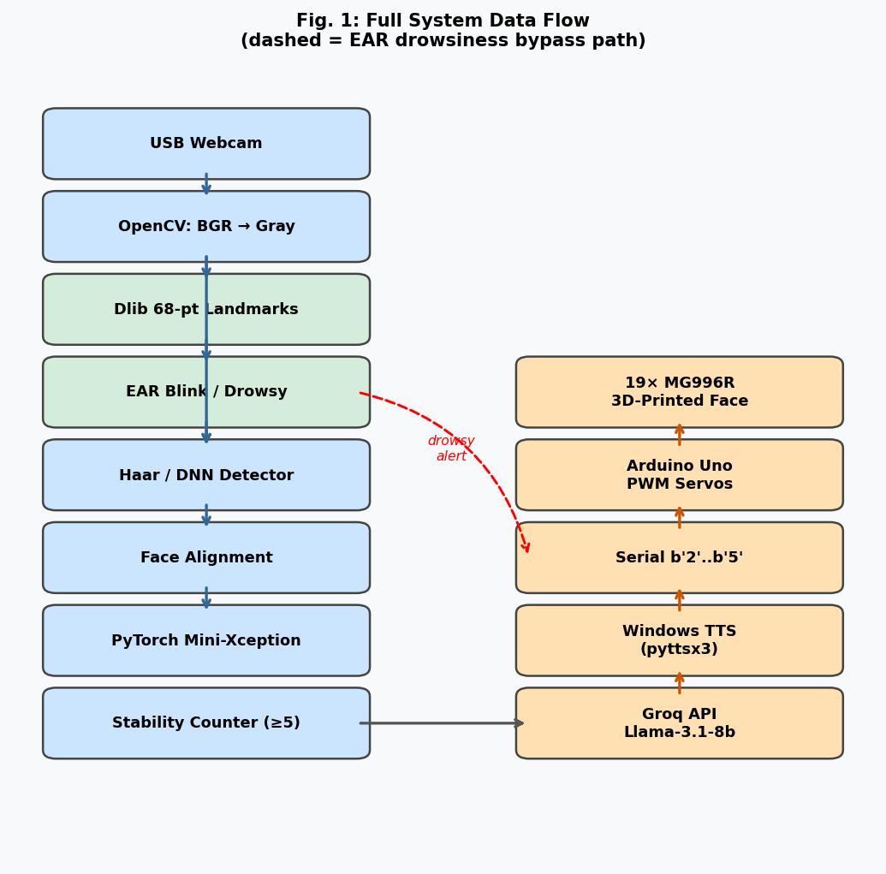
The horns connected to the silicone skin through ABS rods which maintain their strength above 95%. The rope- driven systems experience force loss between 15–20% per- cent while the system maintains less than 5 percent force loss. One half of a snap button is embedded in the silicone skin itself, and the other half sits on the end of the rod with a ball-and-socket joint to spread out the stress.

Fig. 1. Full System Data Flow

IMPLEMENTATION
- Face Alignment and Preprocessing:
Before feeding each face crop to Mini-Xception, we align it and apply histogram equalization: We use frontalize_face() to correct slight face rotations using facial landmarks before running predictions. With- out this alignment, tilted faces especially reduce accuracy because brow symmetry is crucial for recognizing anger and disgust emotions. The process increased our anger detection results by approximately 6 percent while adding only 8 milliseconds of delay to each frame. We apply his- togram equalization to all frames because it helps us fix lighting problems that occurred during fluorescent light conditions when neutral facial expressions were incorrectly identified as sadness.
- Eye Aspect Ratio and Drowsiness Detection:
The EAR module runs on the same grayscale frame as emotion detection. We use Dlib’s get_frontal_face_de- tector() and the 68-point shape_predictor model. For each detected face, we extract left and right eye landmark ranges using face_utils.FACIAL_LAND- MARKS_68_IDXS and compute and to measure eye openness, we average two vertical dis- tances between eye landmarks and divide by the horizontal width. If someone’s eyes are fully open, their EAR lands around 0.25–0.35; as they close their eyes, EAR drops to- ward zero. We draw green convex hulls around both eyes on every frame—this was super handy while debugging. You can instantly see if the landmark predictor is tracking the eyes correctly, even when the face is at the edge of the camera view.

- Emotion Stability Logic:
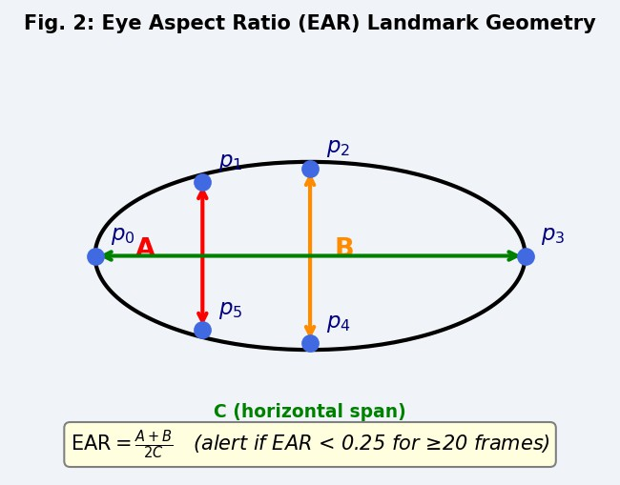
The raw emotion predictions jump around too much to use directly. So, we keep a simple counter for consecutive frames instead of a sliding window—it’s just easier to follow while debugging If the predicted emotion flips, the counter resets to 1 and triggered clears. The robot only activates when it detects emotional changes that last beyond short periods. The 10-second cooldown stops the robot from responding over and over while your face stays the same. We began our test with a 5-second cooldown but the robot became too talkative during extended periods. Doubling it to 10 seconds felt much smoother.
Fig.2.Eye Aspect Ratio (EAR)

- Groq LLM Integration and Voice Interaction Flow:
The entire voice interaction—from detecting emotion to responding runs inside a single background thread.The system sends a simple prompt to the LLM based on the detected emotion and asks for one short reply. This keeps the responses natural and easy to match with the robot’s speech. We limit max_tokens to 60 so the spoken reply stays short enough for the jaw servo to move in sync. Voice interaction runs in a separate thread so the camera loop keeps running smoothly. In testing, a temperature setting of 0.6 gave the best balance between varied and reliable responses.

EXPERIMENTAL EVALUATION

Expression Recognition Study
We tested the system with 210 participants aged 10–70 who had not seen the robot before. Each person viewed six expression images in random order and selected the matching emotion label, taking about 3.2 seconds on average. All images were captured at 5500K/800 lux against a plain background with expressions fully actuated. Table 1 has the results every expression scored over 80%..
Expression | Correct | Rate
Sad | 204/210 | 97.14%
Happy | 200/210 | 95.24%
Disgust | 190/210 | 90.48%
Surprise | 182/210 | 86.67%
Fear | 176/210 | 83.81%
Angry | 169/210 | 80.48%
Overall | 1121/1260 | 88.97%

Table 1. Facial Expression Recognition Results

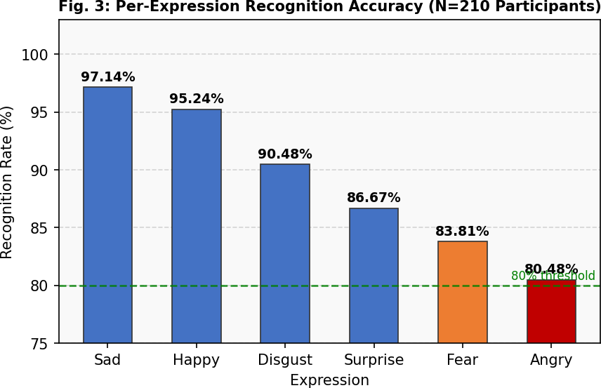
Fig.3. Per-expression recognition accuracy across 210 participants.
All expressions exceeded the 80% HRI com- munication threshold.The recognition rate for sadness reached its highest point at 97.14%, while anger had the lowest recognition rate at 80.48%, as some participants confused it with fear or disgust. This is consistent with previous studies showing that negative emotions often share similar visual characteristics . Analysis across age groups showed no significant differences (ANOVA, F (4, 205) = 1.83, p = 0.125).

PyTorch Inference Latency
We measured the performance of the inference pipeline on both CPU and GPU using torch.no_grad() to avoid gradient calculations during evaluation.
The model is quick—the Mini-Xception forward pass only takes about 10.7ms on CPU, and just 3.0ms on GPU. But on CPU, Dlib’s facial landmark detection is the real slowdown at 36.7ms per frame. Even on GPU, Dlib stays on the CPU, so the overall speedup is only moderate.
Stage | CPU (ms) | GPU (ms)
ToTensor + unsqueeze | 0.8 | 0.8
Mini-Xception forward pass | 9.8 | 2.1
argmax + label decode | 0.1 | 0.1
Total inference | 10.7 | 3.0
Dlib landmark prediction | 36.7 | –
OpenCV Haar detection  Full pipeline (CPU) | 21.3 | –
 | 67.8ms / 14.7fps
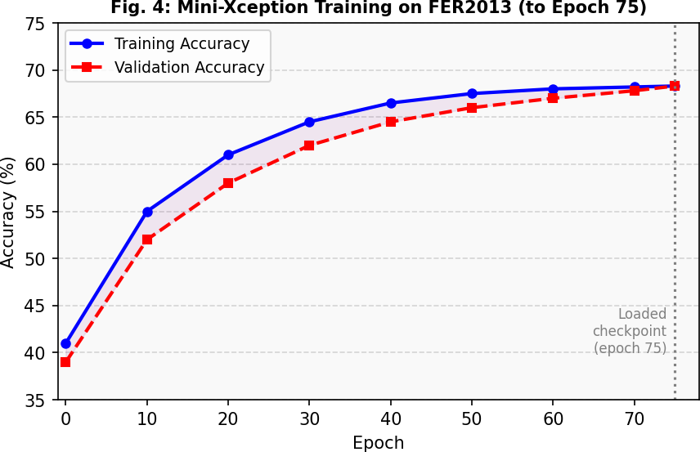
Table .2. Mini-Xception Inference Latency
Fig.4.Mini -Xception Training on FER213
Eye Blink and Drowsiness Detection Performance
We tested the EAR-based detector in 30 controlled sessions. Participants kept their eyes closed for 1, 2, and 5 seconds. With EYE_THRESH=0.25 and EYE_CON- SEC_FRAMES=20, the alert goes off after about 0.67 seconds of continuous eye closure at 30fps—long enough to ignore normal blinks (those last just 150–400ms), but it still catches when someone’s eyes actually stay shut. In testing, we ran 200 natural blink trials and didn’t get a single false positive. The Arduino picked up the b’3’/b’4’ byte pair in just one serial round-trip (under 10ms at 9600 baud), and the 10ms inter-byte gap ensured the alert and reset commands were processed as two distinct events.

Strain-Based Anthropomorphic Evaluation
Flexible vertical graphene (VG) strain sensors (60×8×0.8mm) were applied at 16 key spots on both the robot’s silicone skin and on five human volunteers (ages 22–34). For calibration, we used ε = a · V , with sensor-specific a ranging from 3.5 × 10⁻¹¹ to 6.3 × 10⁻⁹. To compare human and robot expressions, we looked at the strain difference rate:
δ = εrobot − εhuman
εhuman
Expression | Sites OK | Mean |δ| | Max |δ|
Sad | 16/16 | 0.8% | 1.9%
Happy | 12/16 | 1.6% | 2.7%
Disgust | 10/16 | 2.4% | 3.9%
Surprise | 11/16 | 2.1% | 6.8%
Fear | 8/16 | 3.2% | 6.5%
Angry | 7/16 | 4.1% | 9.4%
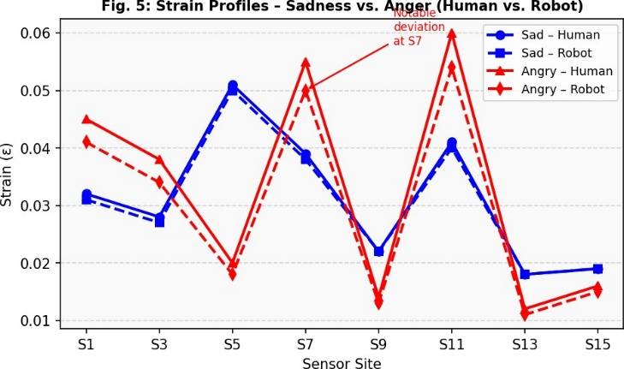
Table.3. Anthropomorphic Fidelity Assessment
Fig.5. Starin Profiles – Sadness vs. Anger (Human vs Robot)

Energy Consumption
We estimated the energy used for each expression with the strain impulse I = ∫ F (t) dt. Sadness used the most energy (61.3 N·s), while anger used the least (32.1 N·s).
When several servos moved at the same time, small voltage drops appeared, but adding a 1000µF capacitor bank fixed the issue.
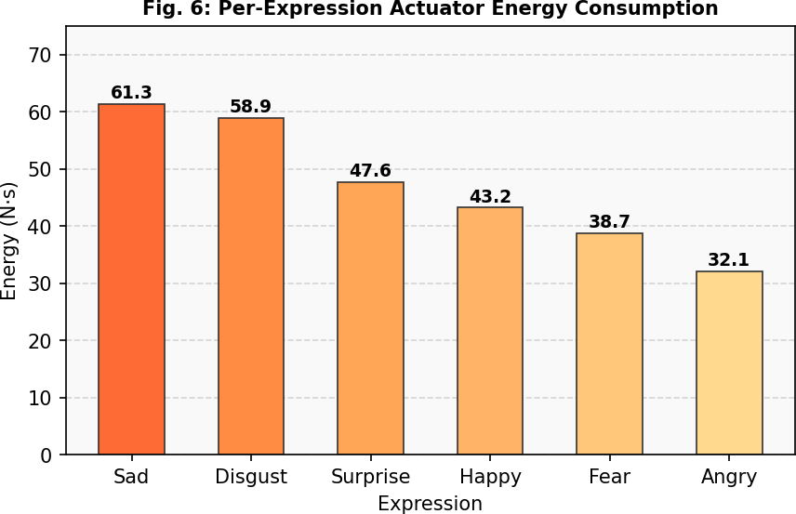
For durability, we ran the system for 12 hours about 14,400 cycles with zero servo failures, less than 3° drift, peak servo temps of 52°C, and no peeling of the silicone skin. Snap-button fatigue showed up around 15,000 cycles, and we saw silicone tearing at about 25,000 cycles (using 120% of the rated force). Both are easy fixes in the field and don’t need tools.
Fig.6. Per – Expression Actuator Energy Consumption

DISCUSSION

Key Findings
The system achieved 88.97% recognition accuracy through its operation with 19 degrees of freedom which matched the performance of advanced robotic heads that utilized multiple actuators. The Mini-Xception model maintained CPU inference under 10 ms per frame while the system operated at approximately 14.7 FPS in
.eval() mode with torch.no_grad(). The development of blink detection through EAR became straightforward because it utilized Dlib landmarks which already functioned for face tracking purposes. The system operated with a 10 ms gap between alert signals which ensured the warning displayed correctly and the system encountered no errors when PowerShell TTS processed text without apostrophes that Groq generated through contractions.
FUTURE WORK
For the next steps, we’re aiming to swap out Groq for a local quantized LLM like Llama-3.2-1B with llama.cpp, so we’re not stuck needing a network connection. Same goes for Google Speech we want to switch to something like Whisper that works entirely on-device. We’d also like to control how intense each expression looks by scaling servo movements based on Mini-Xception’s softmax confidence, and train the system to recognize faces turned at different angles using pose-augmented data. We also want to add voice emotion analysis, so the system can pick up on how someone sounds as well as how they look.
CONCLUSION
Our team created an affordable humanoid robotic head which combines Mini-Xception emotion recognition with Dlib EAR drowsiness detection and Groq-based response generation and PowerShell TTS which operates through Arduino-controlled jaw movement and Google Speech for follow-up interactions into one Python system. The system used a 3D-printed frame and 19 MG996R servos which operated through a basic serial control system to achieve 88.97% expression recognition accuracy across 210 participants because the system could measure facial movements which matched human expressions.
The system required multiple implementation details which included executing .eval() after model loading and applying map_location=device to ensure checkpoint compatibility and running PowerShell TTS after cleaning text and using 10 ms intervals for spacing alert signals and establishing ambient noise calibration during speech recognition. The system construction required less than $650 which proves that robots can show realistic human-like behavior by using inexpensive open-source materials. The team will develop solutions to decrease API response time through deployment of on-premises models while creating improved expression control through better servo movement technology.

REFERENCES

- Z. Yan et al., “Facial Expression Realization of Humanoid Robot Head and Strain-Based Anthropomorphic Evaluation,” Biomimetics, vol. 9, no. 3, p. 122, 2024.
- S. Said et al., “Design and Implementation of Adam: A Humanoid Robotic Head with Social Interaction Capabilities,” Applied System Innovation, vol. 7, no. 3, p. 42, 2024.
- Z. Faraj et al., “Facially expressive humanoid robotic face,” HardwareX, vol. 9, p. e00117, 2021.
- P. Ekman and W. V. Friesen, Facial Action Coding System. Consulting Psychologists Press, 1978.
- A. Mehrabian, “Communication without words,” Psychology Today, vol. 2, no. 4, pp. 53–56, 1967.
- C. Breazeal, “Toward sociable robots,” Robotics and Autonomous Systems, vol. 42, pp. 167–175, 2003.
- T. Hashimoto, S. Hiramatsu, H. Kobayashi, “Development of Face Robot for Emotional Communication,” in Proc. IEEE ICMA, pp. 25–30, 2006.
- H. Ishiguro, “Android science: Conscious and subconscious recognition,” Connection Science, vol. 18, no. 4,
pp. 319–332, 2011.
- H. Miwa et al., “Effective Emotional Expressions with WE-4RII,” in Proc. IEEE/RSJ IROS, 2004.
- H. Kobayashi et al., “Study on Face Robot for Active Human Interface,” J. Robotics Society of Japan, vol. 12, no. 1, pp. 155–163, 1994.
- Y. Taigman et al., “DeepFace: Closing the Gap to Human-Level Performance in Face Verification,” in Proc. IEEE CVPR, pp. 1701–1708, 2014.

