ASP.NET Core 8.0 Web API
Objective:
To create a simple ASP.NET Core Web API application, run it using Swagger, and test the GET endpoints.
Implementation:
Step 1: Create the Web API Project
- Open Visual Studio.
- Create a new ASP.NET Core Web API project named EmployeeWebAPI.
- Build the project successfully.
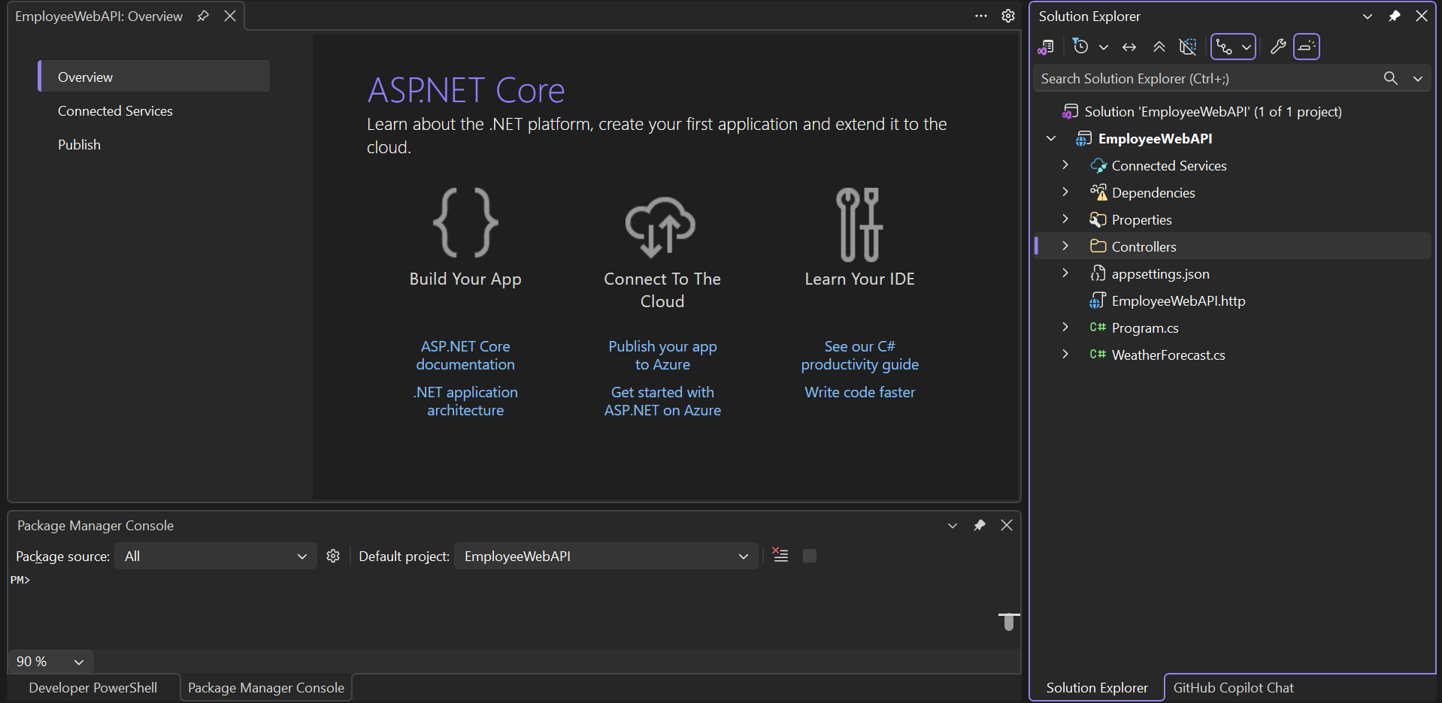

Step 2: Run the Application
- Run the application using the HTTPS launch profile.
- Verify that the application starts successfully and listens on the configured localhost URL. 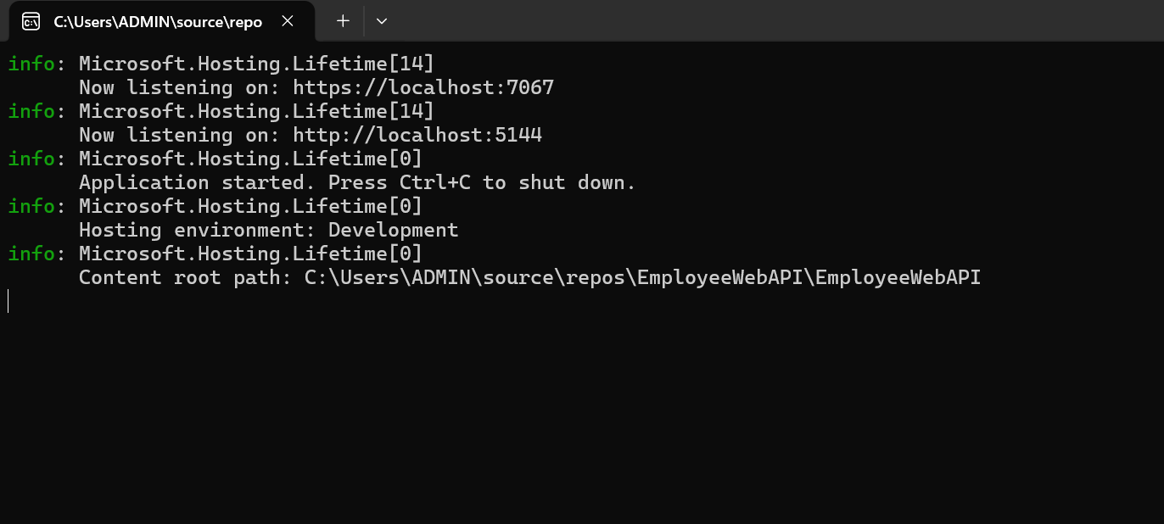

Step 3: Open Swagger UI
- Open the Swagger page in the browser.
- Verify that the available API endpoints are displayed.

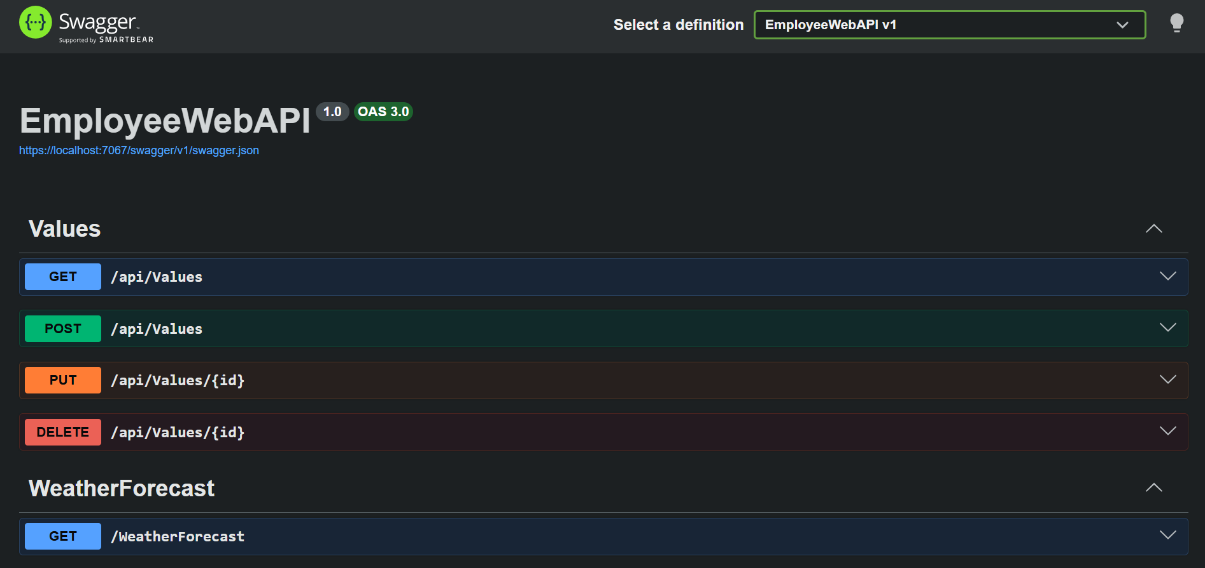

Step 4: Execute Values GET Endpoint

- Select GET /api/Values.
- Click Try it out and then Execute.

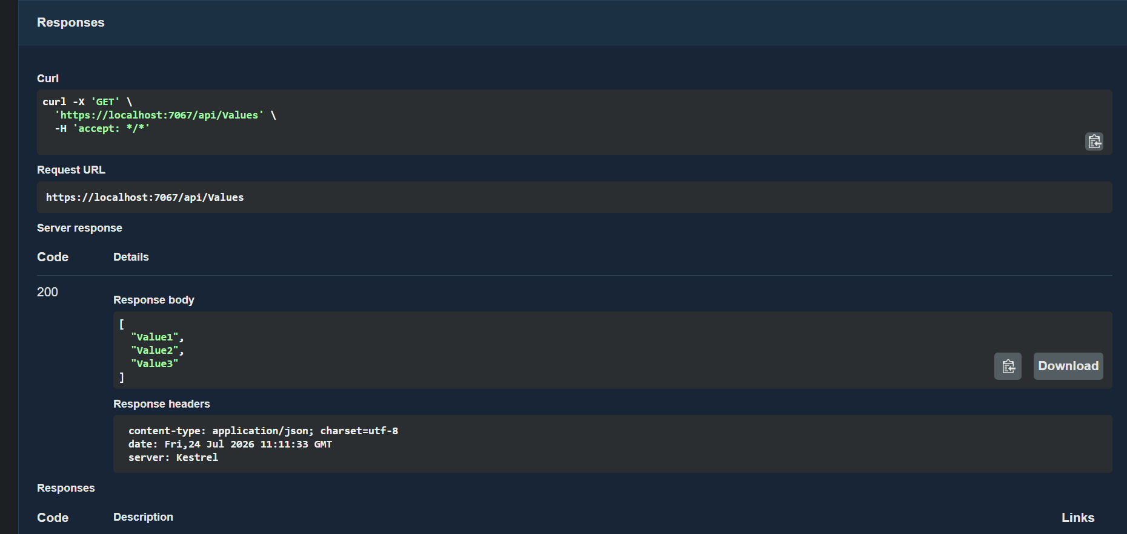

Step 5: Execute WeatherForecast GET Endpoint
- Select GET /WeatherForecast.
- Click Try it out and then Execute.
