Colorectal Cancer Detection using Pre-Trained Ensemble Algorithms
In this project we are employing Pre-trained ensemble deep learning algorithms such as InceptionV3, Resnet50 and EfficientNetB0. To train this algorithms we have utilized colorectal cancer images dataset from KAGGLE repository which can be downloaded from below KAGGLE URL.
https://www.kaggle.com/code/allunia/patterns-of-colorectal-cancer-image-clustering/input
Each algorithm is compared with various metrics such as Accuracy, precision, recall and FSCORE. Among all algorithms InceptionV3 is performing well.
To implement this project we have designed following modules
- New User Sign up: using this module user can sign up with the application
- User Login: after sign up user can login to system
- Train CNN Ensemble Algorithm: after login user can utilize this model to trained all algorithms and then perform prediction on test data to calculate accuracy and other metrics.
- Chatbot Colorectal Cancer Detection: using this module Chatbot will get activated which will ask user to upload image and then employ InceptionV3 algorithm to uploaded image to detect cancer. If cancer detected then Chatbot will forward user to Appointment page where user can appointment with desired doctor. If no cancer detected then user will get greet message from Chatbot.
SCREEN SHOTS
To run project install MYSQL database and then copy content from DB.txt and paste in MYSQL console to create database.
Install python 3.7 and then install all packages given in requirement.txt file and then double click on run.bat file to get below page
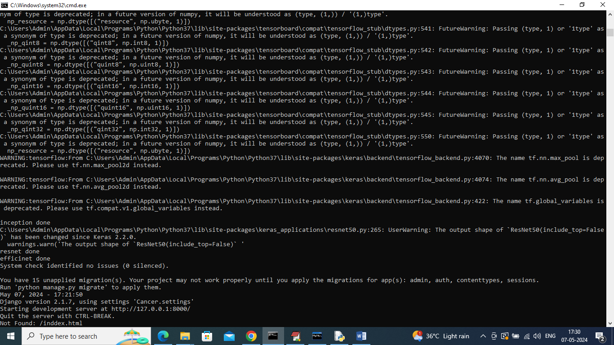
In above screen python server started and now open browser and enter URL as http://127.0.0.1:8000/index.html and press enter key to get below page
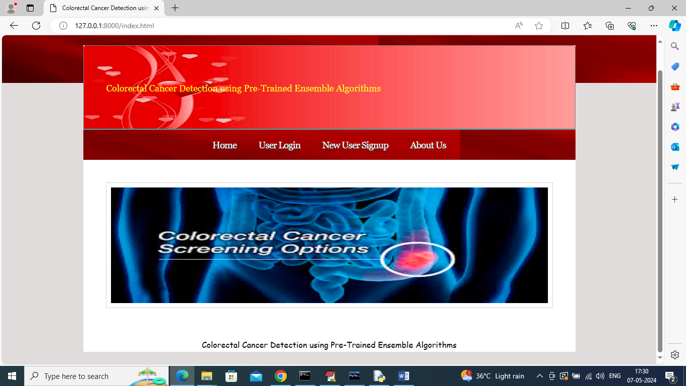
In above screen click on ‘New User Sign up’ link to get below page
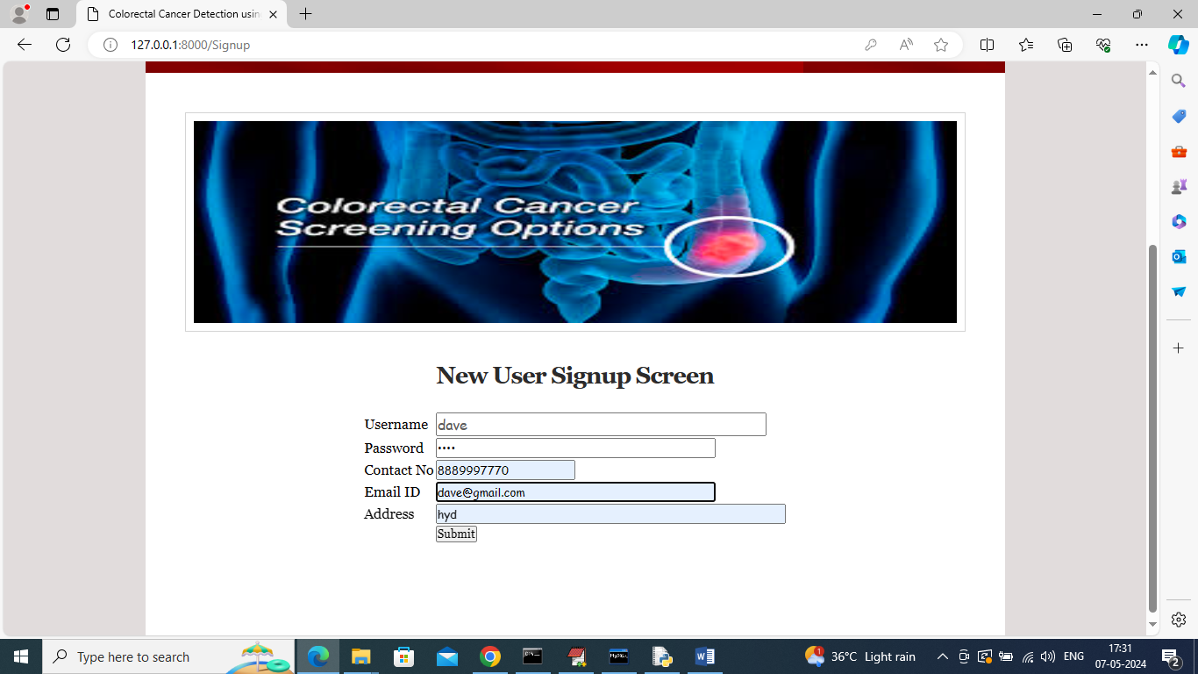
In above screen user entering sign up data and then press button to get below page
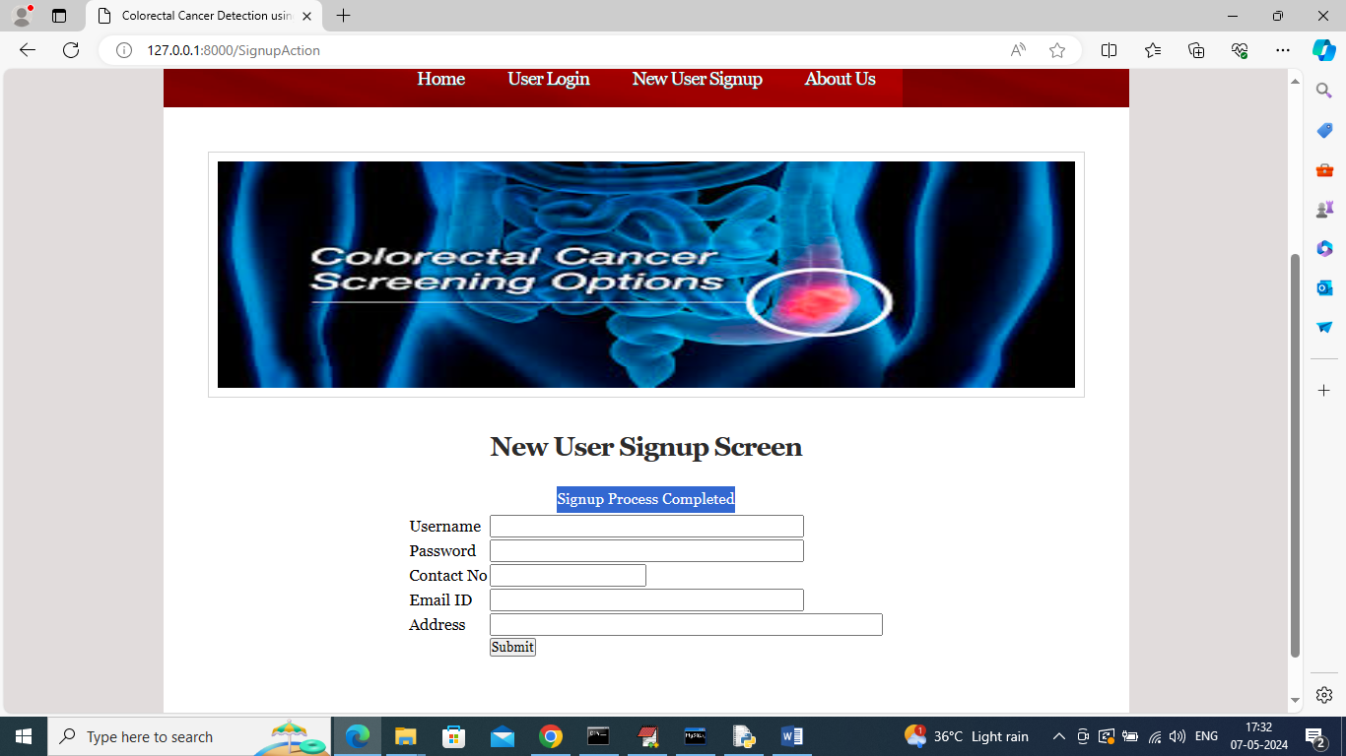
In above screen sign up task completed and now click on ‘User Login’ link to get below page
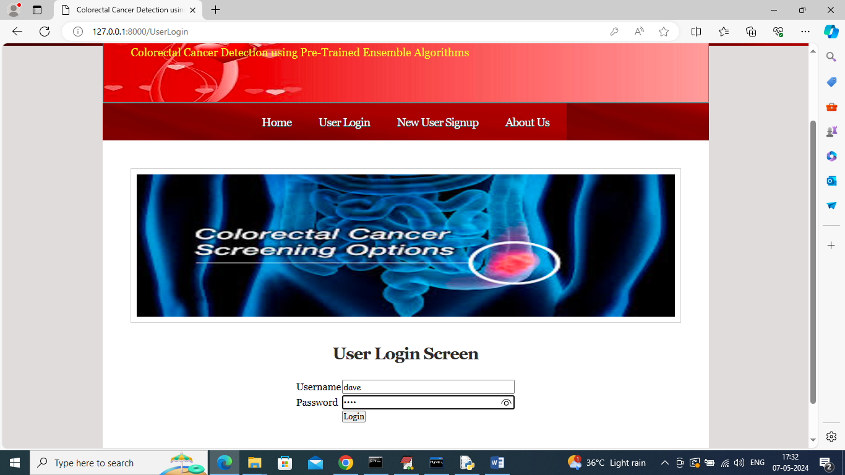
In above screen user is login and after login will get below page
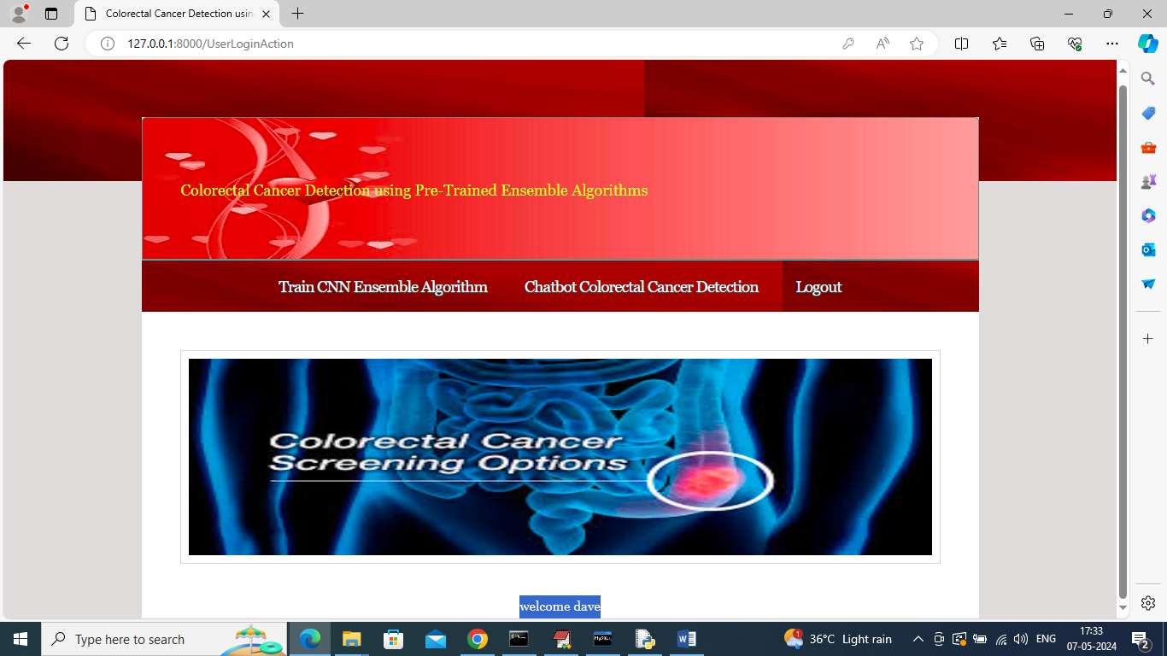
In above screen user can click on ‘Train CNN Ensemble Algorithm’ link to get below output
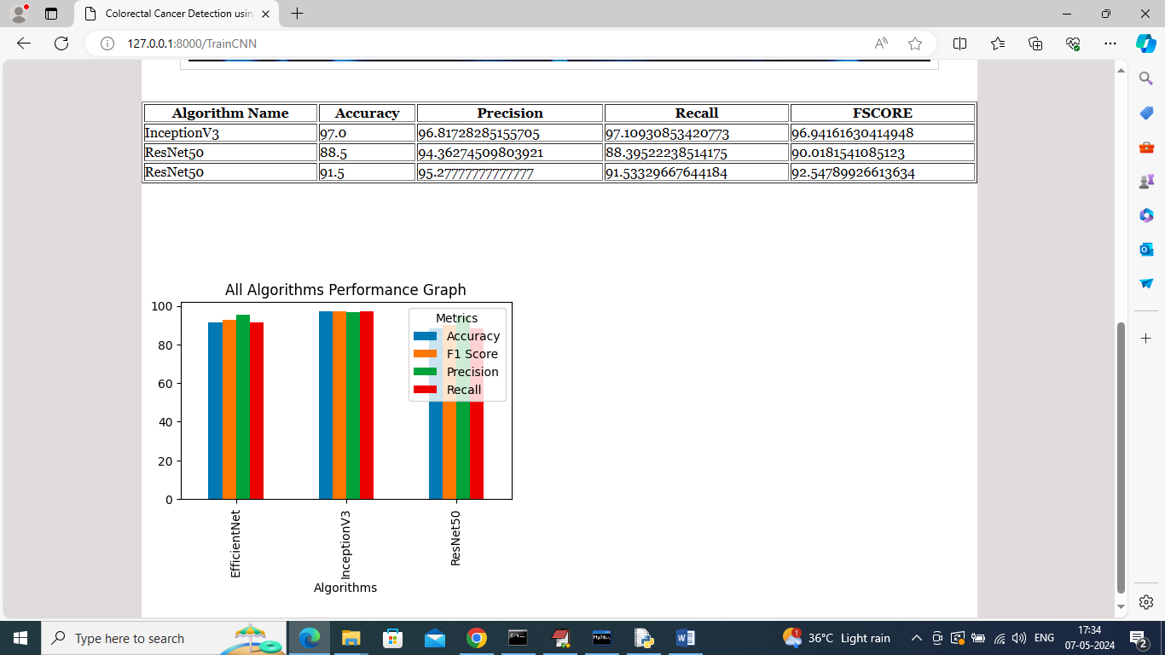
In above screen can see training of all algorithms completed and can see all algorithms results in tabular and graph format. In above graph x-axis represents algorithm names and y-axis represents accuracy and other metrics in different colour bars and in all algorithms IncpetionV3 got high accuracy and now click on ‘Chatbot Colorectal Cancer Detection’ link to get below page
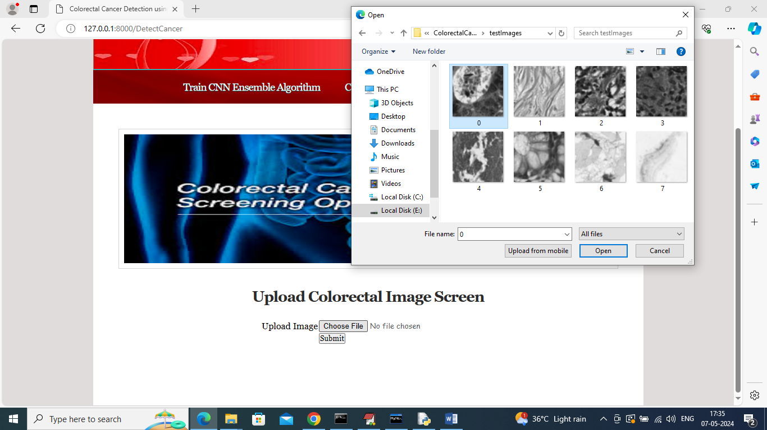
In above screen user will select and upload image and then Chatbot will apply InceptionV3 algorithm to detect cancer type and get below page
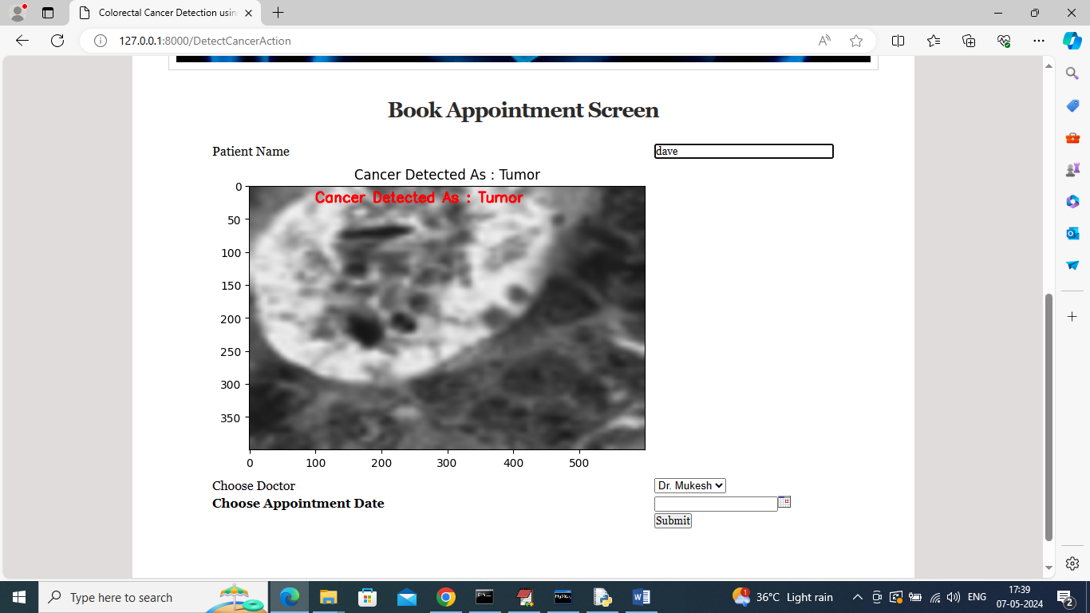
In above screen in first text field can see name of patient who uploaded image and then in image red colour text can see cancer detected as ‘Tumor’ and now Chatbot display available doctor names and appointment date and if user want he can make appointment with desired doctor and get below output
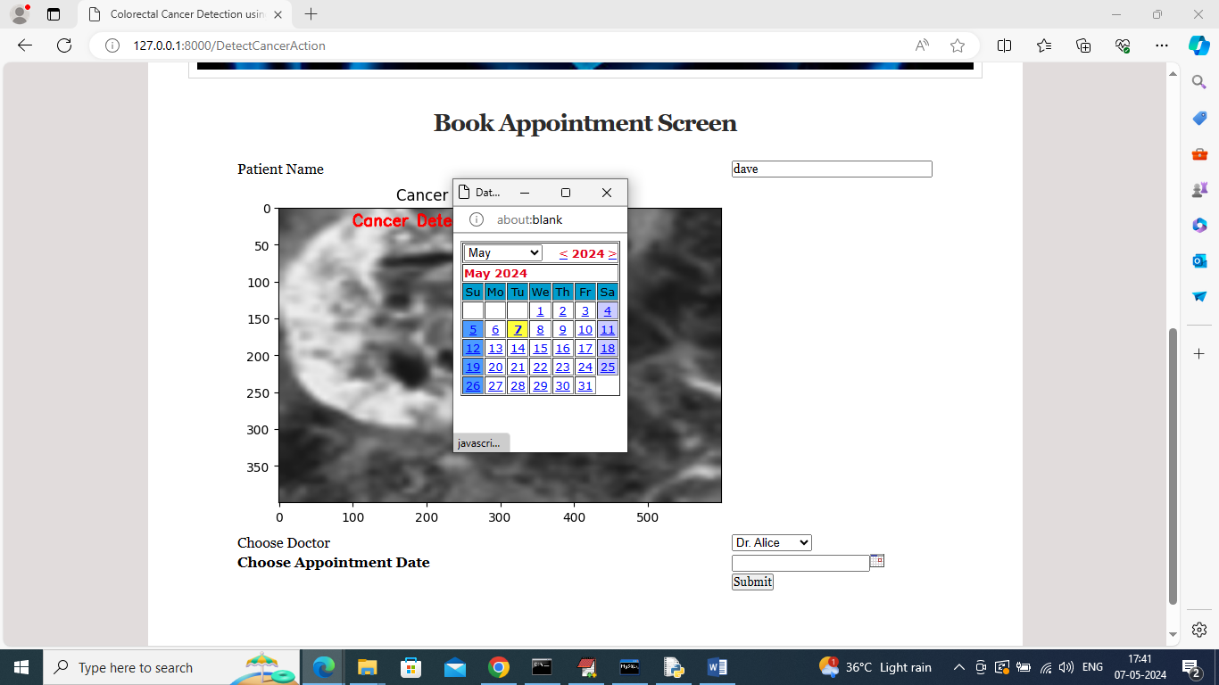
In above screen selected doctor and appointment date and then press button to confirm appointment and get below page
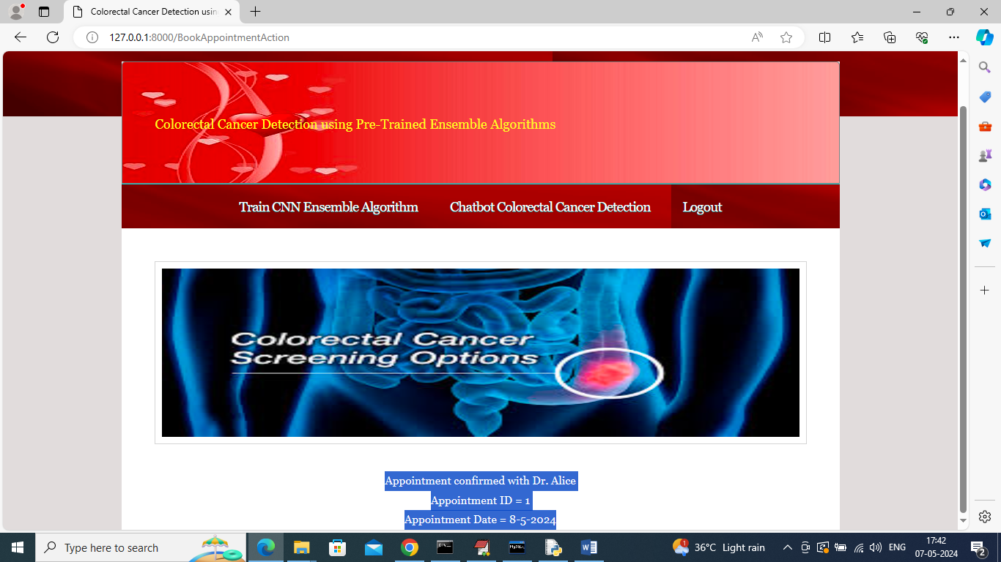
In above screen in blue colour text can see appointment confirmed with doctor Alice and displaying appointment ID and date. Similarly you can upload and detected cancer by following above screens. Below is another example and all test images are available inside ‘test Images’ folder
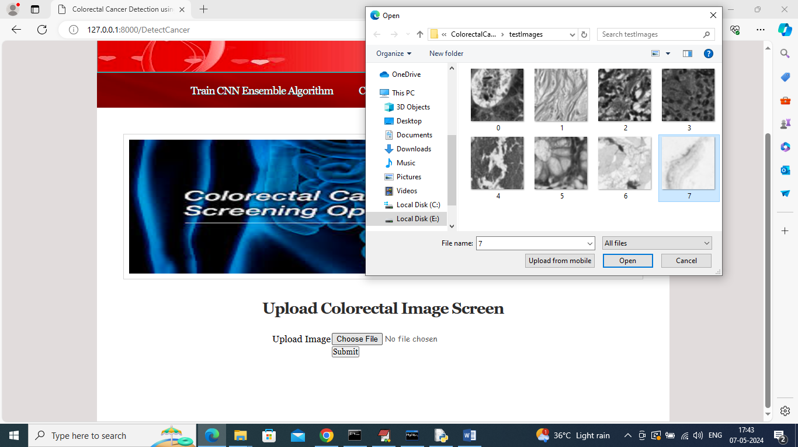
In above screen selecting and uploading 7.png image and then click on Open’ and ‘Submit’ button to get below page
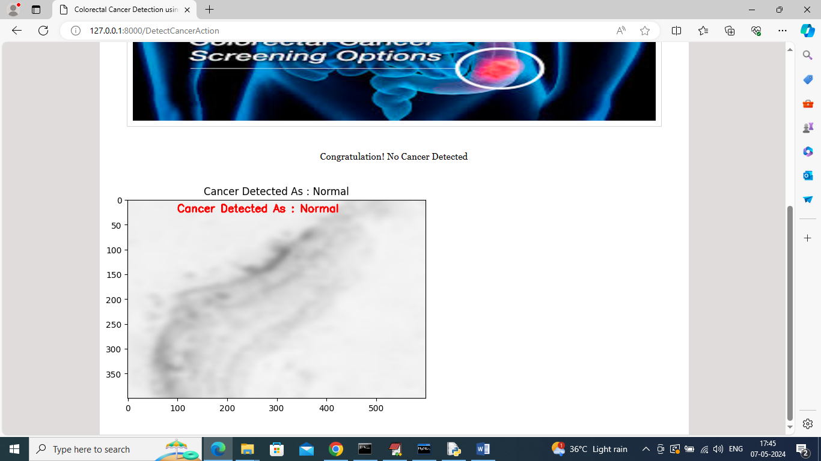
In above screen Chatbot detected ‘Normal’ so no appointment required.

