**SQL-17-05-2025**

**What is sql?**

Queary language

DDL-Data definition language

DML **-**data manuplation language

DCL-Data control language

TCL-transaction control language: commit,rollback

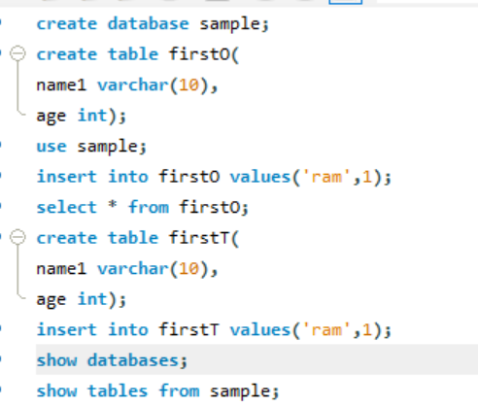

show databases;

create database vit;

show tables from vit;

drop database vit;

create table cse(

s_id int,

s_name varchar(40),

s_mark int);

use vit;

select * from cse;

insert into cse values(101,'Aditya',89);

insert into cse values(101,'Aditya',89);

create database sample;

create table firstO(

name1 varchar(10),

age int);

use sample;

insert into firstO values('ram',10);

insert into firstO values('sam',15);

insert into firstO values('varun',16);

insert into firstO values('raju',19);

insert into firstO values('siva',20);

insert into firstO values('isha',19);

insert into firstO values('krishna',8);

insert into firstO values('sita',16);

insert into firstO values('raghu',15);

insert into firstO values('radha',10);

insert into firstO values('bhanu',14);

insert into firstO values('ravi',8);

select * from firstO;

create table firstT(

name1 varchar(10),

qualification varchar(10));

insert into firstT values('ram','BE');

insert into firstT values('sam','BE');

insert into firstT values('siva','MCA');

insert into firstT values('isha','Btech');

insert into firstT values('radha','Law');

insert into firstT values('krishna','MBBS');

insert into firstT values('ganesh','MBA');

insert into firstT values('sidhu','Mtech');

insert into firstT values('buvan','Bcom');

insert into firstT values('bhoomi','Btech');

show databases;

show tables from sample;

select * from firstT;

alter table firstO add(

address varchar(40));

alter table firstO drop column address;

alter table firstO add (

country varchar(19) default 'india');

alter table firstO drop column country;

update firstO set name1='sravanth' where age=19;

update firstO set age=age+1;