COURSE NAME: Theory of Computation COURSE CODE: CSA1310

COURSE OUTCOME COVERED

CO1: Apply mathematical foundations such as formal proofs, induction, and basic concepts of automata theory to solve computational problems (BL:3)

Assessment Tool Weightage: 10%

QUESTIONS: 5 Total Marks:50
Duration : 1 Hour

Technical Presentation

Code of Conduct:

I Gunapu Sravanthi Name / Reg No) certify that this submission is my original work and that I have adhered to the guidelines specified for this assessment.
I understand that any violation of academic integrity rules will result in disciplinary action.

Signature of the student: Sravanthi

1.How can every Non-Deterministic Finite Automaton (NFA) be converted into an equivalent Deterministic Finite Automaton (DFA), and what are the challenges involved? Consider the NFA given below which accepts some language L over the alphabet 𝚺={0,1}. Construct a DFA that represents the same language L
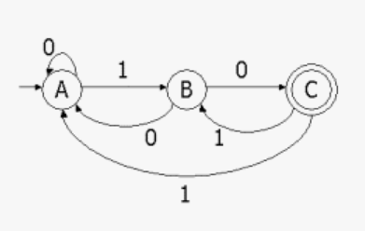

Simulation:
