INSURANCE CROSS-SELL ANALYTICS
Using Excel & Power BI
Consolidated Dashboard depicting Single view of Insurance CrossSell comparing various aspects of the newly received insurance premiums.

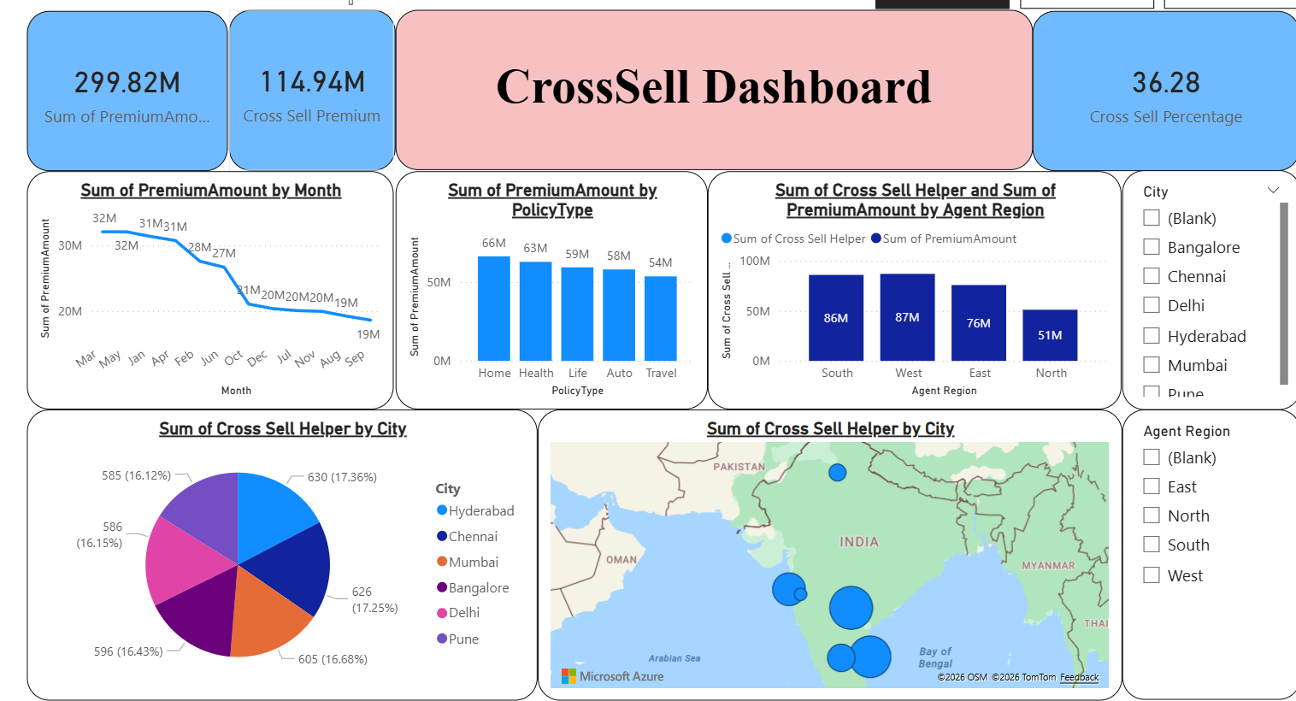
Consolidated Dashboard depicting Single view of Insurance CrossSell comparing various aspects of the newly received insurance premiums from different agents customers of different sectors
.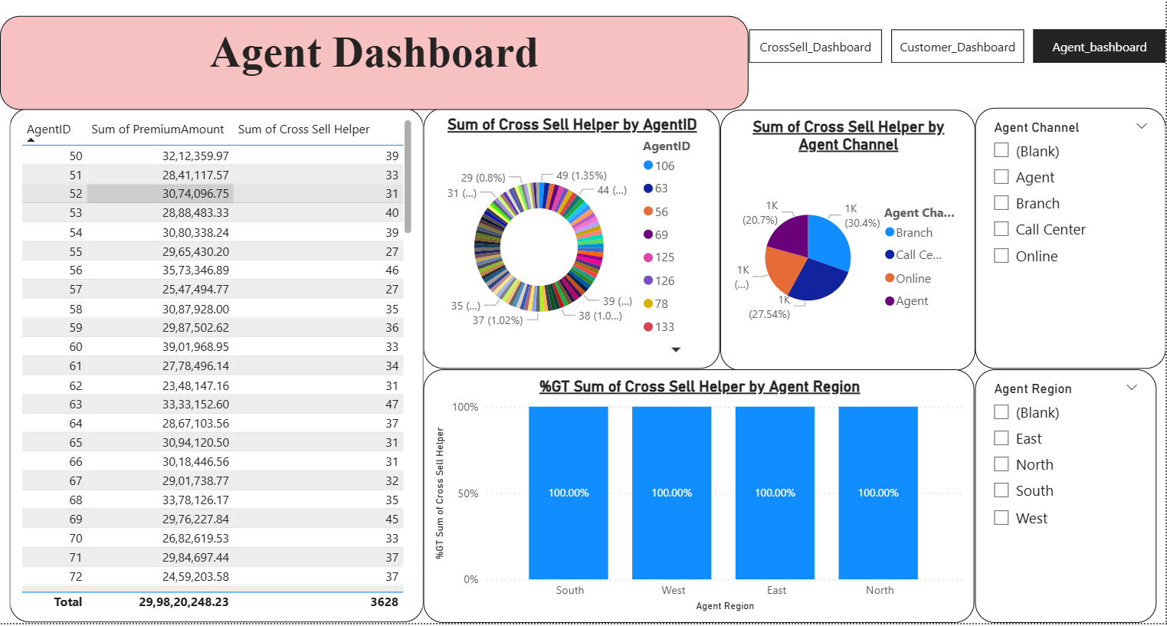
Dashboard showing a single view of Insurance CrossSell comparing various aspects of the newly received insurance premiums from different customers of different sectors

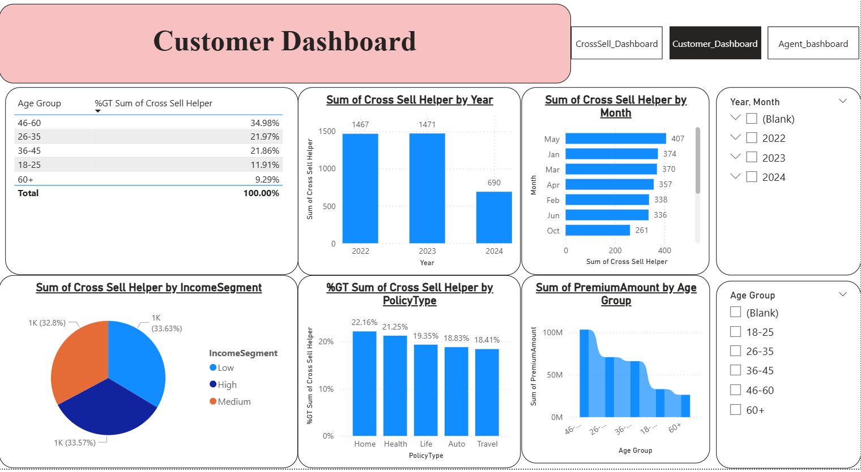

Introduction
In the insurance industry, acquiring new customers is expensive and difficult, making cross-selling to existing customers a key revenue strategy.
This project analyzes insurance sales data to evaluate cross-sell effectiveness using Excel and Power BI.
The primary goal of this project is to analyse customer purchase patterns to drive cross-selling—the practice of selling additional products to existing customers. By understanding which customers own specific insurance types (e.g., Home) but lack others (e.g., Life), the business can target marketing efforts more effectively, increase the "Policies per Customer" ratio, and improve overall Customer Lifetime Value (CLV).
We will also be analysing performance of Agents and Channels in cross selling. Analyzing these metrics is critical because cross-selling is rarely passive; it requires an active nudge from a salesperson or a specific marketing touchpoint.

Business Problem Statement
"The organization currently relies on static reporting, leading to delayed decision-making and a lack of visibility into cross-sell performance, customer behaviour and sales channel effectiveness. Static reports delayed decisions and made it difficult to identify growth opportunities.
The organization’s current reliance on manual, static reporting has created a "data-lag," where insights are often outdated by the time they reach decision-makers. This lack of real-time visibility has led to:
- Information Asymmetry: Stakeholders cannot clearly see the correlation between customer demographics and policy purchase behaviour.
- Missed Revenue Opportunities: High-propensity cross-sell targets remain unidentified within the existing customer base.
- Channel Inefficiency: An inability to distinguish between high-performing and underperforming sales channels (Agent, Online, Call Centre) in real-time.

Project Aim
To analyze insurance policy data and evaluate cross-sell effectiveness, identify high-performing customers, policies, and channels, and present insights through interactive Power BI dashboards.
Mission: To engineer a robust, interactive Business Intelligence (BI) ecosystem that replaces latent reporting with a single source of truth. This ecosystem will empower the organization to transition from "What happened?" to "What is happening, and where can we grow?"
Core Objectives:
- Dynamic Portfolio Visibility: Provide a 360-degree view of the customer journey, identifying which segments (e.g., High-Income individuals in specific cities) are currently underserved.
- Performance Optimization: Implement real-time tracking of Agent and Channel effectiveness to optimize sales force ROI.
- Growth Identification: Utilize "White Space Analysis" to automatically highlight customers who hold single policies but fit the profile for additional insurance products.

Project Objectives
Expected Business Outcomes
Leveraging the provided datasets (Customers, Policies, Agents, Transactions, and Payments), the project will follow a sophisticated data pipeline:
- Data Consolidation (Excel/Power Query): Streamlining the raw multi-sheet data into a structured format, ensuring data integrity and cleaning anomalies in transaction records.
- Advanced Data Modelling (Power BI): Implementing a Star Schema model. By linking the Policy Transactions to various dimension tables, we create a multidimensional environment that supports complex filtering.
- Real-Time Analytics Layer: Moving away from static snapshots to a system where slicers for Region, Income Segment, and Policy Type provide instant answers to ad-hoc business queries.
• Clean and prepare multi-sheet insurance data
• Design a star schema data model
• Create KPIs using DAX
• Analyze customer, policy, and channel performance
• Build interactive dashboards

Project Scope
- Reduced Time-to-Insight: Eliminating the manual preparation time associated with static reports, allowing management to act on market trends immediately.
- Enhanced Cross-Sell Conversion: A projected increase in "Policies per Customer" through data-driven targeting.
- Proactive Retention: Identifying "Lapsed" or "Cancelled" trends early enough to implement customer win-back strategies.
In Scope:
• Data cleaning and transformation
• Descriptive analytics
• Dashboard development
Out of Scope:
• Predictive modeling
• Real-time data integration

Dataset Overview
The dataset is a multi-sheet Excel workbook (~10,000 records) containing policy transactions, customers, policies, agents, and payments.
Policy Transactions:
This is the heart of the analysis. It records every instance of a policy being sold or updated.
- PolicyTransactionID: Unique record for each sale event.
- TransactionDate: When the sale occurred (crucial for time-series and trend analysis).
- CustomerID / PolicyID / AgentID: Foreign keys that link this transaction to the specific customer, product, and salesperson.
- PremiumAmount: The revenue generated. This allows you to calculate the financial impact of cross-selling.
- PolicyStatus: Current state of the policy (Active, Lapsed, Cancelled). Cross-selling should ideally target "Active" customers.
- CrossSellFlag (Yes/No): A direct indicator of whether the transaction was a cross-sell. This is your primary metric for calculating conversion rates.
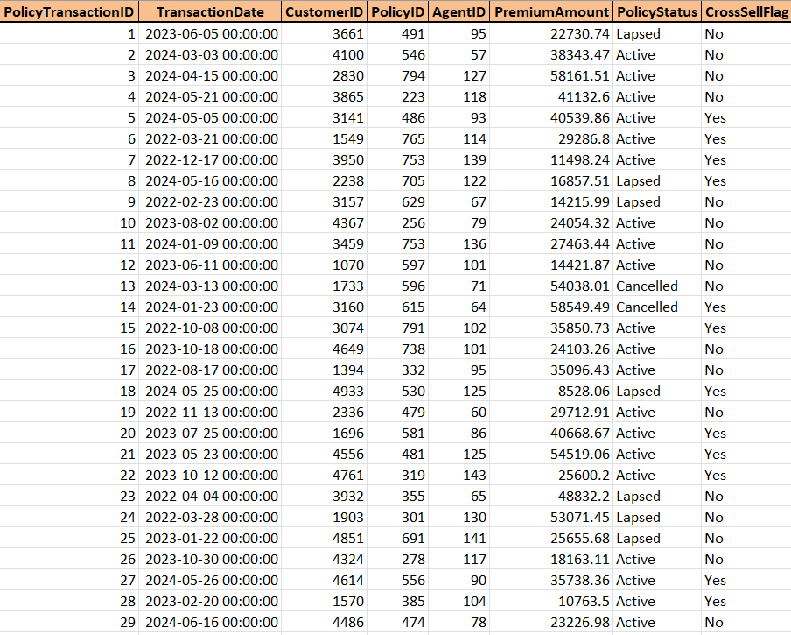

Customer Data:
This table contains the demographic profile of the client base. It is essential for segmenting customers to find cross-sell targets.
- CustomerID: The unique identifier for each customer (Primary Key).
- CustomerName: The name of the individual.
- Gender / Age: Demographic filters used to identify life-stage needs (e.g., younger customers might need travel insurance; older might need life insurance).
- City: Geographical location, useful for regional trend analysis.
- IncomeSegment: Categorizes customers (High, Medium, Low). High-income segments are often prime targets for premium cross-sell products like Wealth or Life insurance.

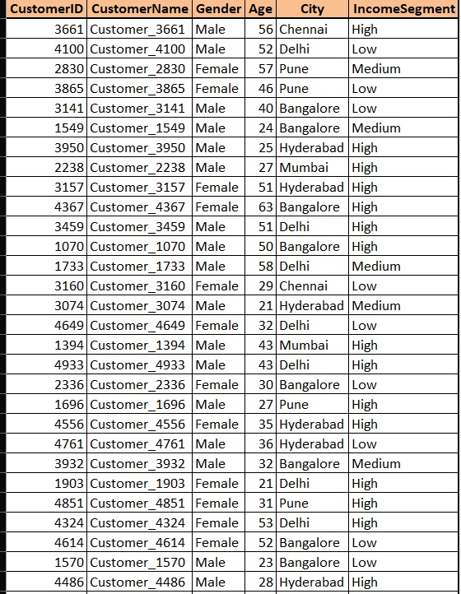

Policies Details:
This is our product catalog. It defines what you are selling.
- PolicyID: Unique identifier for each policy type.
- PolicyName: The specific name of the insurance product.
- PolicyType: The category (e.g., Life, Health, Motor, Travel, Home). This is the most critical column for "White Space" analysis (identifying which types a customer doesn't have).
- PolicyCategory: Defines if it is an Individual, Family, or Corporate plan.
- RiskLevel: The risk rating associated with the policy.
l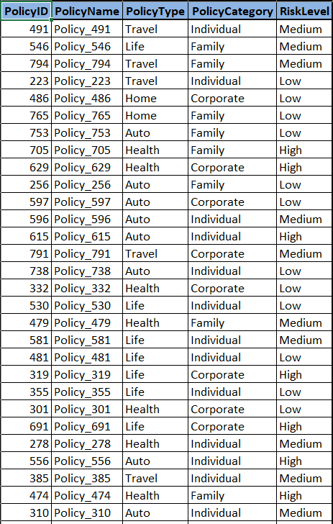

Agents:
This table describes the sales force and distribution network.
- AgentID: Unique identifier for the agent.
- AgentName: The name of the agent responsible for the sale.
- Channel: How the sale was made (Online, Branch, Call Center). This helps you see if certain channels are better at cross-selling than others.
- Region: The broad territory (North, South, East, West) the agent operates in.
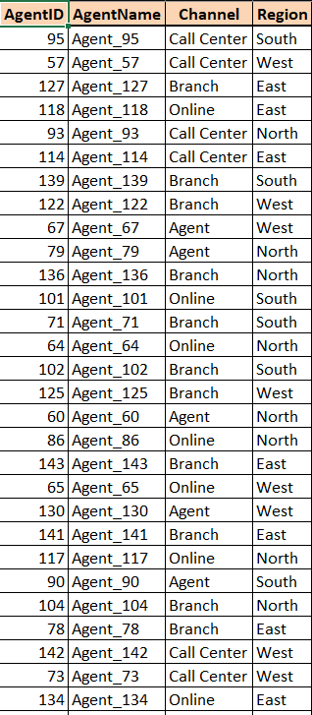

Payment Details:
This adds a layer of behavioral data regarding how customers manage their finances.
- PaymentID: Unique record for the payment.
- PolicyTransactionID: Links the payment back to the specific sale.
- PaymentMode: How they pay (Debit Card, UPI, Credit Card, Net Banking).
- PaymentFrequency: How often they pay (Monthly, Quarterly, Yearly). Yearly payers are often more stable and might be better targets for long-term cross-sell products
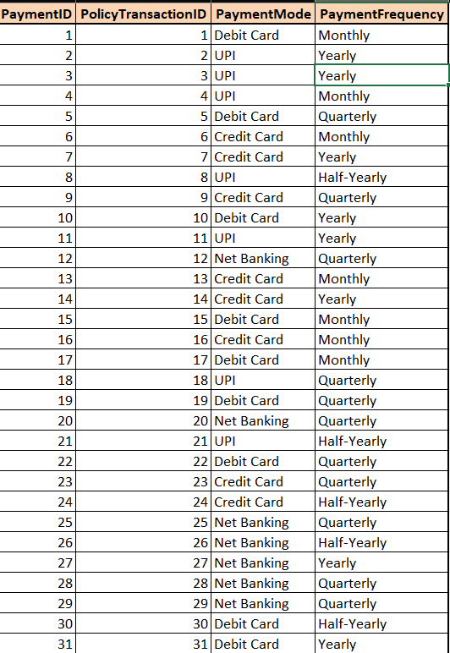

Data Cleaning & Preparation
- Steps performed:
- Removed cancelled policies
- Handled missing and duplicate IDs
- Removed duplicate agent IDs
- Standardized text fields
- Created a CrossSell Helper flag for easy use in arithmetic operations.
- Created derived columns (Year, Month, Age Group)
Policy Transactions after cleanup and preprocessing:
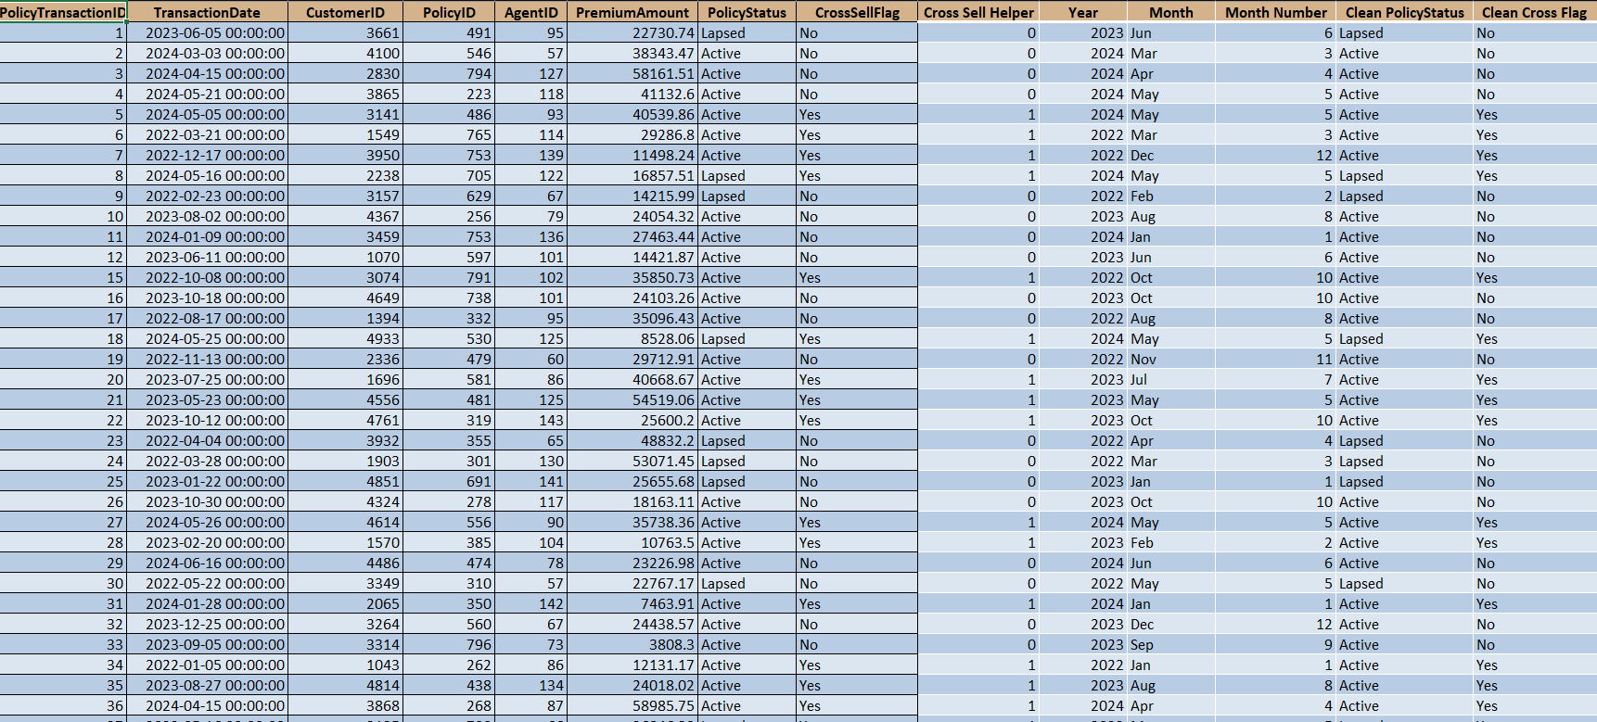Customer Data after cleanup and preprocessing:
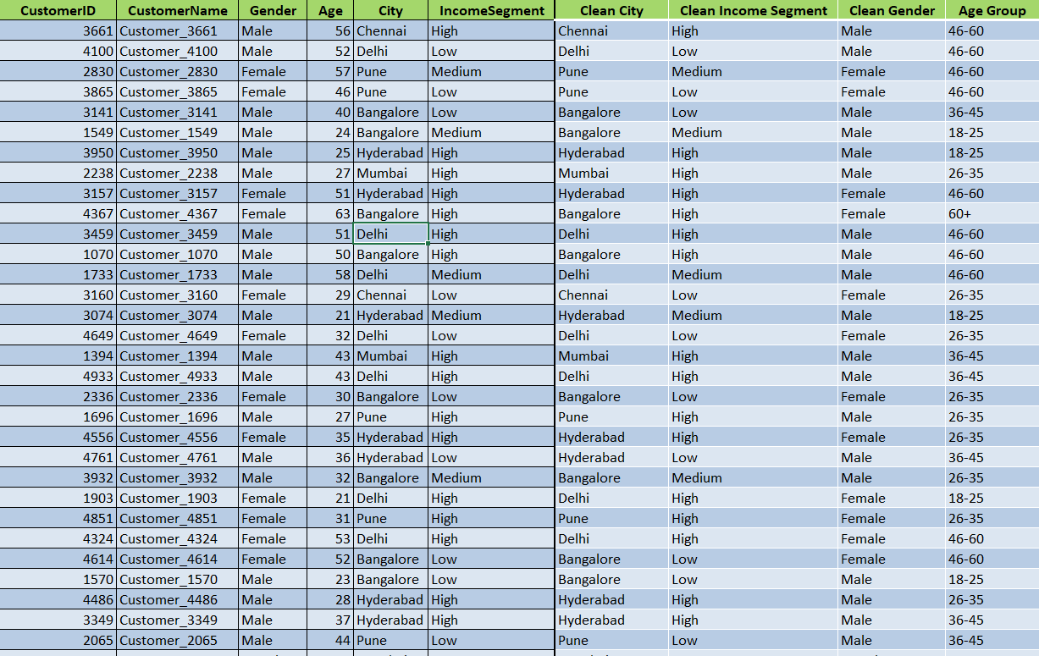
Policy Data after cleanup and preprocessing:
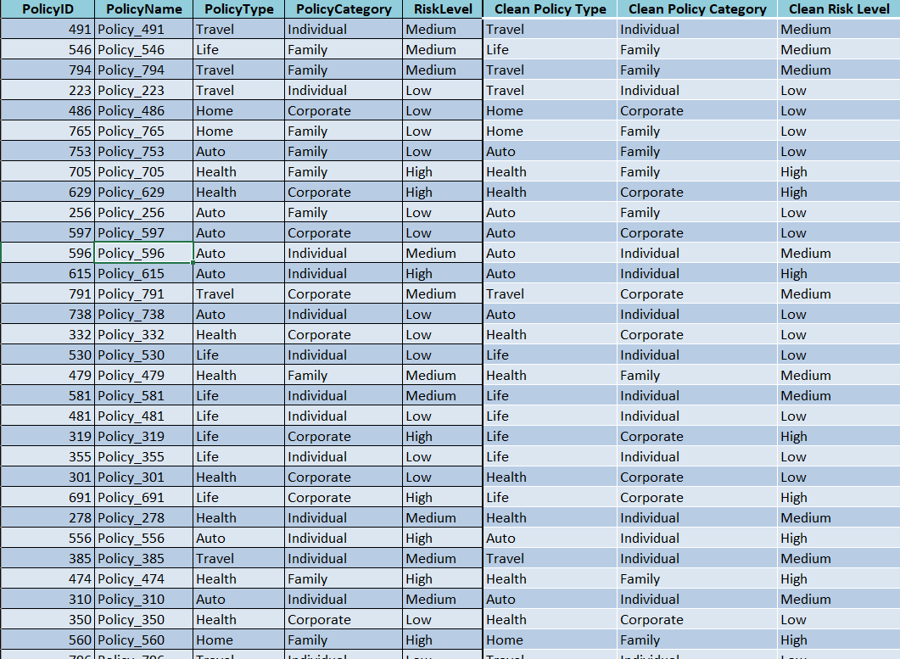Data Modeling
A star schema was implemented with Policy_Transactions as the fact table and Customers, Policies, Agents, Payments, and Date as dimensions.

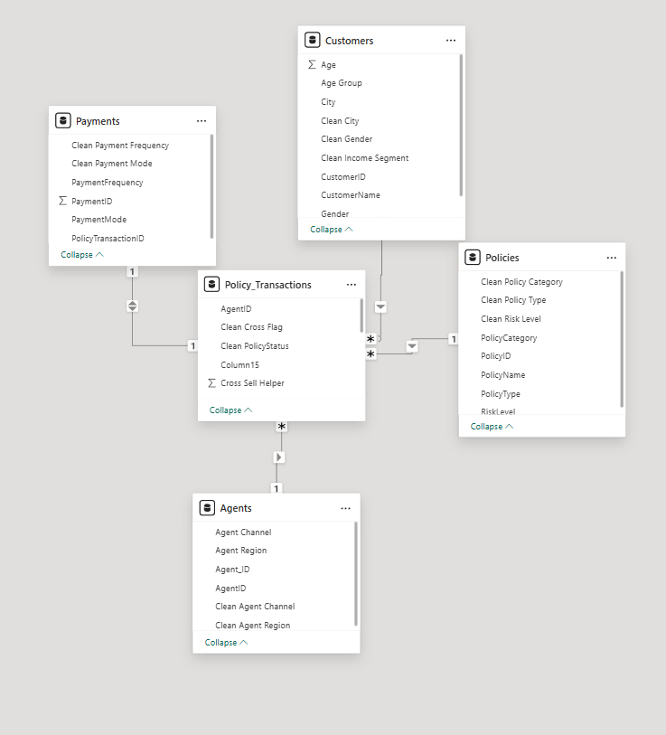

DAX Measures
Key measures created:
- Cross Sell Percentage
- Cross Sell Premium
Formulas used for these calculations are as below.
Cross Sell Percentage = DIVIDE(sum(Policy_Transactions[Cross Sell Helper]),COUNT(Payments[PolicyTransactionID]))*100
Cross Sell Premium = CALCULATE (SUM ( Policy_Transactions[PremiumAmount]), Policy_Transactions[CrossSellFlag]= "Yes")

Dashboard Design
The dashboard includes KPI cards, monthly premium trends, cross-sell analysis by channel and policy, and interactive slicers.
Below are the list of interactive dashboards created.
A Line chart was used to display monthly trends of premium amounts received.
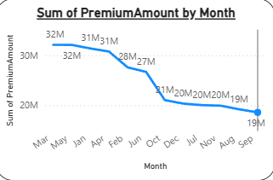
A Column chart was used to display policy amount received based on insurance policy type.
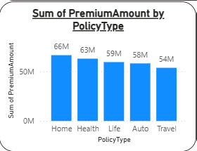
A column chart was used to display region wise total premium amount

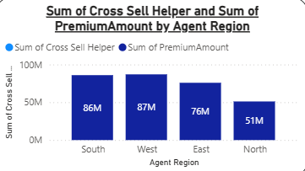
A pie chart was used to display City wise Cross selling percentage

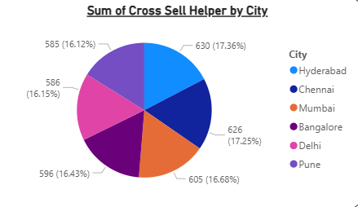

A Column chart was used to display year wise cross sell count

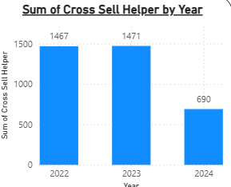
A Bar chart was used to display month wise cross cell count

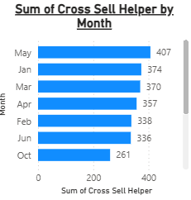
A pie chart used to display customer income segment

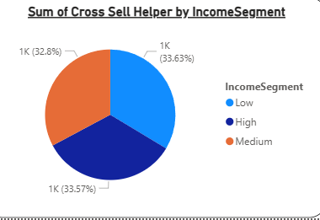
A Donut chart used to display Agent wise cross sell

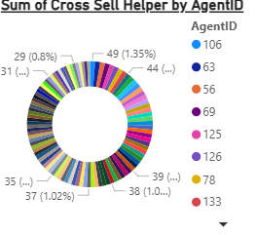
A ribbon chart used to display age wise premium amount
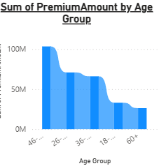
A column chart used to display year wise policy crosscell percentage

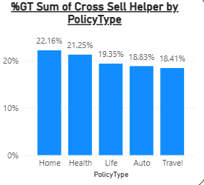

A pie chart used to display Agent cross cell percentage region wise

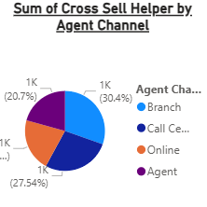

A column chart used to display region wise cross cell percentage

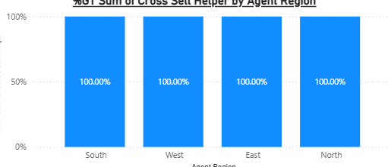
Key Insights
• Health and Life policies generate the highest premium
• Agent channel performs best for cross-sell
• High-income customers show higher acceptance

Business Recommendations
• Focus on high-performing policies which are Home and Health Insurance.
• Strengthen agent channel incentives. Branch sales have highest CrossSell percentage.
• Target high-value customer segments. Customers with highest cross sell percentage are customers with home insurance, aged above 45 with low- and high-income brackets.

Expected Outcomes
• Improved visibility into cross-sell performance
• Data-driven decision making
• Reusable reporting framework

Limitations
• Historical data only
• No predictive analytics
• Dependent on data quality

Conclusion
This project demonstrates an end-to-end analytics solution using Excel and Power BI, transforming raw insurance data into actionable insights.

