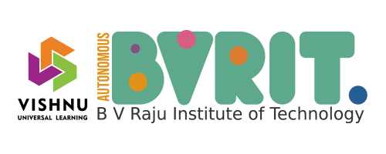

Industrial Internship Report on:

“Transformer monitoring system”

Prepared by: Narlagalla Sravanthi

**Executive Summary:**

* This report provides details of the industrial internship provided by upskill campus and The IOT Academy in collaboration with Industrial partner Uni-Converge Technologies Pvt Ltd (UCT).
* This internship was focused on a project/problem statement provided by UCT. We had to finish the project including the report in 6 weeks' time.
* My project was “Transforming monitoring system which monitors various operating various operating characteristics to make sure they are functioning properly”.
* This internship gave me a very good opportunity to get exposure to industrial problems and design/implement solutions for that. It was an overall great experience to have this internship.



**Table of Content:**

1. Preface 3-4

2. Introduction

2.1 About Uni-Converge technologies Pvt Ltd 4-5

2.2 About Upskill Campus 5-6

2.3 The IOT Academy 7

2.4 Objective 7

2.5 Reference 7

2.6 Glossary 7-8

3.Problem Statement 8-9 4. Existing and proposed solution 10

5. Proposed Design/Model

5.1 Block Diagram 11

5.2 Circuit Diagram 12

6. Performance test 12

6.1 Test procedure 13

6.2 Performance outcome 13-14

7. My learning 14

8. Future work scope 14



1. **Preface:**

Here the summary of the whole 6 week’s work:

**F**rom the 1st day of internship, I enhanced the skills about the Embedded system and IOT. And how the embedded system plays a major role in real-world applications. I chose one project among some of the problem statements and I gathered/searched about the project i.e. how it is designed and about the sensors which used to design the project, about how the system works in real world.

**T**he urge of internship is which gives a practical knowledge and hands-on-experience. Even the recruiters are finding for the one who done different internships. The internships are valuable tool for building one career. They provide skill development, networking opportunities, career exploration and resume building.

**Transformer monitoring system** that monitors the health and performance of transmission. The system collects data on factors such as temperature, oil level, moisture, vibration, overheating, bushing power factor, load tap changer, dissolved gas.

**It** is a great opportunity which is given by USC/UCT. It is a great platform for providing internship for different streams of people, where it unites all the people together, which helps us to increase our collaborative skill. It helps us to enhance our skills in different fields and make us as one in this competitive world.

**T**he program was planned in 6 weeks’ schedule were

01.Explore problem statement & about UCT

02.Follow project instructions & plan a solution

03.Work on project



04.Continue work and check for improvements

05.Validate your implementation & performance

06.Submit project & Report get certified.

**I** acquire a knowledge of Embedded system and IOT, the primary role of embedded and IOT system in smart applications. I enhanced my skills in embedded and IOT. I learnt how the sensors and design of system which monitors the real-world application.

**It**'s a great idea to provide internships to Under Graduates, post Graduates. OfCourse this is the correct time to thank all the team members of this internship program.

**I** suggest my juniors and peers to join this internship program, it is the great online platform to enhance the skills in different streams for different people.

**2. INTRODUCTION**

**2.1 About Uni-Converge Technologies Pvt Ltd**

A company established in 2013 and working in Digital Transformation domain and providing Industrial solutions with prime focus on sustainability.

For developing its products and solutions it is leveraging various Cutting Edge Technologies e.g. Internet of Things (IOT), Cyber Security, Cloud computing



(AWS, Azure), Machine learning, Communication Technologies (4G/5G/LoRa WAN), Java Full Stack, Python, Front end etc.

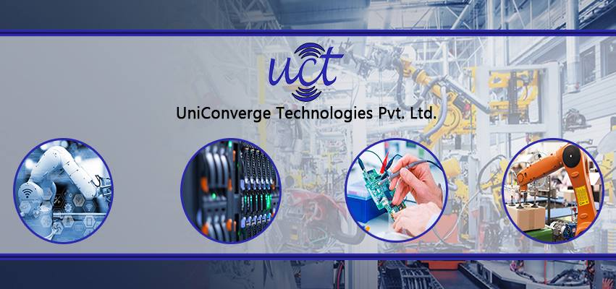

**UCT IOT Platform**

**UCT** Insight is an IOT platform designed for quick deployment of IOT applications on the same time providing valuable “insight” for your process/business. It has been built in java for backend and ReactJS for front end. It support for MySQL and various Databases.

* It enables device connectivity via industry standard IOT protocols- MQTT, CoAP, HTTP, Modbus, TCP, OPC UA
* It supports both cloud and on-premises deployments.



* It has features to:

Build your own dashboard

Analytics and Reporting

Alert and Notification

Integration with third party application

Rule Engine

**2.2 About upskill campus (USC)**

Upskill campus along with the IOT Academy and in association with Uni-Converge technologies has facilitated the smooth execution of the complete internship process.

USC is a career development platform that delivers personalized executive coaching in a more affordable, scalable and measurable way.

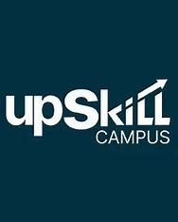



**2.3 The IOT Academy:**

The IOT academy is EdTech Division of UCT that is running long executive certification programs in collaboration with EICT Academy, IITK, IITG in multiple domains.

**2.4 Objectives of this Internship program:**

The Objective of this internship program was to

1. Get practical experience of working in the industry
2. To have improved job prospects
3. To have personal growth like better communication and problem solving
4. To solve real world problems.

**2.5 Reference**

1. [Transformer Monitoring and Security System using IoT | IEEE Conference Publication | IEEE Xplore](https://ieeexplore.ieee.org/document/10053405)
2. [Distribution transformer monitoring system using Internet of Things (IoT) | IEEE Conference Publication | IEEE Xplore](https://ieeexplore.ieee.org/document/8272671)
3. **IOT based Transformer Health Monitoring system | Real time Transformer Health Parameters**
4. [Fault analysis of oil-filled power transformers using spectroscopy](https://ieeexplore.ieee.org/document/8124633/) techniques [**IEEE 2017**]

**2.6 Glossary:**

1. Transformer Monitoring system

2. Power Transformer Monitoring

3. AMI: Advanced Metering Infrastructure

4. AT&C: Aggregate Technical and Commercial



5. B2B: Business-to-Business

6. BI: Business Intelligence

7. CT: Current Transformer

8. GIS: Geographic Information System

9. HT: High Tension (or High Voltage Level)

10. KPIs: Key Performance Indicators

11. KWH: Kilo Watt Hour

12. MDC: Meter Data Collector

13. AMR: Automated Meter Reading

**3. Problem Statement:**

Statement: Transformer Monitoring System

A transformer monitoring system using Arduino and sensors can collect data on transformer health parameters and send alarms if something is wrong.

The Arduino Uno consists of a sensing unit which collects the data from parameters such as current, voltage, and the oil temperature of transformer.

The project is divided into three parts POWER ELECTRONICS, ELECTRONICS IOT. Electricity has several components and equipment helping human to regulate and transfer the distribution according to usage.

The important parameters we need to monitor

* Transformer temperature
* Oil level



* Oil quality
* Current level
* Voltage level
* Humidity
* KVA & power factor
* Incipient fault monitoring

To overcome the drawbacks:

* Most of the distribution transformer are remotely located in rural area, where regular monitoring by human observation is difficult to perform due to insufficient human power.
* Our existing monitoring systems are not supported for real-time operations. There are too many transformer failure cases detected every day.
* Conventional system doesn’t have any internal fault testing [incipient fault monitoring].

To overcome the above drawbacks, we need smart and reliable solution to monitor the transformer parameter and send it to the IOT platforms in real-time. It enables the grid operator to define the performance of the unit. It also provides valuable information about transformer health.



**4.Existing and proposed solution:**

The proposed monitoring system based on IOT consists three main parts:

* Parameter measurement subsystem
* Protection subsystem
* Data reception subsystem

Firstly, Transformer electrical and physical parameters are measured by using the parameter measurement subsystem.

Electrical parameters consist of internal flux, voltage, current, KVA, Frequency and power factor and in physical parameter we include temperature, oil level, oil quality and humidity.

To measure the above parameters, we need different sensors and modules to interface with Arduino microcontroller.

In the protection subsystem, Arduino controls the operation of a fan and protection relay to protect the transformer in a faulty condition.

The current state and measured parameters are sent to the remote IOT server by using data reception subsystem. By using IOT and Arduino monitoring and protection algorithm, a smart self-protection system is designed for the transformer. Where, if any major fault (overvoltage, interturn, stage 2 temperature etc.) is detected in transformer monitoring system transformer is immediately shutdown. If transformer is not serviced in low oil quality, low oil level, the system will send alert.

The Arduino controller is programmed in such a manner so as to continuously scans the transformer and update the parameters at a particular time interval.



4.1 code submission (GitHub link):

https://github.com/SravanthiNarlagalla/test-Code1/blob/main/TMS.ino

4.2 Report submission (GitHub link):

1. Proposed Design/model:

5.1 Block diagram

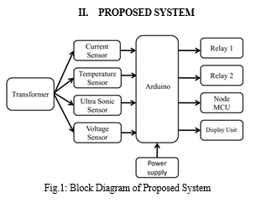



5.2 Circuit diagram:

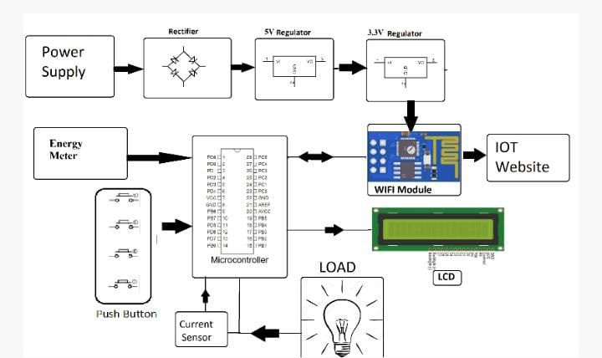

1. **Performance Test:**

The performance test is very important. we learn so many things in class room which are regarding to academics but to get the practical knowledge on theory and hands on experience which we learn in academics we need to do performance test.

Here are some of the constraints:

* Device instability: Devices may be unstable
* Poor anti-jamming capability: Devices may not able to handle jamming
* Low measurement accuracy: Data may not be accurate



We can overcome the constraints:

* Advanced analytics IOT platform
* Automatic interpretation of dissolved gas analysis
* Advanced capabilities and predictive maintenance

**6.1 Test procedure:**

Transformer monitoring systems use a variety of tests to check the quality, reliability, and proper working of transformers. These tests can be performed during the manufacturing process or commissioning, or as routine tests before the transformer is put into service.

Some common tests include:

Insulation test: also known as merger test, this test uses megohmmeter to determine quality of insulation.

Partial discharge monitoring

Dissolved gas analysis

Dielectric response analysis

Frequency domain spectroscopy

Winding resistance test

Temperature rise test

Transformer oil test

**6.2 Performance Outcome:**

A transformer monitoring system can help reduce business risk by improving safety, reducing unplanned outages, and preventing unexpected failures. TMSs can also help increase equipment efficiency



and reduce expenses by identifying problems before they become hazardous and allowing for proper scheduling of repair work.

1. **My Learnings:**

This a great opportunity to learn about Embedded system and IOT. Also, I wonder how the world became automative, we can control the far things from our location. How the transformer works which is combined with internet of things and gives alerts to us when it finds an error or faults.

We get to know how it collects data on factors like temperature, oil level, moisture, overheating, vibration and more.

Enable us to understand machines, interpret, and generate human language in a way that’s more accurate than ever before.

**8.Future work scope:**

All the utilities are quite troubled just because of huge rate of failure of distribution transformers. The rate of failure transformers in our country is around 10-15% which is quite higher in comparison to other developed nation which is even less than 1%. If this system will be implemented by the power utilities of our country, a huge amount of money can be saved which is spent on repair of transformers.This money can be utilized for the development and growth of nation that helps it to become strong and also to sustain that development.