Group Number -

Group Members -

Questions

1- Create all the tables as you proposed and designed according to your group ERD.

2- Make sure you specify the primary and foreign keys and other constraints in the tables

3- Insert / populate data into table. each table must have more than 7 rows/records of data.

4- Submit some sample queries of your database (create, insert, select). Keep it simple.

**Tables Proposed**

1. Department
2. Major
3. Scholarship
4. Scholarship_Sponsor
5. Sponsor
6. Student
7. Student_Age

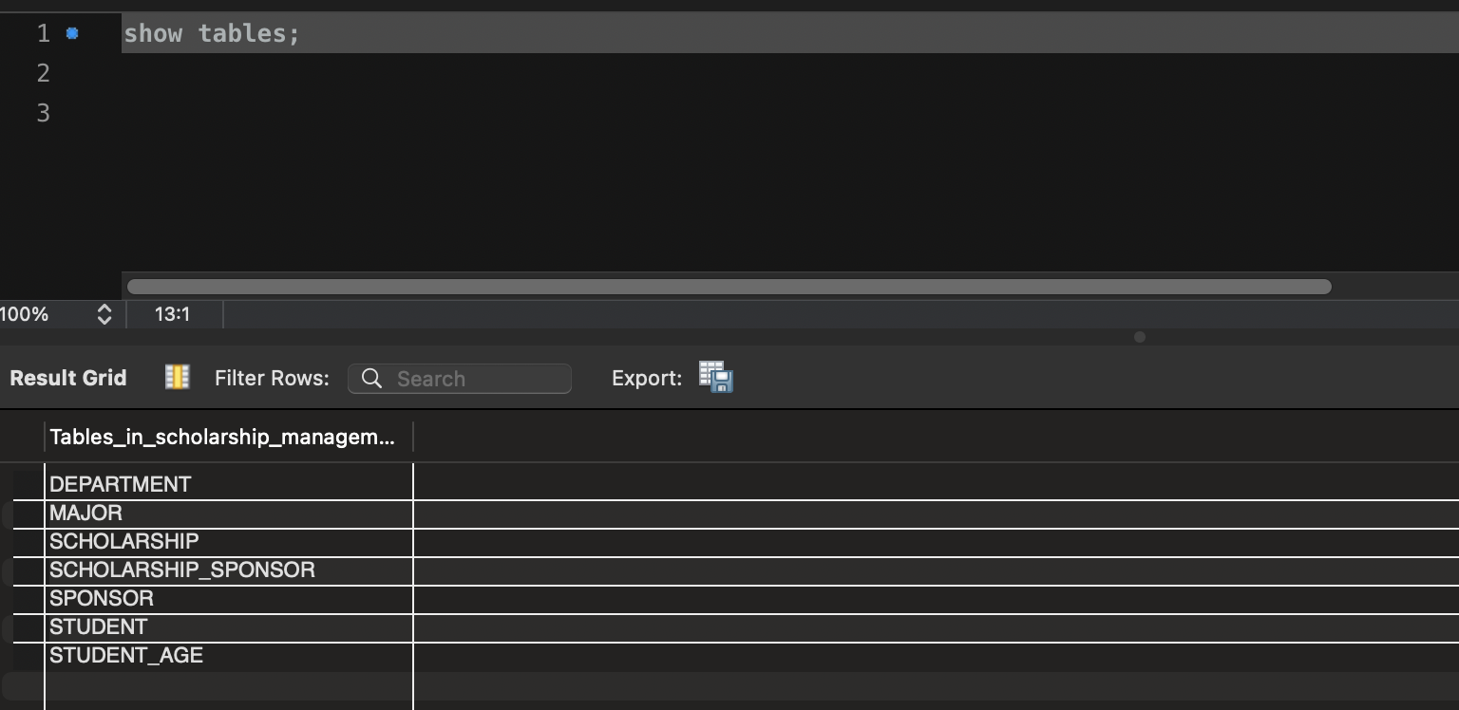

**Primary and Foreign Keys**

Department Table - department_id INT PRIMARY KEY,

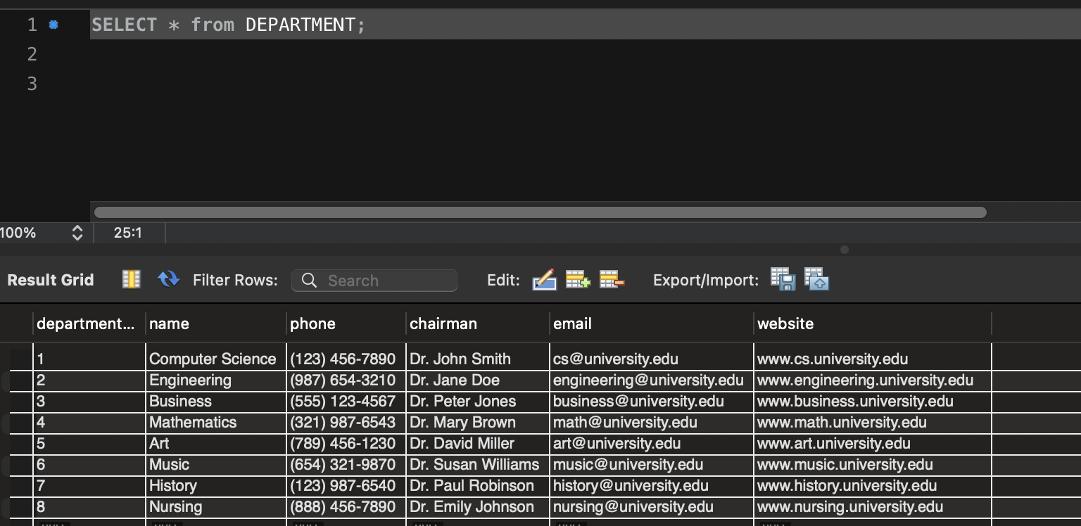

Major Table - major_id INT PRIMARY KEY,

FOREIGN KEY (department_id) REFERENCES DEPARTMENT(department_id)

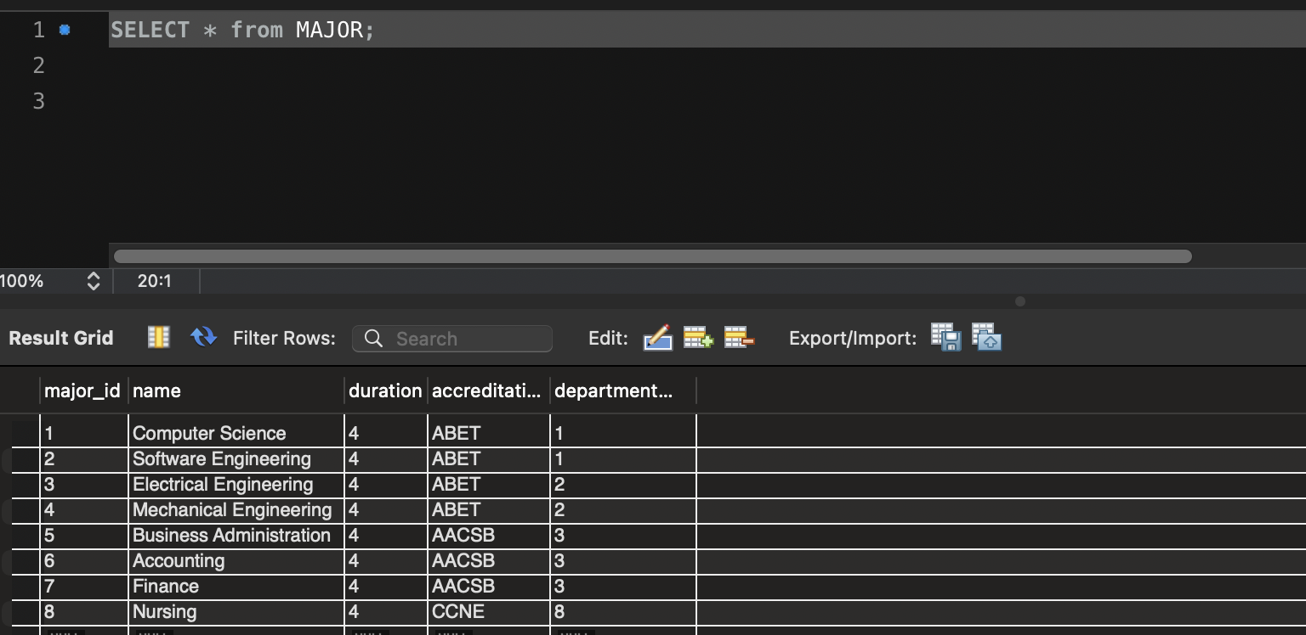

Scholarship - scholarship_id INT PRIMARY KEY,

FOREIGN KEY (department_id) REFERENCES DEPARTMENT(department_id)

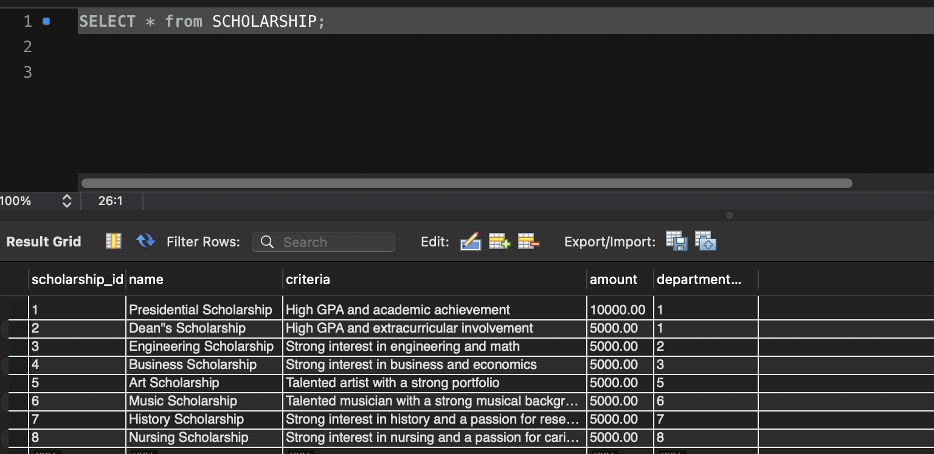

Scholarship_Sponsor - PRIMARY KEY (scholarship_id, sponsor_id),

FOREIGN KEY (scholarship_id) REFERENCES SCHOLARSHIP(scholarship_id),

FOREIGN KEY (sponsor_id) REFERENCES SPONSOR(sponsor_id)

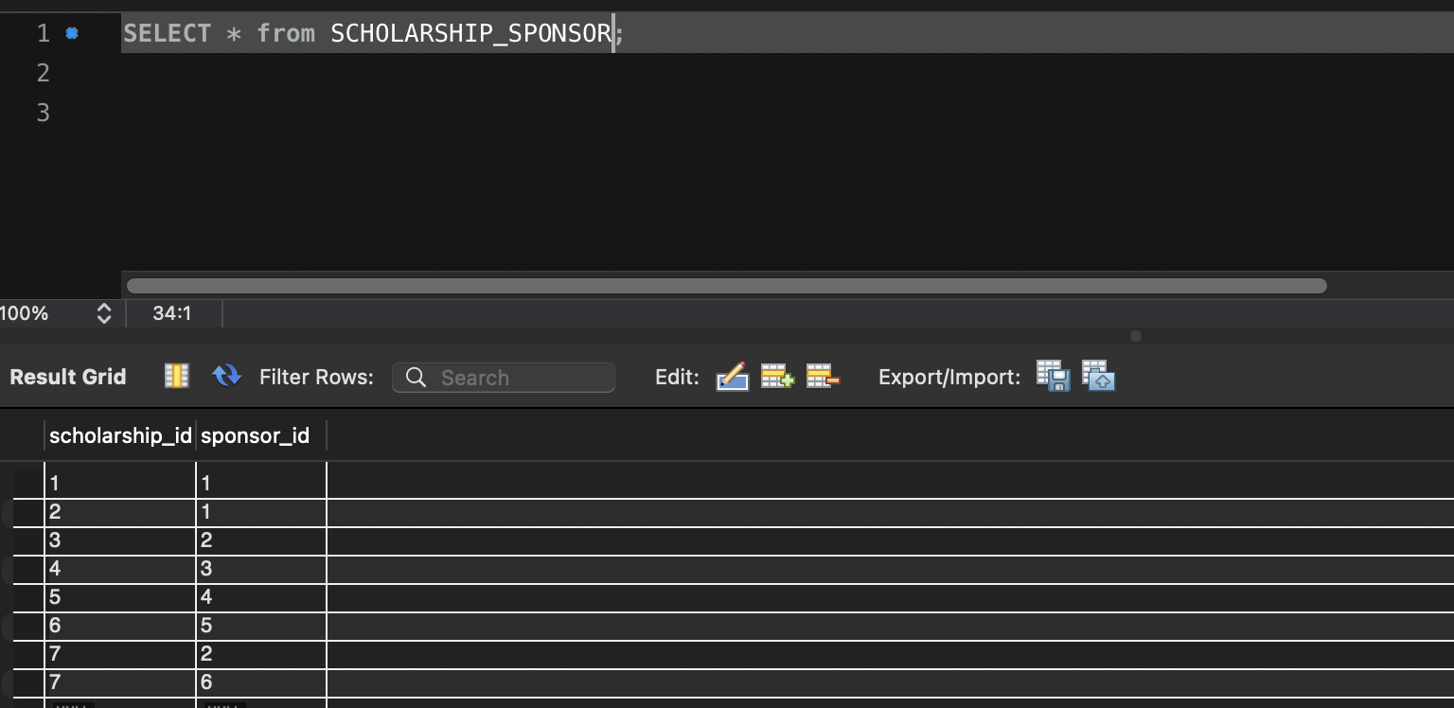

Sponsor - sponsor_id INT PRIMARY KEY

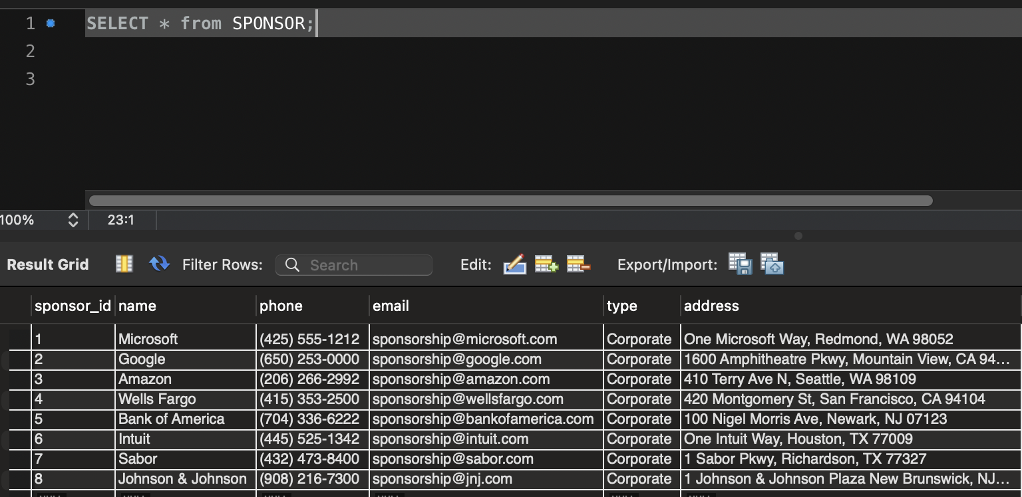

Student - student_id INT PRIMARY KEY,

FOREIGN KEY (date_of_birth) REFERENCES STUDENT_AGE(date_of_birth),

FOREIGN KEY (major_id) REFERENCES MAJOR(major_id),

FOREIGN KEY (scholarship_id) REFERENCES SCHOLARSHIP(scholarship_id)

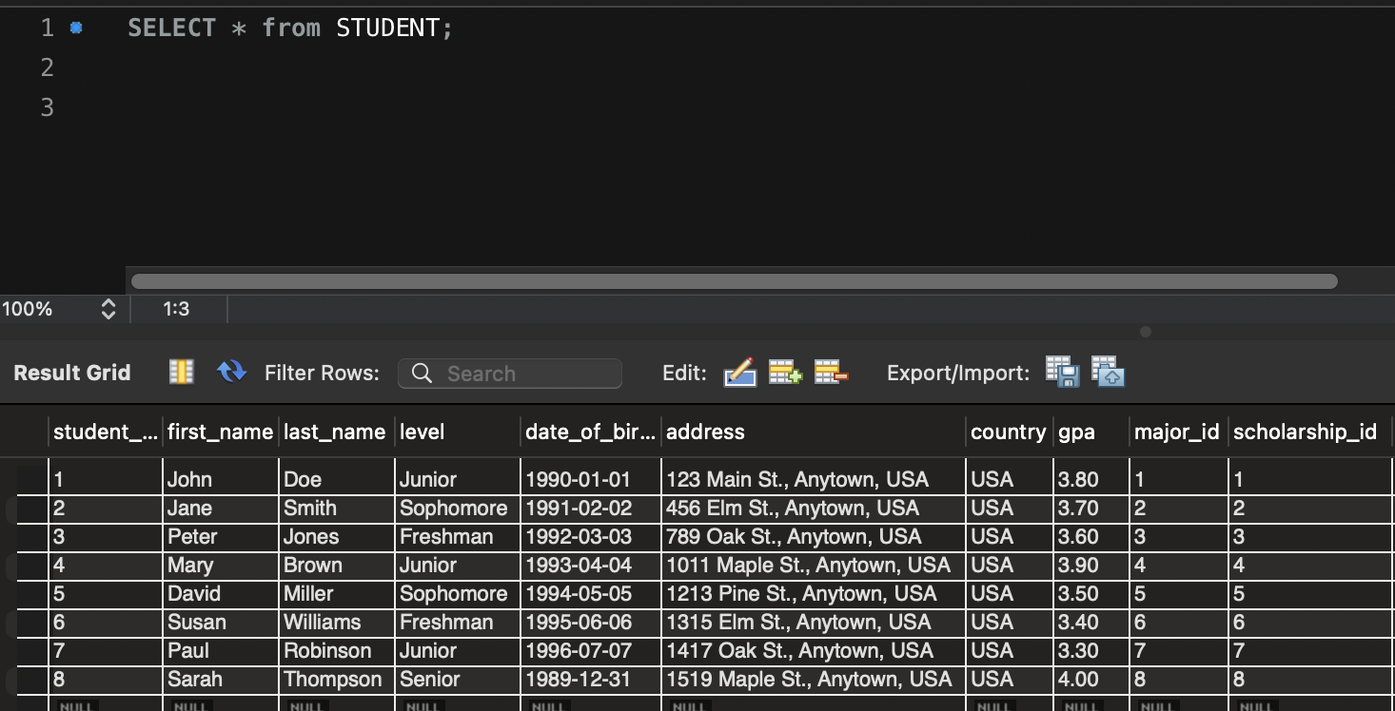

Student_Age - PRIMARY KEY (date_of_birth)

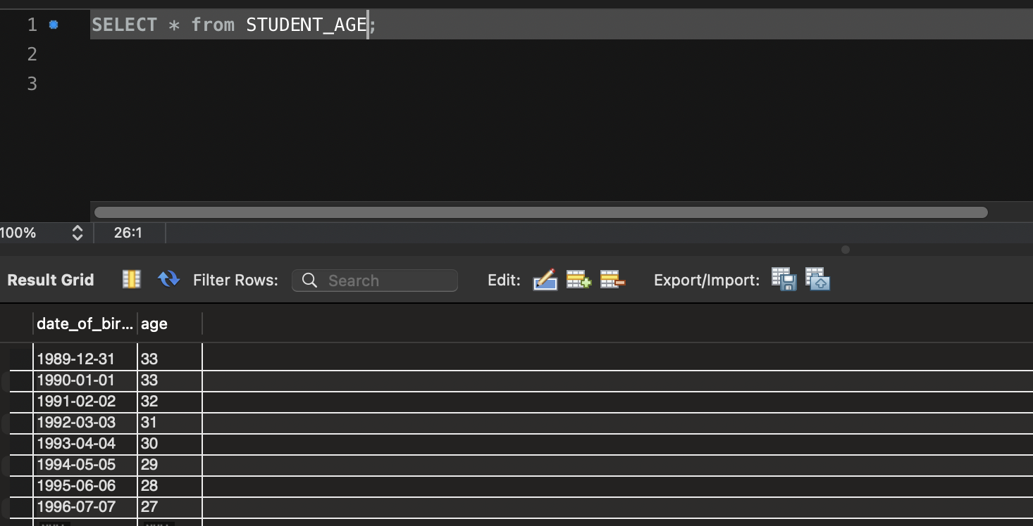

Sample Queries

1) Find the name, department, and scholarship for all students with a GPA of 3.8 or higher.

Query - SELECT s.first_name, s.last_name, d.name AS department_name, sc.name AS scholarship_name

FROM STUDENT s

JOIN STUDENT_AGE sa ON s.date_of_birth = sa.date_of_birth

JOIN MAJOR ma ON s.major_id = ma.major_id

JOIN DEPARTMENT d ON ma.department_id = d.department_id

JOIN SCHOLARSHIP sc ON s.scholarship_id = sc.scholarship_id

WHERE s.gpa >= 3.8;

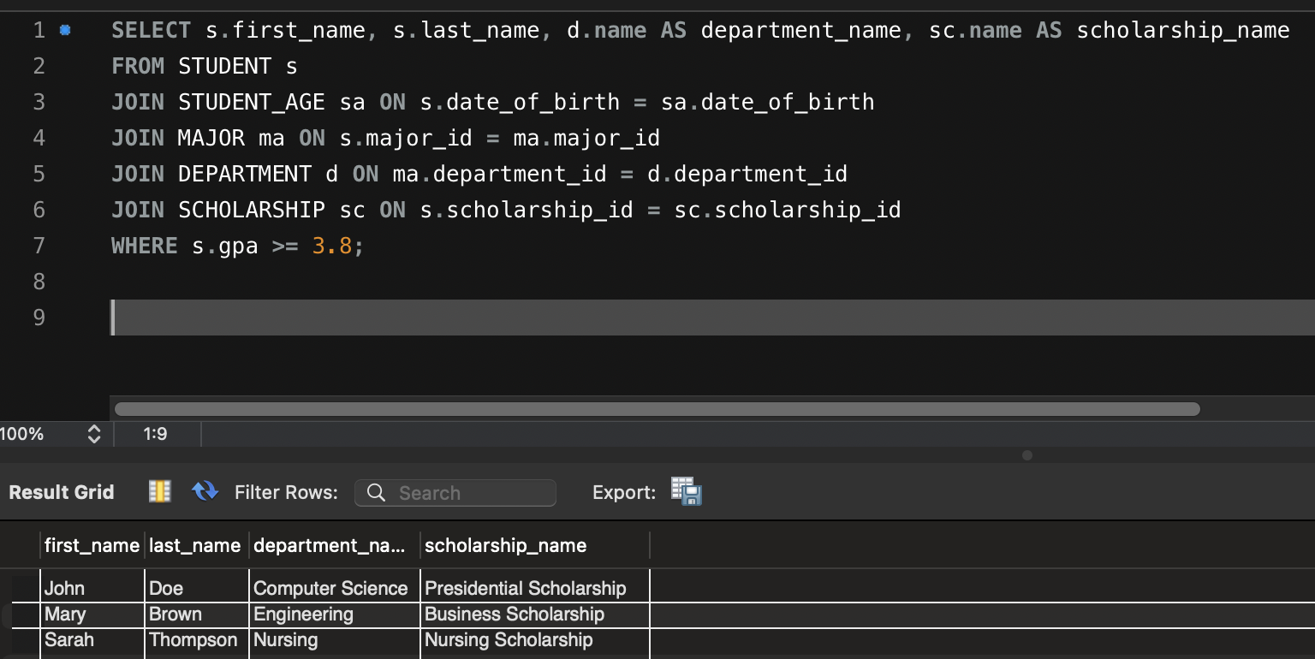

2) List the names of all departments that offer majors with a duration of 4 or more years.

Query - SELECT DISTINCT d.name AS department_name

FROM DEPARTMENT d

JOIN MAJOR ma ON d.department_id = ma.department_id

WHERE ma.duration >= 4;

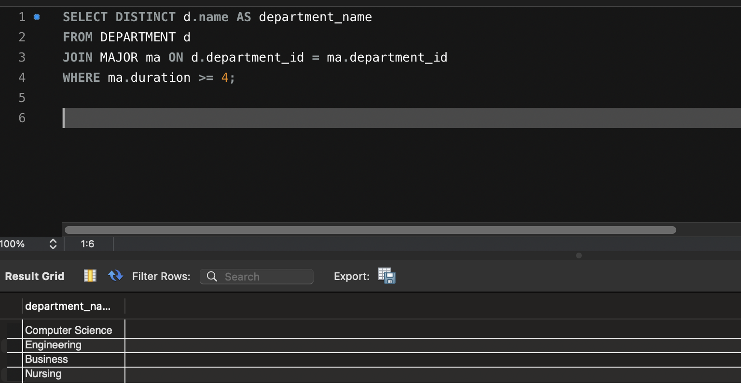

3) Find the total amount of scholarship money awarded to students in the Computer Science department.

Query - SELECT SUM(sc.amount) AS total_amount_awarded

FROM SCHOLARSHIP sc

JOIN STUDENT s ON sc.scholarship_id = s.scholarship_id

JOIN MAJOR ma ON s.major_id = ma.major_id

JOIN DEPARTMENT d ON ma.department_id = d.department_id

WHERE d.name = 'Computer Science';

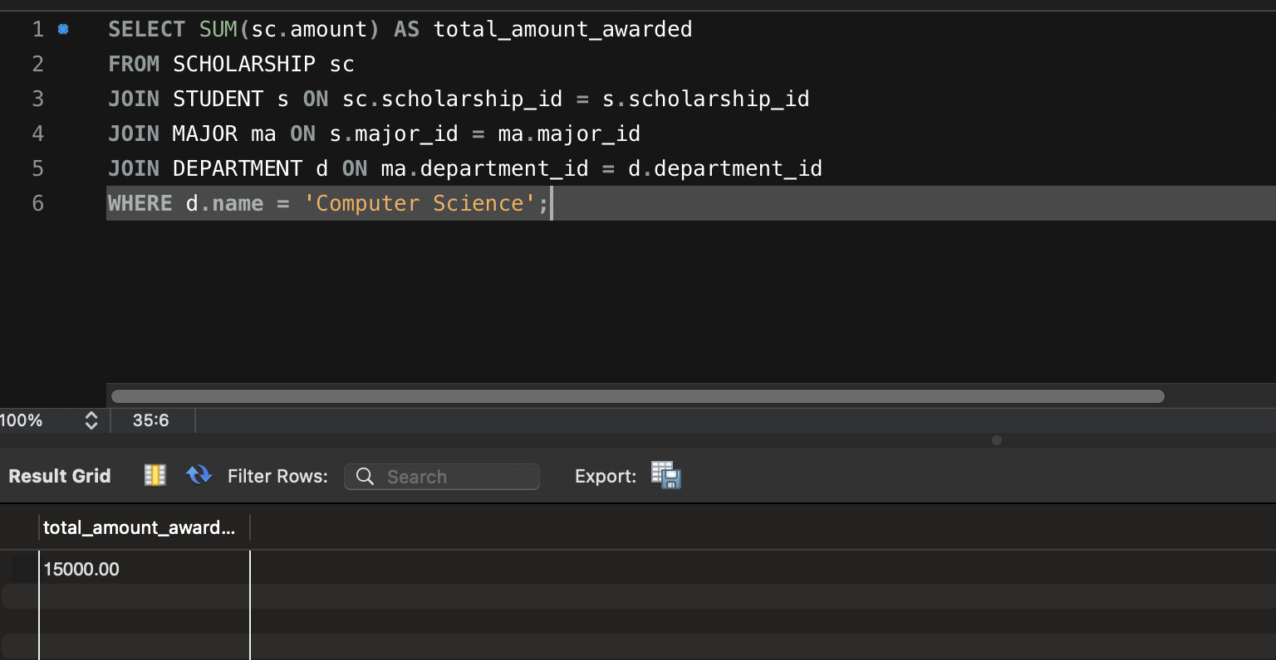

4) Identify the most common scholarship among students in the Engineering department.

Query - SELECT sc.name AS most_common_scholarship, COUNT(*) AS number_of_students

FROM SCHOLARSHIP sc

JOIN STUDENT s ON sc.scholarship_id = s.scholarship_id

JOIN MAJOR ma ON s.major_id = ma.major_id

JOIN DEPARTMENT d ON ma.department_id = d.department_id

WHERE d.name = 'Engineering'

GROUP BY sc.name

ORDER BY number_of_students DESC

LIMIT 1;

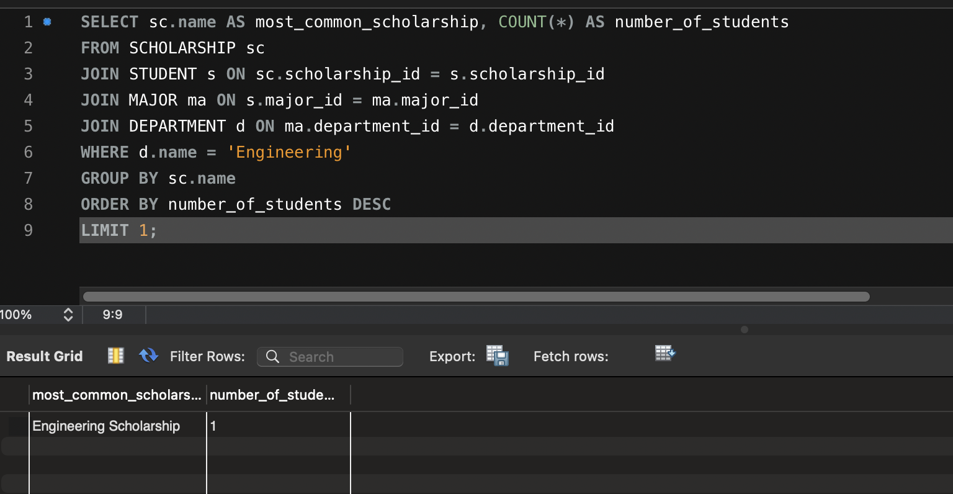

5) Display the names of all sponsors that support scholarships for students in the Business department.

Query - SELECT DISTINCT sp.name AS sponsor_name

FROM SPONSOR sp

JOIN SCHOLARSHIP_SPONSOR scsp ON sp.sponsor_id = scsp.sponsor_id

JOIN SCHOLARSHIP sc ON scsp.scholarship_id = sc.scholarship_id

JOIN STUDENT s ON sc.scholarship_id = s.scholarship_id

JOIN MAJOR ma ON s.major_id = ma.major_id

JOIN DEPARTMENT d ON ma.department_id = d.department_id

WHERE d.name = 'Business';