SIMATS ENGINEERING
ASSESSMENT TOOL 2

COURSE NAME: INTERNET PROGRAMMING
COURSE CODE: CSA4301

COURSE OUTCOME COVERED
CO -2 : Apply CSS layout and styling techniques to create visually appealing and responsive web interfaces, and use JavaScript to enable interactive client-side behavior. (L3)
Assessment Tool : Design Task
Weightage: 20%

QUESTIONS: Total Marks: 20

Question 1: Responsive Navigation Bar Design - Marks(4)
Suppose that an e-commerce website requires a responsive navigation bar that adapts across desktop, tablet, and mobile devices.
(a) Identify key components required in a navigation bar for an e-commerce website.
(b) Design a responsive navigation bar using appropriate CSS techniques.
(c) Demonstrate how the navigation adapts to smaller screens (e.g., hamburger menu).
(d) Evaluate the usability and suggest improvements for better user experience.
(a) Key Components of an E-commerce Navigation Bar
- Company logo
- Home link
- Product Categories
- Search bar
- Cart icon
- User Login/Profile
- Wishlist
- Contact/About link
(b) Responsive Navigation Bar using CSS
HTML
<!DOCTYPE html>
<html>
<head>
<link rel="stylesheet" href="style.css">
</head>
<body>
<nav class="navbar">
<div class="logo">ShopNow</div>
<ul class="nav-links">
<li><a href="#">Home</a></li>
<li><a href="#">Products</a></li>
<li><a href="#">Categories</a></li>
<li><a href="#">Cart</a></li>
<li><a href="#">Login</a></li>
</ul>
<div class="menu">&#9776;</div>
</nav>
</body>
</html>
CSS
*{
margin:0;
padding:0;
box-sizing:border-box;
}

.navbar{
display:flex;
justify-content:space-between;
align-items:center;
background:#333;
color:white;
padding:15px 20px;
}
.nav-links{
display:flex;
list-style:none;
}
.nav-links li{
margin-left:20px;
}
.nav-links a{
color:white;
text-decoration:none;
}
.menu{
display:none;
font-size:28px;
cursor:pointer;
}
(c) Responsive Design (Hamburger Menu)
@media(max-width:768px){
.nav-links{
display:none;
flex-direction:column;
width:100%;
}
.menu{
display:block;
}
}
(d) Evaluation
- Easy navigation across devices.
- Hamburger menu saves screen space.
- Flexible layout improves responsiveness.
- Improvements:
  - Add search suggestions.
  - Increase button size for touch devices.
  - Highlight active page.
  - Include smooth menu animation.
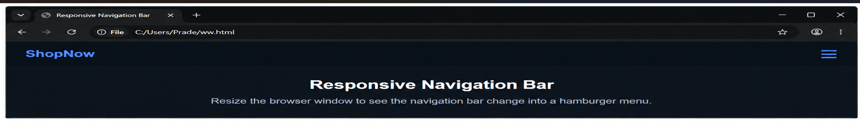

Question 2: Product Hover Effect - Marks(4)
Suppose that an e-commerce website wants to enhance user interaction through visual effects on product items.
(a) Identify suitable CSS properties for hover effects.
(b) Suggest appropriate CSS animation or transition for product interaction.
(c) Design a hover effect for a product card.
(d) Evaluate performance and user experience considerations.
(a) Suitable CSS Properties
- transform
- transition
- box-shadow
- opacity
- background-color
- scale
(b) Appropriate Animation
Use CSS Transition for smooth hover effects because it is lightweight and improves user interaction.
(c) Product Card Hover Effect
HTML
<div class="card">
<img src="product.jpg" alt="Product">
<h3>Wireless Headphones</h3>
<p>₹2,499</p>
</div>
CSS
.card{
width:220px;
padding:15px;
border:1px solid #ccc;
text-align:center;
transition:0.3s;
}
.card:hover{
transform:scale(1.05);
box-shadow:0 8px 20px rgba(0,0,0,0.3);
}
(d) Evaluation
- Hover effect attracts user attention.
- Smooth animation enhances shopping experience.
- Avoid excessive animations as they affect performance.
- Use hardware-accelerated properties like transform for better efficiency.
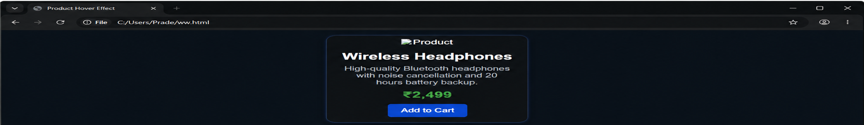

Question 3: Layout Selection (Flexbox vs Grid) - Marks(4)
Suppose that a dashboard layout needs to be designed for a web application.
(a) Identify layout requirements of a dashboard (rows, columns, alignment).
(b) Compare Flexbox and Grid based on layout needs.
(c) Choose the most suitable layout technique and justify your choice.
(d) Evaluate the scalability and responsiveness of the chosen approach.
(a) Dashboard Layout Requirements
- Header
- Sidebar
- Main Content
- Widgets
- Footer
- Proper alignment of rows and columns
- Responsive design
(b) Flexbox vs Grid
Feature | Flexbox | Grid
Layout Type | One-dimensional | Two-dimensional
Best For | Navigation bars, menus | Complete page layouts
Alignment | Excellent | Excellent
Rows & Columns | Limited | Full support
Dashboard Design | Moderate | Best Choice
(c) Suitable Layout Technique
CSS Grid
.container{
display:grid;
grid-template-columns:250px 1fr;
grid-template-rows:80px auto 60px;
gap:15px;
}
(d) Evaluation
- Highly scalable for future widgets.
- Easily adapts to different screen sizes.
- Reduces complex CSS code.
- Better maintainability.
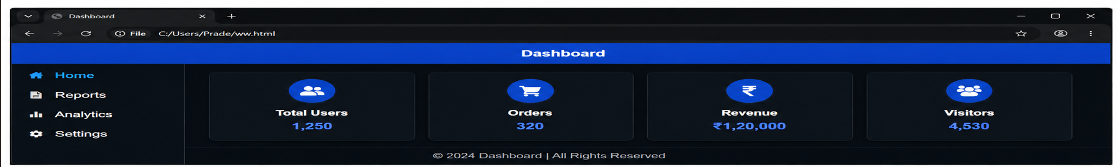

Question 4: Mobile-First Blog Layout - Marks(4)
Suppose that a blog page must be designed following a mobile-first approach.
(a) Identify key sections of a blog layout.
(b) Design a mobile-first layout using CSS.
(c) Demonstrate how the layout scales for larger screens using media queries.
(d) Evaluate accessibility and readability of the design.
(a) Key Sections
- Header
- Navigation
- Blog Articles
- Sidebar
- Footer
- Search
- Categories
(b) Mobile-First CSS
body{
font-family:Arial;
margin:0;
}
.container{
display:flex;
flex-direction:column;
padding:15px;
}
(c) Media Query for Larger Screens
@media(min-width:768px){

.container{
flex-direction:row;
}
article{
width:70%;
}
aside{
width:30%;
padding-left:20px;
}
}
(d) Evaluation
- Mobile-first improves loading speed.
- Readable font size enhances accessibility.
- Responsive layout works across devices.
- Adequate spacing improves readability.
- High color contrast benefits visually impaired users.

Question 5: JavaScript Event Handling for Dynamic Menu - Marks(4)
Suppose that a website includes a dynamic menu that responds to user interactions.
(a) Identify appropriate JavaScript events for menu interaction.
(b) Design event handling logic for menu toggle functionality.
(c) Implement interaction for user actions (click/hover).
(d) Evaluate performance and suggest improvements.
(a) JavaScript Events
- click
- mouseover
- mouseout
- keydown
- touchstart (for mobile)
(b) Event Handling Logic
- User clicks the hamburger icon.
- JavaScript toggles the visibility of the navigation menu.
- Clicking again hides the menu.
(c) Implementation
HTML
<button id="menuBtn">☰</button>
<ul id="menu">
<li>Home</li>
<li>Products</li>
<li>About</li>
<li>Contact</li>
</ul>
CSS
#menu{
display:none;
}
.show{
display:block;
}
JavaScript
const btn = document.getElementById("menuBtn");
const menu = document.getElementById("menu");
btn.addEventListener("click", function(){
menu.classList.toggle("show");
});
(d) Evaluation
- Event listeners improve interactivity.
- classList.toggle() keeps the code simple.
- Avoid attaching multiple listeners unnecessarily.
- Ensure keyboard accessibility and ARIA attributes for better usability.
- Debounce frequent events if needed for better performance.
Code of Conduct:
I SRAVANTHI (192372127) (Name / Reg No) certify that this submission is my original work and that I have adhered to the guidelines specified for this assessment. I understand that any violation of academic integrity rules will result in disciplinary action.
Signature of the student: SRAVANTHI
RUBRICS FOR CALCULATION:

Criteria | Weightage (%) | Level 4 – Exemplary (4) | Level 3 – Proficient (3) | Level 2 – Developing (2) | Level 1 – Beginning (1)
Understanding of Concept | 25 | Demonstrates complete understanding of design requirements and concepts | Good understanding with minor gaps | Basic understanding with some errors | Poor understanding or incorrect concepts
Design / Implementation | 30 | Well-structured, efficient, and responsive design implementation | Correct implementation with minor issues | Basic implementation with inconsistencies | Incorrect or incomplete implementation
Use of Tools (CSS/JS) | 20 | Effective and advanced use of tools/techniques | Appropriate use of tools | Limited or inconsistent use | Incorrect or minimal use
Analysis & Evaluation | 15 | Insightful analysis with strong justification and optimization | Good analysis with justification | Basic analysis with limited depth | Poor or no analysis
Documentation / Clarity | 10 | Clear, well-structured, and properly presented solution | Mostly clear with minor issues | Basic clarity, missing details | Poor or unclear documentation

