|  |
| --- |
| **Final Report**  **Movie Ticket Booking System**  **Name: V. Sravanti**  **USN: 3SL20CS048** |

|  |  |
| --- | --- |
| **Chapter-1** | 3 |
| Introduction | 4 |
| Market Survey : | 4 |
| BookMyShow | 4 |
| Paytm Movies | 5 |
| PVR Cinemas | 5 |
| Overview of Project : | 6 |
| **Chapter-2** | **Error! Bookmark not defined.** |
| Description of the Tool : | 7 |
| VS Code : | 7 |
| Comparison with other tools : | 8 |
| **Chapter-3** | **Error! Bookmark not defined.** |
| Project Planning and Preparation | 9 |
| Paper Pen Designs of the screens : | 9 |
| Persona’s : | 19 |
| Scenario Description : | 24 |
| Use Case Description : | 25 |
| **Chapter-4** | 31 |
| Project Features: | 31 |
| Feature-1 | 31 |
| Feature-2 | 32 |
| Feature-3 | 35 |
| Feature-4 | 37 |
| Feature-5 | 39 |
| Feature-6 | 42 |
| Feature-7 | **Error! Bookmark not defined.** |
| Feature-8 | 47 |
| Feature-9 | 49 |
| Feature-10 | 51 |
| Feature-11 | 53 |
| Feature-12 | 55 |
| Feature-13 | 57 |

|  |  |
| --- | --- |
| Feature-14 | 59 |
| Feature-15 | 61 |
| Feature-16 | 63 |
| Feature-17 | 65 |
| **Chapter-5** | **Error! Bookmark not defined.** |
| Difficulties Encountered and resolved | 67 |
| Making Site Pages Responsive: | 67 |
| Modal for Movies: | 67 |
| Setting up images: | 68 |
| Integration of all the technical features | 69 |
| **Chapter-6** | **Error! Bookmark not defined.** |
| Real Life implementation Perspectives | 70 |
| Challenge faced and solution 1: | 70 |
| Challenge faced and solution 2: | 71 |
| Challenge faced and solution 3: | 71 |
| Challenge faced and solution 4: | 72 |
| **Chapter-7** | 74 |
| References | 74 |
| Concept | 74 |
| Styling Technologies & Tools | 74 |
| Tutorial | 75 |
| Development Tools | 75 |

# Chapter-1

**Introduction**

**Motivation:** The main motivation for the movie booking system development is to reach people in a new level of internet which is proved to very useful

## Market Survey

Here are the 3 websites from real life which are the base of our project idea.

* **BookMyShow:-**

❏ **Weblink**: <https://in.bookmyshow.com/explore/home/ahmedabad>

❏ **Features**: The BookMyShow has been one of the emerging sites in online booking for various events falling under various categories. There is an option of Sign in so you are required to enter your details only for one time which is a good example of the principle of reducing short term memory load. Also there is consistency in the term that you are provided with the customer care and various other details at the end of each page throughout the website which follows the principle of striving for Consistency. It also provides the easy reversibility of actions by cancelling the tickets once booked. It also tries to reduce the error as you are required to enter the place where you want to visit at the beginning so that you don’t end up booking movie tickets at other places as on the basis of your location input you are given filtered alternatives to choose from. There are also sections for adults and childrens.

* **Paytm Movies: -**

❏ **Weblink**: <https://paytm.com/movies/ahmedabad>

❏ **Features**: The Paytm movie booking website provides consistency in terms of the fonts colour and style. It also provides with informative feedback as you are provided with various booking details after booking a ticket for a movie. It also provides consistency in terms of the search bar which remains at its position when you scroll down the page.It also provides the easy reversibility of actions as you can cancel your tickets at any time and get your money back. It provides cultural and international diversity as there are ample categories of movies to choose from. It also provides the features of logging in so you are relieved from entering the details again and again which supports the principle of Reducing short term memory load.

* **PVR Cinemas: -**

❏ **Weblink**: <https://www.pvrcinemas.com/>

❏ **Features**: PVR is a movie ticket booking website. Visibility: 1. Here we can see the selector on the right side of the search bar. 2. There are 2 main sections on the home page. (i) Now Showing & (ii) Upcoming. So users can find the movie easily. 3. On the movie card (in the NOW SHOWING section), new release shows are clearly mentioned On the booking screen, booking details are categorised by different colours AVAILABLE (green), FILLING FAST(yellow), SOLD (red), OUTLAPSED (grey) During finalizing the booking, it shows an alert message to provide some offers (e.g. food) During seat selection, it shows all the seats in appropriate ui (e.g. available, selected, unavailable, social distancing). Here they have mentioned the unavailable seats due to COVID social distancing which makes users more comfortable in terms of safety.

**Overview of Project :**

In the Entertainment category, Ticket Booking site is mainly focused on booking movie tickets and shows or events tickets using online payment methods. BookMyShow, Paytm Movies and PVR.com are famous sites for booking movie tickets and events tickets.One of the best features is that customers can get to know movie show timing and buy tickets online via the internet 24×7.

We have selected a Movie ticket booking system as our project for Human Computer Interaction(HCI). Our plan is to mainly focus on a user friendly interface due to which users can access websites with ease and understanding. We will try to enter the feature that when a particular user visits the website then we will give a list of movies available in his/her languages or region to him. We will try to implement the user interface design which is very recommended by all users like they can view the website in both dark and light mode. We will also try to implement the feature “about the film” which helps the user to select a movie of his choice which follows the more informative feedback principle. We will try to implement the selecting seats and show details about booked tickets which allows the user to select a seat of his choice and we will show the price accordingly. There will be a contact us option through which the user can contact if he faces any problem operating website or want to ask about the updates. In this manner, we will try to follow the principles of HCI.

# Chapter-2

**Description of the Tool**

**VS Code :**

* **Packages:** The Visual Studio Code has a nice plugin(extension) ecosystem with a built in extension management which contains several thousands extensions. The user can select the plugins which are best for the work from a list of available extensions.

* **Editing and Workflow:** It is much faster as compared to other editors as it has no lags because it is built using Node, Electron and HTML/CSS. It feels similar to the Sublime Text and the Atom in usage. The Git Integration is also very much convenient .

* **Customization:** As compared to the features provided by Sublime text and Atom, it has all the expected customization features such as necessary wrapping, indenting,theming, language tweaks etc.

* **Performance:** As the Visual studio code is built on the Nodejs , Electron ,

Html and Css it is faster as compared to the other text editor. The operations such as opening a file or searching a particular phase are very fast and no lag is experienced during their execution. At last it provides with a par performance as compared to the Sublime text and to an extent to the Atom.

**Comparison with other tools**

|  |  |  |  |  |
| --- | --- | --- | --- | --- |
|  | **Packages** | **Editing and Workflow** | **Customization** | **Performance** |
| **VS Code** | It has a nice plugin ecosystem with built in extension management which provides several plugins | It is much faster without any real lags. It also has a debugging feature | Features such as necessary wrapping, indenting ,and  theming are  available. It is similar to that of  Sublime Text and  Atom | Operations such as opening or changing files,searching is fast without any lags as it built on Node.js, Electron,  Html and CSS |
| **Sublime Text** | Basic Package like the Sublime Package Control Plugin in not added by default | Easy and fast search for files or across the files | Aspects such as  Save on lost focus , trim whitespace etc are available | Operations such as opening , closing the editor or searching is smooth and fast |
| **Atom** | It has a package manager installed by default and all the packages are hosted on the  Github | It works smoothly but you need to figure out which additional packages needs to be installed when starting from the beginning | It has an ability to customize your editor to match your development flow and style | It is slow when opening a file or switching between the tabs and it has a lots of lag |

# Chapter-3

**Project Planning and Preparation**

**Paper Pen Designs of the screens**

* Home Page:-

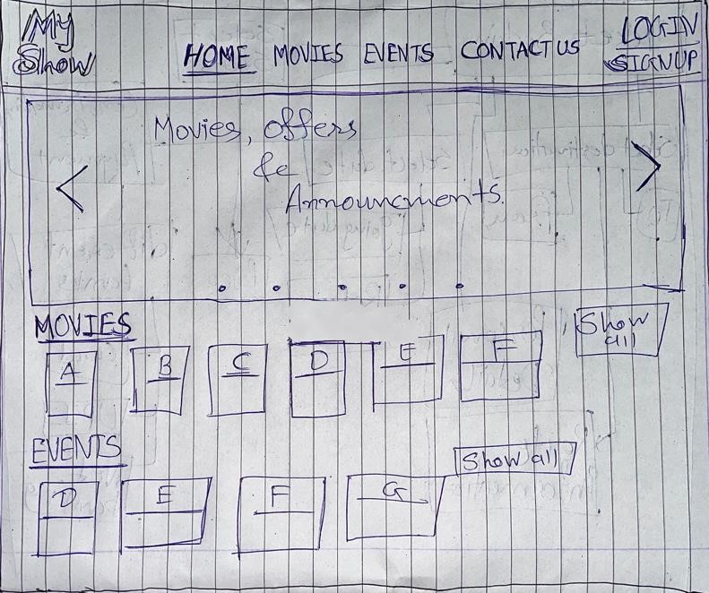

Contact Us Page:-

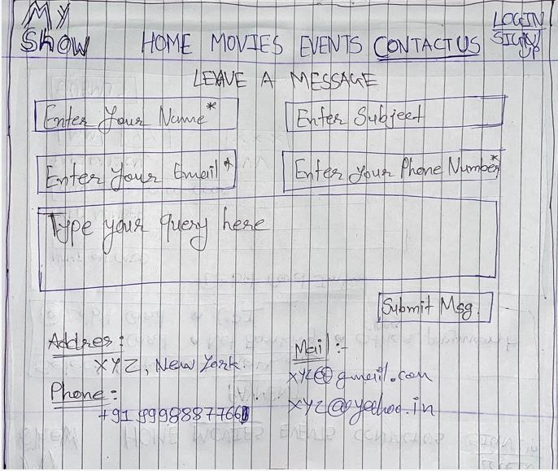

* Payment Page:-

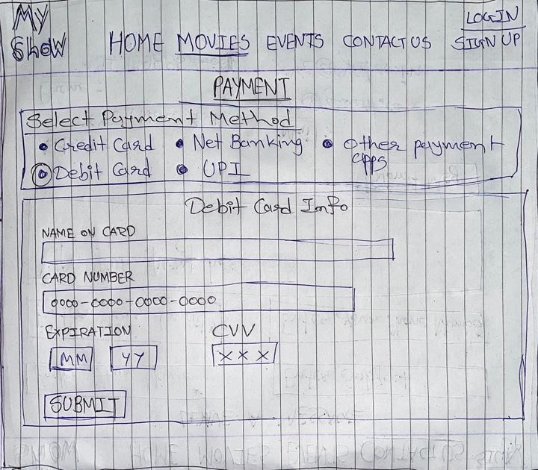

Login Page:-

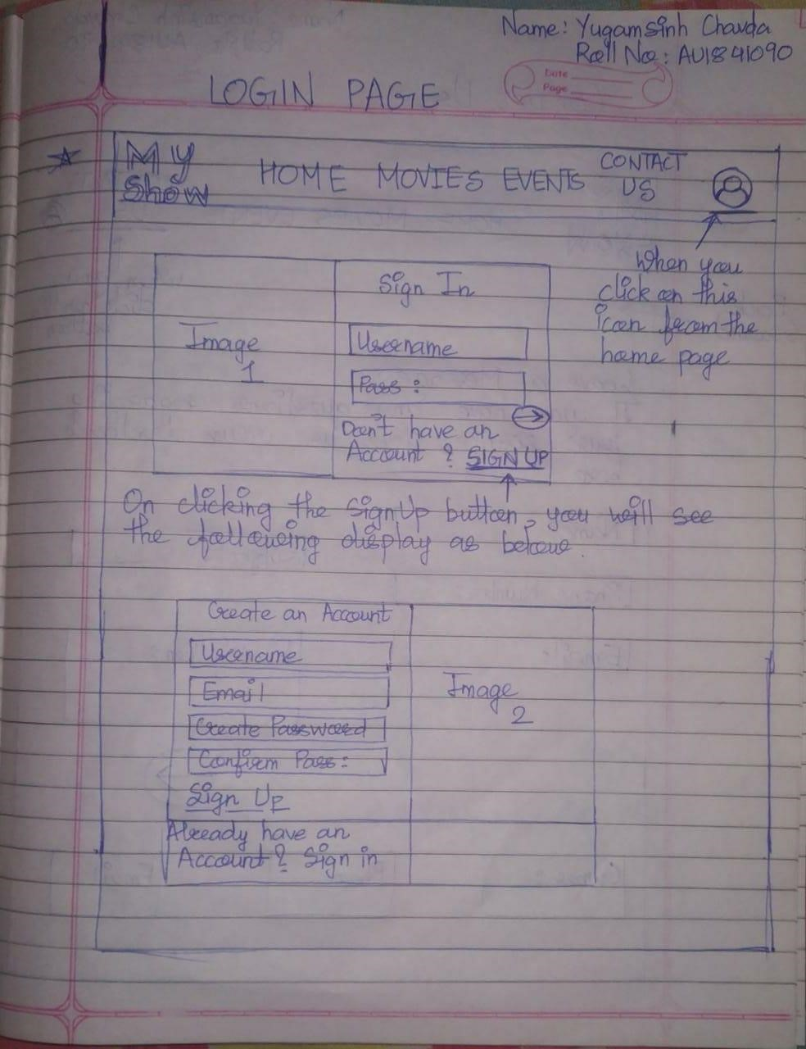

Contact Us Page:-

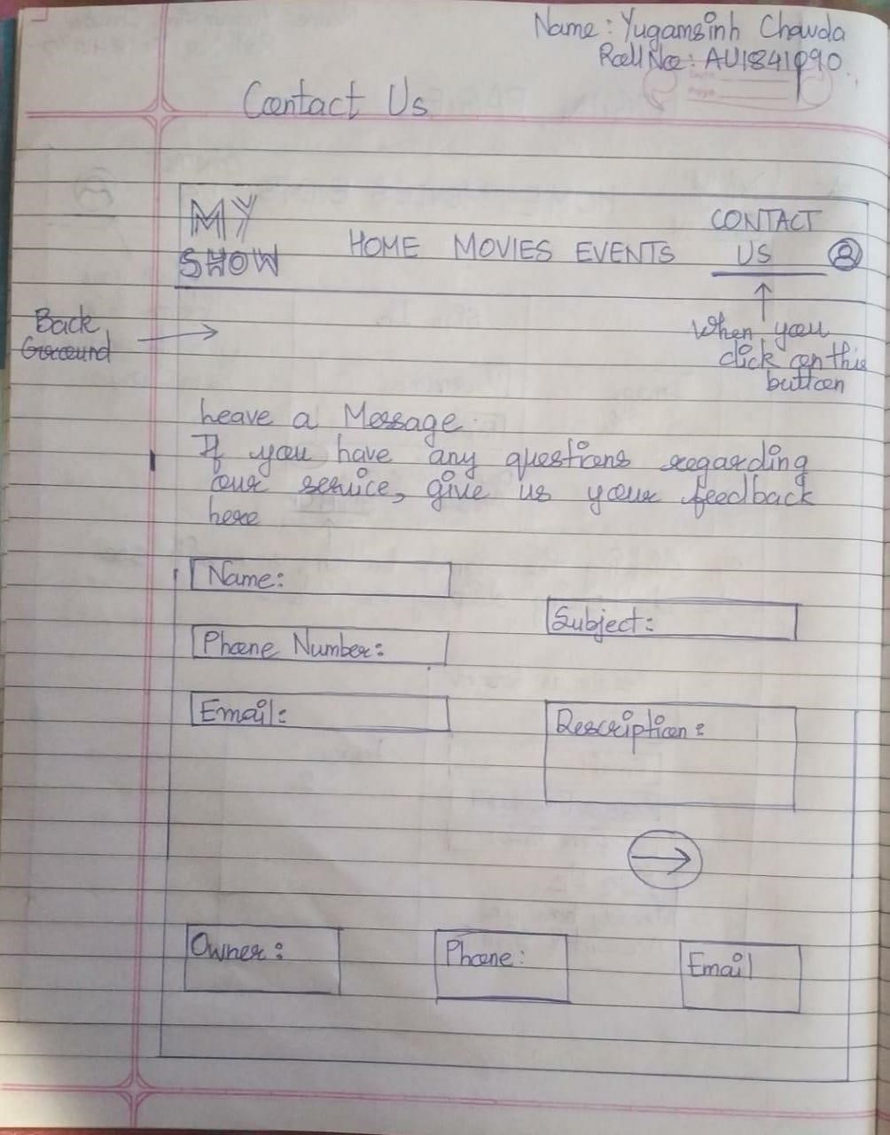

Movies Page:-

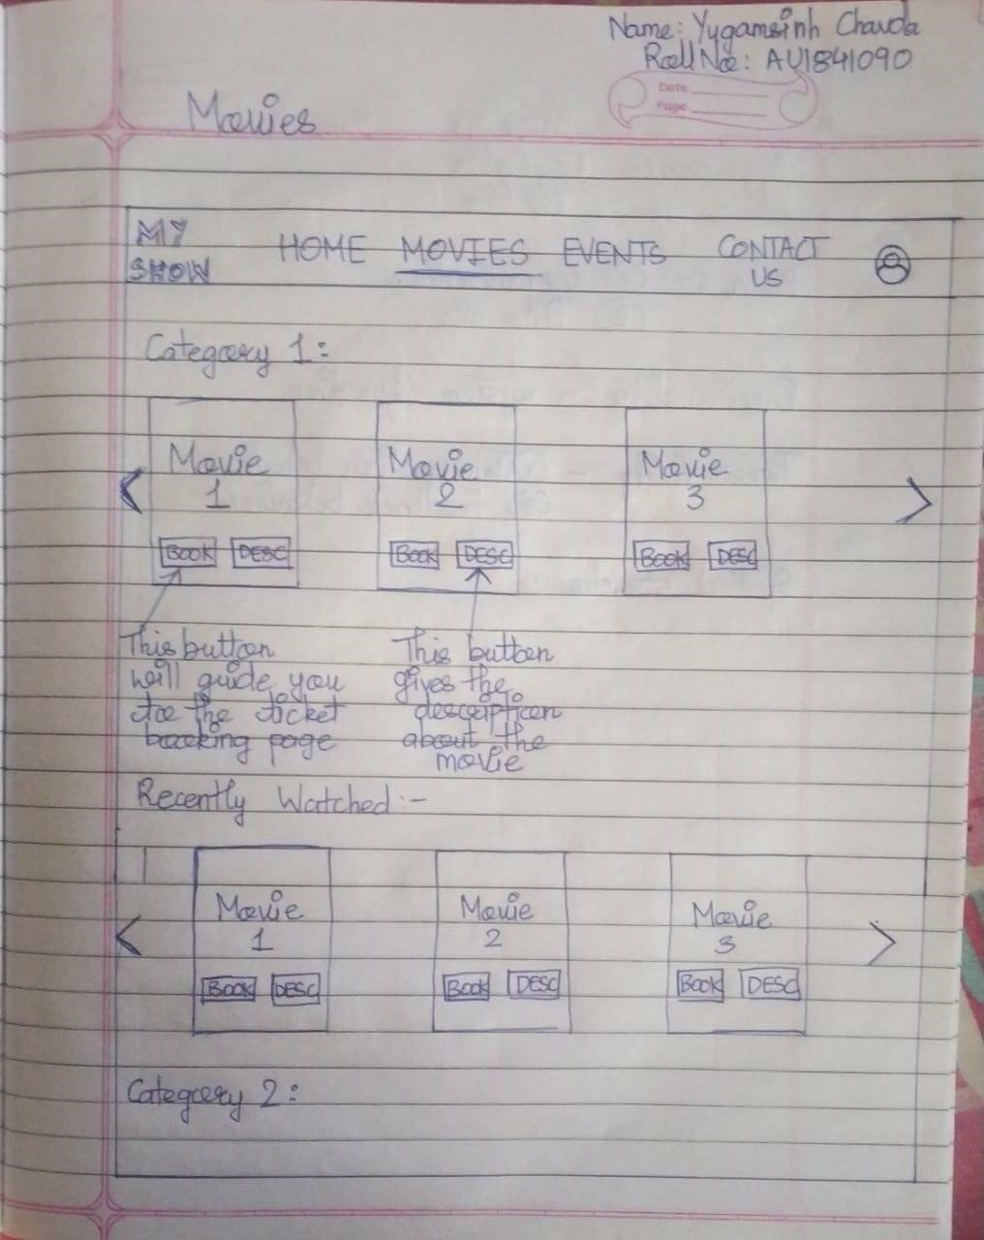

Home Page:-

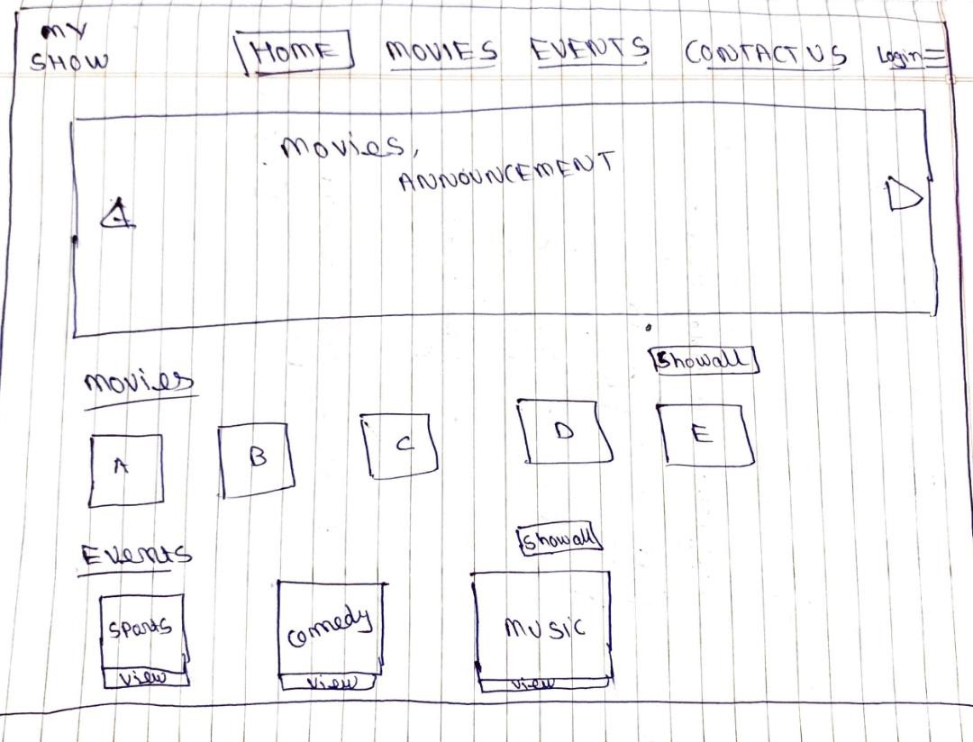

Seat Booking Page:-

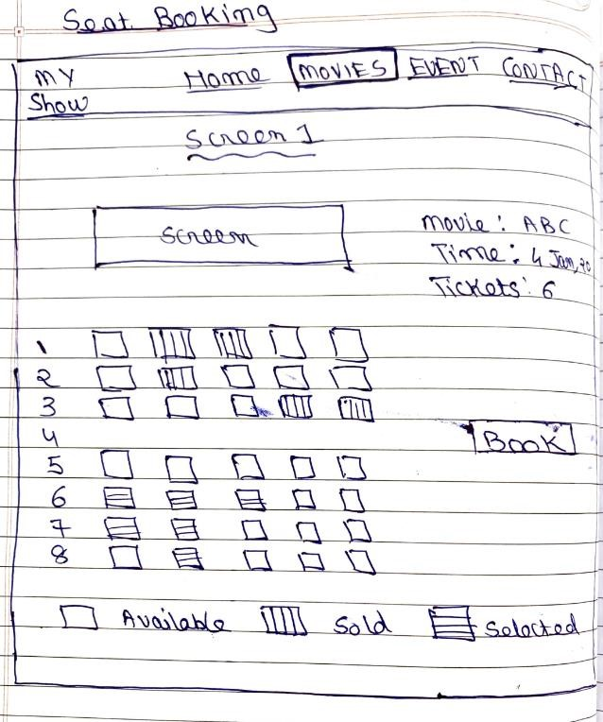

Payment Page:- 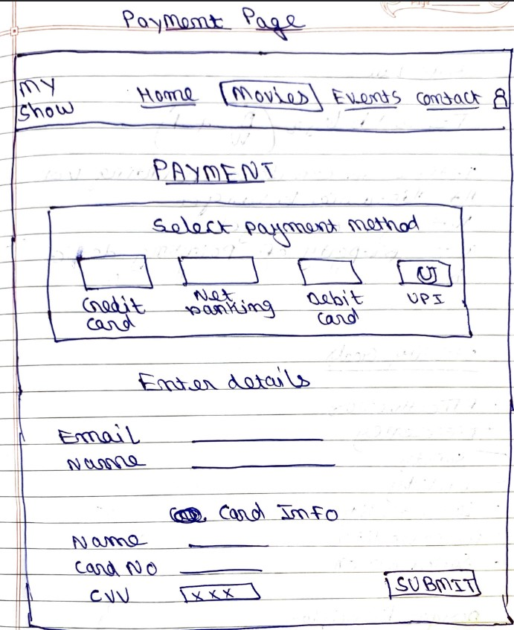

Login Page:-

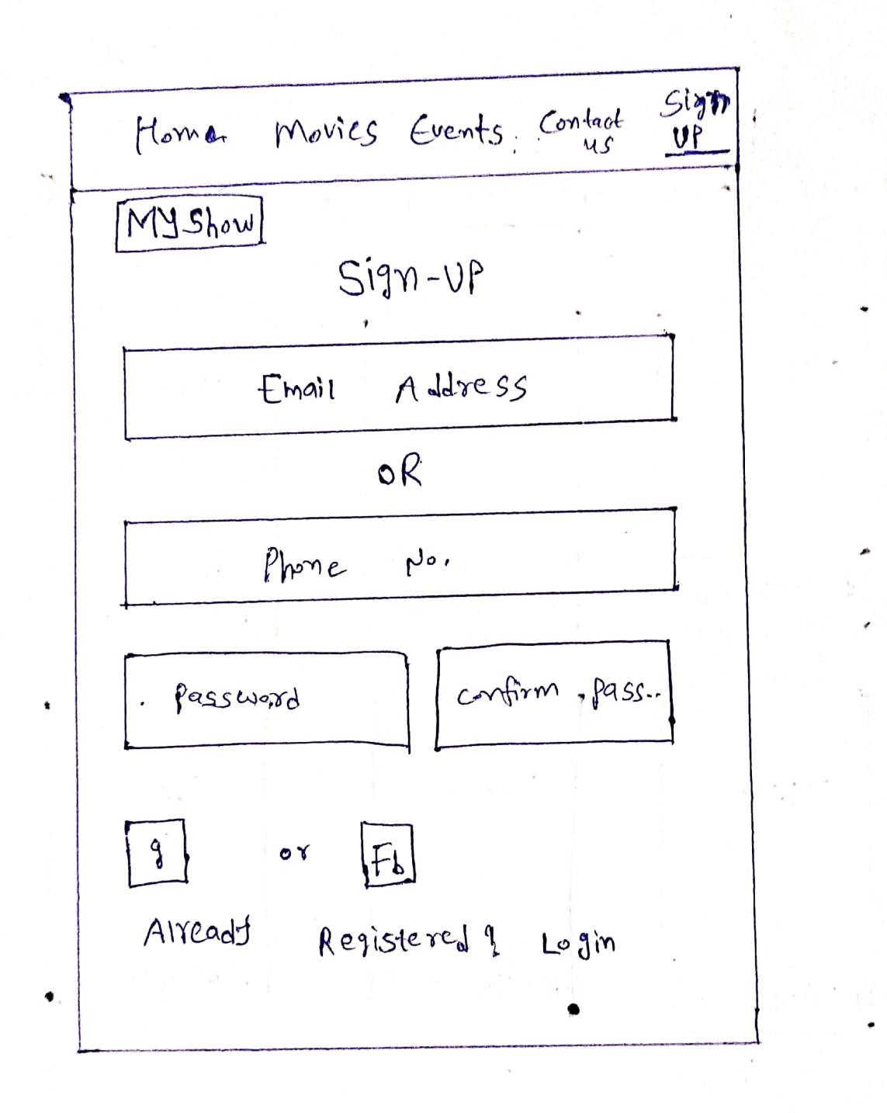

Seat Booking Page:-

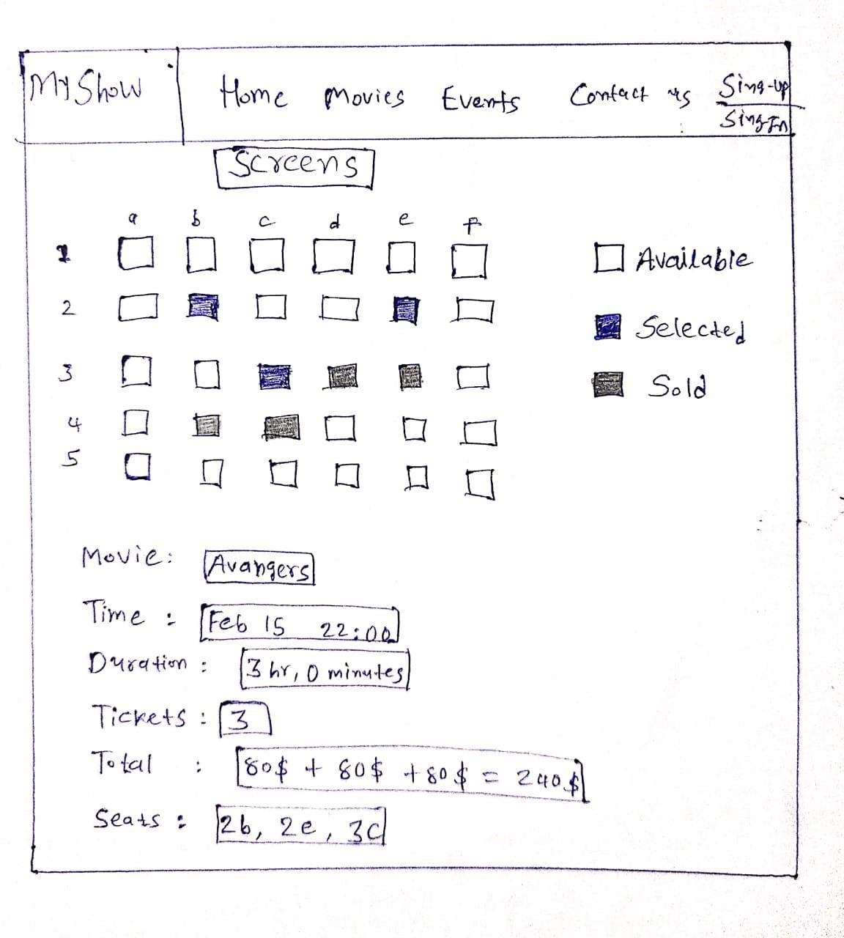

Movie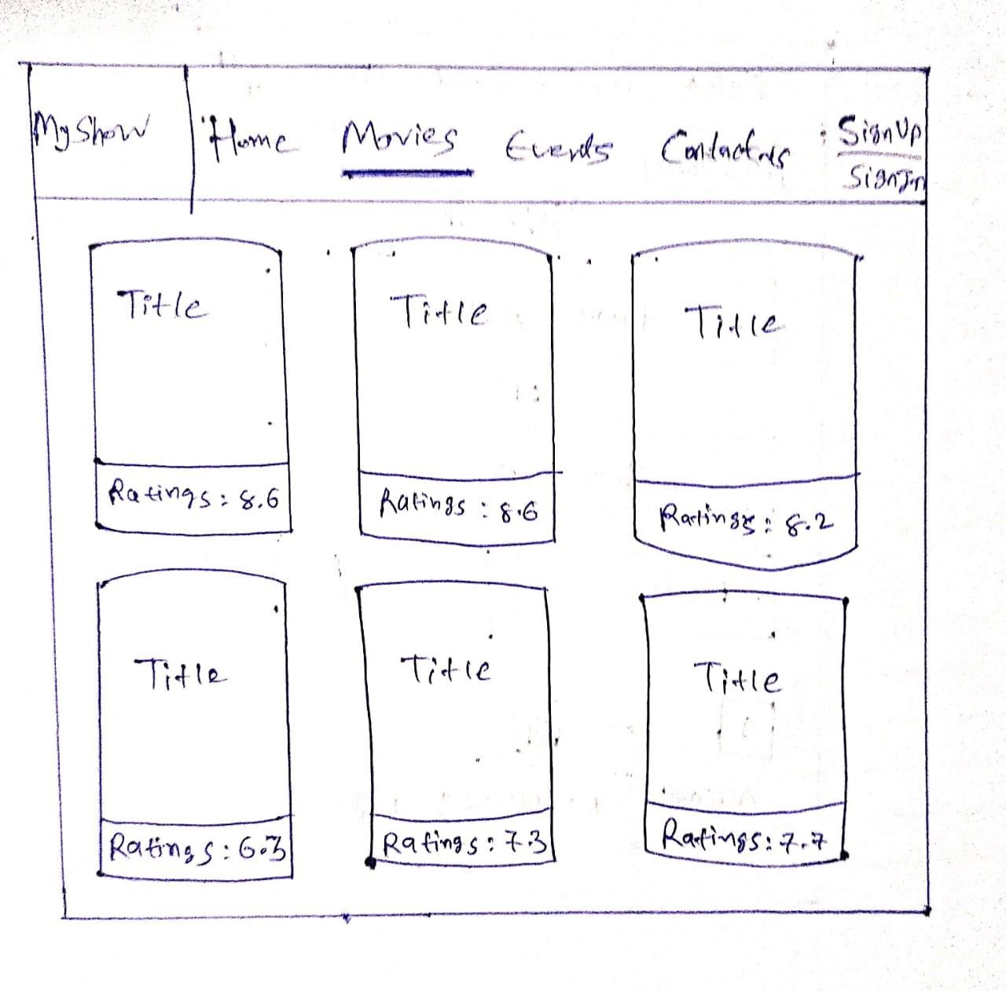s Page:-

## Persona’s

**1)**

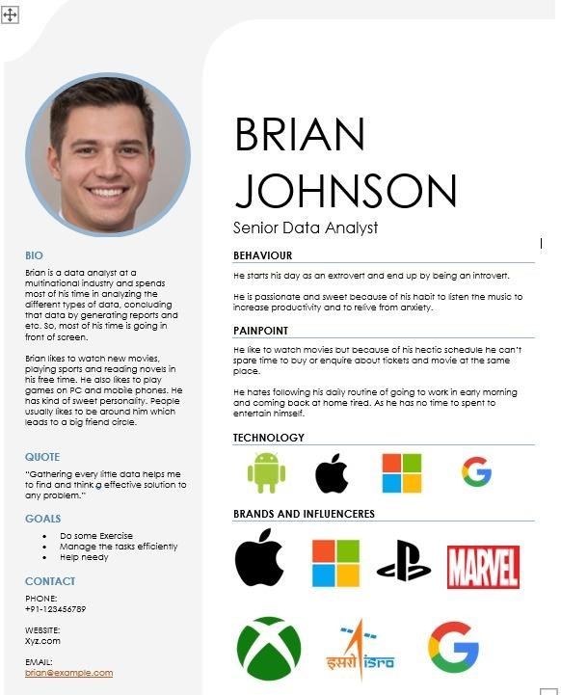

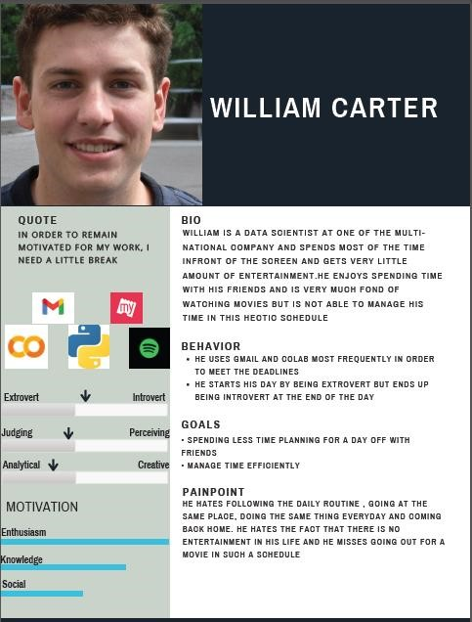

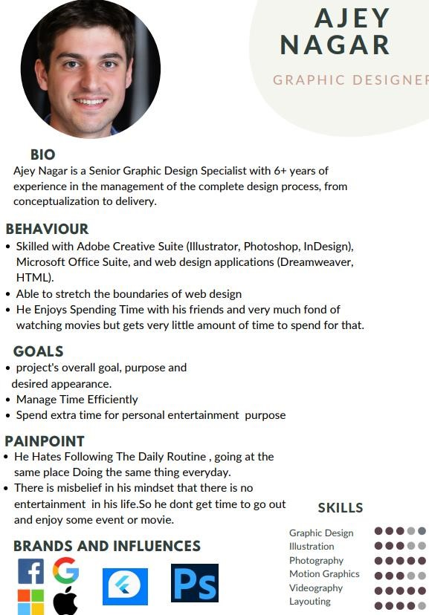

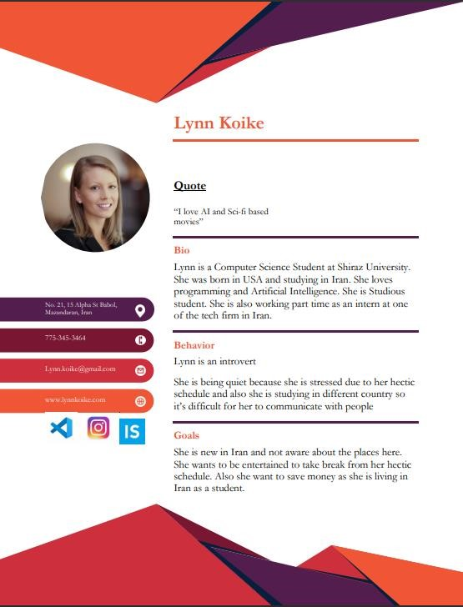

## Scenario Description

**Scenario 1:** Here, when the user visits the website called “MyShow”, User will be prompted to Log in with his/her registered email id and password. Users can skip this option and go to the home page where he/she will select the movie along with the movie theatre and then will proceed to the seat booking section where he/she can select the date and time of the movie. While booking seats, the booking system will show the tickets availability and price. After the user clicks the ‘Book Seats’ button, the system will check if the user is logged in or not and will prompt to login first if not. Then the user will be redirected to the payment and confirmation page and upon successful payment, A ticket will be sent to the user via registered email.

**Scenario 2:** William is a data scientist at one of the multinational companies and spends most of his time in front of the screen and gets very little entertainment. He enjoys spending time with his friends and is very much fond of watching movies but is not able to manage his time in this hectic schedule. He is looking at a place where he could book for a movie without wasting too much of his time. Our app provides a place where he could book for a movie with his friends by following some simple steps which are made in such a way that there are very few changes of error. He doesn't need to login at first when he enters a website which is different as seen compared to other websites. He can easily search for his desired movie theatre, movie , date and time along with the seat number without going to an individual place for inquiry which helps him save a lot of time and he can as well as book tickets online with the help of various payment options and get the receipt through the email.

**Scenario 3:** Ajey nagar is graphic designer at one of the most prominent company and spends most of his time in front of the screen so he gets very less amount of time to spare it for entertainment.He also likes to attend some live musical events, sports events.So our website My Show will be very much helpful for him. There will be a signup page if a new user visits the website .The existing user will login and can select which movie to watch.The website will have different web pages like home page,Movies section, Events Section,contact us.In movies there will be list of movies on the basis of their different genres.The movie can be booked by selection of his choice and after that user can select his desired seat and proceed accordingly.The system will also check that there won't be any clash in seat selection.And Payment page will handle the payment process where different options will be available to user like UPI,Credit card,Debit card,Net banking. An electronic generated ticket will be sent to the user through email.

**Scenario 4:** Lynn Koike is a Computer Science Student in Iran. She was born in the US but is studying here. She is also doing a part time internship. Now, The main issue with her is that she likes watching movies to take a break from her hectic schedule but she is not aware of theatres near by and also as a student in a different country, she wants to save money. Our web-site 'MyShow' can help her to find theatre with budget movie tickets. She can find different section on the home page i.e. Exclusive Movies, Trending Movies, Upcoming Movies, etc. In the Movies page, She can go through the different genres of movies. On the seat selection page, seats will be highlighted by different colors like green, red, gray to represent available seats, booked seats, selected seats. So, She can easily choose her seat. Payment pages will handle all the payment related processes where she can choose different payment methods like cards, UPI or net banking.

## Use Case Description

**Use case 1:**

1. User login using registered email address and password or skip log in.
2. System checks the login credentials are correct if the login button is clicked.
3. Users can select the movies from the cards shown on home screen or can search the movie name and select the movies from search results.
4. After selecting the movie, the user can see details about the movie and proceed to book by clicking the book seats button.
5. Upon clicking the book button, User will get a prompt to select the city or the location of his/her locality.
6. System will show the list of theaters according to the location entered in step 4.
7. Then the user can select the date and time to watch that movie from the given list of shows.
8. The user will select the seats of his choice.
9. System will check the availability of the selected seats and inform the user about that.
10. Upon the click on Book tickets button, System will check if the user is logged in or not and will prompt to login first if not.
11. After step 9, the user will be redirected to the payment and confirmation page.
12. User enters the payment details and the system will perform the payment transaction.
13. Tickets will be sent via mail and the system will reserve the selected seats and will make them unavailable for other users.

### Alternative Courses:-

1. If the entered credentials are not valid
   1. The system displays an error message
   2. The system returns to step 1

1. If the entered location is invalid
   1. The system displays an error message
   2. The system returns to step 4

1. If that particular seat is not available
   1. The system displays an error message
   2. The system returns to step 8

1. If that payment information is invalid
   1. The system displays an error message
   2. The system returns to step 10

**Use Case 2:**

* + 1. The user enters the login credentials.
    2. The system checks if the entered credentials are valid or not.
    3. The user chooses the option to book a movie ticket.
    4. The system prompts the user to enter the location of the movie theatre.
    5. The user then enters the place.
    6. The system then looks for the items that satisfies the inputted condition and then presents with a list of Theatres.
    7. The user then enters or searches for the movie he wishes to watch.
    8. The user selects the date and time when he wishes to watch the movie.
    9. The system checks if the chosen movie is available on that particular inputted time or not.
    10. The user selects the seat in the theatre.
    11. The system checks for the availability of that seat.
    12. The system makes that seat unavailable for others and prompts the user to enter the payment details for booking the ticket.
    13. The user enters the details for the payment.
    14. The system performs the transaction and sends the print of the ticket through the Email.

### Alternative Courses:-

1. If the entered credentials are not valid
   1. The system displays an error message
   2. The system returns to step 1

1. If the entered location is invalid
   1. The system displays an error message
   2. The system returns to step 4

1. If the particular movie is not available at that time
   1. The system displays an error message
   2. The system returns to step 7

1. If that particular seat is not available
   1. The system displays an error message
   2. The system returns to step 10

**Use Case 3:**

* + 1. user enters his login details
    2. System checks if the details are valid or not.
    3. The user chooses the option to book a movie ticket
    4. user then search for his desired movie
    5. The user selects the date and time when he wishes to watch the movie.
    6. The system checks if the chosen movie is available on that particular time or not.
    7. The user selects the seats in the theatre as per his wish
    8. The system checks for the availability of that seat
    9. System shows the payment portal for the user to enter the payment details for booking the ticket.
    10. The user enters the details for the payment
    11. The system performs the transaction and sends the print of the ticket through the Email

### Alternative courses:-

1. If the entered credentials are not valid
   1. The system displays an error message
   2. The system returns to step 1

1. If the particular movie is not available at that time
   1. The system displays an error message
   2. The system returns to step 4

1. If that particular seat is not available
   1. The system displays an error message
   2. The system returns to step 7

**Use Case 4:**

* + 1. Users can Sign-Up/Sign-In at the start of the site. User can also skip this process for now
    2. Users may explore the different sections for movies like 'Currently Trending', 'Recommended', 'Exclusive' OR search for specific movies OR find the movies based on genre.
    3. On clicking a specific movie, System will take the user to the Movie detail page where there'll be a movie description, trailer, rating, button to book tickets.
    4. By clicking on 'book tickets', the system will prompt the page to select theatre, screen and time.
    5. Users will be prompted to seat selection page by selecting theatre, screen and time.
    6. Users will have to select the seats from an interactive seats page where seats will be highlighted in different colors like 'red', 'green', 'gray' in order to describe 'booked seats', 'available seats', 'selected seats'.
    7. By selecting seats, ticket price and total price will be described clearly on the seat selection page.
    8. By clicking on 'Pay Now', the user will be prompted to the payment page where the user can use cards, net banking or UPI for payments.
    9. By proceeding to payment, users will be able to access ticket details.

### Alternative Courses:-

1. Users may find the theatres by entering their city name.
   1. if movie is not available in that particular city then system will prompt an error message
   2. The system returns to step-4

1. On clicking the 'Pay Now' button, the system will check if the user is currently logged in or not.

8.1 If user is not logged in then system will prompt an error message 8.2 The system returns to step-1 (no option to skip sign-in/sign-up)

# Chapter-4

**Project Features**

## Feature-1 Home page – Strive for Consistency

**Functionality:** The use of this feature is to help users navigate through the various pages like the Movies page, contact Us, About Us. It would help the user to create a new account or login in to an existing account through the Login Option provided. It will also help the user to change the color theme (light or dark).

**Photo of Implementation:**

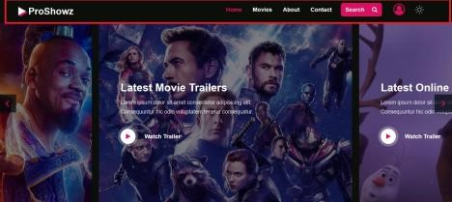

**Description of Principle:** Strive for Consistency • Similar operations to achieve similar tasks.

* Makes things easy to learn and use
* Example: Many functions on MS word and MS Power point function ribbons.
* Consistency can be in terms of colors (red, Green...), etc.. • Identical technology in prompts, menus, help.
* Color, capitalization, layout, fonts
* Consistency between next versions of s/w or app.

**Description of the implementation in our feature:** As you can even when the user scrolls down through the webpage the navigation bar remains fixed at the top which prevents the user from scrolling back up again and again if he wishes to perform some tasks. There is also a button at the end of the page which on clicking guides the user to the starting of the page. The Logo of the website is always shown on the left-hand side which shows the consistency and the theme option is always provided on the top right corner.

**2**

## Movies page - Reduce short term memory load

**Functionality:** This feature provides a complete path of the webpage that the user currently at and it deprives the user from remembering which was the previous page as he can easily go to the previous page through the path provided.

**Photo of Implementation:**



**Description of Principle:** Reduce Short Term Memory Load •Humans have limited capacity to store/process information in short term memory (seven plus or minus two chunks). • cell phones should not require re-entry of phone numbers when redialing.

* website locations should remain visible.
* Multiple page display should be consolidated
* Sufficient training time should be given for difficult sequences of actions.

**Description of the implementation in our feature:** The principle aims at reducing the amount of information that the user has to remember. The principle is implemented in a way that the complete path of the webpage is provided at the top of the webpage. For example, if the user moves from the Home page to the Movies page, then the path would be given as Home>>Genre. This gives information that the previous page was home page and on clicking home he can go to the Home page. In this manner the user does not have to remember things.

**3**

## Home page - Cultural and International diversity

**Functionality:** With the help of these features the user can select from a variety of movies based on language such as Hindi, Gujarati, English etc. This provides choices for a large category of users.

**Photo of Implementation**

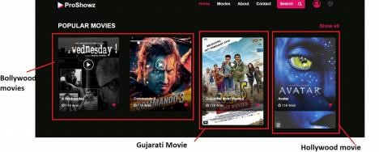

**Description of Principle:** Cultural and International

Diversity • Date and Time formats

* Numeric and Currency formats
* Left to right vs Right to left reading
* Weight and Measures
* Icons, buttons, and colors
* Etiquette, formalities, metaphors

**Description of the implementation in our feature:** The principle is implemented in a way that the user is provided with a number of options of the movies which he wishes to watch on the basis of different languages such as Hindi, Gujarati, English etc. For E.g. A user from India would prefer watching Hindi or Gujarati movies whereas the User from south or from foreign would prefer watching English movies. Hence in this way a large audience can be targeted.

**Interaction Style:** The interaction style would be menu selection where the user reads from a list of movies, selects an appropriate movie as per his convenience, and observes the effect of that action. It has a clear structure for the decision making as all possible choices are present at one time

**4**

## Movies page - Types of user (children, adult…)

**Functionality:** This feature provides a list of movies on the basis of various categories such as new releases, Children section, adult movies, recently watched etc. which makes it easy for the user to choose from on the basis of his preference.

**Photos of Implementation:**

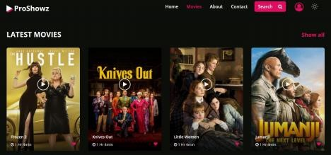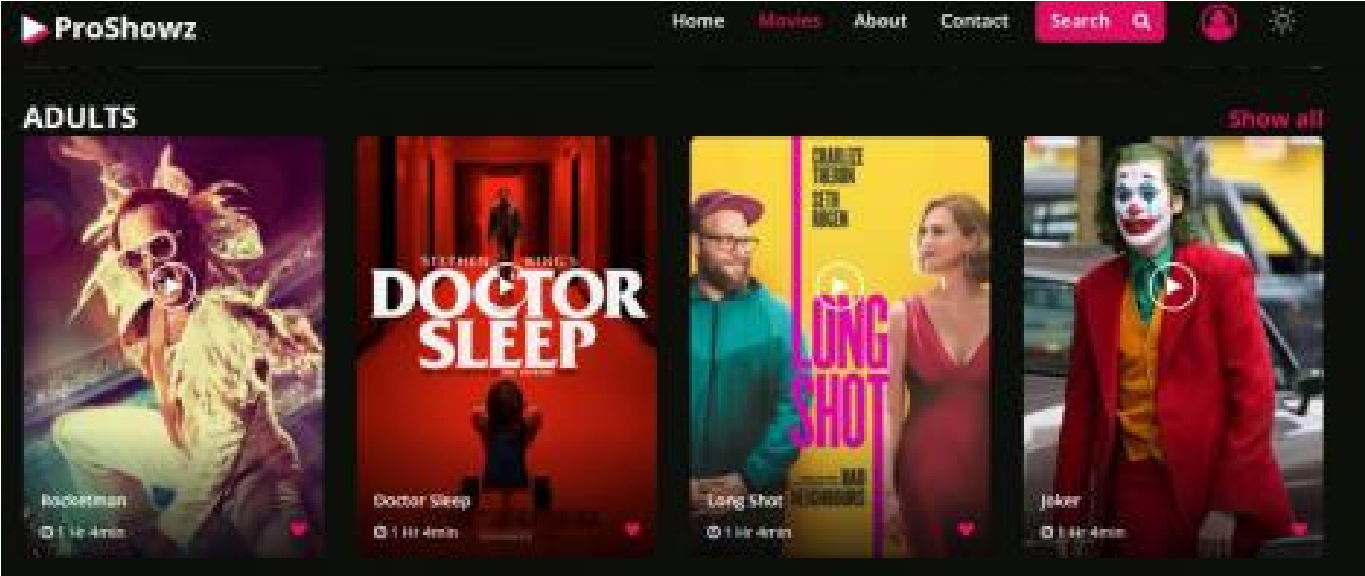

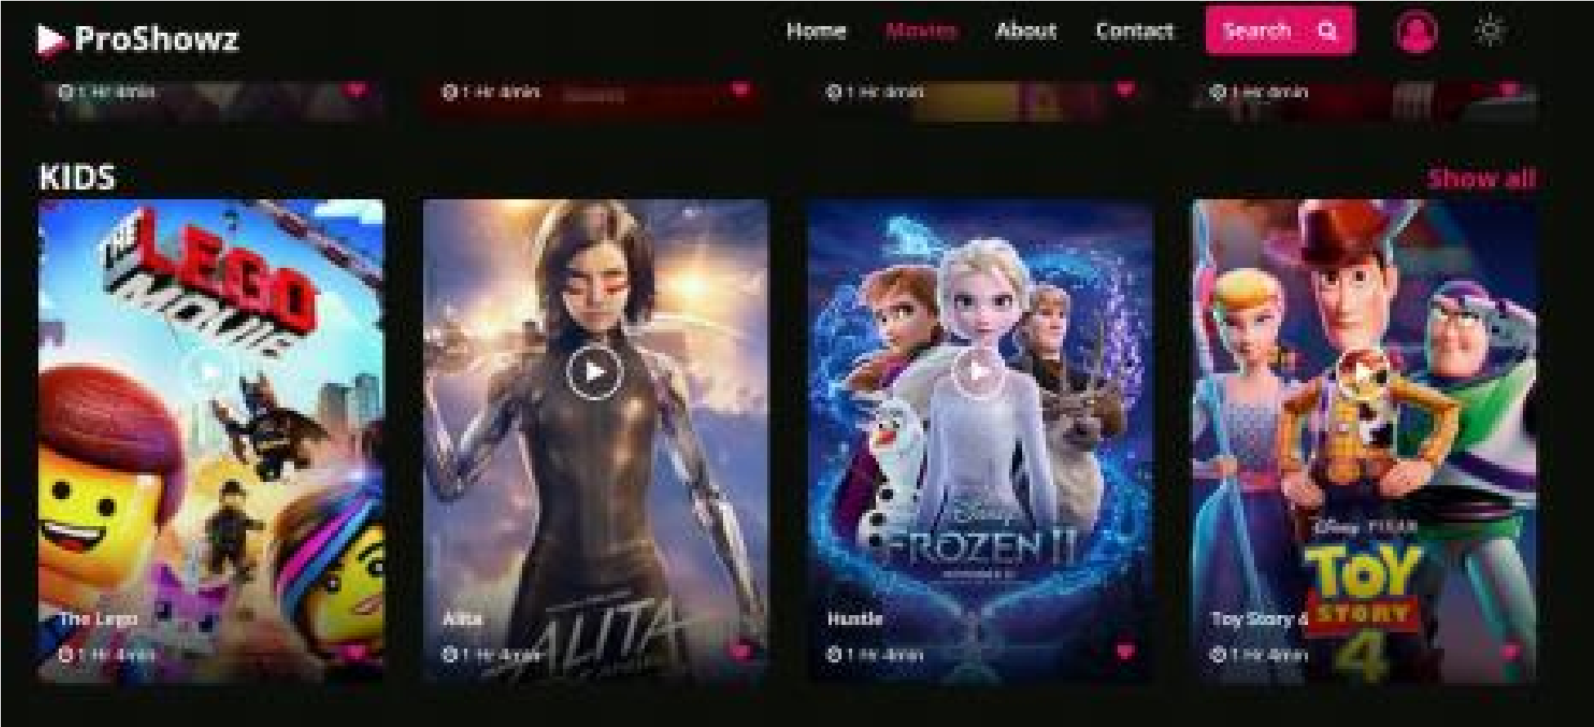

**Description of the implementation in our feature:** The principle is implemented in a way that there is a separate section for the children which would include cartoon movies, series etc. There is also a section which include only some movies which would have some age restrictions which would allow only a certain audience to watch the movie.

**Description of Interaction Style:** The interaction style would be menu selection where the user reads from a list of movies, selects an appropriate movie as per his convenience, and observes the effect of that action. It has a clear structure for the decision making as all possible choices are present at one time

**_**

**5**

## Contact us page - Prevent errors and constraint

**Functionality:** This feature is used for recording the user response regarding the experience of the website or if they have any feedback regarding the services provided or if they are not satisfied with the features that are currently provided. These details can be further used for improvement of the website.

**Photo of Implementation:**

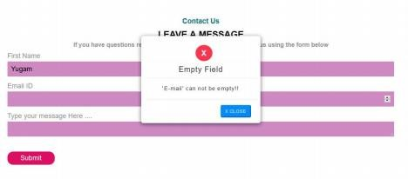

**Description of Principle:** Prevent Errors and Constraints • Design system such that the user cannot make serious errors • Gray out menu that are not appropriate

* Do not allow alphabetic characters in numeric entry fields Constraints
* Restricting users to actions that can take place at a given time.
* Prevents unintentional error.
* Example: Order in Flipkart

**Description of the implementation in our feature:** The principle aims at designing the system in such a way that the user does not make serious errors. The principle is applied to the form in a way that all the fields are necessary to be filled. If the user does not fill any of the fields and clicks on the submit button then the form would not be submitted and the user would be asked to fill the field first. The Email field also has a validation that it should end with @gmail.com. There is also a validation in the Mobile number field that alphabetic characters would not be allowed.

**Description of Interaction Style:** The interaction style is form fill in where the user fills in the blanks about the information they are asked to provide. The user sees a display of related fields, move the cursor among the fills and enters the data

**6**

## Contact us page -Design dialogs to yield enclosure

**Functionality:** This feature is used for providing messages to the user after the completion of a particular task which informs the user what actions have been completed and also provides some additional information like summary etc.

**Photo of Implementation:**

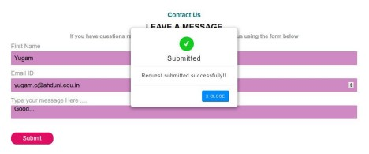

**Description of Principle:** Design Dialogues to Yield Closure Sequences of actions should be organized into groups with beginning, middle and end.

• Example: e-commerce websites move users from selecting products to checkout, ending with a clear confirmation page that completes the transaction.

**Description of the implementation in our feature:** The principle

Design Dialogs to yield closure aim on providing a clear confirmation after the completion of a particular task. For example, when the user fills the form regarding the submission of feedback on the Contact Us page, then after submitting the form, a pop-up message appears which contains the information like Thank You for your message and your feedback would soon be taken into consideration.

**7**

## Login/Sign Up Page -Preventing Error and Constraints

**Functionality:** This feature is used for creating a new account for the website or to help the existing user log in to his account by providing the Username and the password. This feature is very helpful if a new user wants to perform some purchase activities etc.

**Photos of Implementation:**

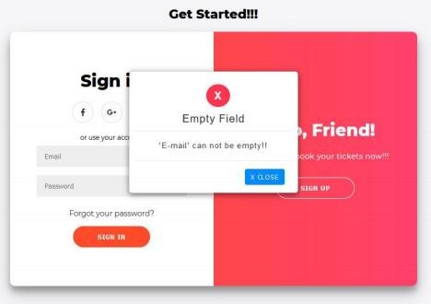

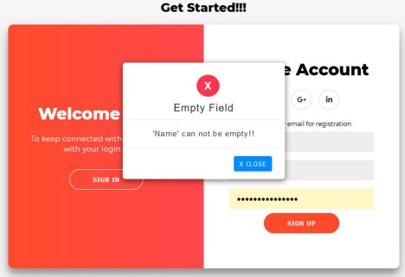

**Description of Principle:** Prevent Errors and Constraints • Design system such that the user cannot make serious errors • Gray out menu that are not appropriate

* Do not allow alphabetic characters in numeric entry fields Constraints
* Restricting users to actions that can take place at a given time.
* Prevents unintentional error

**Description of the implementation in our feature:** The principle aims at designing the system in such a way that the user does not make serious errors. The form is designed in such a way that errors do not occur. Like There is a validation that all the fields should be filled before submitting or pressing the submit button. If the user presses the submit button without filling all the necessary fields

then a message would appear asking the user to fill in the details before submitting.

**Description of Interaction Style:** The interaction style used here is form filling where the users are required to enter the set of information asked for the purpose of creating an account.

## Feature-8 About Us Page -Reduce short term memory load

**Functionality:** This feature is used to provide information to the user in brief regarding how many movies are being shown or the number of shows completed so far, the number of members of the particular website or the number of visits to the website per year.

**Photos of Implementation:**

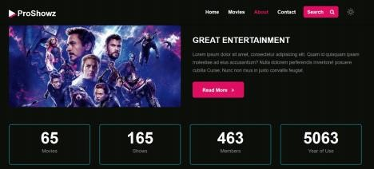

**Description of Principle:**

* Reduce Short Term Memory Load
* Humans have limited capacity to store/process information in short term memory (seven plus or minus two chunks).
* cell phones should not require re-entry of phone numbers when redialing
* website locations should remain visible.
* Multiple page display should be consolidated
* Sufficient training time should be given for difficult

sequences of actions

**Description of the implementation in our feature:** The principle aims at reducing the amount of information that the user needs to remember. The principle is implemented in a way that the users are provided with all the information regarding the website at one page. For example, it provides information like the number of movies being shown. It also provides information like the number of members which might be useful information for the admin and they can take certain measures to increase the number of users. This feature is helpful for the admin which helps him maintain the website.

## Feature-9 For all Pages : Cater for universal Usability

**Functionality:** With the help of the feature named responsive website, the user will be able to open the website on any device, be it phone, laptop or on the desktop. With the help of this feature the website would automatically reshape itself on the basis of the dimensions of the device where it is being used.

**Photo of Implementation:**

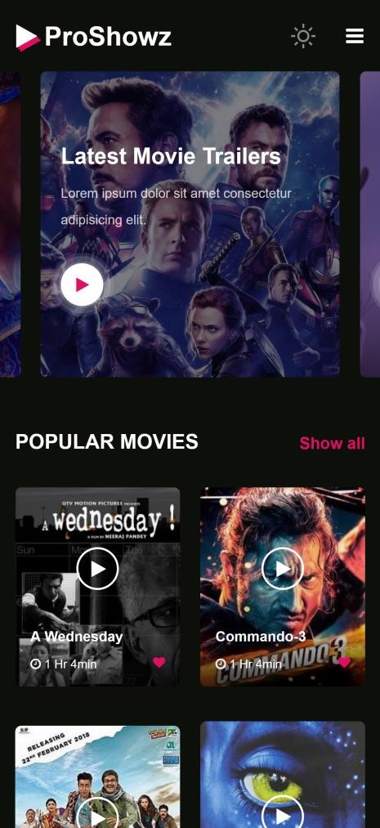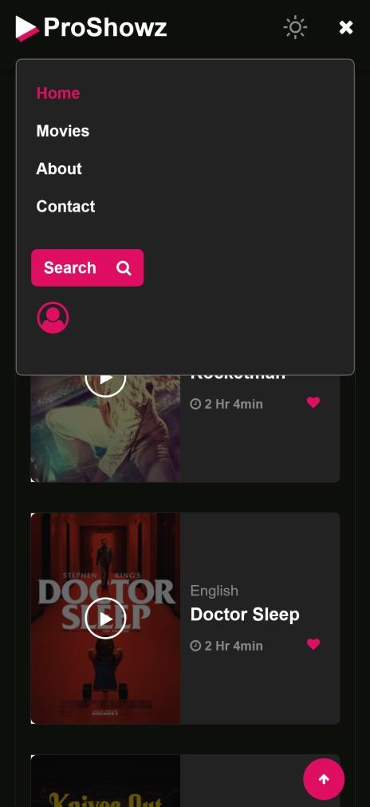

**Description of Principle:** Cater for Universal Usability •

Recognize the need of diverse users and design accordingly. •

Novice (include explanation) to Expert (include shortcuts) •

Age range

* Technological diversity (website can be opened on any platform, any device)
* Users with disabilities

**Description of the implementation in our feature:** When the user opens the website on the mobile phone or any android phone, the figure 1 shows how the website will look like on that particular device and if the user opens the same website on the laptop or the desktop, the figure 2 shows how that same website would appear. In this manner the principle is implemented.

## Feature-10 Ticket Booking Page – Design Dialogs to Yield Closure

**Functionality:** This feature is used to provide information to the user regarding what actions have been performed or what steps have been accomplished for performing a certain task and what tasks are yet to be performed.

**Photo of Implementation:**

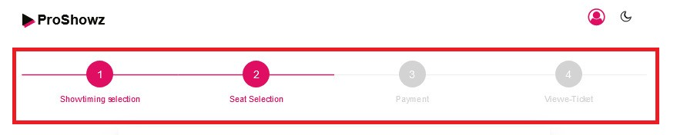

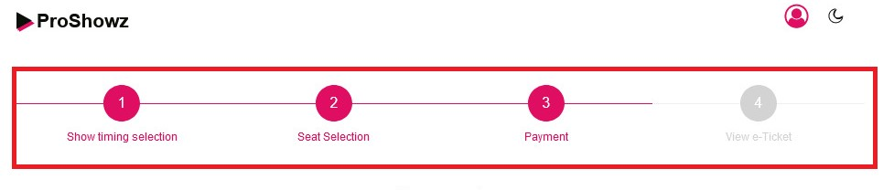

**Description of Principle:** Design Dialogs to Yield closure

This principle aims at arranging the sequence of actions in groups starting with beginning,middle and the end. The example is of an ecommerce website where the user moves from selecting a product to checkout, ending with a clear confirmation page that completes the transaction.

**Description of the implementation in our feature:** As you can see a progress bar on the top of the page which shows the list of steps that needs to be performed to achieve the desired output starting from the first step to the end step. With the completion of each of the tasks, the circle gets highlighted which informs the user that which tasks are still left to be performed.

## Feature-11

**Booking Page permits easy reversal of actions**

**Functionality:** This feature provides the user to move back to the previous steps when performing a particular task which relieves the user from performing the whole action from beginning if any error occurs.

**Photo of Implementation:**

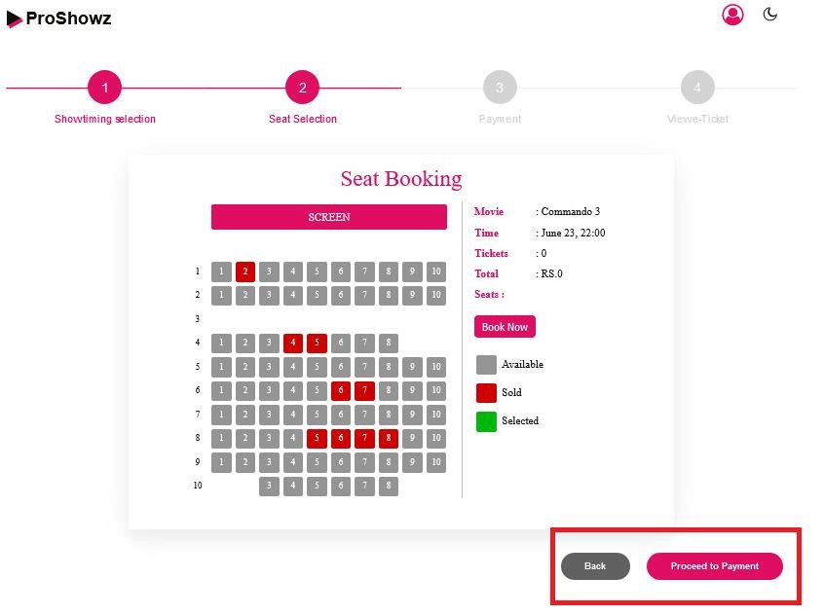

**Description of Principle:** Permits easy reversal of actions the principle aims at providing reversibility for all actions. As much as possible all the actions should be reversible. This principle relieves anxiety in the user and makes the user comfortable as the user knows that my action can be reverted back.

**Description of the implementation in our feature:** The principle aims at providing the user with the flexibility of moving back to a certain step in a process at any point of time. Here in our example the user can move back from the seat selection to the time selection step if he wants to change the timing for the movie by pressing the previous button at the end of the page.

## Feature-12 Payment Page - Cultural and International diversity

**Functionality:** This feature is used to provide the users with a various list of paying methods while performing online transactions and the user selects from the list as per his convenience.

**Photo of Implementation**

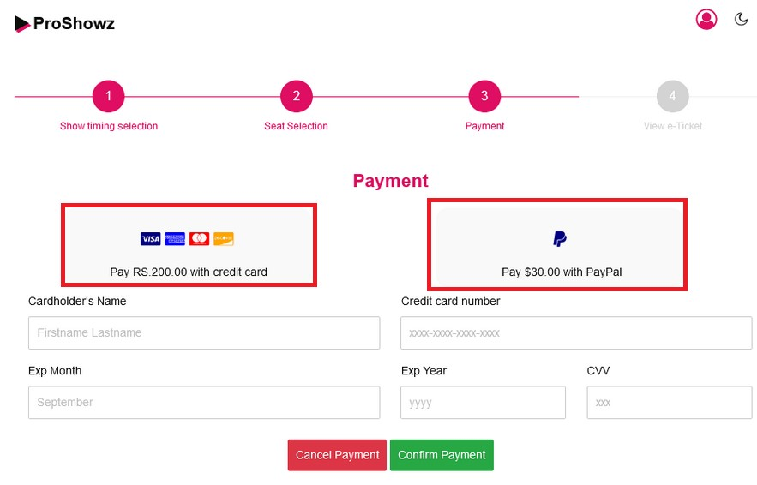

**Description of Principle:** Cultural and International

Diversity • Date and Time formats

* Numeric and Currency formats
* Left to right vs Right to left reading
* Weight and Measures
* Icons, buttons, and colors
* Etiquette, formalities, metaphors

**Description of the implementation in our feature:** The principle is implemented in a way that the user is provided with a number of options for the payment. Here in the pay with card option , the amount for the tickets is shown in one currency format, and with the paypal option the amount is shown in dollars.

**Interaction Style:** The interaction style would be menu selection where the user reads from a list of payment options, selects an appropriate option as per his convenience, and observes the effect of that action. It has a clear structure for the decision making as all possible choices are present at one time

## Feature-13 Booking Page - Offer Informative Feedback

**Functionality:** This feature is used for selecting the seats for a movie in a theatre from a list of available seats and categories of seats

**Photo of Implementation:**

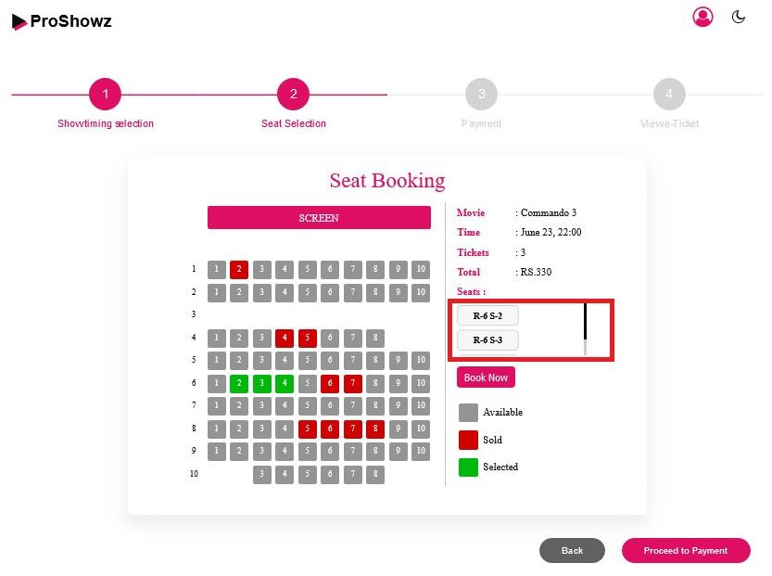

**Description of Principle:**

Offer Informative Feedback The principle is described as for every user action there should be a system feedback. The system sends back the information to the user that what actions have been performed and what has been accomplished. This allows the user to continue with his activities

**Description of the implementation in our feature:** The principle is implemented in a way that when the user selects a particular seat , the colour of the seat changes which shows that the seat has been selected and the seat number appears in the box and the amount for the seat also appears. In this way the user is provided with information after selecting a seat.

**Description of Interaction Style:** The interaction style is menu selection as the user selects from a list of available seats as per his convenience. It has a clear structure for the decision making as all the possible choices are present at one time.

## Feature-14 E Ticket Page – Reduce Short term memory load

**Functionality:** This feature is used to provide information to the user regarding the movie including the seat number, screen number and total cost of the seat , timing of the movie etc **Photo of Implementation:**

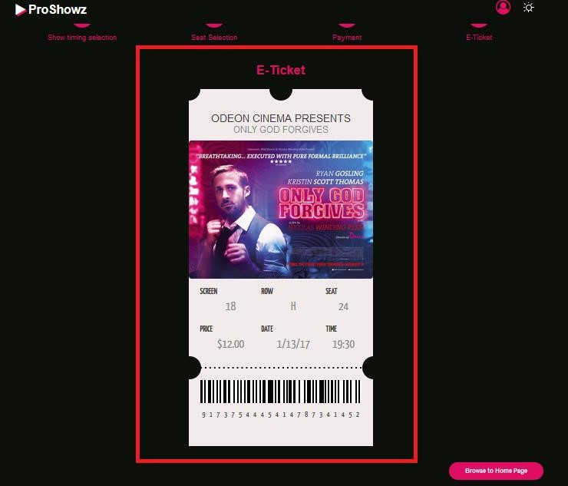

**Description of Principle:** Reduce Short Term Memory load

This principle aims at reducing the amount of information that the user has to remember as the humans have a limited capacity to store/process information in short term memory. For example the cell phones should not require re-entry of phone number while redialling. The website locations should always be visible and the multiple page display should be consolidated.

**Description of the implementation in our feature:** The principle is implemented in a way that all the information regarding the movie like the screen number,movie timing, seat number , total cost are all visible in the ticket generated which relieves the user from remembering any of the particular information. The user can just see the details printed on the ticket.

## Feature-15 Payment Page : Permits easy reversal of actions

**Functionality:** This feature allows the user to cancel the booking for a particular movie and sends the user back to the movies page where he can select for another movie if he wants.

**Photo of Implementation:**

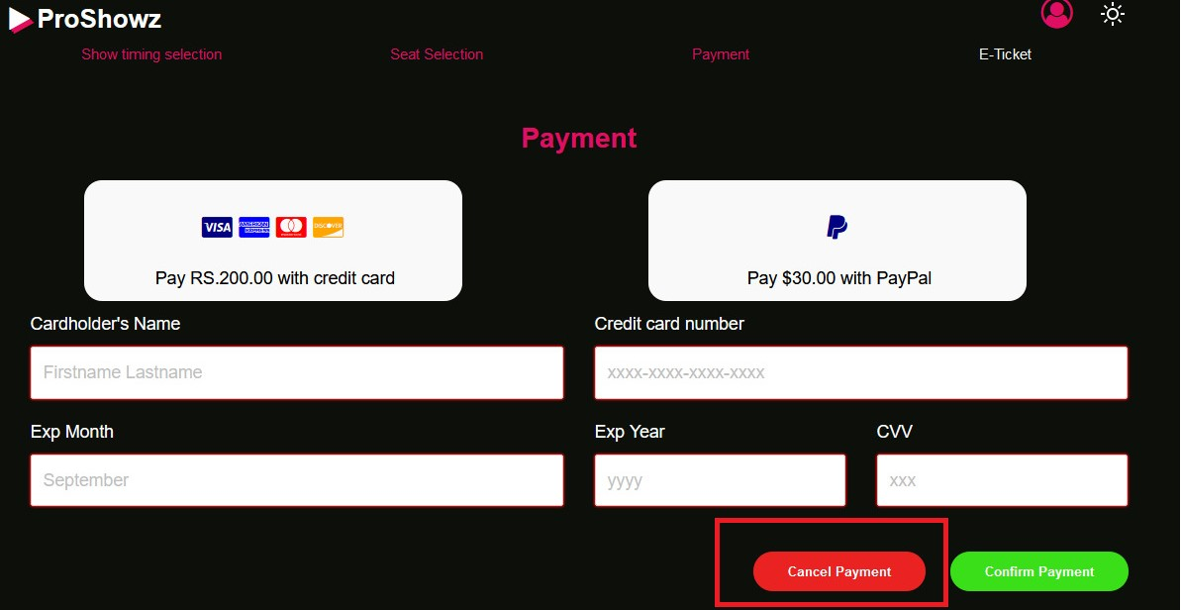

**Description of Principle:** Permits easy reversal of actions the principle aims at providing reversibility for all actions. As much as possible all the actions should be reversible. This principle relieves anxiety in the user and makes the user comfortable as the user knows that my action can be reverted back.

**Description of the implementation in our feature:** The principle is implemented in a way that if the user wants to cancel the booking for a particular movie and wants to book another movies, then by clicking the cancel booking button, the booking for the current selected movie is cancelled and the user is directed to the movie page where he can select other movies which he wishes to watch.

## Feature-16 Movies Page - Reduce Short Term memory load

**Functionality:** This feature is used to provide the users with the information regarding the recent movies which the users have visited or viewed

**Photo of Implementation**

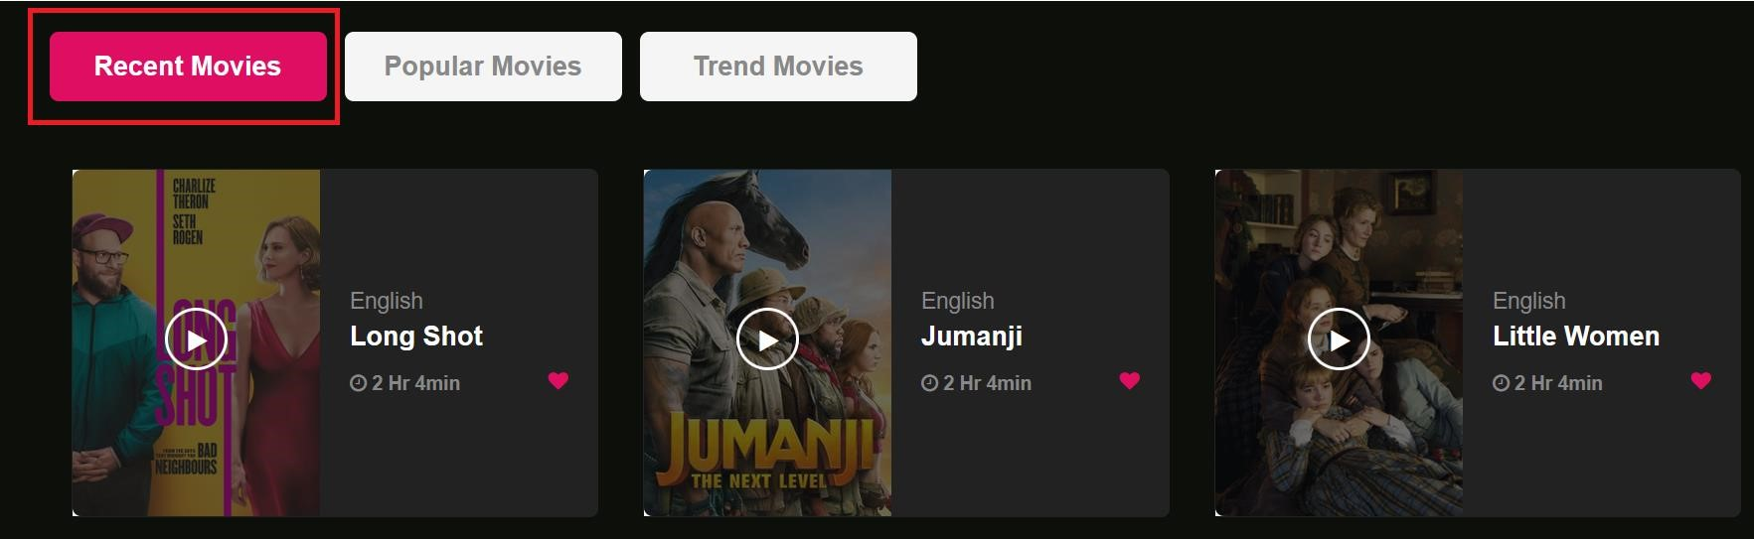

**Description of Principle:** This principle aims at reducing the amount of information that the user has to remember as the humans have a limited capacity to store/process information in short term memory. For example the cell phones should not require re-entry of phone number while redialling. The website locations should always be visible and the multiple page display should be consolidated

**Description of the implementation in our feature:** The principle is implemented in a way that the system keeps a note of the movies that the user has viewed recently and provides the user with the list which relieves the user from remembering which movies he has watched in the recent time. The user can just visit the recent movies list on the movies page.

## Feature-17 Home Page - Offer Informative Feedback

**Functionality:** This feature helps the user to search for the movies based on various categories from the home page.

**Photo of Implementation:**

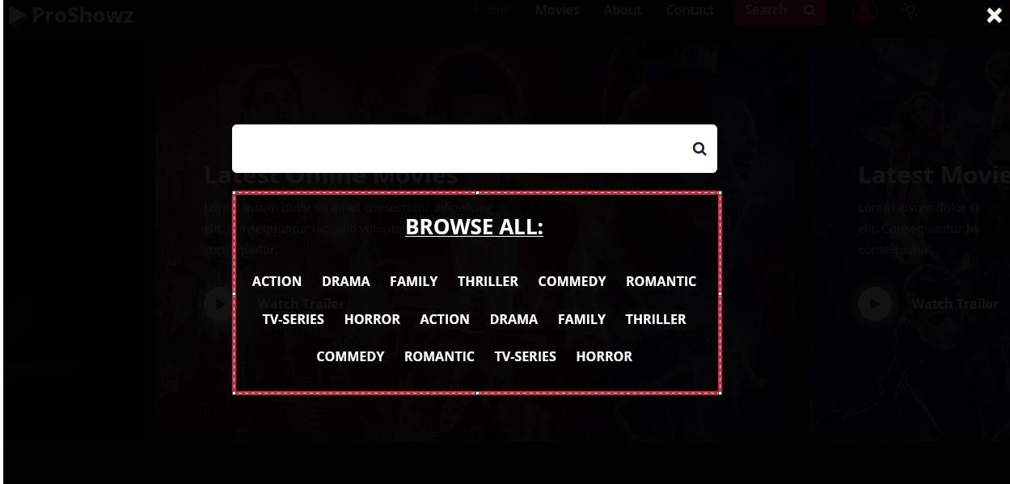

**Description of Principle:** The principle focuses on providing system feedback for every user action. The system sends back information to the user that what action has been done and what has been accomplished. This allows the user to continue with activities

**Description of the implementation in our feature:** The principle is implemented in a way that when the user presses the search button. The user is provided with a list of categories of movies to choose from and when the user selects any particular option, then the user is directed to the page where the selected category appears. Hence the user doesn’t have to move through the whole website finding for various movies

**Description of Interaction Style:** The interaction style is menu selection as the user selects from a list of available categories(genre) for movies as per his convenience. It has a clear structure for the decision making as all the possible choices are present at one time.

# Chapter-5

**Difficulties Encountered and resolved**

## ● Making Site Pages Responsive

In today's technological world, there are many different devices of different sizes available and connected to the internet. Users will be visiting websites using their compatible devices and the size of all devices is different. So, a website should be flexible in all devices which is called a responsive website. So, To make the website responsive after integration of all features is a very challenging task and we have faced many difficulties in that process. One of the main difficulties is that the css(cascaded style sheet) of all features is conflicting as the width and height of all features are different. So, first we have to resolve that doubt by making the width and height of every feature compatible with each other for standard desktop websites. After that, we have to specify the width and height of each feature for different devices and change the icons and navbars for each page of the website for handheld devices and desktops. To solve this, We have to see the standard sizes of all devices to make the site responsive accordingly. And setting the content of features as per the device size.

## ● Modal for Movies

We have created a model which will be useful in providing the information about a particular movie. Some of the challenges that were faced was setting the contents in a particular format in the model so after enough efforts and problem solving we overcame the problems .One problem was that when the user opens the model then if he clicks on the screen outside that of the modal, then the modal should close. A significant amount of time was spent solving these problems. one of the problems that we faced was that when more than one model was created for different movies , we were getting the details of only one movie in all the movie descriptions. As a result after looking for how to solve the problem and after debugging we created different classes for each movie which solved the problem.

## ● Setting up images

As we Know that in any website design ,images aren’t just a factor of beauty: in user experience design but also play an important part in building up usability of a website. So keeping in mind this we have designed our website in the same manner. We also made sure that high quality images wouldn't slow down our website. There arose many difficulties of setting of a particular image on movies page in our website where we need to accurately set all the images of same size and one main thing that movies page should be responsive .As we need to find all images of same size and set them in our webpage it took some time to set it perfectly by applying css and we troubleshooted it to give best experience to end user.

## ● Integration of all the technical features

As per our project structure, all team members had to make different features. Therefore, different team members used different coding structures in their respective technical features. All members used HTML, CSS and java-script but due to different structure and different coding style, programming properties were far different from each other. This variation caused an inappropriate effect on the final output while integration and the site was not looking as good as it should be.

Most of the components on each & every page of the site were overlapping or had different positions compared to the original and due to this, those features were not working at all. Moreover, many features caused compile time & run time error in the code. So, the site was completely unusable. The '.css' files which are responsible for styling of page elements were conflicting to each other and were mainly responsible for integration errors. To encounter these integration issues, we made some common '.css' files and merged others. Also, modified some properties by using 'variables' in such a way that it works globally to all the elements of site pages.

# Chapter-6

**Real Life implementation Perspectives**

## ● Challenge faced and solution 1

One of the main Challenges that may be critical to encounter, if this movie ticket booking system will be implemented or to be used in the real world is the “Reservation Process”. There are two critical situations about the reservation process. First is Secure Payment and Second is long transactions. In Secure Payment, First of all, it has to be considered that, if the consumer is not forced to pay for reserved seats immediately by, e.g., inserting a proper credit card number, there is always the problem that the reservation service can be misused. In case that payment can be done online by credit card or other payment options, severe security problems arise. Therefore security systems should be standard. In long transaction, First of all, there is a possibility of two customers might be booking at same time and one customer has selected the seats and paid immediately but the second customer has chosen same seats as the entered the booking session at same time so seat chart will be same, but he took long time to process his transaction. So, while processing for payment, they will encounter the error that “it is already booked!”.

**Solution:** to maintain a seat chart in real time will be the critical problem for the reservation process in the real world.

## ● Challenge faced and solution 2

The challenges that will be faced if the ticket booking system is implemented in the real world can be considered with the help of the example. Consider the example that you are running an online movie ticket booking business and due to some circumstances you want to close the booking for some of the movies due to the infrastructure development or any other. So this can only be achieved if your online booking system has the features to restrict bookings on any specific weekdays or throughout the week. Another example is of the ticket cancellation requests from the customers. If you provide the feature of ticket cancellation, then you will frequently receive tons of messages for the ticket cancellation which would be too complex to manage. The solution for this is to provide with a feature in the booking system in such a way that the customers can request the merchant to cancel their booking rather than offering them a direct cancel option

## ● Challenge faced and solution 3

Challenges that might be faced , if this movie ticket booking system to be used in real world is that ,Unfortunate network loss while paying online can leave you in confusion whether u have paid or not so you have to contact customer care.Another example is that there may arise some software glitch and can cause you to buy same ticket twice and then you have to contact customer care about your problem. So, it’s important to know their concerns, acknowledge their problems and provide them a satisfactory solution for their problems. And for this, you need to provide the option on your booking website from where customers can raise their issues.

## ● Challenge faced and solution 4

Our current system is static. So any of the components of our current site can not be changed as it is not dynamic. So, our site can not provide exclusive user interaction based on user activities and also can't accommodate immediate changes like announcing different offers to different users or dealing with COVID-19 situations. i.e. making seats unavailable to maintain socialdistancing. So in such cases where booking needs to be closed for some reasons like sudden ban on movie or theater shutdown due to critical circumstances, then we also have to modify our system to close the booking which is not possible in a static website.

Static sites also have low control over user interactions. i.e. Assume a scenario where 2 or more than 2 users are active on the site and are booking a ticket. Now, during the seat selection phase, if 2 or more than 2 users select the exact same seat then the user who's quick and has the fastest internet speed will secure that specific seat. Now, by that time he/she booked that seat, other users might still be in the process of booking and when they complete the whole procedure of booking, they will be shown an error which causes users to lose interest. This makes our website fail in a scalability

**Solution:** We can use advanced technology like cloud computing to encounter such issues.

# Chapter-7

**References**

## Concept: -

* [Movie Tickets Online Booking Delhi-NCR, Check Showtimes & Watch Trailer at PVR Cinemas](https://www.pvrcinemas.com/)

* [BookMyShow: Movie Tickets, Plays, Sports, Events & Cinemas nearby](https://in.bookmyshow.com/explore/home/)

* [Movies - Online Movie Ticket Booking & Get Cashback/Offers at Paytm.com](https://paytm.com/movies/)

## Styling Technologies & Tools: -

* [Bootstrap 3 Tutorial](https://www.w3schools.com/bootstrap/)

* [Code Icon](https://fontawesome.com/icons/code)

## Tutorial: -

● [https://www.freecodecamp.org/learn/responsive-webdesign/](https://www.freecodecamp.org/learn/responsive-web-design/#basic-html-and-html5)

## Development Tools: -

* [Visual Studio Code - Code Editing. Redefined](https://code.visualstudio.com/)

* [GitHub: Where the world builds software · GitHub](https://github.com/)