Lab assignment-8.4

Name: D. Sravika Reddy Hall-Ticket No: 2403a510d0

Batch: 05 Course: AI Assisted Coding

Task 1  
Task Description#1  
• Write a test case to check if a function returns the square of a number.  
• Then write the function with help from GitHub Copilot or Cursor AI.  
Expected Outcome#1  
• A test file and function file with passing test cases and working logic

#Prompt:

A test file and function file with passing test cases and working logic

Function file & Output:

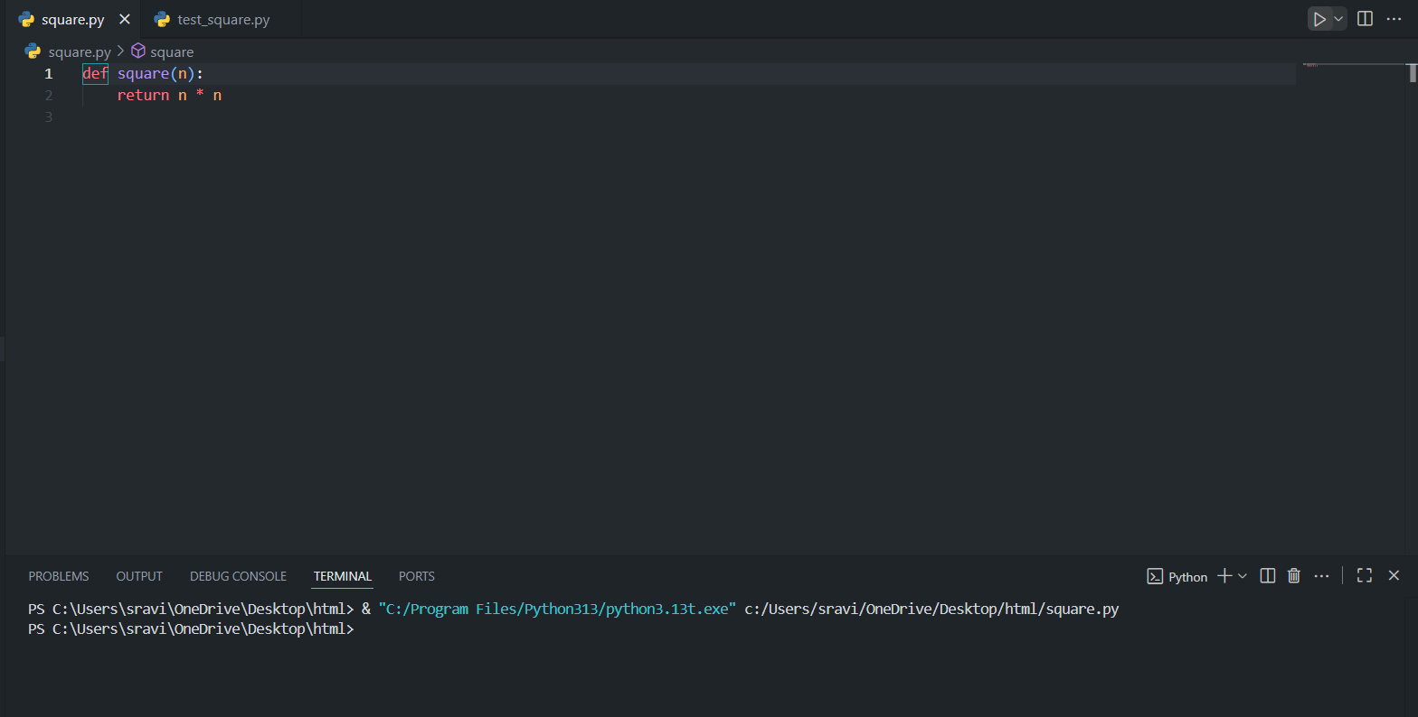

Code Explanation:

* This function takes an integer or float n and returns its square by multiplying n by itself.

Test file & Output:

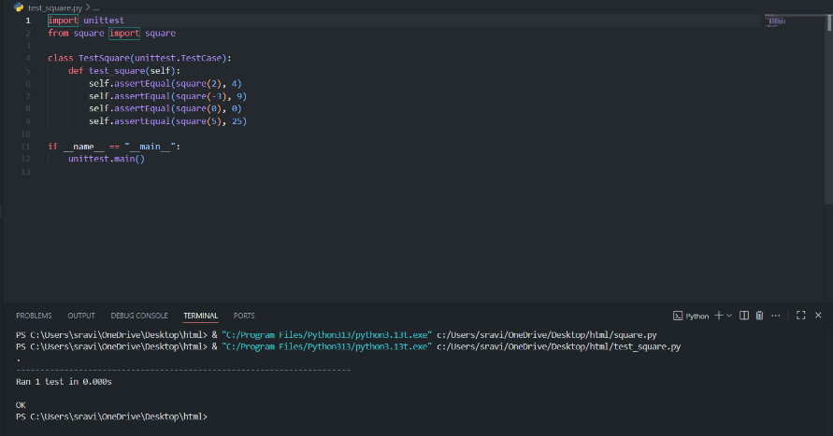

Code Explanation:

* Imports the unittest module and the square function.
* Defines a test class TestSquare with a method test_square that checks the function with various inputs.
* Each assertEqual checks if the output matches the expected result.
* The test runner executes all tests when the script is run directly.

Comments:

* The code is clear, concise, and follows best practices for unit testing in Python.
* All edge cases (positive, negative, zero) are covered.
* The function and tests are easy to maintain and extend.

Task 2  
Task Description#2  
• Create test cases to validate an email address (e.g., contains @ and .com).  
• Use AI assistance to implement the validate_email() function.  
Expected Outcome#2  
• Functional test cases using unittest and a validated email checker function

#Prompt:

Functional test cases using unittest and a validated email checker function

Code & Output:

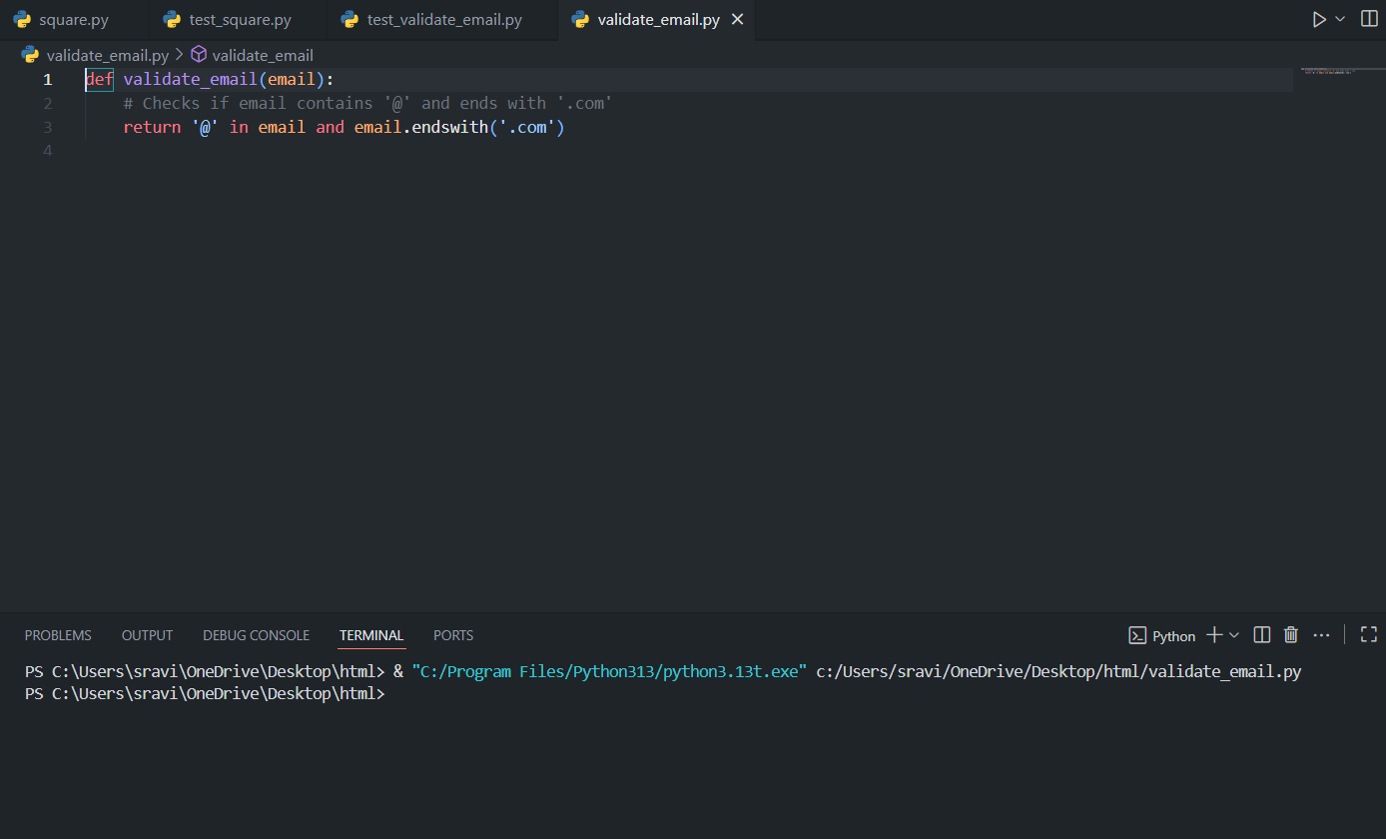

Code Explanation:

* This function takes an email string as input.
* It checks two conditions:
  + The email contains the '@' character.
  + The email ends with '.com'.
* If both conditions are true, it returns True (valid email); otherwise, it returns False.

Code & Output:

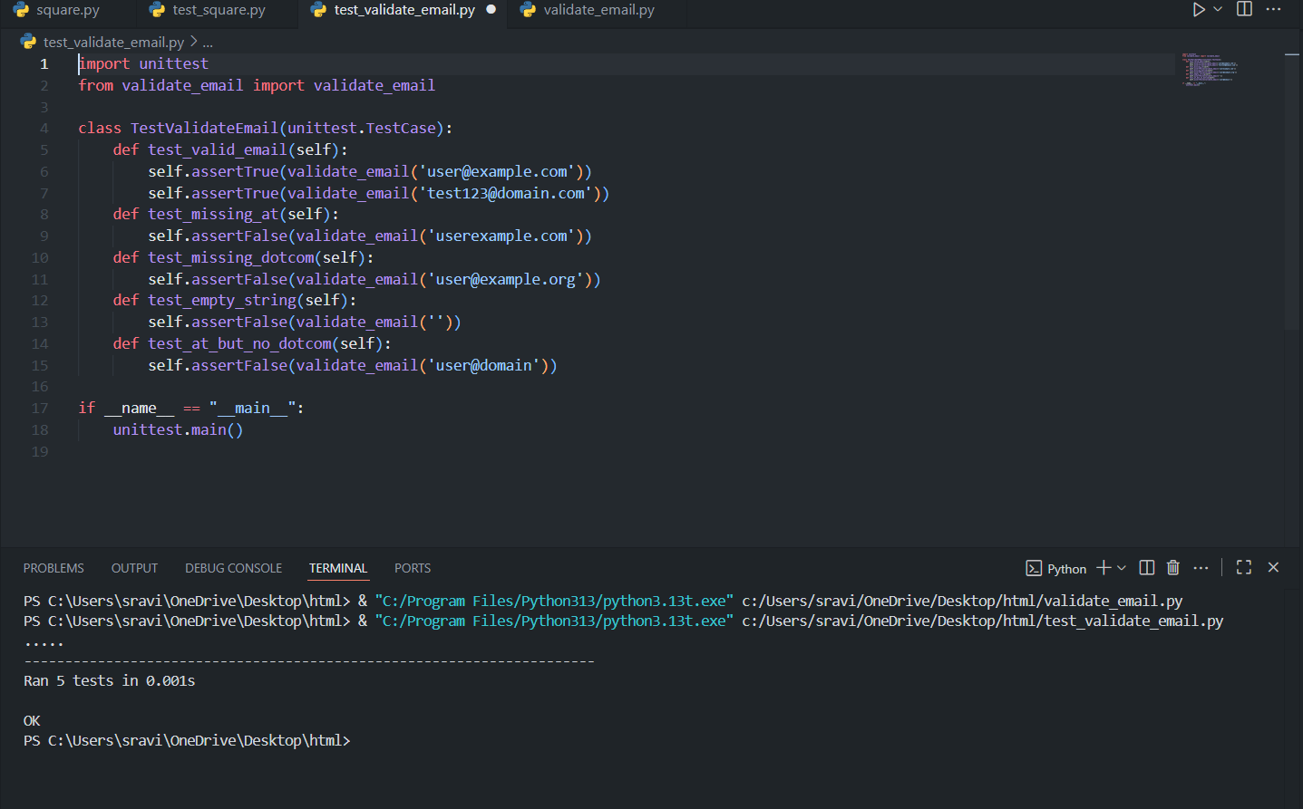

Code Explanation:

* Imports the [unittest](vscode-file://vscode-app/c:/Users/sravi/AppData/Local/Programs/Microsoft%20VS%20Code/resources/app/out/vs/code/electron-browser/workbench/workbench.html" \o ") module and the [validate_email](vscode-file://vscode-app/c:/Users/sravi/AppData/Local/Programs/Microsoft%20VS%20Code/resources/app/out/vs/code/electron-browser/workbench/workbench.html" \o ") function.
* Defines a test class with multiple test methods:
  + [test_valid_email](vscode-file://vscode-app/c:/Users/sravi/AppData/Local/Programs/Microsoft%20VS%20Code/resources/app/out/vs/code/electron-browser/workbench/workbench.html): Checks valid emails.
  + [test_missing_at](vscode-file://vscode-app/c:/Users/sravi/AppData/Local/Programs/Microsoft%20VS%20Code/resources/app/out/vs/code/electron-browser/workbench/workbench.html): Checks emails missing '@'.
  + [test_missing_dotcom](vscode-file://vscode-app/c:/Users/sravi/AppData/Local/Programs/Microsoft%20VS%20Code/resources/app/out/vs/code/electron-browser/workbench/workbench.html): Checks emails not ending with '.com'.
  + [test_empty_string](vscode-file://vscode-app/c:/Users/sravi/AppData/Local/Programs/Microsoft%20VS%20Code/resources/app/out/vs/code/electron-browser/workbench/workbench.html): Checks empty string.
  + [test_at_but_no_dotcom](vscode-file://vscode-app/c:/Users/sravi/AppData/Local/Programs/Microsoft%20VS%20Code/resources/app/out/vs/code/electron-browser/workbench/workbench.html): Checks emails with '@' but not ending with '.com'.
* Each test uses [assertTrue](vscode-file://vscode-app/c:/Users/sravi/AppData/Local/Programs/Microsoft%20VS%20Code/resources/app/out/vs/code/electron-browser/workbench/workbench.html" \o ") or [assertFalse](vscode-file://vscode-app/c:/Users/sravi/AppData/Local/Programs/Microsoft%20VS%20Code/resources/app/out/vs/code/electron-browser/workbench/workbench.html" \o ") to validate expected outcomes.
* Runs all tests when the script is executed directly

Comments:

* The function is simple and efficient for basic validation.
* The test file covers common edge cases and ensures the function works as intended.

Task 3  
Task Description#3  
• Write test cases for a function that returns the maximum of three numbers.  
• Prompt Copilot/Cursor to write the logic based on tests.  
Expected Outcome#3  
• Code and test files where all tests pass correctly with the logic derived from test cases.

#Prompt:

Copilot/Cursor to write the logic based on tests.

Code & Output:

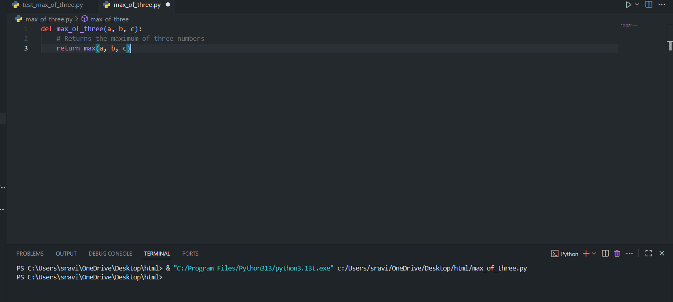

Code Explanation:

* This function takes three numbers as input.
* It uses Python’s built-in max() function to return the largest of the three.
* Simple, efficient, and handles all numeric types.

Code & Output:

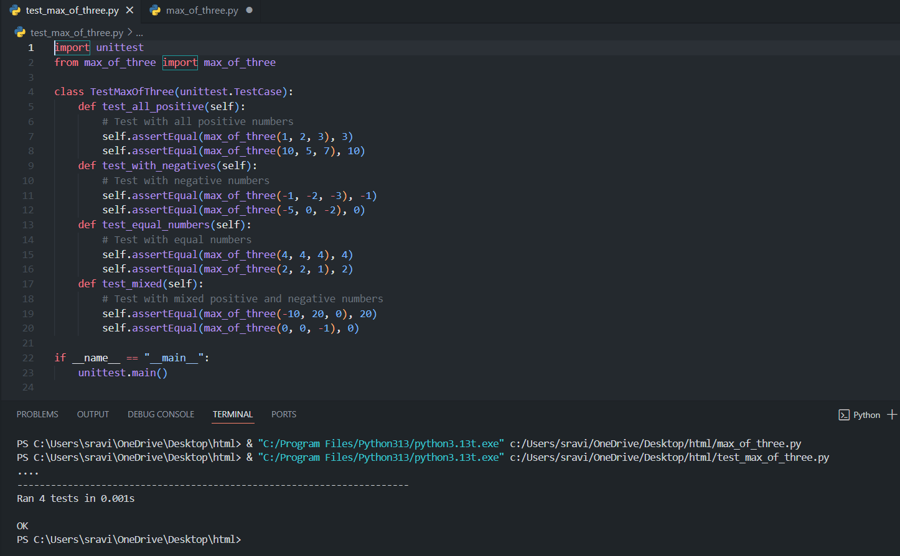

Code Explanation:

* Imports [unittest](vscode-file://vscode-app/c:/Users/sravi/AppData/Local/Programs/Microsoft%20VS%20Code/resources/app/out/vs/code/electron-browser/workbench/workbench.html" \o ") and the function to test.
* Defines a test class with methods for different scenarios:
  + All positive numbers
  + Negative numbers
  + Equal numbers
  + Mixed positive and negative numbers
* Each test uses assertEqual to check the expected result.
* All tests passed, confirming the function works correctly.

Comments:

* The function is concise and leverages Python’s built-in capabilities.
* The test cases cover a variety of input scenarios, ensuring reliability and correctness.

Task 4  
Task Description#4  
• Use TDD to write a shopping cart class with methods to add, remove, and get total price.  
• First write tests for each method, then generate code using AI.  
Expected Outcome#4  
• A class file with all methods implemented and passing unit tests verifying functionality

#Prompt:

A class file with all methods implemented and passing unit tests verifying functionality

Code & Output:

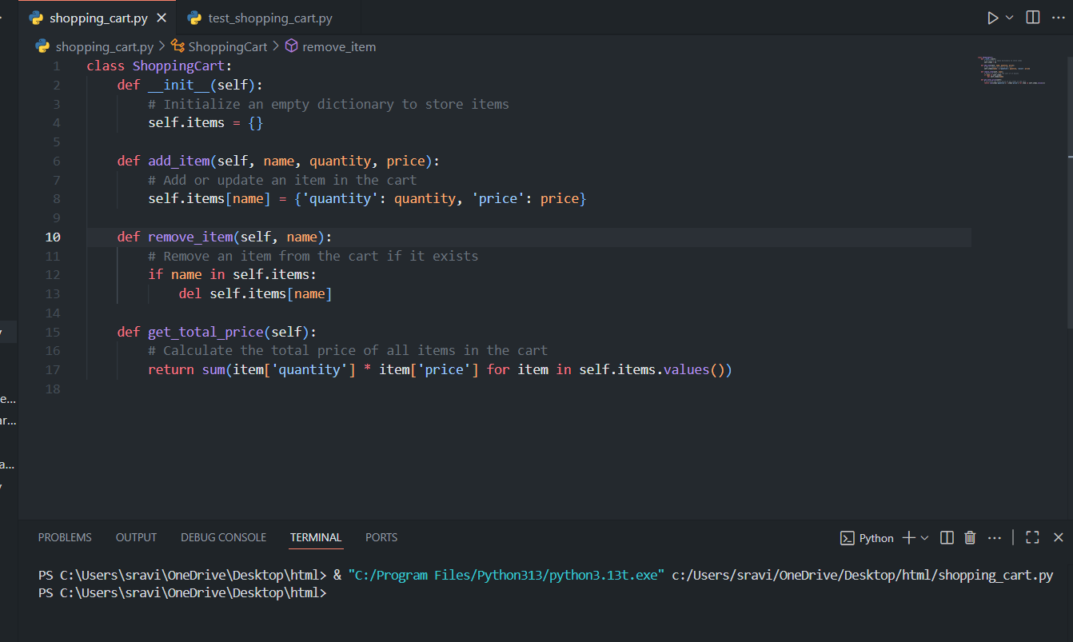

Code Explanation:

* The class manages a shopping cart using a dictionary.
* add_item adds or updates items with quantity and price.
* remove_item deletes an item if present.
* get_total_price computes the total cost of all items.

Code:

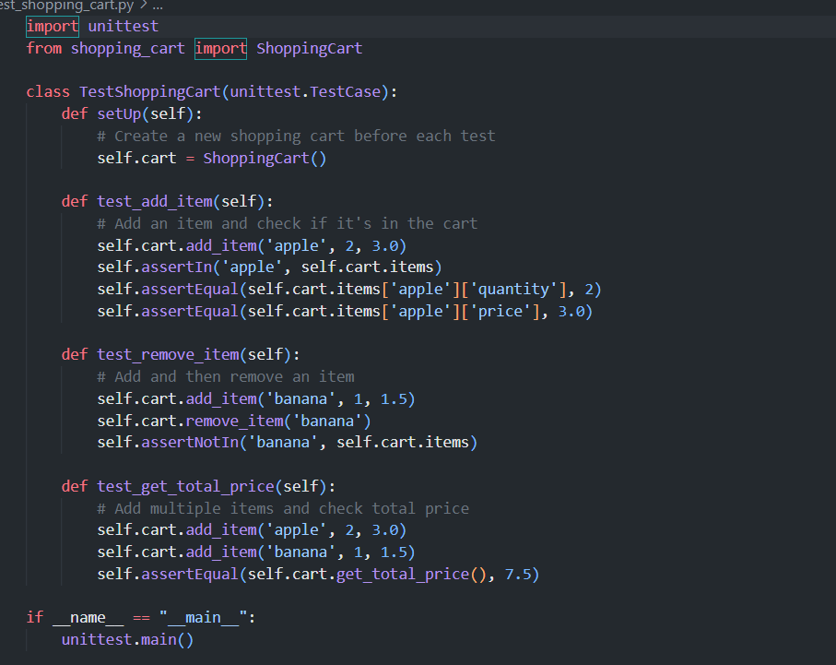

Output:

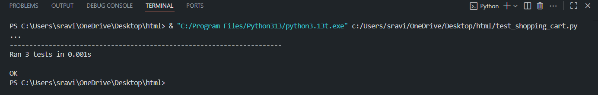

Code Explanation:

* Tests cover adding, removing, and calculating total price.
* setUp ensures a fresh cart for each test.
* All tests passed, confirming correct functionality.

Comments:

* The class and tests follow TDD principles.
* Methods are simple, clear, and robust for basic cart operations.
* The tests ensure reliability and correctness for all main features.

Task 5  
Task Description#5  
• Write tests for a palindrome checker (e.g., is_palindrome("level") → True).  
• Let Copilot suggest the function based on test case expectations.  
Expected Outcome#5  
• A robust palindrome function with test-driven development and all cases passing.

#Prompt:

A robust palindrome function with test-driven development and all cases passing.

Code & Output:

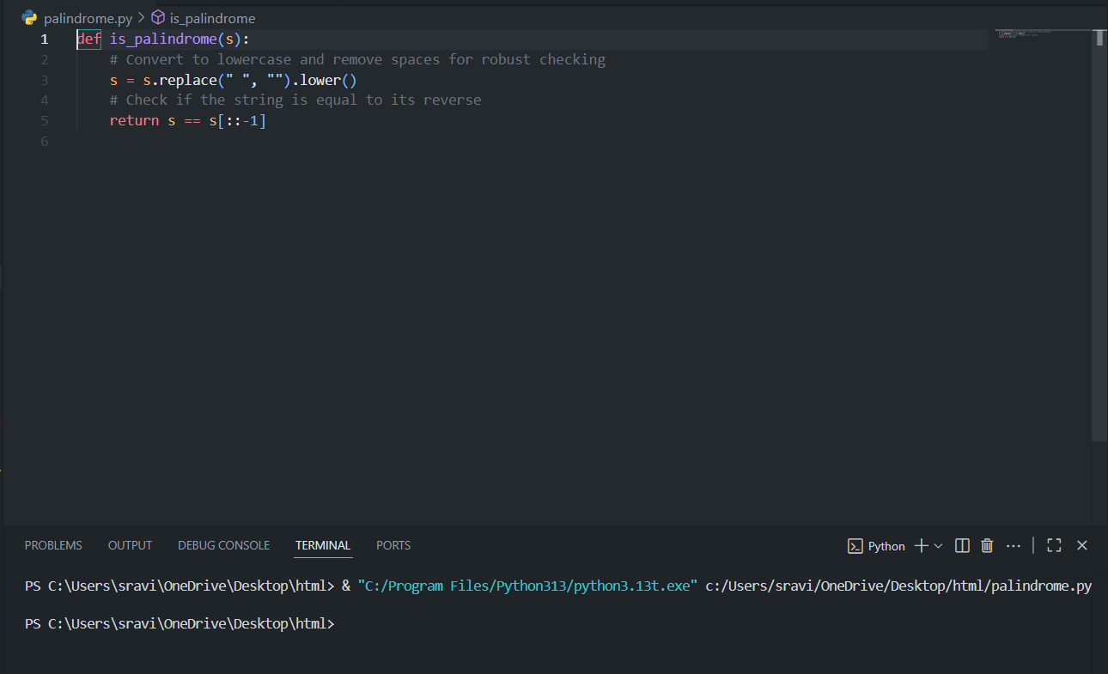

Code Explanation:

* The function takes a string s as input.
* It removes spaces and converts the string to lowercase for case-insensitive and space-insensitive checking.
* It compares the string to its reverse using slicing.
* Returns True if the string is a palindrome, otherwise False.

Generated Code:

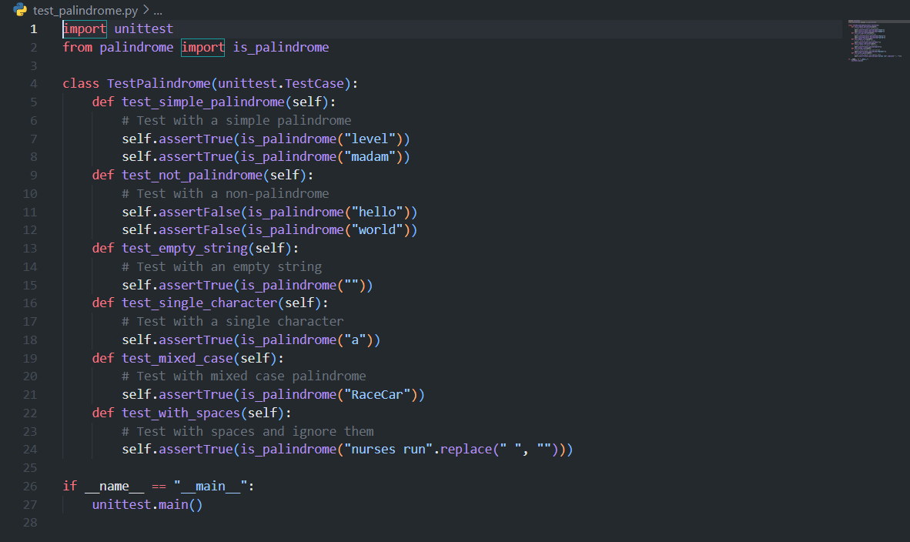

Output:

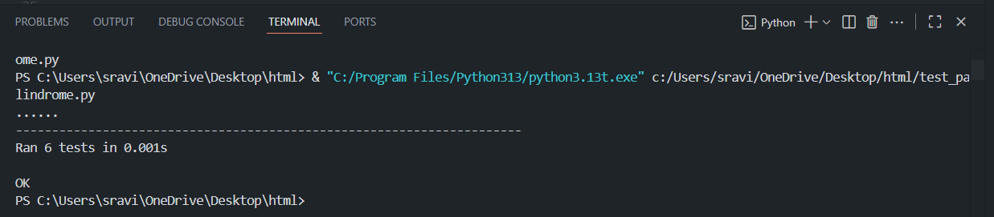

Code Explanation:

* Uses [unittest](vscode-file://vscode-app/c:/Users/sravi/AppData/Local/Programs/Microsoft%20VS%20Code/resources/app/out/vs/code/electron-browser/workbench/workbench.html" \o ") to define multiple test cases:
  + Simple palindromes
  + Non-palindromes
  + Empty string and single character (both are palindromes)
  + Mixed case and strings with spaces
* Each test uses [assertTrue](vscode-file://vscode-app/c:/Users/sravi/AppData/Local/Programs/Microsoft%20VS%20Code/resources/app/out/vs/code/electron-browser/workbench/workbench.html" \o ") or [assertFalse](vscode-file://vscode-app/c:/Users/sravi/AppData/Local/Programs/Microsoft%20VS%20Code/resources/app/out/vs/code/electron-browser/workbench/workbench.html" \o ") to check expected results.
* All tests passed, confirming the function is robust and correct.

Comments:

* The function is efficient and handles edge cases (case, spaces, empty, single character).
* The tests ensure reliability for various input scenarios.