HINO:2403A51286  
 Assignment:10.3

**Task#1**

**Zero-shot:** Prompt AI with only the instruction — Write a Python function to  
generate the Fibonacci sequence up to n terms  
Expected Output#1  
• A working function without using any sample inputs/outputs

**Prompt:**

**Zero-Shot Prompt**

Write a Python function to generate the Fibonacci sequence up to n terms.

**Code:**

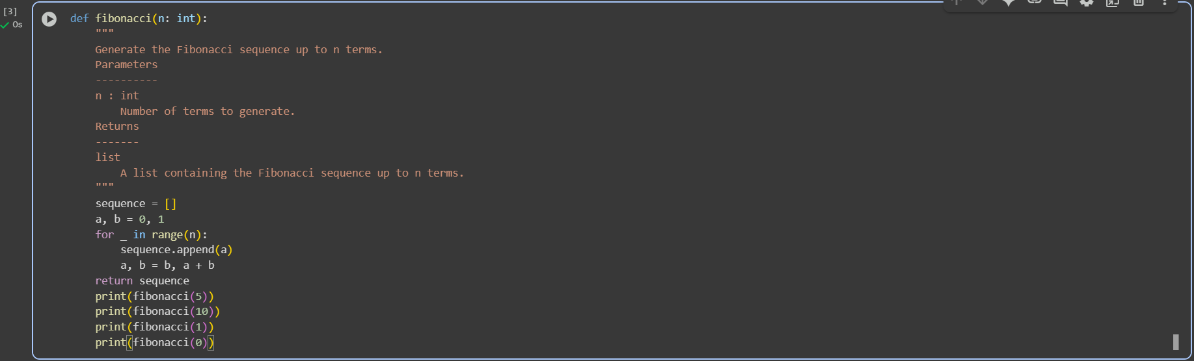

**Task#2**

Task Description#2  
• One-shot: Provide one example: Input: 100, Output: 37.78 to help AI generate a  
function that converts Fahrenheit to Celsius.  
Expected Output#2  
• A correct conversion function guided by the single example.

**Prompt:**

**One-Shot Prompt**

Write a Python function to convert Fahrenheit to Celsius.

Example: Input: 100 → Output: 37.78

**Code:**

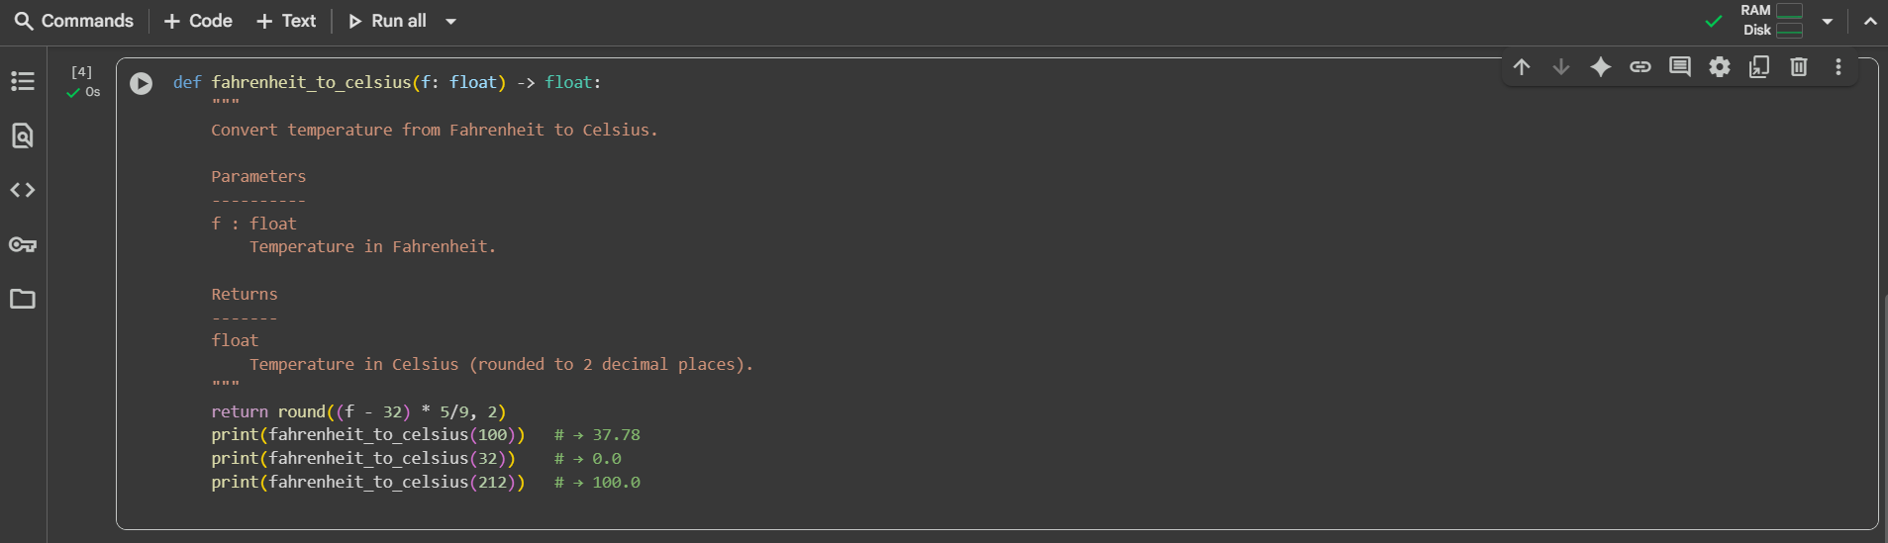

**Task#3**• Few-shot: Give 2–3 examples to create a function that extracts the domain name from  
an email address.  
Expected Output#3  
• Accurate function that returns only the domain portion of an email (e.g.,  
@gmail.com)

**Prompt:**

Few-Shot Prompt

Write a Python function to extract the domain name from an email address.

Examples:

Input: "john.doe@gmail.com" → Output: "gmail.com"

Input: "alice@yahoo.co.in" → Output: "yahoo.co.in"

Input: "student@mit.edu" → Output: "mit.edu"

**Code and Output:**

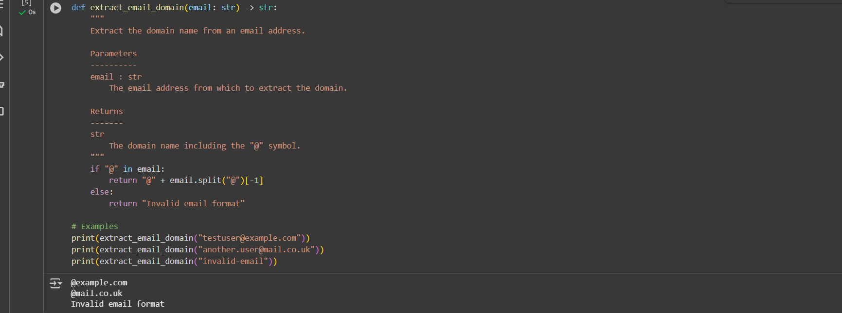

**Task#4**  
• Compare zero-shot vs few-shot prompting for generating a function that checks  
whether a word is a palindrome, ignoring punctuation and case.  
Expected Output#4  
• Output comparison + student explanation on how examples helped the model.

**Prompt:**

**Prompt for Zero-Shot**

Write a Python function that checks whether a word or phrase is a palindrome.

The function should ignore punctuation, spaces, and case.

**Code:**

