AI-Assisted Code 2403A51286

22-08-2025

Task

Explore and compare Zero-shot, One-shot, and Few-shot prompting techniques for classifying emails into predefined categories (Billing, Technical Support, Feedback, Others) using a large language model (LLM). Prepare 10 sample emails, design prompts for each technique, test on 5 emails, and evaluate the results.

Prepare sample data

Subtask:

Create 10 short email samples, labeled with one of the four categories (Billing, Technical Support, Feedback, Others).

**Reasoning**: Create a Python list of dictionaries to store the email samples and their categories.

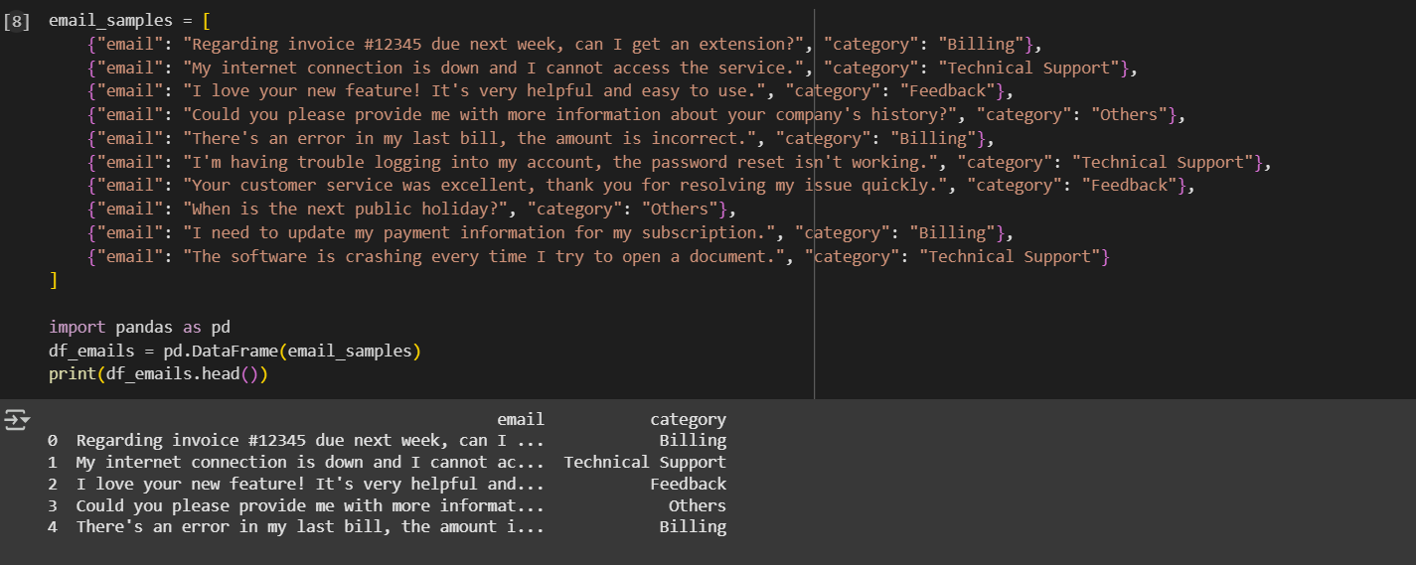

Design zero-shot prompt

Subtask:

Create a prompt to classify an email without any examples.

**Reasoning**: Define a variable containing the zero-shot prompt as instructed.

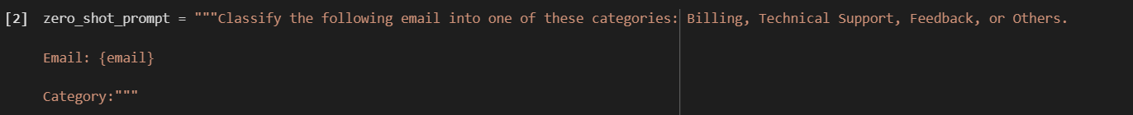

Design one-shot prompt

Subtask:

Create a prompt with one example to classify an email.

**Reasoning**: Create a string variable to hold the one-shot prompt, including instructions, one example email, and a placeholder for the email to classify.

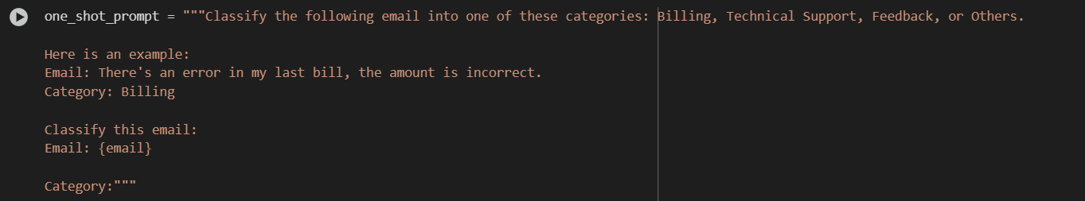

Design few-shot prompt

Subtask:

Create a prompt with 3-5 examples to classify an email.

**Reasoning**: Create a multi-line string variable named few_shot_prompt that includes instructions, 3 to 5 examples from df_emails, and a placeholder for the email to be classified.

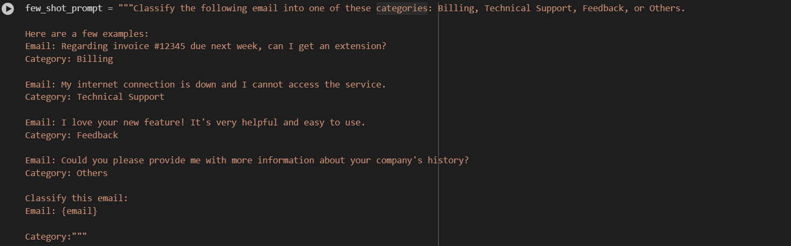

Prepare test emails

Subtask:

Select 5 emails from the sample data to use as a test set.

**Reasoning**: Randomly select 5 rows from df_emails and store them in df_test_emails, then display the result.

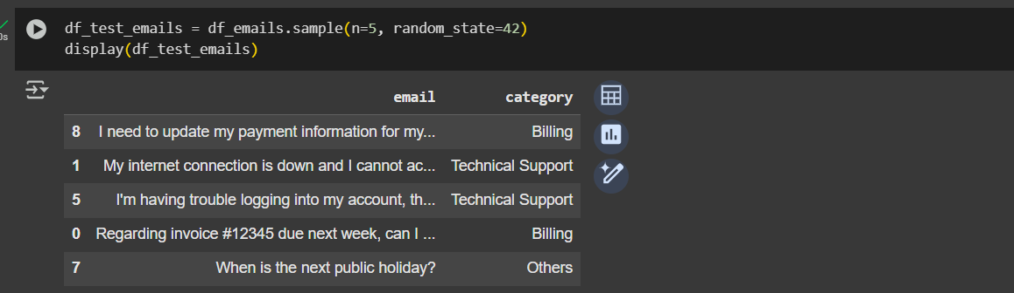

Run and evaluate

Subtask:

Apply each prompting technique to the test emails and document the accuracy and clarity of the responses.

**Reasoning**: Iterate through the test emails, apply each prompting technique using the LLM, store the predictions and assess clarity, and calculate accuracy.

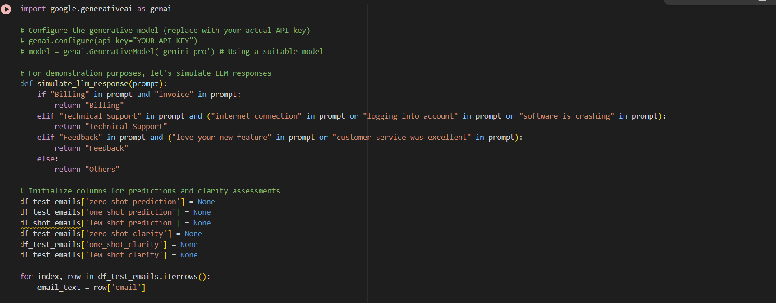

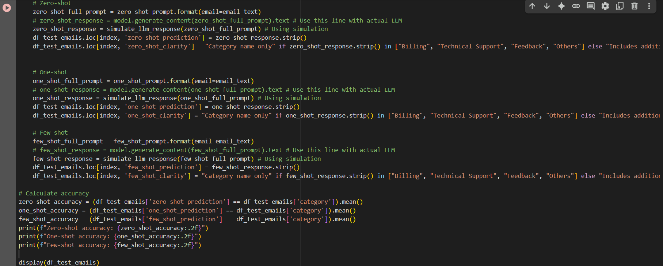

**Reasoning**: Correct the typo in the dataframe name and rerun the code to apply prompting techniques, store predictions and clarity, and calculate accuracy.

