HINO:2403A51286  
 Assignment:6.2

**Task#1:** **Classes)**• Prompt AI to generate a Book class with attributes: title, author, year. Add a method  
get_summary() to return a formatted string.

**Prompt**

Write a Python class called Book with the following:

- Attributes: title, author, year

- A method get_summary() that returns a formatted string like:

"Title: <title>, Author: <author>, Year: <year>"

Also, show an example of creating a Book object and calling get_summary().

**Code:**

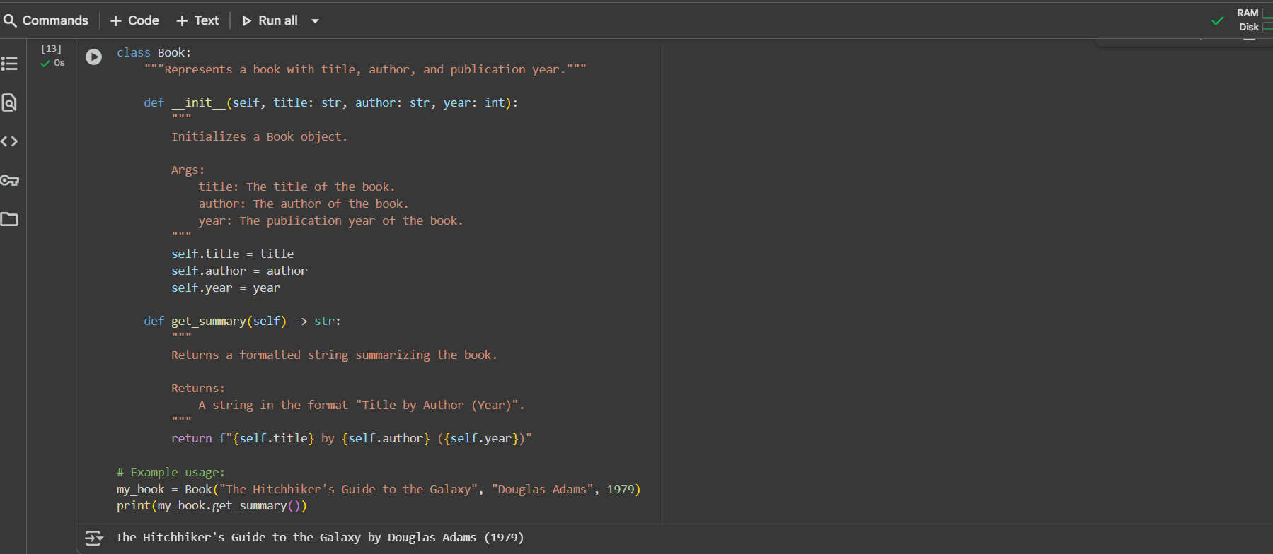

**Task#2:(Loops)**  
• Ask AI to generate a function that prints the even numbers between 1 and 50 using a  
for loop. Then regenerate using a while loop.  
Expected Output#2  
• Correct loop-based implementation

**Prompt:**

Write a Python class called Book with the following:

- Attributes: title, author, year

- A method get_summary() that returns a formatted string like:

"Title: <title>, Author: <author>, Year: <year>"

Also, show an example of creating a Book object and calling get_summary().

**Code:**

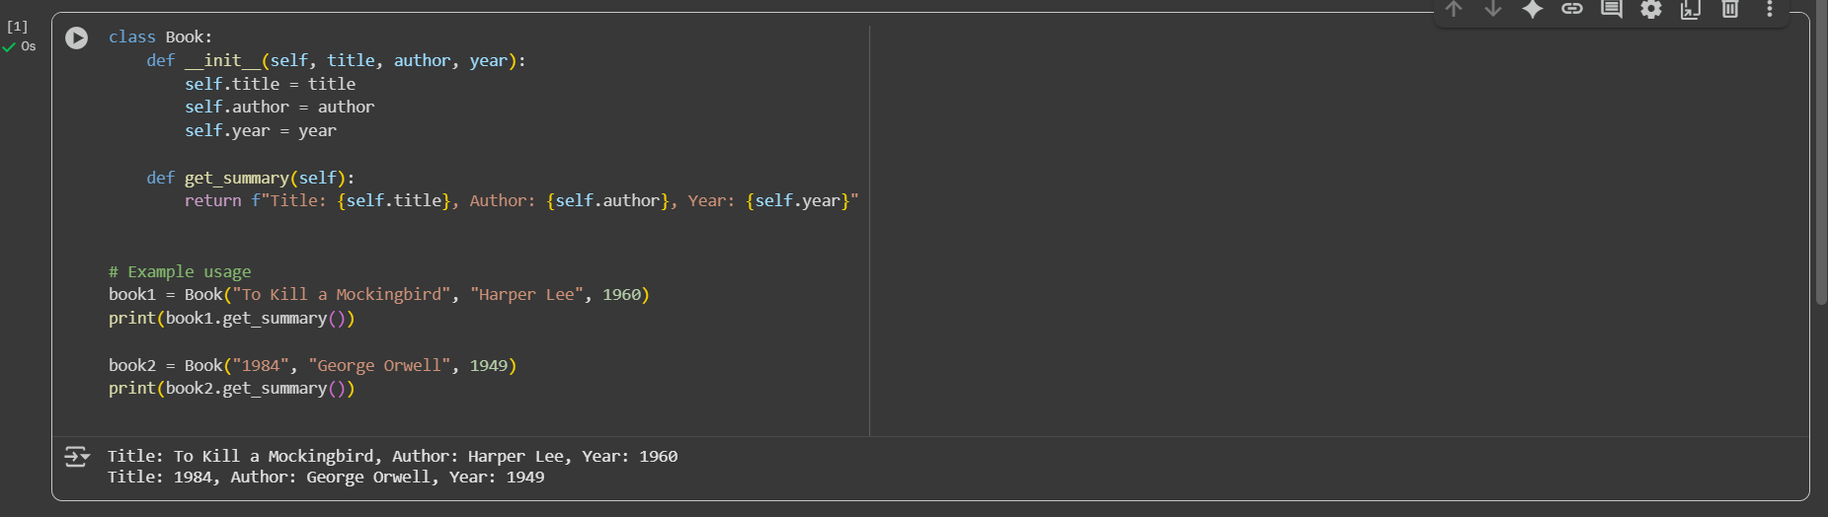

**Task#2:(Conditional Statements)  
•** Ask AI to write a function that determines the grade category (A, B, C, Fail) based on  
marks using if-elif-else. Then test it with sample inputs.  
Expected Output#3  
• Function must handle score boundaries and include appropriate logic. Students  
analyze boundary cases

**Prompt:**

Write a Python function that determines the grade category based on marks using if-elif-else.

Conditions:

- A: 75 and above

- B: 60–74

- C: 40–59

- Fail: below 40

The function should handle boundary cases correctly (like 74, 75, 40).

Then, test the function with sample inputs.

**Code:**

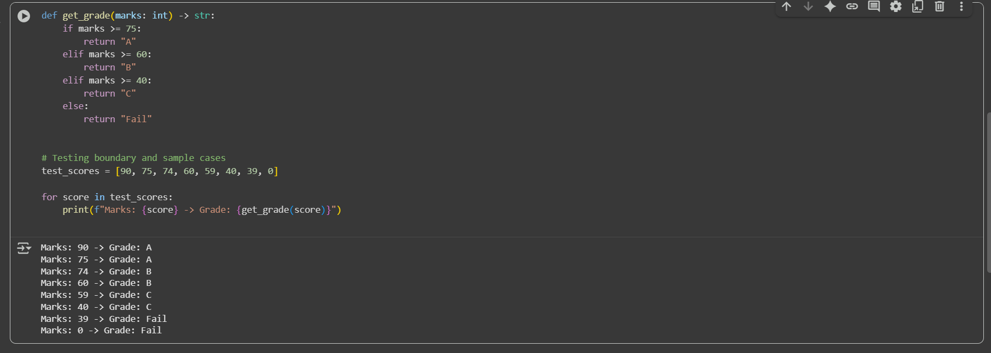

**Task#3:** **(For and While loops)**• Generate a function check_eligibility(age, has_id) that checks if a person is eligible to  
vote (age ≥ 18 and must have ID). Use nested ifs.  
Expected Output#4  
• Python code with explanation

**Prompt**

Write a Python function check_eligibility(age, has_id) that checks if a person is eligible to vote.

Conditions:

- The person must be at least 18 years old.

- The person must have an ID.

Use nested if statements to implement the logic.

Also, test the function with different inputs.

**Code:**

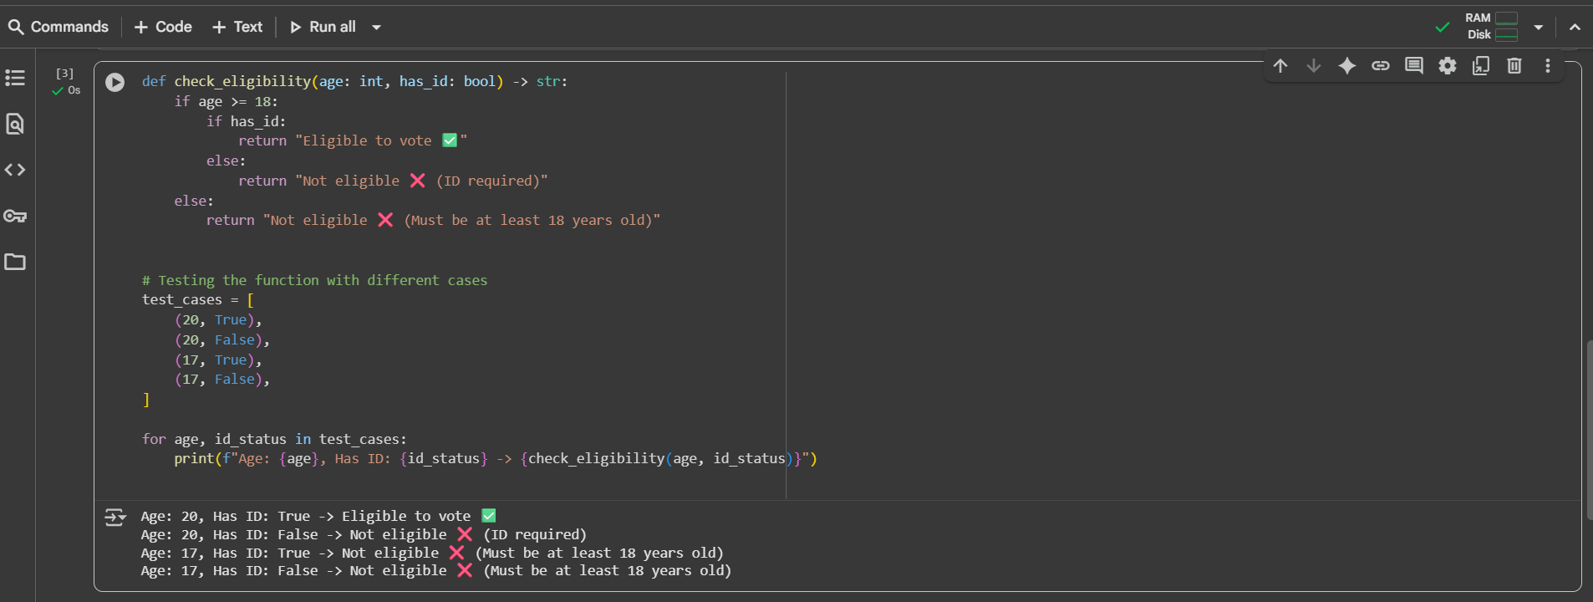

**Task #4 (For and While loops)**  
• Generate a function check_eligibility(age, has_id) that checks if a person is eligible to  
vote (age ≥ 18 and must have ID). Use nested ifs.  
Expected Output#4  
• Python code with explanation

**Prompt**

Write a Python function check_eligibility(age, has_id) that checks if a person is eligible to vote.

Conditions:

- A person must be at least 18 years old.

- A person must also have an ID.

Use nested if statements to implement the logic.

After writing the function, test it with different inputs (e.g., age below 18, age above 18 with/without ID).

Finally, explain how the nested ifs work in your code.

**Code:**

