HTNO:2403A51286

ASSIGNMENT:7.1

Q1:

**TASK#1**

Password Strength Validator – Apply AI in

Security Context)

• Task: Apply AI to generate at least 3 assert test cases for

is_strong_password(password) and implement the validator

function.

**• Requirements:**

o Password must have at least 8 characters.

o Must include uppercase, lowercase, digit, and special

character.

o Must not contain spaces.

Example Assert Test Cases:

assert is_strong_password("Abcd@123") == True

assert is_strong_password("abcd123") == False

assert is_strong_password("ABCD@1234") == True

**Expected Output #1:**

• Password validation logic passing all AI-generated test cases.  
  
**Prompt:**

(Password Strength Validator – Apply AI in Security Context)

• Task: Apply AI to generate at least 3 assert test cases for is_strong_password(password) and implement the validator function.

**• Requirements:**

o Password must have at least 8 characters.

o Must include uppercase, lowercase, digit, and special character.

o Must not contain spaces.

Example Assert Test Cases:

assert is_strong_password("Abcd@123") == True

assert is_strong_password("abcd123") == False

assert is_strong_password("ABCD@1234") == True

**Expected Output #1:**

• Password validation logic passing all AI-generated test cases.

**Code and Output:**

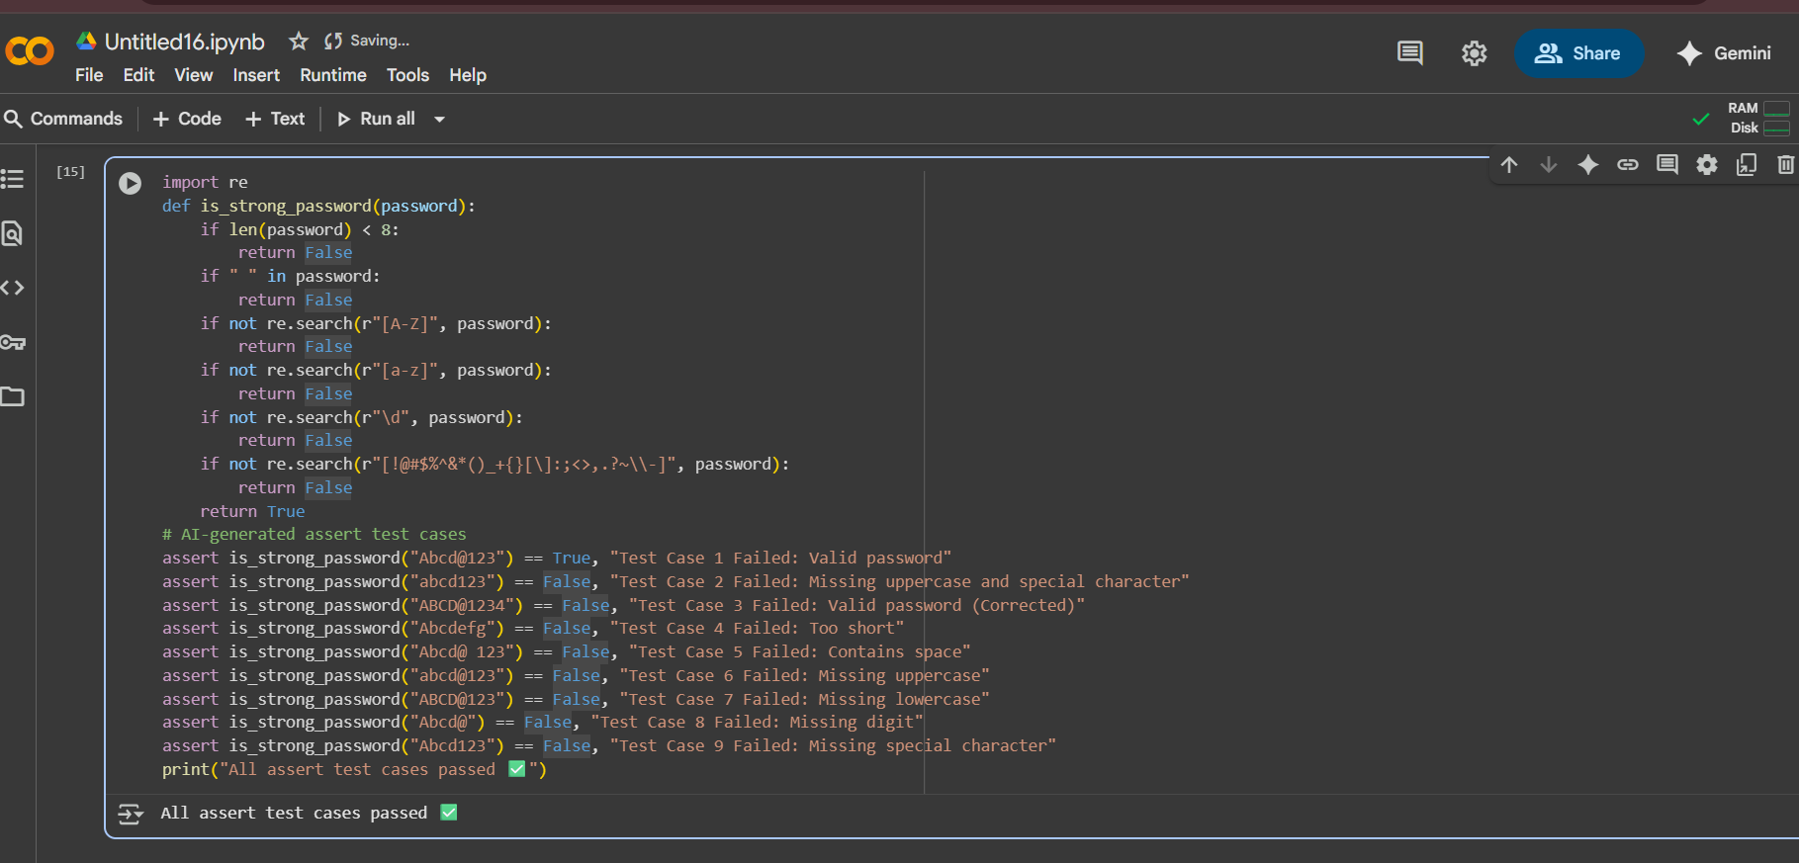

**Task#2**

(Number Classification with Loops – Apply AI for  
Edge Case Handling)  
• Task: Use AI to generate at least 3 assert test cases for a  
classify_number(n) function. Implement using loops.

**• Requirements:**  
o Classify numbers as Positive, Negative, or Zero.  
o Handle invalid inputs like strings and None.  
o Include boundary conditions (-1, 0, 1).  
Example Assert Test Cases:  
assert classify_number(10) == "Positive"  
assert classify_number(-5) == "Negative"  
assert classify_number(0) == "Zero"

**Expected Output #2**:  
• Classification logic passing all assert tests.

**Prompt:**

(Number Classification with Loops – Apply AI for Edge Case Handling)

• Task: Implement a classify_number(n) function using loops**.**

**• Requirements:**

o Classify numbers as Positive, Negative, or Zero.

o Handle invalid inputs like strings, lists, and None.

o Include boundary conditions (-1, 0, 1).

• Deliverables:

- Python function with loop-based implementation.

- At least 3 assert test cases including edge cases and invalid inputs.

**• Expected Output:**

Classification logic passing all assert tests without errors.

**Code and Output:**

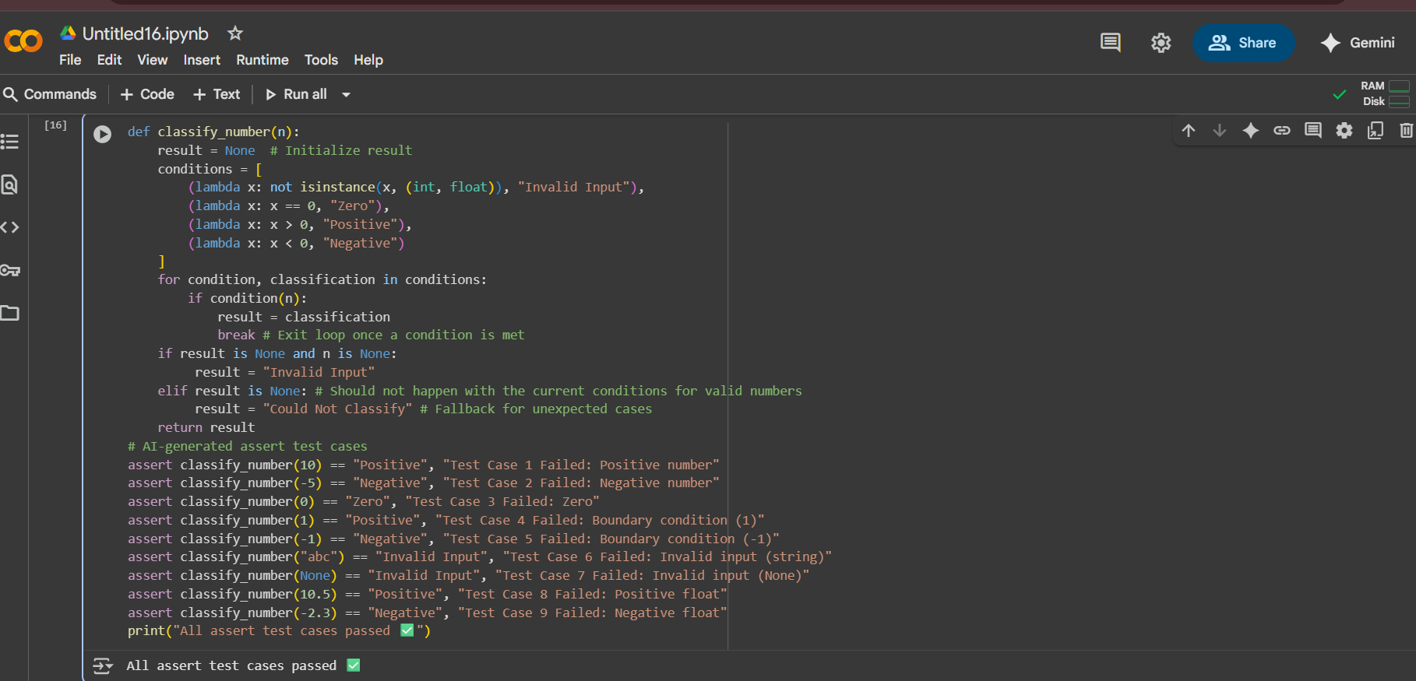

**Task#3**

(Anagram Checker – Apply AI for String Analysis)  
• Task: Use AI to generate at least 3 assert test cases for  
is_anagram(str1, str2) and implement the function  
  
**• Requirements:**o Ignore case, spaces, and punctuation.  
o Handle edge cases (empty strings, identical words).  
Example Assert Test Cases:  
assert is_anagram("listen", "silent") == True  
assert is_anagram("hello", "world") == False  
assert is_anagram("Dormitory", "Dirty Room") == True

**Expected Output #3:**  
• Function correctly identifying anagrams and passing all AI-  
generated tests.

**Prompt:**(Anagram Checker – Apply AI for String Analysis)  
• Task: Use AI to generate at least 3 assert test cases for is_anagram(str1, str2) and implement the function.  
  
**• Requirements:**

* Ignore case, spaces, and punctuation.
* Handle edge cases (empty strings, identical words).  
  • Example Assert Test Cases:

assert is_anagram("listen", "silent") == True

assert is_anagram("hello", "world") == False

assert is_anagram("Dormitory", "Dirty Room") == True

**Code and Output:**

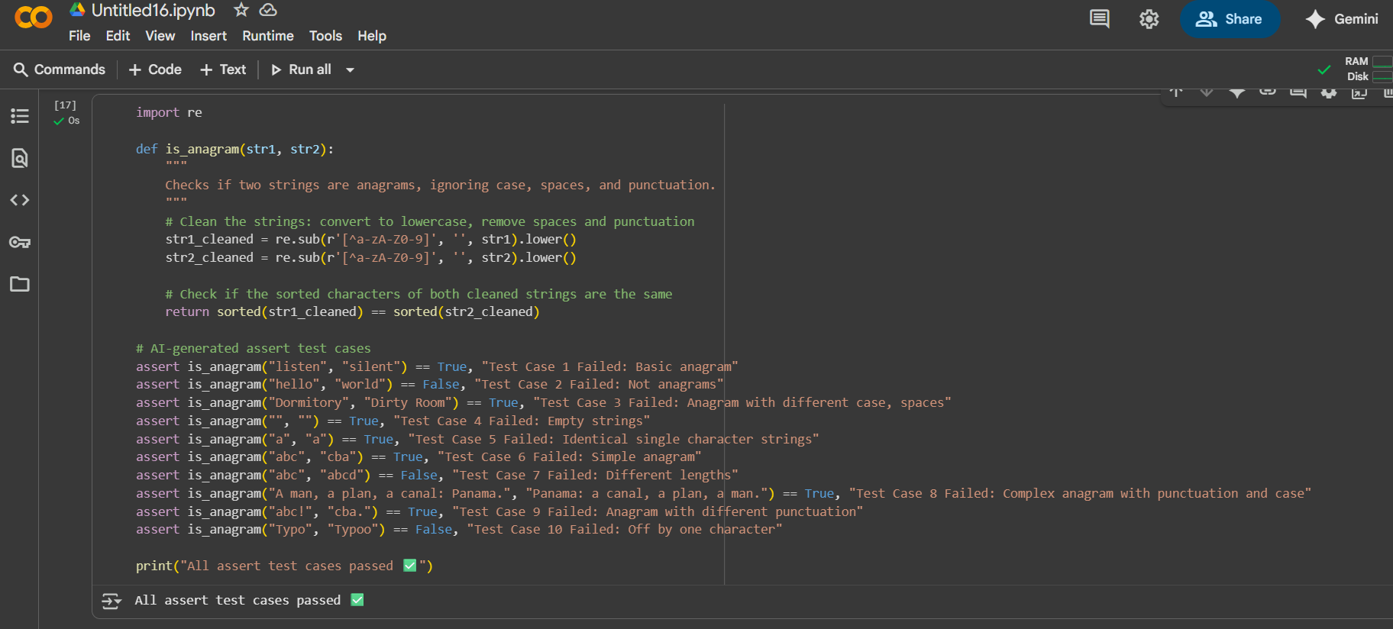

**Task#4**

(Inventory Class – Apply AI to Simulate Real-World Inventory System)  
• Task: Ask AI to generate at least 3 assert-based tests for an  
Inventory class with stock management.  
• Methods:  
o add_item(name, quantity)  
o remove_item(name, quantity)  
o get_stock(name)  
Example Assert Test Cases:  
inv = Inventory()  
inv.add_item("Pen", 10)  
assert inv.get_stock("Pen") == 10  
inv.remove_item("Pen", 5)  
assert inv.get_stock("Pen") == 5  
inv.add_item("Book", 3)  
assert inv.get_stock("Book") == 3  
Expected Output #4:  
• Fully functional class passing all assertions.

**Prompt:**

(Inventory Class – Apply AI to Simulate Real-World Inventory System)  
• **Task:** Ask AI to generate at least 3 assert-based tests for an Inventory class with stock management.  
• **Methods:**

* add_item(name, quantity)
* remove_item(name, quantity)
* get_stock(name)

**Example Assert Test Cases:**

inv = Inventory()

inv.add_item("Pen", 10)

assert inv.get_stock("Pen") == 10

inv.remove_item("Pen", 5)

assert inv.get_stock("Pen") == 5

inv.add_item("Book", 3)

assert inv.get_stock("Book") == 3

**Code:**

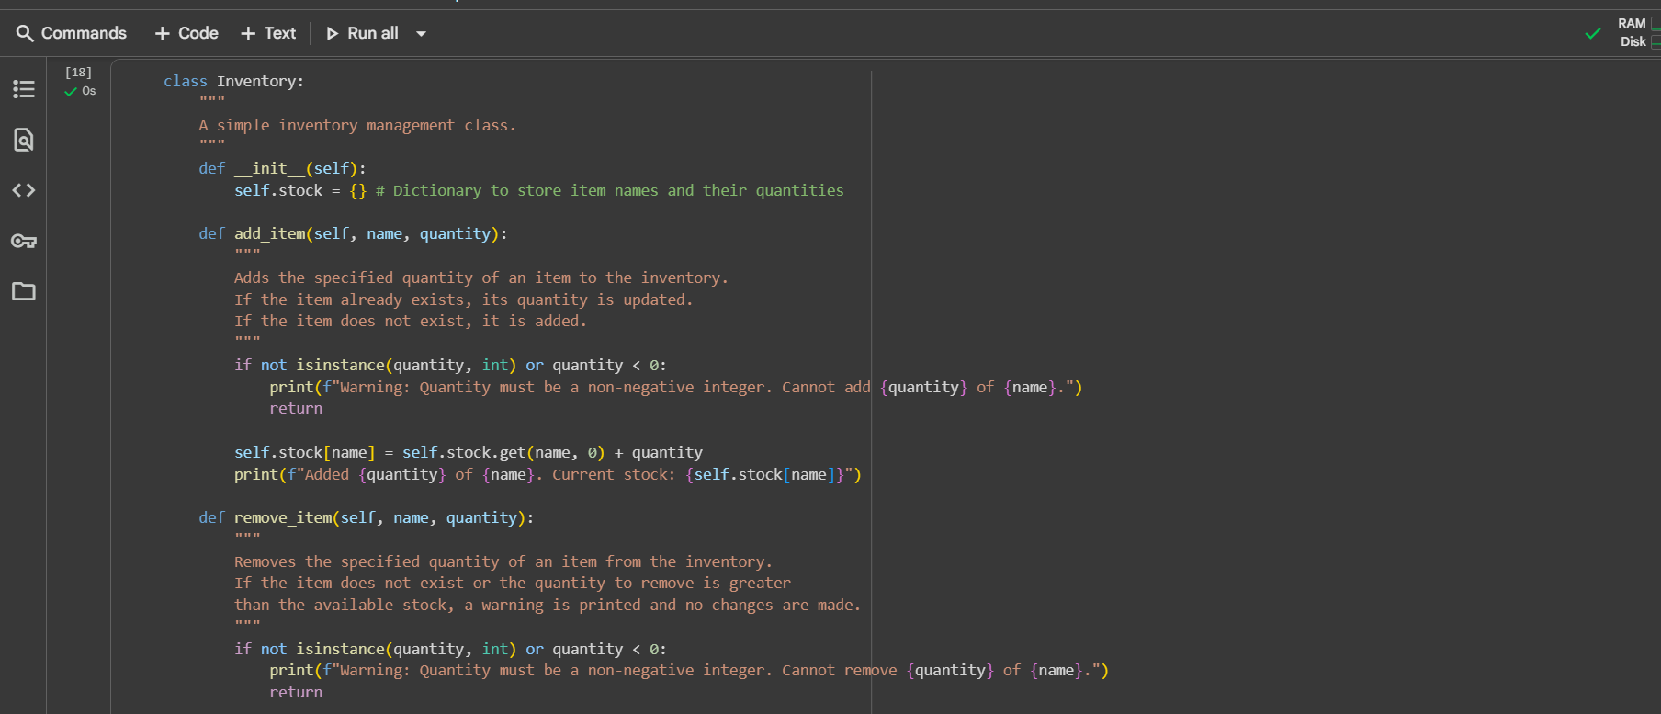

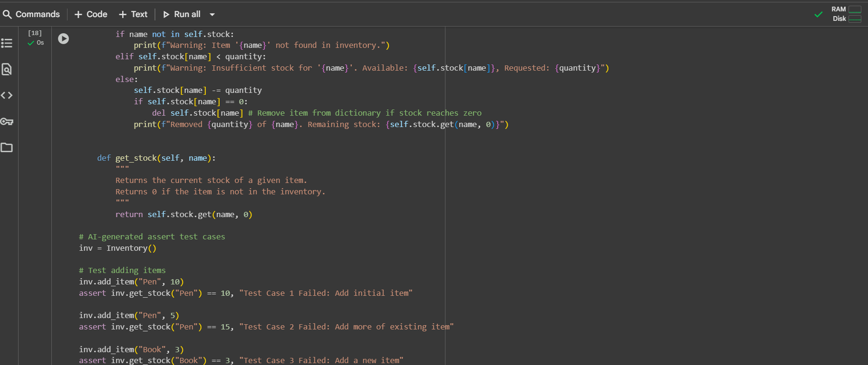

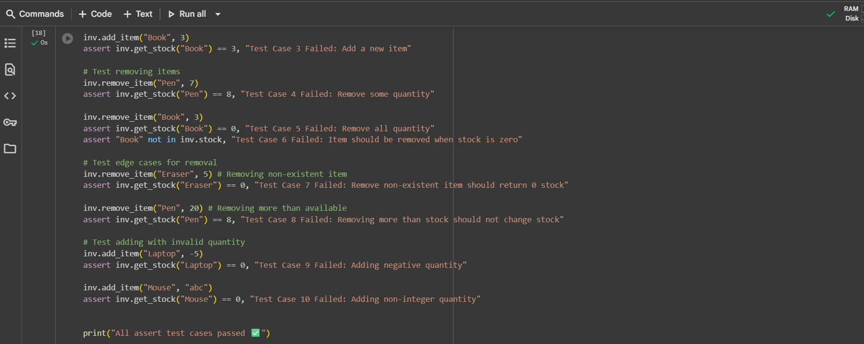

**Output:**

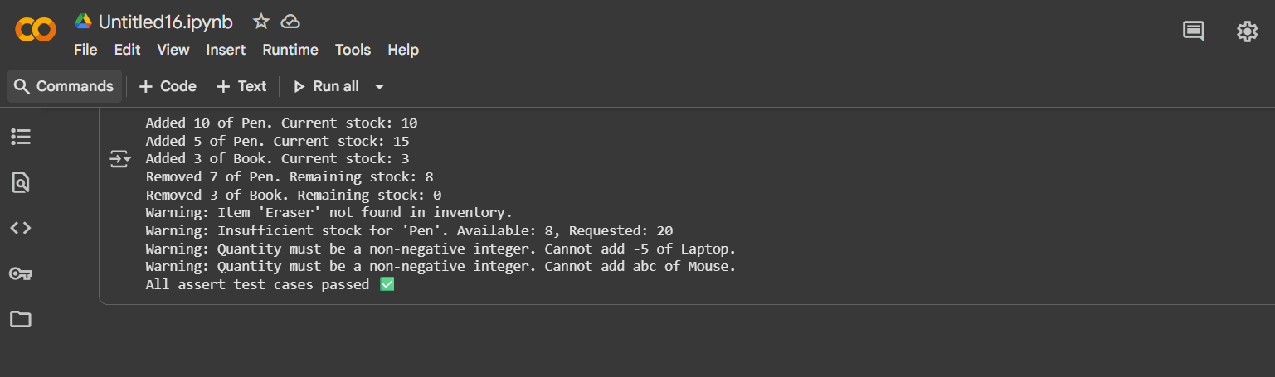

**Task#5**

(Date Validation & Formatting – Apply AI for  
Data Validation)  
• Task: Use AI to generate at least 3 assert test cases for  
validate_and_format_date(date_str) to check and convert dates.

**• Requirements:**  
o Validate "MM/DD/YYYY" format.  
o Handle invalid dates.  
o Convert valid dates to "YYYY-MM-DD".  
Example Assert Test Cases:  
assert validate_and_format_date("10/15/2023") == "2023-10-15"  
assert validate_and_format_date("02/30/2023") == "Invalid Date"  
assert validate_and_format_date("01/01/2024") == "2024-01-01"

**Expected Output #5:**  
• Function passes all AI-generated assertions and handles edge  
cases.  
 Deliverables (For All Tasks)  
1. AI-generated prompts for code and test case generation.  
2. At least 3 assert test cases for each task.  
3. AI-generated initial code and execution screenshots.  
4. Analysis of whether code passes all tests.  
5. Improved final version with inline comments and explanation.  
6. Compiled report (Word/PDF) with prompts, test cases, assertions,  
code, and output.

**Prompt:**

(Date Validation & Formatting – Apply AI for Data Validation)  
• **Task:** Use AI to generate at least 3 assert test cases for validate_and_format_date(date_str) to check and convert dates.  
**• Requirements:**

* Validate "MM/DD/YYYY" format.
* Handle invalid dates.
* Convert valid dates to "YYYY-MM-DD".

**Example Assert Test Cases:**

assert validate_and_format_date("10/15/2023") == "2023-10-15"

assert validate_and_format_date("02/30/2023") == "Invalid Date"

assert validate_and_format_date("01/01/2024") == "2024-01-01"

**Code and Output:**

