HTNO:2403A51286

Assignment:9.3  
Q

**Task#1**

**Basic Docstring Generation**  
• Write python function to return sum of even and odd numbers in the given list.  
• Incorporate manual docstring in code with Google Style  
• Use an AI-assisted tool (e.g., Copilot, Cursor AI) to generate a docstring describing  
the function.  
• Compare the AI-generated docstring with your manually written one.  
**Expected Outcome#1:** Students understand how AI can produce function-level documentation.  
  
**Prompt:**  
# Write a Python function that takes a list of integers and returns

# the sum of even numbers and the sum of odd numbers separately.

# Generate a detailed Google-style docstring for this function.  
  
Code and Output:

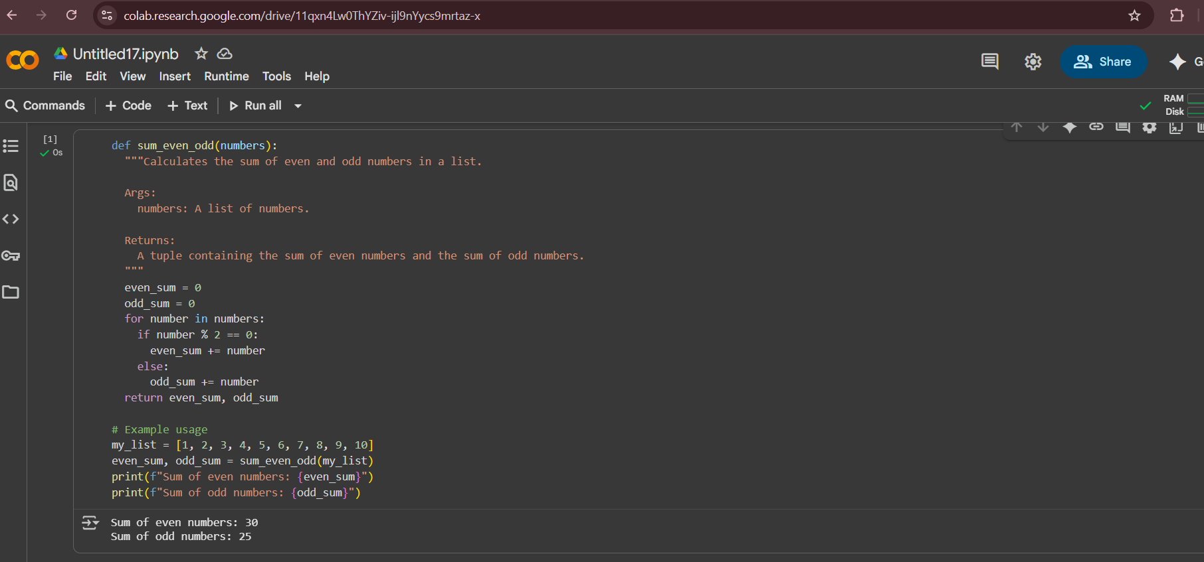

**Task#2**

**Automatic Inline Comments**  
• Write python program for sru_student class with attributes like name, roll no.,  
hostel_status and fee_update method and display_details method.  
• Write comments manually for each line/code block  
• Ask an AI tool to add inline comments explaining each line/step.  
• Compare the AI-generated comments with your manually written one.

**Expected Output#2**: Students critically analyze AI-generated code comments.

**Prompt:**

# Write a Python program that defines a class `sru_student`

# with attributes: name, roll_no, hostel_status.

# Include two methods:

# 1. fee_update() – updates the student’s fee payment status.

# 2. display_details() – displays student details.

# Add inline comments for each line of code explaining what it does.  
  
**Code:**

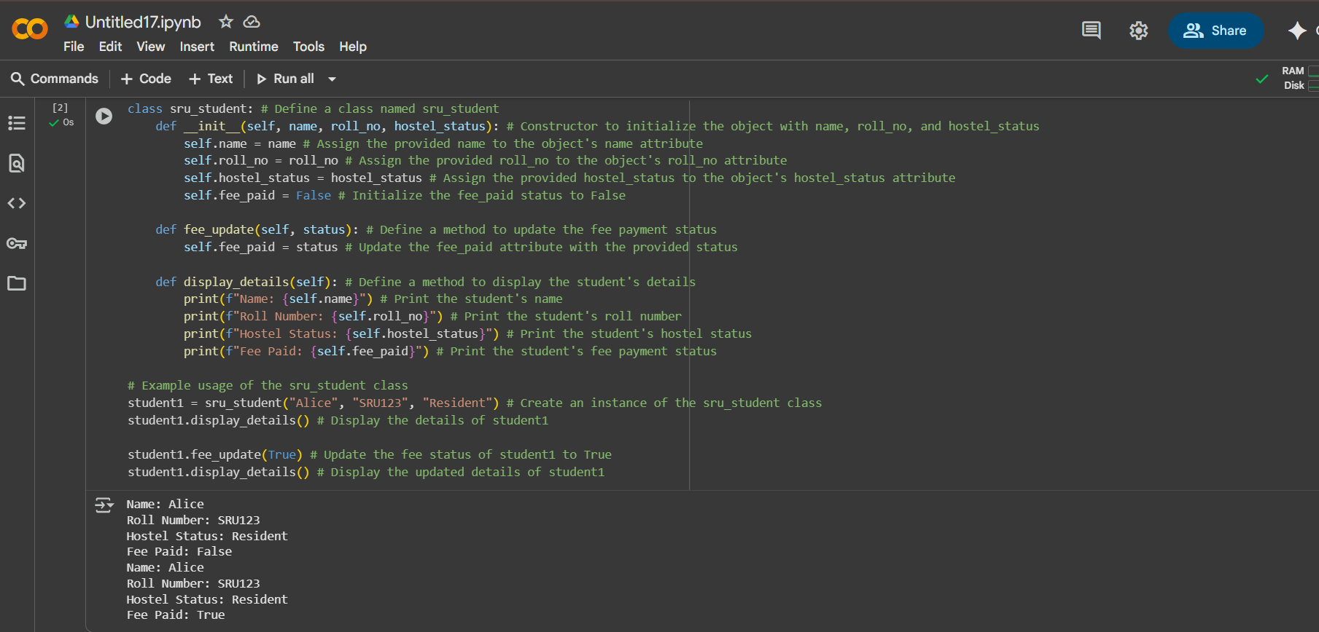

**Task#3**

Write a Python script with 3–4 functions (e.g., calculator: add, subtract, multiply,divide).

• Incorporate manual docstring in code with NumPy Style

• Use AI assistance to generate a module-level docstring + individual function

docstrings.

• Compare the AI-generated docstring with your manually written one.

**Expected Output#3**: Students learn structured documentation for multi-function scripts.

**Prompt:**

# Write a Python module with multiple functions:

# 1. add_numbers(a, b) – returns the sum of two numbers.

# 2. divide_numbers(a, b) – returns the division of two numbers (handle divide by zero).

**# Generate:**

# - A module-level docstring describing the purpose of this script.

# - Individual function-level docstrings using NumPy style.  
  
**Code:**

