Assisted_Coding  
 Assignment:11.5

HTNO:2403A51286

Q1:

Task:   
Ask your AI tools to generate a mini software project in Python/Java.

The project must include:

User Authentication System (Login/Registration with password hashing).

Data Processing Module (e.g., CSV/JSON data analysis with statistics & visualization).

Error Handling & Logging System.

Requirements:

Generate the entire project skeleton with AI.

You must refactor at least two modules manually (improve code structure, optimize loops, or replace inefficient logic).

Add unit tests (minimum 5 test cases).   
  
  
Code:

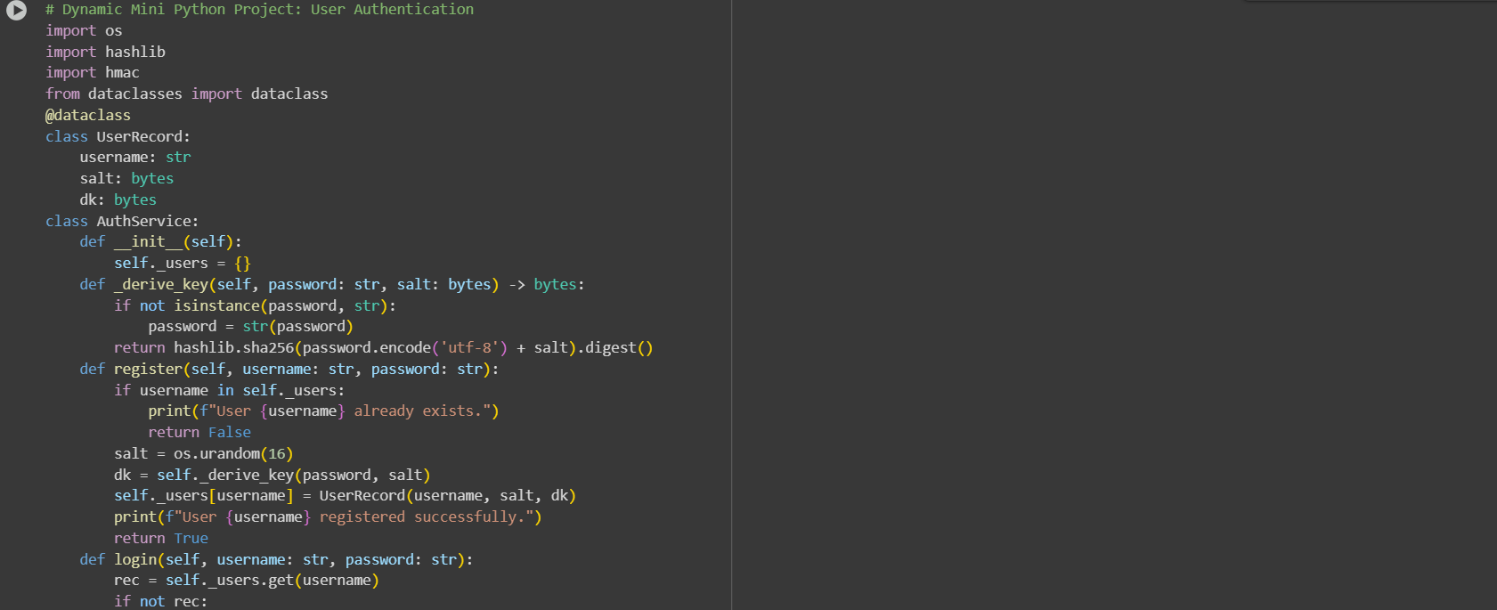

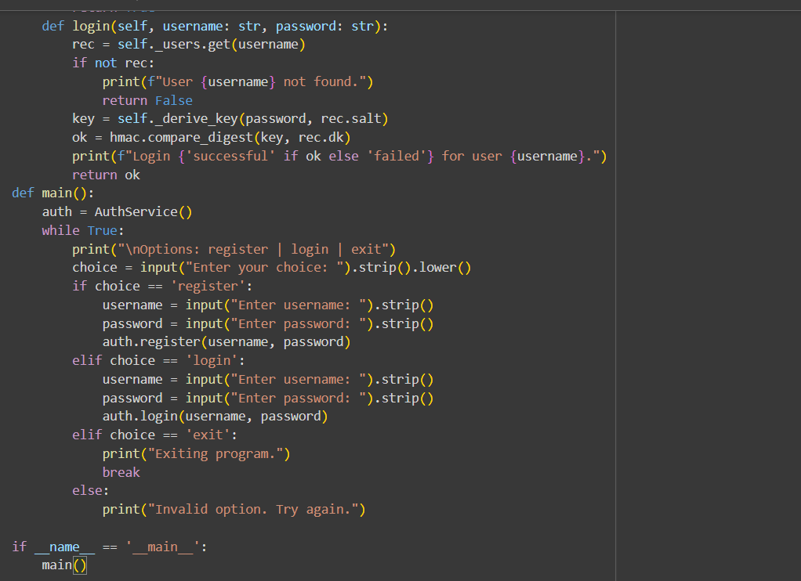

Output:

