Lab test: 1 29-08-2025

2403A51286

Task#4

Question:  
write a python code that reads the CVS file containing student names and marks of 3 subjects,

calculate the total and average marks for each student. use cursor AI tool.

Prompt:

"Write a Python script using Pandas that reads a CSV file named students.csv containing student names and marks in 3 subjects (Math, Physics, Chemistry). Calculate the total and average marks for each student, add these as new columns, and display the updated data. Also, optionally save the updated data to a new CSV file."

CODE:

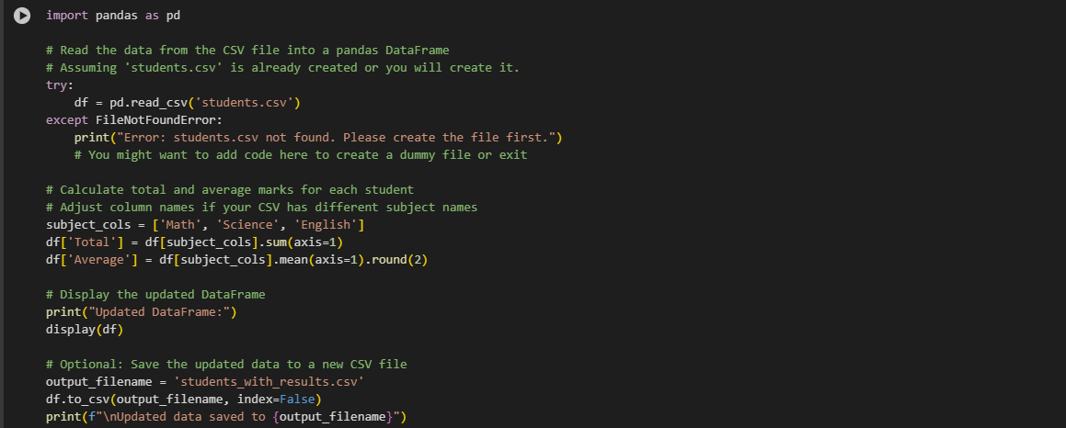

OUTPUT:

