HTNO:2403A51286

LAB EXAM:2

AI ASSISTED CODING

**Question CODE: G**

**TASK#G.1** Sum CSV column ignoring bad rows

**Context:**

CSV exports in real estate listings platform have invalid numerics.

Your Task: (Sum 'value' ints; skip invalid rows.

Data & Edge Cases:

id,value

1,10

2,NA

3,7 -> 17.

**AI Assistance Expectation:**

Use AI to draft csv.DictReader solution and tests.

Constraints & Notes:

Optionally report skipped count.

**Sample Input**

id,value  
1,10  
2,NA  
3,7

**Sample Output**

17

Acceptance Criteria: Skips invalid rows; correct total

**Prompt:**

**Sum CSV Column Ignoring Invalid Rows**  
👉 *Write a Python program using csv.DictReader that sums all valid integers from the "value" column of a CSV, skips invalid rows (like NA or empty), optionally reports the skipped row count, and verify with a test where the input id,value\n1,10\n2,NA\n3,7 produces a total of 17 with 1 skipped row.*

**CODE:**

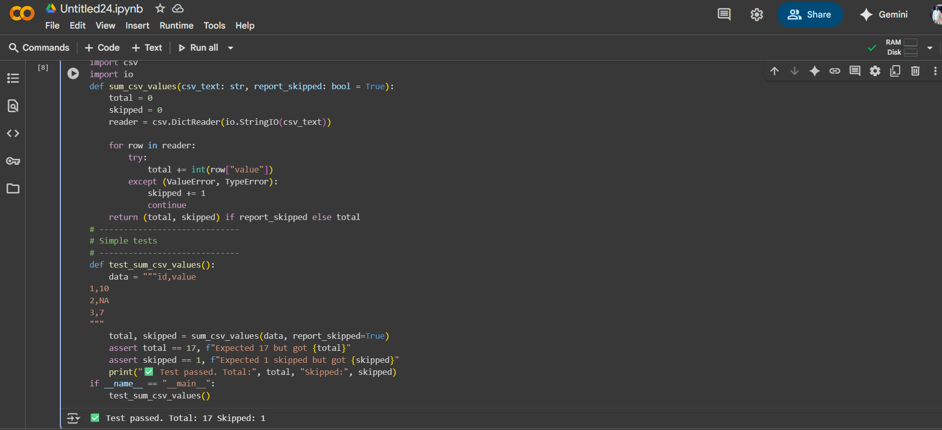

**TASK#G.2** Merge two CSVs by id

**Context:**

Merge two CSVs in real estate listings platform by id.

Implement inner & left joins without pandas.

Data & Edge Cases:

A:id,price; B:id,qty.

**AI Assistance Expectation:**

Dict map + loops; add tests.

Constraints & Notes:

Stable order preferred.

**Sample Input**

id,price  
A,10  
B,20  
---  
id,qty  
A,2  
C,5

**Sample Output**

inner=[('A',10,2)], left=[('A',10,2),('B',20,None)]

Acceptance Criteria: Correct semantics

**Prompt:**

**Merge Two CSVs by ID (Joins Without Pandas)**  
👉 *Write a Python program using csv.DictReader that merges two CSVs on the "id" column, implementing both an INNER JOIN (rows present in both) and a LEFT JOIN (all rows from the first CSV, with missing matches as None), preserving order, and verify with a test where CSV A = id,price\nA,10\nB,20 and CSV B = id,qty\nA,2\nC,5 produces inner=[('A',10,2)] and left=[('A',10,2),('B',20,None)].*

**Code:**

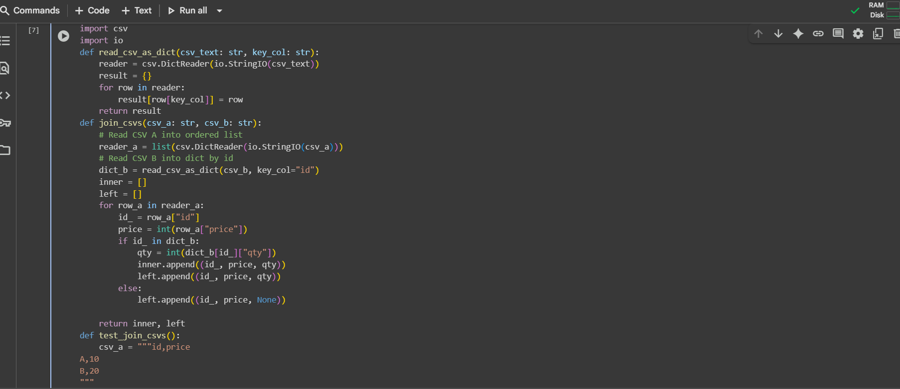

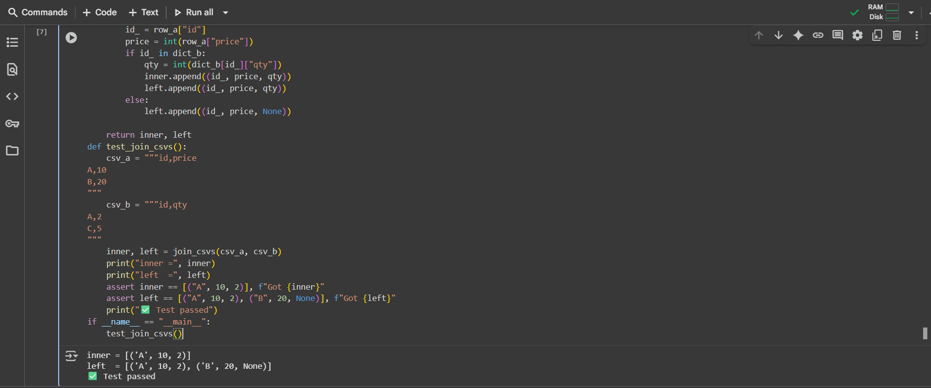

**Output:**

