**Mannava Sravya**

**700747750**

**Semester: Spring**

**Course Id : CS 5710**

**CRN: 23922**

**GitHub Id :** [**https://github.com/Sravya-mannava**](https://github.com/Sravya-mannava)

**Question 1**

**Explanation**

* The list contains the ages of 10 students and the name of list is Ages and used sorted function to sort the list and the printed that sorted list apart from that maximum and minimum age of the student is also displayed by list indexing.
* Now adding the minimum and maximum ages to sortedList and the found length of list using len() function.
* Calculating the median of the sortedList.
* To calculate the average of sortedList. First calculate sum of elements present in the list and find divide with length of sortedList.
* Calculate the range of sortedList by calculating the difference between minimum and Maximum.

**Question 2:**

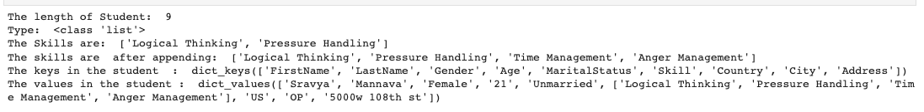

**Explanation:**

* Created a dictionary called dog.
* The keys are name, colour, breed, legs, age added to dog dictionary.
* Now creating student dictionary which contain the attributes like First name, Lastname, Gender, Age, Marital status, Skill, Country, City, Address.
* To find the Length of student dictionary, I used len() function and using append keyword I add some elements to skill list. And to check the type of skill I used type keyword.
* To access the keys and values of student dictionary is used the methods called student.keys() &student.values().

**Question 3:**

**Explanation:**

* Created two tuples namely Bro and Sis and later on joined two tuples using + symbol and assigned it to siblings and then evaluated the length of siblings using len() method.
* In the next step I added two names to siblings with +symbol then I assigned siblings to Family.

**Question 4:**

**Explanation:**

* Given the string called its_companies and calculated the length of it using len() function. And add Twitter to it using add() function.
* Now To Insert multiple IT companies, I used other list called extra_companies and Used update keyword to insert to multiple in its_companies.
* Now used remove keyword to remove the element from given string.
* Now to join two sets, A.union(B) is used.
* To evaluate Insertsection A.intertsection(B) is used and to find if A is subset of I used A.issubset(B) inbuilt function.
* To calculate the symmetric difference I used symmetric_difference() method is used.
* And then I performed type conversion from list to set. And calculated the lengths of both list and set.

**Question 5:**

**Explanation:**

* Given radius of circle. Now import math package then assign pi value to some constant. Then calculate the area of Circle using area of circle i.e., pi*radius*radius.
* And to calculate the circumference of Circle use 2*pi*radius formula.
* Now to enter the radius of circle manually I used input() function.

**Question 6:**

**Explanation:**

* Given the sentence and to split them into words I used split function and then to store them I used sets function called set().
* Now to calculate the unique words in given sentence I used len() method.

**Question 7:**

**Explanation:**

* Tab space i.e., \t is used to print the output with space in the same line
* new line i.e., \n is used to print the output in new line.

**Question 8:**

**Explanation:**

* format() function is used to hold the value at particular space and used add the values to string at the time of execution.

**Question 9:**

**Explanation:**

* input() method is used to accept the input from user. The size of list and values are taken by user manually
* And the two lists are created to covert lbs into kgs. And to access the elements in for loop is used. And the formula to covert lbs to kgs is lbs*0.453592.

**Question 10:**

