Mannava Sravya

700747750

Semester: Spring

Course Id : CS 5710

CRN: 23922

GitHub Link: <https://github.com/Sravya-mannava/Assignment3>

1. Numpy

a. Using NumPy create random vector of size 15 having only Integers in the range 1-20. 1. Reshape the array to 3 by 5 2. Print array shape. 3. Replace the max in each row by 0.

Explanation:

* By using import numpy package was imported and renamed as np
* Reshape method is used to reshape the array
* Max() method is used to get the maximum value from the array.

Create a 2-dimensional array of size 4 x 3 (composed of 4-byte integer elements), also print the shape, type and data type of the array.

Explanation:

* Type() is used for returning the type of the data variable.

1.b.Write a program to compute the eigenvalues and right eigenvectors of a given square array given below: [[ 3 -2] [ 1 0]].

Explanation:

* From numpy linalg package is imported.
* eig() is the method present in the linalg package which returns eigen values.

1.c. Compute the sum of the diagonal element of a given array. [[0 1 2] [3 4 5]]

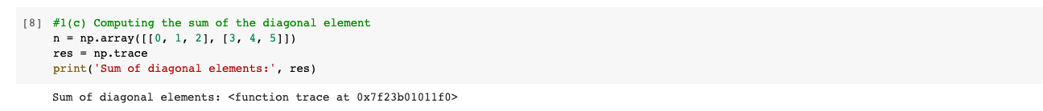

Explanation:

* trace() function is used to trace the data.

1.d. Write a NumPy program to create a new shape to an array without changing its data. Reshape 3x2: [[1 2] [3 4] [5 6]] Reshape 2x3: [[1 2 3] [4 5 6]].

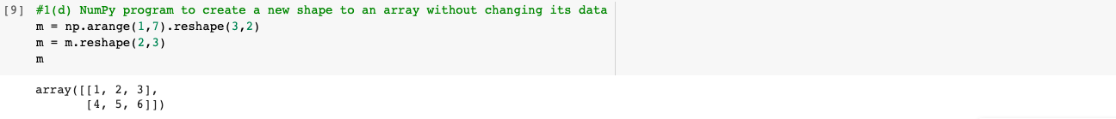

Explanation:

* arrange() is used to arrange the elements in the array and reshape is used to reshape the elements.

2. Write a Python programming to create a below chart of the popularity of programming Languages. Sample data: Programming languages: Java, Python, PHP, JavaScript, C#, C++ Popularity: 22.2, 17.6, 8.8, 8, 7.7, 6.7

Explanation:

* matplotlib.pyplot is package in python renamed is as plt.
* Pie() is method used in python to access the pie chart.