Department of Artificial intelligence and Machine Learning
B.Tech III Semester
Academic Year 2026 – 2027
Data Analysis Essentials ( 2501AI06)
Corner Stone Project Documentation

Surampalem, Kakinada District
Andhra Pradesh – 533437

ADITYA UNIVERSITY
School of Computing
Department of Artificial Intelligence and Machine Learning
DATA ANALYSIS ESSENTIALS
Certificate
This is to certify that the Cornerstone project work entitled “Hospital patient data analysis and decision support system”
is submitted by
Ch. Madhu Latha(25B11AI213)
Y. Lalitha Sravya (25B11AID08)
I. Vasanti (25B11AI412)
A. Swarupa(25B11AI017)
in partial fulfilment of the requirements for the award of the B.Tech. degree in Artificial intelligence and machine learning the academic year 2026-2027.

Project Guide Head of the Department B. Sai Venkata Ganesh Dr. K. Naga Bhargavi, Ph.D,
Assistant Professor, Associate Professor & HOD
Department of AIML Department of AIML

CERTIFICATE
This is to certify that the project work entitled “Hospital patient data analysis and decision support system” is submitted by Ch. Madhu Latha(25B11AI213), Y. Lalitha Sravya (25B11AID08), I. Vasanti (25B11AI412), A. Swarupa(25B11AI017) in partial fulfilment of the requirements for the award of the B.Tech. degree in Artificial Intelligence and Machine Learning during the academic year 2026–2027.
The project has been carried out under the guidance of B. Sai Venkata Ganesh and demonstrates the application of data collection, data cleaning, exploratory data analysis, time-series analysis, and data visualization techniques.

Project Guide: B. Sai Venkata Ganesh
Department of AIML

DECLARATION
We hereby declare that the project entitled “Hospital patient data analysis and decision support system” is our original academic work and is submitted to ADITYA UNIVERSITY, Surampalem, in partial fulfilment of the requirements for the award of the B.Tech. degree in Artificial Intelligence and Machine Learning.
We further declare that this project work has not been submitted, either in full or in part, for the award of any degree or diploma in this or any other institution. We confirm that the work has been carried out with academic honesty and that the analysis and visualizations presented in this documentation are prepared for academic purposes.

Place: Surampalem
Date: 27-09-2026

Ch. Madhu Latha (25B11AI213)
Y. Lalitha Sravya (25B11AID08)
I. Vasanti (25B11AI412)
A. Swarupa (25B11AI017)

ACKNOWLEDGEMENT
We express our sincere gratitude to our project guide, B. Sai Venkata Ganesh, for his valuable guidance, encouragement, and suggestions throughout the development of the Hospital patient data analysis and decision support system. His support helped us understand the practical application of data analysis concepts.
We also thank the Department of Artificial Intelligence and Machine Learning and the faculty members of Aditya University for providing the academic environment, laboratory facilities, and resources required to complete this project.
Finally, we thank our classmates, friends, and everyone who supported us directly or indirectly during the collection, processing, analysis, and presentation of the project.

ABSTRACT
The Hospital Patient Data Analysis & Decision Support System is a Python-based data analytics project that analyses hospital patient records to improve healthcare decision-making.The project uses Pandas to load and process patient datasets, performs data preprocessing to handle missing values, analyses patient records, visualizes hospital trends using charts, and generates meaningful insights.The system also performs Patient Risk Score Analysis and provides Decision Support Recommendations to help hospitals identify high-risk patients and improve treatment prioritization.

TABLE OF CONTENTS
Chapter 1: Introduction
1.1 Introduction to the Project
1.2 Problem Statement
1.3 Objectives of the Project
1.4 Scope of the Project
1.5 Motivation for the Project
1.6 Organisation of the Documentation
1.7 Overview of Technologies Used
1.8 Overview of the Data Analysis Life Cycle
Chapter 2: Dataset Description and Understanding
2.1 Dataset Source
2.2 Dataset Description
2.3 Features and Attributes of the Dataset
2.4 Target Variables: Patient Risk Status and Patient Outcome
2.5 Dataset Statistics and Initial Exploration
2.6 Data Quality Assessment
2.7 Ethical Use and Privacy of Healthcare Data
Chapter 3: Data Preprocessing
3.1 Dataset Collection and Loading
3.2 Identification and Handling of Missing Values
3.3 Detection and Removal of Duplicate Records
3.4 Handling Inconsistent Data
3.5 Numerical and Categorical Data Preprocessing
3.6 Data Transformation and Encoding
3.7 Summary of Preprocessing Steps
3.8 Validation of the Cleaned Dataset

Chapter 4: System Design and Methodology
4.1 Proposed Methodology
4.2 System Workflow and Architecture
4.3 System Flowchart
4.4 Tools and Technologies Used
4.5 Exploratory Data Analysis Methods
4.6 Patient Risk Analysis Methodology
4.7 Logistic Regression Model Design
4.8 Software and Hardware Requirements
4.9 Modular Design of the System
4.10 Decision-Support System Design
Chapter 5: Implementation
5.1 Development Environment – Google Collab
5.2 Importing Required Python Libraries
5.3 Dataset Loading and Initial Exploration
5.4 Implementation of Data Preprocessing
5.5 Exploratory Data Analysis (EDA)
5.6 Patient Risk Level Analysis
5.7 Patient Recovery Outcome Analysis
5.8 Implementation of the Logistic Regression Model
5.9 Model Training and Testing
5.10 Model Evaluation Using Performance Metrics
5.11 Common Errors and Their Solutions
Chapter 6: Data Visualization and Results
6.1 Patient Risk Level Distribution
6.2 Patient Count by Triage Level
6.3 Patient Recovery Distribution
6.4 Recovery Rate by Age Group
6.5 Medical History and Recovery Analysis
6.6 Treatment Cost Analysis Using Box Plots
6.7 Interpretation of Visualizations
6.8 Visualization-Based Findings
Chapter 7: Analysis of Results and Discussion
7.1 Analysis Approach
7.2 Patient Risk Distribution Analysis
7.3 Analysis of Patient Age and Recovery Rates
7.4 Impact of Medical History on Recovery
7.5 Analysis of Hospital Stay and Diagnosis
7.6 Logistic Regression Model Performance
7.7 Interpretation of Accuracy, Precision, Recall and F1-Score
7.8 Key Findings and Observations
7.9 Decision-Support Recommendations
7.10 Limitations of the Analysis
Chapter 8: Output Screenshots
8.1 Dataset Loading Output
8.2 Dataset Before and After Cleaning
8.3 Missing Values and Duplicate Removal Output
8.4 Cleaned Dataset Output
8.5 Exploratory Data Analysis Outputs
8.6 Patient Risk Analysis Graphs
8.7 Patient Recovery Visualization Outputs
8.8 Logistic Regression Model Output
8.9 Model Evaluation Results
Chapter 9: Conclusion and Future Enhancements
9.1 Conclusion
9.2 Project Achievements
9.3 Limitations of the System
9.4 Future Enhancements
9.5 Learning Outcomes
9.6 Summary of Objectives and Outcomes
9.7 Final Remarks
Chapter 10: References
10.1 Python Documentation
10.2 Pandas and NumPy Documentation
10.3 Matplotlib and Seaborn Documentation
10.4 Scikit-learn Documentation
10.5 Dataset Reference
Chapter 11: Appendix – Source Code
11.1 Python Libraries and Dataset Loading Code
11.2 Data Preprocessing Code
11.3 Exploratory Data Analysis Code
11.4 Data Visualization Code
11.5 Logistic Regression Implementation Code
11.6 Model Evaluation Code

Chapter 1: Introduction

1.1 Introduction to the Project
The Hospital Patient Data Analysis & Decision Support System is a data analysis project developed to analyze hospital patient records and identify meaningful patterns in patient health information. Hospitals generate large amounts of data related to patient demographics, medical history, triage levels, treatment, and recovery outcomes. Analysing this information manually can be difficult and time-consuming.
This project uses Python and data analysis libraries to clean patient records, perform exploratory data analysis, create visualizations, and examine patient risk levels and recovery outcomes. The system uses data analysis and a Logistic Regression model to support the interpretation of patient information and provide decision-support insights.
The project follows a systematic workflow that includes dataset loading, data cleaning, preprocessing, exploratory data analysis, visualization, model training, evaluation, and interpretation of results. The final objective is to convert raw hospital data into useful information that can support healthcare analysis and decision-making.

1.2 Problem Statement
Hospital datasets may contain missing values, duplicate records, inconsistent information, and large numbers of patient records. Examining such data manually makes it difficult to identify patient risk patterns, compare recovery outcomes, and understand relationships between patient characteristics and medical results.
Therefore, a systematic data analysis system is required to clean and organize hospital data, identify important patterns, visualize patient information, and analyse risk levels and recovery outcomes. The proposed system aims to address these challenges using Python-based data analysis and machine learning techniques.

1.3 Objectives of the Project
- To load and understand the hospital patient dataset using Python.
- To identify and handle missing values and duplicate records.
- To preprocess numerical and categorical patient information.
- To perform Exploratory Data Analysis (EDA).
- To analyse patient risk levels, triage levels, and recovery outcomes.
- To create meaningful visualizations using Matplotlib and Seaborn.
- To implement a Logistic Regression model for classification.
- To evaluate the model using accuracy, precision, recall, and F1-score.
- To generate useful findings that support healthcare decision-making.

1.4 Scope of the Project
The project focuses on analysing hospital patient records and identifying patterns related to patient characteristics, risk levels, and recovery outcomes. It includes dataset loading, data cleaning, preprocessing, statistical analysis, visualization, and model evaluation.
The project can help users understand the distribution of patient risk categories, compare recovery rates among different age groups, and examine the relationship between medical history and recovery outcomes.

1.5 Motivation for the Project
Healthcare organizations collect large amounts of patient information every day. When this information is stored in large datasets, identifying important patterns through manual examination becomes difficult.
This project was selected to understand how data analysis and machine learning can be applied to healthcare information. It provides practical experience in handling real-world-style datasets, preprocessing missing data, creating visualizations, and interpreting analytical results.

1.6 Organization of the Documentation
This documentation is divided into eleven chapters. Chapter 1 introduces the project, its objectives, scope, and motivation. Chapter 2 describes the dataset, its attributes, and initial exploration. Chapter 3 explains the preprocessing techniques used to clean the data.
Chapter 4 presents the system design and methodology. Chapter 5 describes the implementation using Python and Google Collab. Chapter 6 presents the visualizations and their results. Chapter 7 discusses the analysis findings and model performance. Chapter 8 contains screenshots of the outputs. Chapter 9 presents the conclusion, limitations, and future enhancements. Chapter 10 lists the references, and Chapter 11 contains the source code.
Table 1.1: Organization of the Documentation
Chapter | Title | Purpose
1 | Introduction | Background, problem statement, objectives, scope, and motivation of the project
2 | Dataset Description and Understanding | Hospital dataset source, dataset files, attributes, patient details, and initial data exploration
3 | Data Preprocessing | Data cleaning, handling missing values, removing duplicate records, and preparing data for analysis
4 | System Design and Methodology | System workflow, flowchart, architecture, tools, techniques, and proposed methodology
5 | Implementation | Step-by-step Python code, dataset loading, preprocessing, exploratory data analysis, and Logistic Regression implementation
6 | Data Visualization and Results | Visualizations using bar charts, pie charts, and box plots to analyze patient risk levels, triage levels, and recovery outcomes
7 | Analysis of Results | Interpretation of patient risk distribution, recovery patterns, model performance, findings, and discussion
8 | Output Screenshots | Screenshots of dataset loading, data cleaning, analysis, visualizations, and model evaluation outputs
9 | Conclusion and Future Enhancements | Project summary, achievements, limitations, learning outcomes, and future improvements
10 | References | References to Python, Pandas, NumPy, Matplotlib, Seaborn, Scikit-learn, Google Collab, and the dataset source
11 | Appendix – Source Code | Complete Python source code used for data preprocessing, analysis, visualization, and model evaluation
Appendix B | Glossary of Terms | Definitions of important terms used in hospital patient data analysis and machine learning

1.7 Overview of the Technologies Used
Before starting the analysis, the team studied the tools used in the Hospital Patient Data Analysis & Decision Support System. A short overview of each tool is given below.
1.7.1 Python
Python is a high-level programming language widely used in data analysis, artificial intelligence, and machine learning. Its simple syntax makes it easy to write and understand programs. In this project, Python is used to load hospital patient data, perform analysis, create visualizations, and implement the machine learning model.
1.7.2 Pandas
Pandas is a Python library used for data manipulation and analysis. It provides Series and DataFrame structures for handling data in tabular form. In this project, Pandas is used to load the hospital dataset, identify missing values, remove duplicate records, clean data, calculate statistics, and analyze patient information.
1.7.3 NumPy
NumPy is a Python library used for numerical calculations and mathematical operations. It provides efficient tools for working with numerical data. In this project, NumPy supports numerical data processing and helps handle numerical values during preprocessing.
1.7.4 Matplotlib
Matplotlib is a Python library used to create graphs and charts. It supports bar charts, line charts, pie charts, histograms, and box plots. In this project, Matplotlib is used to visualize patient risk levels, triage distributions, and recovery outcomes.
1.7.5 Seaborn
Seaborn is a Python data visualization library built on Matplotlib. It provides attractive statistical graphs and helps display relationships between variables. In this project, Seaborn is used to visualize patient data and understand patterns in the dataset.
1.7.6 Scikit-learn
Scikit-learn is a machine learning library that provides tools for data preprocessing, classification, and model evaluation. In this project, it is used to prepare the data, implement the Logistic Regression model, and evaluate model performance using classification metrics.
1.7.7 Google Collab
Google Collab is an online Python notebook environment that runs through a web browser. It allows users to write and execute Python code without installing the complete development environment. In this project, Google Collab is used to upload the dataset, execute the analysis, generate graphs, and display results.
1.7.8 CSV (Comma-Separated Values)
CSV is a file format used to store tabular data in rows and columns. It is widely supported by data analysis tools. In this project, CSV files are used to store the original hospital patient dataset and the cleaned dataset.
Table 1.2: Technologies Used in the Project
Tool | Category | Role in the Project
Python | Programming language | Writes and executes the analysis code
Pandas | Data analysis library | Loading, cleaning, grouping, and calculating statistics
NumPy | Numerical library | Numerical calculations and data processing
Matplotlib | Visualization library | Creating graphs and charts
Seaborn | Visualization library | Statistical graphs and relationship analysis
Scikit-learn | Machine learning library | Data preprocessing, Logistic Regression, and model evaluation
Google Collab | Development environment | Running code and viewing outputs
CSV | File format | Storing the original and cleaned hospital datasets

1.8 The Data Analysis Life Cycle
The project follows a sequence of stages to transform raw patient data into meaningful information.
- Problem Definition: Identify the need to analyse patient risk levels and recovery outcomes.
- Data Collection: Obtain the hospital patient dataset.
- Data Loading: Load the dataset into Python using Pandas.
- Data Cleaning: Identify missing values, duplicate records, and inconsistent information.
- Data Preprocessing: Prepare numerical and categorical variables for analysis.
- Exploratory Data Analysis: Examine patient distributions and relationships.
- Visualization: Generate charts to represent important patterns.
- Model Development: Train the Logistic Regression classification model.
- Evaluation: Measure model performance using classification metrics.
- Interpretation: Summarize the findings and identify decision-support insights.

Chapter 2: Dataset Description and Understanding

2.1 Dataset Source
The dataset used in this project, Hospital Patient Data Analysis & Decision Support System, contains hospital patient records used to analyze patient information, risk levels, and recovery outcomes. The dataset was loaded into Python using Pandas and processed in Google Colab.
The dataset used during the project contains patient-related information, including demographic details, medical information, and outcome-related attributes. The initial dataset consisted of 1,020 rows and 18 columns. After preprocessing, 1,002 rows remained.
The original dataset file used in the project is hospital_patient_dataset_before_cleaning.csv, and the cleaned dataset is saved as hospital_patient_dataset_cleaned.csv.
Note: The exact original source of the dataset should be mentioned here. If it was downloaded from Kaggle, include the dataset title and its Kaggle URL. The information provided so far does not confirm the exact source.
2.1.1 Step-by-Step Process Followed to Obtain and Load the Dataset
The following steps describe how the hospital patient dataset is prepared and loaded for analysis. These steps can be represented in the flowchart shown in Fig. 2.1.
Step 1: Identify the dataset.
The hospital patient dataset required for the project was identified based on its suitability for analyzing patient information, risk levels, and recovery outcomes.
Step 2: Obtain the dataset.
The dataset file, hospital_patient_dataset_before_cleaning.csv, was obtained and made available for use in the project.
Step 3: Prepare the working environment.
Google Collab was opened in a web browser to create a Python notebook. This environment was used to execute the code and display the analysis results.
Step 4: Upload the dataset.
The CSV file was uploaded to Google Collab using the file upload option. The uploaded file was then made available for processing in the notebook.
Step 5: Import the required libraries.
The Pandas and NumPy libraries were imported to support data loading, numerical operations, and preprocessing.
Step 6: Load the dataset into Python.
The pd.read_csv() function was used to read the CSV file into a Pandas Data Frame. The dataset was then displayed to confirm that it had been loaded successfully.
Step 7: Inspect the dataset.
The first few rows, column names, data types, dataset dimensions, missing values, and duplicate records were examined to understand the structure and quality of the data.
Step 8: Begin data cleaning and preprocessing.
After inspecting the dataset, the preprocessing steps described in Chapter 3 were applied. These included handling missing values, removing duplicate records, and preparing the dataset for further analysis.
Step 9: Save the cleaned dataset.
The cleaned records were saved as hospital_patient_dataset_cleaned.csv. This file was used for exploratory data analysis, visualization, and further model development.
Fig. 2.1: Steps to Obtain and Load the Hospital Patient Dataset
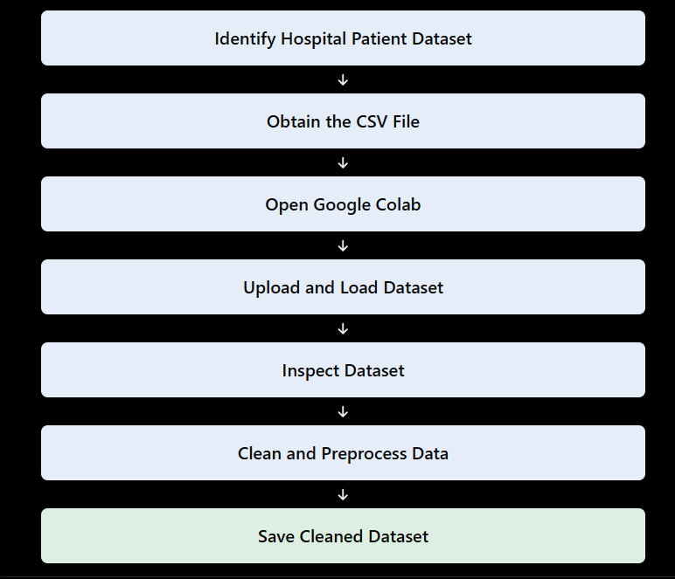
Fig 2.1: Steps to Obtain the Dataset from Kaggle
2.1.2 Files Available in the Dataset
The hospital patient dataset used in this project is stored in CSV format. The original dataset contains 1,020 rows and 18 columns. After data preprocessing, the cleaned dataset contains 1,002 rows and 18 columns. The files used in this project are listed in the table below.

Table 2.1: Files Available in the Dataset
File Name | Level of Data | Used For
hospital_patient_dataset_before_cleaning.csv | Original hospital patient records containing 18 columns | Initial data inspection, identifying missing values, and detecting duplicate records
hospital_patient_dataset_cleaned.csv | Cleaned hospital patient records containing 1,002 rows and 18 columns | Exploratory data analysis, patient risk analysis, and visualization
Cleaned dataset in Pandas DataFrame (df) | Patient records loaded into Python for analysis | Calculating statistics, grouping patient categories, and generating graphs
Model input and target data | Selected patient features and the target variable used by the model | Training and testing the Logistic Regression classification model
Note: The table is based on the dataset filenames and preprocessing details available for your project. The original dataset source and any additional CSV files should be added if they were actually used.

2.2 Dataset Description
The dataset contains hospital patient records that can be analysed to understand patient conditions, treatment details, risk levels, and recovery outcomes. The main information includes patient age, gender, medical history, blood pressure, blood sugar, cholesterol, BMI, triage level, treatment details, and other clinical factors. These attributes help identify patterns in patient health, analyse recovery outcomes, and understand factors associated with patient risk levels.
The data is stored in CSV (Comma Separated Values) format. A CSV file is a plain text file in which each line represents one record and the values of different columns are separated by commas. This format is easy to use in Excel and can be loaded directly into Python using Pandas.
2.2.1 Characteristics of the Dataset
- Format: CSV (Comma Separated Values), used to store hospital patient records.
- Type of data: Numerical data, such as age and clinical measurements, together with categorical data, such as gender, medical history, triage level, and risk status.
- Coverage: The original dataset contains 1,020 records and 18 columns. After removing duplicate records and handling missing values, the cleaned dataset contains 1,002 records and 18 columns.
- Data quality: The original dataset contained 289 missing values and 18 duplicate records. After preprocessing, the cleaned dataset contains no missing values or duplicate records.
- Use in this project: Data cleaning, exploratory data analysis (EDA), statistical analysis, visualization, patient risk analysis, and machine learning using Logistic Regression.

2.3 Features / Attributes
Table 2.2: Features and Attributes of the Dataset
Attribute | Type | Description
Age | Numeric (integer) | Age of the patient in years
Gender | Categorical (text) | Gender of the patient
Blood Pressure | Numeric | Blood pressure measurement of the patient
Blood Sugar | Numeric | Blood sugar level of the patient
Cholesterol | Numeric | Cholesterol level of the patient
BMI | Numeric (decimal) | Body Mass Index of the patient
Medical History | Categorical (text) | Previous medical conditions of the patient
Triage Level | Categorical / Numeric | Indicates the priority level assigned to the patient
Department | Categorical (text) | Hospital department responsible for the patient
Arrival Time | Date/Time | Time at which the patient arrived at the hospital
Treatment Start | Date/Time | Time at which treatment began
Discharge Time | Date/Time | Time at which the patient was discharged
Risk Level | Categorical (text) | Patient risk category: Low, Medium, or High
Outcome | Categorical (text) | Indicates the patient's recovery or treatment outcome
Patient ID | Identifier | Unique identifier assigned to a patient, if available
Other Clinical Factors | Numeric / Categorical | Additional clinical information recorded for analysis

2.3.1 Categorical and Numerical Attributes
Categorical attributes, such as Gender, Medical History, Department, Risk Level, and Outcome, are used to group patient records and compare different categories. Numerical attributes, such as Age, Blood Pressure, Blood Sugar, Cholesterol, and BMI, are used to calculate totals, averages, and other statistical measures.
Date and time attributes, such as Arrival Time, Treatment Start, and Discharge Time, are used to analyse patient waiting time, treatment duration, and hospital stay duration. These attributes help identify patterns in patient conditions and support hospital decision-making.

2.4 Target Variable
The target variable for the Hospital Patient Data Analysis & Decision Support System is Patient Risk Status, which is categorized into Low Risk, Medium Risk, and High Risk. It helps identify the risk category of patients based on the available patient information and clinical factors.
The project also analyses patient recovery outcomes, medical history, triage levels, and treatment details. Logistic Regression is used for machine learning analysis, and the model's performance is evaluated using suitable evaluation metrics.

2.5 Dataset Statistics / Initial Exploration
Initial exploration is performed to understand the structure and quality of the hospital patient dataset. It includes checking the number of rows and columns, column names, data types, missing values, duplicate records, descriptive statistics, and sample records.
Python libraries such as Pandas and NumPy are used for this process. Functions such as head(), info(), describe(), isnull().sum(), and duplicated().sum() help examine the dataset before performing further analysis.
2.5.1 Commands Used for Initial Exploration
import pandas as pd
import numpy as np
df = pd.read_csv("hospital_patient_dataset_before_cleaning.csv")
print(df.shape)
print(df.columns.tolist())
print(df.head())
df.info()
print(df.describe())
print(df.isnull().sum())
print(df.duplicated().sum())
Table 2.3: Initial Dataset Exploration Commands
Command | What it tells us
df.shape | Total number of rows and columns
df.columns.tolist() | Names of all columns in the dataset
df.head() | Displays the first five records
df.info() | Shows column data types and non-null values
df.describe() | Provides statistical summaries of numerical columns
df.isnull().sum() | Counts missing values in each column
df.duplicated().sum() | Counts duplicate records

2.5.2 Observations from Initial Exploration
- The original dataset contains 1,020 rows and 18 columns.
- The dataset initially contains 289 missing values.
- A total of 18 duplicate records are identified.
- Data cleaning is performed to handle missing values and remove duplicate records.
- After preprocessing, the cleaned dataset contains 1,002 rows and 18 columns, with no missing values or duplicate records.
- The cleaned dataset is used for exploratory data analysis, visualization, patient risk analysis, and machine learning.

2.6 Data Quality Assessment
Before performing analysis, the quality of the hospital patient dataset is assessed using five common dimensions.
Table 2.4: Data Quality Assessment
Dimension | Meaning | How it was checked
Completeness | Checks whether required values are present | df.isnull().sum()
Uniqueness | Checks whether repeated records exist | df.duplicated().sum()
Consistency | Checks whether values and formats are uniform | Examining column values and formats
Validity | Checks whether values have appropriate data types and ranges | df.info() and df.describe()
Timeliness | Checks whether date and time information is suitable for the analysis | Examining available date and time columns
The initial checks help identify data quality problems before analysis. Missing values are handled, and duplicate records are removed during preprocessing. Data types and numerical ranges are examined to identify values that may require further investigation.
After cleaning, the dataset contains 1,002 records with 18 columns and no missing values or duplicate records. This improves its suitability for further analysis.

2.7 Ethical Use and Licence of the Data
The hospital patient dataset is used for academic learning, data analysis, visualization, and decision-support purposes. The dataset source and licence should be acknowledged in the project references according to the original provider's requirements.
Patient information must be handled responsibly. If the dataset contains personal or identifiable information, it should not be disclosed unnecessarily. The analysis should be used to identify patterns in the available data and should not be treated as a substitute for professional medical judgment.
Important: Verify the original dataset source and its licence before submitting this section. Do not claim that the dataset is anonymous or publicly licensed unless the source confirms it.

Chapter 3: Data Preprocessing

3.1 Data Collection / Loading
Data collection was completed by obtaining the hospital patient dataset in CSV format. The original dataset, hospital_patient_dataset_before_cleaning.csv, was loaded into a Pandas DataFrame for inspection and analysis. A DataFrame is a two-dimensional table containing rows and columns and is the main data structure used in Pandas for data manipulation and analysis.
3.1.1 Steps Followed for Loading the Data
- Import the Pandas library.
- Upload the original hospital patient CSV file to Google Colab.
- Load the CSV file using pd.read_csv().
- Store the loaded data in a DataFrame variable named df.
- Display df.head() and df.shape to verify that the file was loaded correctly.
- Check column names, data types, missing values, and duplicate records.
Python Code:
import pandas as pd
df = pd.read_csv("hospital_patient_dataset_before_cleaning.csv")
print("Hospital patient data:", df.shape)
print(df.columns.tolist())
print(df.head())
df.info()
Expected dataset shape:
Hospital patient data: (1020, 18)

3.2 Handling Missing Values
Missing values are entries that are empty in the hospital patient dataset. They can affect statistical calculations, visualizations, and machine learning results. Missing values are identified using df.isnull().sum(), which displays the number of missing values in each column.
The original hospital patient dataset contained 289 missing values. These missing values were handled during data preprocessing using suitable methods based on the data type of each column.

3.2.1 Methods of Treating Missing Values
Table 3.1: Methods of Treating Missing Values
Method | When it is used | Pandas function
Drop rows | When records are duplicated or cannot be used for analysis | df.dropna()
Fill with 0 | When zero is a meaningful value for the column | df.fillna(0)
Fill with median | When a numerical column contains missing values | df[col].fillna(df[col].median())
Fill with mode | When a categorical column contains missing values | df[col].fillna(df[col].mode()[0])
Keep as it is | When missing values are acceptable for the analysis | No change
Python Code:
import pandas as pd
df = pd.read_csv("hospital_patient_dataset_before_cleaning.csv")
print("Missing values before cleaning:")
print(df.isnull().sum())
num_cols = df.select_dtypes(include="number").columns
cat_cols = df.select_dtypes(include="object").columns
for col in num_cols:
df[col] = df[col].fillna(df[col].median())
for col in cat_cols:
if df[col].isnull().sum() > 0 and not df[col].mode().empty:
df[col] = df[col].fillna(df[col].mode()[0])
print("Missing values after cleaning:")
print(df.isnull().sum().sum())
The numerical columns are filled using their median values, while categorical columns are filled using their mode values. These methods help preserve the dataset for further analysis.
Observation: After preprocessing, the cleaned dataset contains zero missing values. The selected methods help prepare the hospital patient data for exploratory data analysis, visualization, and machine learning.

3.3 Handling Duplicate / Inconsistent Data
Duplicate records are rows that appear more than once with identical values. They can affect statistical calculations and produce inaccurate results during patient data analysis. The number of duplicate records is identified using df.duplicated().sum(), and duplicate rows are removed using df.drop_duplicates().
The original hospital patient dataset contained 18 duplicate records. These records were removed during data preprocessing to improve the quality of the dataset.
Python Code
import pandas as pd
df = pd.read_csv("hospital_patient_dataset_before_cleaning.csv")
print("Duplicates before:", df.duplicated().sum())
df = df.drop_duplicates()
print("Duplicates after:", df.duplicated().sum())
df.columns = df.columns.str.strip()
for col in df.select_dtypes(include="object").columns:
df[col] = df[col].str.strip()
print("Data cleaning completed")
Handling Inconsistent Data
Inconsistent data includes extra spaces in column names, unnecessary spaces in text values, and differences in formatting. Such inconsistencies can affect grouping and analysis.
To handle these issues, column names are standardized using df.columns.str.strip(). Extra spaces are removed from text values using .str.strip(). These steps help maintain consistency in the dataset.
Observation:
- Duplicate records before cleaning: 18
- Duplicate records after cleaning: 0
- Extra spaces in column names and text values are removed.
After removing duplicate records and standardizing text values, the dataset becomes more suitable for further analysis, visualization, and machine learning.

3.4 Date and Time Processing
In the hospital patient dataset, date and time columns are used to analyse patient arrival, treatment start, and discharge details. When a CSV file is loaded, these columns may be stored as text. They must be converted into the datetime format using pd.to_datetime() to calculate waiting time, treatment duration, and hospital stay duration.
Python Code
import pandas as pd
df = pd.read_csv("hospital_patient_dataset_cleaned.csv")
df["Arrival Time"] = pd.to_datetime(df["Arrival Time"], errors="coerce")
df["Treatment Start"] = pd.to_datetime(df["Treatment Start"], errors="coerce")
df["Discharge Time"] = pd.to_datetime(df["Discharge Time"], errors="coerce")
df["Waiting Time"] = (df["Treatment Start"] - df["Arrival Time"]).dt.total_seconds() / 60
df["Hospital Stay"] = (df["Discharge Time"] - df["Arrival Time"]).dt.total_seconds() / 3600

print(df[["Waiting Time", "Hospital Stay"]].head())
Date and time processing helps identify patient waiting periods and hospital stay durations. Use the exact column names available in your CSV file.

3.5 Project-Specific Preprocessing
The Hospital Patient Data Analysis & Decision Support System requires preprocessing to prepare the patient records for analysis and machine learning. The main preprocessing tasks include:
- Loading the hospital patient dataset.
- Inspecting the rows, columns, and data types.
- Handling missing values using median and mode.
- Removing duplicate records.
- Standardizing column names and text values.
- Converting date and time columns into the appropriate format.
- Preparing patient data for grouping, visualization, and machine learning.
For machine learning, categorical encoding and feature scaling may be required depending on the selected features and algorithm. These steps should be applied only when required by the actual model implementation.

3.6 Summary of Preprocessing Steps
Table 3.2: Summary of Preprocessing Steps
No. | Step | Purpose
1 | Load CSV into a DataFrame | Bring the data into Python
2 | Inspect shape, columns, and data types | Understand the dataset structure
3 | Check and treat missing values | Handle incomplete records
4 | Remove duplicate records | Avoid repeated records affecting analysis
5 | Clean column names and text values | Maintain consistent formatting
6 | Convert date and time columns | Support time-based analysis
7 | Create derived columns | Calculate waiting time and hospital stay
8 | Group and aggregate data | Prepare summarized data for charts
9 | Prepare data for machine learning | Support model training and evaluation

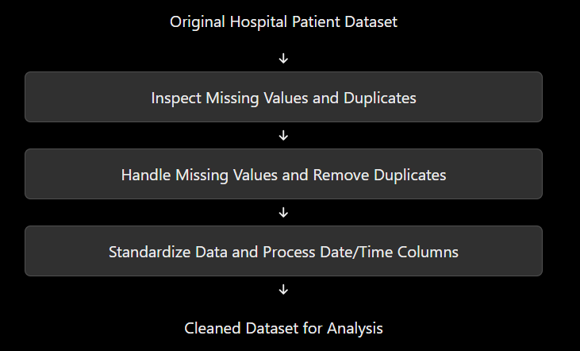
Fig 3.1: Data Cleaning Decision Flowchart

3.7 Data Transformation and Aggregation
After cleaning, the hospital patient data is transformed into useful forms for statistical analysis and visualization. Sorting, selecting, grouping, and creating derived columns help identify patterns in patient risk, treatment, and recovery.
3.7.1 Sorting and Selecting
Records can be sorted by age or selected according to the columns required for analysis.
top_patients = df.sort_values("Age", ascending=False).head(10)
subset = df[["Age", "Gender", "Department", "Risk Level", "Outcome"]]
print(subset.head())
3.7.2 Grouping
Grouping is used to summarize patient records by risk level or department.
risk_counts = df.groupby("Risk Level").size()
department_counts = df.groupby("Department").size()
print(risk_counts)
print(department_counts)
3.7.3 Creating Derived Columns
df["Waiting Time"] = (df["Treatment Start"] - df["Arrival Time"]).dt.total_seconds() / 60
df["Hospital Stay"] = (df["Discharge Time"] - df["Arrival Time"]).dt.total_seconds() / 3600
print(df[["Waiting Time", "Hospital Stay"]].head())

3.8 Validation After Preprocessing
After preprocessing, the dataset is checked to ensure that it is suitable for further analysis.
Table 3.3: Validation After Preprocessing
Check | Expected Result | Command
Missing values | 0 missing values | df.isnull().sum().sum()
Duplicate rows | 0 duplicate rows | df.duplicated().sum()
Column names | Consistent names | df.columns.tolist()
Date/time data types | Datetime format for valid date/time columns | df.dtypes
Negative numerical values | Investigate invalid negative values where not logically valid | (df.select_dtypes(include="number") < 0).sum()
Dataset dimensions | 1,002 rows and 18 columns after cleaning | df.shape

Chapter 4: System Design and Methodology

4.1 Proposed Methodology
- Collect or obtain the hospital patient dataset.
- Load the dataset into a Pandas DataFrame.
- Inspect rows, columns, data types, missing values, and duplicate records.
- Clean the dataset by handling missing values and removing duplicates.
- Perform exploratory data analysis (EDA) and statistical analysis.
- Analyse patient risk levels, triage levels, medical history, and recovery outcomes.
- Generate visualizations using Matplotlib and Seaborn.
- Prepare patient data for machine learning.
- Train and evaluate the Logistic Regression model.
- Generate patient risk analysis results and decision-support recommendations.
- Interpret the results and prepare the final report.
4.1.1 Explanation of the Methodology
The methodology follows a standard data analysis and machine learning pipeline. First, the hospital patient dataset is collected and loaded into Python. Next, the data is inspected and cleaned to improve its quality. The cleaned data is then analysed using descriptive statistics, grouping, and visualizations. Patient risk patterns are examined, and the Logistic Regression model is trained and evaluated. Finally, the results are interpreted to support hospital decision-making.
Table 4.1: Proposed Methodology and Outputs
Phase | Activities | Output
Data acquisition | Obtain the hospital patient dataset | Original CSV file
Data understanding | Inspect rows, columns, and data types | Understanding of dataset structure
Data preparation | Handle missing values and remove duplicates | Cleaned dataset
Exploratory analysis | Statistics, grouping, and comparisons | Summary tables
Visualization | Create charts and graphs | Visual analysis results
Risk analysis | Examine patient risk categories and clinical factors | Patient risk insights
Model development | Train Logistic Regression | Trained model
Model evaluation | Evaluate model performance | Performance metrics
Interpretation | Explain findings and recommendations | Decision-support results

4.2 System Workflow / Architecture
The overall workflow of the project can be represented as:
Hospital Patient Dataset → Data Loading → Data Inspection → Data Cleaning → Data Preprocessing → Exploratory Data Analysis → Patient Risk Analysis → Logistic Regression Model → Model Evaluation → Visualization → Decision-Support Recommendations → Final Report.
The system is designed to process patient data in stages. Each stage produces information that is used by the next stage. This structured workflow supports systematic analysis and helps present the results clearly.

4.3 System Flowchart
The project flowchart represents the sequence of activities from dataset input to the final analysis and decision-support output.
The flowchart uses standard symbols: rounded rectangles for the start and end, rectangles for processing steps, diamonds for decisions, and arrows to indicate the direction of flow. It can be drawn in black and white so that it prints clearly.

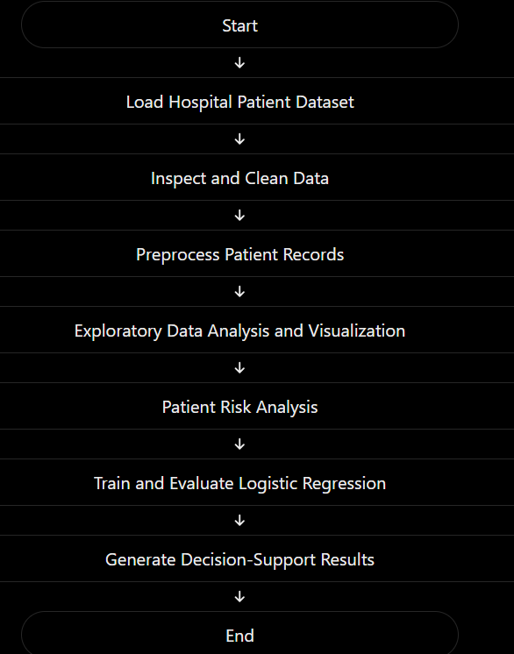
Fig 4.3: Project Workflow / System Architecture Flowchart
4.3.1 Description of the Blocks in the Flowchart
- Hospital Patient Dataset: Contains the original patient records.
- Data Loading: Loads the CSV file into a Pandas DataFrame.
- Data Inspection: Checks rows, columns, data types, missing values, and duplicates.
- Data Cleaning: Handles missing values and removes duplicate records.
- Data Preprocessing: Prepares the dataset for analysis and machine learning.
- Exploratory Data Analysis: Examines patient information using statistics and grouping.
- Patient Risk Analysis: Studies the distribution of Low, Medium, and High risk categories.
- Logistic Regression Model: Performs the model training and prediction specified in the project.
- Model Evaluation: Measures model performance using evaluation metrics.
- Decision-Support Results: Presents the analysis findings and recommendations.

4.4 Tools and Technologies Used
- Python: Primary programming language for data analysis and machine learning.
- Pandas: Used for loading, cleaning, grouping, and analysing patient records.
- NumPy: Supports numerical calculations and data processing.
- Matplotlib: Used to create charts and graphs.
- Seaborn: Used for statistical visualizations and comparisons.
- Scikit-learn: Used for preprocessing, Logistic Regression, and model evaluation.
- Google Collab: Development environment for executing Python code.
- CSV: File format used to store the original and cleaned datasets.

4.5 Exploratory Data Analysis Methods
Exploratory Data Analysis (EDA) is used to understand the dataset, identify patterns, and examine relationships between patient attributes. It helps summarize patient information before developing the machine learning model.
4.5.1 Descriptive Statistics
Descriptive statistics summarize numerical attributes such as age and clinical measurements. Functions such as describe() provide count, mean, standard deviation, minimum, maximum, and quartiles.
4.5.2 Grouping and Aggregation
The groupby() function divides records into groups based on attributes such as department, triage level, or risk level. Functions such as count(), mean(), and sum() help summarize the data.
4.5.3 Patient Risk Analysis
Patient risk analysis examines the distribution of Low, Medium, and High risk categories. It helps identify the number of patients in each category and explore how patient characteristics relate to risk levels.
4.5.4 Data Visualization
Visualization presents numerical information through graphs, making patterns easier to understand.

Table 4.2: Analysis Questions and Chart Types
Analysis Question | Chart Type
How many patients belong to each risk category? | Bar chart
How are patients distributed across departments? | Bar chart
How are numerical clinical measurements distributed? | Histogram
How do clinical measurements vary across risk categories? | Box plot
What is the relationship between two numerical attributes? | Scatter plot
How are patients distributed across categories? | Pie chart

4.6 Software and Hardware Requirements
Patient risk analysis is performed to understand the distribution of patients among Low, Medium, and High risk categories. The analysis uses the available patient information and clinical factors in the dataset.
The methodology includes:
- Examine the number of patients in each risk category.
- Compare risk levels across departments and triage categories.
- Analyse relevant clinical attributes and medical history.
- Visualize the distribution of patient risk categories.
- Identify patterns that may support hospital decision-making.
The project dataset contains the following risk distribution:
Table 4.3: Patient Risk Level Distribution
Risk Level | Number of Patients
High | 435
Medium | 410
Low | 157
Total | 1,002
These counts describe the risk categories recorded in the cleaned dataset. They do not, by themselves, establish the medical cause of a patient's risk level.

4.7 Logistic Regression Model Design
Logistic Regression is a supervised machine learning algorithm used for classification. In this project, it is used for the model analysis described in the project implementation.
The model development process includes the following steps:
- Select the input features and target variable.
- Separate the dataset into training and testing sets.
- Preprocess the selected features when necessary.
- Train the Logistic Regression model using the training data.
- Generate predictions using the testing data.
- Evaluate the results using suitable performance metrics.
An 80:20 train-test split is used in the described model setup.
The model's performance is evaluated using metrics such as accuracy, precision, recall, and F1-score. These metrics help assess how well the model classifies the selected target.
Important: Confirm the target column against your actual Python code. If the code uses Outcome as the target, the documentation must describe prediction of patient outcome rather than Patient Risk Status. These are different classification tasks.

4.8 Dashboard Layout Design
Table 4.4: Software and Hardware Requirements
Requirement | Details
Programming language | Python 3.x
Libraries | Pandas, NumPy, Matplotlib, Seaborn, Scikit-learn
Development environment | Google Colab or Jupyter Notebook
Data format | CSV
Operating system | Windows, Linux, or macOS
Processor | Standard modern computer processor
RAM | 4 GB or more recommended
Storage | Sufficient space for datasets and notebooks
Internet connection | Required for Google Colab and online resources

4.9 Modular Design of the System
The project is divided into modules, with each module performing a specific task. This structure makes the system easier to understand, maintain, and modify.
Table 4.5: Modular Design of the System
Module | Responsibility | Main Functions / Tools
Data Loading Module | Load patient records | pd.read_csv()
Data Cleaning Module | Handle missing values and duplicates | fillna(), drop_duplicates()
Preprocessing Module | Prepare data and convert data types | Pandas, NumPy
EDA Module | Generate descriptive statistics and group summaries | describe(), groupby()
Visualization Module | Create charts and graphs | Matplotlib, Seaborn
Risk Analysis Module | Analyse patient risk categories | Pandas grouping and aggregation
Machine Learning Module | Train the classification model | Scikit-learn Logistic Regression
Evaluation Module | Assess model performance | Accuracy, precision, recall, F1-score

4.10 Decision-Support System Design
The Decision-Support System (DSS) presents the results of patient data analysis in a form that can help users understand patient risk patterns and hospital operations.
The system uses the cleaned dataset, exploratory analysis, visualizations, and machine learning results to provide information for decision-making.
The main components are:
- Patient Data Input: Receives the hospital patient dataset.
- Data Processing: Cleans and prepares the records.
- Risk Analysis: Summarizes patient risk categories and related attributes.
- Visualization: Displays patient distributions and analytical results using charts.
- Prediction Results: Presents the output generated by the trained Logistic Regression model.
- Recommendations: Provides data-based insights for further review by hospital staff.

Chapter 5: Implementation

5.1 Development Environment
Google Colab is an online platform used to write and execute Python programs. It provides a notebook environment where code, output, graphs, and explanations can be displayed together.
In this project, Google Colab is used to load the hospital patient dataset, perform data cleaning, conduct exploratory data analysis, visualize patient information, and implement the Logistic Regression model.

5.2 Importing Required Python Libraries
Python libraries provide predefined functions for data analysis, visualization, and machine learning. The following libraries are used in the project.
import pandas as pd
import numpy as np
import matplotlib.pyplot as plt
import seaborn as sns
from sklearn.model_selection import train_test_split
from sklearn.linear_model import LogisticRegression
from sklearn.metrics import accuracy_score, precision_score, recall_score, f1_score
from sklearn.impute import SimpleImputer
- Pandas: Data loading, cleaning, and analysis.
- NumPy: Numerical calculations.
- Matplotlib: Creating charts and graphs.
- Seaborn: Statistical data visualization.
- Scikit-learn: Data preprocessing, model training, and evaluation.

5.3 Dataset Loading and Initial Exploration
df = pd.read_csv("hospital_patient_dataset_before_cleaning.csv")
print(df.shape)
print(df.head())
print(df.info())
print(df.isnull().sum())
print(df.duplicated().sum())

5.4 Implementation of Data Preprocessing
df = df.drop_duplicates()
df.columns = df.columns.str.strip()
num_cols = df.select_dtypes(include="number").columns
cat_cols = df.select_dtypes(include="object").columns
for col in num_cols:
df[col] = df[col].fillna(df[col].median())
for col in cat_cols:
if df[col].isnull().sum() > 0 and not df[col].mode().empty:
df[col] = df[col].fillna(df[col].mode()[0])
df.to_csv("hospital_patient_dataset_cleaned.csv", index=False)
print(df.shape)
print(df.isnull().sum().sum())
print(df.duplicated().sum())

5.5 Exploratory Data Analysis
Exploratory Data Analysis is performed to understand patient characteristics, identify patterns, and summarize the dataset using statistical methods and visualizations.
The following activities are performed:
- Calculate descriptive statistics.
- Examine the distribution of patient ages.
- Compare patient counts across departments.
- Analyse triage levels.
- Study the distribution of patient risk categories.
print(df.describe())
df["Risk_Level"].value_counts().plot(kind="bar")
plt.title("Patient Risk Level Distribution")
plt.xlabel("Risk Level")
plt.ylabel("Number of Patients")
plt.show()

5.6 Patient Risk Level Analysis
Patient risk analysis examines the distribution of patients among Low, Medium, and High risk categories. This analysis helps identify the number of patients in each category and understand the overall risk distribution.
The recorded distribution in the cleaned dataset is:
Risk Level | Number of Patients
High | 435
Medium | 410
Low | 157
Total | 1,002

Python implementation:
risk_counts = df["Risk_Level"].value_counts()
print(risk_counts)
risk_counts.plot(kind="bar")
plt.title("Patient Risk Level Analysis")
plt.xlabel("Risk Level")
plt.ylabel("Number of Patients")
plt.show()
The results show that the High Risk category has the largest number of records, followed by Medium Risk and Low Risk. These values represent the categories in the dataset and should not be interpreted as a clinical diagnosis.

5.7 Patient Recovery Outcome Analysis
Patient recovery outcome analysis examines the recorded treatment outcomes and compares them across patient groups. It can help identify differences in recorded recovery rates according to age, medical history, or hospital department.
The following code displays the distribution of recorded outcomes:
outcome_counts = df["Outcome"].value_counts()
print(outcome_counts)
outcome_counts.plot(kind="bar")
plt.title("Patient Recovery Outcome Analysis")
plt.xlabel("Outcome")
plt.ylabel("Number of Patients")
plt.show()
Recovery rates can also be compared across groups, provided the outcome values and column names are correctly identified in the dataset. The results summarize the available records and do not establish that a particular factor causes recovery.

5.8 Implementation of the Logistic Regression Model
Logistic Regression is a supervised machine learning algorithm used for classification. It learns relationships between selected input features and a target variable using the training data.
The model implementation involves selecting the input features, identifying the target column, handling missing values where necessary, and preparing the data for training.
Important: The target variable must match the actual implementation. If the code predicts Outcome, this section describes recovery outcome classification. If it predicts Risk_Level, it describes patient risk classification.
Example implementation for a categorical outcome target:
from sklearn.model_selection import train_test_split
from sklearn.linear_model import LogisticRegression
from sklearn.impute import SimpleImputer
from sklearn.preprocessing import LabelEncoder
features = ["Age"]
target = "Outcome"
data = df[features + [target]].dropna().copy()
X = data[features]
y = LabelEncoder().fit_transform(data[target])
imputer = SimpleImputer(strategy="median")
X = imputer.fit_transform(X)
X_train, X_test, y_train, y_test = train_test_split(
X, y, test_size=0.2, random_state=42
)
model = LogisticRegression(max_iter=1000)
model.fit(X_train, y_train)
y_pred = model.predict(X_test)
This is a simplified example using Age as the only input feature. For the final documentation, the features and target should be replaced with those used in the actual project code.

5.9 Model Training and Testing
The dataset is divided into training and testing sets using an 80:20 ratio.
- Training set (80%): Used to train the Logistic Regression model.
- Testing set (20%): Used to evaluate the model on records not used during training.
The model learns patterns from the training data and generates predictions for the testing data. The predictions are compared with the actual target values to measure performance.
The train_test_split() function from Scikit-learn is used to divide the data, while model.fit() trains the model and model.predict() generates predictions.

5.10 Model Evaluation Using Performance Metrics
The model is evaluated using accuracy, precision, recall, and F1-score. These metrics provide different perspectives on classification performance.
print("Accuracy:", accuracy_score(y_test, y_pred))
print("Precision:", precision_score(y_test, y_pred, average="weighted", zero_division=0))
print("Recall:", recall_score(y_test, y_pred, average="weighted", zero_division=0))
print("F1 Score:", f1_score(y_test, y_pred, average="weighted", zero_division=0))

Table 5.1: Model Evaluation Metrics
Metric | Description
Accuracy | Proportion of all predictions that are correct
Precision | Measures how many predicted class assignments are correct
Recall | Measures how many actual class instances are identified correctly
F1-score | Combines precision and recall into a single measure
The project presentation reports an accuracy of 69.9%, precision of 71.6%, and F1-score of 81.8%. These values should be included in the final report only after confirming that they were obtained from the same target variable, test split, and averaging method. The recall value should be taken from the actual model output rather than estimated.

5.11 Common Errors and Their Solutions
Table 5.2: Common Errors and Their Solutions
Error | Possible Cause | Solution
FileNotFoundError | CSV file is not uploaded or the path is incorrect | Upload the file to Colab and check its name
KeyError | Incorrect column name | Check df.columns.tolist()
NameError | Variable or model was not defined | Run the required cells in order
ValueError | Incorrect data format or unsupported input | Inspect data types and preprocess the values
Missing values error | Input data contains empty values | Apply suitable imputation
Model training error | Target or feature data is not prepared correctly | Check target labels and feature data
Incorrect graph output | Wrong column selected or unsuitable chart | Verify the selected data and chart type
Unexpected model score | Different features, split, or target were used | Confirm the model configuration and evaluation code

Chapter 6: Data Visualization and Results

6.1 Patient Risk Level Distribution
Patient Risk Level Distribution represents the number of patients classified into different risk categories, such as Low Risk, Medium Risk, and High Risk. This visualization helps identify the proportion of patients who may require different levels of medical attention.
Python Code
import pandas as pd
import matplotlib.pyplot as plt
from google.colab import files
uploaded = files.upload()
filename = next(iter(uploaded))
df = pd.read_csv(filename)
print("Dataset Shape:", df.shape)
print(df.head())
df["Risk_Level"].value_counts().plot(kind="bar", color="gray", edgecolor="black")
plt.title("Patient Risk Level Distribution")
plt.xlabel("Risk Level")
plt.ylabel("Number of Patients")
plt.xticks(rotation=0)
plt.tight_layout()
plt.show()
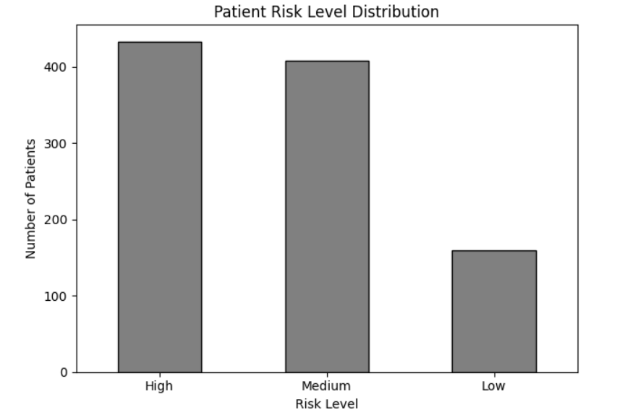

Interpretation:
The bar chart compares the number of patients in each risk category. The category with the tallest bar contains the largest number of patients. These results can help hospital staff understand the overall risk distribution in the dataset.

6.2 Patient Count by Triage Level
Triage Level represents the priority assigned to patients based on the urgency of their medical condition. This visualization helps identify the number of patients in each triage category and supports understanding of patient workload and urgency.
Python Code:
df["Triage_Level"].value_counts().sort_index().plot(kind="bar", color="gray", edgecolor="black")
plt.title("Patient Count by Triage Level")
plt.xlabel("Triage Level")
plt.ylabel("Number of Patients")
plt.xticks(rotation=0)
plt.tight_layout()
plt.show()
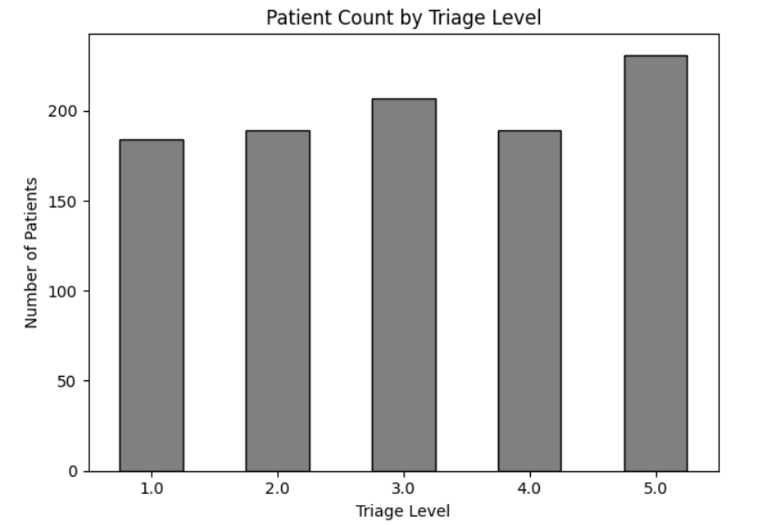
Interpretation of the Bar Graphs
The bar chart displays the number of patients in each triage level. The tallest bar represents the triage category with the highest patient count. This information can help hospital staff understand patient urgency and plan resources accordingly.

6.3 Patient Recovery Distribution
Patient Recovery Distribution normally represents the number of patients who recovered, did not recover, or have another recorded outcome. However, the current dataset does not appear to contain a patient recovery or outcome column. Therefore, recovery distribution cannot be calculated directly.
As an alternative, the following code visualizes the distribution of Decision Support Recommendations recorded in the dataset.
Python Code:
df["Decision_Support"].value_counts().plot(kind="bar", color="gray", edgecolor="black")
plt.title("Distribution of Decision Support Recommendations")
plt.xlabel("Decision Support Recommendation")
plt.ylabel("Number of Patients")
plt.xticks(rotation=45, ha="right")
plt.tight_layout()
plt.show()
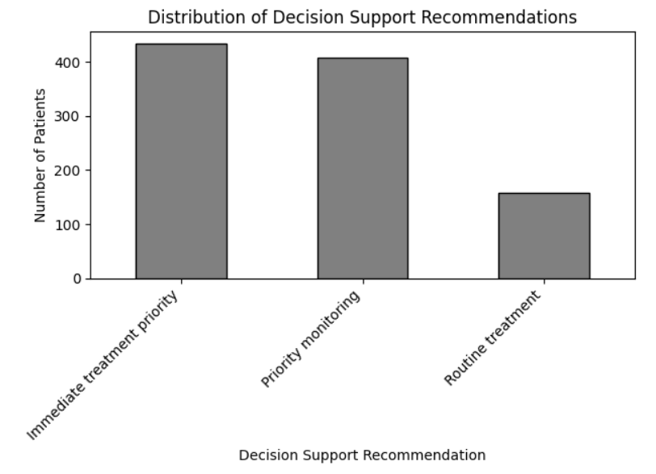Interpretation:
The chart compares the frequency of the decision-support recommendations recorded for patients. It helps identify the most common recommendations in the dataset. These recommendations should be interpreted as analytical support rather than as a replacement for decisions made by qualified medical professionals.

6.4 Recovery Rate by Age Group
Recovery rate by age group requires both patient age and recovery outcome information. Since a recovery outcome column is not available in the current dataset, the following alternative compares patient risk levels across different age groups.
Python Code:
df["Age_Group"] = pd.cut(
df["Age"],
bins=[0, 18, 35, 50, 65, 100],
labels=["0-18", "19-35", "36-50", "51-65", "66-100"],
include_lowest=True
)
pd.crosstab(df["Age_Group"], df["Risk_Level"]).plot(
kind="bar",
edgecolor="black"
)
plt.title("Patient Risk Level by Age Group")
plt.xlabel("Age Group")
plt.ylabel("Number of Patients")
plt.xticks(rotation=0)
plt.tight_layout()
plt.show()
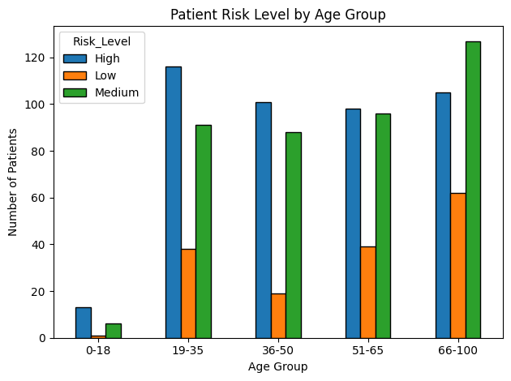

Interpretation of the Box Plot
The chart compares the distribution of patient risk levels across age groups. It helps identify which age groups contain more patients classified as low, medium, or high risk. These patterns describe the dataset and do not, by themselves, establish that age causes a particular risk level.

6.5 Medical History and Recovery Analysis
Medical history and recovery analysis requires a recovery outcome column. As an alternative, the following code examines the relationship between previous medical history and patient risk level.
Python Code:
pd.crosstab(df["Prevoius_History"], df["Risk_Level"]).plot(
kind="bar",
edgecolor="black"
)
plt.title("Previous Medical History and Patient Risk Level")
plt.xlabel("Previous Medical History")
plt.ylabel("Number of Patients")
plt.xticks(rotation=0)
plt.tight_layout()
plt.show()
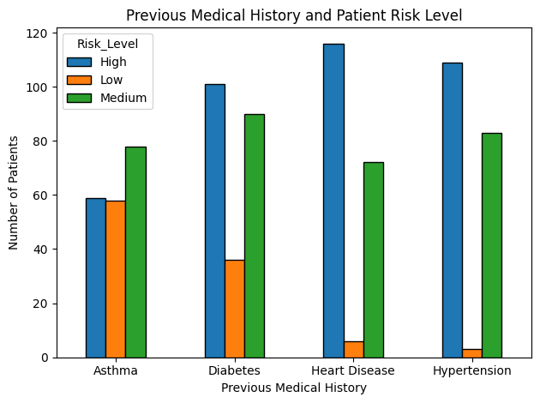

Interpretation
The chart compares risk categories among patients with different recorded medical-history values. It can help identify patterns that may require further investigation. The results show associations in the available data and should not be treated as proof that medical history directly causes a specific risk level.

6.6 Treatment Cost Analysis Using Box Plots
A box plot is used to identify the distribution, median, spread, and possible outliers in numerical data. Since the current dataset does not appear to contain a treatment-cost column, Total_Delay is used as an alternative to examine patient delays.
Python Code:
df["Total_Delay"] = pd.to_numeric(df["Total_Delay"], errors="coerce")
df[["Total_Delay"]].plot(
kind="box",
vert=True,
color="black"
)
plt.title("Box Plot of Total Patient Delay")
plt.ylabel("Total Delay")
plt.tight_layout()
plt.show()
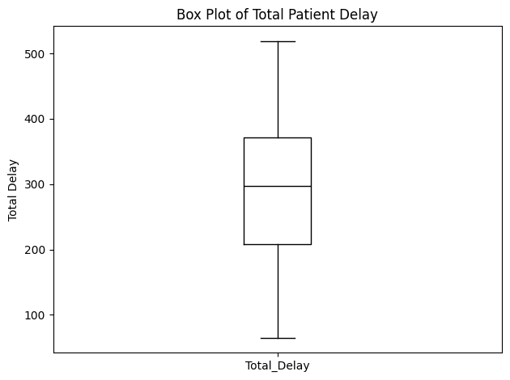
Interpretation:
The box plot displays the distribution of total patient delay. The central line represents the median, while the box represents the middle 50% of the observations. Points outside the whiskers may indicate unusually high or low delay values. These values should be checked before drawing conclusions.

6.7 Interpretation of Visualizations
The visualizations provide an overview of patient risk levels, triage categories, decision-support recommendations, age groups, medical history, and total patient delay.
- The risk-level chart shows the number of patients in each risk category.
- The triage chart compares patient counts across triage levels.
- The decision-support chart displays the frequency of recorded recommendations.
- The age-group chart compares risk levels across different age groups.
- The medical-history chart compares risk levels for recorded medical-history categories.
- The box plot shows the spread of total patient delay and may identify unusual values.
These visualizations help summarize the available data and support further investigation. They do not independently prove medical causes or patient recovery outcomes.

6.8 Visualization-Based Findings
The following findings can be reported after examining the generated graphs:
- The distribution of low-, medium-, and high-risk patients can be identified from the risk-level chart.
- The triage chart shows which triage categories contain more patients.
- The decision-support chart identifies the most frequently recorded recommendations.
- The age-group chart helps compare risk patterns across age groups.
- The medical-history chart helps examine possible associations between recorded history and patient risk.
- The delay box plot shows the spread of patient delays and possible outliers.

Chapter 7: Analysis of Results and Discussion

7.1 Analysis Approach
The project uses Python libraries such as Pandas, NumPy, Matplotlib, and Scikit-learn to analyze hospital patient data. The analysis includes loading the dataset, checking missing values and duplicate records, examining important variables, visualizing patient risk categories, and evaluating a machine-learning classification model.
The analysis focuses on identifying patterns in the available data and presenting information that may support hospital decision-making.

7.2 Patient Risk Distribution Analysis
Patient risk distribution is analyzed using the Risk_Level column. The patients are grouped into the recorded risk categories: Low, Medium, and High.
Python Code:
print("Patient Risk Distribution:")
print(df["Risk_Level"].value_counts())
print("\nPatient Risk Percentages:")
print((df["Risk_Level"].value_counts(normalize=True) * 100).round(2))
Discussion:
The output shows the number and percentage of patients in each risk category. A category with a larger percentage represents a greater share of the patients in the dataset. Hospital staff may use this information to understand the overall distribution of recorded risk levels.

7.3 Analysis of Patient Age and Recovery Rates
The current dataset does not appear to contain a recovery outcome. Therefore, actual recovery rates cannot be calculated. Instead, patient age is analyzed against recorded risk levels.
Python Code:
print(df.groupby("Risk_Level", observed=True)["Age"].describe())
df.boxplot(column="Age", by="Risk_Level")
plt.title("Patient Age by Risk Level")
plt.suptitle("")
plt.xlabel("Risk Level")
plt.ylabel("Age")
plt.tight_layout()
plt.show()
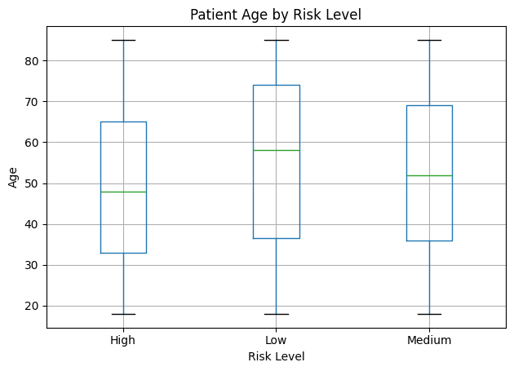

Discussion:
The statistical output summarizes patient ages within each risk category. The box plot compares the age distributions of low-, medium-, and high-risk patients. The results can reveal patterns in this dataset but cannot establish recovery rates or prove that age causes a particular risk level.

7.4 Impact of Medical History on Recovery
Recovery impact cannot be measured without a recovery outcome variable. However, the relationship between recorded medical history and risk level can be examined.
Python Code:
print(pd.crosstab(df["Prevoius_History"], df["Risk_Level"]))
print(
pd.crosstab(
df["Prevoius_History"],
df["Risk_Level"],
normalize="index"
).round(2)
)
Discussion:
The first table displays patient counts, while the second displays the proportion of risk categories within each medical-history category. These results help identify patterns for further investigation. They do not establish a causal relationship between medical history and risk.

7.5 Analysis of Hospital Stay and Diagnosis
The available dataset does not appear to contain explicit Hospital_Stay or Diagnosis columns. Therefore, the following analysis uses Total_Delay to examine patient delay across risk categories.
Python Code:
df["Total_Delay"] = pd.to_numeric(df["Total_Delay"], errors="coerce")
print(df.groupby("Risk_Level", observed=True)["Total_Delay"].describe())
df.boxplot(column="Total_Delay", by="Risk_Level")
plt.title("Total Patient Delay by Risk Level")
plt.suptitle("")
plt.xlabel("Risk Level")
plt.ylabel("Total Delay")
plt.tight_layout()
plt.show()

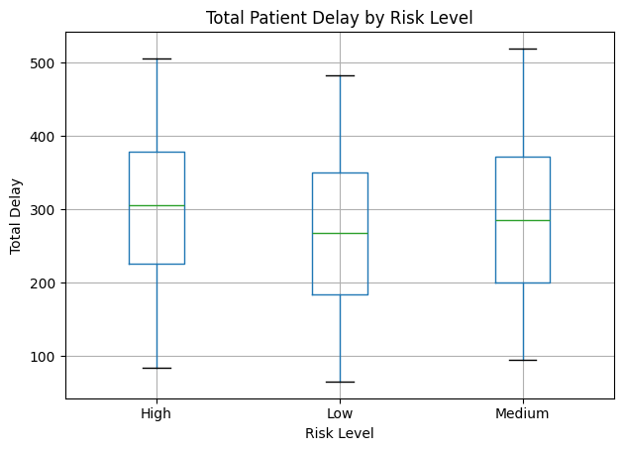
Discussion:
The output compares the distribution of recorded delays across risk categories. Differences may indicate patterns that deserve further investigation. Total delay should not be described as hospital length of stay unless the dataset definition confirms that it measures the full duration of a patient's hospital stay.

7.6 Logistic Regression Model Performance
Logistic Regression is a supervised machine-learning algorithm used for classification. In this project, it can be used to predict the recorded Risk_Level from selected patient attributes.
Important: If Risk_Level was originally calculated from Triage_Level, Risk_Score, or Total_Delay, using those variables as predictors may cause data leakage or circular prediction. The model's results must therefore be interpreted cautiously. The code below is an exploratory example, not proof of clinical prediction accuracy.
Python Code:
from sklearn.model_selection import train_test_split
from sklearn.compose import ColumnTransformer
from sklearn.pipeline import Pipeline
from sklearn.preprocessing import OneHotEncoder, StandardScaler
from sklearn.impute import SimpleImputer
from sklearn.linear_model import LogisticRegression
from sklearn.metrics import accuracy_score, classification_report
numeric_features = ["Age"]
categorical_features = ["Gender", "Symptoms", "Prevoius_History"]
features = numeric_features + categorical_features
X = df[features].copy()
y = df["Risk_Level"]

numeric_transformer = Pipeline([
("imputer", SimpleImputer(strategy="median")),
("scaler", StandardScaler())
])
categorical_transformer = Pipeline([
("imputer", SimpleImputer(strategy="most_frequent")),
("encoder", OneHotEncoder(handle_unknown="ignore"))
])
preprocessor = ColumnTransformer([
("num", numeric_transformer, numeric_features),
("cat", categorical_transformer, categorical_features)
])
model = Pipeline([
("preprocessor", preprocessor),
("classifier", LogisticRegression(max_iter=2000))
])
X_train, X_test, y_train, y_test = train_test_split(
X, y,
test_size=0.2,
random_state=42,
stratify=y
)
model.fit(X_train, y_train)
y_pred = model.predict(X_test)
print("Accuracy:", round(accuracy_score(y_test, y_pred), 4))
print(classification_report(y_test, y_pred, zero_division=0))
Discussion:
The model is trained using the training data and evaluated on the test data. Accuracy measures the proportion of correctly classified test records. The classification report provides precision, recall, and F1-score for each risk category. These metrics describe performance on the selected test set and do not establish that the model is suitable for real clinical use.

7.7 Interpretation of Accuracy, Precision, Recall and F1-Score
- Accuracy: The proportion of all test records classified correctly.
- Precision: Among records predicted as a particular risk category, the proportion that truly belongs to that category.
- Recall: Among records that truly belong to a category, the proportion correctly identified by the model.
- F1-score: The harmonic mean of precision and recall.
A model should not be judged by accuracy alone, particularly when the classes are imbalanced. Recall for the High Risk category may be important to examine, but any model used for medical decisions requires appropriate clinical validation.

7.8 Key Findings and Observations
The project supports the following observations, subject to confirmation from the actual output:
- Patient risk categories can be summarized using counts and percentages.
- Triage levels provide information about the distribution of patient urgency.
- Age and medical-history categories can be compared with recorded risk levels.
- Total patient delay can be examined for variation and possible outliers.
- Logistic Regression can be used as an exploratory classifier for the recorded risk category.
- The quality of the findings depends on data accuracy, completeness, and the definitions of the dataset columns.

7.9 Decision-Support Recommendations
Based on the analysis approach, the following recommendations may help hospital staff:
- Monitor the distribution of recorded patient risk levels.
- Review triage categories to understand patient urgency.
- Investigate unusually high patient-delay values.
- Check missing, inconsistent, or duplicate records before analysis.
- Review risk patterns by age and medical-history categories.
- Evaluate classification models using multiple metrics, not accuracy alone.
- Keep final clinical decisions with qualified healthcare professionals.

7.10 Limitations of the Analysis
The project has the following limitations:
- The analysis is limited to the variables available in the dataset.
- Recovery rates cannot be calculated without a recovery outcome column.
- Treatment cost cannot be analyzed without a treatment-cost column.
- Diagnosis and hospital length of stay cannot be analyzed directly if their respective columns are absent.
- Relationships found in the dataset do not prove causation.
- Machine-learning results depend on the quality and representativeness of the data.
- A model that predicts a risk label derived from its input features may produce misleadingly strong results.
- The system is intended for academic analysis and should not replace professional medical judgment.

Chapter 8: Output Screenshots

8.1 Dataset Screenshots
The dataset is uploaded and loaded using Pandas. The dataset shape and first five records are displayed to verify successful loading.
Python Code:
print("Dataset Shape:", df.shape)
print(df.head())
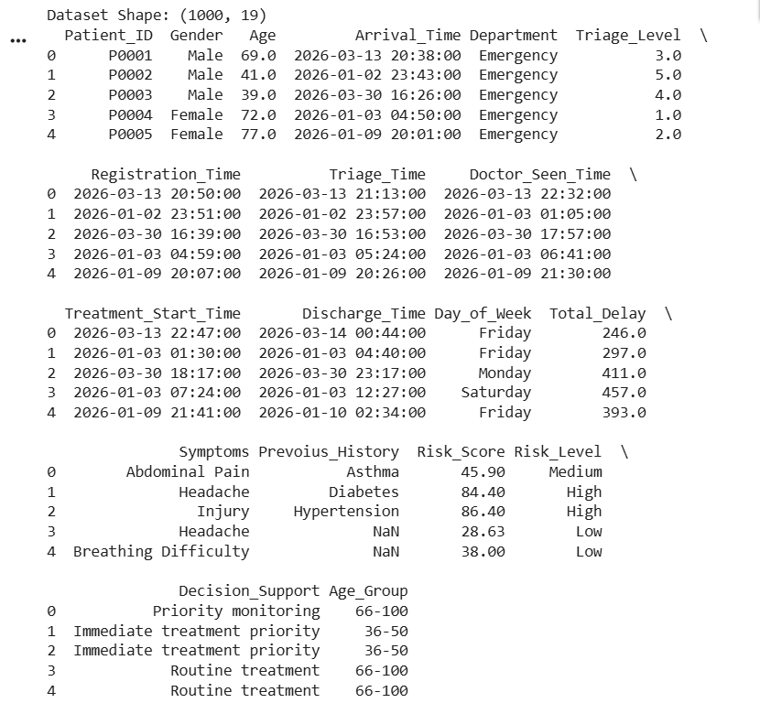

8.2 Dataset Before and After Cleaning
This section compares the dataset before and after preprocessing. If you saved both versions as separate CSV files, upload them to compare their shapes.
Python Code:
from google.colab import files
import pandas as pd
uploaded = files.upload()
Output:
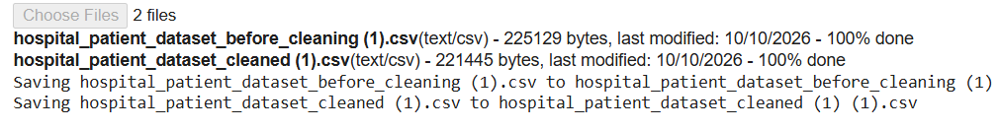
Python Code:
import io
before_file = next(
name for name in uploaded
if "before" in name.lower()
)
after_file = next(
name for name in uploaded
if "cleaned" in name.lower()
)
before_df = pd.read_csv(io.BytesIO(uploaded[before_file]))
after_df = pd.read_csv(io.BytesIO(uploaded[after_file]))
print("Before Cleaning:", before_df.shape)
print("After Cleaning:", after_df.shape)
Output:
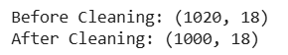

8.3 Missing Values and Duplicate Removal Output
This section displays the number of missing values and duplicate rows in the current dataset.
Python Code:
print("Missing Values Before Cleaning:")
print(df.isnull().sum())
print("\nDuplicate Rows:")
print(df.duplicated().sum())
Output:
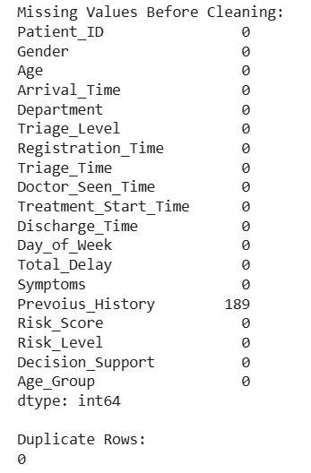

8.4 Cleaned Dataset Output
The cleaned dataset is checked to confirm its structure and data quality.
Python Code:
print("Cleaned Dataset Shape:", df.shape)
print(df.head())
print("\nTotal Missing Values:", df.isnull().sum().sum())
print("Total Duplicate Rows:", df.duplicated().sum())

Output :
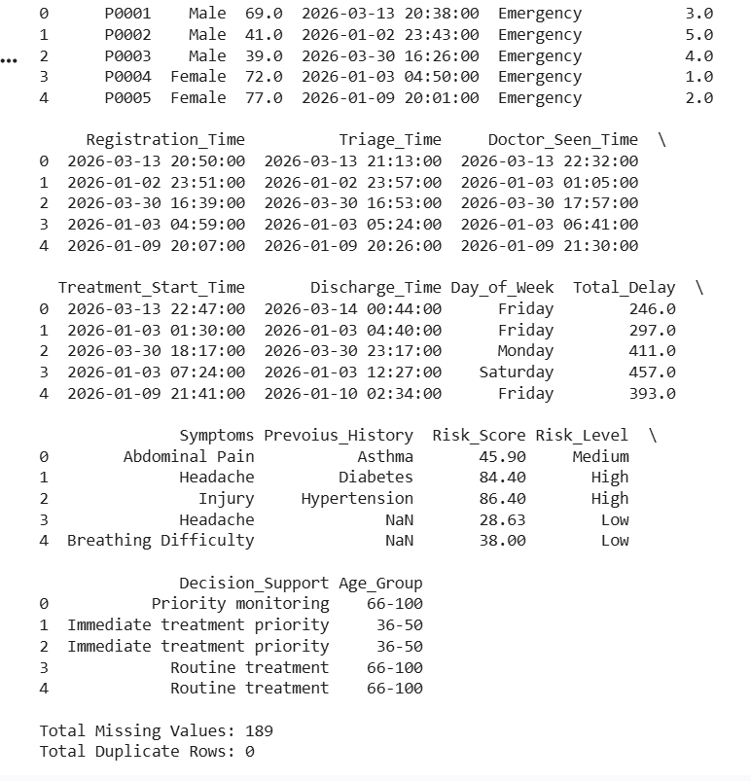

8.5 Exploratory Data Analysis Outputs
Exploratory Data Analysis (EDA) helps understand the structure and characteristics of the dataset.
Python Code:
print(df.info())
print(df.describe(include="all"))
print(df["Risk_Level"].value_counts())

Output:
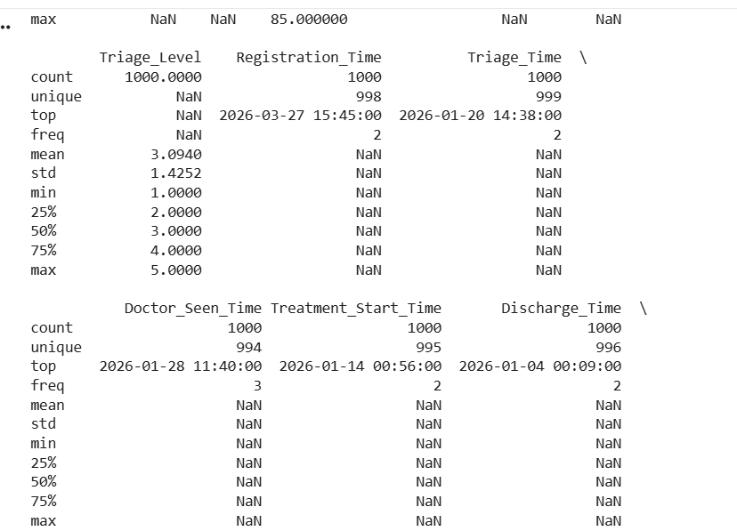
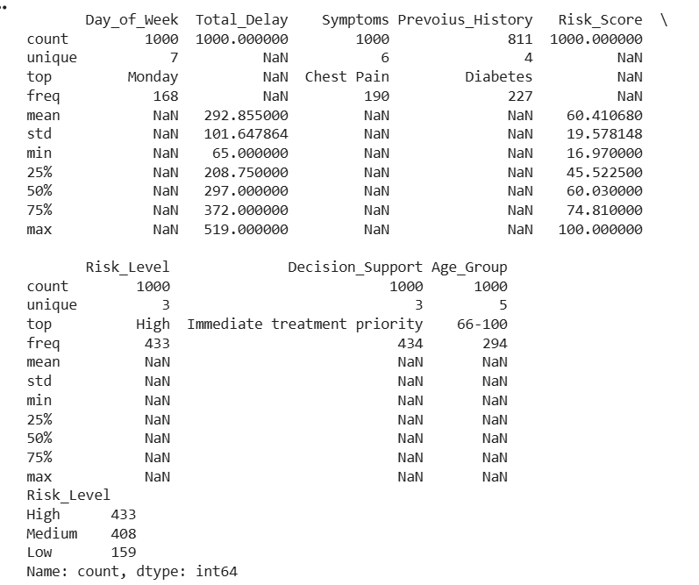

8.6 Patient Risk Analysis Graphs
The risk-level and triage-level graphs show how patients are distributed across categories.
Python Code:
df["Risk_Level"].value_counts().plot(
kind="bar",
color="gray",
edgecolor="black"
)
plt.title("Patient Risk Level Distribution")
plt.xlabel("Risk Level")
plt.ylabel("Number of Patients")
plt.xticks(rotation=0)
plt.tight_layout()
plt.show()
df["Triage_Level"].value_counts().sort_index().plot(
kind="bar",
color="gray",
edgecolor="black"
)
plt.title("Patient Count by Triage Level")
plt.xlabel("Triage Level")
plt.ylabel("Number of Patients")
plt.xticks(rotation=0)
plt.tight_layout()
plt.show()

Output:
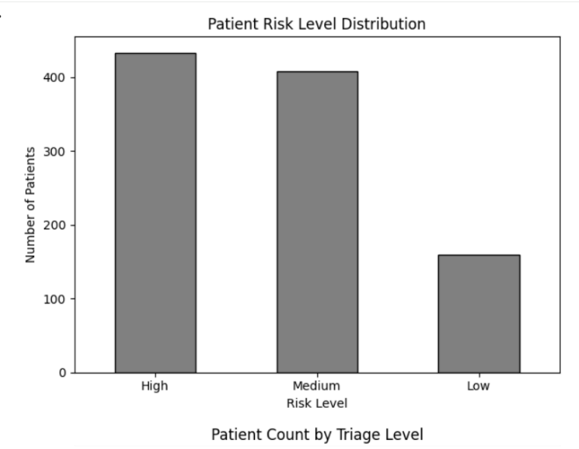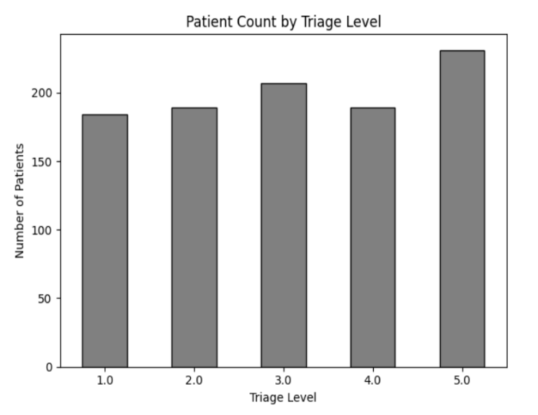

8.7 Patient Recovery Visualization Outputs
The dataset does not appear to contain a recovery outcome column. Therefore, use the decision-support visualization instead of presenting it as a recovery graph.
The dataset does not appear to contain a recovery outcome column. Therefore, use the decision-support visualization instead of presenting it as a recovery graph.
Python Code:
df["Decision_Support"].value_counts().plot(
kind="bar",
color="gray",
edgecolor="black"
)
plt.title("Distribution of Decision Support Recommendations")
plt.xlabel("Decision Support Recommendation")
plt.ylabel("Number of Patients")
plt.xticks(rotation=45, ha="right")
plt.tight_layout()
plt.show()
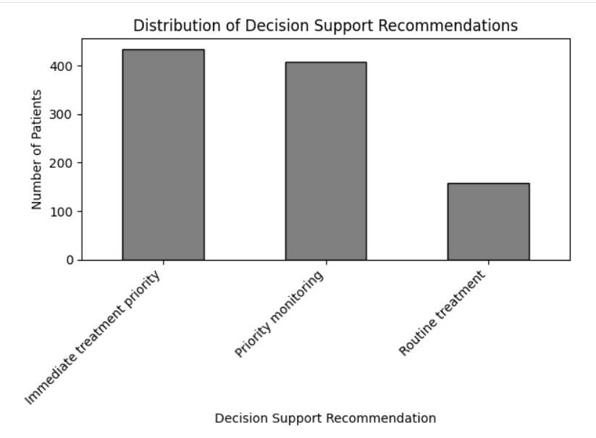

8.8 Model Evaluation Results
A confusion matrix compares the actual risk categories with the categories predicted by the model.
Python Code:
from sklearn.metrics import ConfusionMatrixDisplay
ConfusionMatrixDisplay.from_predictions(
y_test,
y_pred,
xticks_rotation=45,
cmap="Greys"
)
plt.title("Confusion Matrix for Patient Risk Classification")
plt.tight_layout()
plt.show()
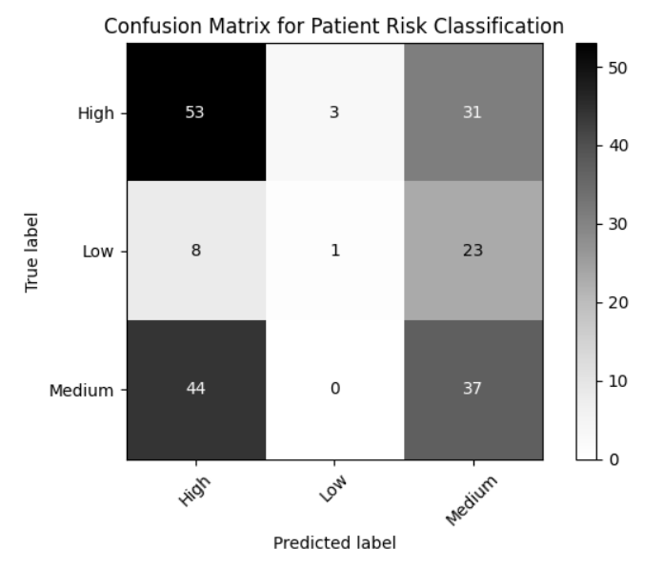

Chapter 9: Conclusion and Future Enhancements

9.1 Conclusion
The Hospital Patient Data Analysis and Decision Support System demonstrates how Python-based data analysis can be applied to hospital patient records. The project uses Pandas for data handling and preprocessing, Matplotlib for visualization, and Scikit-learn for exploratory machine-learning classification.
The system helps analyze patient risk levels, triage categories, age groups, medical history, and patient delays. The visualizations make it easier to understand patterns in the dataset. Logistic Regression demonstrates how machine-learning techniques can classify recorded risk categories.
The project provides an academic foundation for hospital data analysis. However, its results depend on the quality of the available data, and it is not a replacement for professional medical decisions.

9.2 Project Achivements
- Loaded and examined hospital patient data using Python.
- Checked missing values and duplicate records.
- Performed exploratory data analysis.
- Visualized patient risk levels and triage categories.
- Examined risk patterns by age and medical history.
- Analyzed total patient delay using a box plot.
- Implemented Logistic Regression for risk-category classification.
- Evaluated model performance using classification metrics.

9.3 Limitations of the System
- Its performance depends on the quality and completeness of the dataset.
- Actual patient recovery analysis requires recovery outcome data.
- Treatment cost analysis requires treatment-cost information.
- The system may not represent all hospitals or patient populations.
- Machine-learning predictions require further validation before practical medical use.
- The system does not replace doctors or other healthcare professionals.

9.4 Future Enhancements
- Include recovery outcomes and treatment-cost information when available.
- Add diagnosis and hospital admission/discharge details.
- Develop an interactive dashboard for hospital staff.
- Compare multiple machine-learning algorithms.
- Improve data validation and missing-value handling.
- Use larger, representative datasets for model evaluation.
- Conduct clinical validation before considering real-world use.
- Add secure access controls if patient information is handled in a deployed application.

9.5 Learning Outcomes
Through this project, the team gained practical experience in Python programming, data preprocessing, exploratory data analysis, data visualization, and machine learning. The project also helped develop skills in interpreting analytical results, identifying data limitations, and presenting findings in a structured manner.

9.6 Summary of Objectives and Outcomes
Table 9.1: Summary of Objectives and Outcomes
Objective | Outcome
Load hospital patient data | Dataset loaded using Pandas
Examine data quality | Missing values and duplicates checked
Analyze patient records | Descriptive statistics generated
Visualize patient information | Bar charts and box plots created
Study risk patterns | Risk categories compared with available features
Apply machine learning | Logistic Regression implemented
Evaluate the model | Classification report and confusion matrix generated

9.7 Final Remarks
The Hospital Patient Data Analysis and Decision Support System demonstrates the usefulness of data analytics in understanding hospital patient records. By combining preprocessing, visualization, and machine learning, the project provides a foundation for further development of data-driven healthcare support tools.

Chapter 10. References
10.1 Python Documentation
Python Software Foundation. Python Documentation.
https://docs.python.org/3/

10.2 Pandas and NumPy Documentation
- Pandas Documentation: https://pandas.pydata.org/docs/
- NumPy Documentation: https://numpy.org/doc/

10.3 Matplotlib and Seaborn Documentation
- Matplotlib Documentation: https://matplotlib.org/stable/
- Seaborn Documentation: https://seaborn.pydata.org/

10.4 Scikit-learn Documentation
Scikit-learn. Machine Learning in Python.
https://scikit-learn.org/stable/

10.5 Dataset Reference
Dataset name: Hospital Patient Dataset
File used: hospital_patient_dataset_cleaned (1).csv
Source: Add the original dataset creator, website, or institution here. If the dataset was provided by your college or created by your team, state that accurately.

Chapter 11. Appendix – Source Code
The following appendix contains the main Python code used in the project. Since the code in Section 6.1 already loads the CSV file, the later sections can reuse the existing df variable in the same Google Colab session.
11.1 Python Libraries and dataset Loading Code
import pandas as pd
import numpy as np
import matplotlib.pyplot as plt
from google.colab import files
uploaded = files.upload()
filename = next(iter(uploaded))
df = pd.read_csv(filename)
print("Dataset Shape:", df.shape)
print(df.head())
print(df.info())
11.2 Data Preprocessing code
df = df.copy()
print("Missing Values Before Cleaning:")
print(df.isnull().sum())
print("Duplicate Rows Before Cleaning:", df.duplicated().sum())
df = df.drop_duplicates()
for col in df.columns:
if df[col].isnull().any():
if pd.api.types.is_numeric_dtype(df[col]):
df[col] = df[col].fillna(df[col].median())
else:
mode_values = df[col].mode()
if not mode_values.empty:
df[col] = df[col].fillna(mode_values[0])
print("Missing Values After Cleaning:", df.isnull().sum().sum())
print("Duplicate Rows After Cleaning:", df.duplicated().sum())
print("Cleaned Dataset Shape:", df.shape)
df.to_csv("hospital_patient_dataset_cleaned.csv", index=False)
files.download("hospital_patient_dataset_cleaned.csv")
11.3 Exploratory Data Analysis Code
print("Dataset Information:")
print(df.info())
print("\nDescriptive Statistics:")
print(df.describe(include="all"))
print("\nMissing Values:")
print(df.isnull().sum())
print("\nDuplicate Rows:")
print(df.duplicated().sum())
print("\nRisk Level Distribution:")
print(df["Risk_Level"].value_counts())
11.4 Data Visualization Code
df["Risk_Level"].value_counts().plot(
kind="bar",
color="gray",
edgecolor="black"
)
plt.title("Patient Risk Level Distribution")
plt.xlabel("Risk Level")
plt.ylabel("Number of Patients")
plt.xticks(rotation=0)
plt.tight_layout()
plt.show()
df["Triage_Level"].value_counts().sort_index().plot(
kind="bar",
color="gray",
edgecolor="black"
)
plt.title("Patient Count by Triage Level")
plt.xlabel("Triage Level")
plt.ylabel("Number of Patients")
plt.xticks(rotation=0)
plt.tight_layout()
plt.show()
df["Age_Group"] = pd.cut(
df["Age"],
bins=[0, 18, 35, 50, 65, 100],
labels=["0-18", "19-35", "36-50", "51-65", "66-100"],
include_lowest=True
)
pd.crosstab(df["Age_Group"], df["Risk_Level"]).plot(
kind="bar",
edgecolor="black"
)
plt.title("Patient Risk Level by Age Group")
plt.xlabel("Age Group")
plt.ylabel("Number of Patients")
plt.xticks(rotation=0)
plt.tight_layout()
plt.show()
pd.crosstab(df["Prevoius_History"], df["Risk_Level"]).plot(
kind="bar",
edgecolor="black"
)
plt.title("Medical History and Patient Risk Level")
plt.xlabel("Previous Medical History")
plt.ylabel("Number of Patients")
plt.xticks(rotation=0)
plt.tight_layout()
plt.show()
df["Total_Delay"] = pd.to_numeric(
df["Total_Delay"],
errors="coerce"
)
df[["Total_Delay"]].plot(kind="box")
plt.title("Box Plot of Total Patient Delay")
plt.ylabel("Total Delay")
plt.tight_layout()
plt.show()
11.5 Logistic Regression Implementation Code
from sklearn.model_selection import train_test_split
from sklearn.compose import ColumnTransformer
from sklearn.pipeline import Pipeline
from sklearn.preprocessing import OneHotEncoder, StandardScaler
from sklearn.impute import SimpleImputer
from sklearn.linear_model import LogisticRegression
numeric_features = ["Age"]
categorical_features = ["Gender", "Symptoms", "Prevoius_History"]
features = numeric_features + categorical_features
X = df[features].copy()
y = df["Risk_Level"]
numeric_transformer = Pipeline([
("imputer", SimpleImputer(strategy="median")),
("scaler", StandardScaler())
])
categorical_transformer = Pipeline([
("imputer", SimpleImputer(strategy="most_frequent")),
("encoder", OneHotEncoder(handle_unknown="ignore"))
])
preprocessor = ColumnTransformer([
("num", numeric_transformer, numeric_features),
("cat", categorical_transformer, categorical_features)
])
model = Pipeline([
("preprocessor", preprocessor),
("classifier", LogisticRegression(max_iter=2000))
])
X_train, X_test, y_train, y_test = train_test_split(
X,
y,
test_size=0.2,
random_state=42,
stratify=y
)
model.fit(X_train, y_train)
y_pred = model.predict(X_test)
print("Model Training Completed")
print("Predictions:", y_pred[:10])
11.6 Model Evaluation Code
from sklearn.metrics import (
accuracy_score,
classification_report,
confusion_matrix,
ConfusionMatrixDisplay
)
print("Accuracy:", round(accuracy_score(y_test, y_pred), 4))
print("\nClassification Report:")
print(classification_report(y_test, y_pred, zero_division=0))
print("\nConfusion Matrix:")
print(confusion_matrix(y_test, y_pred))
ConfusionMatrixDisplay.from_predictions(
y_test,
y_pred,
xticks_rotation=45,
cmap="Greys"
)
plt.title("Confusion Matrix for Patient Risk Classification")
plt.tight_layout()
plt.show()

Appendix B – Glossary of Terms
Table B.1: Glossary of Terms
Term | Meaning
Dataset | A collection of hospital patient records organised in rows and columns.
CSV | Comma-Separated Values, a file format used to store tabular data.
DataFrame | A two-dimensional table structure provided by Pandas.
Series | A one-dimensional labelled data structure in Pandas.
Patient Record | A collection of information related to an individual patient.
Data Preprocessing | The process of preparing data for analysis by handling missing values, duplicates, and inconsistencies.
Missing Value | An empty or unavailable value in a dataset.
Duplicate | A record that appears more than once in a dataset.
Outlier | A value that differs significantly from most other values.
Aggregation | Combining multiple values into a summary, such as a sum, count, or mean.
GroupBy | A Pandas operation used to group data and calculate statistics for each group.
EDA | Exploratory Data Analysis, the process of examining data using statistics and visualizations.
Median | The middle value of a dataset when its values are arranged in order.
Mean | The average of a set of numerical values.
Triage | The process of prioritising patients according to the urgency of their medical conditions.
Risk Level | A category used in the dataset to represent a patient's recorded risk, such as Low, Medium, or High.
Risk Score | A numerical value used to represent the risk associated with a patient, according to the dataset's definition.
Decision Support | Information or recommendations intended to assist in decision-making.
Data Visualization | The presentation of data using charts, graphs, and other visual representations.
Bar Chart | A graph that uses rectangular bars to compare values across categories.
Box Plot | A graph that summarizes the distribution of numerical data and may help identify outliers.
Age Group | A category formed by dividing patient ages into specified ranges.
Correlation | A statistical relationship between two variables; it does not necessarily imply causation.
Machine Learning | A field of computing that uses data to develop models that identify patterns or make predictions.
Logistic Regression | A supervised machine-learning algorithm commonly used for classification tasks.
Classification | The process of assigning data records to predefined categories.
Training Data | The portion of a dataset used to train a machine-learning model.
Testing Data | The portion of a dataset used to evaluate a trained model.
Accuracy | The proportion of predictions that are correct out of all predictions evaluated.
Precision | The proportion of positive predictions for a class that are correct.
Recall | The proportion of actual records in a class that are correctly identified.
F1-Score | A measure that combines precision and recall using their harmonic mean.
Confusion Matrix | A table comparing actual classes with the classes predicted by a classification model.
Data Leakage | A problem in machine learning where information unavailable at prediction time improperly influences model training or evaluation.
Dashboard | A single view that presents important information through charts, graphs, and summaries.

