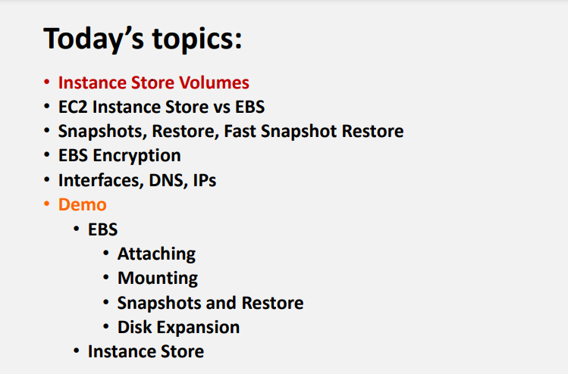

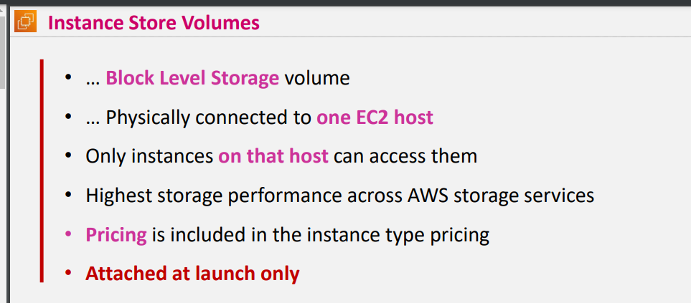

Only instances on which they have been hosted can access them … once instance got stopped when u create again host gets changed

Highest performance when compare to EBS ,EFX&FSX

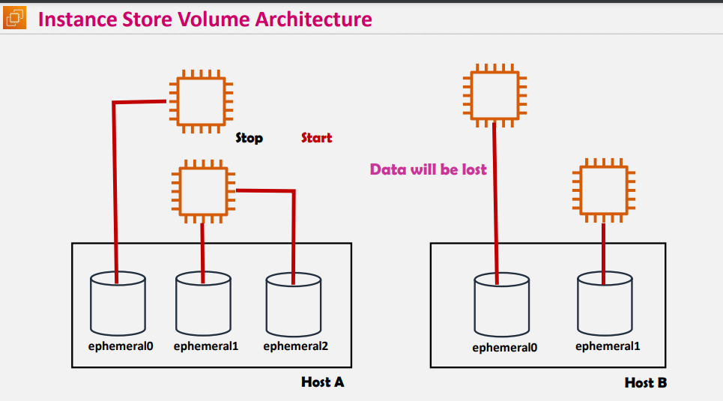

When u create instance store its gets attached to to some ephemeral volumes when you stop the instance connection between ephemeral volume and instance gets deleted and data in the volume also gets deleted

* When you recreate the instance again it gets attached to another ephemeral volumes but once you stop the instance the ephemerals volume gets detached to the instance
* Based on the instance types ephemeral volumes gets attached
* Nvme SSD disks are more faster than normal ssd
* Reasons for why instance store performance is higher when compare to EBS
* Instance store has direct attached disk where as EBS is network attached disk that’s the reason it has slow performance when compare to Instance store
* EBS supports only HDD &SSD where as instance store consists of Nvme ssd disks which is more faster than SSD That’s the reason Instance store performance is high when compare to EBS
* 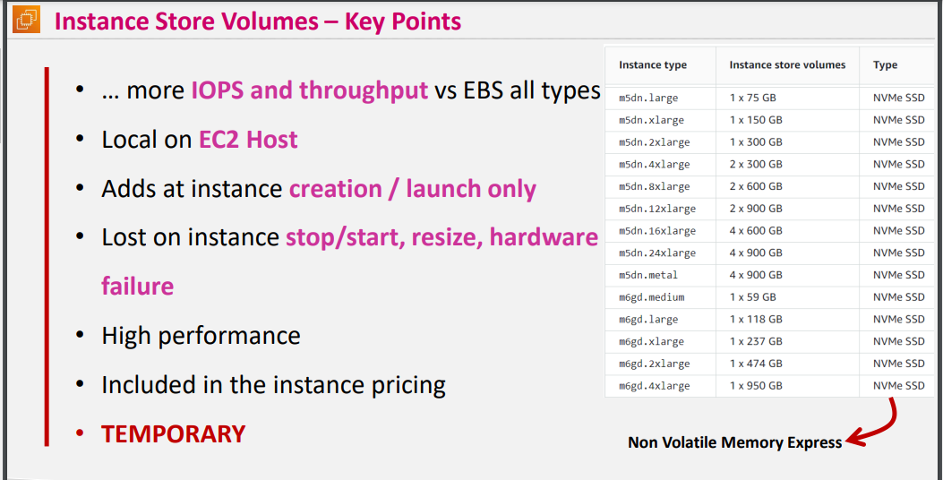

<https://docs.aws.amazon.com/AWSEC2/latest/UserGuide/InstanceStorage.html>

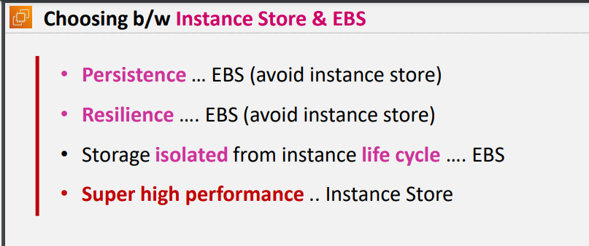

PERSISTENCE/permanent storage is EBS

* Resilience is high availability (EBS)
* Storage isolated(even when you stop the instance disk contains the same data without any data lost ) from instance life cycle …… EBS
* Super high performance (instance store)

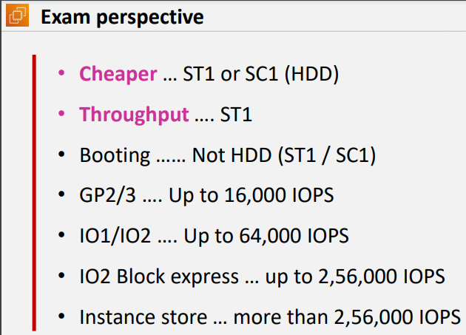

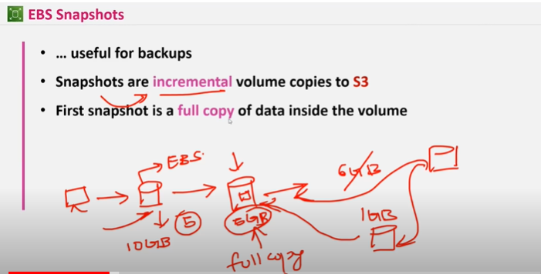

Snapshots are incremental for suppose EBS has 10 gb volume size and contains only 5gb data init so when you create 1st snapshot it will be the entire copy of 5gb data -> 2nd snapshot will be only the changes which has happened to 5gb of data i.e 1gb data and its interlinked with 1st snapshot and 2nd snapshot

* EBS volumes cant be attached to different region instances
* And snapshots of one region can t be attached to different region disks
* 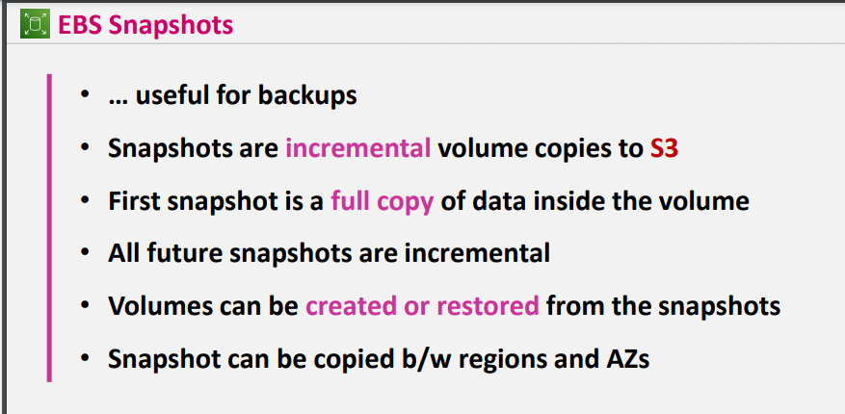

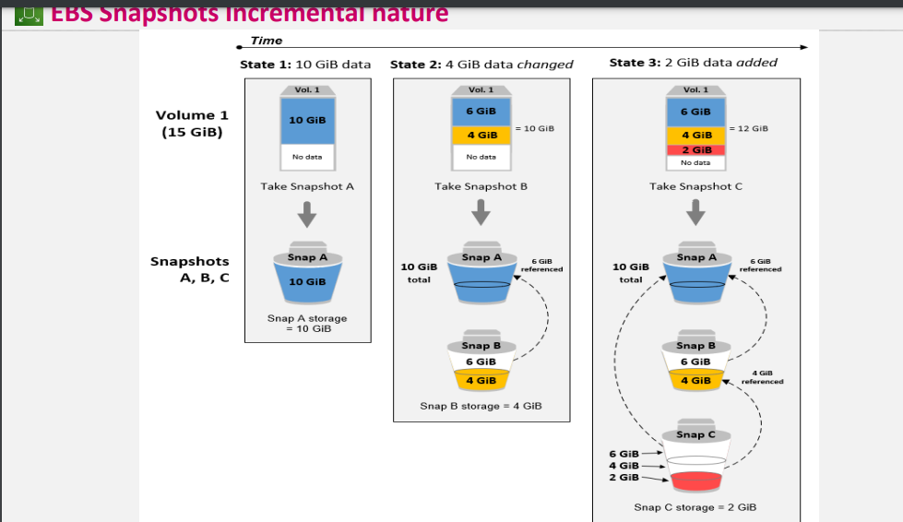

Snapshot pricing will be GB/month

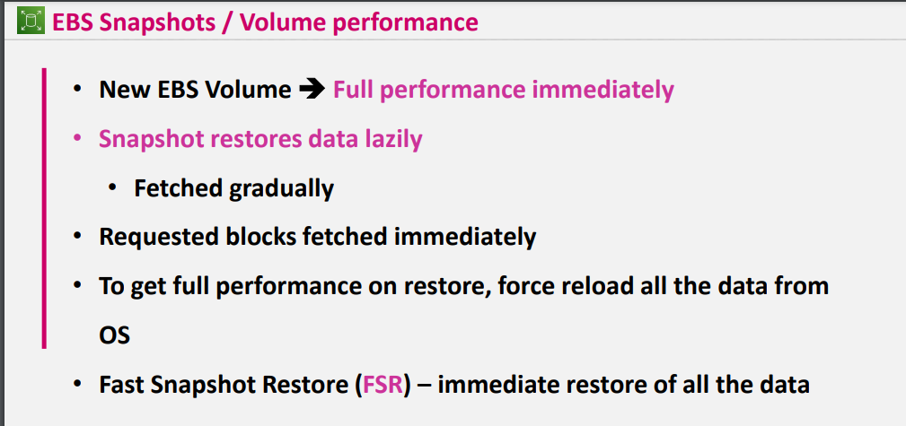

New feature has been added in aws as Fast snapshot restore which restores immediately

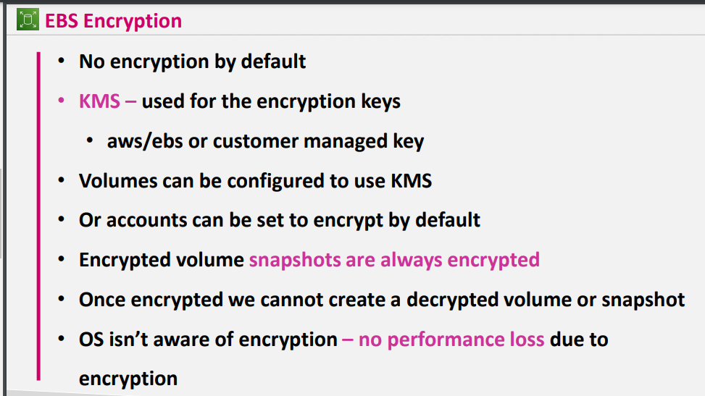

If you are creating snapshots from the encrypted volume those snapshots will also be encrypted automatically

Once encrypted you cant decrypt the volume or snapshot but you can able to read your data

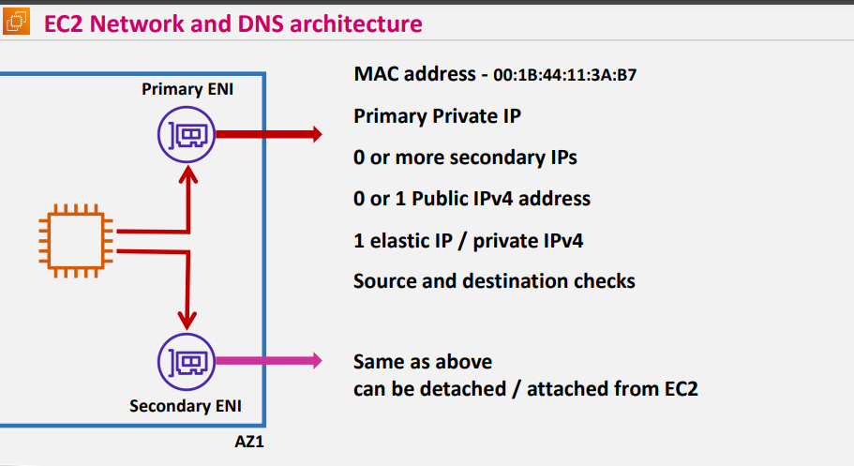

* Whenever you create EC2 Elastic network interface gets created and for that Eni PUBLIC IP, Security groups will gets attached by default will get primary ENI which we can’t remove
* But if you want to add explicitly u can add secondary ENI and you can remove that ENI
* FOR EXAM PERSPECTIVE : Source and destination checks should be configured at ENI for Nat instance
* 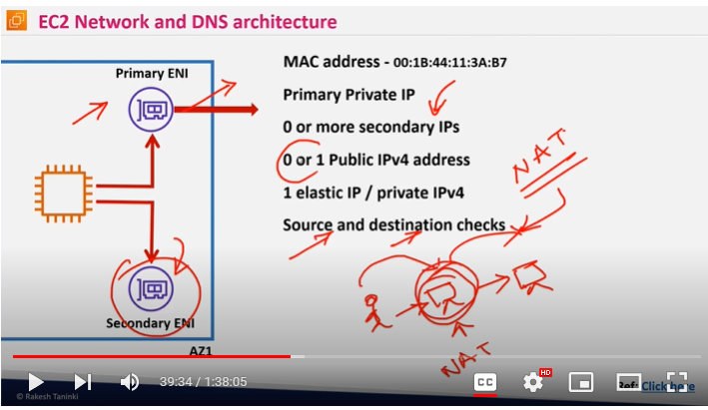

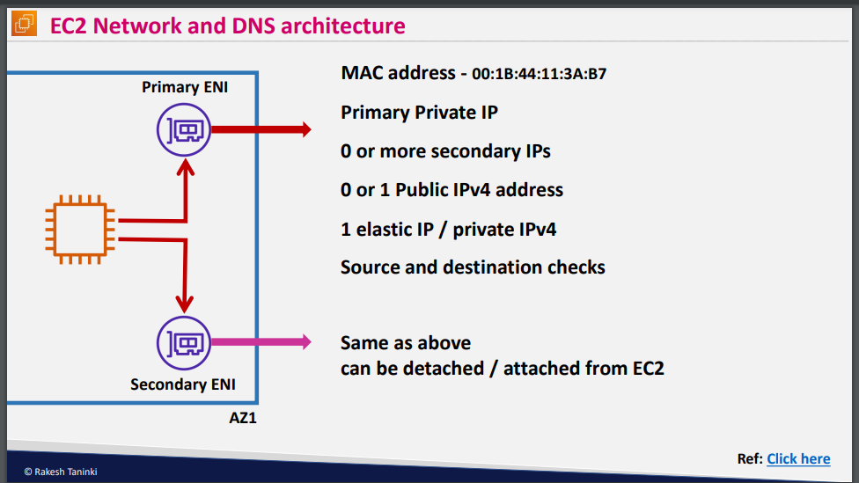

<https://docs.aws.amazon.com/AWSEC2/latest/UserGuide/using-eni.html#AvailableIpPerENI>

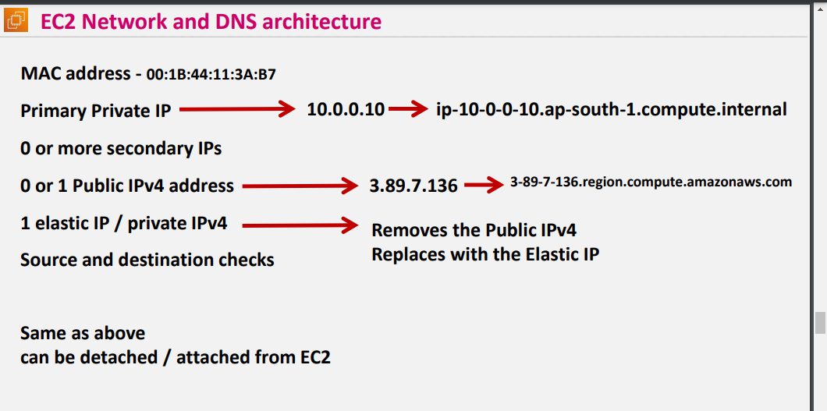

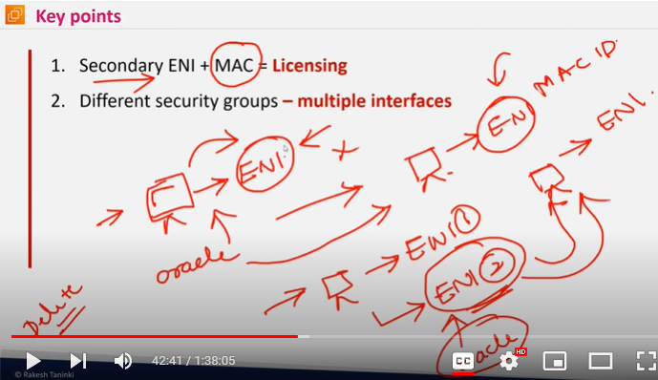

SECONDARY ENI used for licensing when you create server automatically eni gets created And when you install oracle on that particular primary eni and when you want to attch it to another server you cant attach it again you need to install oracle over that server

So by using secondary eni even you delete the server primary eni gets deleted but secondary eni wont get deleted you can attach it to different server

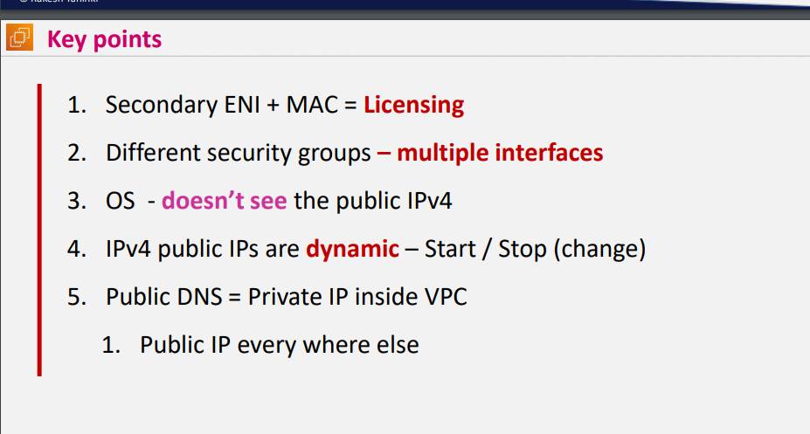

Agenda

* Create vpc ,rt,subnets,igw,EBS and attach it to server

Df -ht to see the partitions

Sudo lsblk or lsblk

* Lsblk – to list blocks
* df -hT
* Volumes wont get attached to os level directly you need to mount
* Sudo file -s /dev(device)/xvda(disk name)
* Sudo mkfs -t xfs /dev/xvdf to create file system in that disk
* And then check sudo file-s/dev/diskname

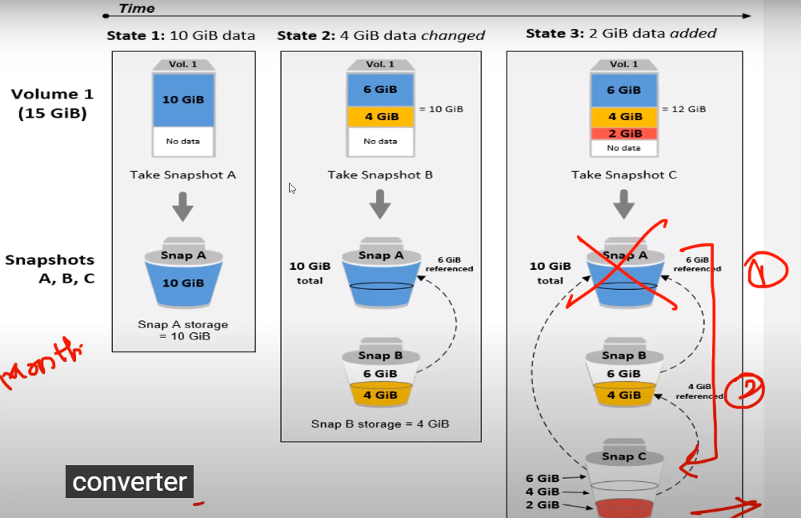

When you try to remove aws snapshot it removes from console but not from datacenter as that particular snapshot is linked with other snapshots

* And snapshot will be permanently removed from data center only when its not linked to any other snapshot

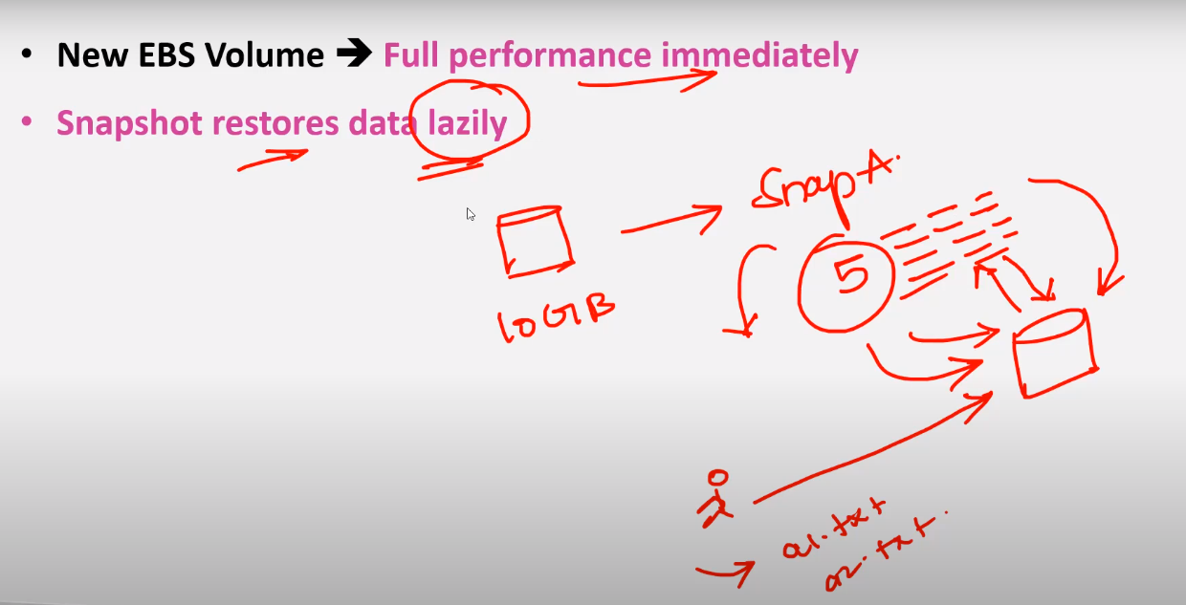

Snapshots restores lazily

When you are restoring the snapshots it wont copy to the disk immediately what ever files you are trying to pen those files will reflect to the disk immediately

* If you want to restore the whole data you need to open all the files from the disk