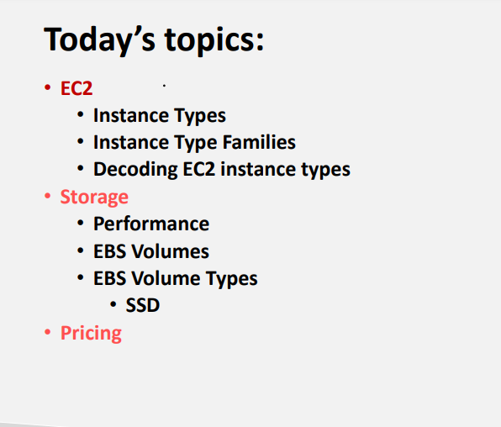

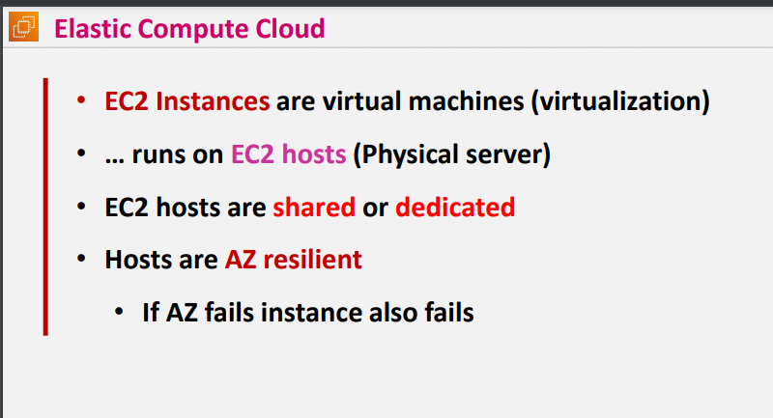

Servers are AZ resilent if one AZ fails ur server will be lost so for high availability create the same copy OF Server in different AZ.

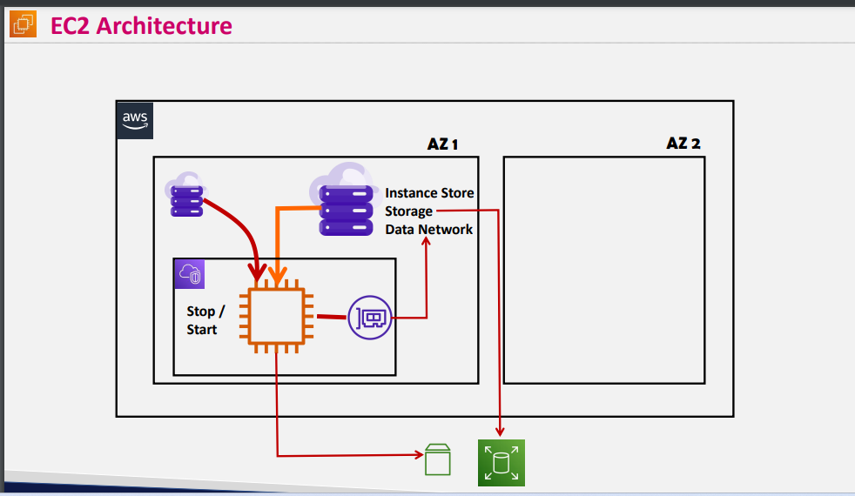

If u creating a EC2 server directly it wont create in your vpc

* Which ever host as space there it creates your server and by ENI (Network interface it will create a connection between vpc and the server
* Instance store is a direct attached storage to physical host
* There is a dependency for physical host and instance store
* EBS (elastic block store ) is a persistent storage
* If you stop the server instance store will get removed as its directly attached to VM but EBs wont get removed
* if u stop the server there wont be any charges for server
* if you stop the server even they for EBS they will charge
* Instance store is a temporary storage
* IF YOU STOP THE INSTANCE AND again u will be creating new server public ip get changed
* And if u r hosting a website in that particular server and dns mapping should be configured manually
* So if u want only 1 ip for that particular server need to go with Elastic ip ( its also public ip)

If u stop and start the server same ip will be there

* Where as in public ip if u stop and strt the instance public ip gets changed
* Elastic ip is a permanent ip
* If u keeping elastic ip then only its chargeable if u attach it to any server it wont be chargeable

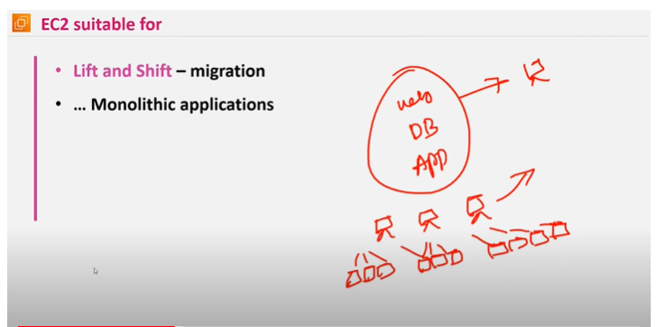

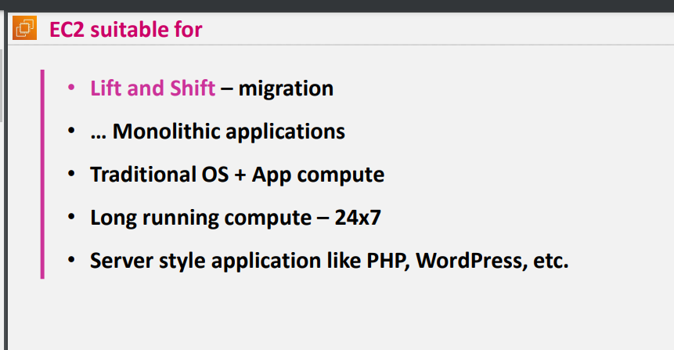

Lift and shift migration – from onpremise to cloud lift the same server from onpremise to cloud

* Monolithic applications all the components in one server

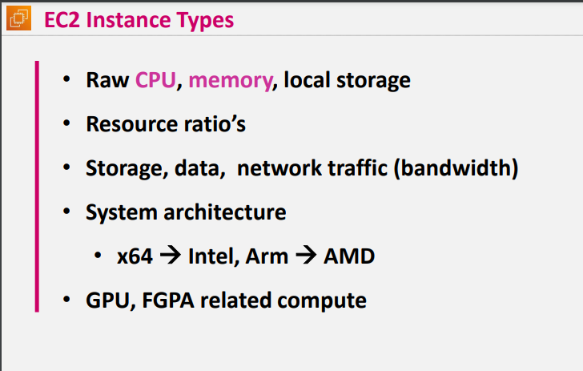

Resource Ratio’s Cpu : Ram 1:1 -> 1core cpu: 1gb ram

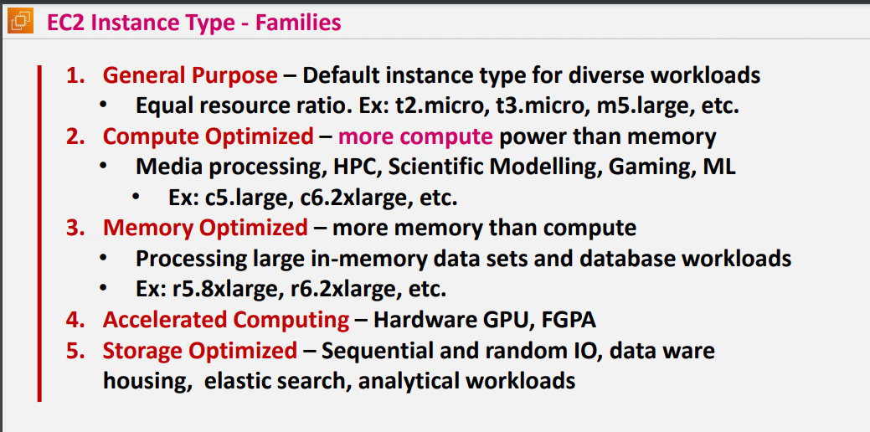

General purpose for cpu and ram ratios will be equal and used for development purpose

* Compute optimized if u want more cpu than ram then will choose compute optimized instances
* Memory optimized : if u want more ram than cpu then u will go with Memoory optimized

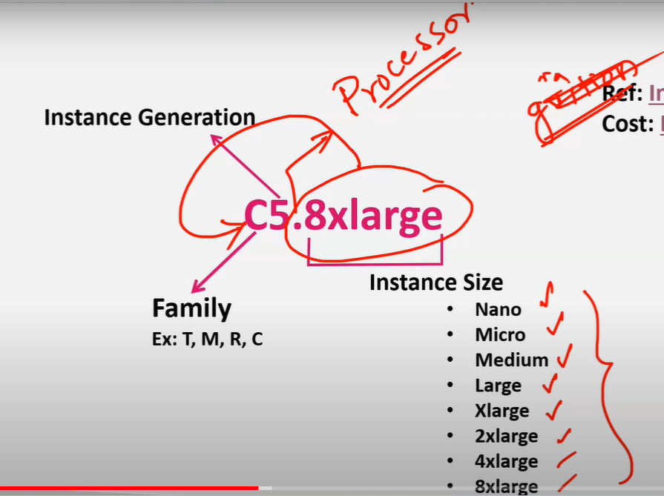

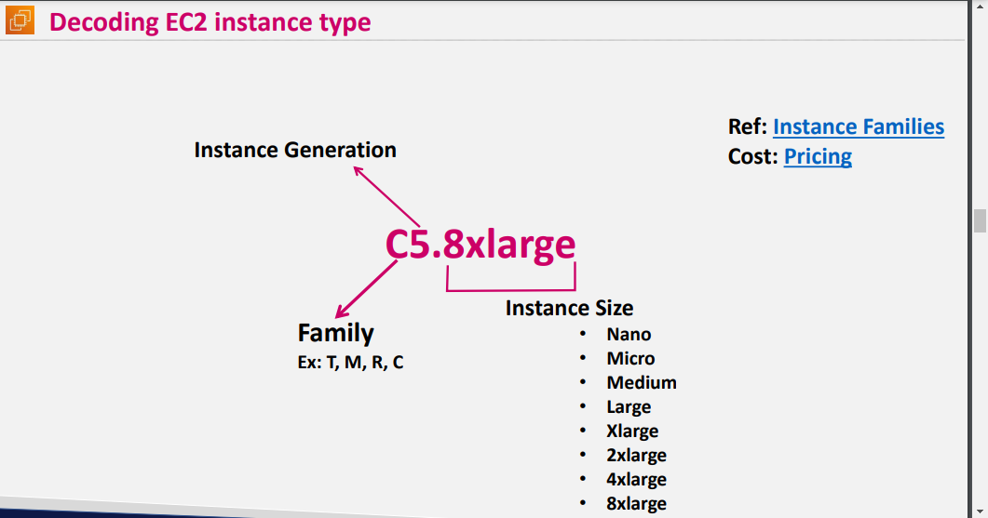

<https://aws.amazon.com/ec2/instance-types/> ---- instance families

<https://aws.amazon.com/ec2/pricing/on-demand/> ---- pricing link



1 EBS \* 75 INSTANCE STORE

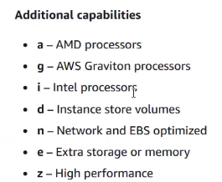

m7g.medium

3rd character G indicates processor aws graviton processors

If there is any character in 3rd place by default its intel

<https://aws.amazon.com/ec2/pricing/on-demand/> --- link

<https://calculator.aws/#/> pricing calculator

* Baremetal : instead of creating vm it gives you overall server
* M series are mostly used in projects for web and application series
* For data base servers r series are used
* 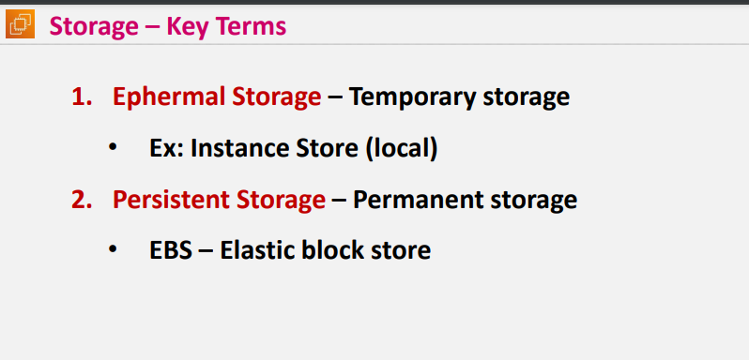

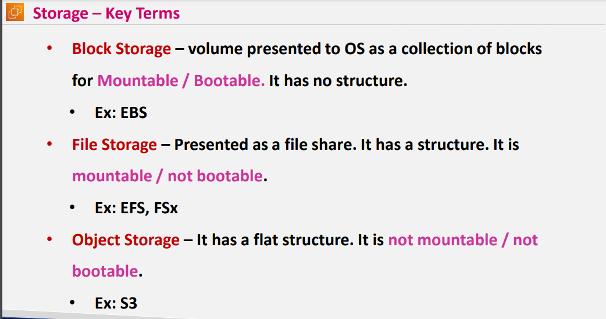

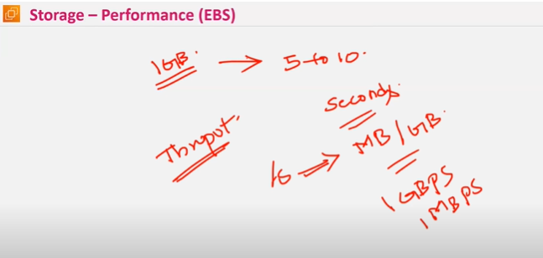

Previously if we want to transfer 1 gb file to someone it taks 5 to 10 mins now its transferring faster bcz previously hardware performance was less

Now its giving fast performance that’s called thruput

Thruput : the amount of data getting transferred per sec 1GBps ---🡪 1gb per sec

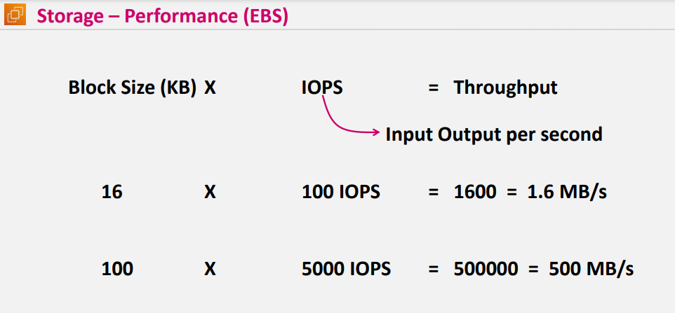

More Iops the more data will be transferred fastly

Based on iops data gets transferred

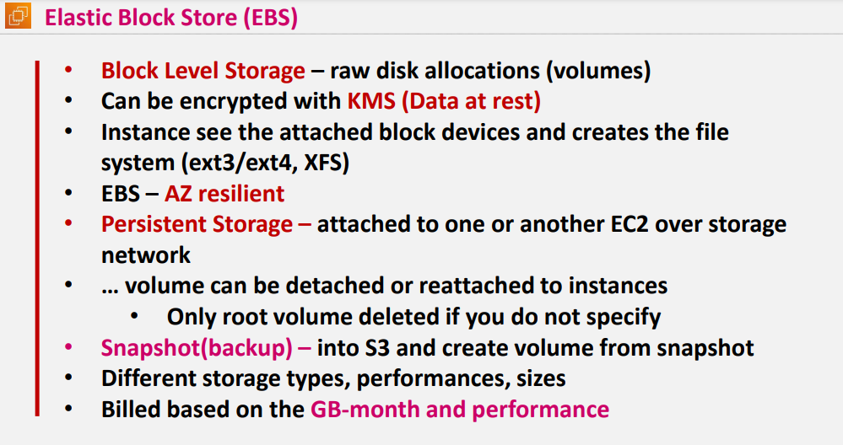

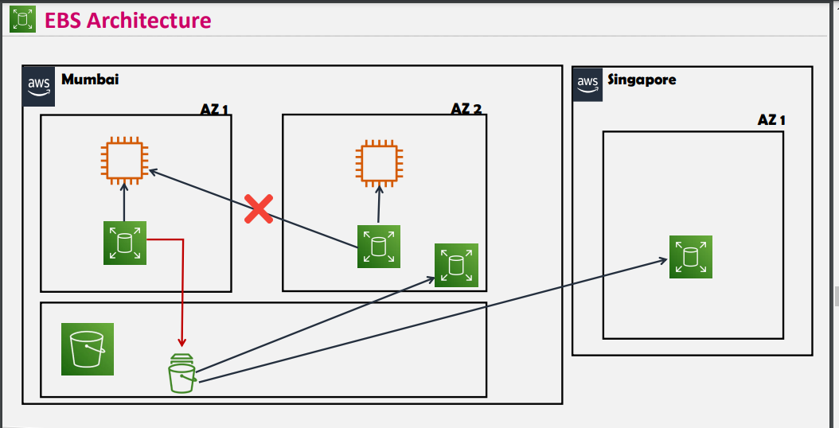

Ebs are AZ-resilent

* If you want to attach same Ebs to different AZ it wont be possible
* By creating snapshot and attaching to different az will be possible
* Same will be applicable to different region if you want to attach Ebs to different region need to take snapshot and attach it to different server
* 