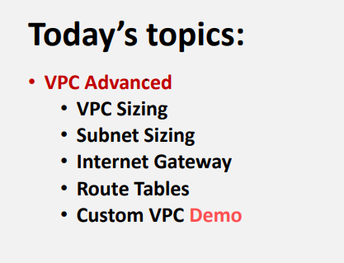

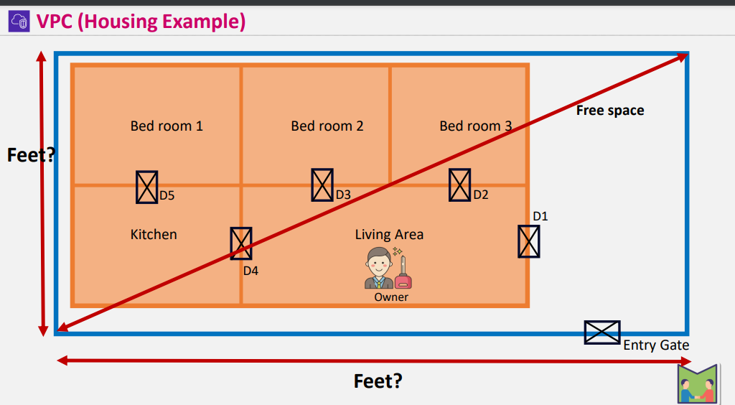

* In normal house housing size will be calculated in feets

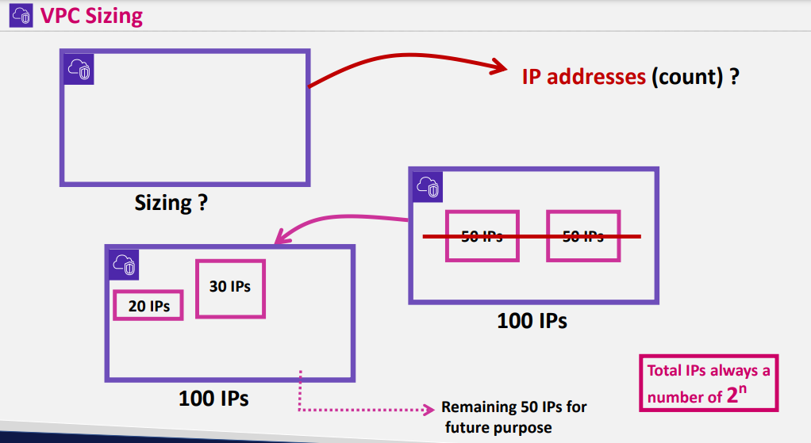

Here the sizing is number of ip counts

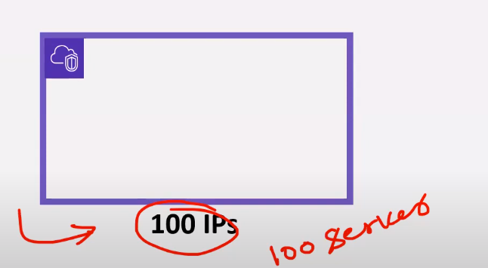

If you are giving size to vpc that many servers you can create

* According to the requirement of business we define sizing
* Actually vpc sizing is a range
* All Ips wont be allocated to the subnets they will only utilize some count and remaining count will be used for future purpose
* In networking they will leave some space for future purpose
* Ip’s always calculated in 2n
* I.e 20,21,22

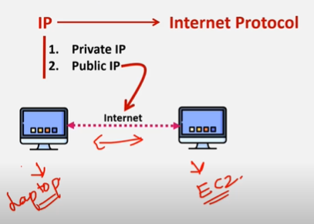

If you want to connect local machine to some server through internet you want public ip

* Private ip is used when local machines wants to connect through wired connect same router
* 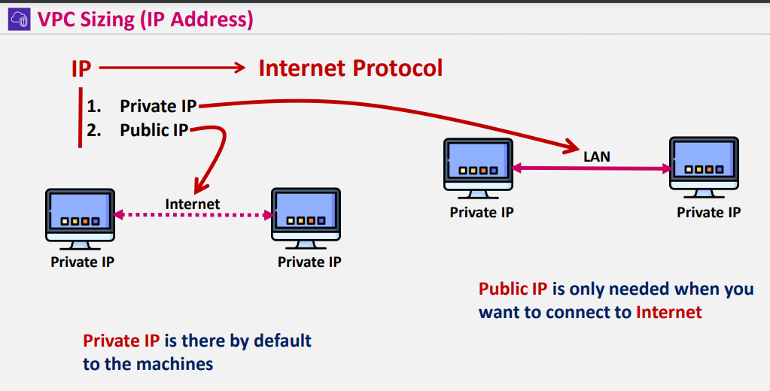
* If u want to conenect to EC2 using SSH or Rdp u need to have public ip If not it wont work

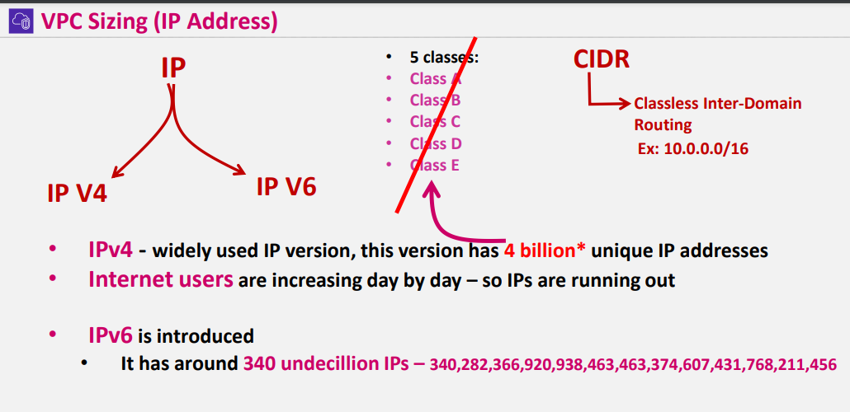

Ipv4 & Ipv6 are the versions of Ip

* As Internet users are increasing day by day IPV4 ip’s are running out so Ipv6 came into picture
* Still most of the organization uses IPV4 for production purposes
* Ipv4 – we have public and private ip’s
* But in Ipv6 we only have public ip’s
* Public ip’s will be unique if you are using public ip and that particular public ip wont be used by any other person
* Private ip’s can be same for different machines
* 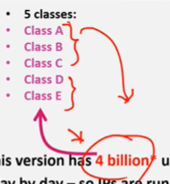

Class A, Class B ,class C are available for all the users who are using internet

* Class D & E is freezed for scientific technology and for future purpose
* But we wont consider about classes we only have CIDR Range
* /16 , /24, /32
* / defines the range of ip’s

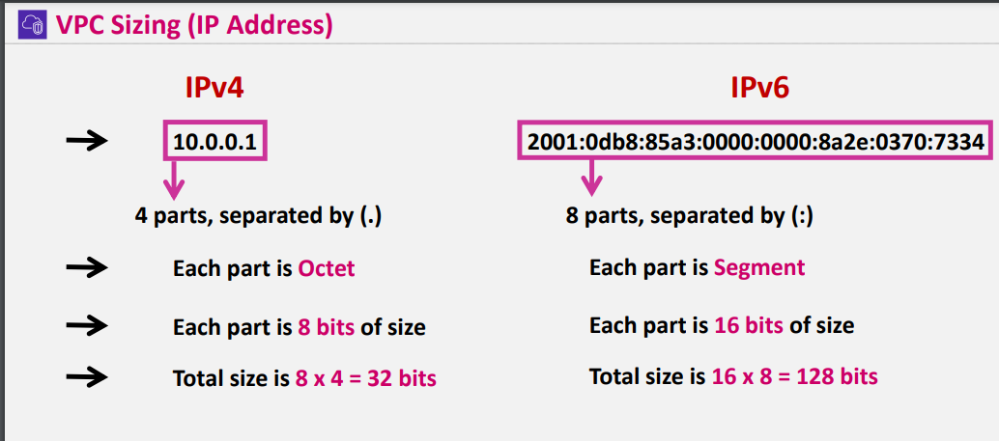

Maximum bits supported by Ipv4 is 32



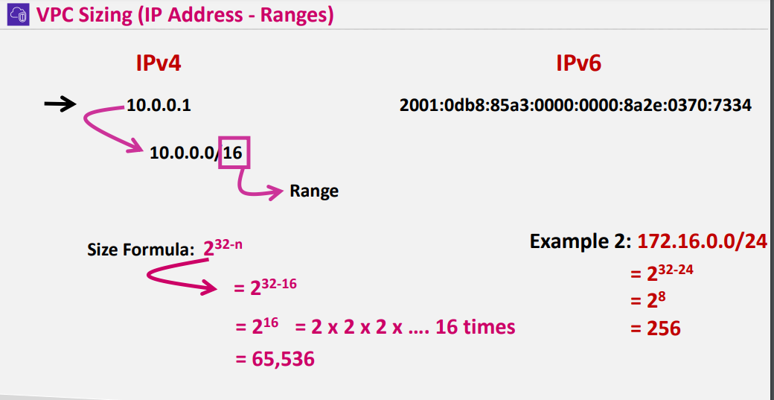

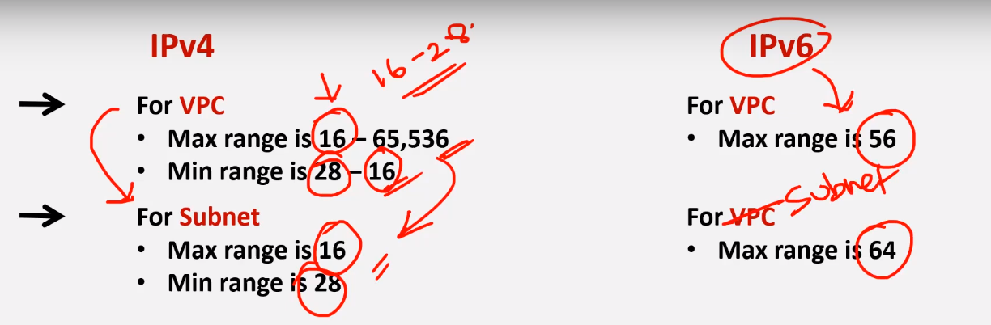

For subnet range should be equal to or less than vpc range

Max range for subnets is /16 min is /28

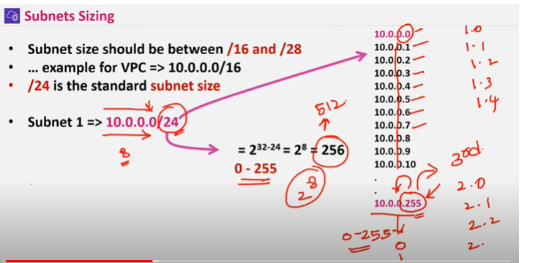

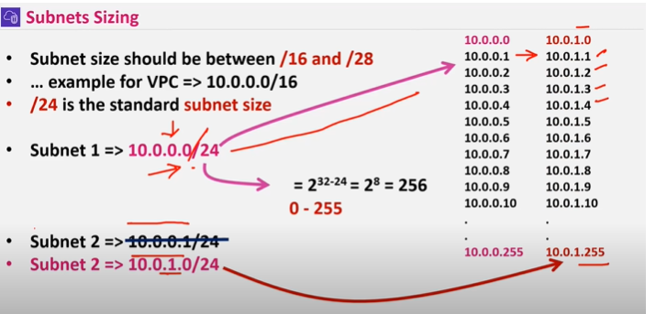

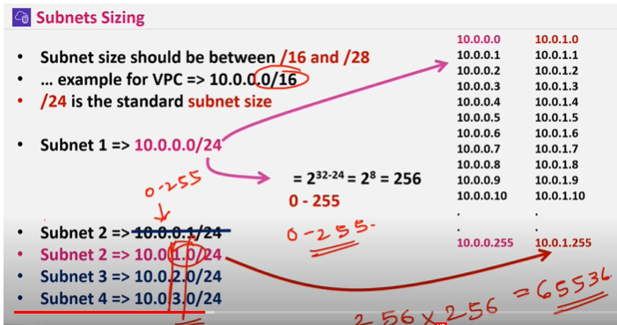

Only in vpc 10.0.0.0/16 last two octects gets used as vpc max range is /16

* Vpc range should be same for different vpc’s
* Just for differentiation purpose you can use 10.1.0.0/16 ------ 65536 ip’s
* For every subnet aws locks 5 ips bcz it needs to connect for vpc creation

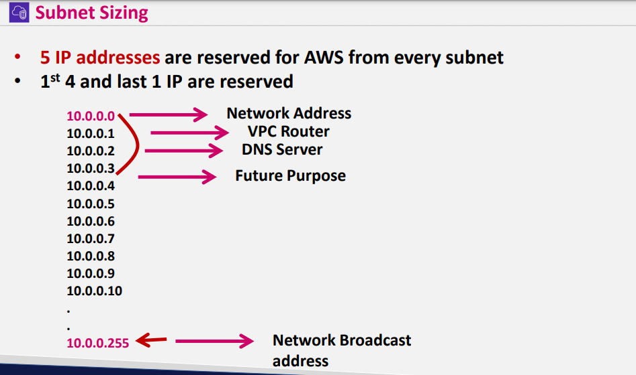

Last ip is used for broad casting -----------which aws doen’t support

For eah octet 0-255 ip’s are allowed

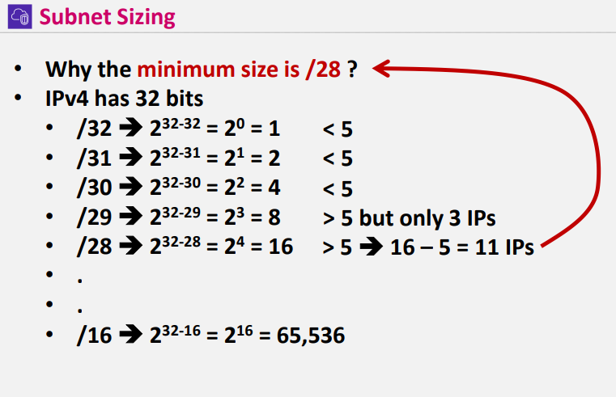

/32 is not acceptable for subnet bcz for 32 2 32 =232-32=20=1 by default aws reserves 5 ips in subnets

So 1 is < 5 its not accepted that’s y mi nimum size for subnet is /28

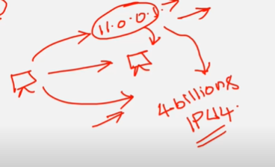

**Why we need to create vpc in that particular range**

* **If we create vpc 11.0.0.1/16 Will be in ipv4 4billion ips**
* **So there will be a ambiquity while connecting to the server**
* **It might get connected to public ip or private ip**
* **So we need to follow RFC 1918 protocol**
* **Private ip’s have different range where it wont included in public ipv4 ip’s**
* 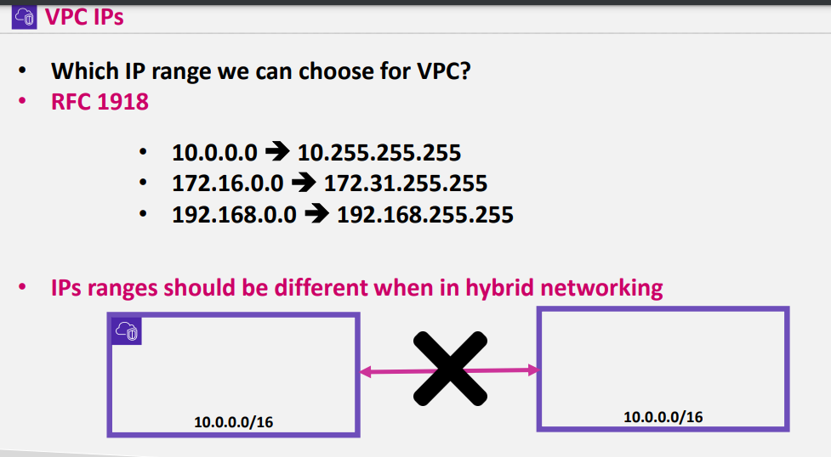

In hybrid networking if we create same

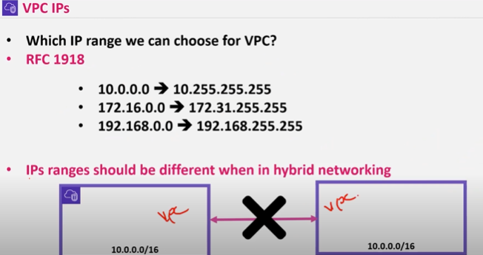

Same CIDR Block wont work if we are connecting

* Every Vpc is a regional specific
* For every Vpc there will be 3 availability zones
* 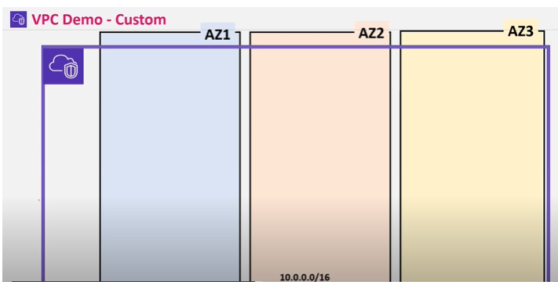
* Subnets are avability zones specific
* For subnets creation we need to specify in which availability zone we are ceating the subnets
* For best practice we need to create subnets atleast in 2 AZ’S

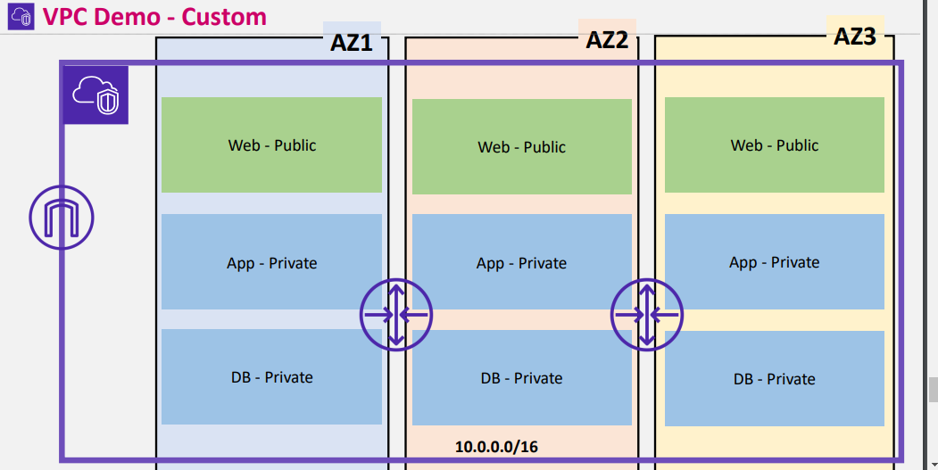

We need to maintain public and private subnets in three availability zones or else minimum 2 AZ’s

Vpc -demo

1. Create vpc
2. Create subnets create 3 public subnet and 3 private subnet
3. Create EC2 Enabling public ip in public subnet
4. Create EC2 disabling public ip in public subnet
5. Create EC2 enabling public ip in private subnet
6. Create EC2 disabling public ip in private subnet
7. Create IGW and attach it vpc
8. Create route table and add routes

VPC

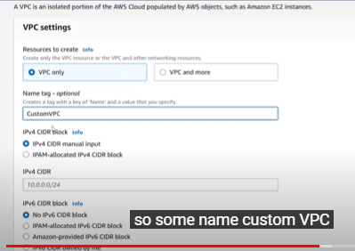

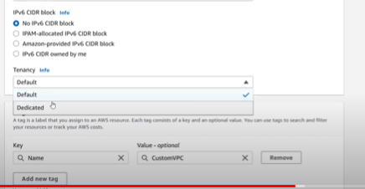

After creating Vpc

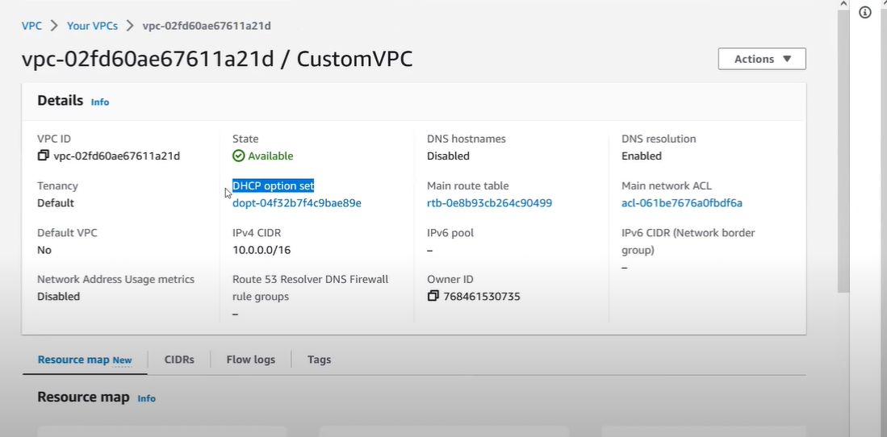

DNS Hostname

DNS resolution: enable from vpc if you to connect any other servers then dns resolution should be enable for routing

For example in dnschecker.org type youtube.com and check the ip where it routes when youtube has been called this is called dns resolution

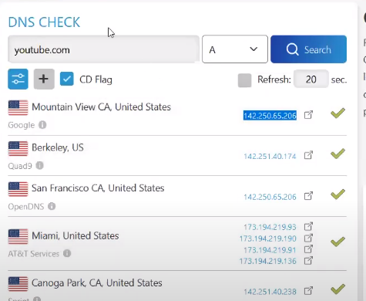

DHCP protocol : which assigns private ip automatically which ever is not used

For example in vpc : 10.0.0.0/16 we get 65536 ip’s in that which ever ip is not used it assigns automatically

* previously network engineers assignes private ips manually

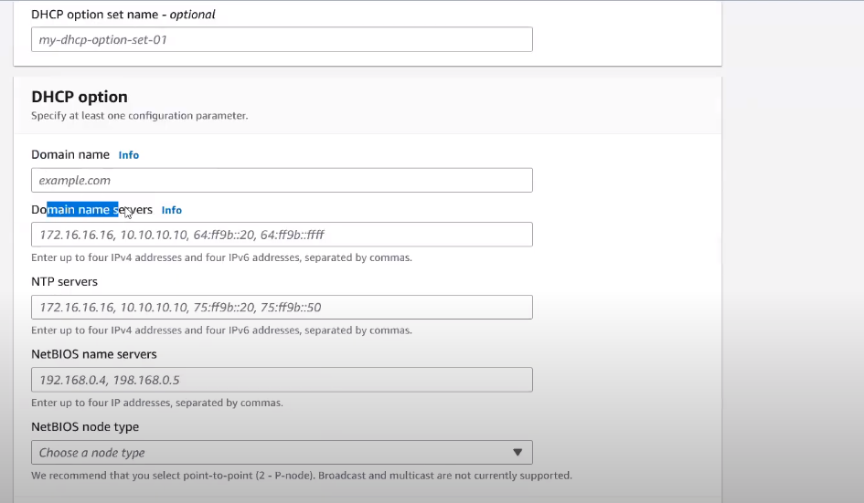

We can create custom DHCP options

We can attach only 1 IGW to 1 vpc

* For best practice in every AZ subnets should be present or else either in two AZ’S
* By default subnets wont be difined as public or private while creating which ever subnet is attached to igw its public subnet
* Vpc per region 5
* Subnets per vpc 200

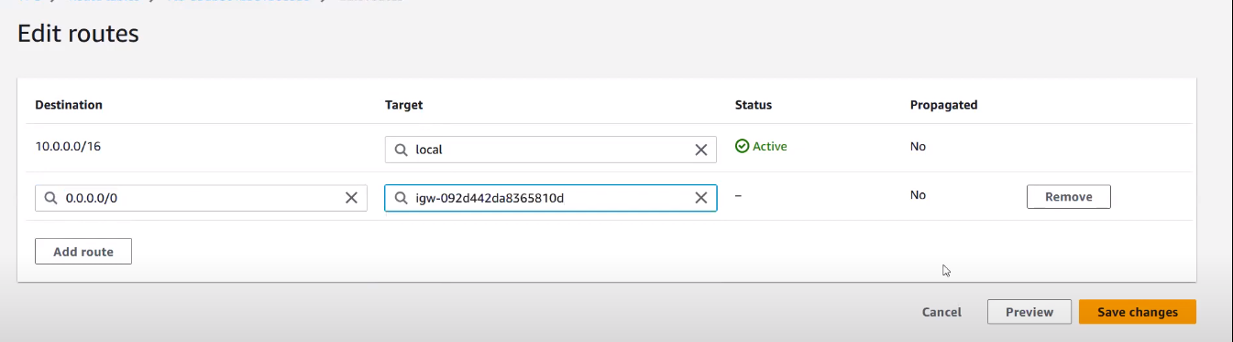

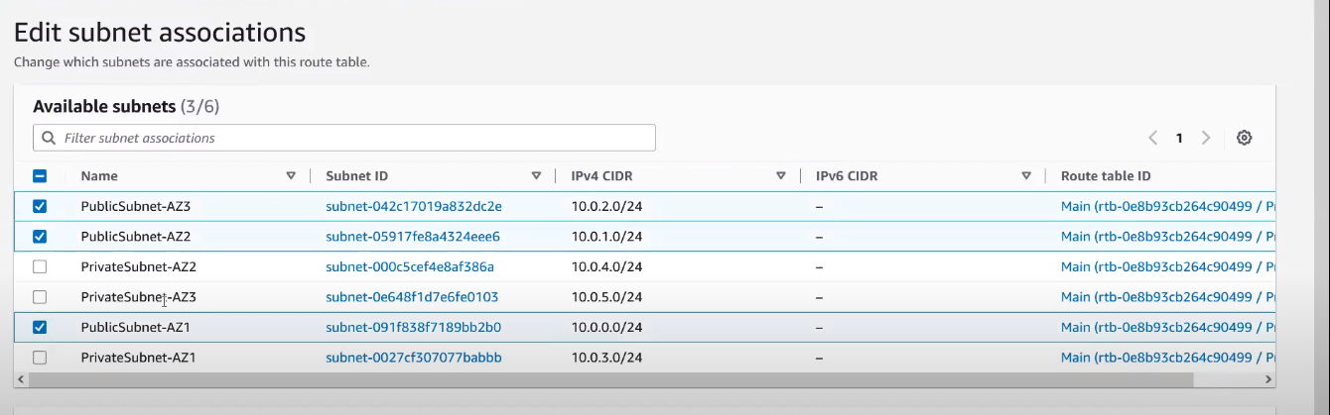

In subnet association add the subnets

In private Route table add private subnets in association part

**Demo**

**In vpc section check with dns hostname enabled**

**To auto assign public ipv4 enabling go to subnets section and edit auto assign public ipv4 –“yes”**

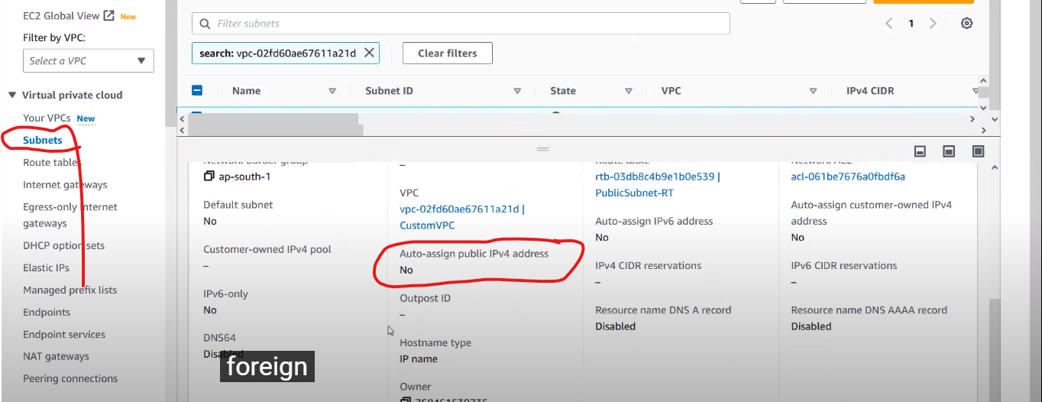

**When you enable dns hostname in vpc**

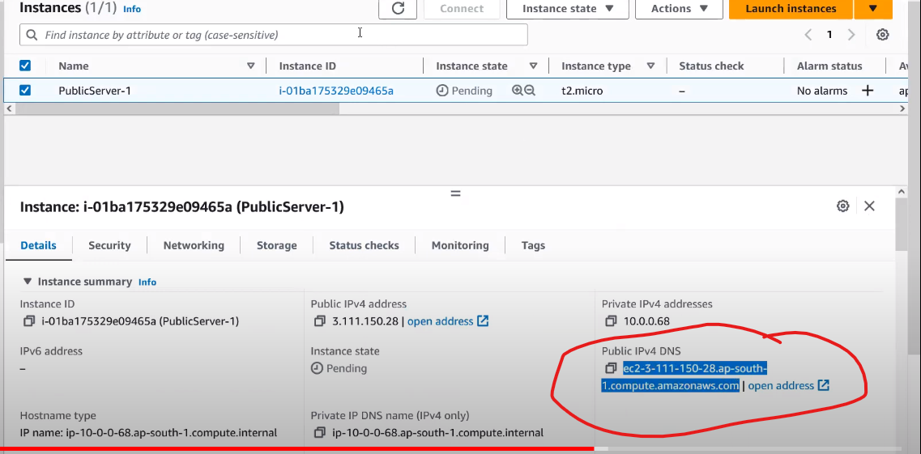

**When u create ec2 its reflecting as you have enable dns hostname in vpc**

**When you disable that option you wont get public ipv4 dns**

* When you want to connect to public subnet you need to connect to Vpn or bastion host or direct connect

Without public ip and without vpn through session manager we can connect

* **Check with Dns resolution enabling and disabled in vpc and check the instances whether they can ping google.com**

**AGENDA**

Vpc -demo

Create vpc

Create subnets create 3 public subnet and 3 private subnet

Create EC2 Enabling public ip in public subnet

Create EC2 disabling public ip in public subnet

Create EC2 enabling public ip in private subnet

Create EC2 disabling public ip in private subnet

Create IGW and attach it vpc

Create route table and add routes

**When u create ec2 its reflecting as you have enable dns hostname in vpc**

**When you disable that option you wont get public ipv4 dns**

* When you want to connect to public subnet you need to connect to Vpn or bastion host or direct connect

Without public ip and without vpn through session manager we can connect

* **Check with Dns resolution enabling and disabled in vpc and check the instances whether they can ping google.com**