ELB: for autoscaling we need load balancer but for loadbalancer autoscaling is not necessary

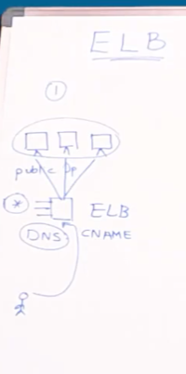

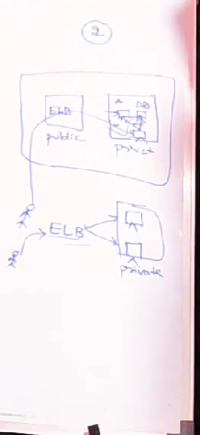

To create ELB you need two public subnets if not it wont get created

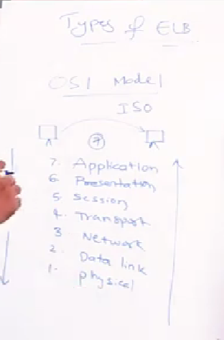

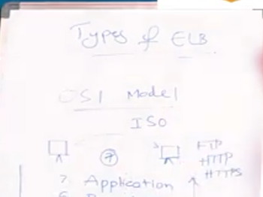

Presentation layer -> encryption will be done

Session layer – session gets created

Transport layer -> what ever data comes from session layer it coverts to segments tcp & UDP related protocols will be used

* TCP- Wired Ex-lan
* UDP – Wireless Ex -wifi

Network layer - segments will be converted to packets ip4 and ipv6 ( logical addressing)

Datalink layer - addressing mac address will be attached (physical addressing )

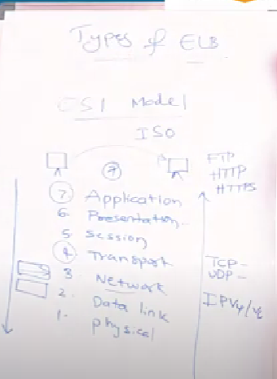

2006 they have introduced v1 LB (Classic load balancer which works both in application layer and transport layer)

2016 they have introduced v2 Lb (Alb ) which works only in application layer i.e http and https protocols

2017 they have introduced v2 lb (Nlb) which works only in transport layer i.e tcp & Udp protocols

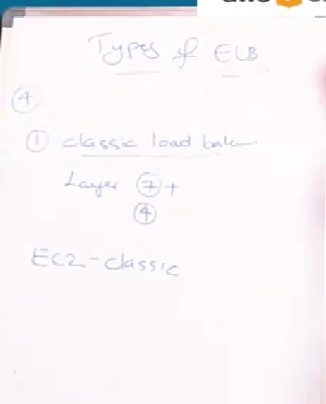

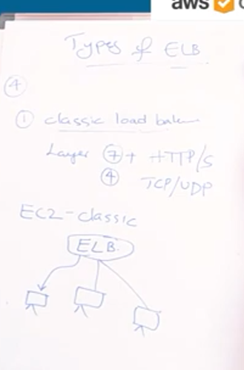

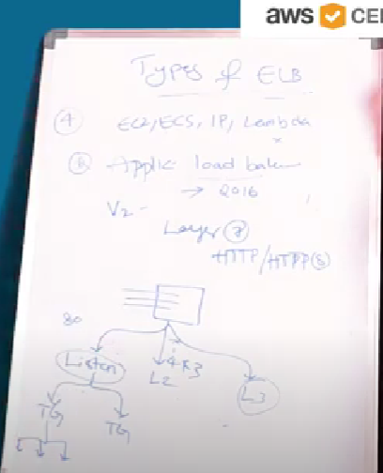

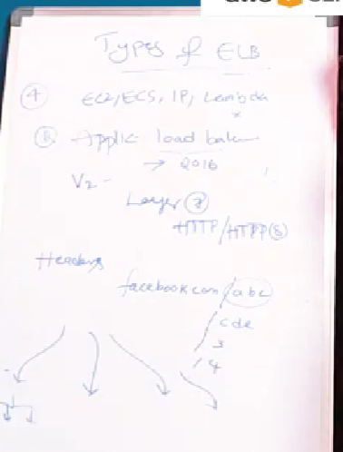

Path based routing will be there in application load balancer if facebook.com/abc it routes to one target group

If its facebook.com/cde it routes to another target group

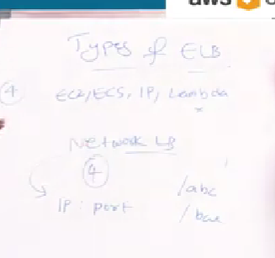

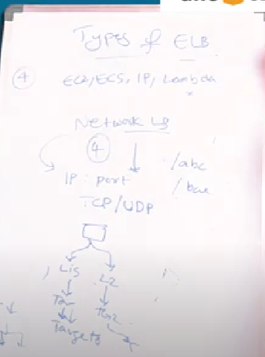

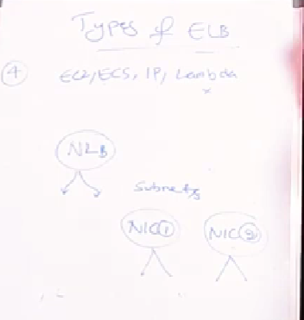

If you want Ip for load balancer you will get through Nlb

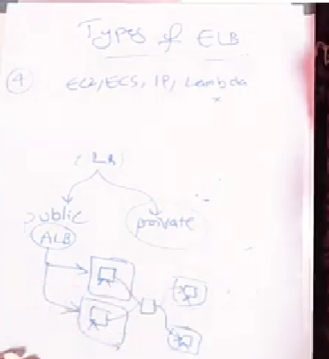

Lambda is only supported in ALB

* EC2,ECS,IP will be there both in ALB and NLB