

Advantages of lambda

1. No maintainance
2. Pay as you use
3. High availability
4. Scalability

If so many users request lambda creates those many containers at the same time and then gets killed after giving response to the customer

In 1 region 1000 concurrent requests can be made at once

And there wont be any relation between containers as they are isolated



If the code doesnot gets executed then u can check the logs through cloud watch

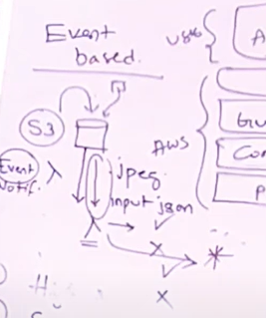

Lambda is used for event based triggers

Here the use case will be when user upload the file it should trigger the lambda and should process only jpeg files rest it should reject

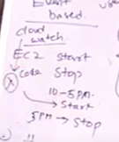

Another use case is EC2 start and stop it should strt at 10 am and stop at 5pm for cost effective and it is integrated with cloud watch

Maximum time to run the code in lambda is 15 mins it doesnot support to execute more than 15 min the container gets killed

If u r code is more than 10 mb than keep your code file in s3 and then upload that link in lambda it’s a best practice

**Lambda configuration and settings**

If you want to create a lambda function on trigger based then we use triggers option in lambda function

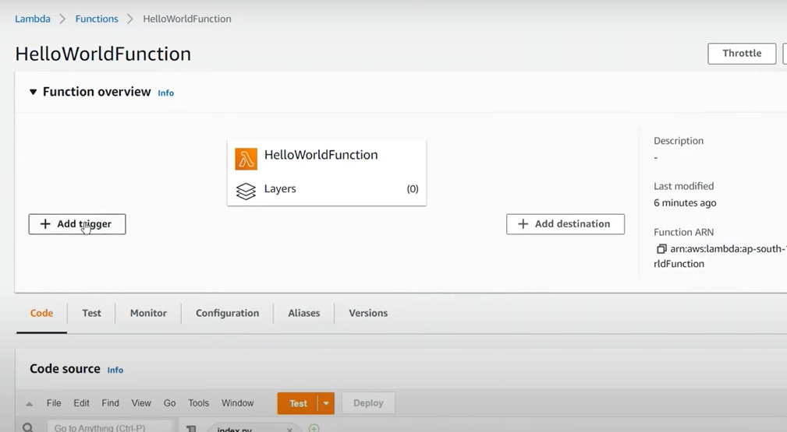

And also to store the response from lambda function we use destination

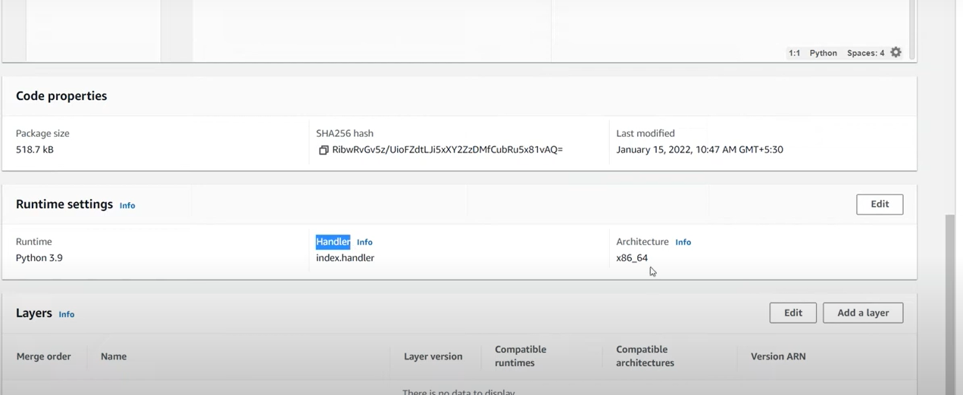

By using code properties u can check the last modified code

And u can also change runtime settings using runtime settings

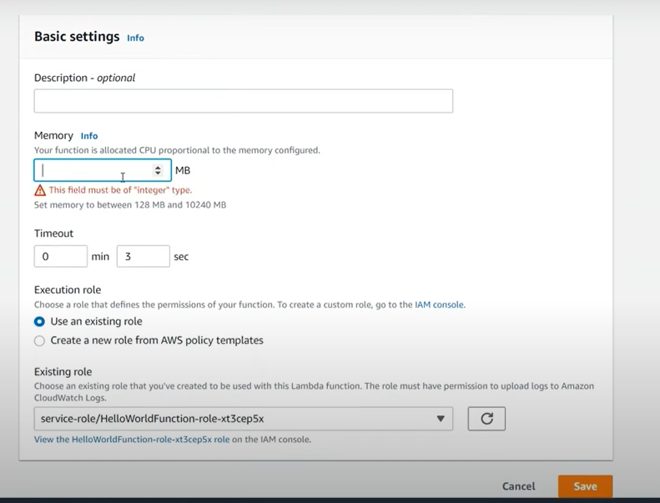

You can edit the memory based on code to run

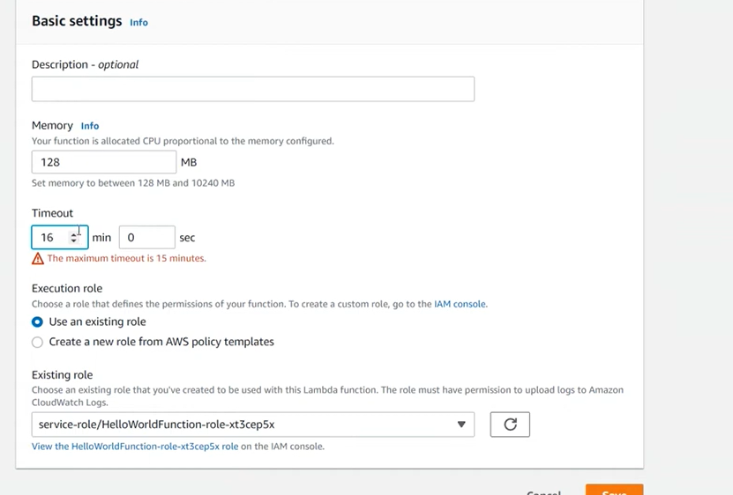

Maximum time is 15 min

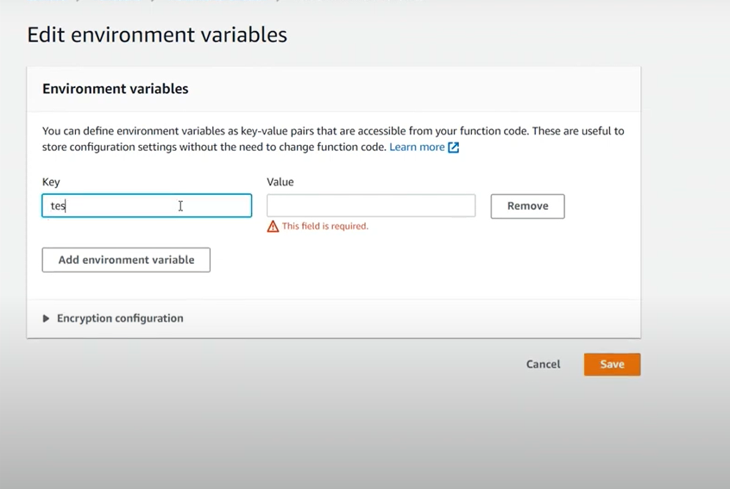

This is for environment variables which are used in our code we can edit here

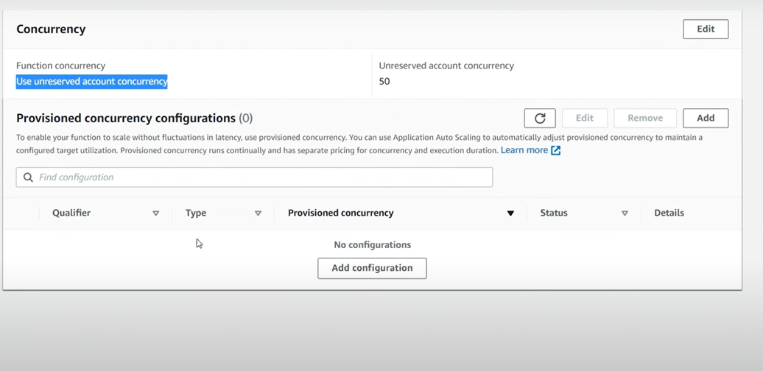

Concurrency is nothing but how many requests can these lambda can accept at once u can increase this according to the requirement by talking with support team