**LAMBDA LAYERS**

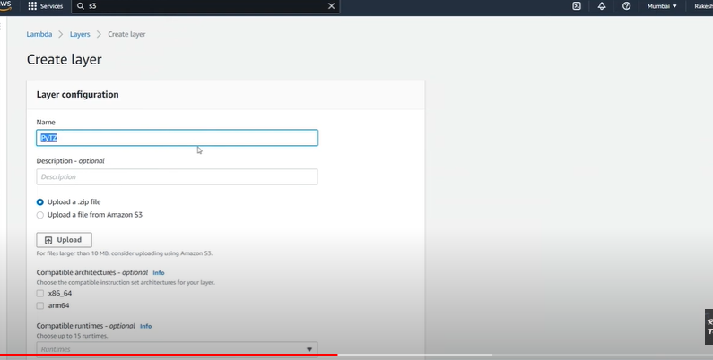

**Lambda layers is a concept where u can put ur code dependency libraries here with that u can reduce the space of the functions**

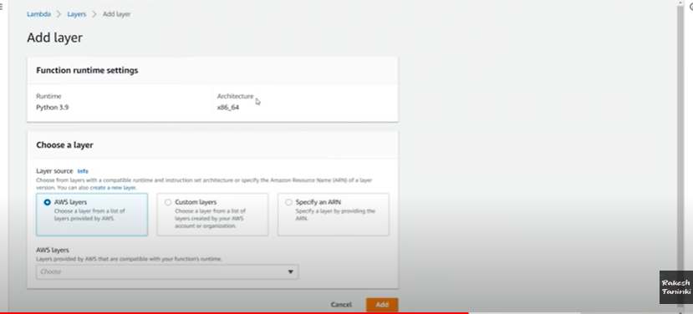

**U can intergrate layers to the lambda function by selecting add layer option**