

As a aws engineer u need to track the resources usage for cost effective

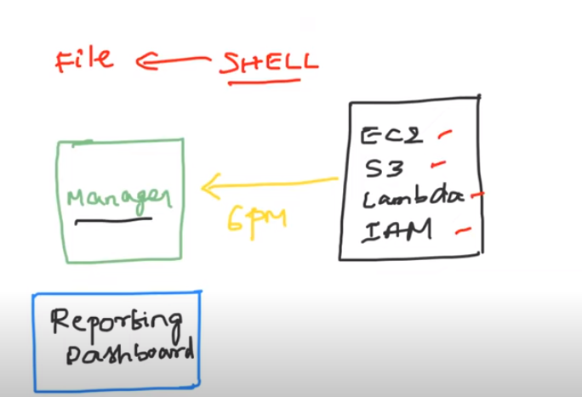

In this project we are just report the services usage daily to manager

Here in one file just u just create the scripts which runs automatically and generate the report

* That shellscript will integrate with cron jobs to run the scripts automatically

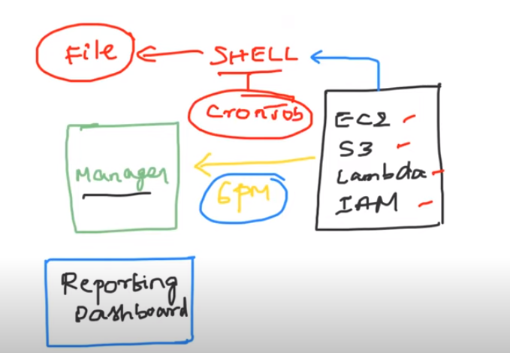

* By using cronjobs u can the run the shell scripts automatically

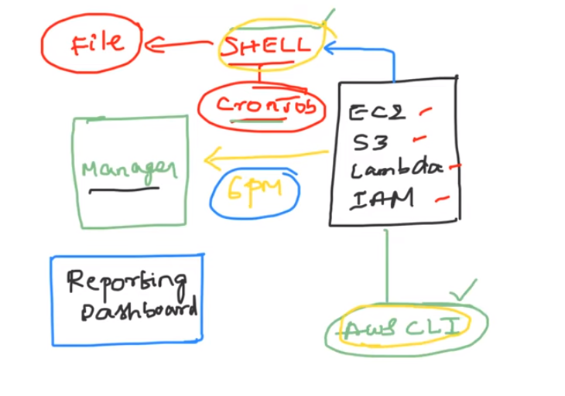

Later open the linux server –configure aws credentials

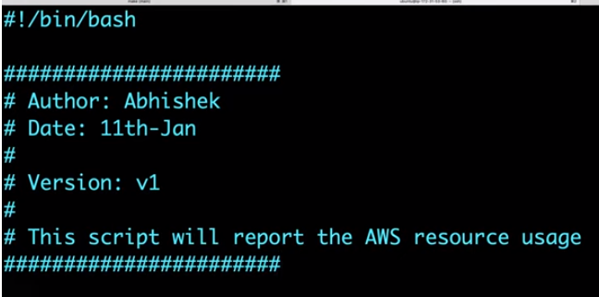

Create a file by vi aws-resource-tracker

And the provide the above details

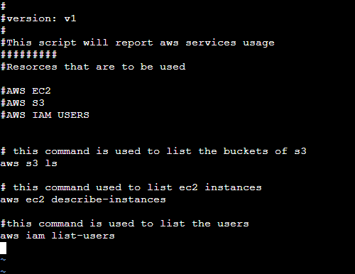

Write the commands and run the script for the output

Save the file by giving :wq and give the permission by using chmod 777 file name

* To run the file use ./file name
* To read the output in a better way ./ file | more by this pipe u can read the output in a better way
* By using print statements user can understand the debug output

In linux we use echo for print the statements

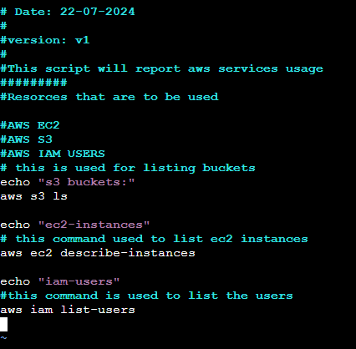

* Set -x is used for debugging the output

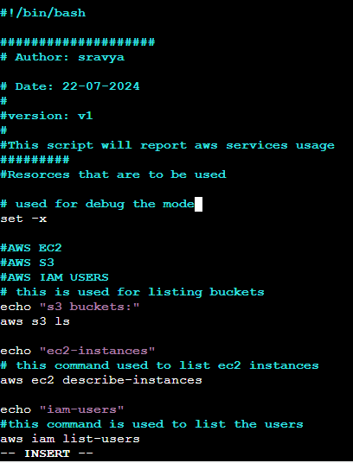

This will the effective output by using set -x

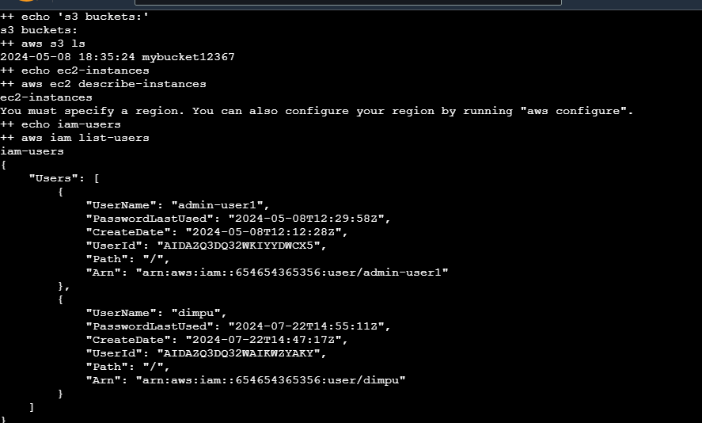

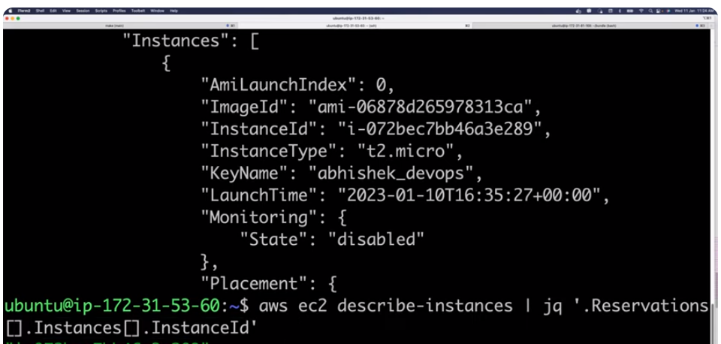

This will give only instance id

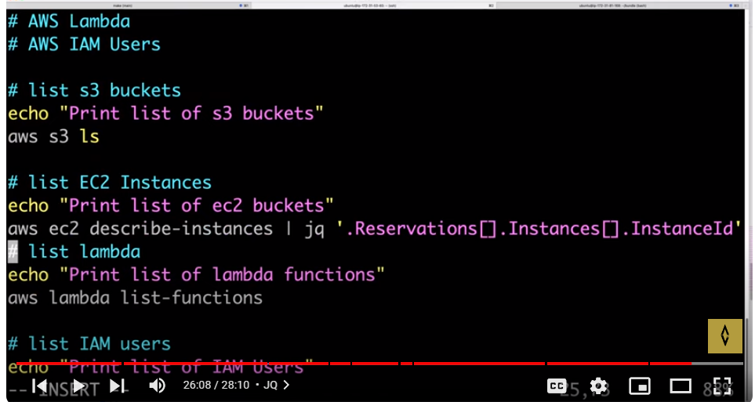

You can redirect every output to a file aws s3 ls > resource tracker

