DevOps is a culture which improves organisations to deliver applications

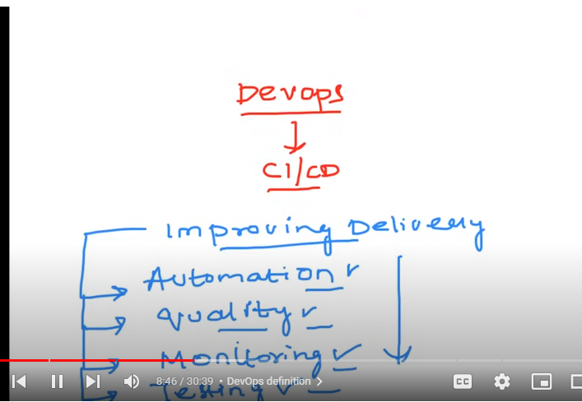

DevOps is nothing but improving delivery and ensuring proper automation and quality , and proper monitoring setup and proper testing is done

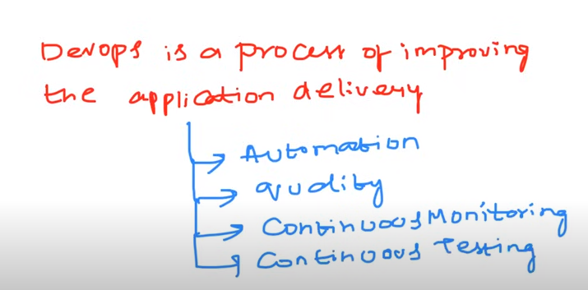

The end goal of devOps is faster delivery process by automation

**Why Devops?**

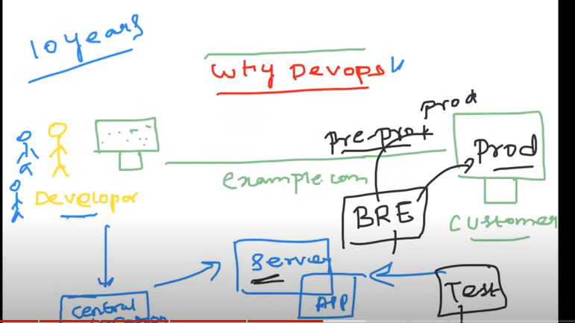

Before 10 years back there is no automation process and there is devops

system admin who develop the code will used to keep their code in centralized system as there wont be 1 person to develop the code

System admin will create a server and place the developed application in that server

Tester tests the code which is in server

Build release engineer will take those tested application code and transfer to pre prod or staging if everything goes fine they will transfer to production stage

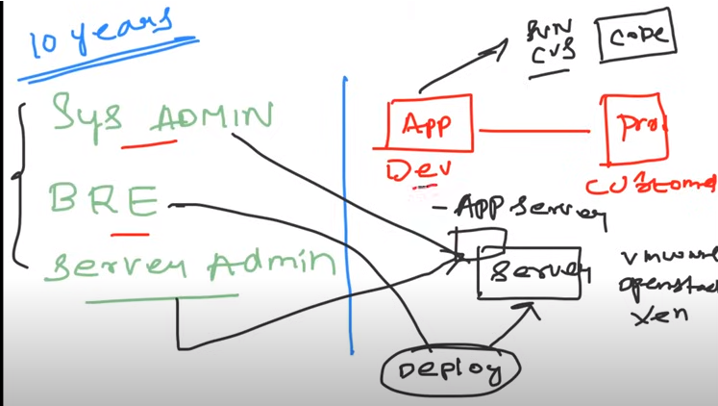

Developer develops the code and keeps the code in centralized system

System admin creates a server

Server admin creates a app server

Build release engineer deploys a code on application

Tester tests the code from application server and transfer to pre production if everything goes fine they will send the code to production

All these steps are for to deploy the application in client server

APP (development)

Delivery(production)

This is a manual process so it’s a time taking process

To improve the above process everybody has moved to new concept called devOps which automates the entire process without any manual effort

**Introduce yourself as a devOps engineer**

**My self sravya am a devOps engineer and have overall experience as 3+ years**

**And before I used to work as cloud Sme (explain previous experience )**

**As a devOps engineer I take of Automation,I ensure that there is quality , I ensure that I have setup continuous monitoring and have automated testing scipts to devOps life cycle**

**For tools am using git hub actions for CICD Pipelines**

**For deployment of application on to container orchestration i used Kubernetes**

**For configuration management i am using ansible**

**For infrastructure automation am using terraform**

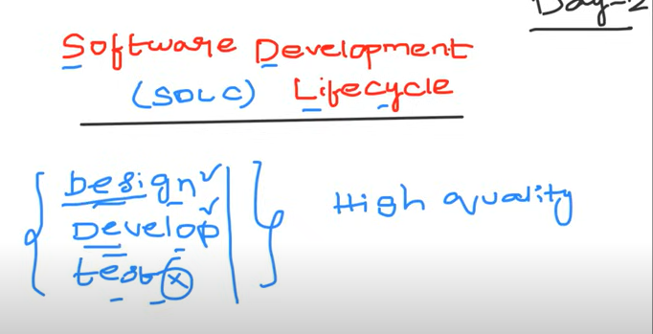

Sdlc is a process that is followed by every organization that is to design develop and test to deliver high quality product to the customer

The main stages in SDLC are design develop and test and end goal of sdlc is to give high quality product to a customer

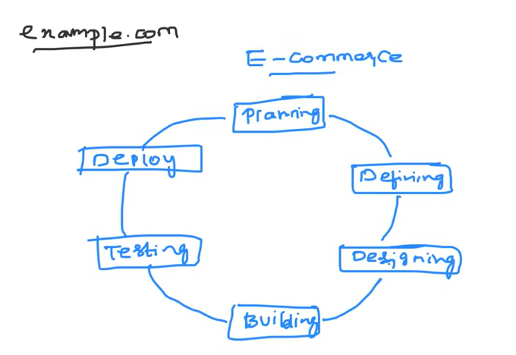

For example if you r trying to build an application or website you need to follow these steps

1.planning - requirements gathering (business core or business analyst will be doing this task that means planning and requirements)

2. Defining – they will write a requirements in the form of documents that is software requirement specifications they will mentions all the things which are collected in planning phase.

3. Designing – in designing it’s a critical phase where they do highlevel design and low level design architect or team lead will be designing this that means in high level it should be scalable when ever there is huge load

4. Building – once requirements are ready and highlevel and lowlevel design is ready developer develops the application by writing a code and he will keep it in a centralized repository(Git) after raising a PR(pull request) as there wont be a single developer

5.Testing – once the product is developed the quality engineers test the application by taking it from repository to staging server where they tests the application

6.Deploying - finally after testing the application the product will be sent to production server (customer )

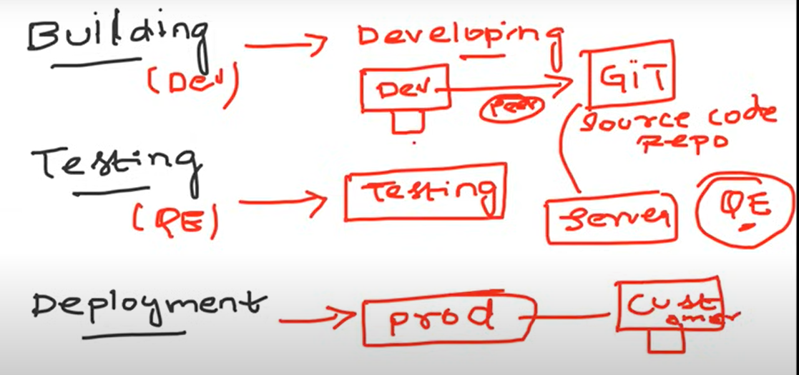

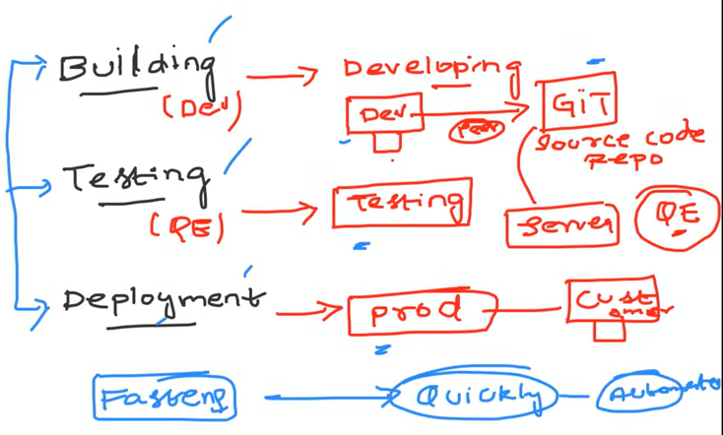

Devops engineer fastens the process without any manual process he writes automation scripts to automate the process he wont build ,test ,and deploy the software but he only automates the process

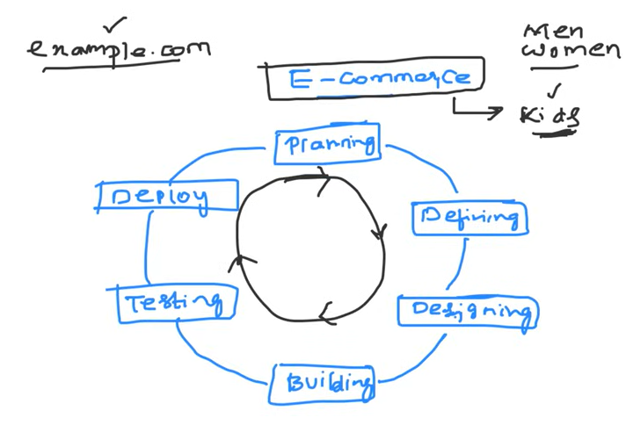

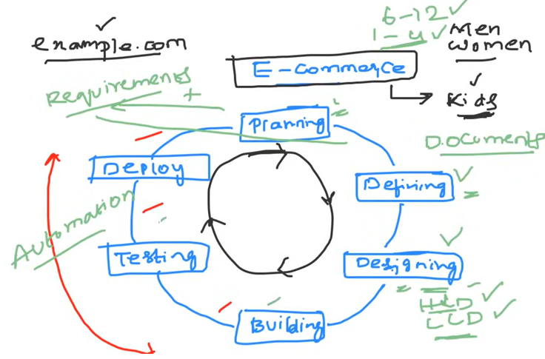

**The automation strts from building testing and deployment here devops comes into picture**