**Linux operating system**

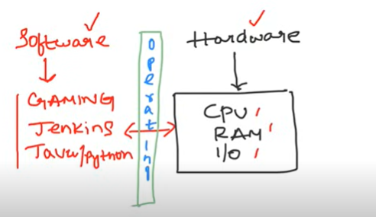

Operating system acts as a bridge between software and hardware

Hardware is nothing but cpu /RAM software is application

A computer system is divided into two categories: Hardware and Software. Hardware refers to the physical and visible components of the system such as a monitor, CPU, keyboard and mouse. Software, on the other hand, refers to a set of instructions which enable the hardware to perform a specific set of tasks.

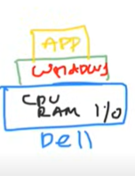

Example you purchase a dell operating system that is in that dell will give you hardware that is cpu ram i/o and it installs windows operating system on it so that’s the reason you can install the application on windows

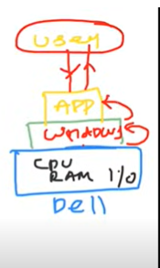

As a user you will give some instructions to application and app talks to operating systems and operating system talks to hardware and it responses back to os and os responses back to app and app sends to user vise versa

As a user you install application on server and server sends info to operating system and operating system sends info to the hardware from there hardware reverts backs it response to os and os sends back to server and servers sends it feedback to app and app sends to user

* Without operating systems you cant do anything it’s a core thing
* 90 % of applications are tested on linux operating systems

**Why linux is so popular**

* It’s a free and opensource
* Linux is very secure
* It has lots of distributions ubuntu, centos, redhat
* It is very fast … linux os is very fast bcz in production system most of the time ppl prefer for fast response operating systems
* So these are the reasons y ppl choose linux operating system over windows

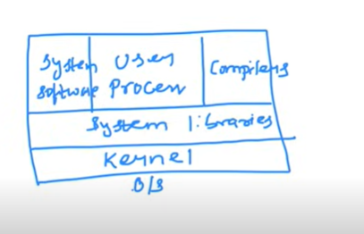

On linux you have kernel the heart of linux os

And system processers , system related softwares , compilers whenever you install linux on your system the mentioned things like kernel , system libraries, compilers,user processors , system related software gets automatically installed on your system

* These are the fundamentals of the operating system
* Kernel is responsible for the communication between hardware and software

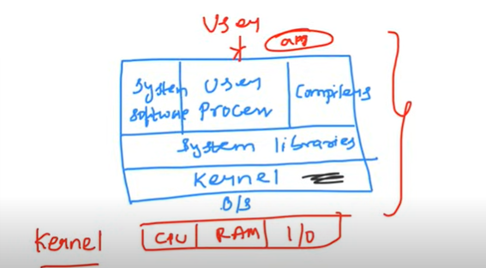

When you install app on linux kernel is responsible for the communication between hardware and software

**What Is the importance of kernel**

* **It’s the heart of operating system which does device management**
* **Memory management**
* **Process management**
* **Responsible for Handling system calls**

**System libraries**

* System libraries are basically responsible for performing tasks
* Ex: libc is one of the system libraries

**Compilers**

* If you want to run java application our operating system need to compile the code for that we have compilers user processers system softwares

**Shell Scripting**

* Shell scripting is nothing but to automate the linux commands which are used for day-day activities
* Shell scripting is nothing but talking with operating systems through command line interface
* Shell commands are mostly common on different distributions like centos, ubuntu etc
* Unlike windows All the time we mostly use shell scripting to communicate with the operating systems in production servers
* Ubuntu is most widely used operating system

**Commands**

* In windows you can easily navitage to files and folders by using mouse but in linux
* To navigate files and folders type command call **“ls”**
* **“Pwd” stands for present working directory**
* **“Cd”** change directory **cd directory name**/
* **Cd .. to go back to one directory**
* **Cd ../.. to go back to two directories**
* **To move two directories cd directory name/directory name**
* **Ls -ltr to know the owner of the file , to know the files and directories if letter starts with d it’s a directory if not it’s a file**
* **To list the files and folders ls is enough to the details of files like when its created(time stamp) then use ls -ltr**
* 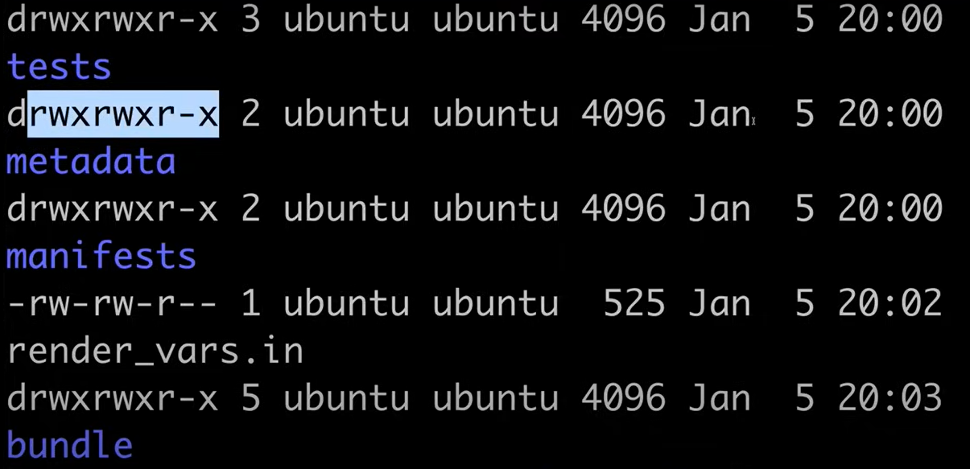
* **To create a file touch file name**
* 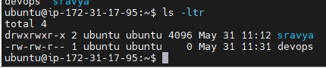
* The above drw…. Is a directory
* -rw-rw… is a file
* Most of the time u want to create file and write content init then type **“vi filename”**
* **To strt writing inside a file click escape “I” to insert the content**
* **To save the file escape :wq**
* **To print the file “cat filename”**
* **To create a directory mkdir directoryname**
* **To remove files rm filename**
* **To remove directory rm -r directory name**
* **If you want check the performance of the server we usually click on task manager on windows for cpu ram and memory**
* **Free – g to know the memory size of the server**



* **Nproc command to know about the cpu**



* **Df -h to know the disk size**

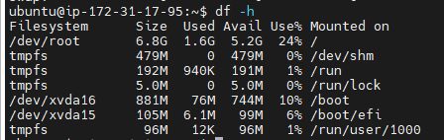

* **“Top” is the command where u can see cpu ram and memory utilization just like task manager**

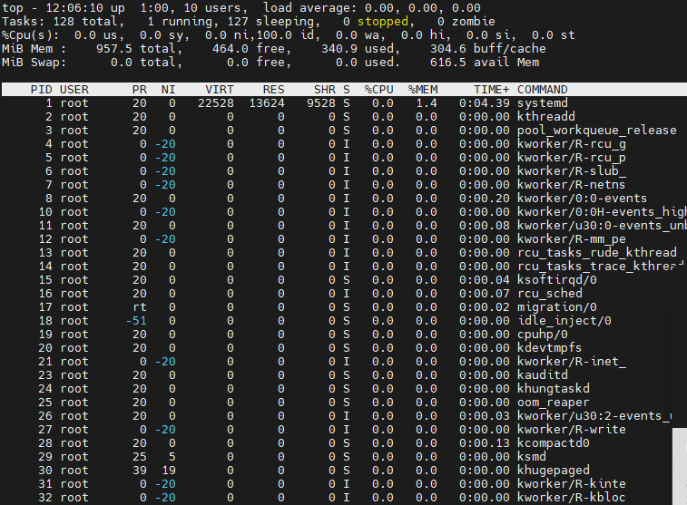

* **Man is the command just like help command “ man ls “ you will get details about ls**

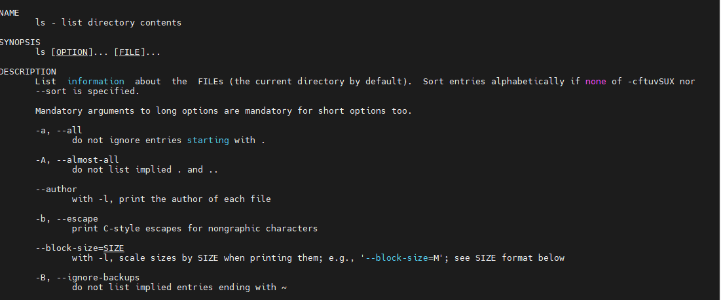

* **#!/bin/bash or sh or ksh this is called shebang this is first everybody writes in shell scripting**
* 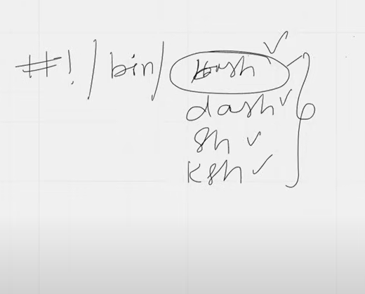 **bash/dash/sh/ksh these are the executables of shell scripting**
* You have to inform kernel that these are the executables of shell scripting
* **These executables slightly varies in terms of syntax**
* **Most widely executable is bash**
* 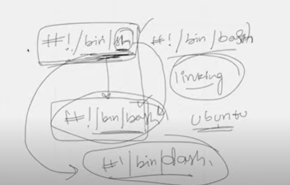
* **Previously** #!/bin/sh and #!/bin/bash were same now #!/bin/sh is redirecting to #!/bin/dash
* **“Echo” is used to print the statement just like print in python**
* **Without opening and closing the files cat command helps us to view the content withot opening**
* **./ file name to execute files or sh filename to execute the shell scripts**
* **If your creating a file and want to execute the file u can grant permission that who can access the file**
* **Chmod is the command that grants permissions to a file**
* 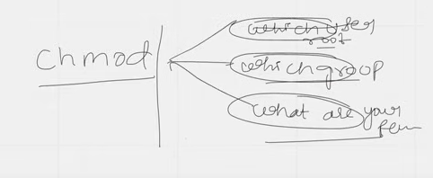
* **Script for practice**
* 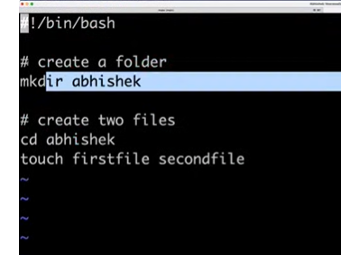
* **When u call the above file it should change the folder and create two files automatically**
* **What is the purpose of shell scripting in devops**

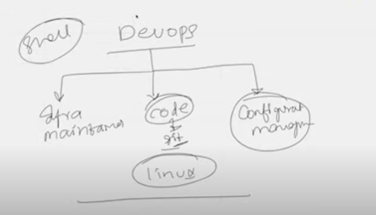

**As a devops engineer u need to maintain infrastructure and code we use git so most of the organisations uses linux and as a devops engineer you need to manage configuration**

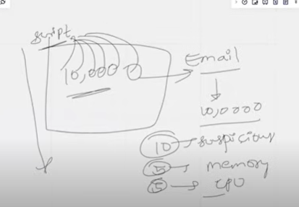 **one of the use case for shell scripting**

**To automate the script for every two days to check the servers utilization and can send the notification to respective member so shell scripting is important for devops engineer.**

**Use case and if some one asks where u used linux: I have automated all the node health of my virtual machines without doing manually we have close to 1000 virtual machines everytime its difficult to check the status of each vm so have used there**

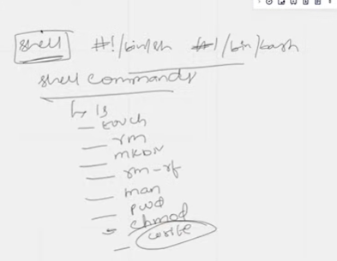

**Nproc – used to check cpu**

**Free - used to check ram utilization**

**Top – to check cpu ram all at once**

**Here is the script to automate the nodehealth status check**

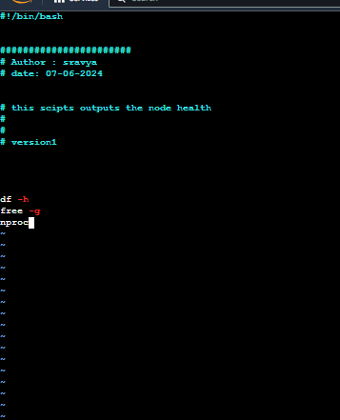

**After this save the file and change permissions by giving chmod 777 file name**

**And call this file ./nodehealth.sh**

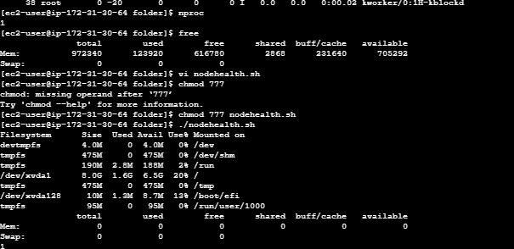

**This is the output**

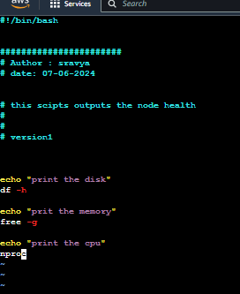**this is the best practice to write the scripts**

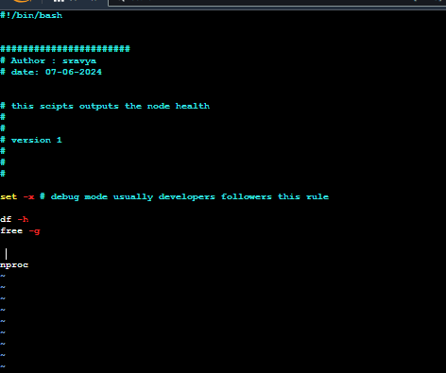 **here is the method where usually developers follows these methods to write the scripts**

**Set -x is the command to debug the scripts**

* **Ps -ef is the command that shows what are the processes running on vm**

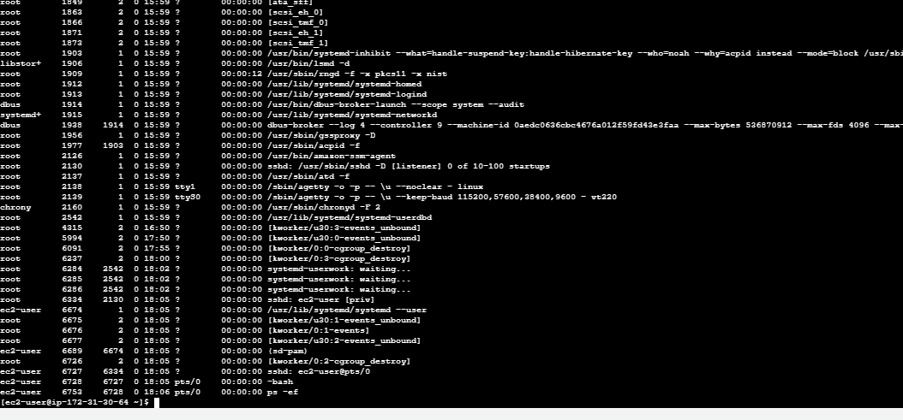

* **To get processes with the process id for ex if we want to know the id of particular process its difficult to find it out with overall list**
* **Ps -ef |grep “process name”**

**Output : **

**Gives only that process related id’s**

* **If u want to kill the processes u need process id’s**
* **Grep command fetches only information that is required**
* **| pipe is the mediator which transfers the output to another filter (pipe sends out put of the first command to the second command)**
* **Interview question on pipe date | echo “date is” but it doesnot transfer the date output to echo command**

**The reason behind is there are diffent channels stdin stdout stder so date command sends output to stdin so when we run**

**Date | echo “ date is” date is not sending the output to pipe**

* **Awk command is : it gives specific coloumn as output where as grep it gives entire statement**

**Ps -ef |grep “amazon” |awk -F: ‘{ print $1}’**

**Output : it prints only column 1**

* **Set -e exit the scripts when there is an error instead of skipping the error**
* **Set -o exits when there are pipe failures in set -e it doesnot shows the pipe errors**
* **Set -exo (combination of e x and o )but don’t use this command**
* **Devops use case:As a devops engineer there are thousands of logs running and if one log fails we need to find the errors**

**For suppose if there logs are stored in external storage like google or amazon s3 u want to retrieve the log file**

**Then simply use curl loglocation**

* **Curl command retrieves the information from internet**

**Curl log url |grep “error” retrieves the error files**

* **Wget is the command which downloads the files where as curl retrives the info from that file**
* **Find command isused to find the files find / -name filename**
* **Sudo is root user sudo find/-name filename**
* **Sudo su- takes you to the root user using sudo you can navigate between the users**
* **Su (switch user)**
* **Sudo u can run commands on behalf of root user**

**Ifelse in shell scripting**

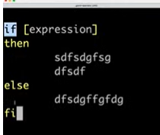

**Example:** 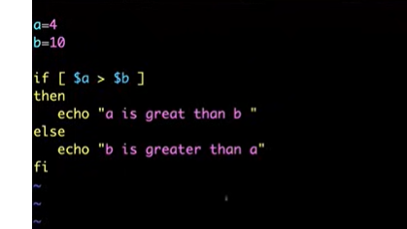

**For loops:**

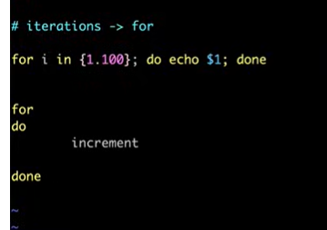

* **Trap is a command for trapping signals**

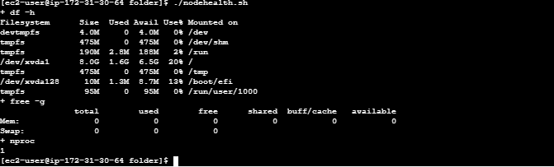

* **Chmod has been divided into 3 sections - which root has access**
* **Which group has access**
* **What are ur permissions**
* **Chmod 777**  i.e change permission for root, change permission for group , change permission for you
* **Linux categorized permission in form of numbers**

1. **4 to read**
2. **2 to write**
3. **1 to execute**

**Chmod 444 file name i.e you r giving permission to read the file for all the users**

* **History is the command to check all the previous commands in the server**

