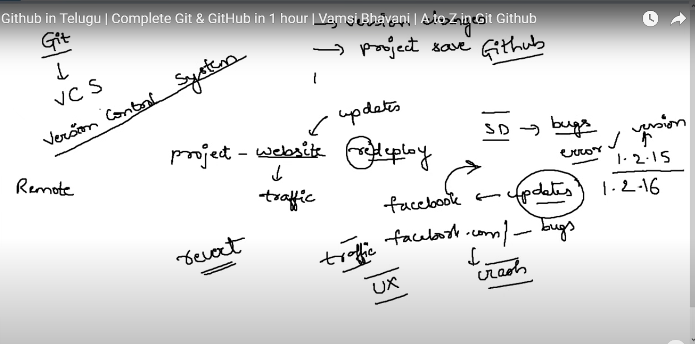

Git is a version control system

* Git And Github are two different functionalities
* Git we use for versions storage and project save purpose
* For suppose facebook got crashed due to some bugs if we want to put into normal state we need previous version
* So that’s the reason we use git where we store it remotely
* There are lot of version control systems available in market but Git is famous among all the version control systems
* Download git of latest version
* Install git

Git : is a Remote Repository that means a folder / Package 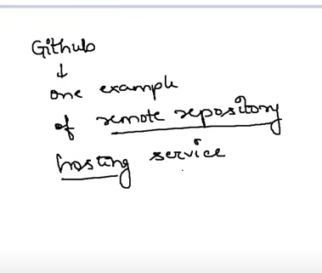

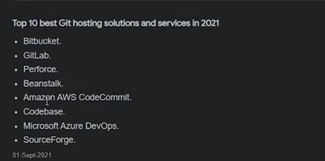

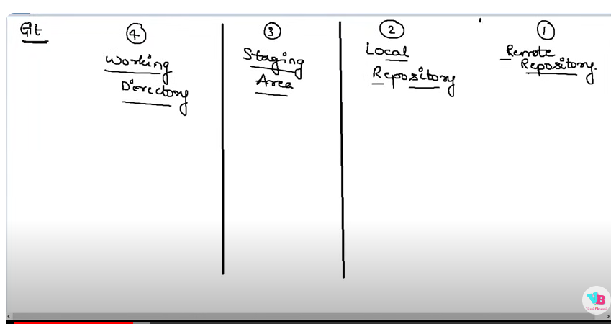

Remote Repository is a folder / package

Local repo is a folder / package which is in ur laptop where u are working the file

Working Directory is a Directory where u just created the folder and updating the folder without running Git command(untracked section is called working directory)

* If you want to send file in remote repository first it should be saved in local repository

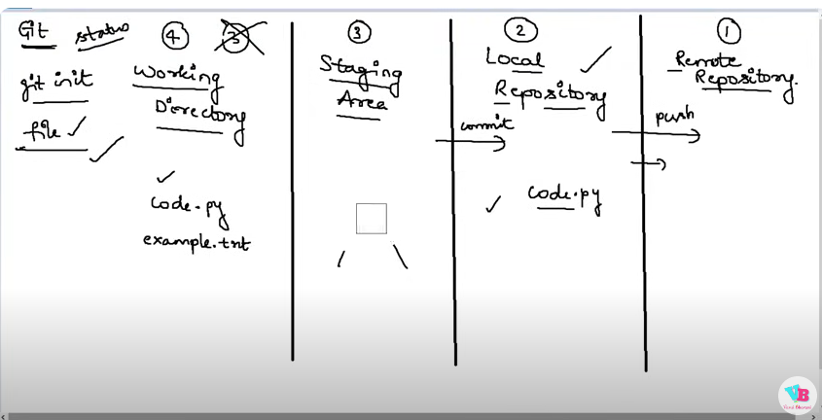

If you want to send only 1 file to remote repository code.py without staing area its not possible to commit only 1 file to repo

* From working directories to staging area you will send files one by one
* But from staging area to local repository and from local repo to remote repo will send files by batch (group of files together)
* 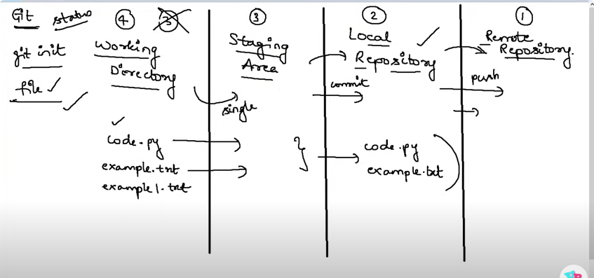

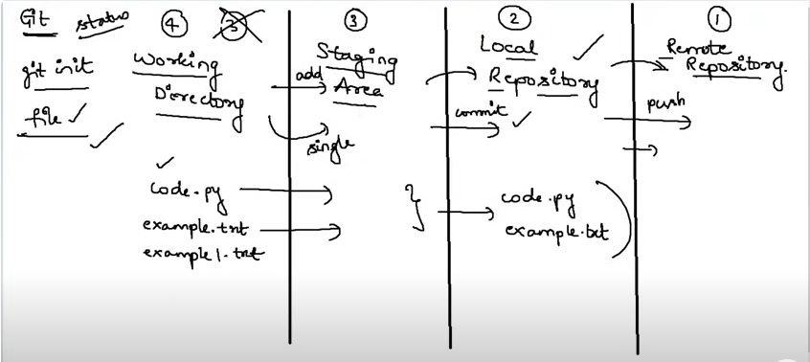

* From working directory to staging area will send files by command called git add
* From staging area to local repo will send files by command called git commit -m “message for commiting” to know the reaon of commit as in organizations there will be many ppl who will be working in same repo
* From local repo to remote repo will send files by command called git push

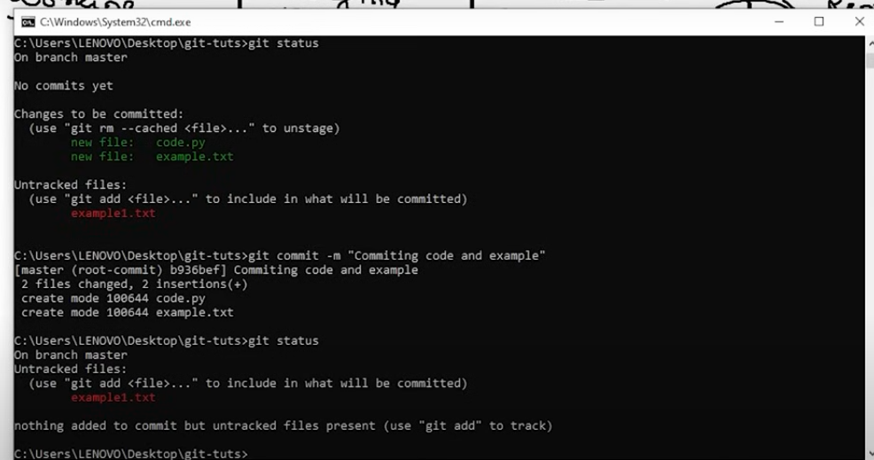

To send files to remote repository first you need to create repo in git hub then only u can push

1. Git commands

* Git init – to initialize the repository
* Git status- when ever you want to check the status
* Git add file name
* Git commit -m “ comments “ for commiting the file
* Git push specify where u want to push either origin or branch

Branches

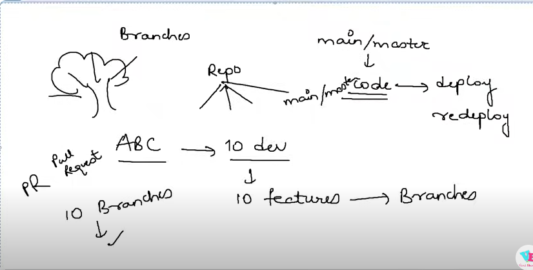

Branches are nothing but copies of main or master

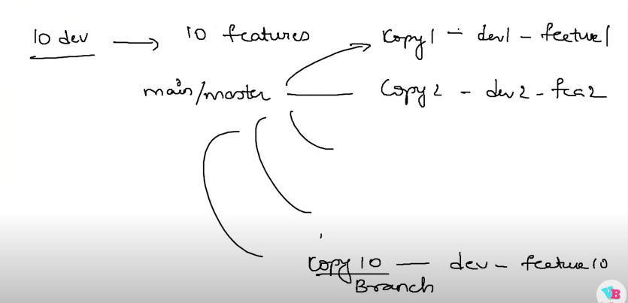

For example in real time scenarios in an office there are lots of ppl work on same repo so they separately create branches for each member and after finishing their task they raise pull req

If manager is satisfied with his file he merges with main file if not he asks for some changes

* To create branches git checkout -b branch name
* Git add file name
* Git commit -m “comments”
* Git push – to branch location

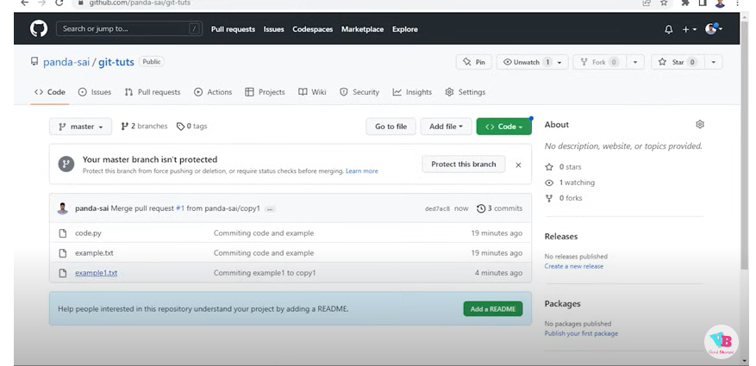

Forks are nothing but for example if u want to do some changes from other repo but u don’t have permission in that case u can use fork so that whole project will be copied from others repo to ur repo

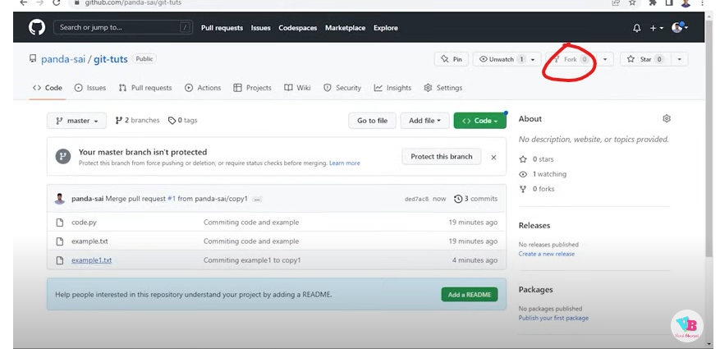

And if you want to make the changes first that repo should be in your local laptop

* Create a folder and git clone that code from your repo
* Make the changes and
* then add file to repo again after changing the directory cd directory name instead of init we use git clone here bcz init is used to create a new repo
* But in our case its already there in remote repo so that’s the reason we have to clone
* 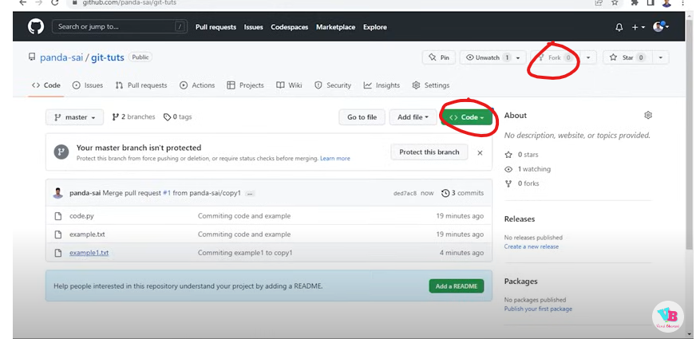
* After cloning git add or git commit
* And then push

issues

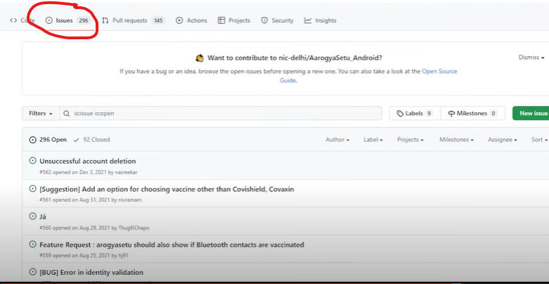

Issues are the problem which they are facing in that particular project if you can solve the problem you can solve it and raise the PR

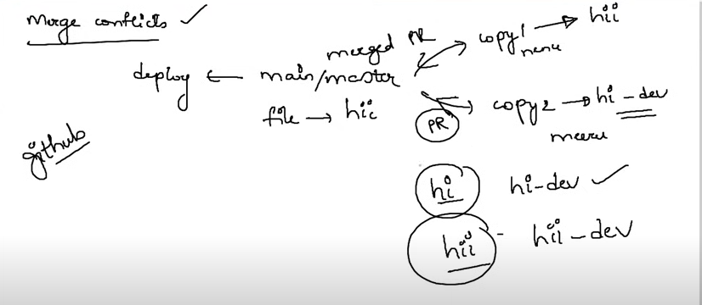

Merge conflicts: if there are conflicts merge simply adds both the requests to master copy 1 and copy 2

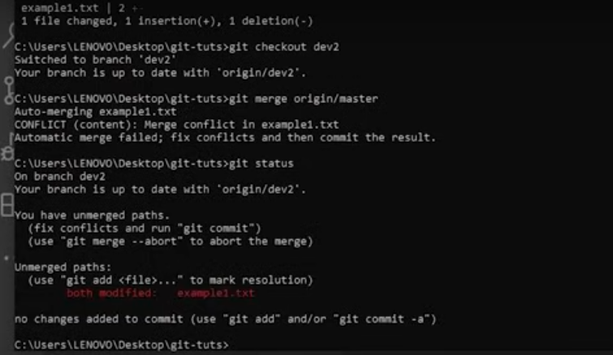

Git fetch : where as it shows the changes

Git pull : it gets the changes updated as well