Practice Exam – 01
50 points

- Instructions to create the project.

- You will be creating BMI calculator for this exam. BMI means Body Mass Index value for human beings given weight in pounds and height in inches.
- Create a project in XCode with the name “LastName_PracticeExam01”.
- While creating the app make sure to follow minimum deployment and project format as shown below:

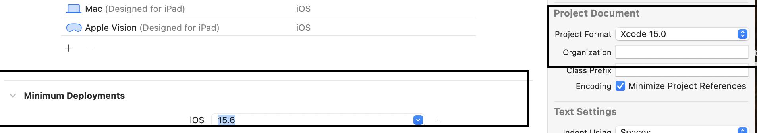

- Instructions to create the BMI App.

- The user interface (UI) of the app is shown in Figure 1. Design a BMI app that takes the patients height in feet and weight in lbs as input. The app should be able to categorize the patients as per the below Table:

Category | BMI Range | Health tip
Underweight | <= 18.5 | Eat more protein and healthy fats.
Normal | 18.6–24.9 | Excellent! Maintain a balanced lifestyle.
Overweight | 25–29.9 | Lose weight by maintaining a balanced diet less and increasing physical activity.
Obesity/obese | BMI of 30 or greater | Consult a doctor for personalized advice.

- Your app should consist of the following UI components and you may use your own colors of choice.
  - A header label shows ‘BMI Calculator’ in your choice of color
  - Three text fields to enter
    - Patient’s height in feet
    - Patient’s height in inches
    - Patient’s weight in lbs.
  - One button to calculate the BMI

  - $BMI=703* \frac{weight}{{height }^{2}}$
Weight is lbs and height in inches.
For easy calculation, convert the height into inches
Example:
When the user enters
Height as 5 feet and 9 inches and
Weight is 120 lbs
The BMI is 17.7
Hint: Convert the feet to inches.
5 feet 9 inches = 5 *12 +9 = 69 inches
The calculated BMI value must be rounded to one digit.
  - A label to print Message in three different lines:
Your Body Mass Index is ____.
This is considered _____.
Health tip: ________.
  - A UIImage to display the image related to the category. [NOTE: images are provided to you]

UI IMAGES:

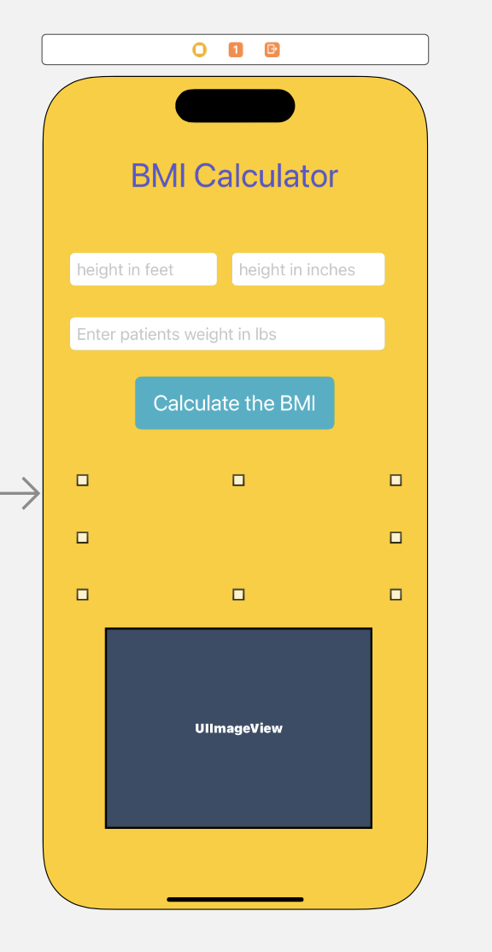
Figure 1: App Design

- Refer below images for sample output

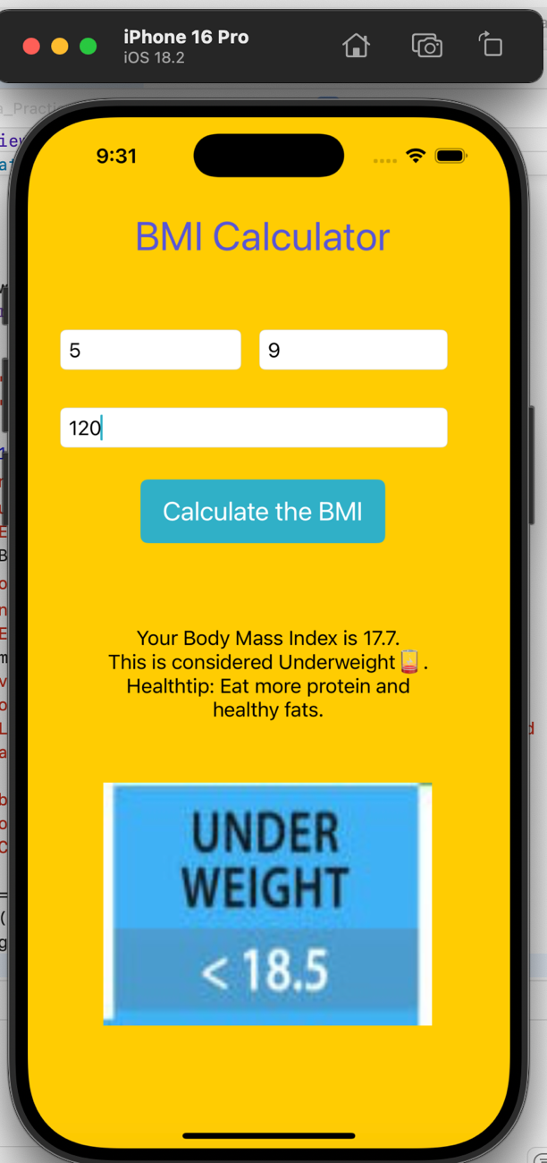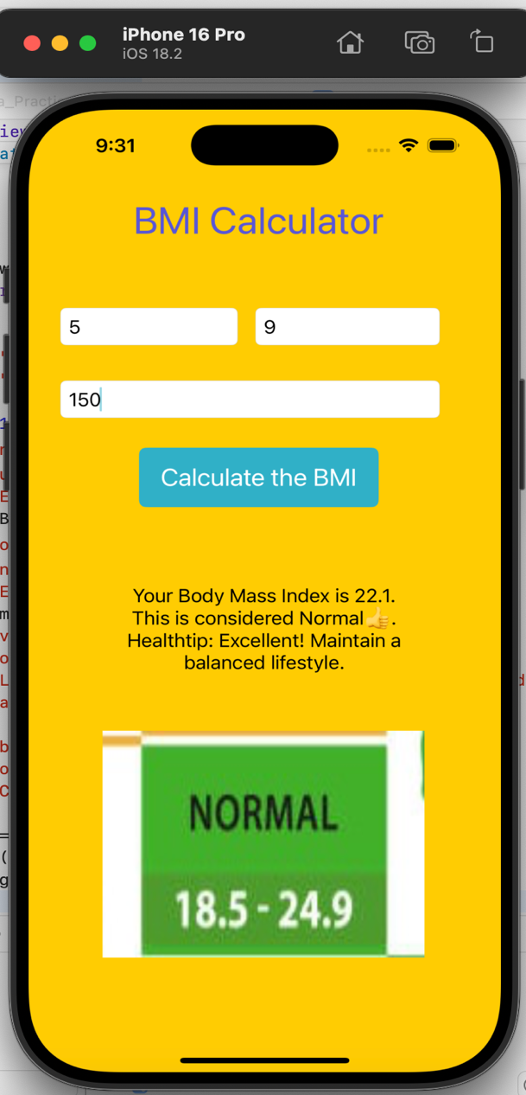

Figure 2: View of Underweight Figure 3: View of Normal
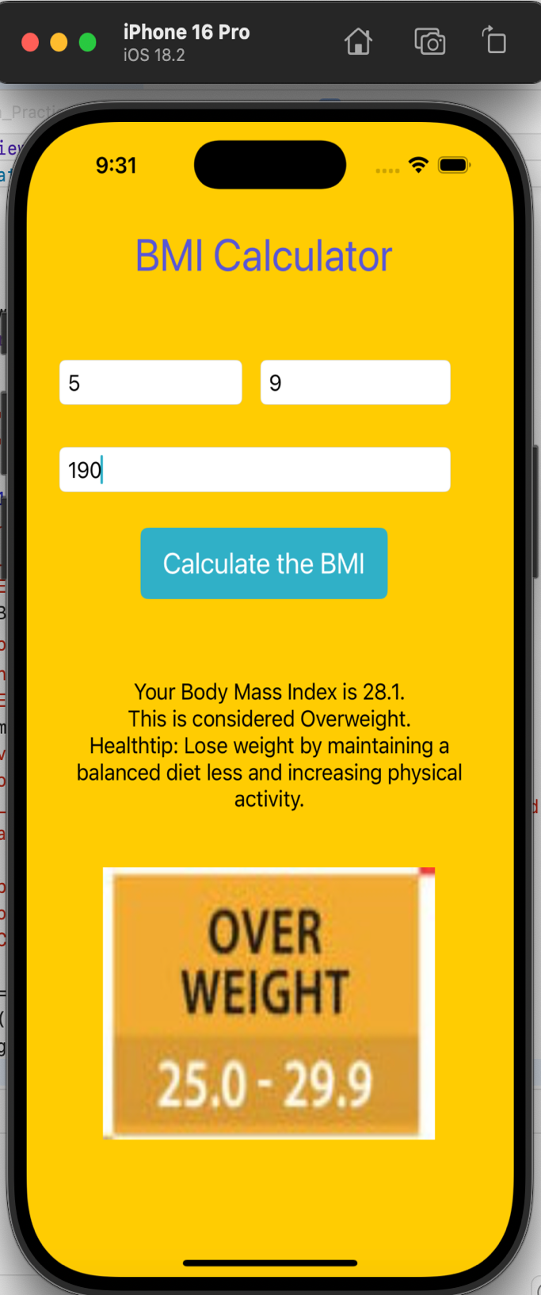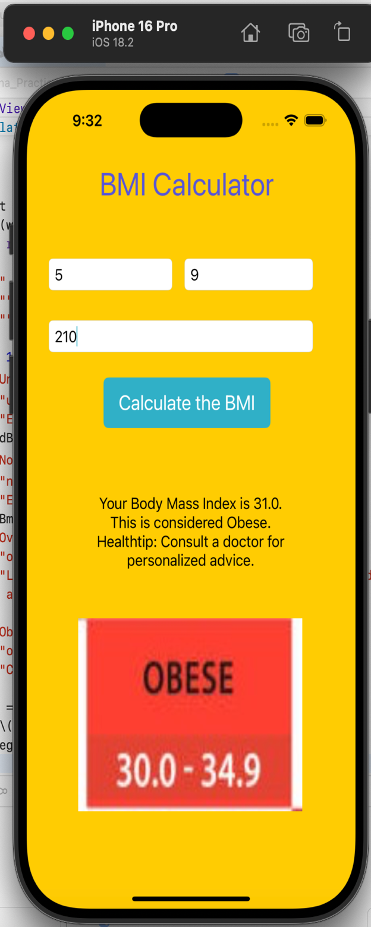

Figure 4: View of Overweight Figure 5: View of Obese

Submission Instructions:
- Save your XCode project of BMI App.
- Name it with your LastName_PracticeExam01. Compress the folder and submit it to this exam

